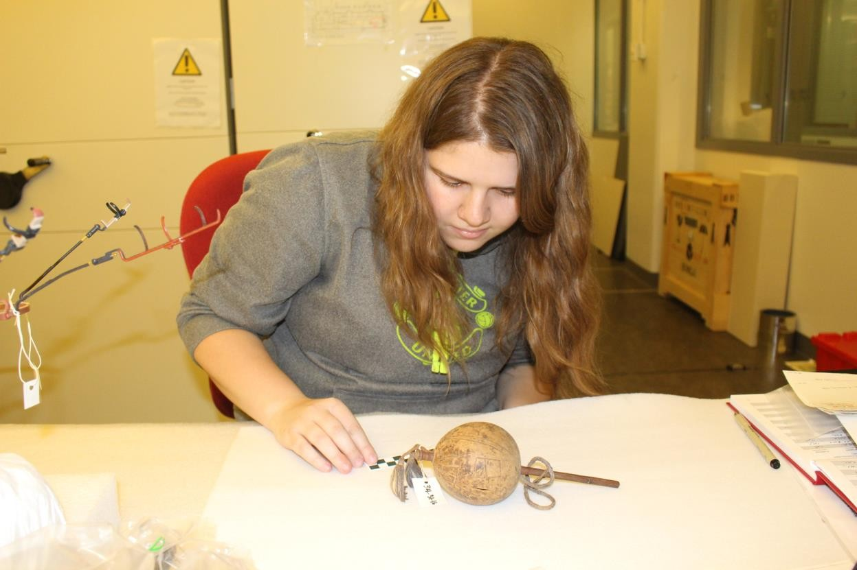

Figure 1. Examining a Yaruro rattle from Apure, Venezuela in the Penn Museum (Object No. 34-31-18).

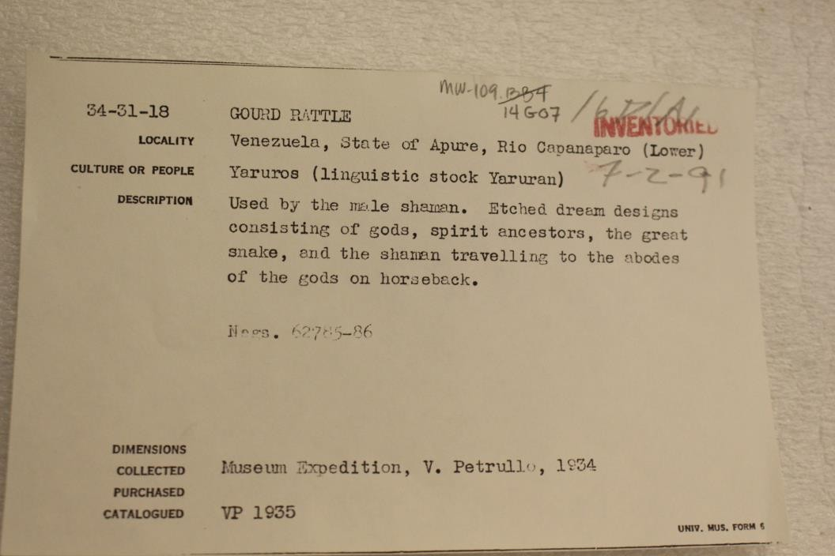

Figure 2. Registrar’s Card for a rattle chosen for modelling (Object no. 34-31-18).

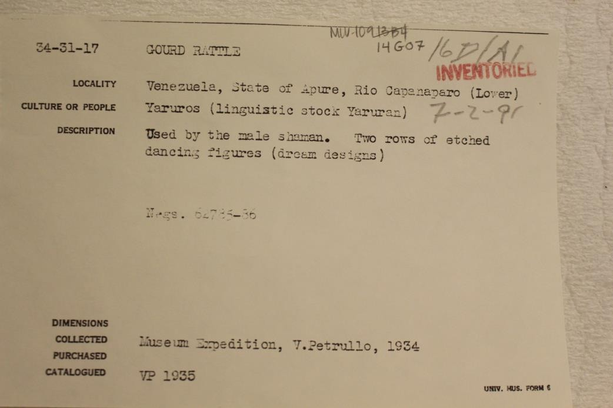

Figure 3. Registrar’s Card for a rattle chosen for modelling (Object no. 34-31-17).

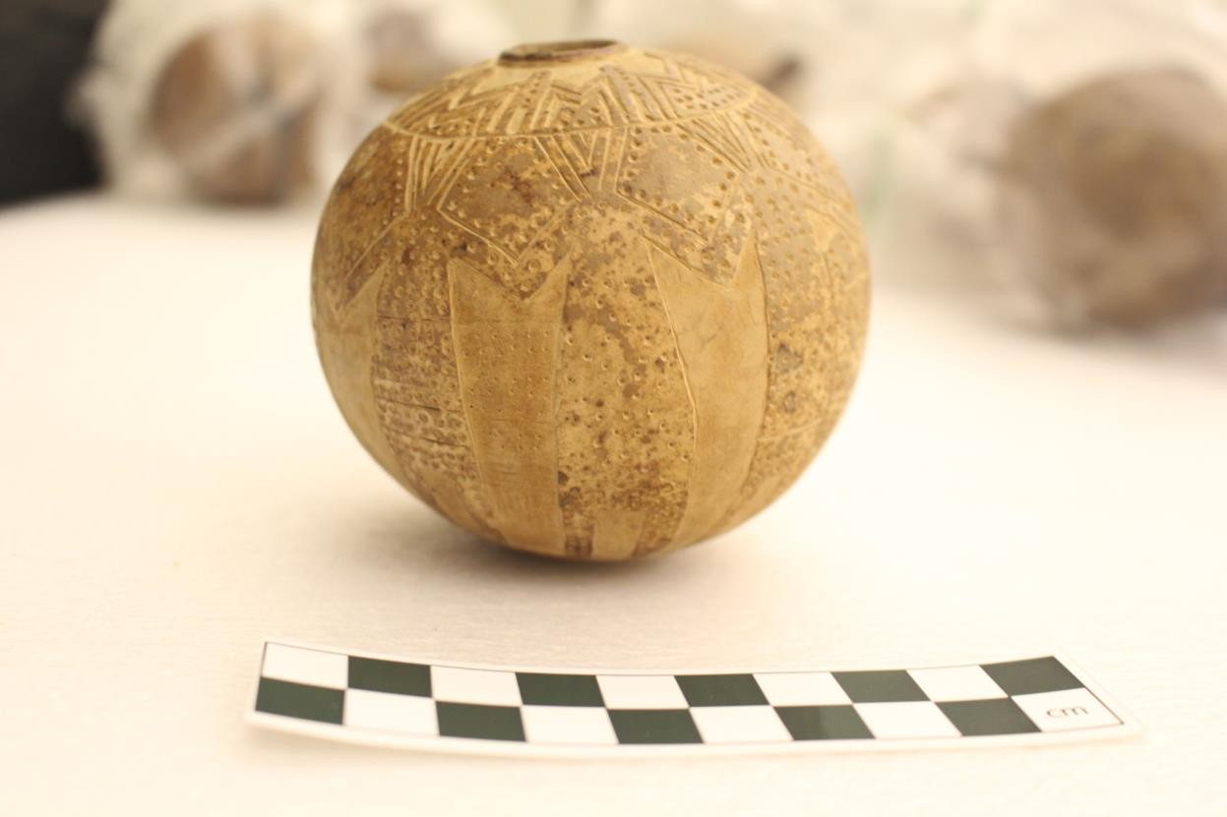

Figure 4. Side-view of rattle chosen for modelling (Object no. 34-31-17).

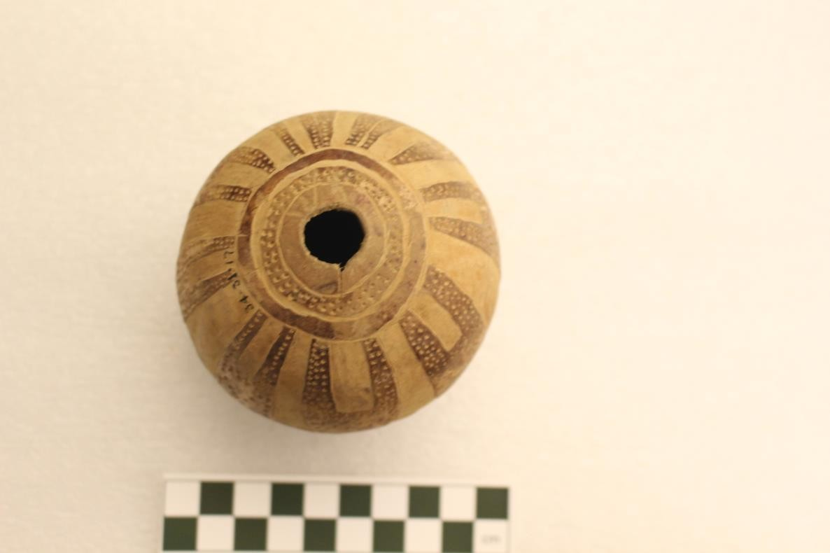

Figure 5. Bottom view of one of the rattles chosen for modelling (Object no. 34-31-17).

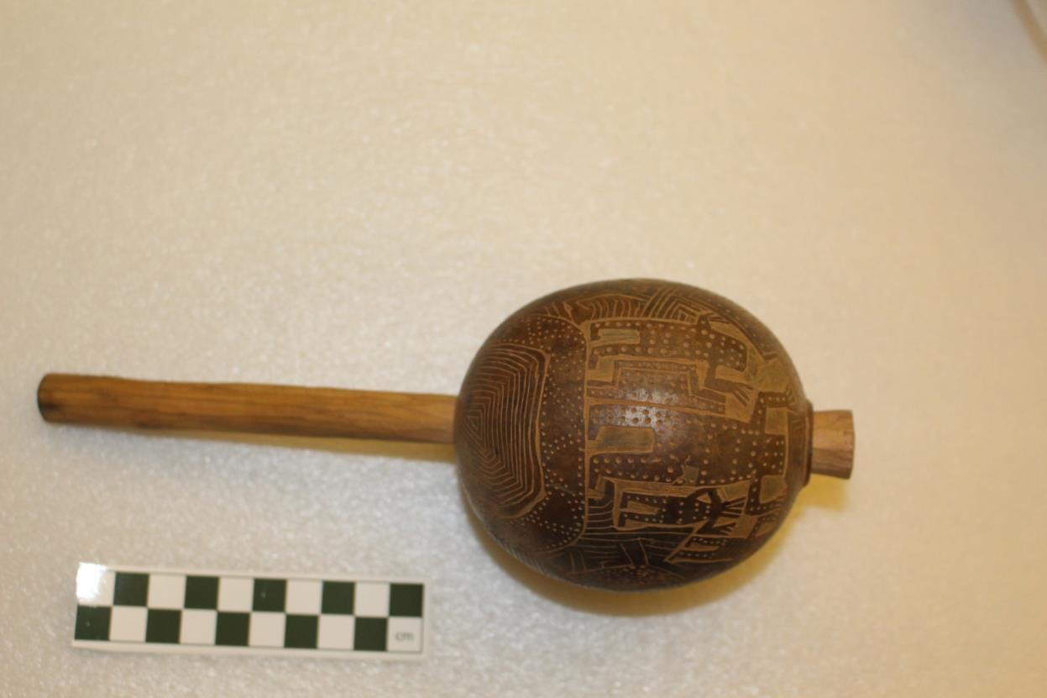

Figure 6. Bottom view of one of the rattles chosen for modelling (Object no. 34-31-18).

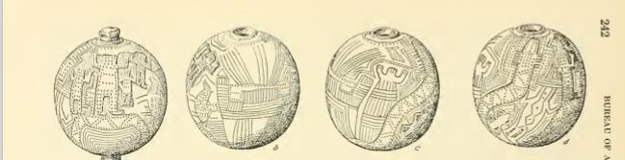

Figure 7. Sketches of the darker rattle (34-31-18 (Petrullo 1934: Figure 27).

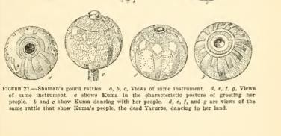

Figure 8. Sketches of the lighter rattle (34-31-17) (Petrullo 1934: Figure 27).

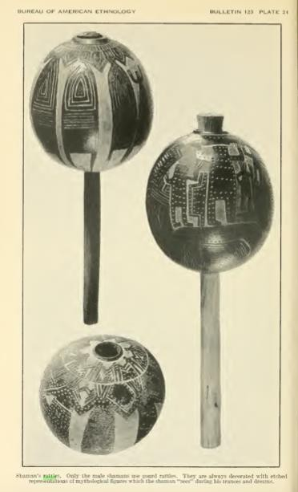

Figure 9. Photograph of both rattles (Petrullo 1934: Figure 28).

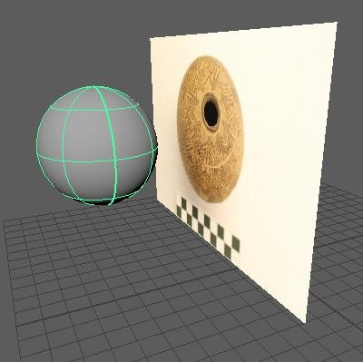

Figure 10. Beginning of modelling: the free-image plane and polygon sphere

(later scaled).

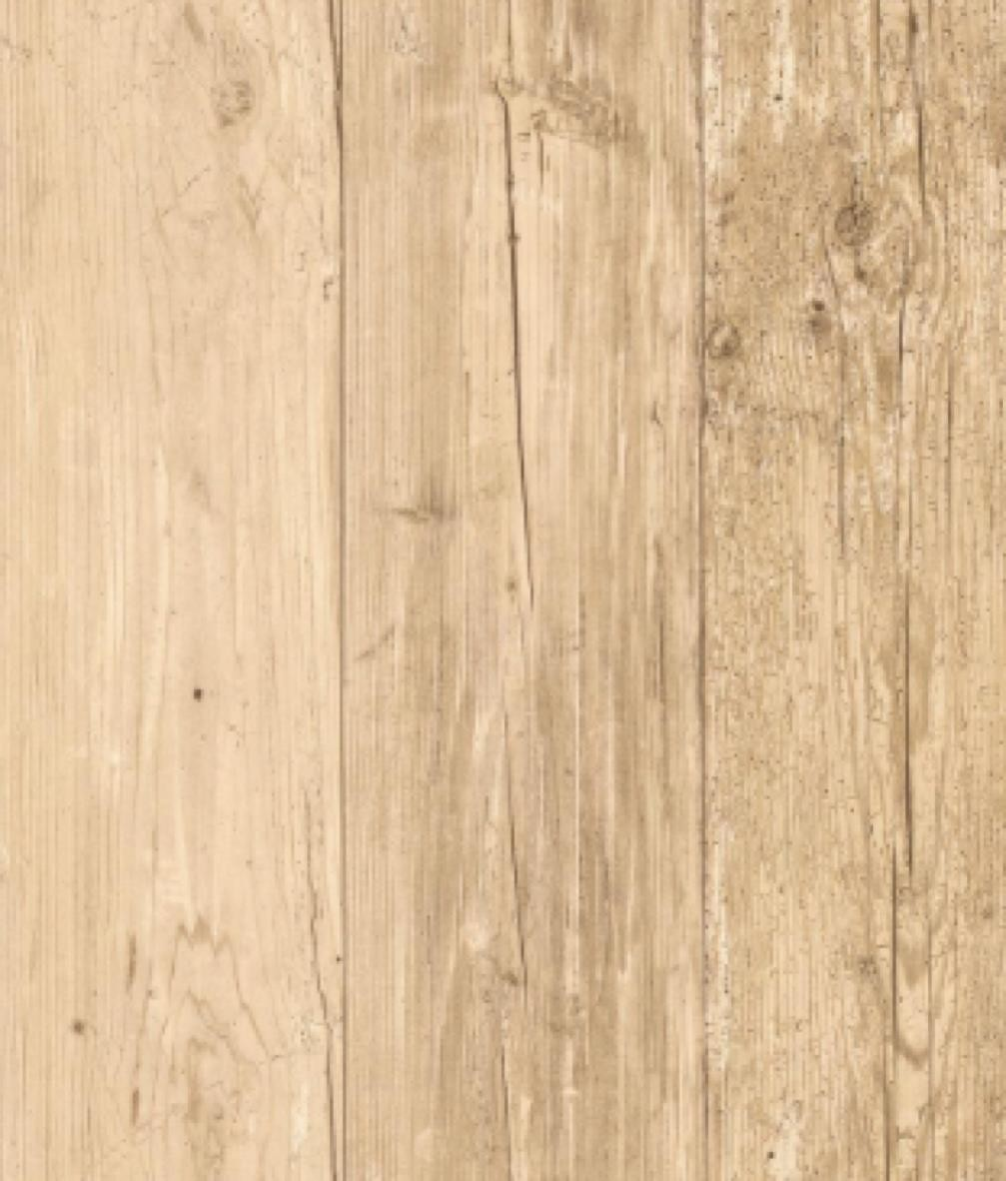

Figure 11. Image used to texture the handle after inserting and scaling the cylinder.

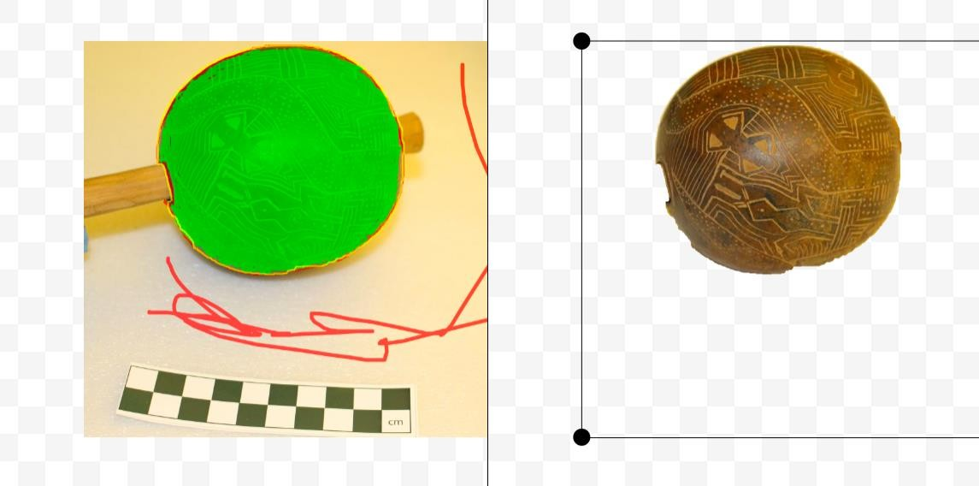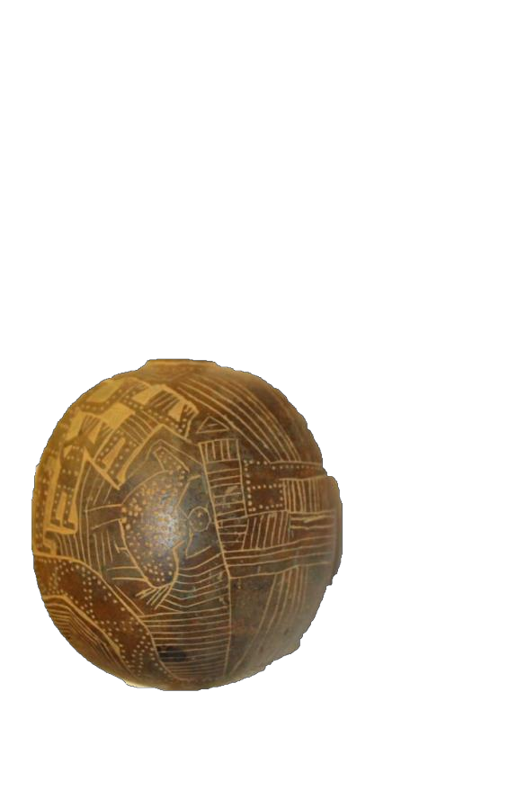

Figure 12. Part of approach one: Using photo scissors online to remove background from photos to be inserted into Hugin. Two faces shown have clear overlapping points the program could not recognize properly.

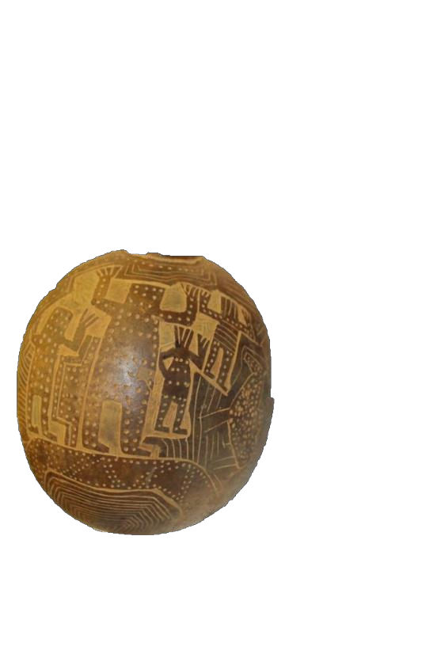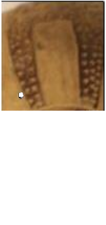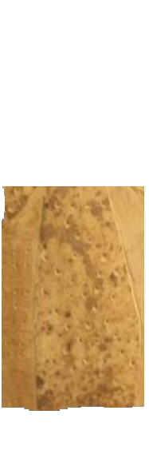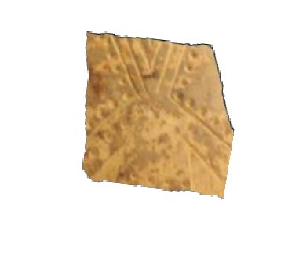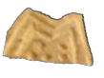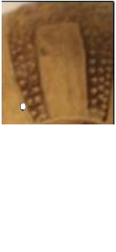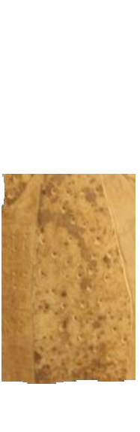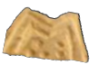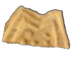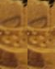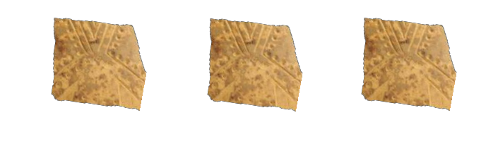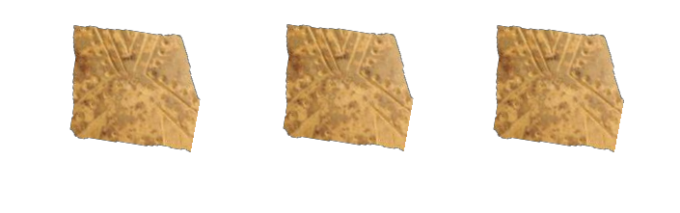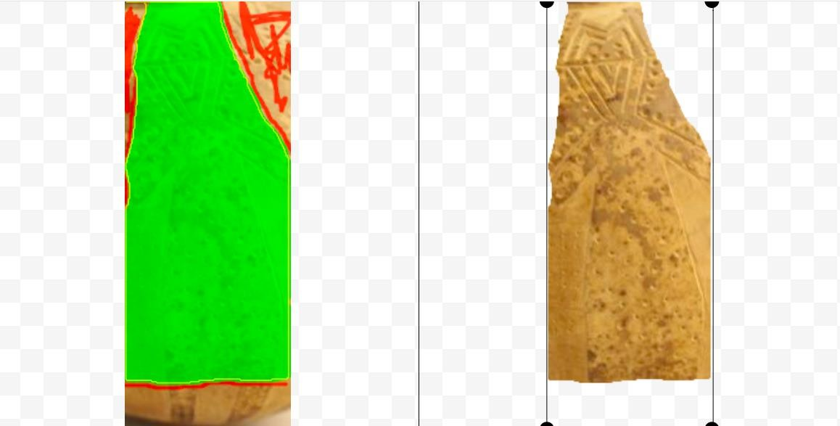

Figure 13. Part of approach two: Using online photo scissors to remove background from screenshots. Pieces later assembled in Word.

Figure 14. Part of approach two: Copy and pasting the figures together and grouping them to create a texture in Word.

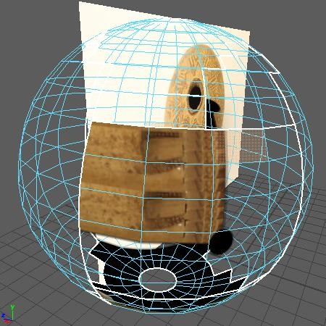

Figure 15. Part of approach two: texture becoming warped in UV (before learning to manipulate the UV shell).

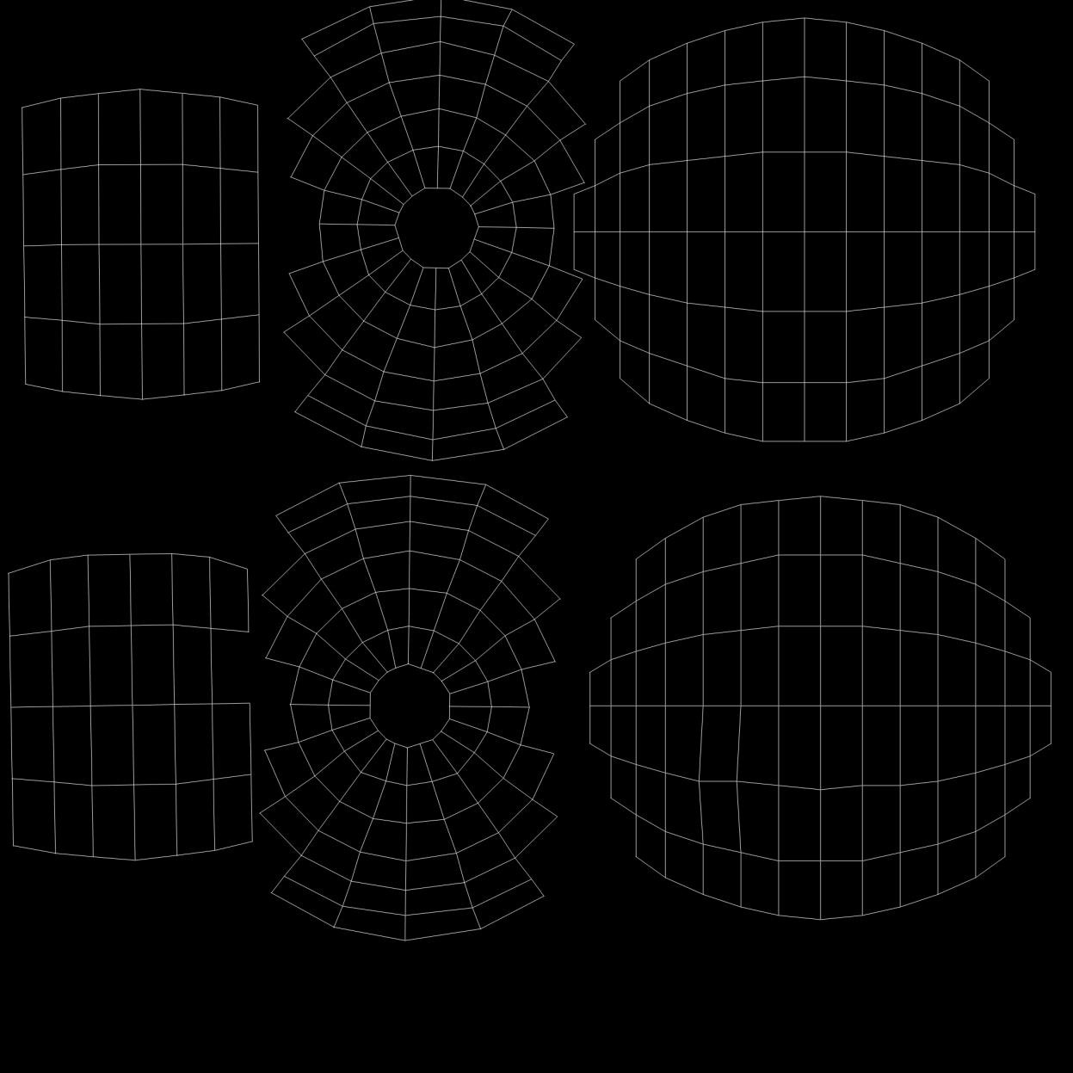

Figure 16. Part of approach three: printing out the unwrapped spherical UV shell (later inverted to black and white using online program), cut out and drawn on.

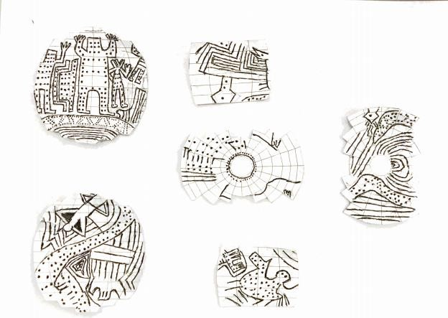

Figure 17. Part of approach three: Scanned version of the drawn-on UV map.

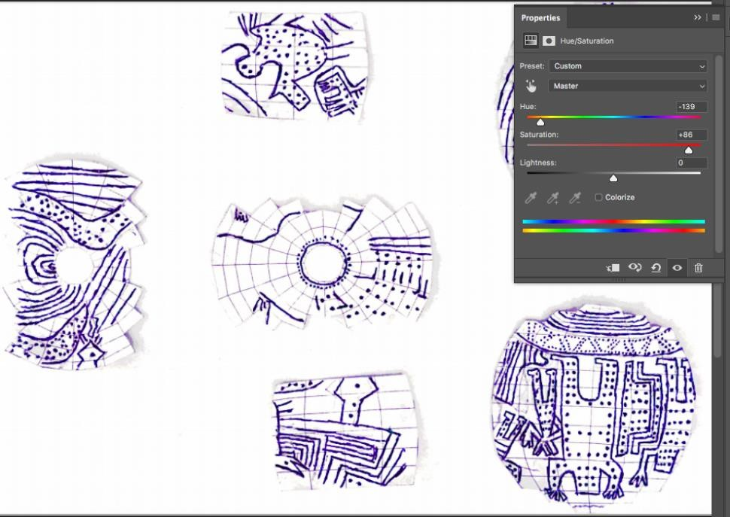

Figure 18. Part of approach three: creating new layer and changing hue of details in Photoshop. White background later removed using Magic Wand Tool.

Figure 19. Part of approach three: final Photoshopped version.

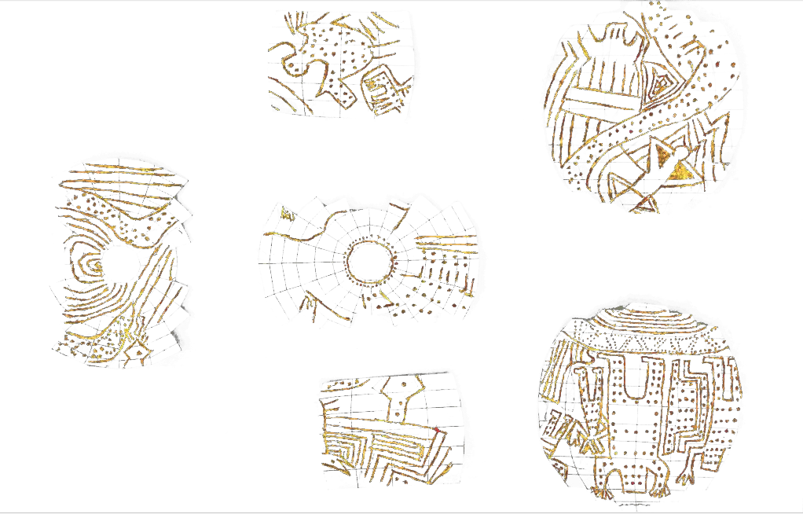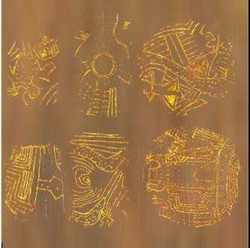

Figure 20. Part of approach three: layering details onto texture in word to create cohesive image. (UV map was layered on top to scale the details to the right size).

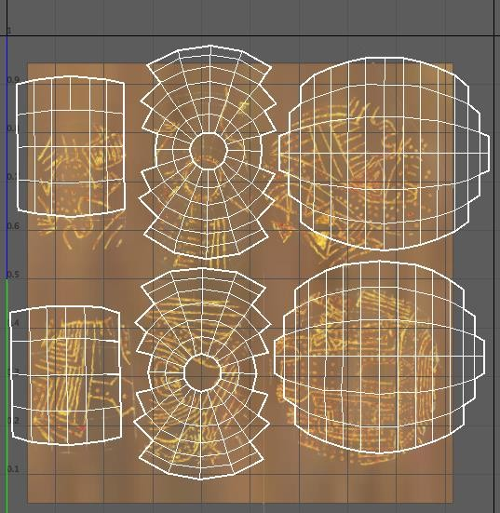

Figure 21. Part of approach three: despite scaling in word, the images were slightly small, out of order, etc. UV shell manipulated to fit.

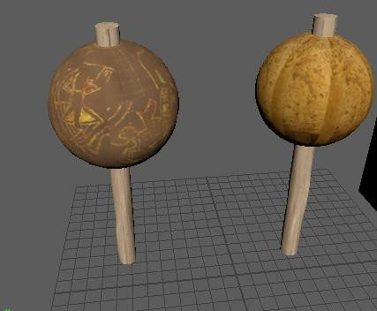

Figure 22. View of both rattles.

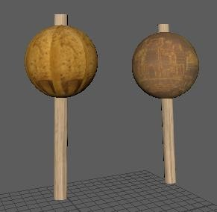

Figure 23. Another view of the rattles.

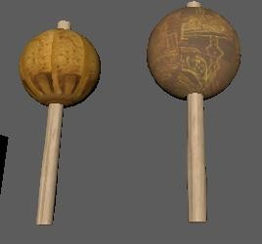

Figure 24. Another view of the rattles.

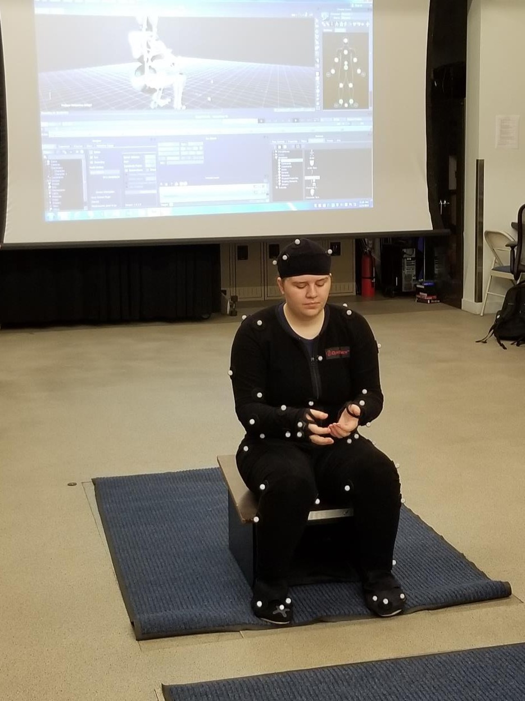

Figure 25. Motion capture in the SIG Laboratory, University of Pennsylvania.