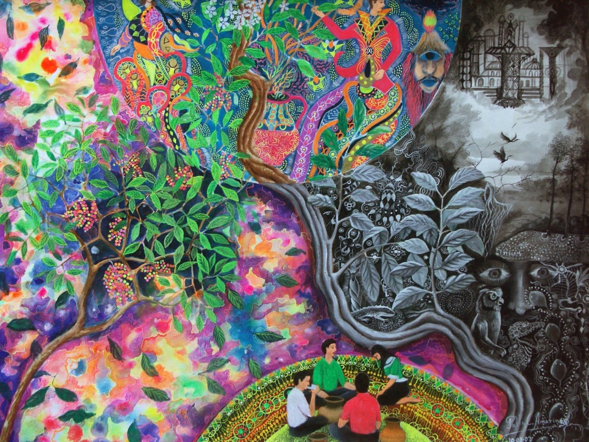
Figure 1: A recreation of an ayahuasca caused hallucination
(Illustration by Pablo Amaringo; Charing et al. 2011).

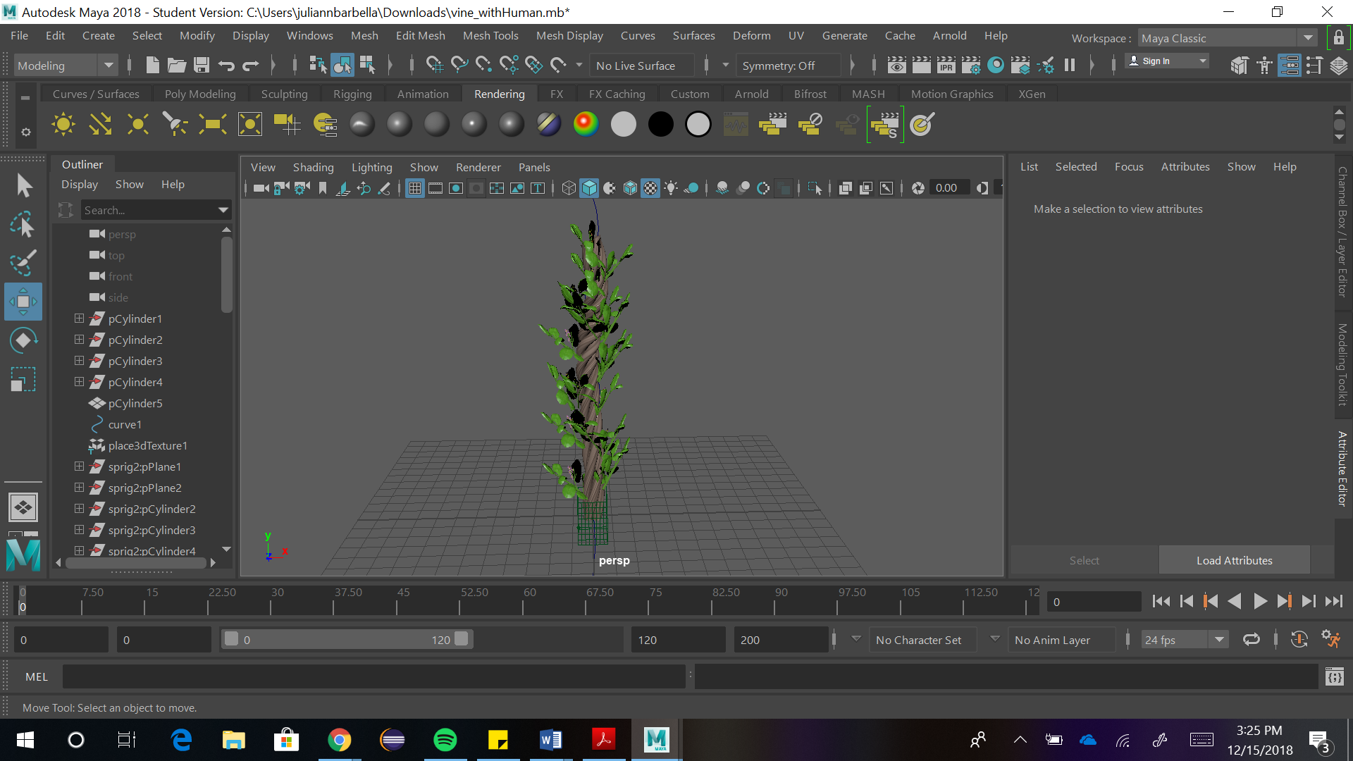
Figure 2: The ayahusaca vine, leaves, and flowers modeled in Maya.

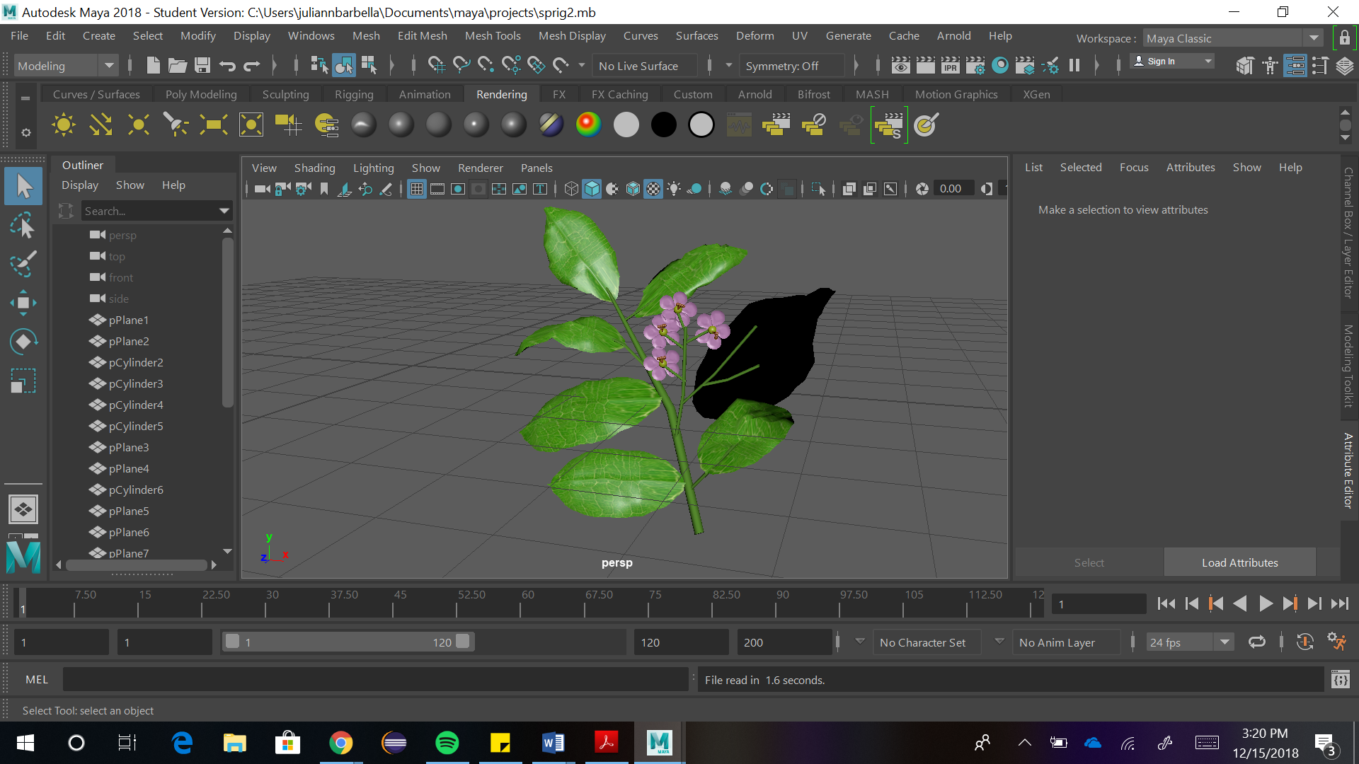
Figure 3: The ayahuasca shrub model in Maya.

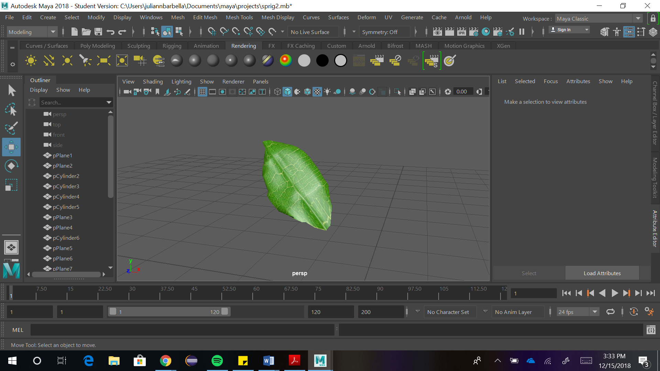
Figure 4: The leaf from the ayahuasca plant, modeled in Maya.

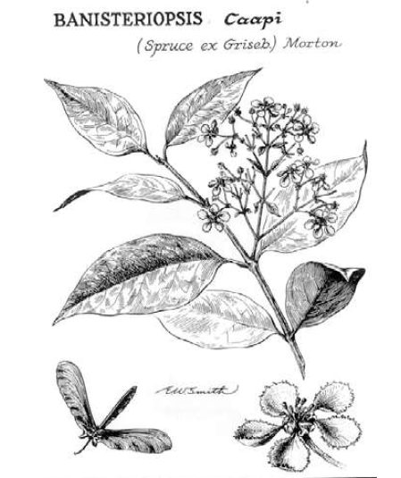
Figure 5: An illustration of a sprig of the ayahuasca plant
(Artwork by Smith
Barba 2003: 193 Figure 16.1).

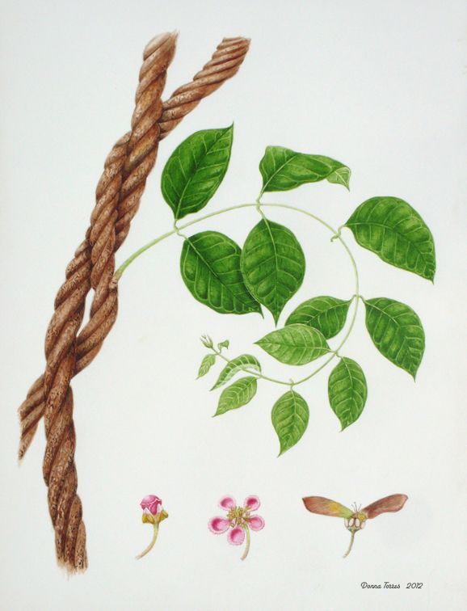
Figure 6: A colored illustration of the ayahuasca plant
(Drawing by Donna Torres 2012).

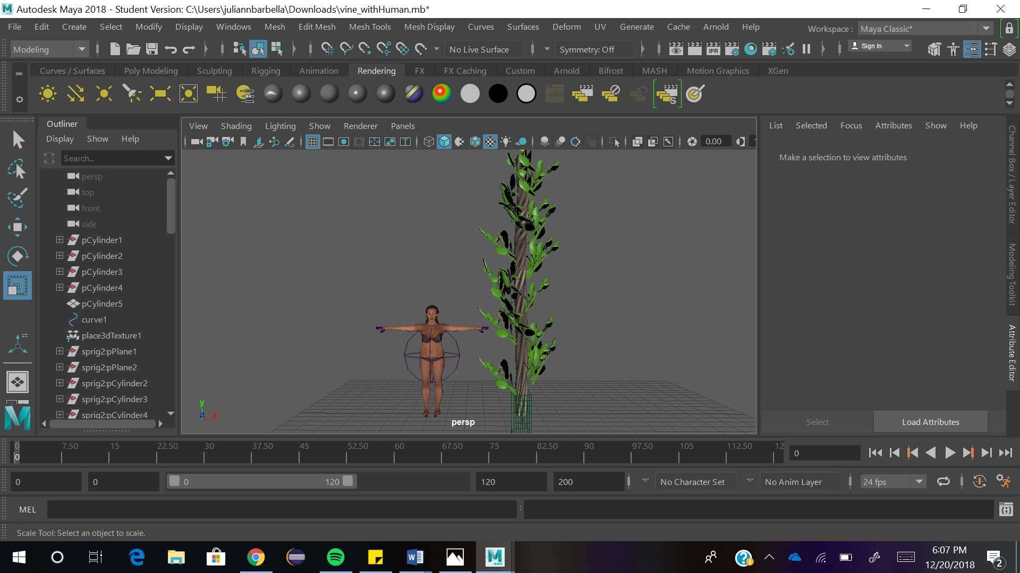
Figure 7: The full ayahuasca vine model with a human model to show scale.

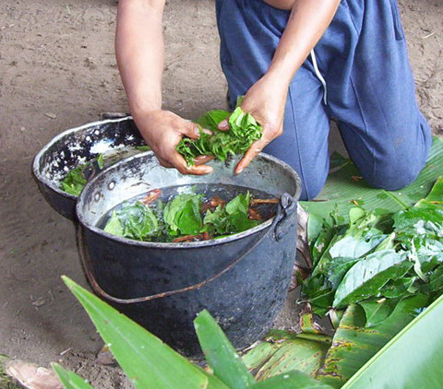
Figure 8: The ayahuasca leaves and bark being placed into a boiling pot to make the ayahuasca tea from Penn Box.

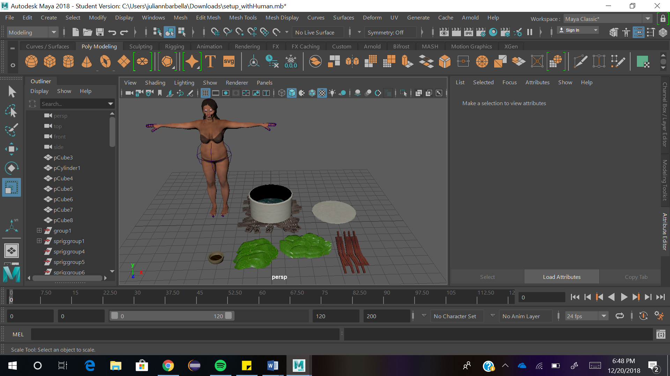
Figure 9: The preparatory process of brewing ayahuasca tea including the wood for the fire, pot, lid, large leaves, small leaves, bark scrapings, and cup with a human model to show scale.

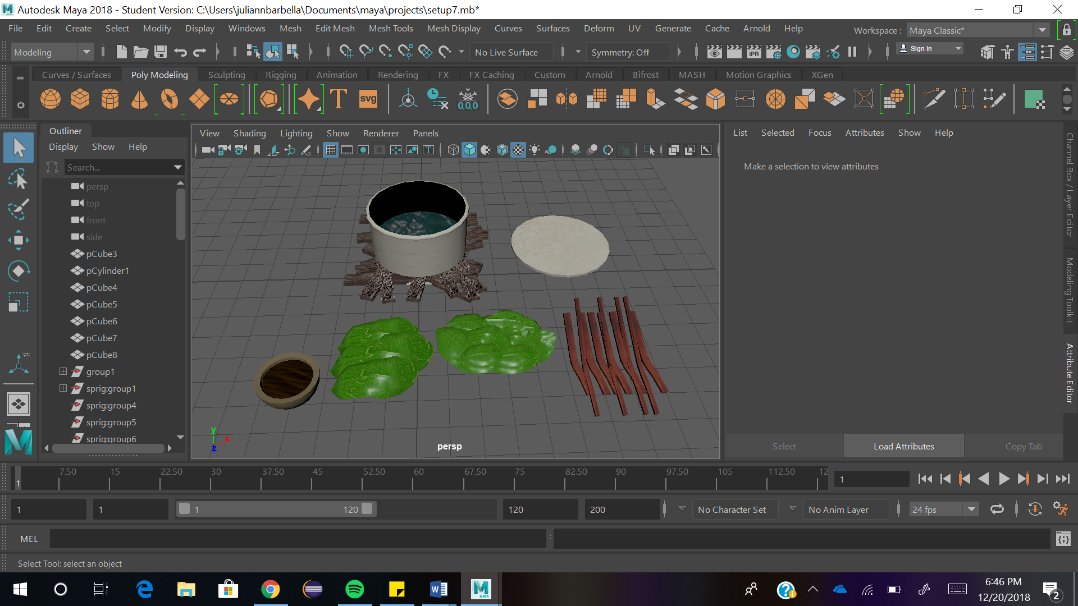
Figure 10: The preparatory process of producing the ayahuasca tea, consisting of small leaves, large leaves, bark, wood, a pot with boiling water, the top of the pot, and a cup for the tea.

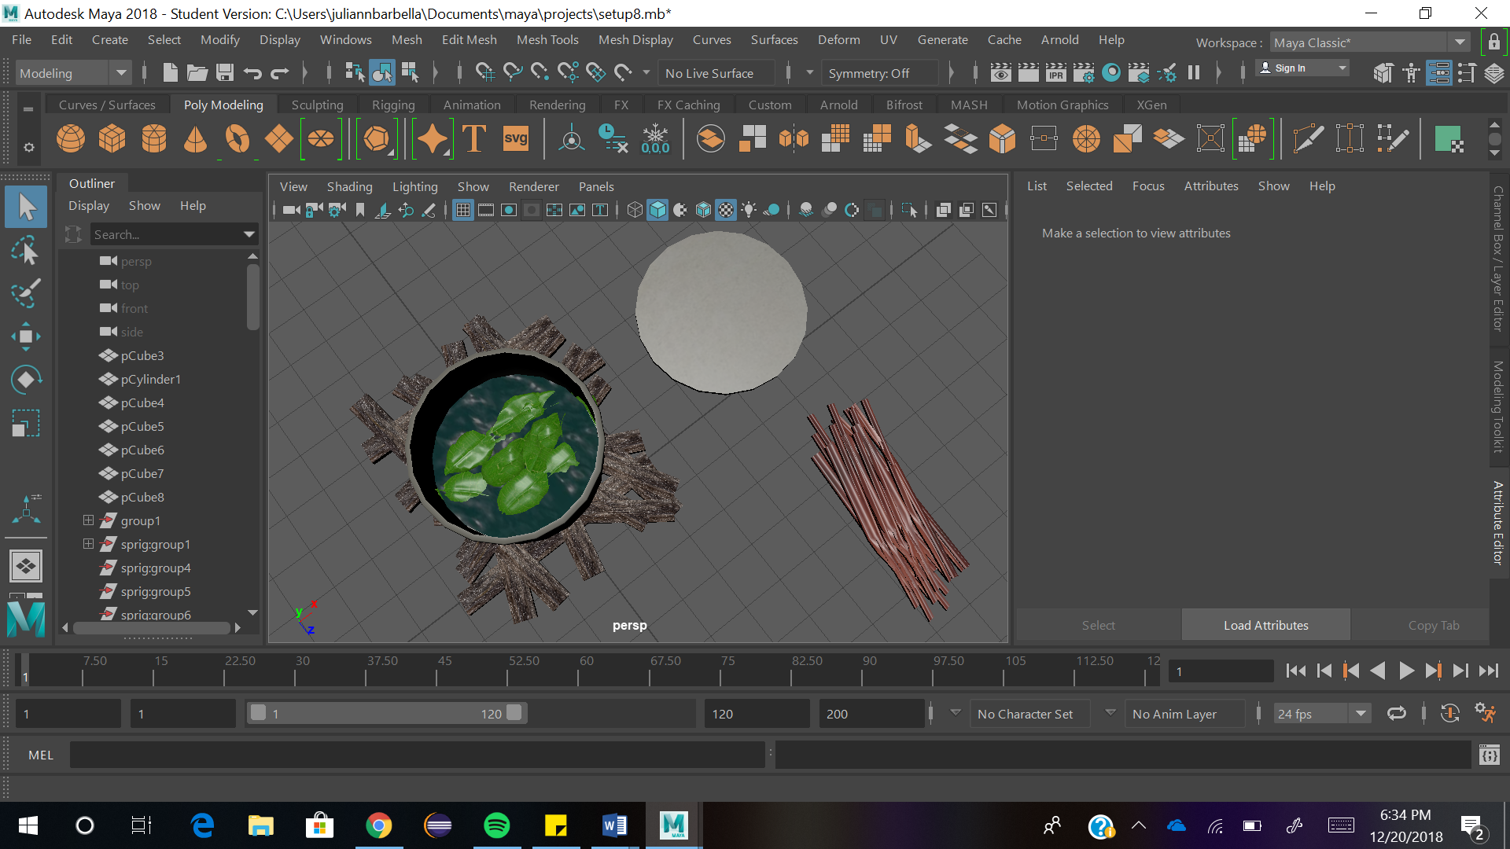
Figure 11: Smaller leaves are first placed into the pot of boiling water to create ayahuasca tea.

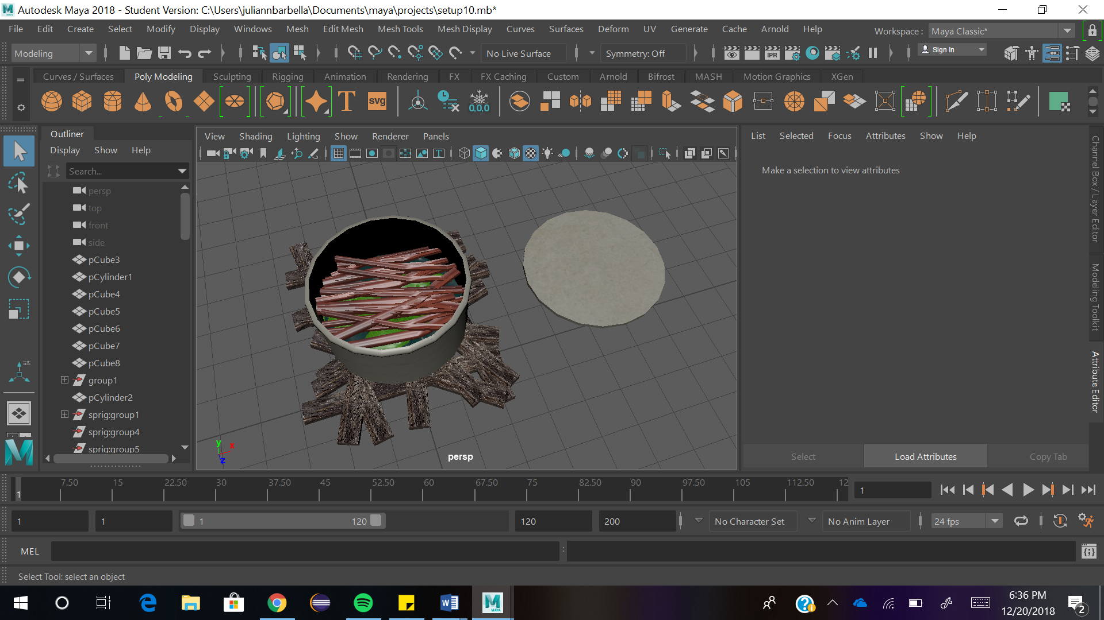
Figure 12: The bark scrapings or cut down sections of the vine’s bark is placed into the pot next.

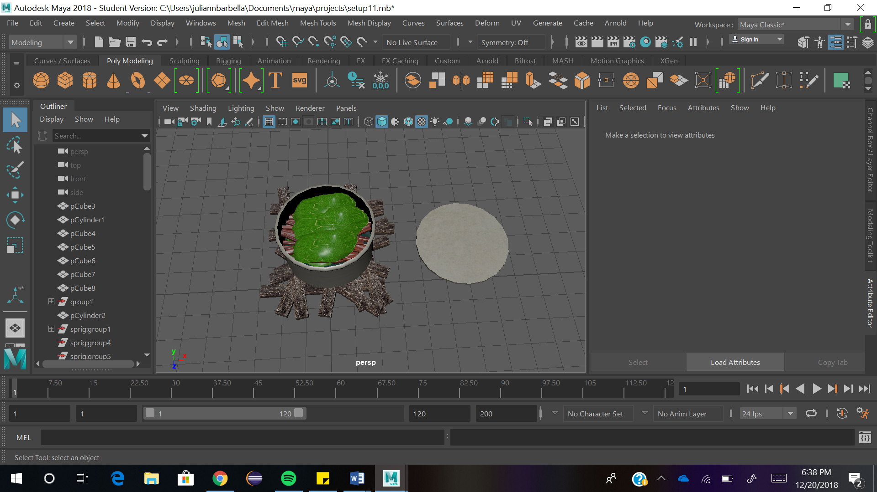
Figure 13: The big leaves are finally placed into the pot of boiling water.

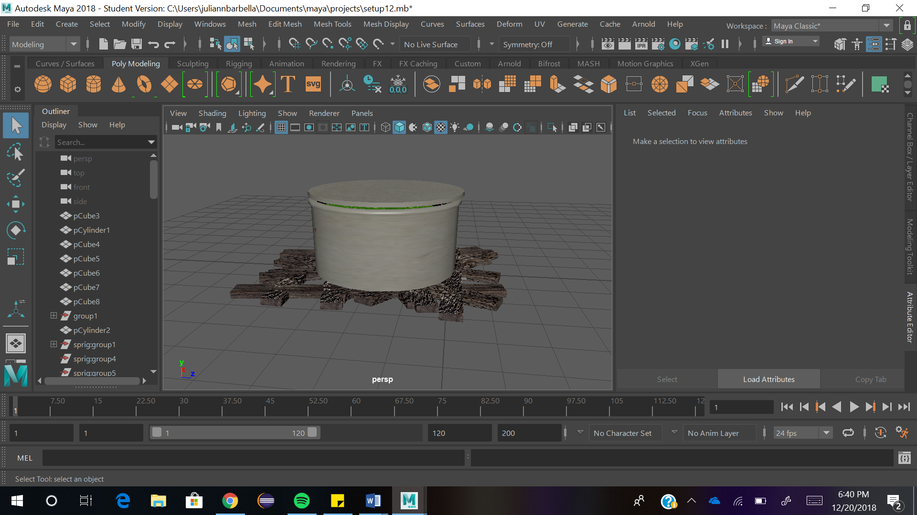
Figure 14: The lid is placed onto the pot to help the tea brew faster.

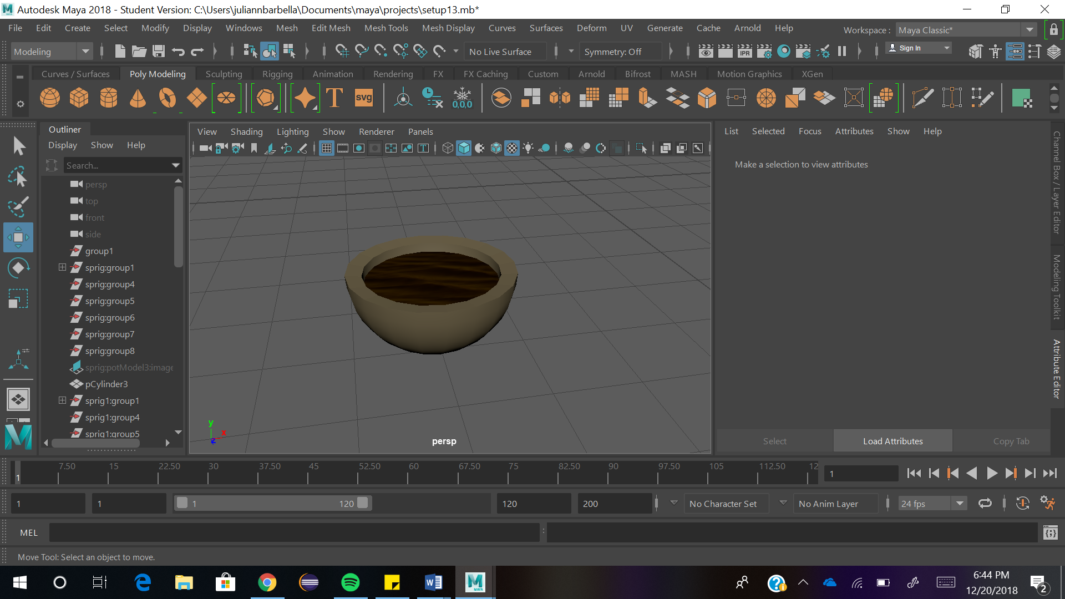
Figure 15: The final product: the ayahuasca tea in a small cup.

1 2 3
4 5 6
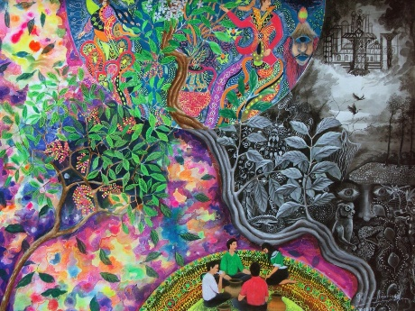
7 8 9 10
Figure 16: Storyboard

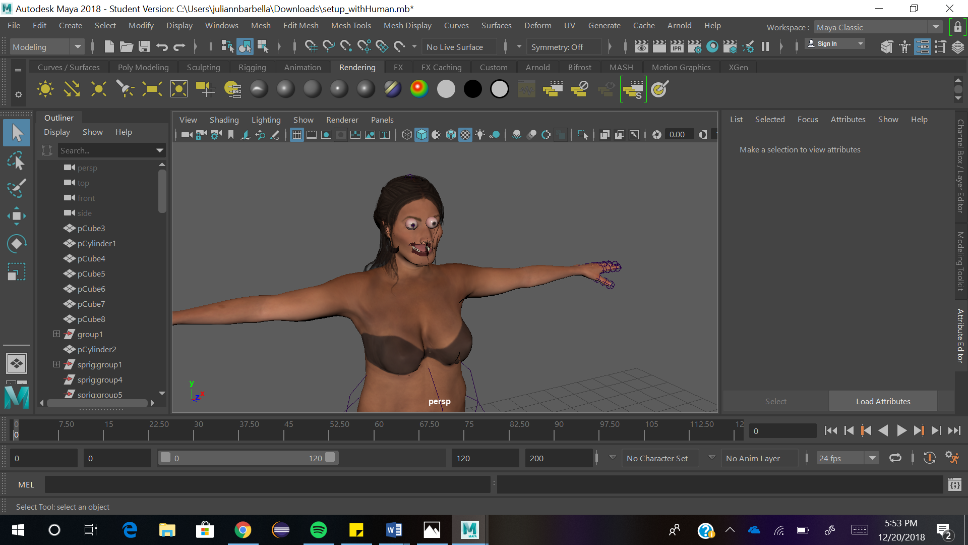
Figure 17: Alteration of the adult woman model’s face.

