Susan Xie
ANTH 258/CIS 106
Visualizing the Past/Peopling the Past
Assignment 6b
15 December 2018

Water on the Landscape of the Pre-Columbian Bolivian Amazon
Figures

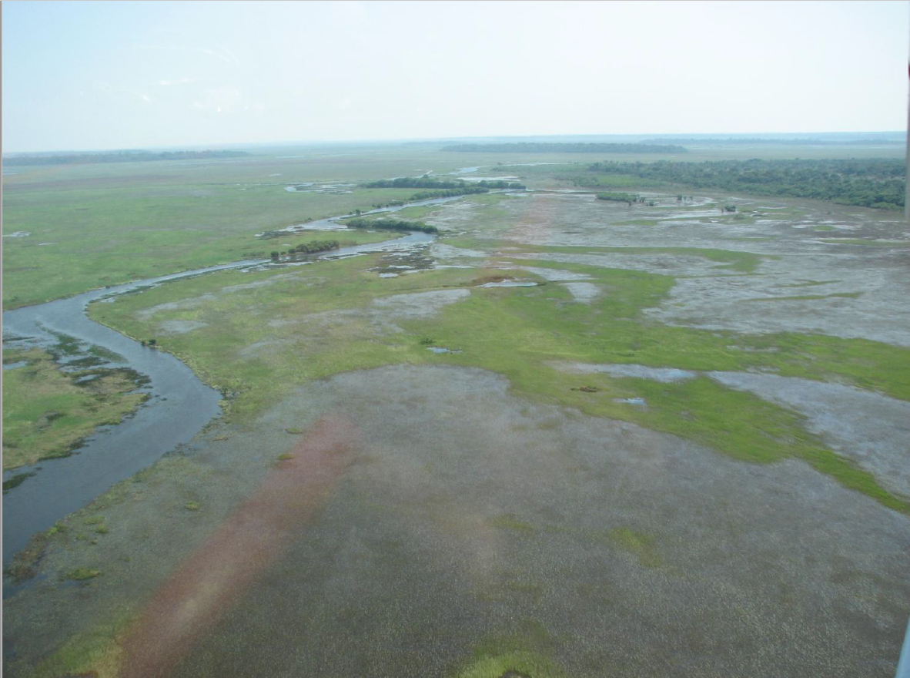
Figure 1: Photograph showing partially inundated savanna in Baures, Bolivia
(Erickson et al. 2018a:Figure 6).
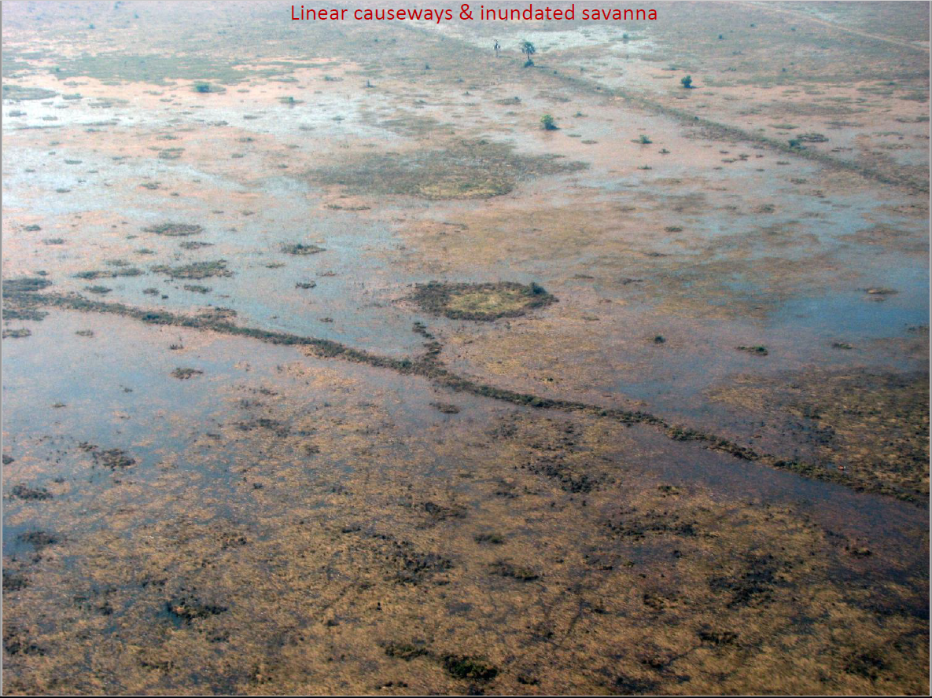
Figure 2: Photograph showing linear causeways crossing an inundated savanna
(Erickson et al. 2018a:Figure 14).

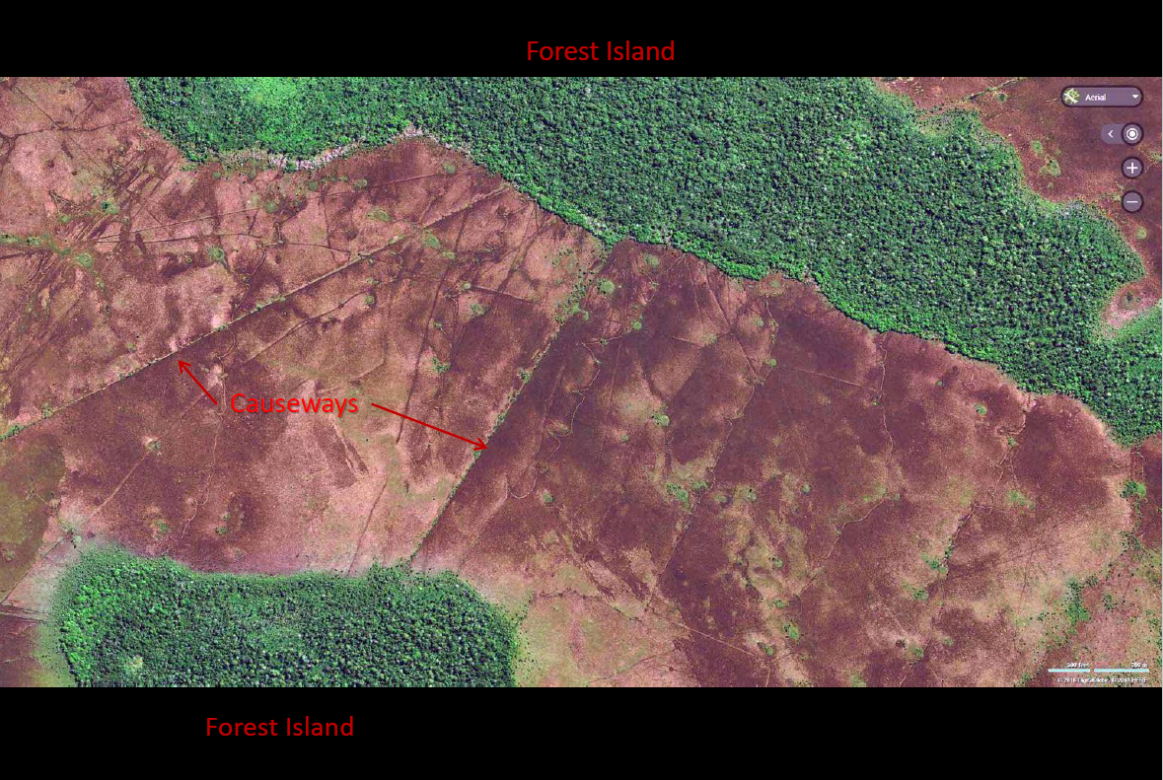
Figure 3: Principle reference for landscape model: satellite imagery showing forest islands and causeways (Erickson et al. 2018a:Figure 11).
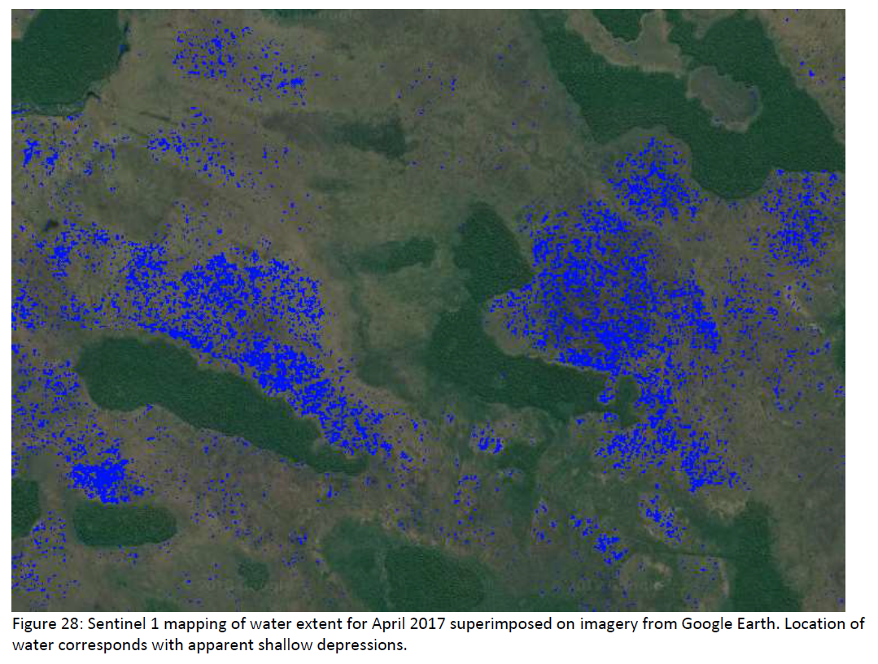
Figure 4: Sentinel 1 mapping of water extent from April 2017 superimposed
on imagery from Google Earth containing the modelled region (Erickson et al. 2018b:46 Figure 28).

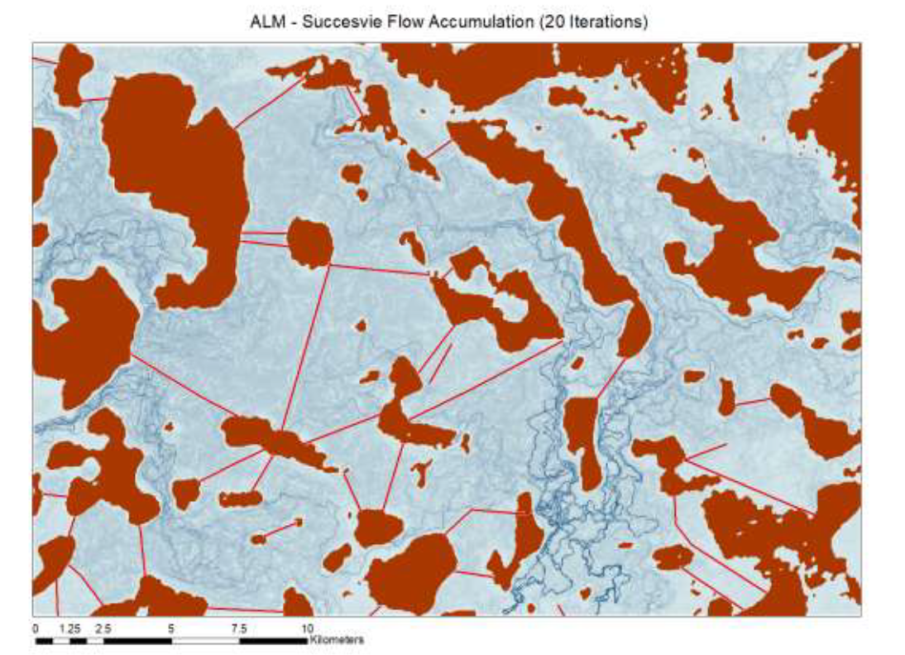
Figure 5: Natural Landscape Model (NLM) showing 20 iterations of Successive Flow Accumulation on a subset of landscape containing the referenced region (Erickson et al. 2018b:42 Figure 22).
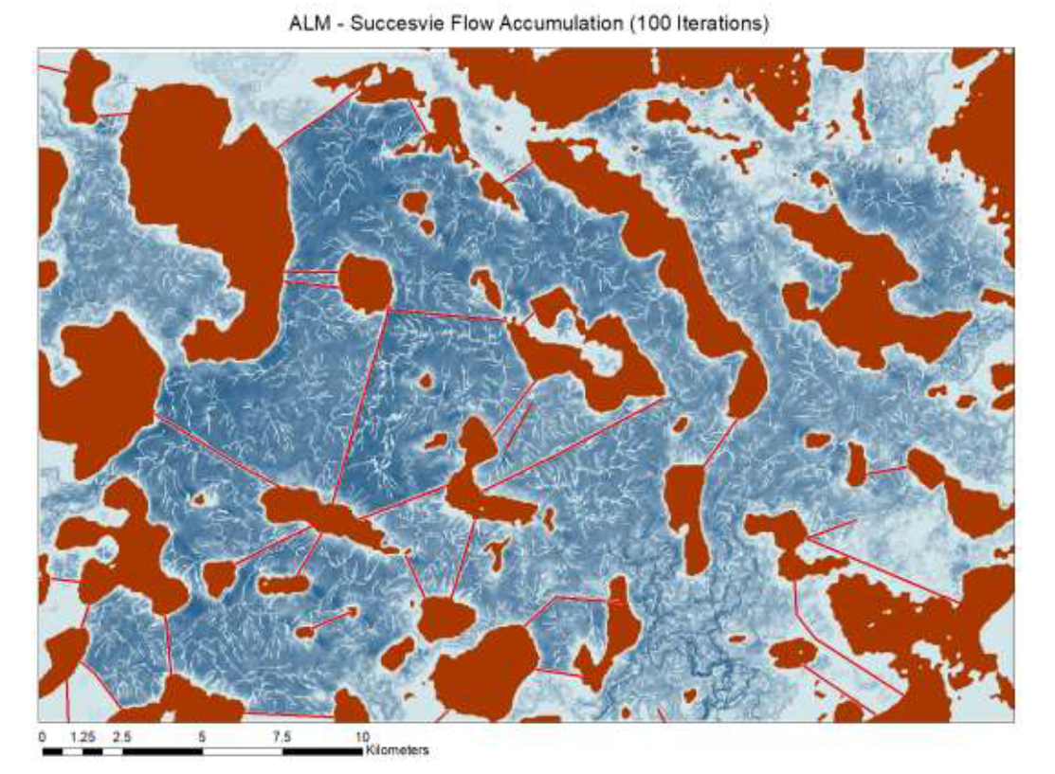
Figure 6: Natural Landscape Model (NLM) showing 100 iterations of Successive Flow Accumulation on a subset of landscape containing referenced region (Erickson et al. 2018b:42 Figure 23).

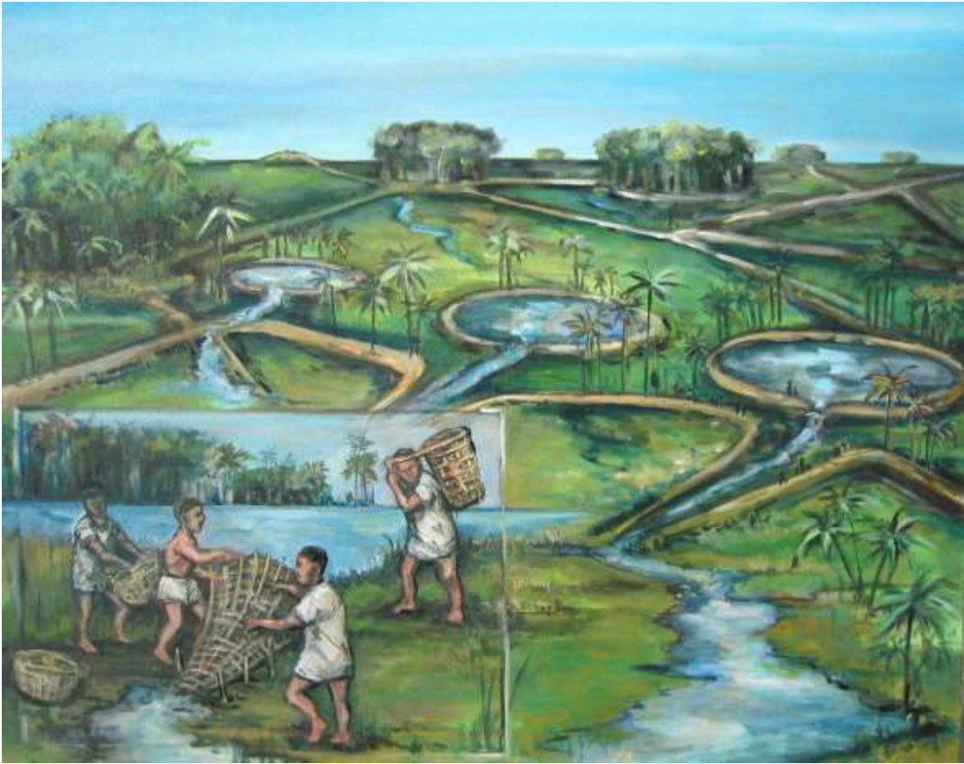
Figure 7: Artistic reconstruction by Dan Brinkmeier of pre-Columbian fish weirs and ponds
(Erickson et al. 2018b:37 Figure 9).
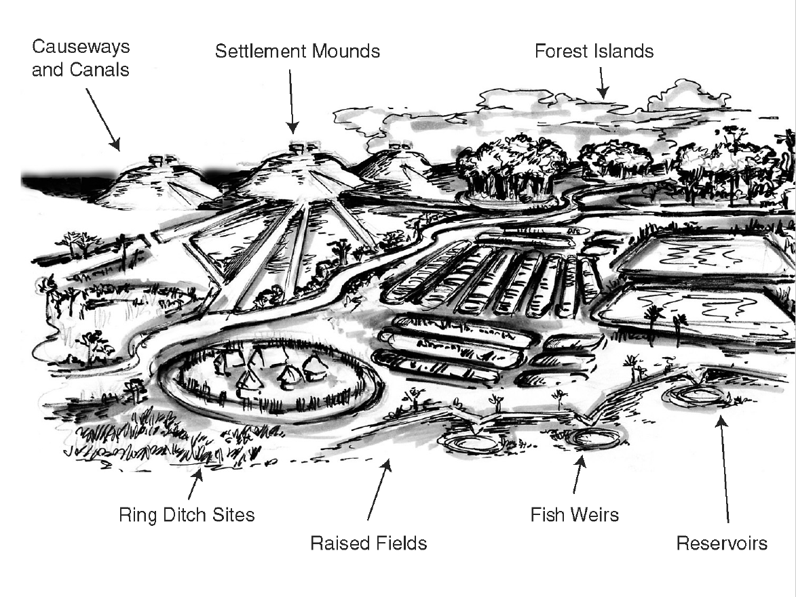
Figure 8: Labelled artistic reconstruction by Dan Brinkmeier of pre-Columbian
earthworks of the Bolivian Amazon (Erickson 2018:Figure 25).

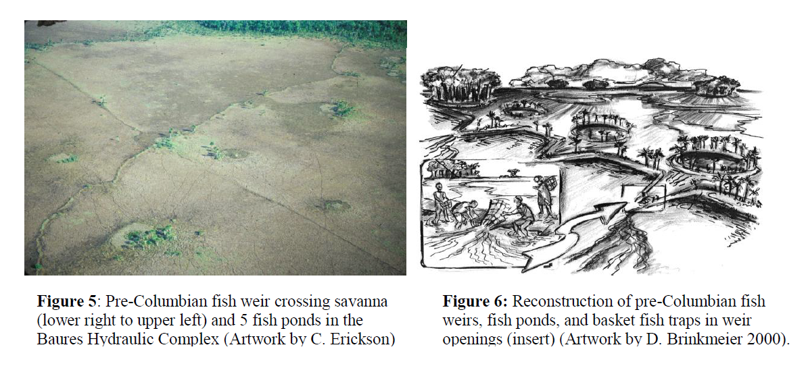
Figure 9: Pre-Columbian fish weirs and fish ponds on the savanna landscape of Baures (Erickson et al 2018:Figure 61b).

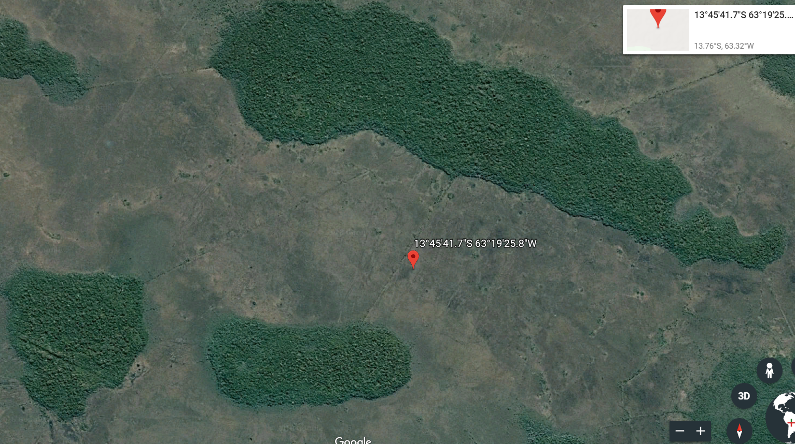
Figure 10: Satellite imagery of region referenced for landscape model (Google Earth 7.3.2, 2018. Bolivian Amazon 13º45’41.65” S, 63º19’25.82”W, elevation 150M. [online] Available through: https://earth.app.goo.gl/7h52pa [Accessed 7 December 2018]).

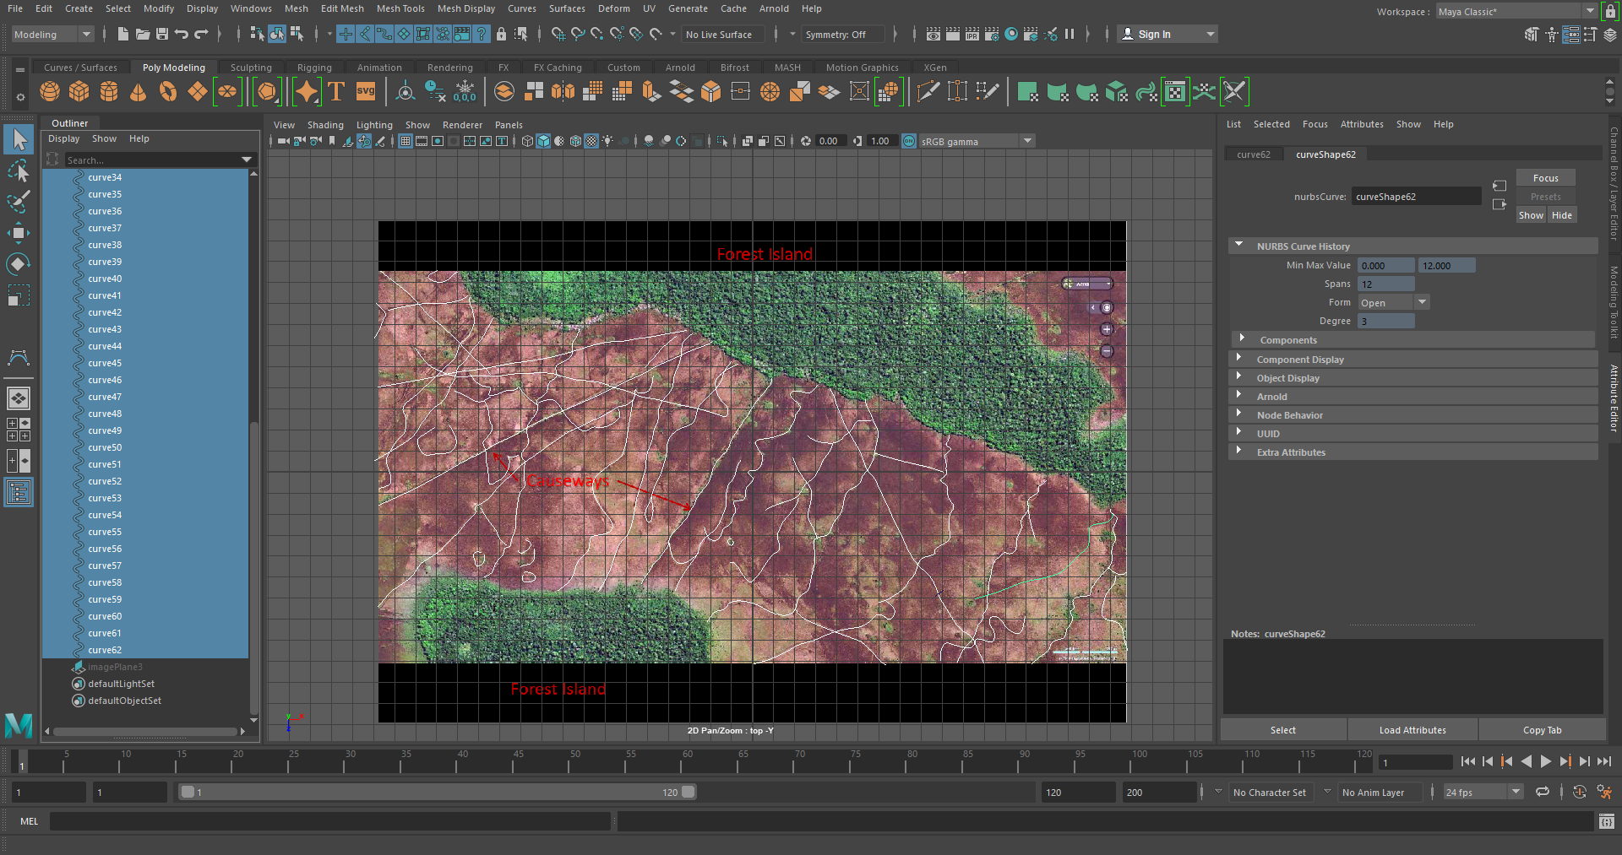
Figure 11: Digitized causeways and fish weirs of the sample landscape
of the Bolivian Amazon.

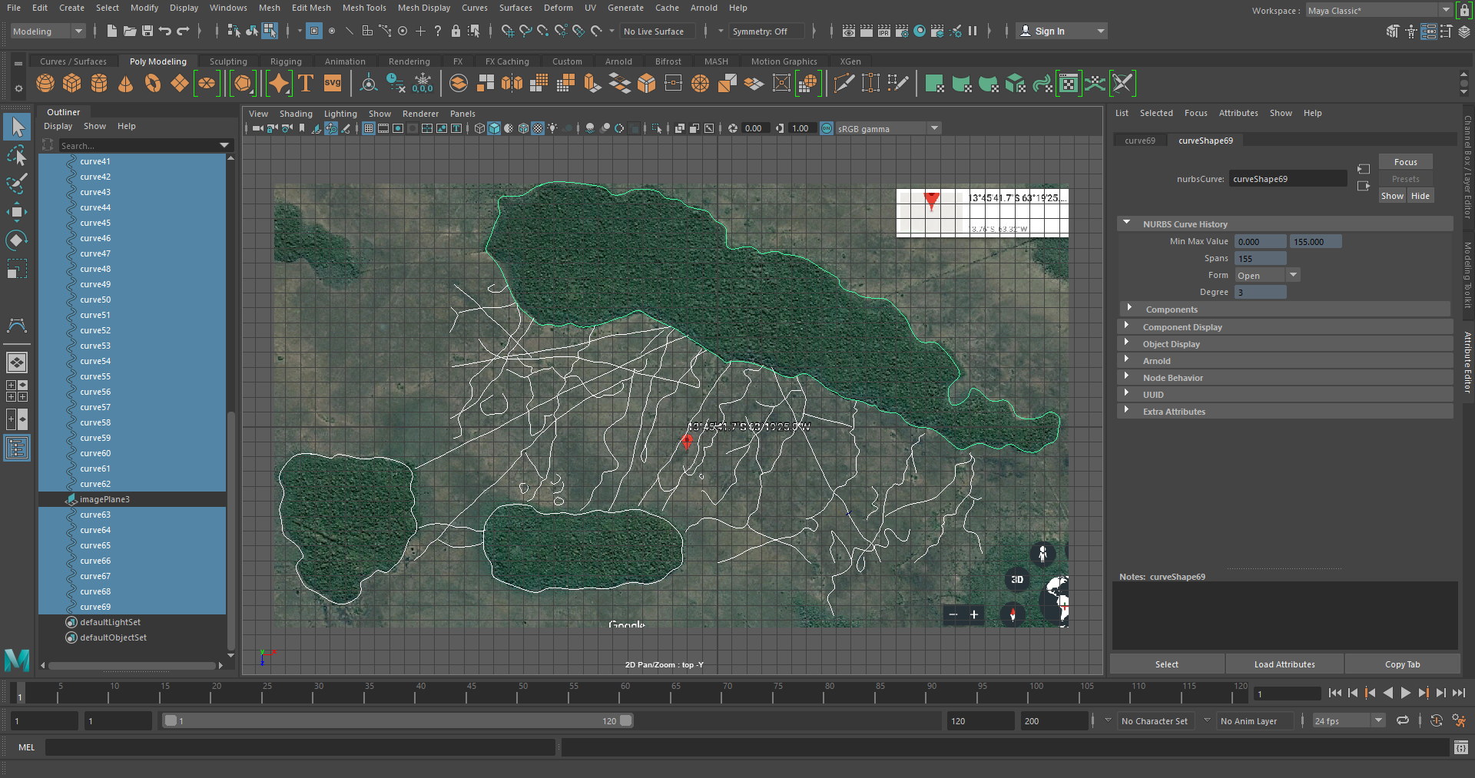
Figure 12: Digitized forest islands of the sample landscape of the Bolivian Amazon.

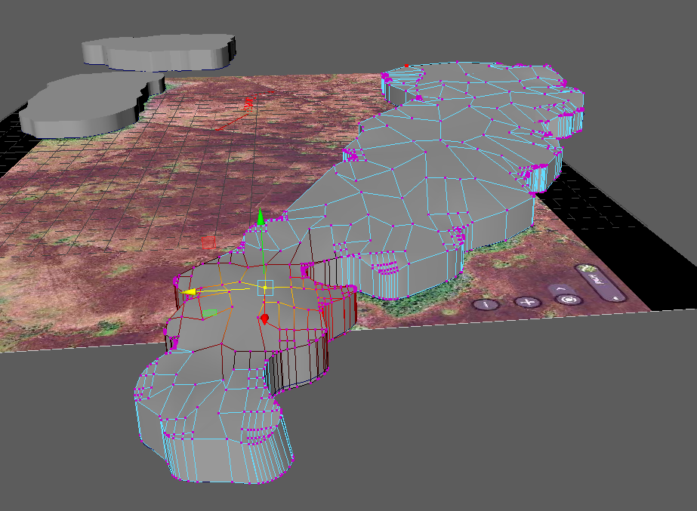
Figure 13: Extruding and modeling a forest island in Maya.

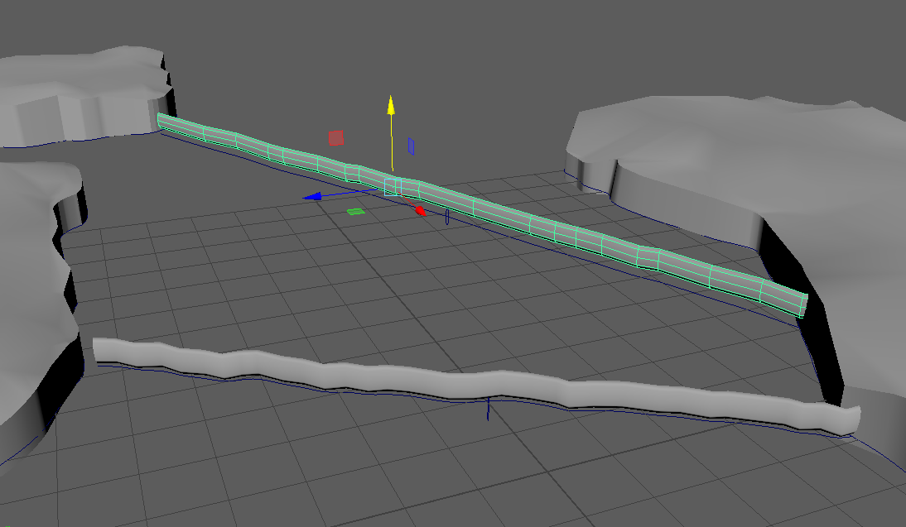
Figure 14: Extruding and modeling causeways between forest islands in Maya.

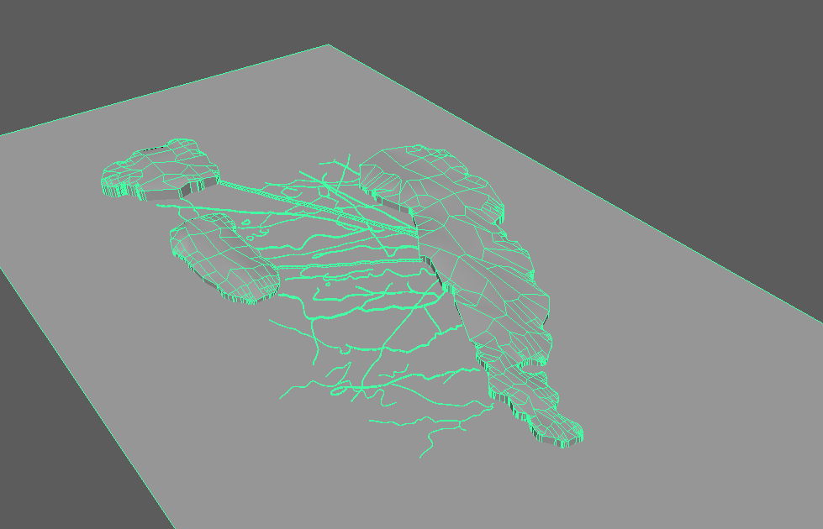Figure 15: Forest islands and network of earthworks on the landscape modeled in Maya.

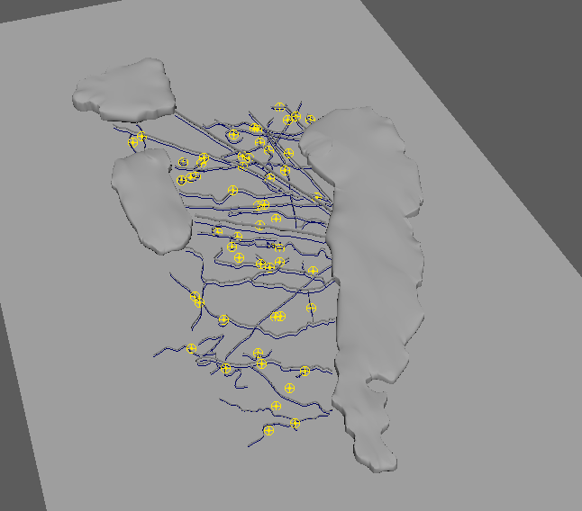
Figure 16: Preparing causeways, fish weirs, and forest islands for nCloth simulation.

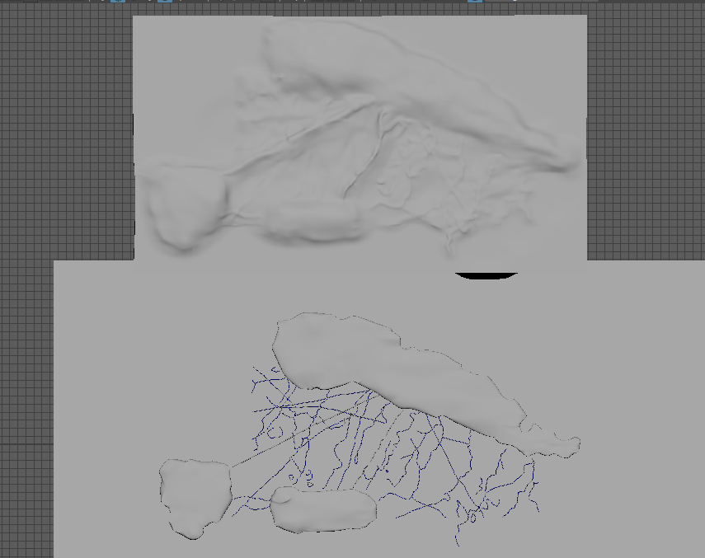
Figure 17: Result of nCloth simulation on forest island and earthwork passive colliders.

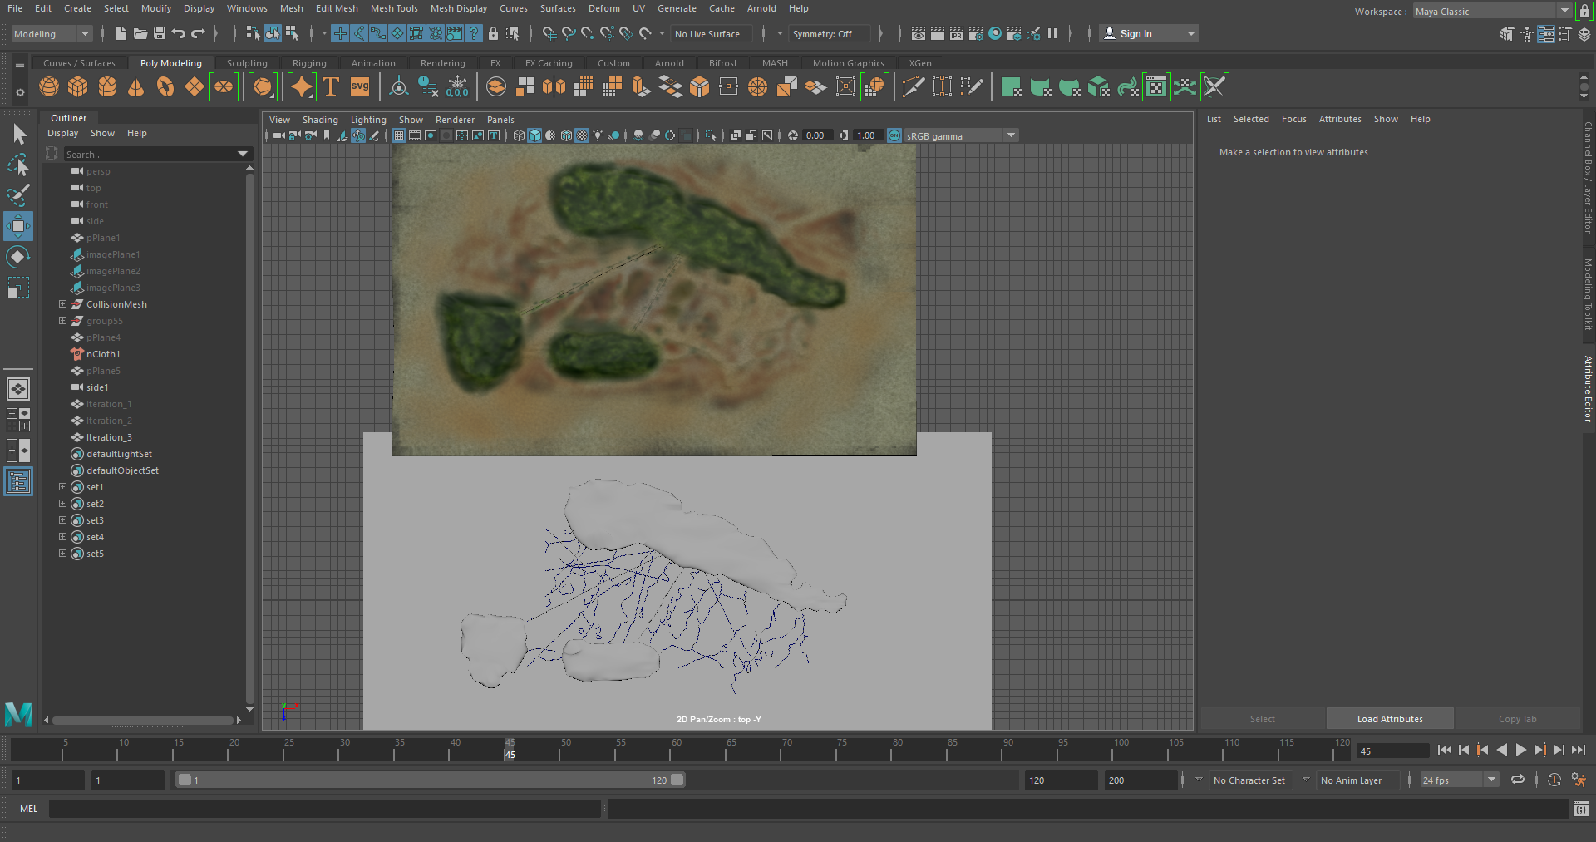
Figure 18: Initial texturing landscape mesh in MudBox.

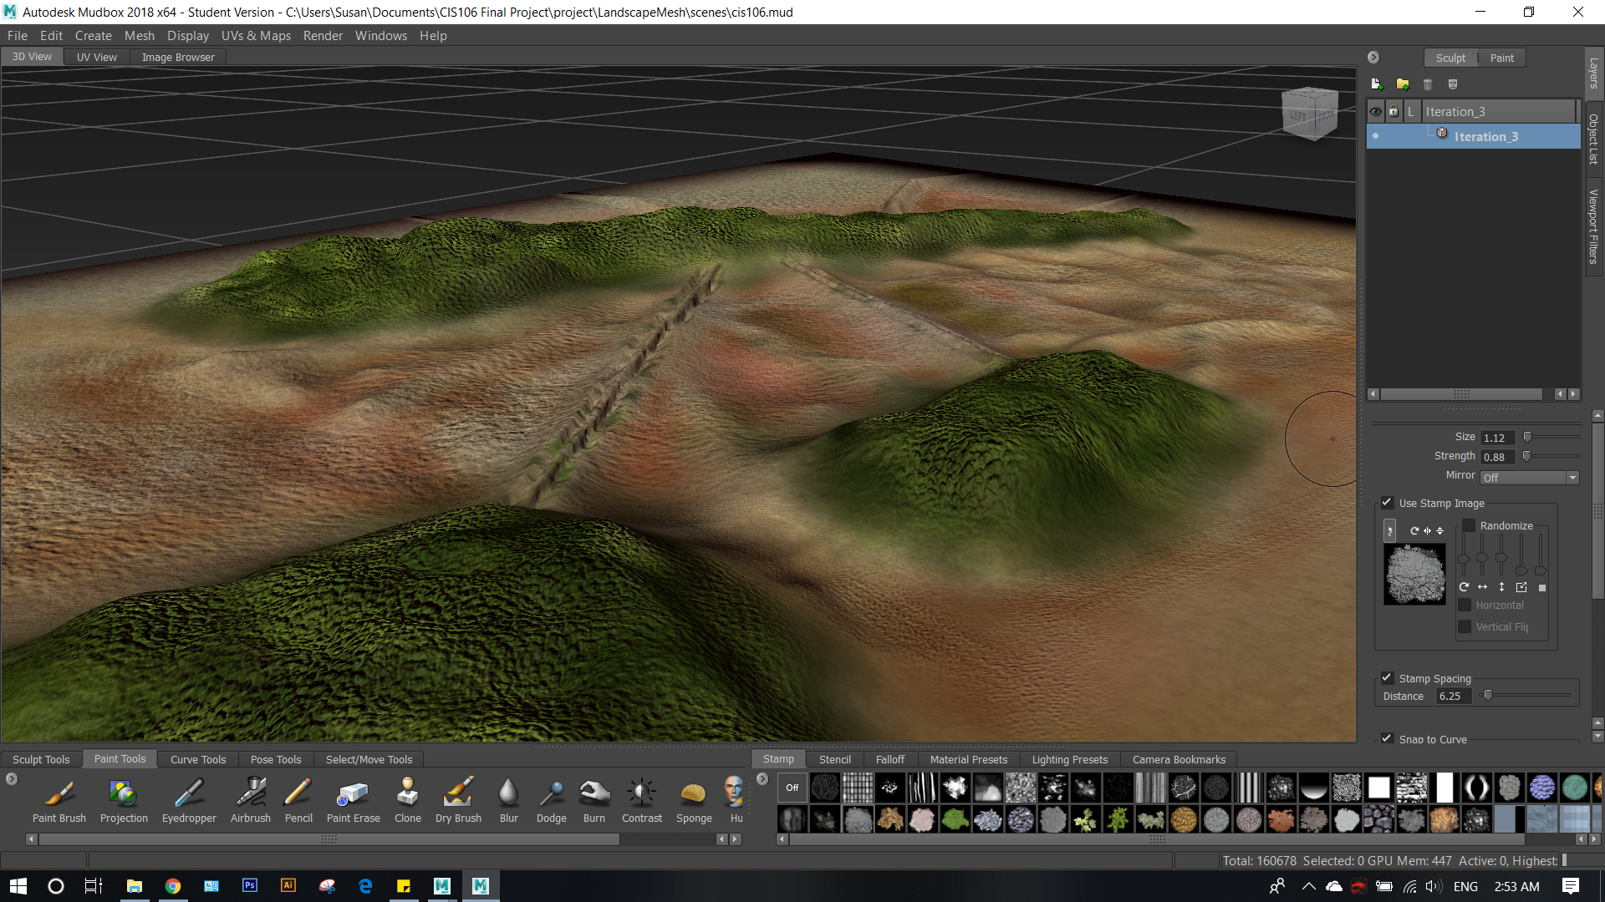
Figure 19: Final landscape mesh with color and bump maps in MudBox.

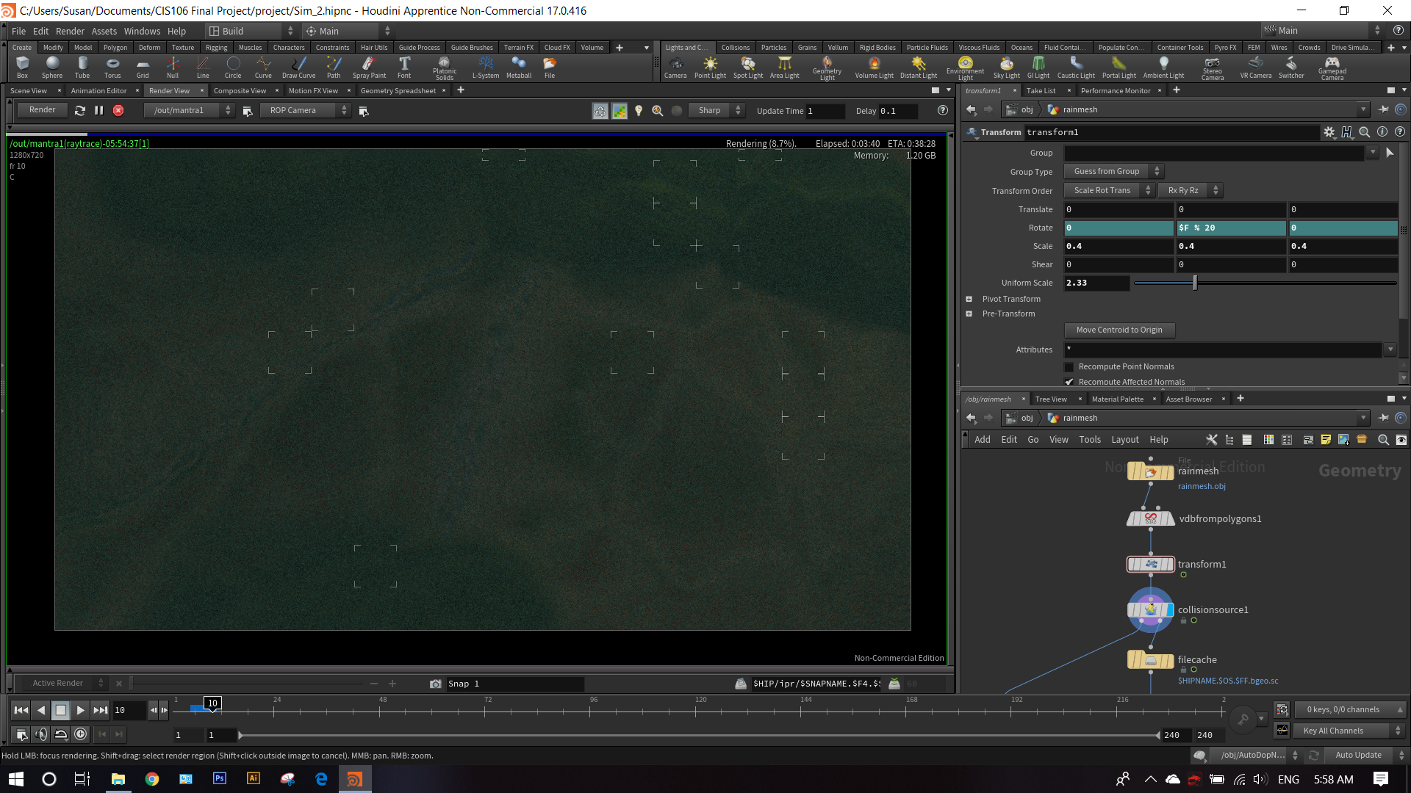
Figure 20: Camera set-up in Houdini.

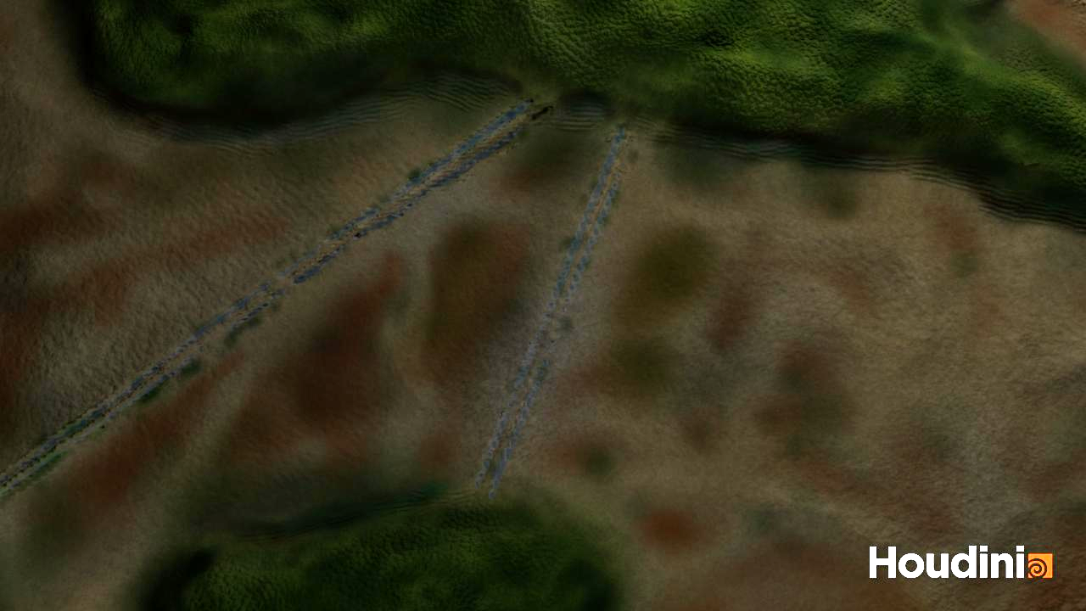
Figure 21: Camera 1 Position.

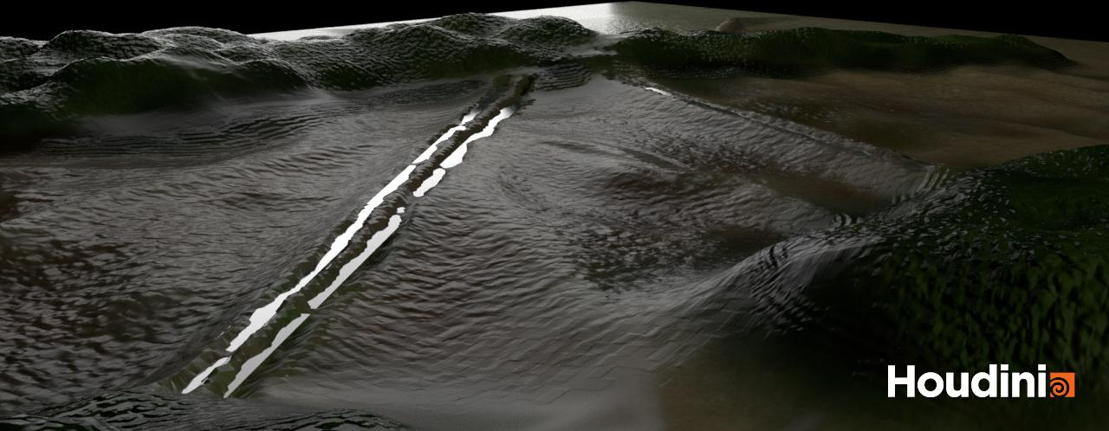
Figure 22: Camera 2 Position.

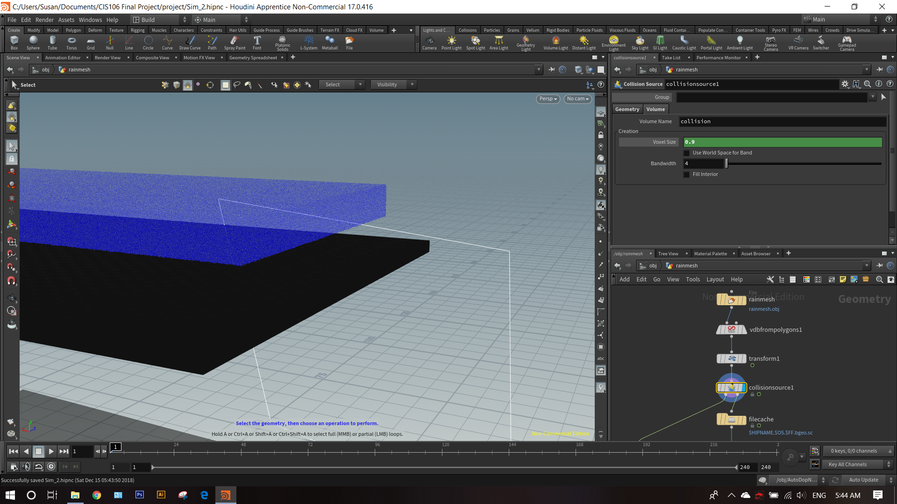
Figure 23: Initial fluid container set-up in Houdini.

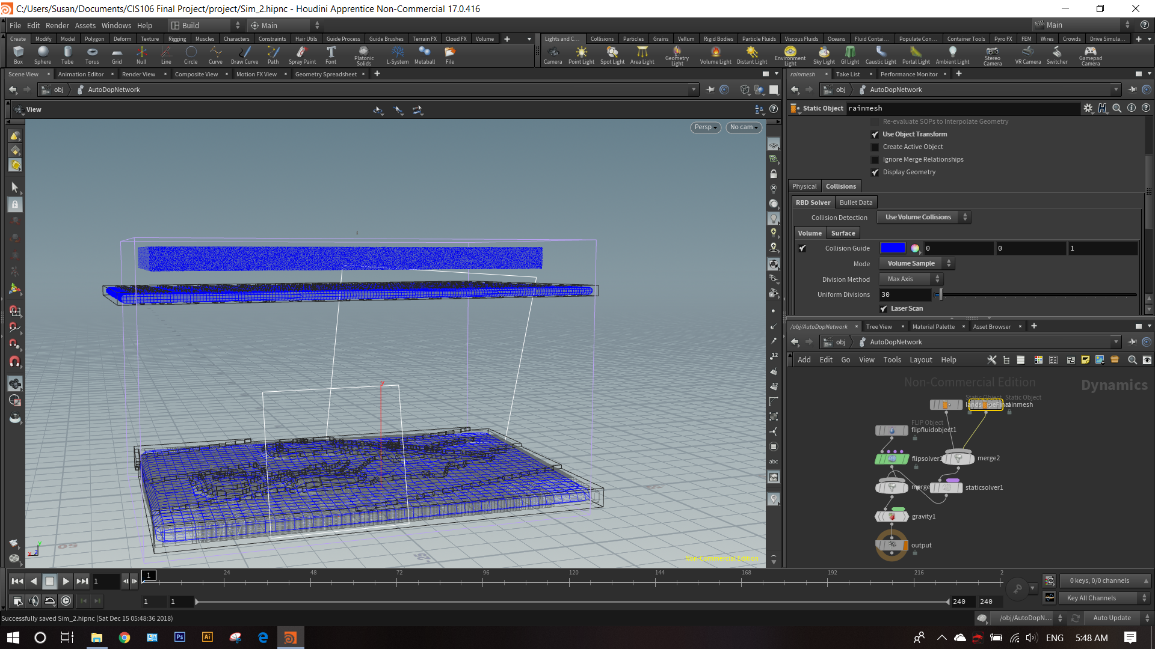
Figure 24: FLIP fluid rain simulation attempt in Houdini.

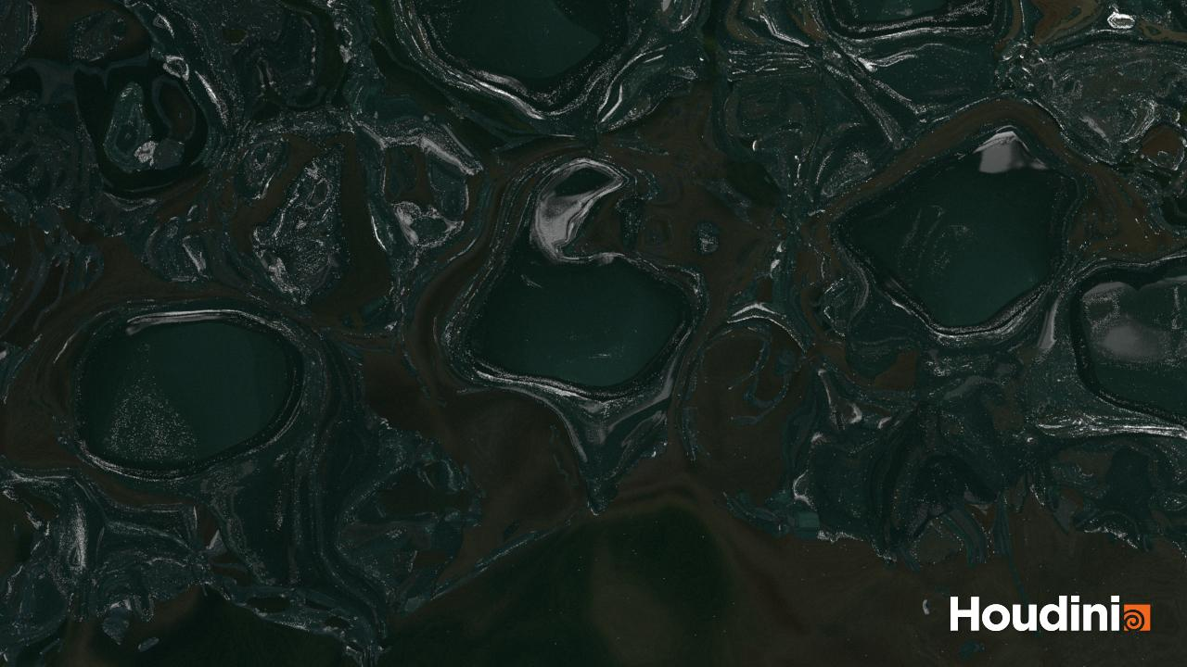
Figure 25: Failed FLIP fluid simulation attempt.

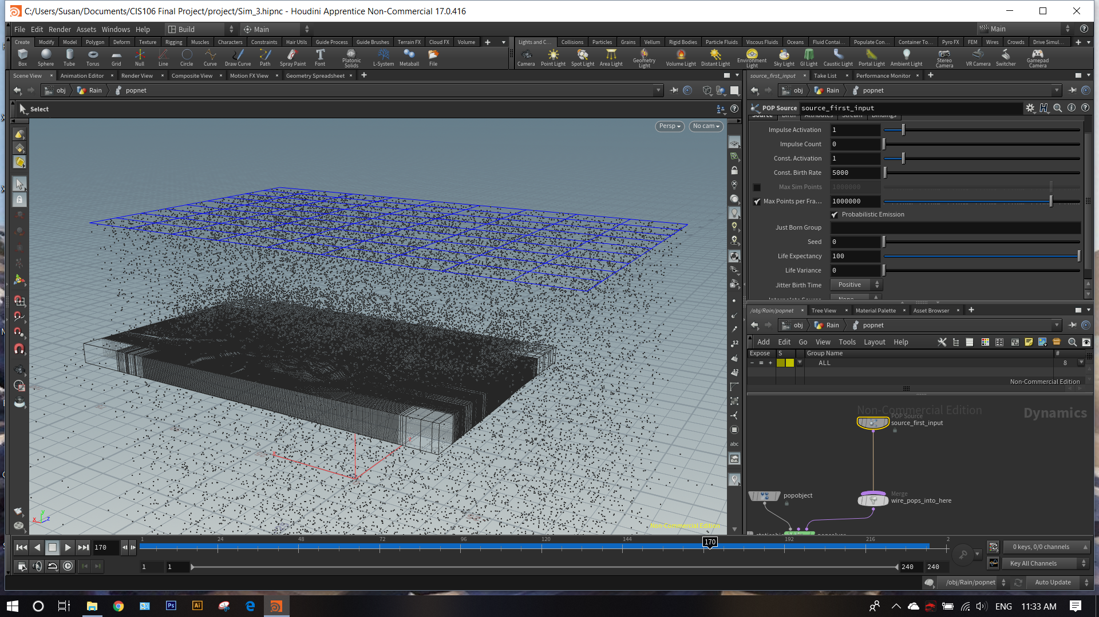
Figure 26: POPnetwork rain simulation set-up in Houdini with landscape as static object.

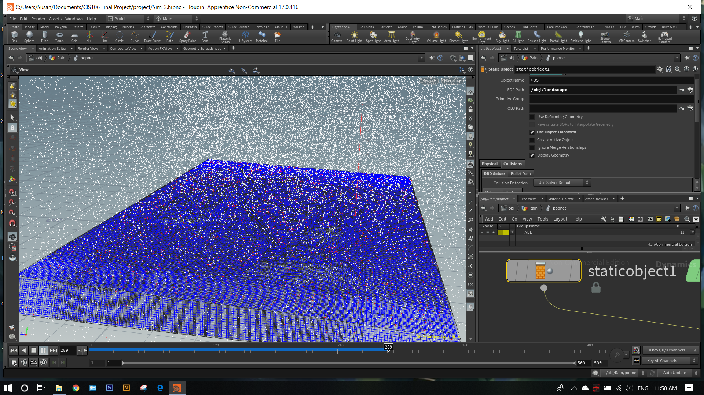
Figure 27: Rain simulation in action.
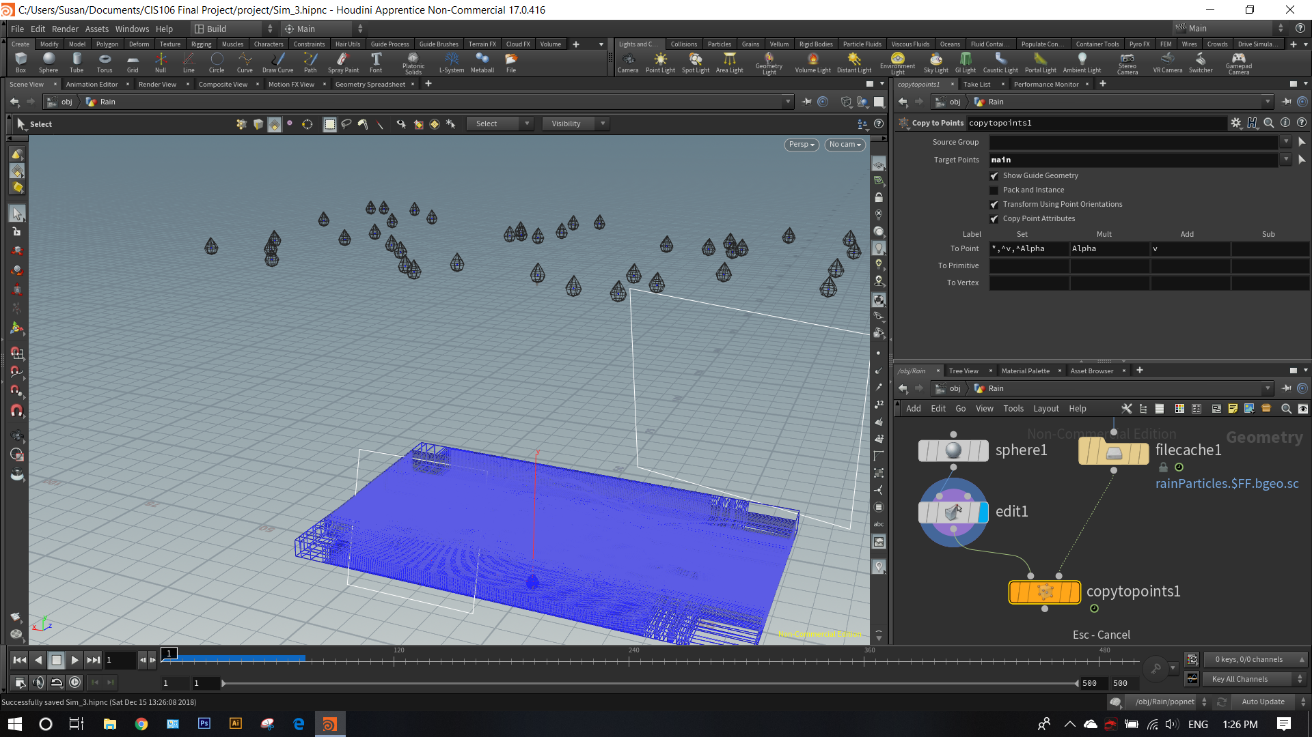
Figure 28: Geometric shape, later removed, applied to rain droplets (exaggerated).

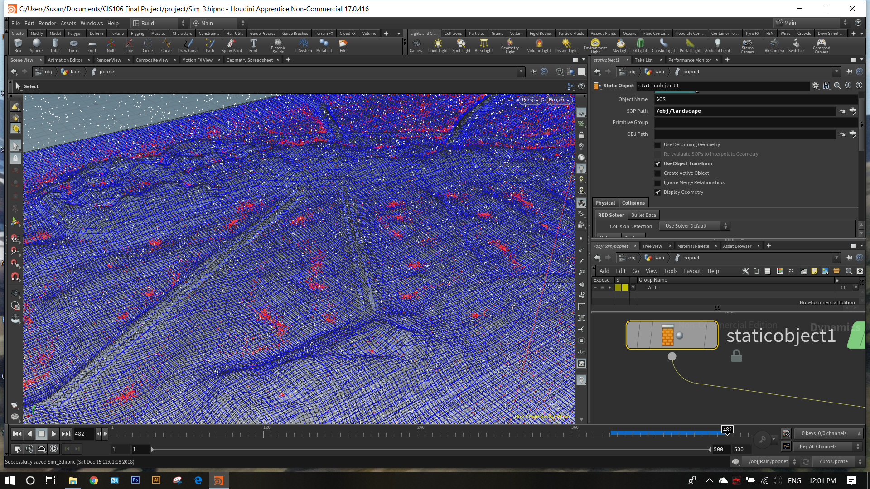
Figure 29: “Slide” effect added to POPnetwork rain to allow for pooling of water at lower points in the mesh.

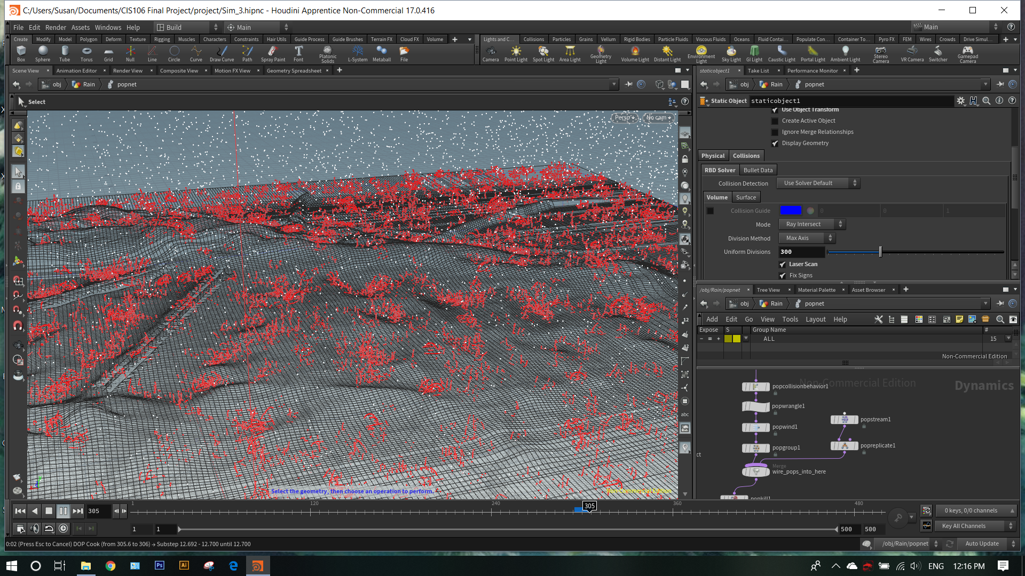
Figure 30: Splash effect added to POPnetwork rain.

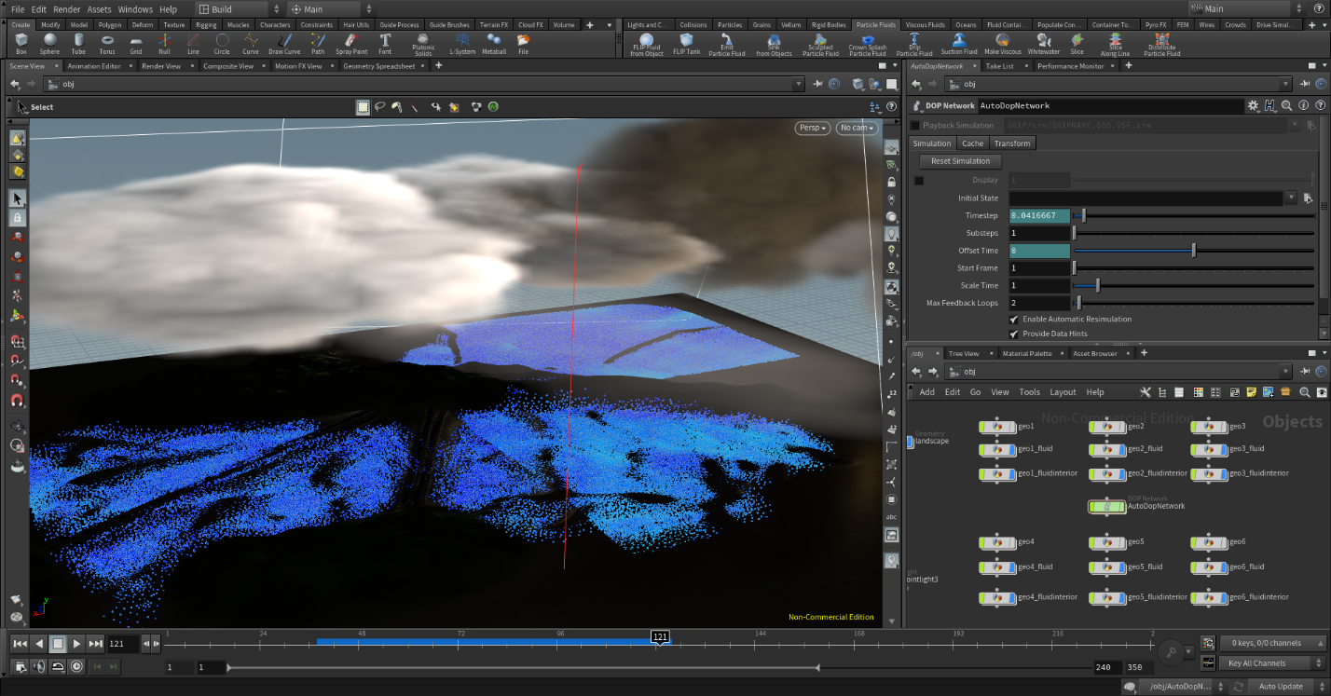
Figure 31: FLIP fluid flood simulation preview using six FLIP fluid containers.

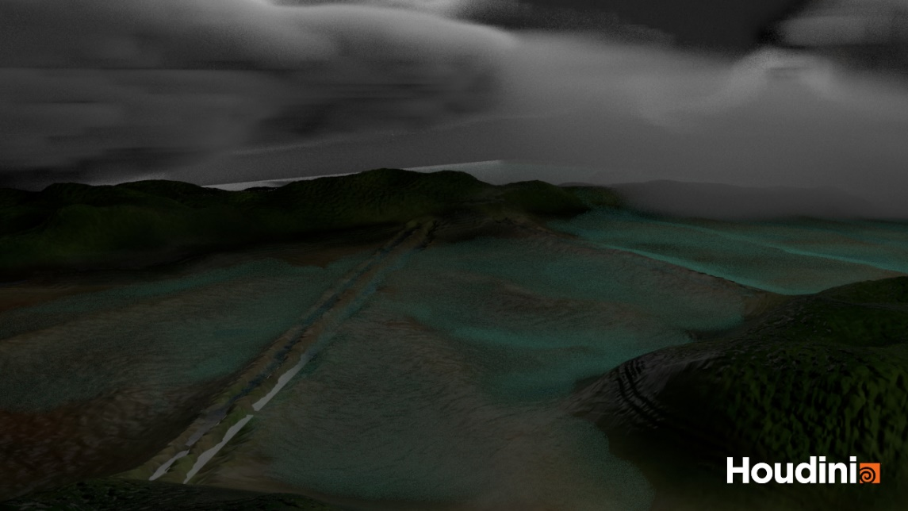
Figure 32: Dry landscape and clouds through final camera angle set-up.

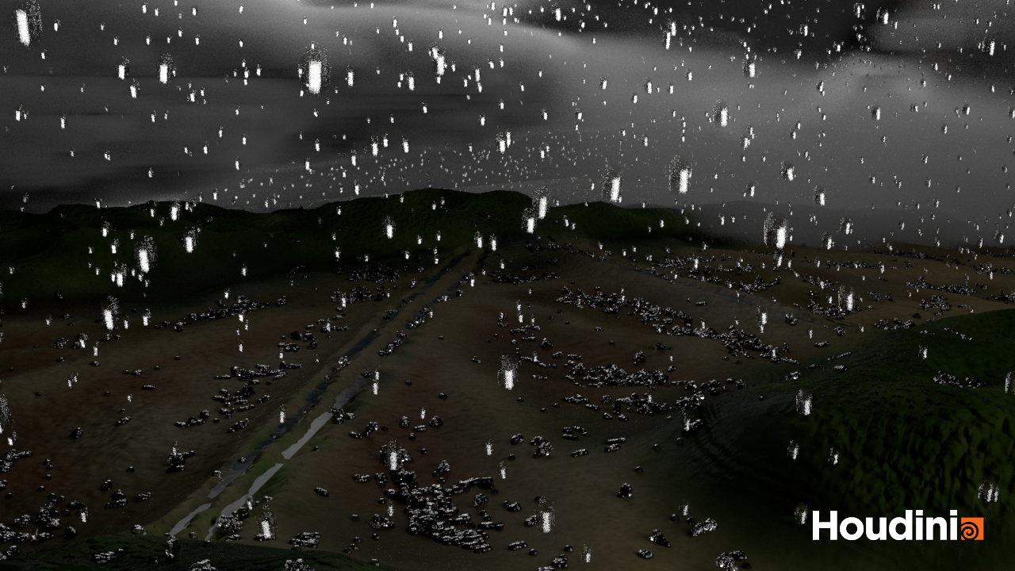
Figure 33: Frame 446 from the POPnetwork rain simulation.
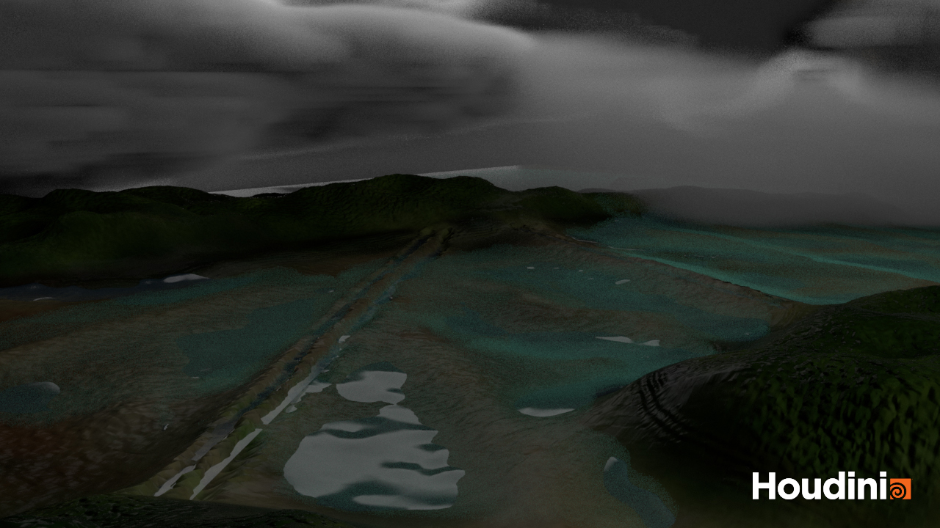
Figure 34: Level 1: low flood water level.

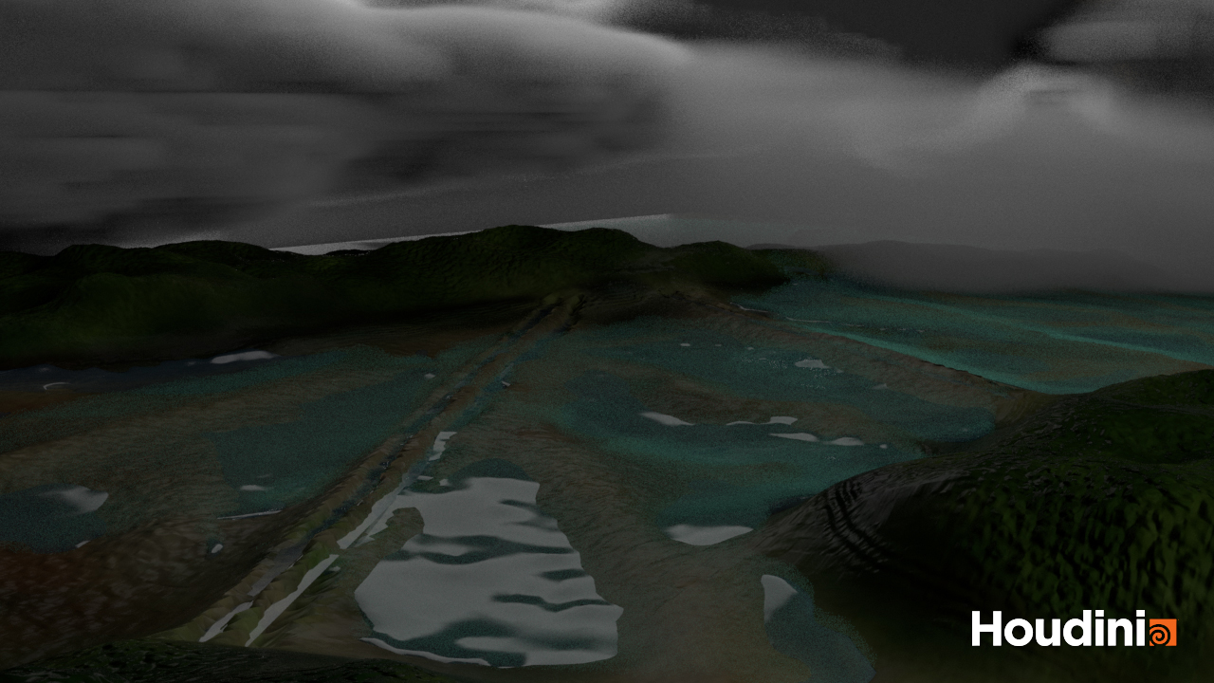
Figure 35: Level 2: lower-middle flood water level.

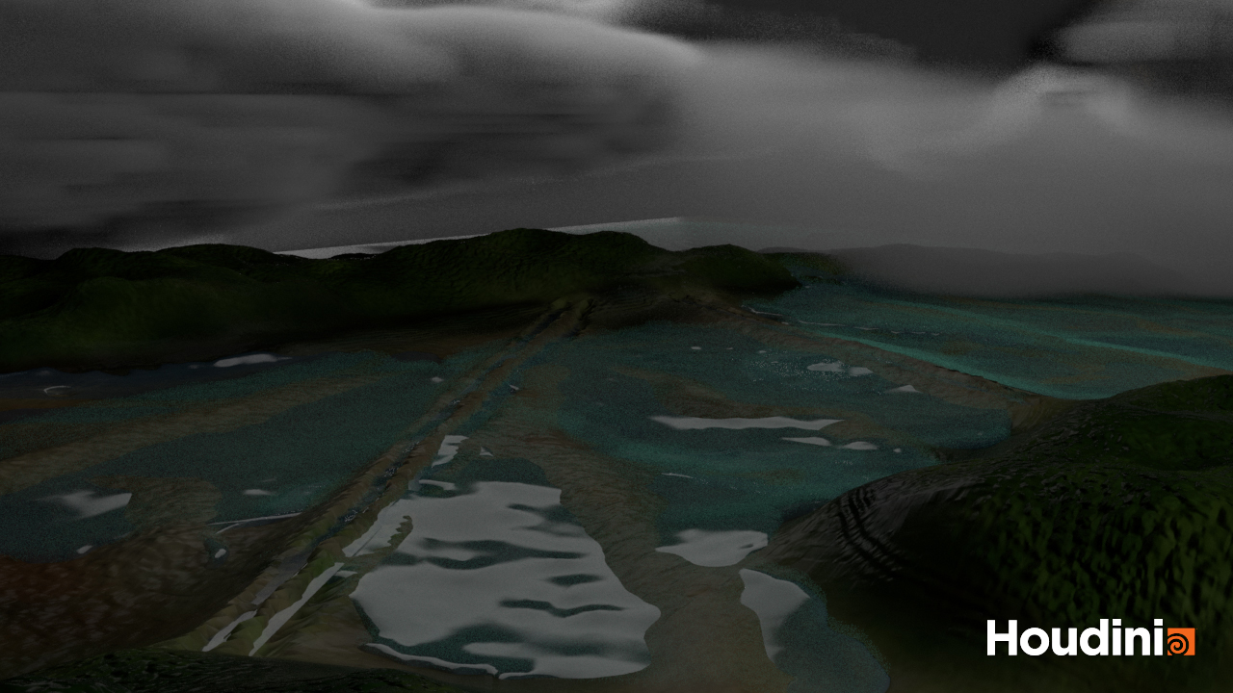
Figure 36: Level 3: middle flood water level

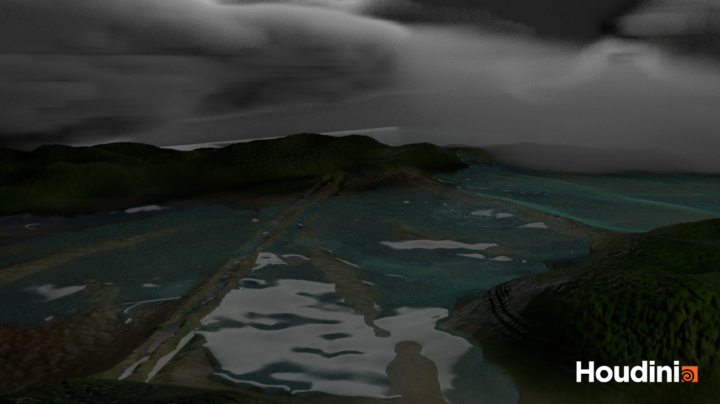
Figure 37: Level 4: upper-middle flood water level
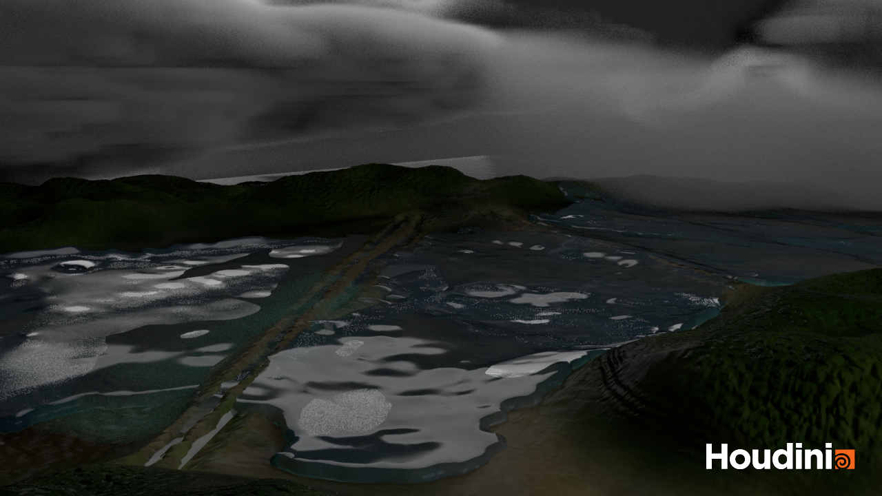
Figure 38: Level 5: high flood water level.

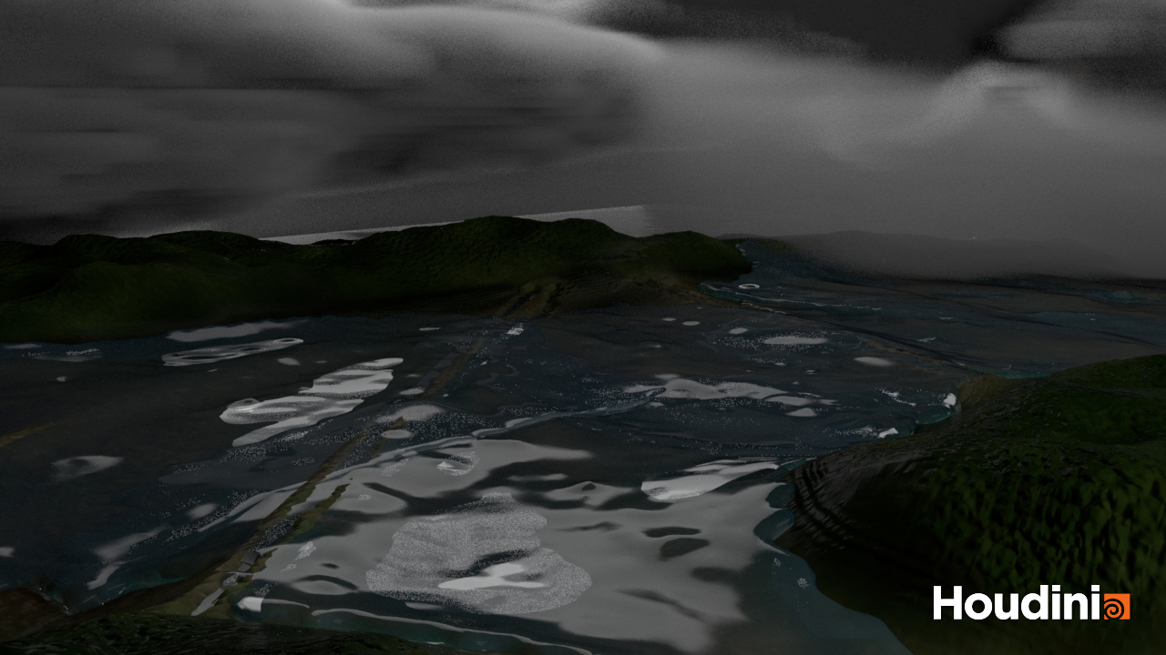
Figure 39: Level 6: highest flood water level.

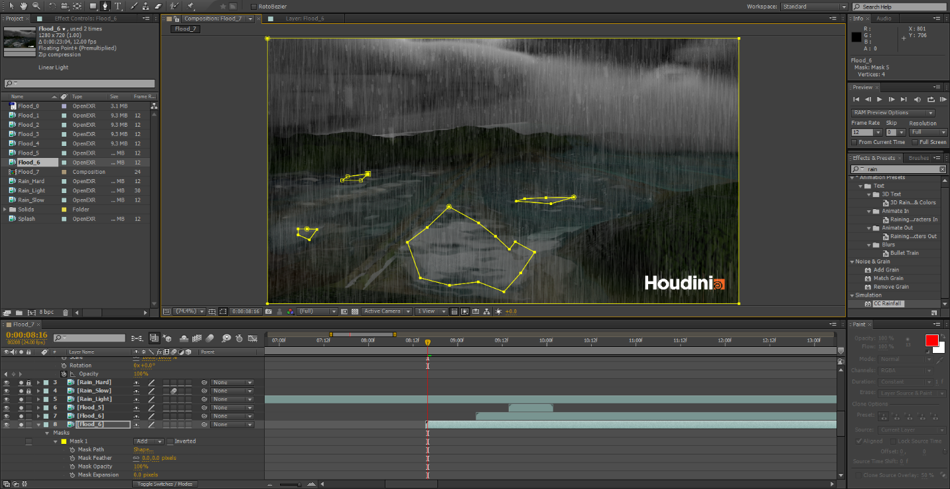
Figure 40: Timeline and mask view of wet season scene in timelapse.

