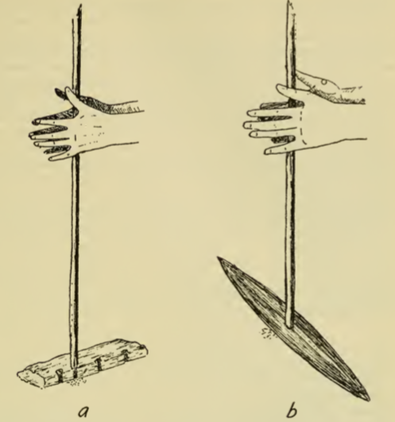

**Figure 1:** Fire Drills. a) Guarayú b) Chacobó (Métraux, Redrawn from Nordenskiöld, 1924)

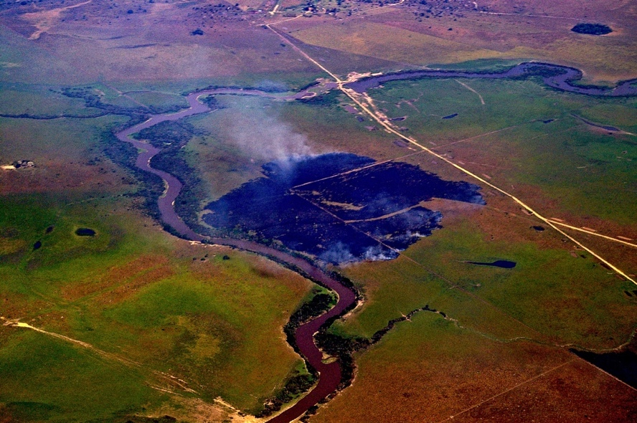

**Figure 2**: Annual intentional burning of old grass on savanna - aerial point of view

(photograph by Clark Erickson).

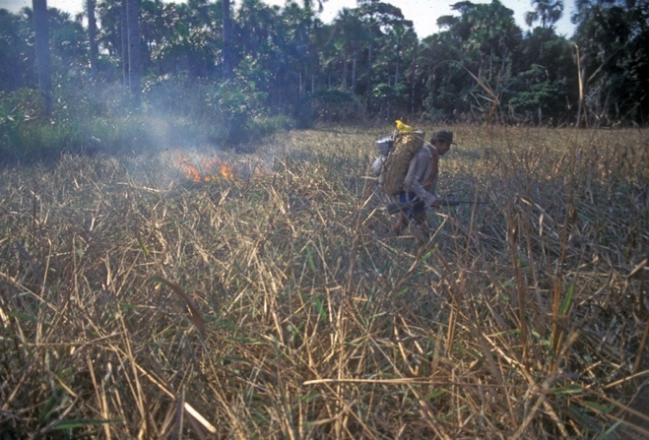

**Figure 3**: Anthropogenic dry grass fire on the savanna.

(photograph by Clark Erickson).

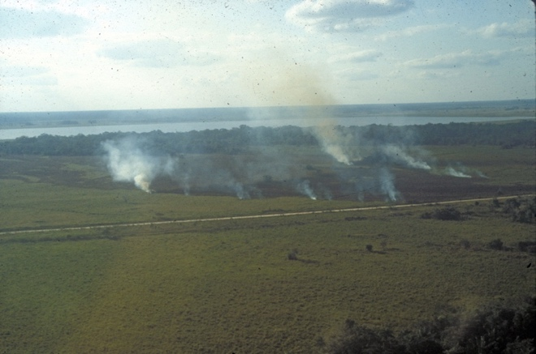

**Figure 4**: Annual intentional burning of old grass on savanna - perspective view

(photograph by Clark Erickson).

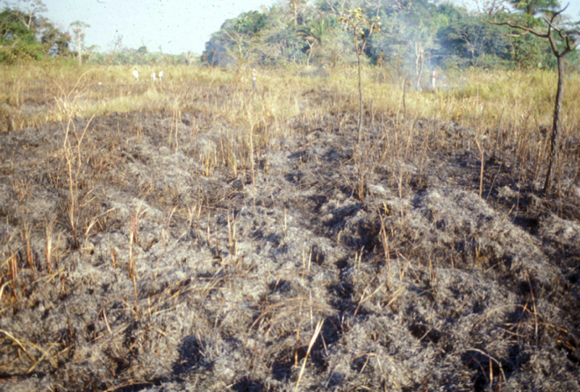

**Figure 5**: Post-burning color desaturation used to aid the design of post-burning grass and land coloration

(photograph by Clark Erickson).

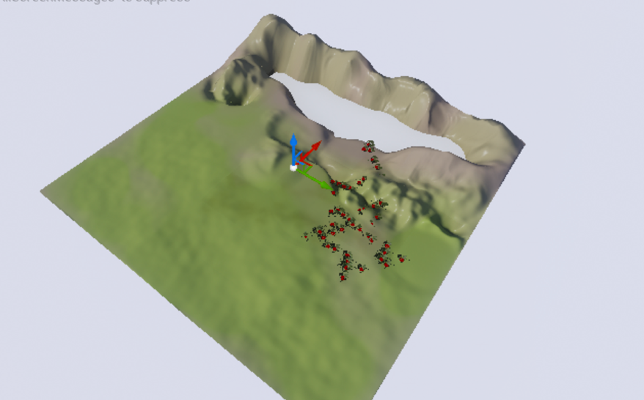

**Figure 6:** Model of a generic landscape with low polygon count to quickly test the algorithm.

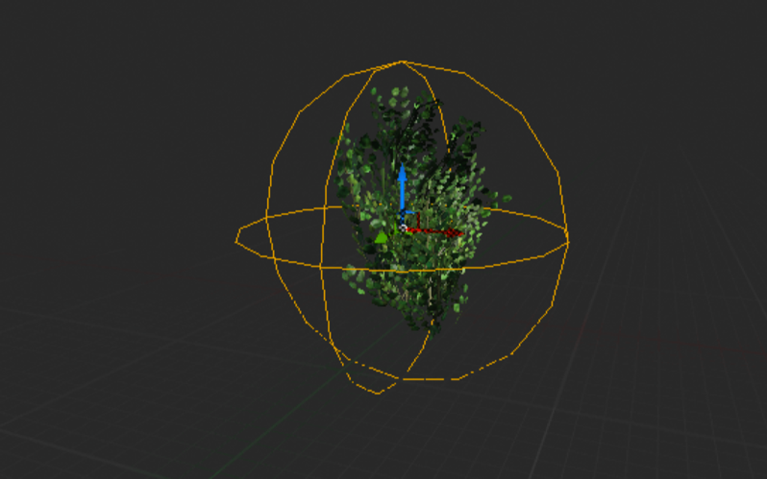

**Figure 7**: Foliage object and collision sphere.

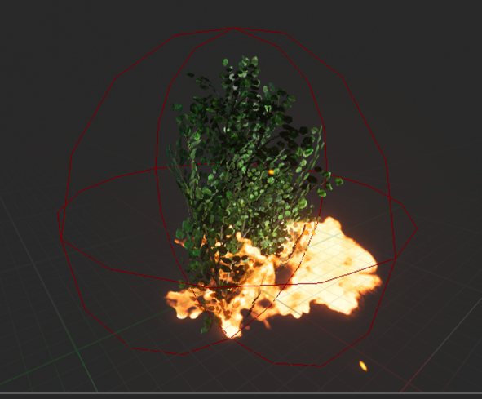

**Figure 8**: Unreal preset fire particle effect.

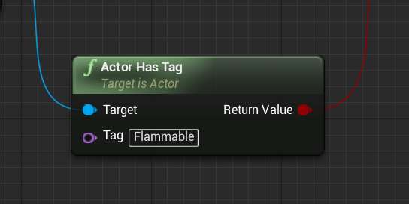

**Figure 9**: Blueprint showing the flammable tags indicating that an object can be set on fire.

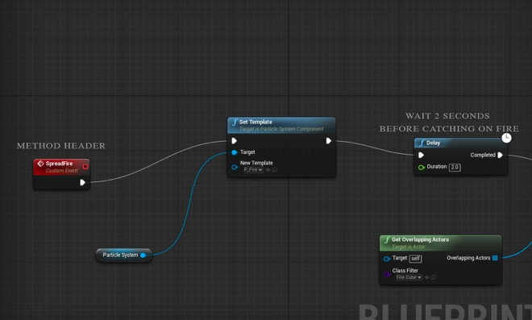

**Figure 10:** Blueprint used to initiate the fire. SpreadFire is the routine name.

**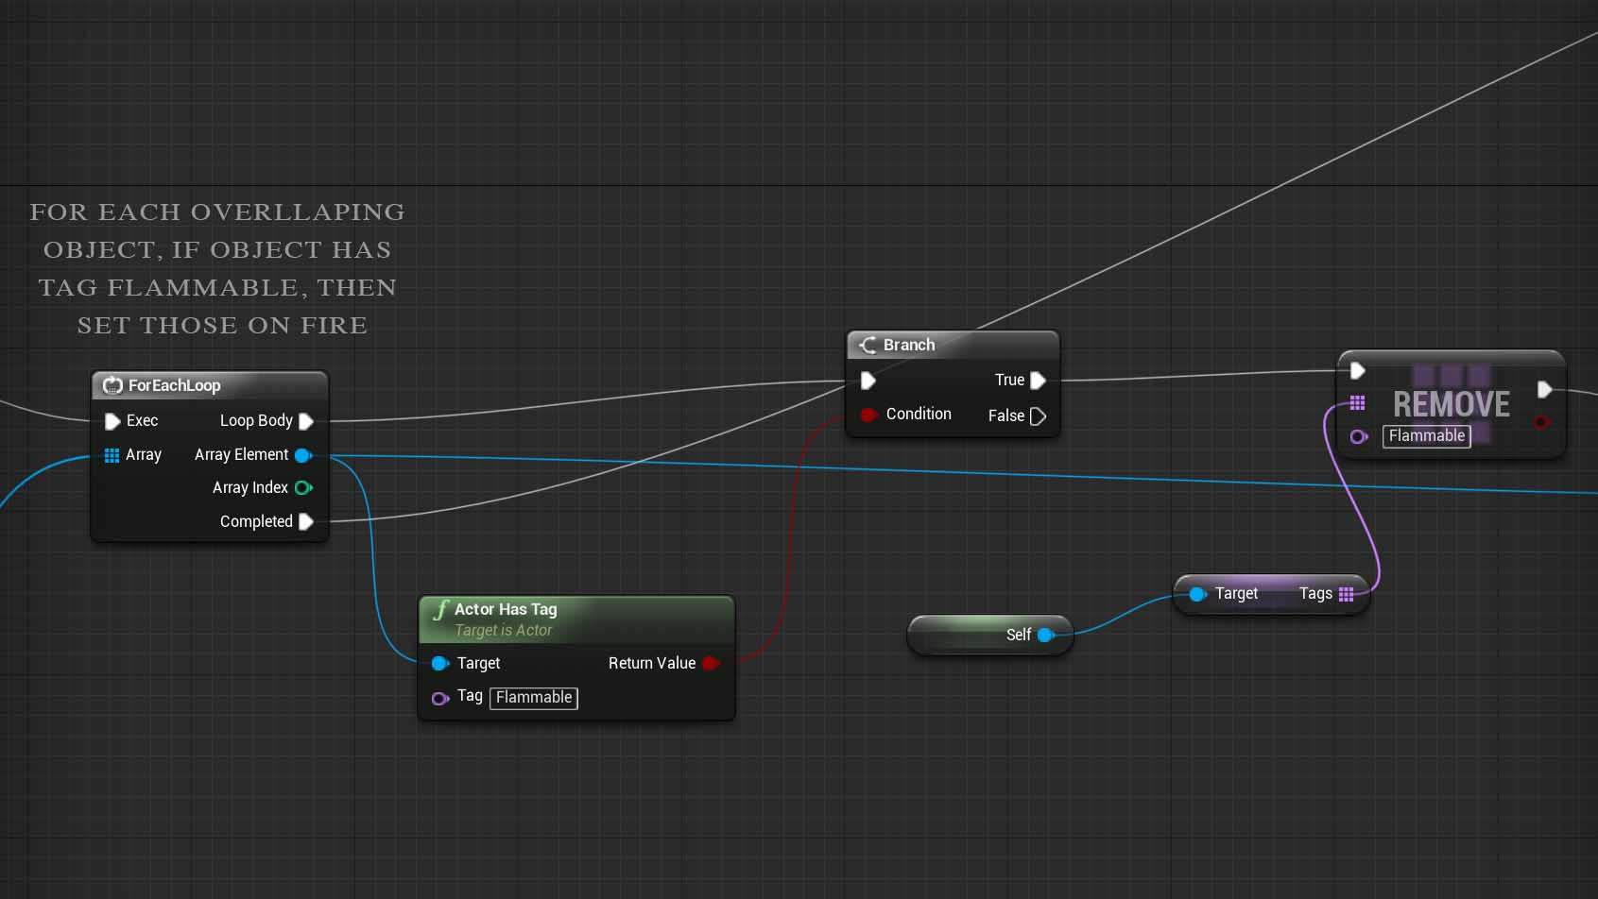  
Figure 11:** Blueprint used to initiate the fire. SpreadFire is the routine name.

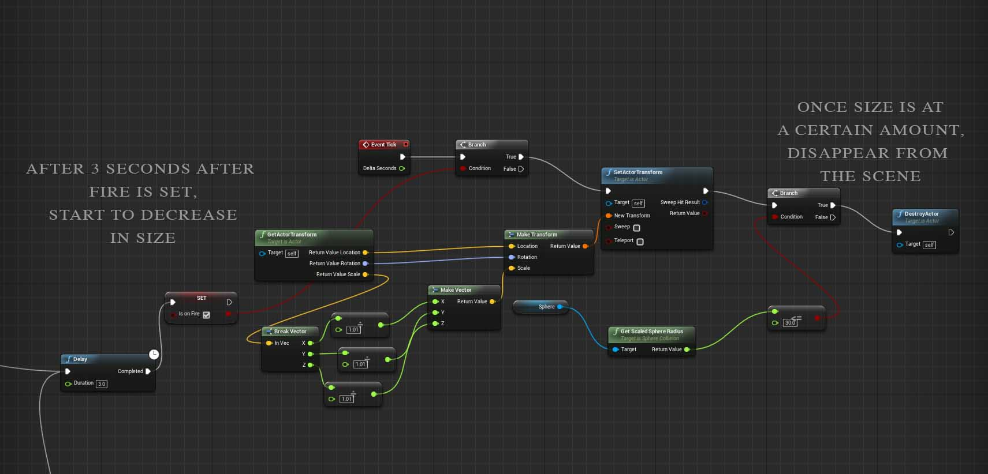

**Figure 12:** Blueprint showing size decreasing subroutine.

For the raw files, please see “Relevant files” folder.

**Figure 13**: Video showing size-independent decreasing subroutine ([online link](https://vimeo.com/307801687)).

**Figure 14:** Video showing fire propagation on landscape ([online link](https://vimeo.com/307801653)).

Password: cis106