Dillon Horwitz
ANTH 258/CIS 106
Visualizing the Past/Peopling the Past
Assignment 6b
12/20/18

Reconstructing a Ring Ditch with Palisade Wall

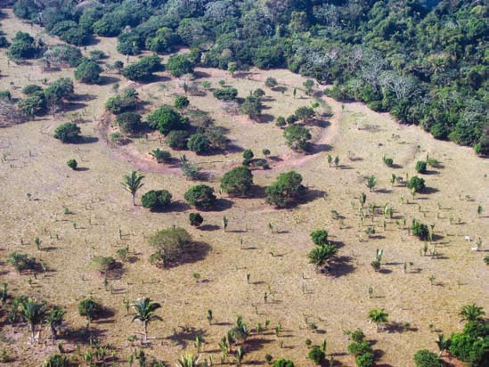

Figure 1: A ring ditch in the Amazonia landscape.
(Photograph courtesy Clark Erickson
Erickson et al. 2008:13 Figure 2).

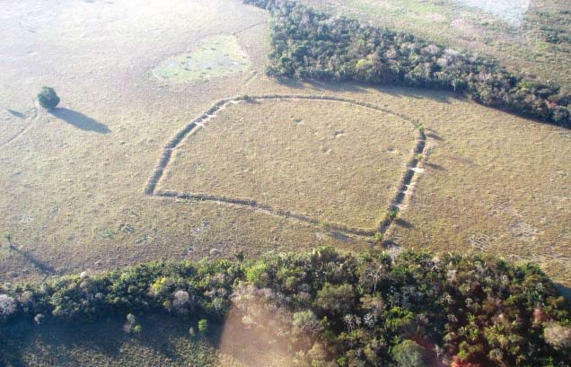

Figure 2: A ring ditch with a geometric form.
(Photograph courtesy Clark Erickson
Erickson et al. 2008:13 Figure 3).

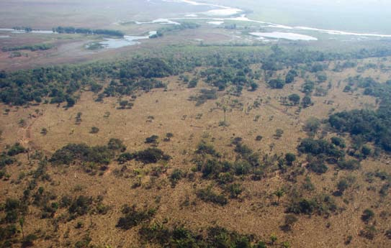

Figure 3: A ring ditch with the flooded savanna in the background.
(Photograph courtesy Clark Erickson
Erickson et al. 2008:14 Figure 4).

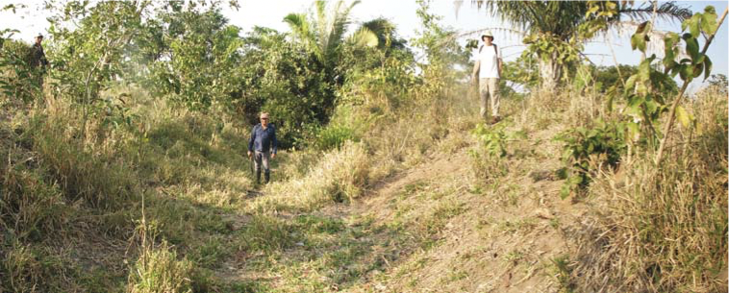

Figure 4: Researchers standing in an overgrown and eroded ring ditch.
(Photograph courtesy Clark Erickson
Erickson et al. 2008:29 Figure 15).

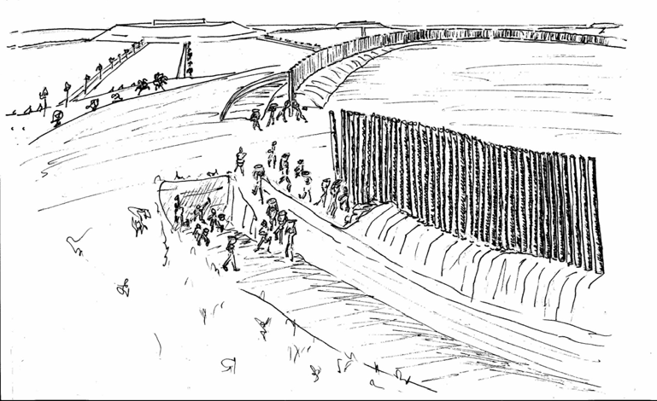

Figure 5: A palisade wall surrounding a ring ditch.
(Artwork by Danny Brashear
Erickson 2010:630 Figure 5).

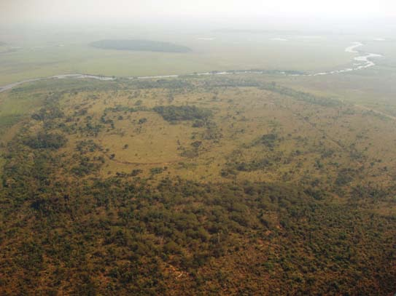

Figure 6: Cleared trees in and around a ring ditch on a forest island.
(Photograph courtesy Clark Erickson
Erickson et al. 2008:14 Figure 5).

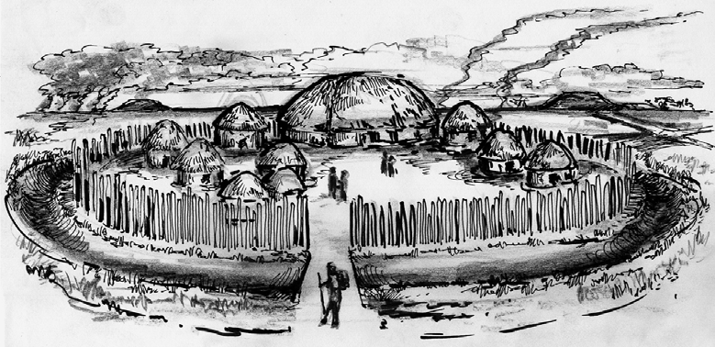

Figure 7: A ring ditch with occupants engaged in daily life.
(Artwork by Daniel Brinkmeier
Erickson 2010:631 Figure 6).

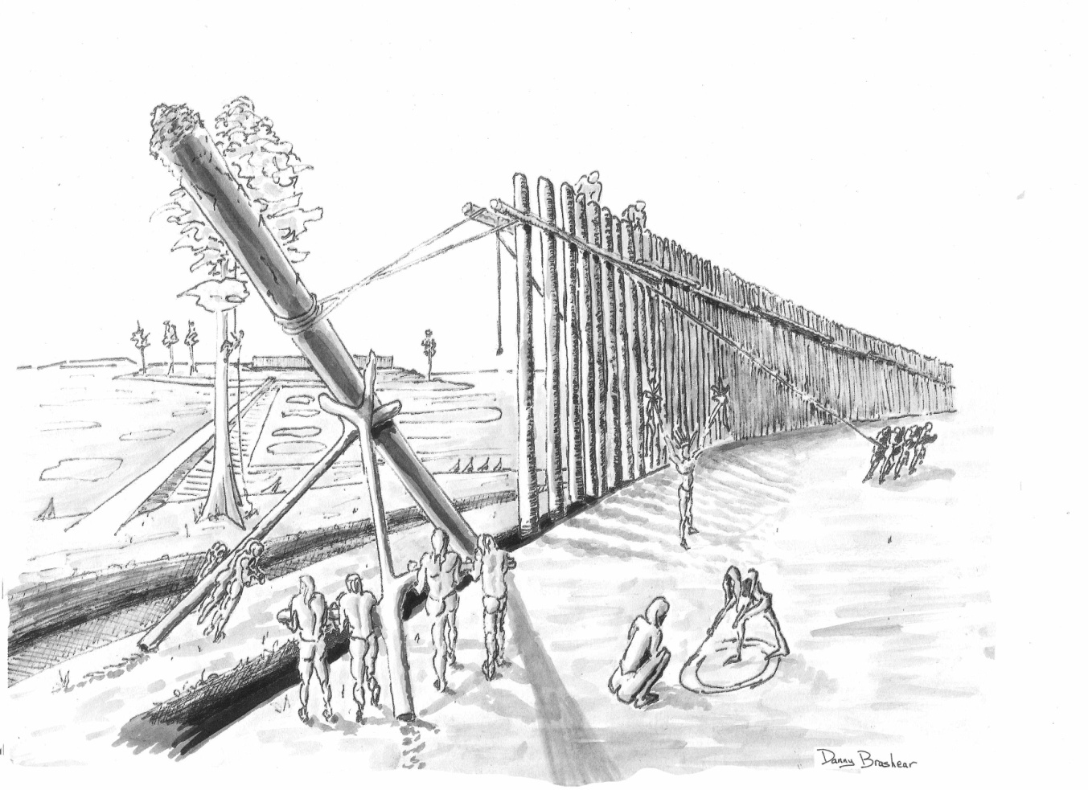

Figure 8: A palisade wall being constructed around a ring ditch.
(Artwork by Danny Brashear
Erickson 2010:636 Figure 8).

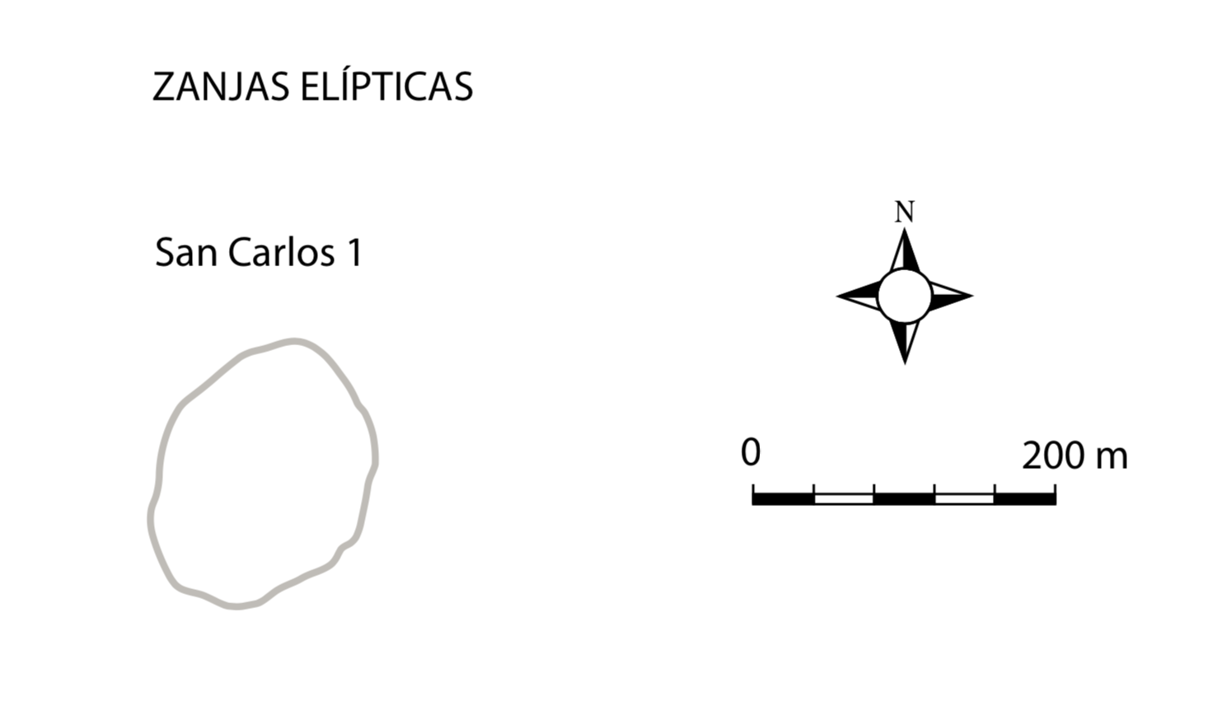

Figure 9: Plan drawing of the San Carlos 1 ring ditch.
(Drawing courtesy Clark Erickson
Erickson et al. 2008:56 Figure 35).

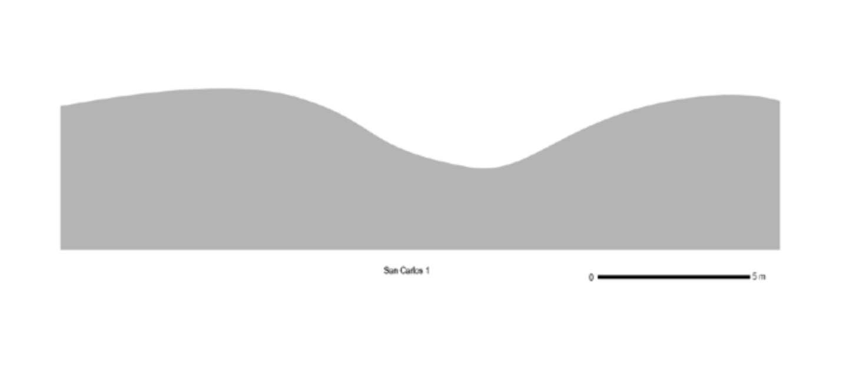

Figure 10: Section drawing of the San Carlos 1 ring ditch.
(Drawing courtesy Clark Erickson
Erickson et a. 2008:50 Figure 30).

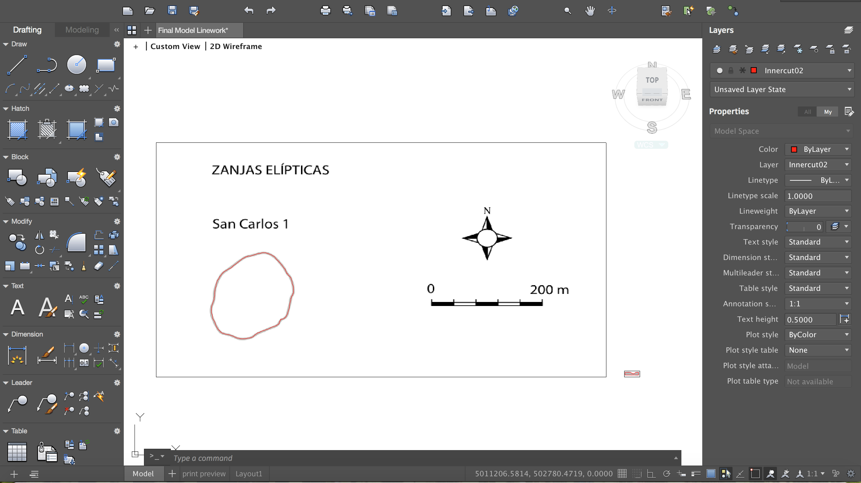

Figure 11: AutoCAD spline tracing over the plan drawing of a ring ditch.

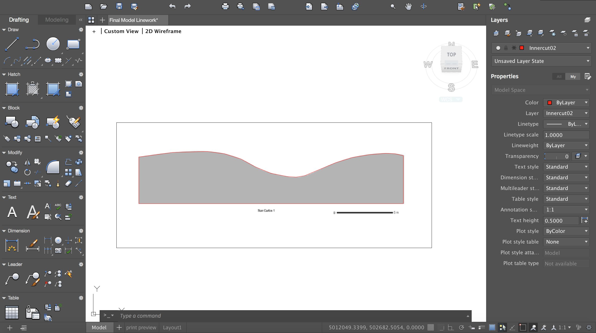

Figure 12: AutoCAD spline tracing over the section drawing of a ring ditch.

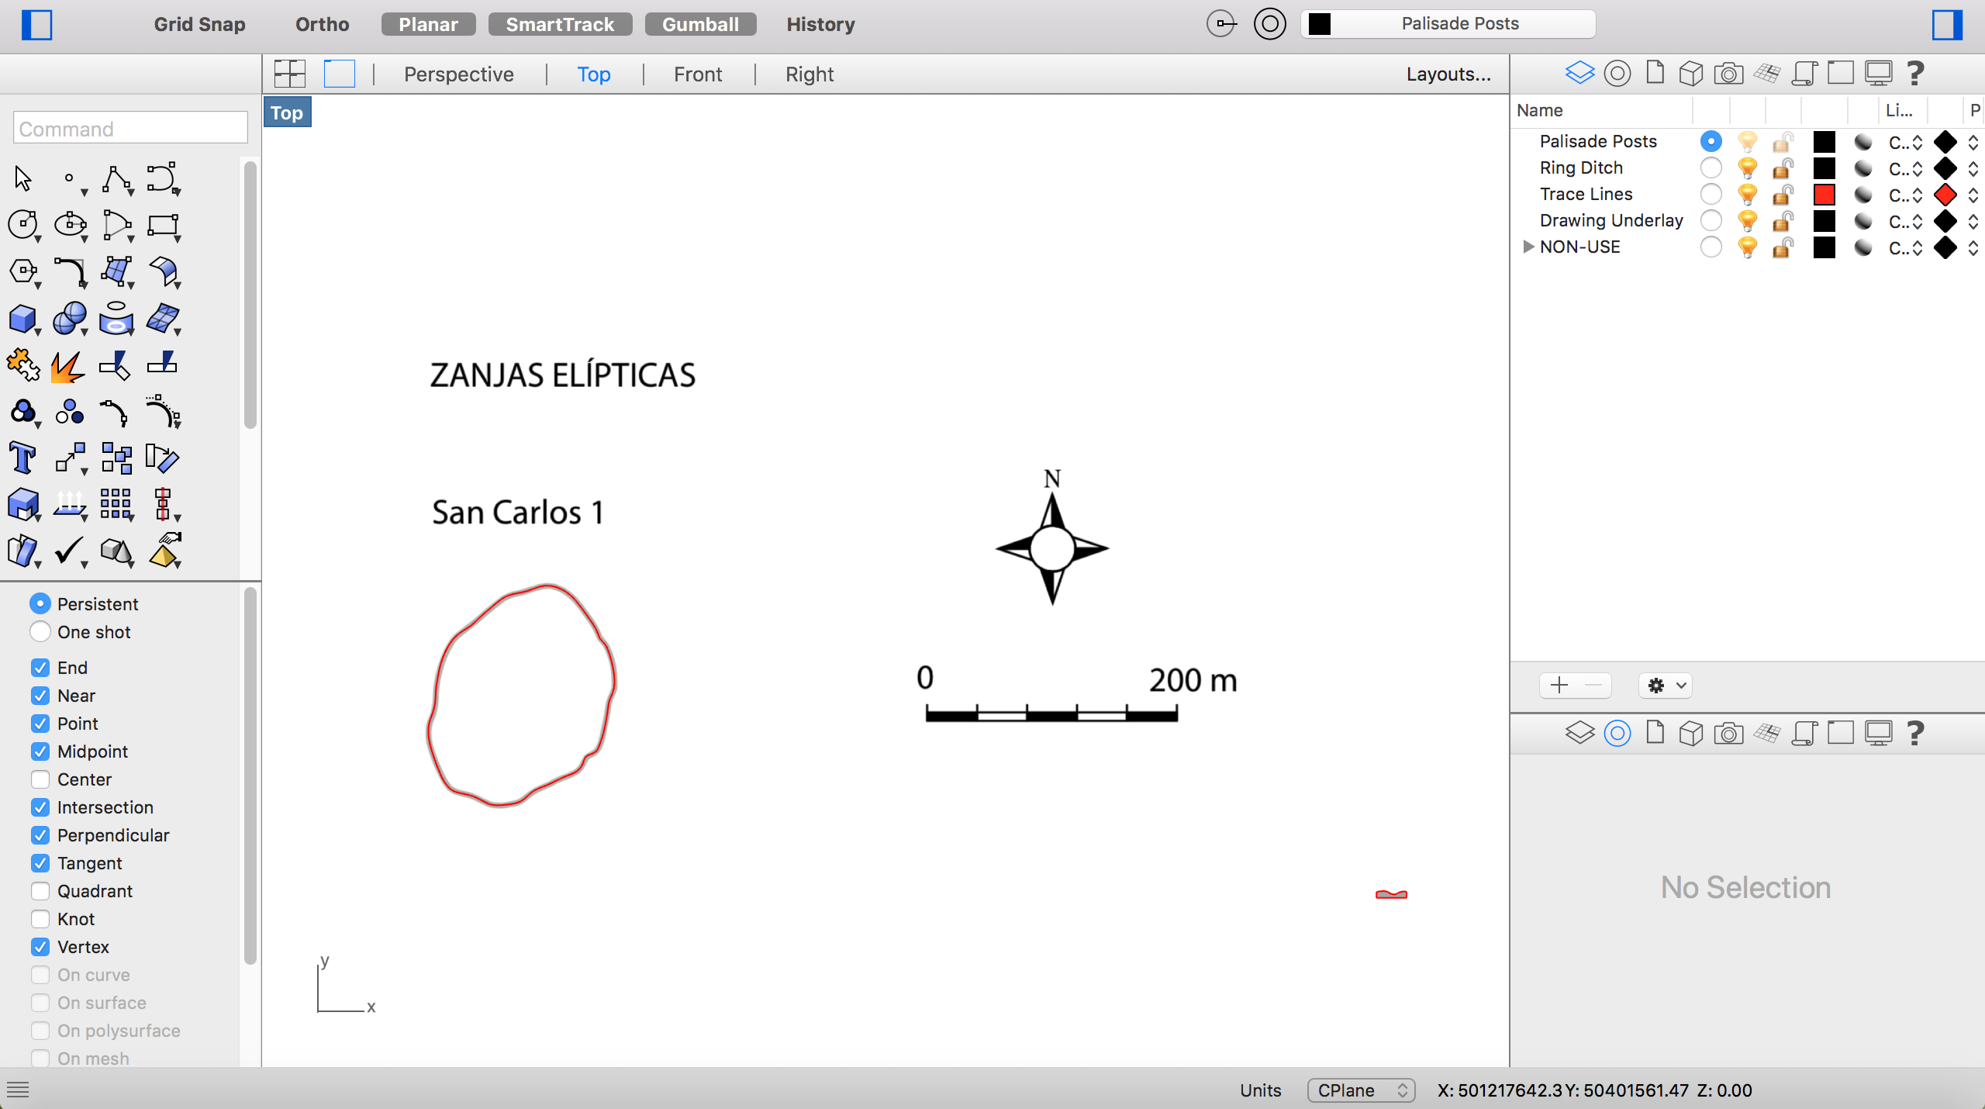

Figure 13: Scaled drawings and linework in Rhino.

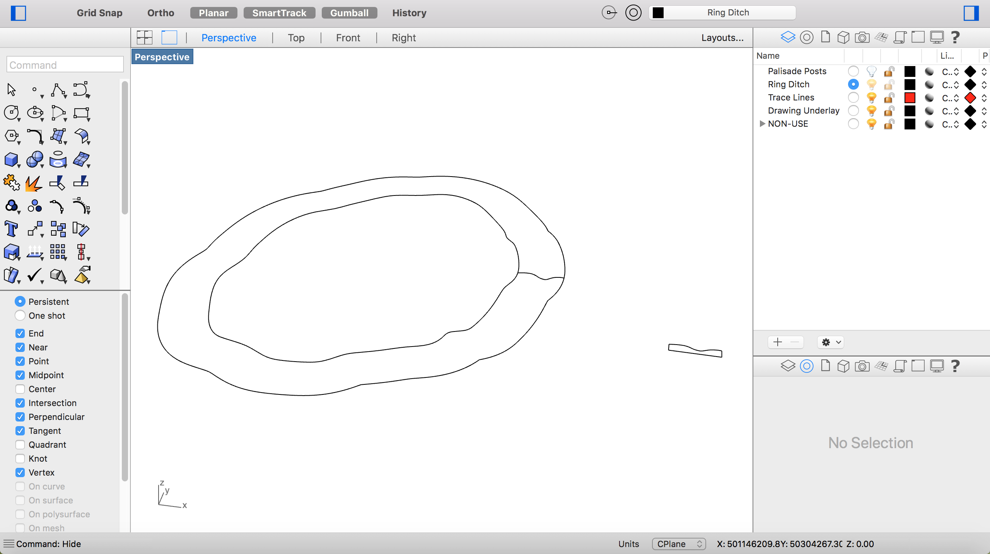

Figure 14: Offset plan curves in Rhino.

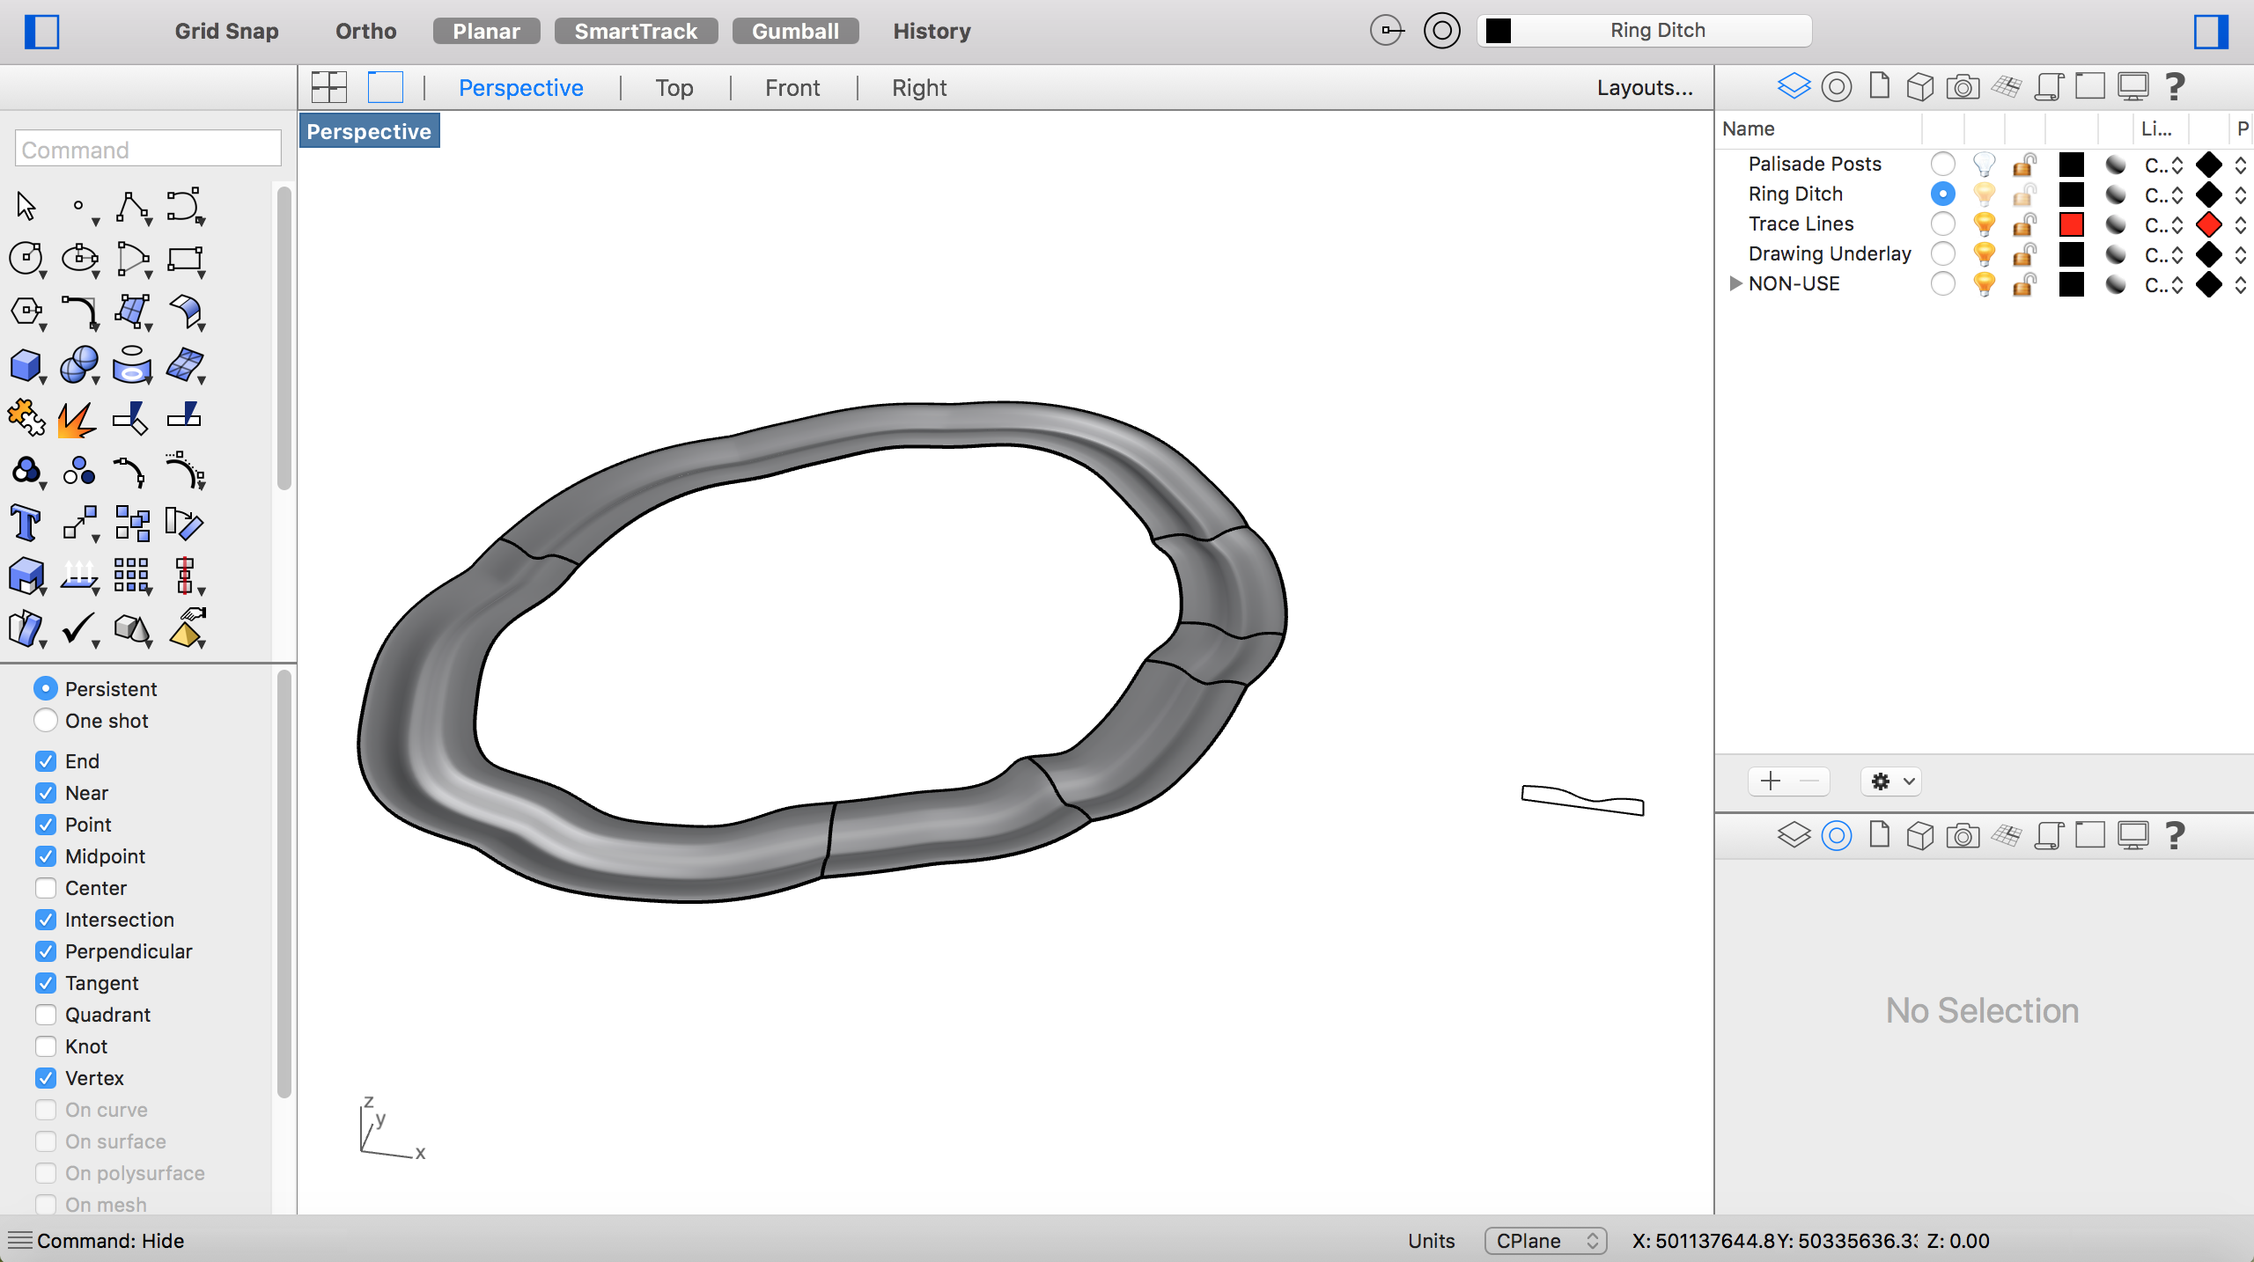

Figure 15: Ditch surface between the two plan curves, based on section curve, in Rhino.

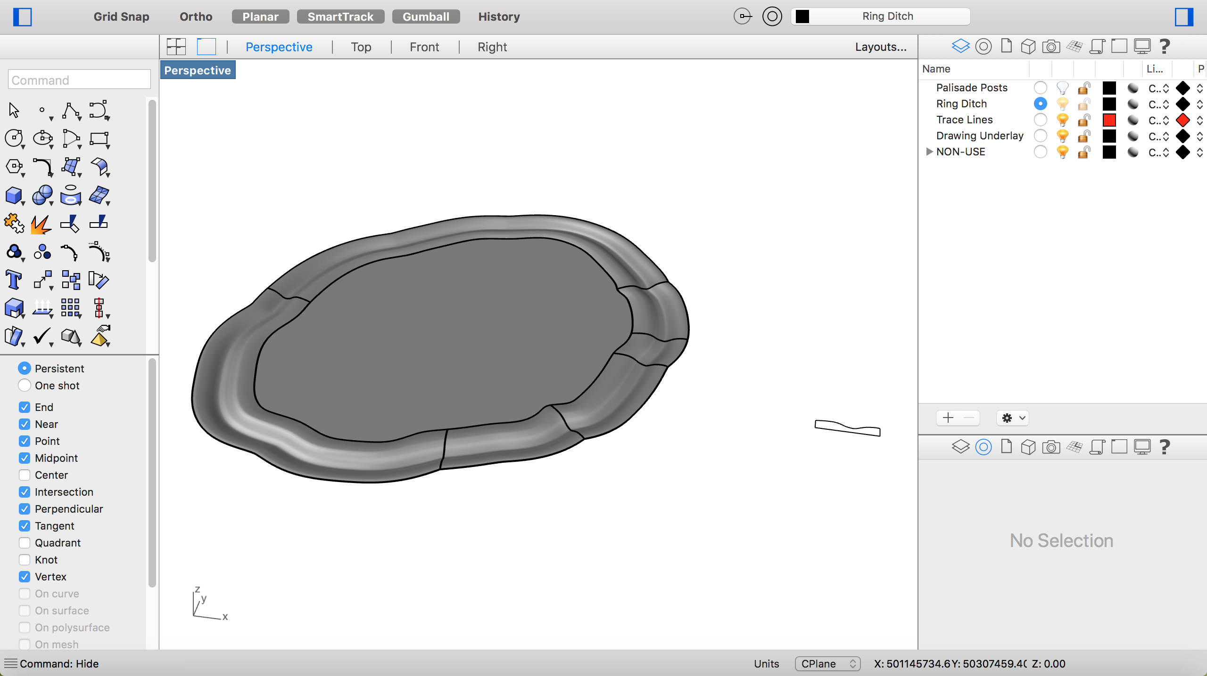

Figure 16: Inner fill in the middle of the ring ditch, in Rhino.

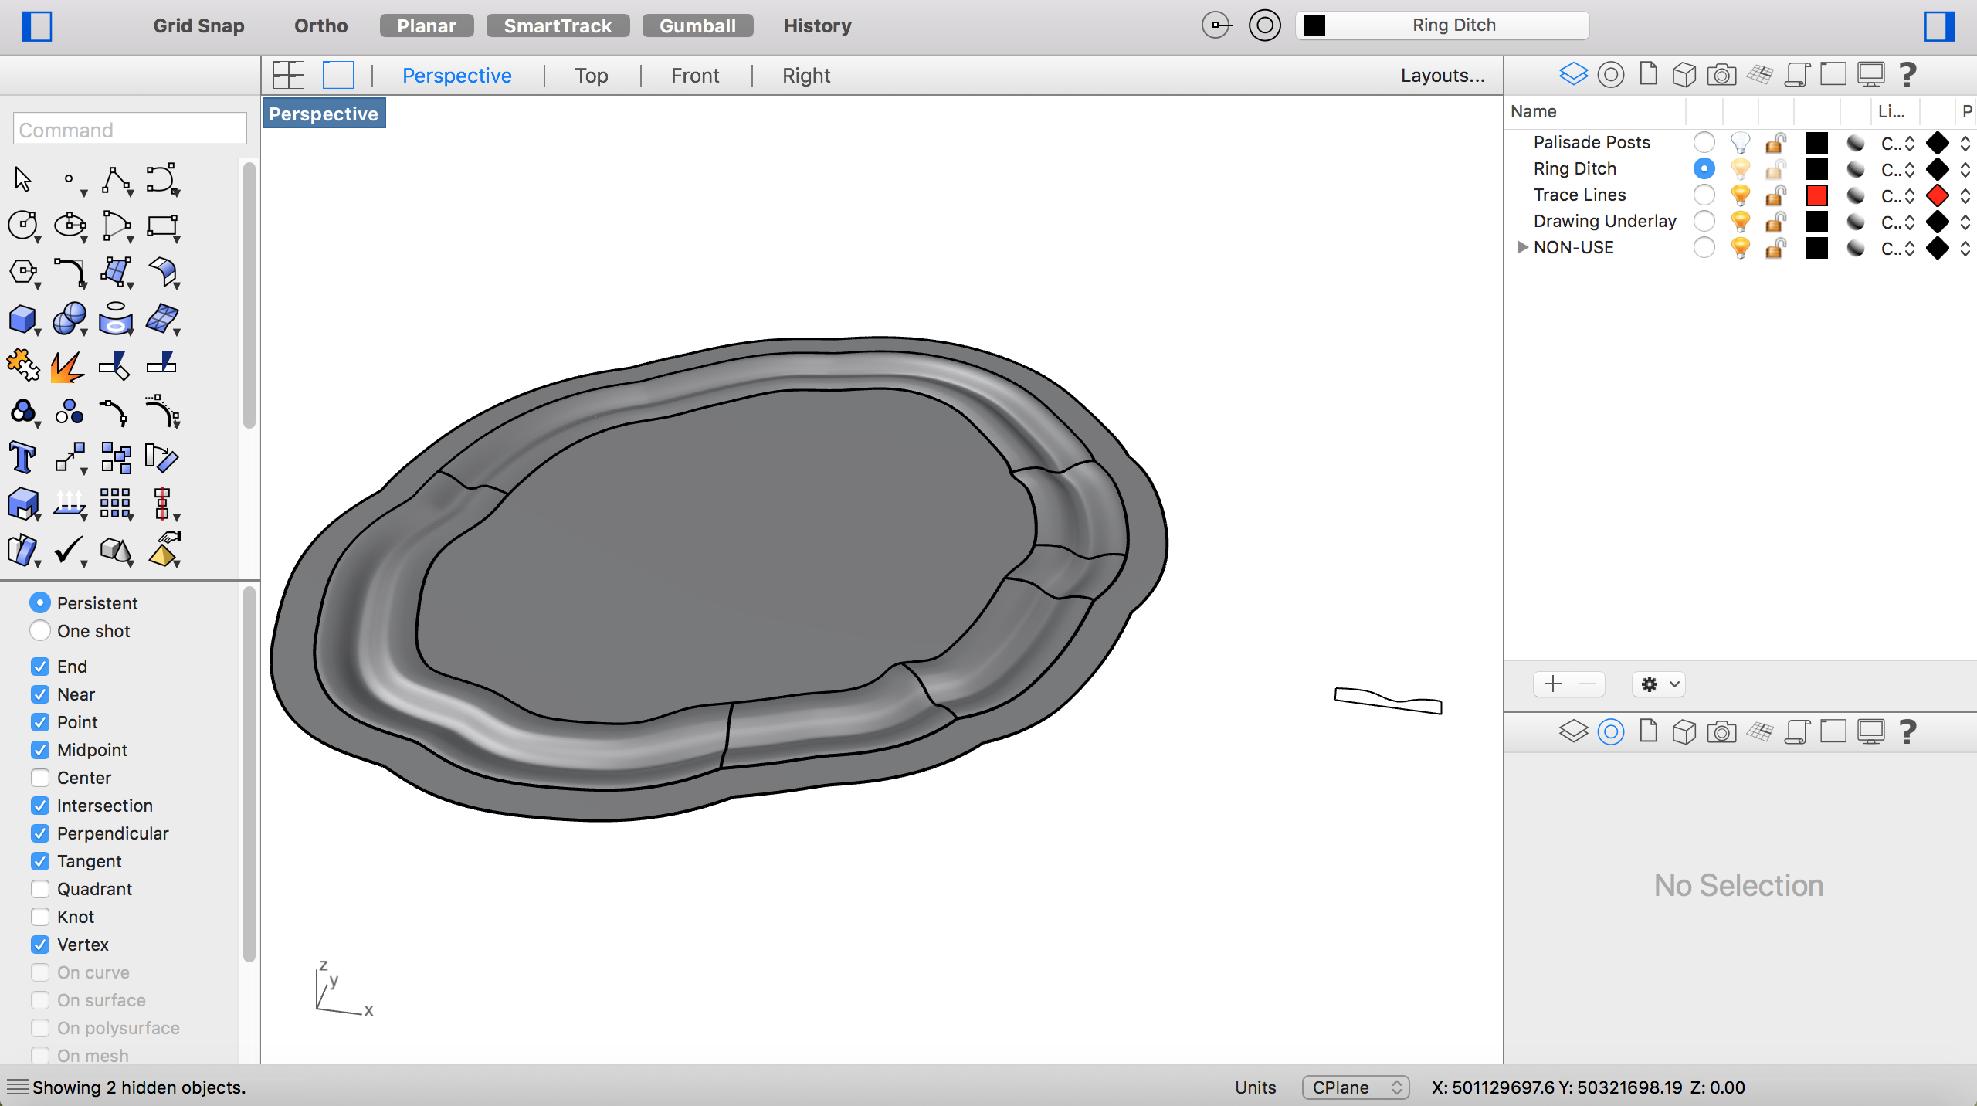

Figure 17: Outer fill to allow a more seamless integration into the existing landscape, in Rhino.

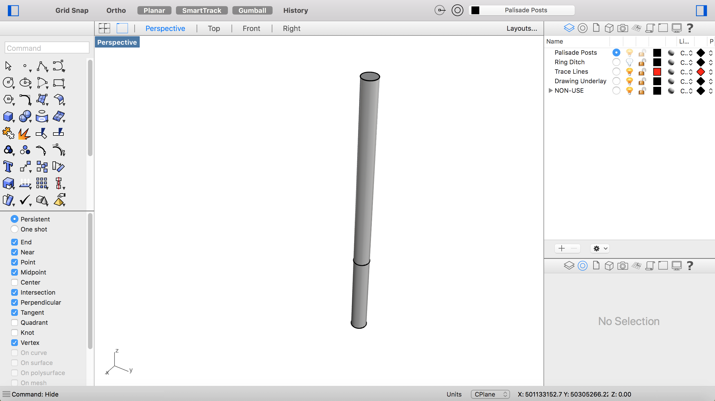

Figure 18: Standard palisade wall post with rough ground line marked, in Rhino.

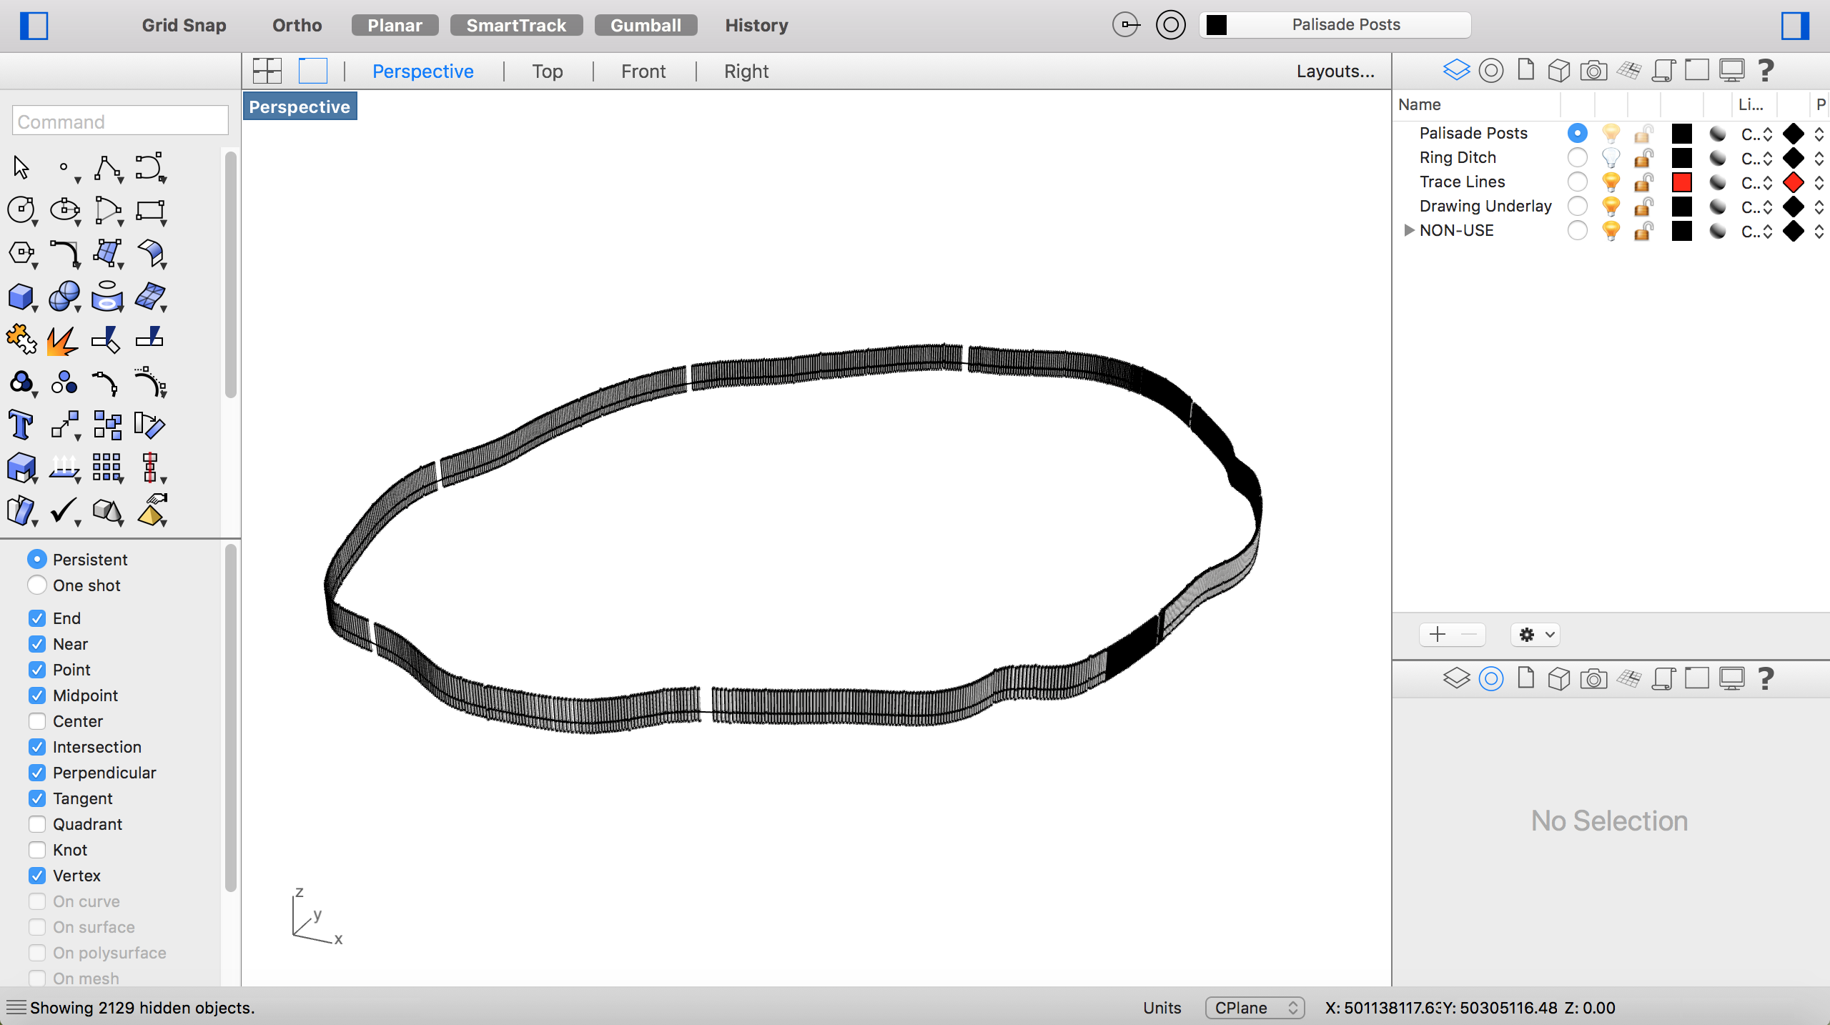

Figure 19: Palisade wall with posts at varying heights and gaps for passage, in Rhino.

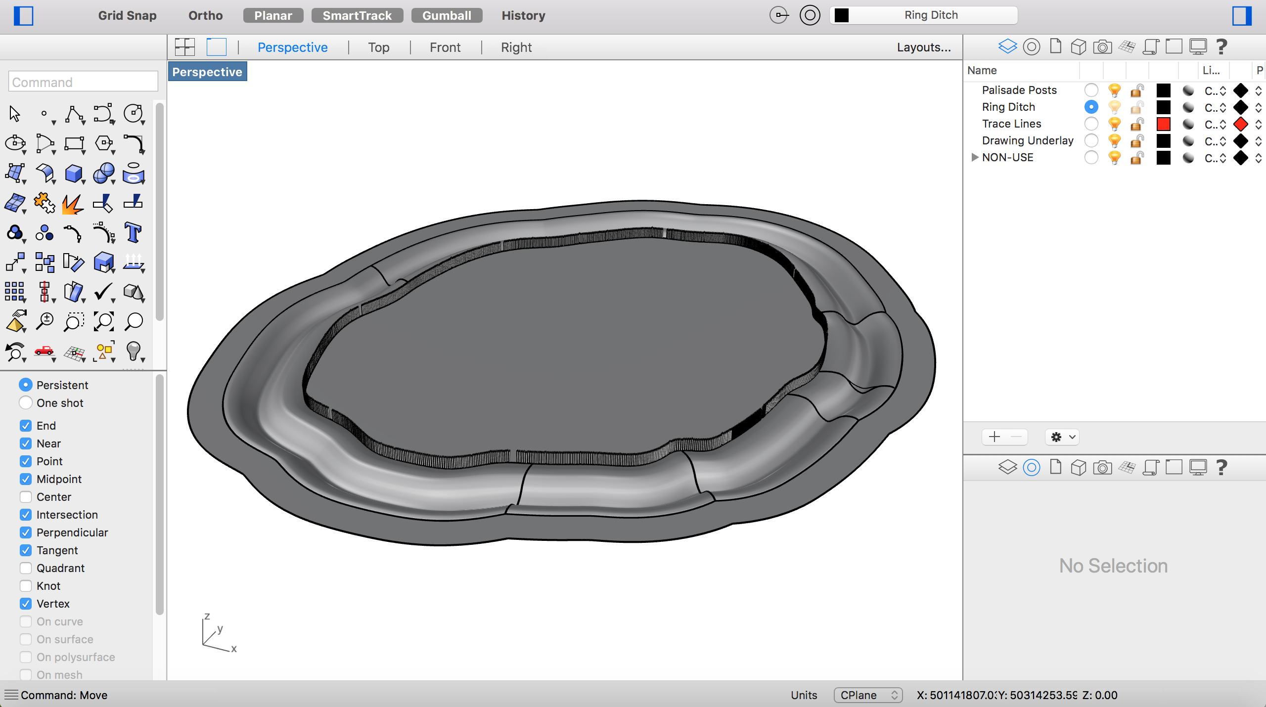

Figure 20: Final Rhino model.

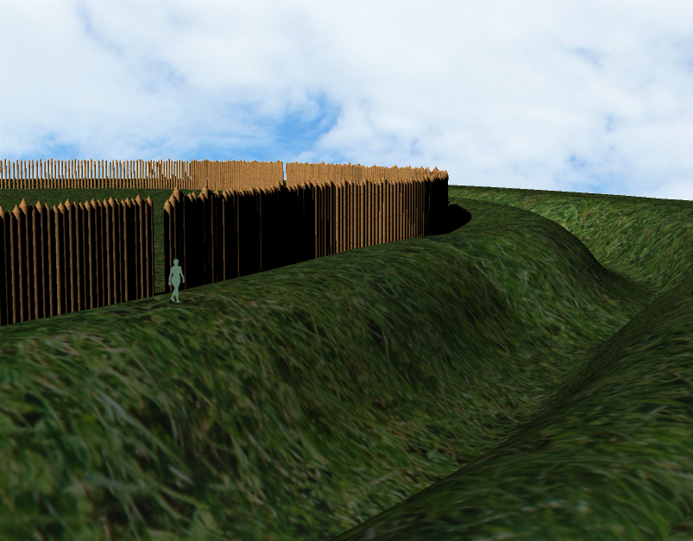

Figure 21: Final Rhino model.

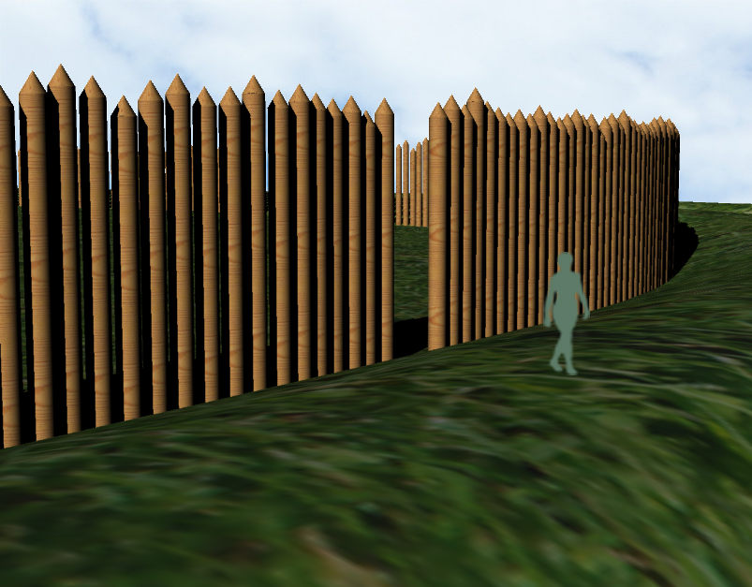

Figure 22: Final Rhino model.
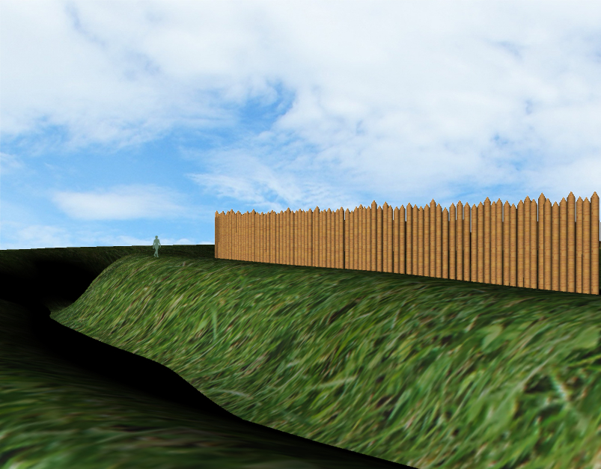

Figure 23: Final Rhino model.

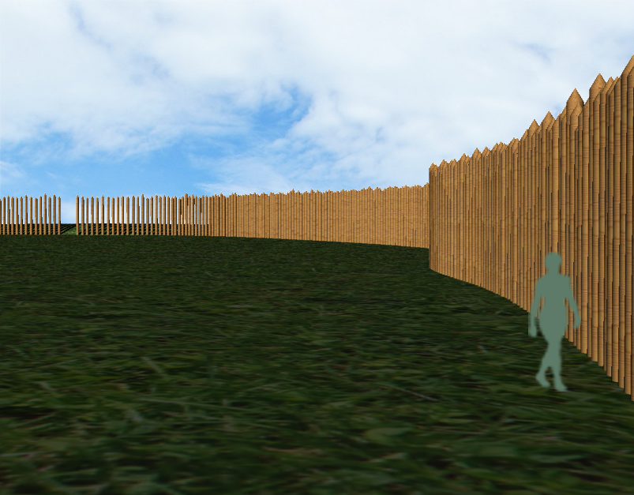

Figure 24: Final Rhino model.

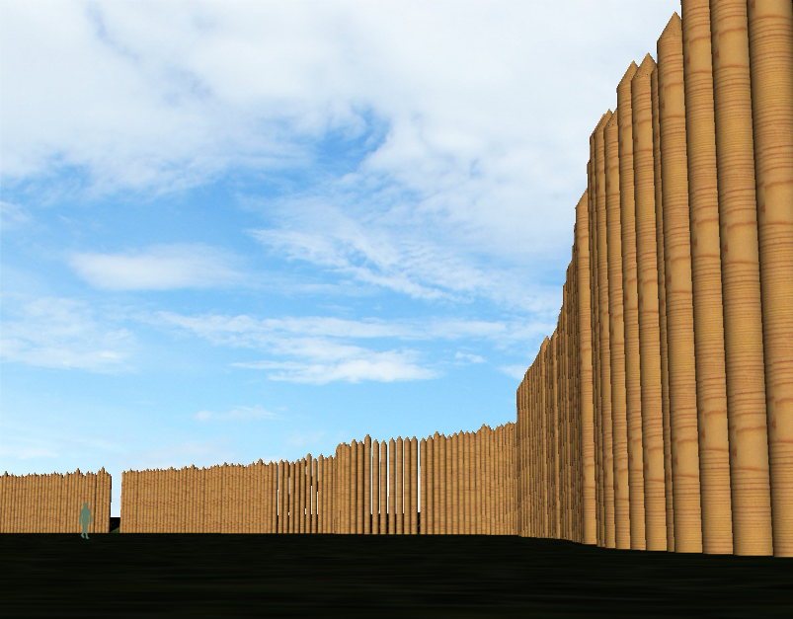

Figure 25: Final Rhino model.

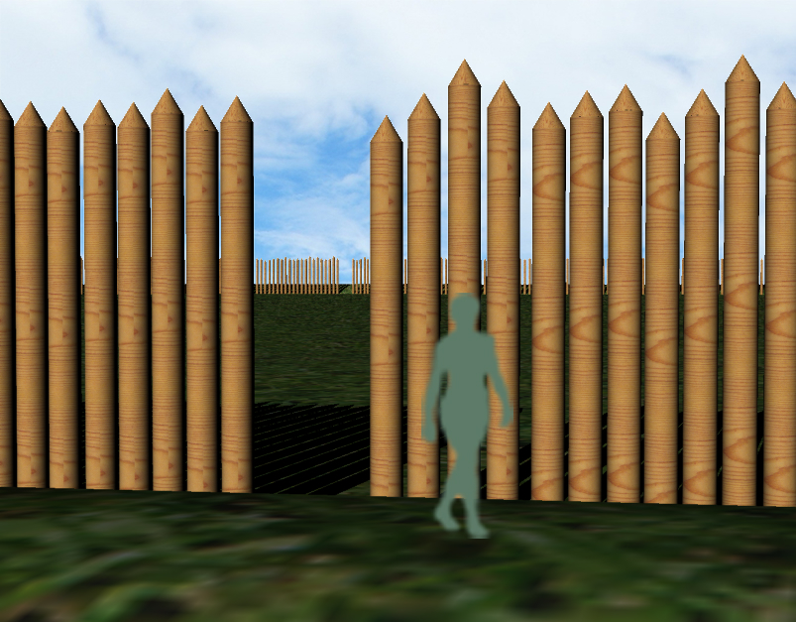

Figure 26: Final Rhino model.
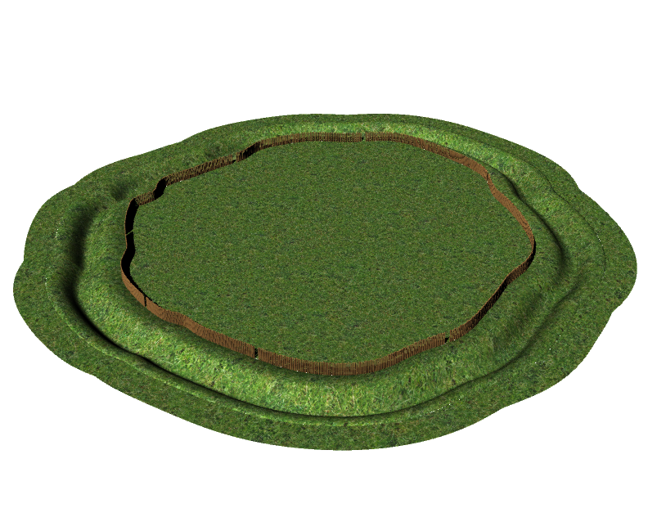

Figure 27: Final Rhino model.

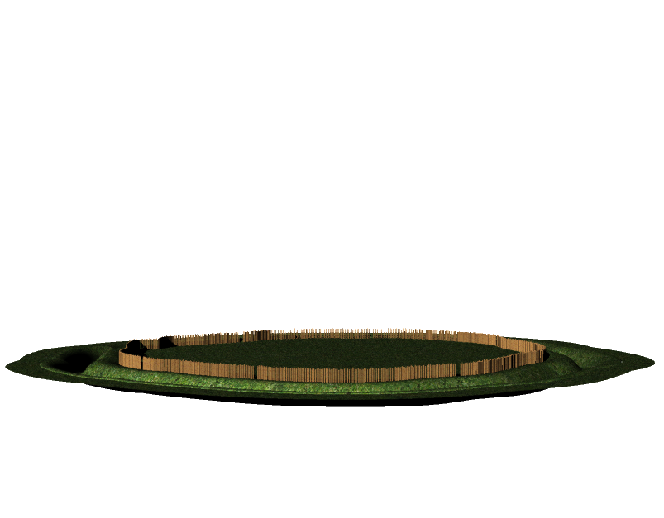

Figure 28: Final Rhino model.

