**Zane Stiles**

**ANTH 258/CIS 106**

**Visualizing the Past/Peopling the Past**

**Assignment 7c**

**December 22, 2017**

**Final Project Figures**

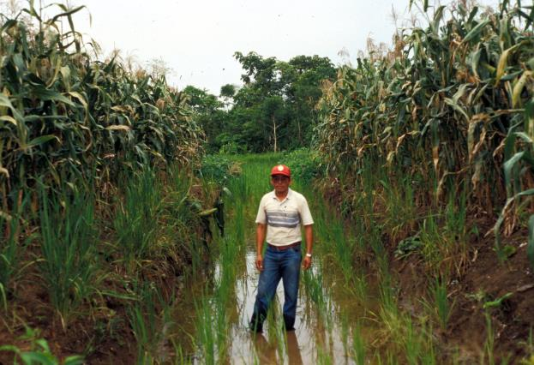

Figure 1. Experimental raised fields with maize in 1993, Community of Bermeo, Bolivia (photograph by Clark Erickson).

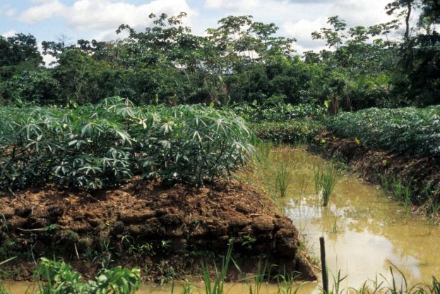

Figure 2. Experimental raised fields with manioc in 1993, Community of Bermeo, Bolivia (photograph by Clark Erickson).

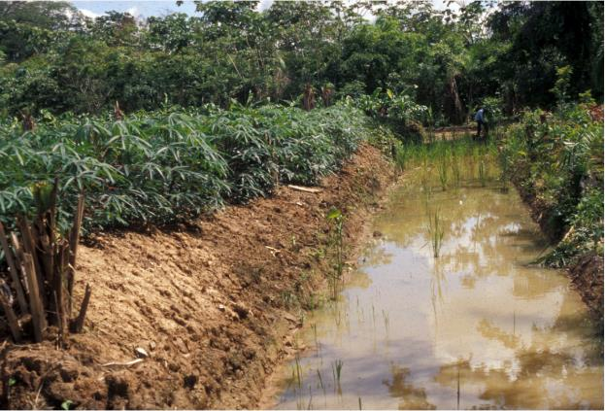

Figure 3. Experimental raised field with maize in 1993, Community of Bermeo, Bolivia (photograph by Clark Erickson).

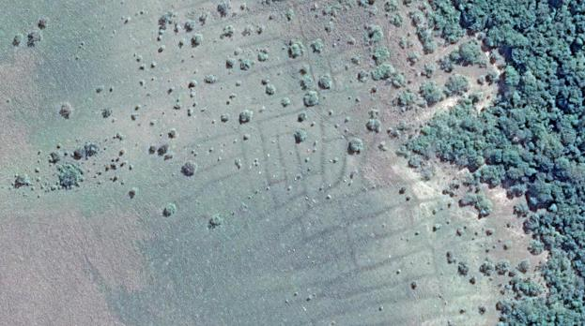

Figure 4. Raised field platforms (light green) and canals (light gray) near Orobayaya, Bolivia (Google Earth—see style guide for how to format and cite Google Earth images).

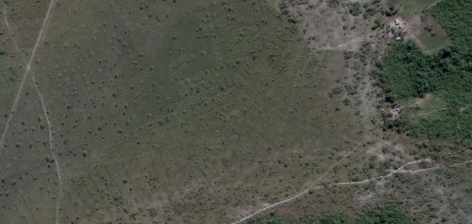

Figure 5. Raised field platforms (light green) and canals (light gray) near Orobayaya, Bolivia.

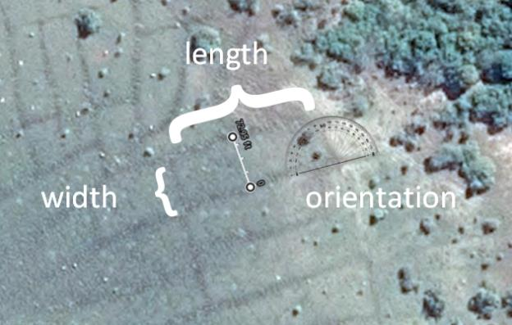

Figure 6. Diagram of the measurements taken of a raised field.

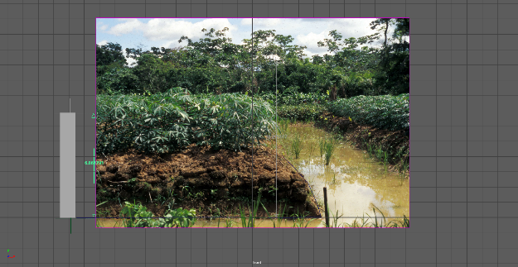

Figure 7. Image of experimental raised field within Maya software to guide modeling.

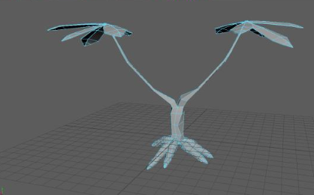

Figure 8. Manioc low-poly 3D model in Maya software

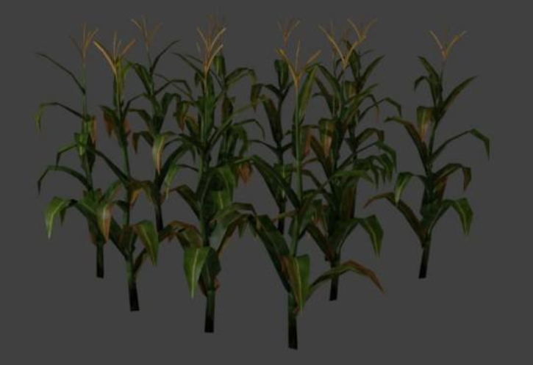

Figure 9. Maize low-poly 3D model in Maya software.

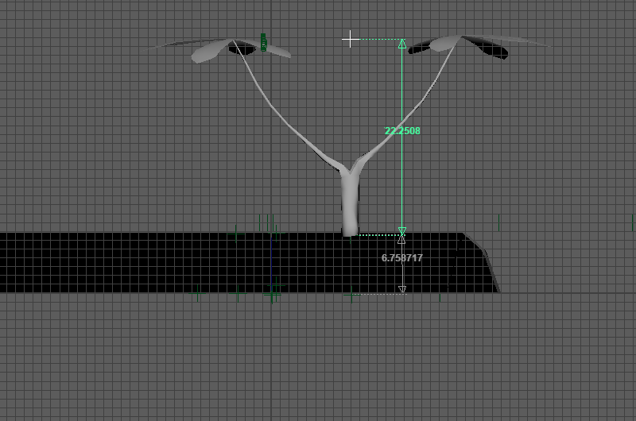

Figure 10. Manioc scaled relative to a raised field.

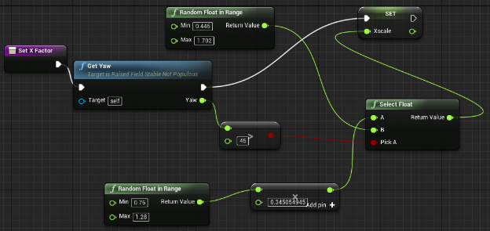

Figure 11. Blueprints logic used to scale raised fields for procedural generation modeling in Unreal Engine.

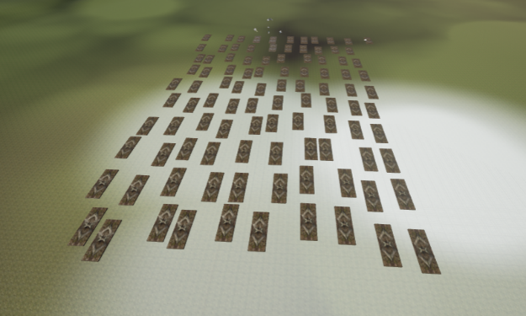

Figure 12. Procedurally generated raised fields in grid fashion.

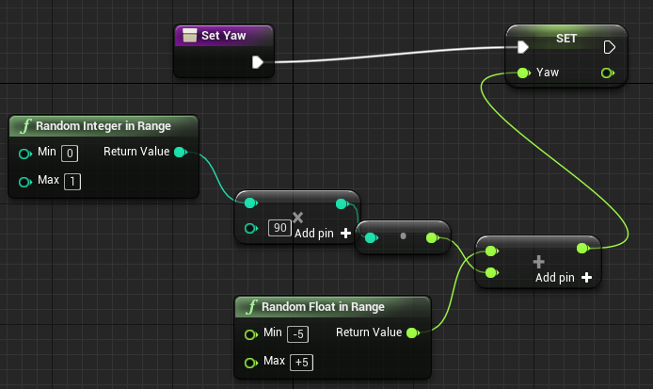

Figure 13. Blueprints logic used to set random orientation to a raised field.

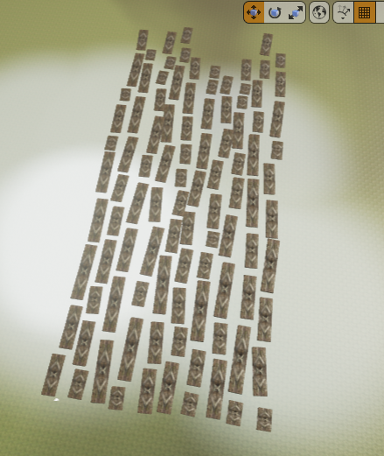

Figure 14. Raised fields procedurally generated with random orientation within a grid pattern.

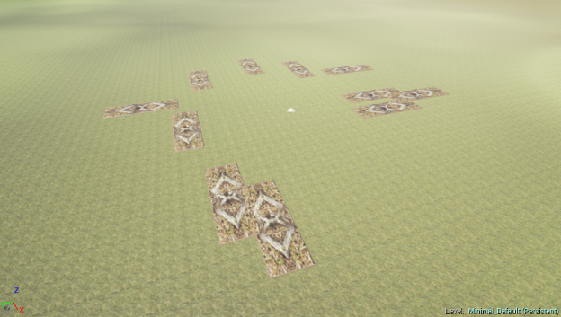

Figure 15. Procedurally generated raised fields with random locations but overlapping.

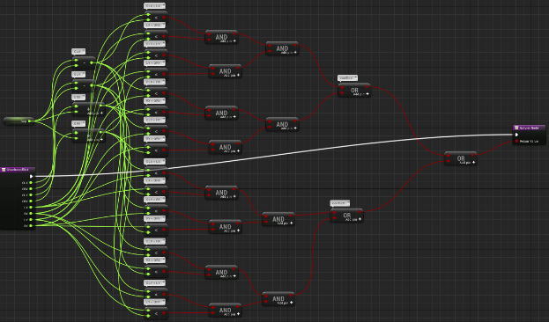

Figure 16. Blueprints logic used to detect and prevent overlapping raised fields.

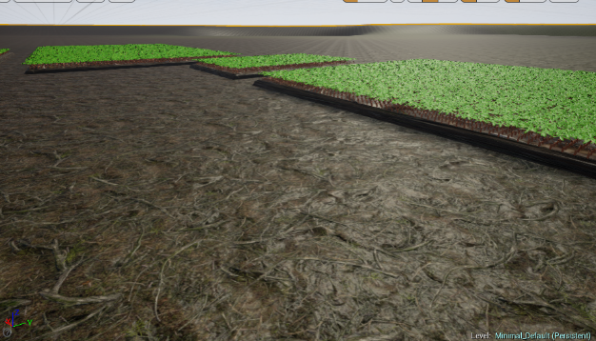

Figure 17. Raised field populated with manioc in rows.

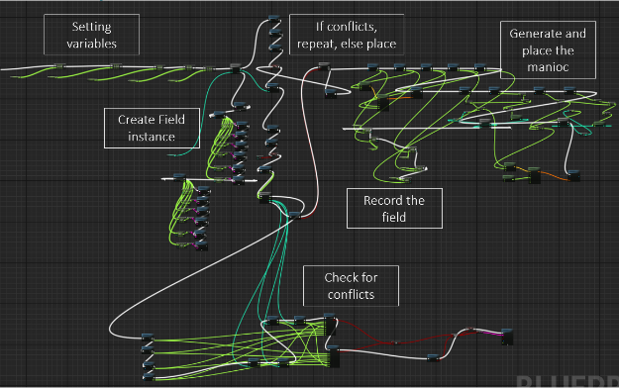

Figure 18. Main function in Blueprints with major subfunctions labeled.

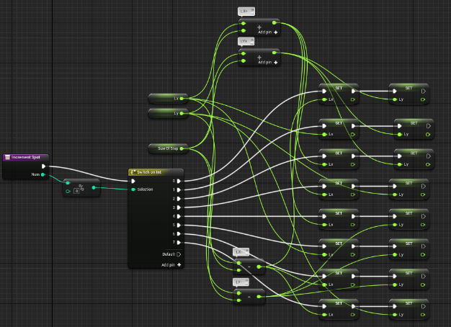

Figure 19. Blueprints logic used to randomly place the field.



Figure 20. Blueprints logic used to set the yaw of the raised field.



Figure 21. Blueprints logic used to set scale of the raised field.

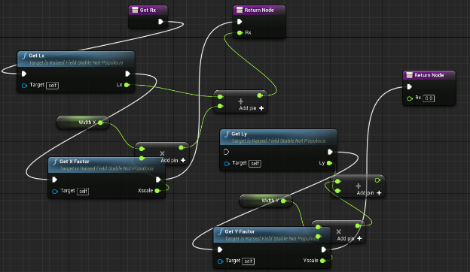

Figure 22. Blueprints logic used to determine the bounding box of a raised field for overlap detection and prevention.

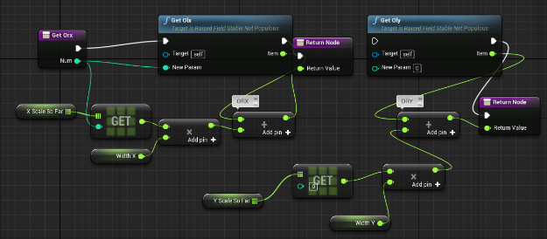

Figure 23. Blueprints logic used to determine bounding box of all raised fields placed.



Figure 24. Blueprints logic used to detect overlapping raised fields.

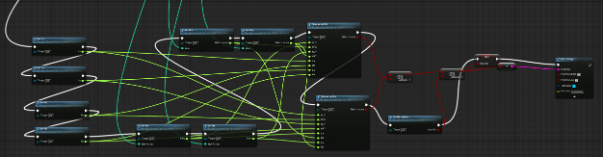

Figure 25. Blueprints logic used to prevent fields from overlapping.

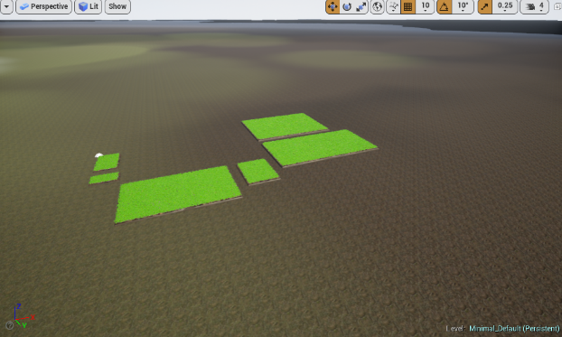

Figure 26. Procedurally generated manioc foliage on 6 raised fields.

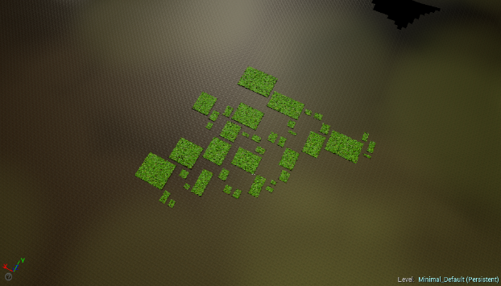

Figure 27. Procedurally generated manioc foliage on 40 raised fields.

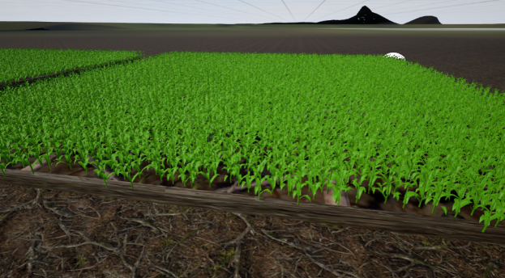

Figure 28. Procedurally generated maize foliage on 2 raised fields.



Figure 29. Procedurally generated manioc foliage on 3 raised fields.

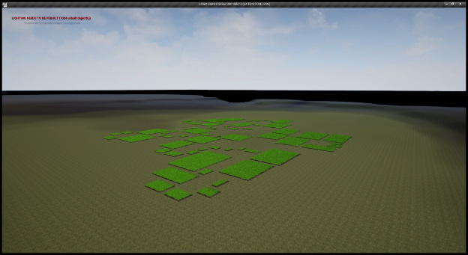

Figure 30. Procedurally generated foliage and raised fields.

<https://www.youtube.com/watch?v=c9ahB8dUZsQ&feature=youtu.be>

Video 1. 100 procedurally generated and populated fields and fly through (click link)