Final Project Figures: Stone Axes

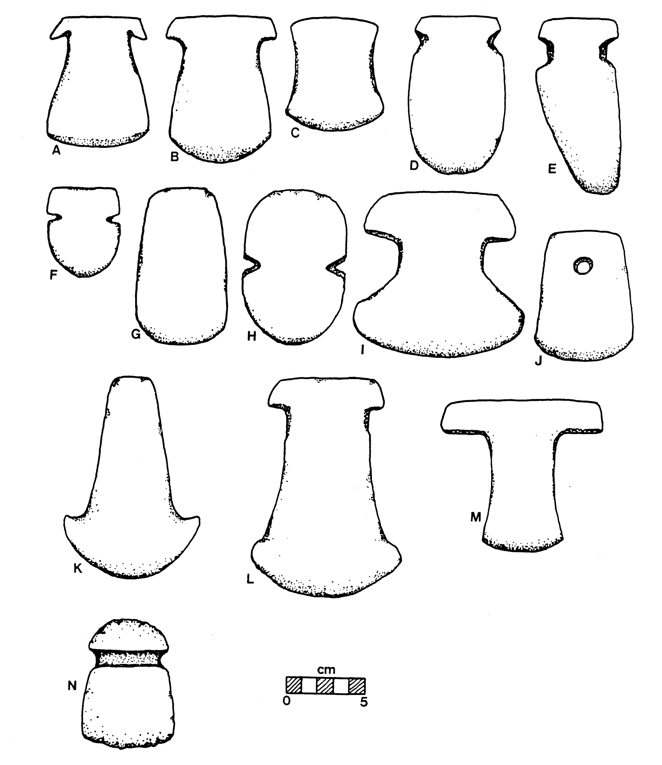

**Figure 1:** DeBoer’s labeled diagram from the letter A to N, showing the diversity in size and shape of stone axe blades.

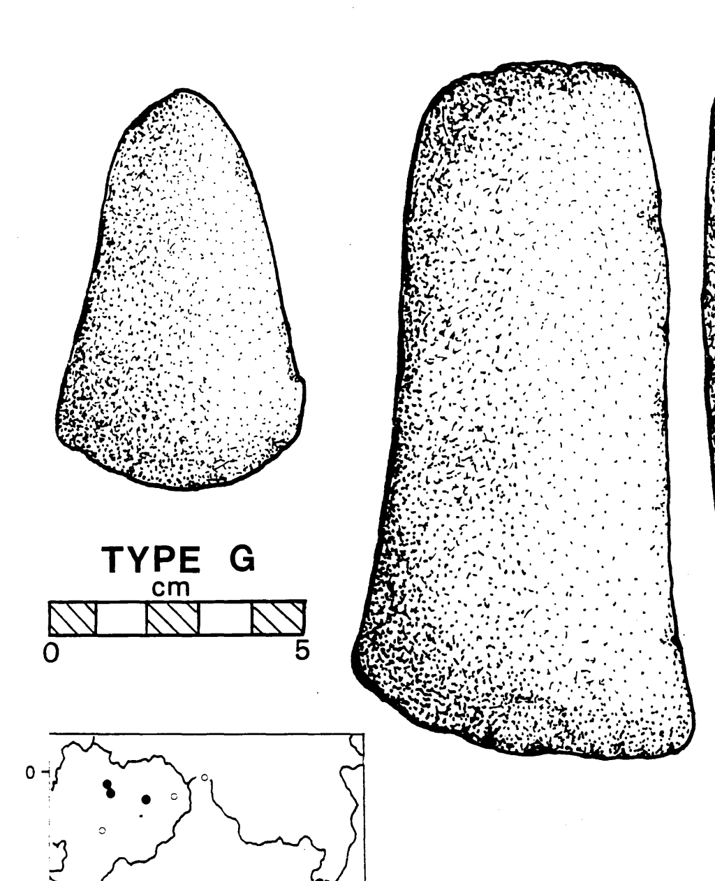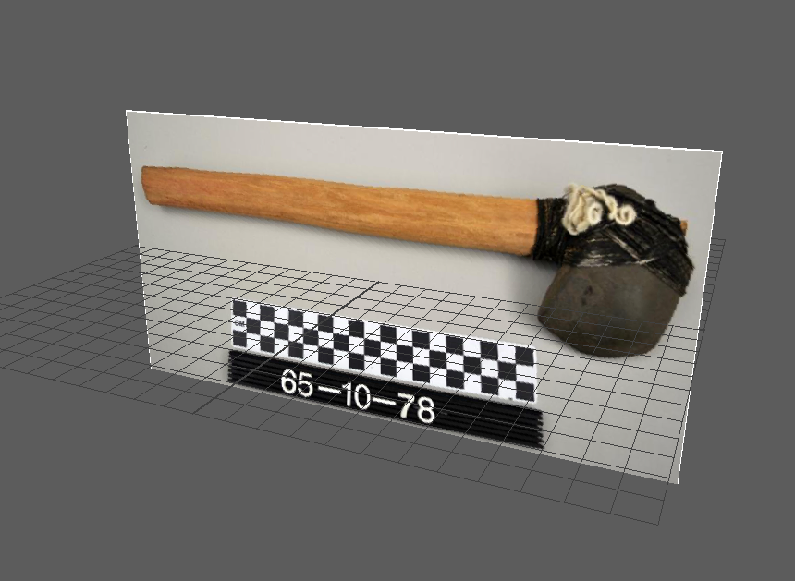

**Figure 3:** DeBoer’s rectangular and rounded tip “Type G” stone axe blade.

**Figure 2:** Photograph from the Penn Museum Object Database depicting a pre-Columbian Amazonian stone axe from the Rio Curanja region of Peru.

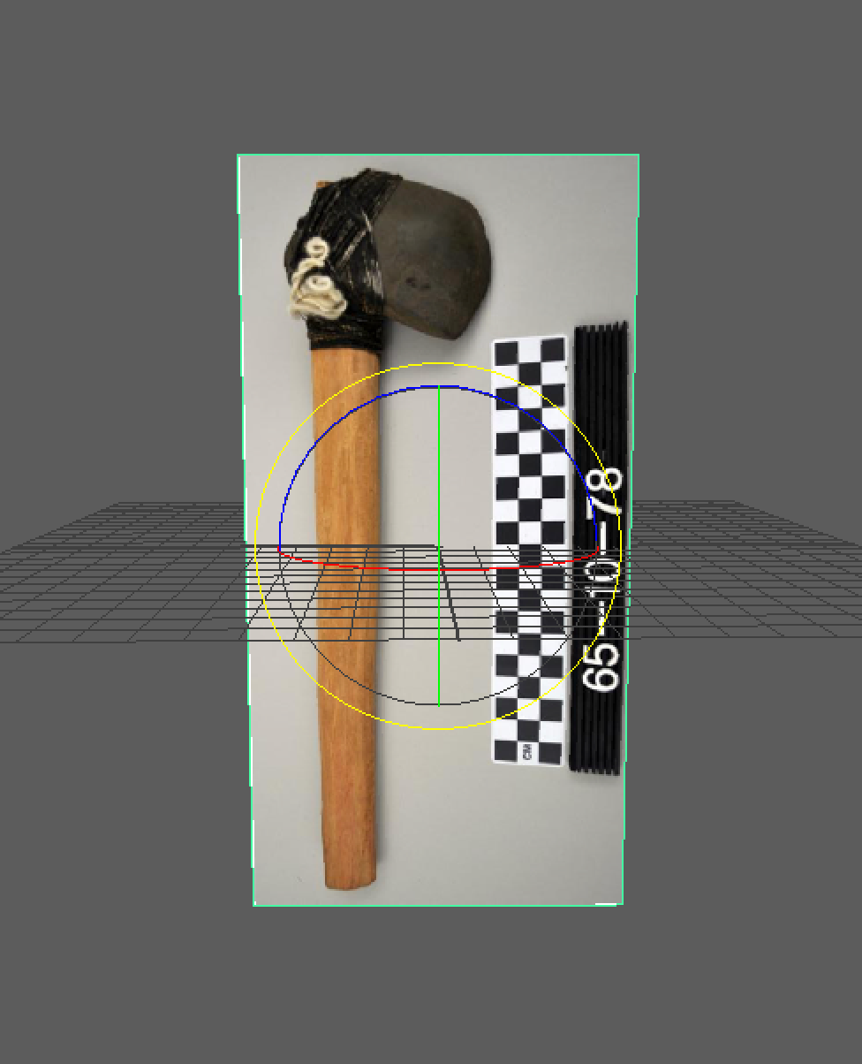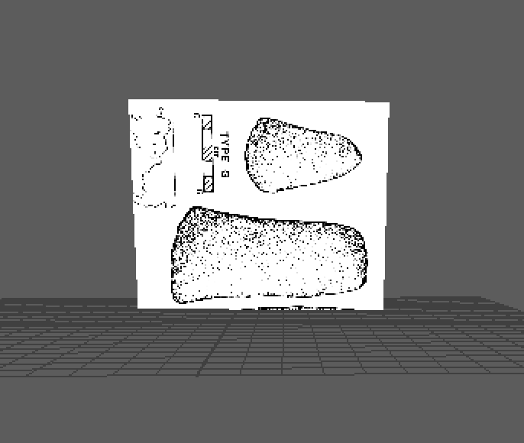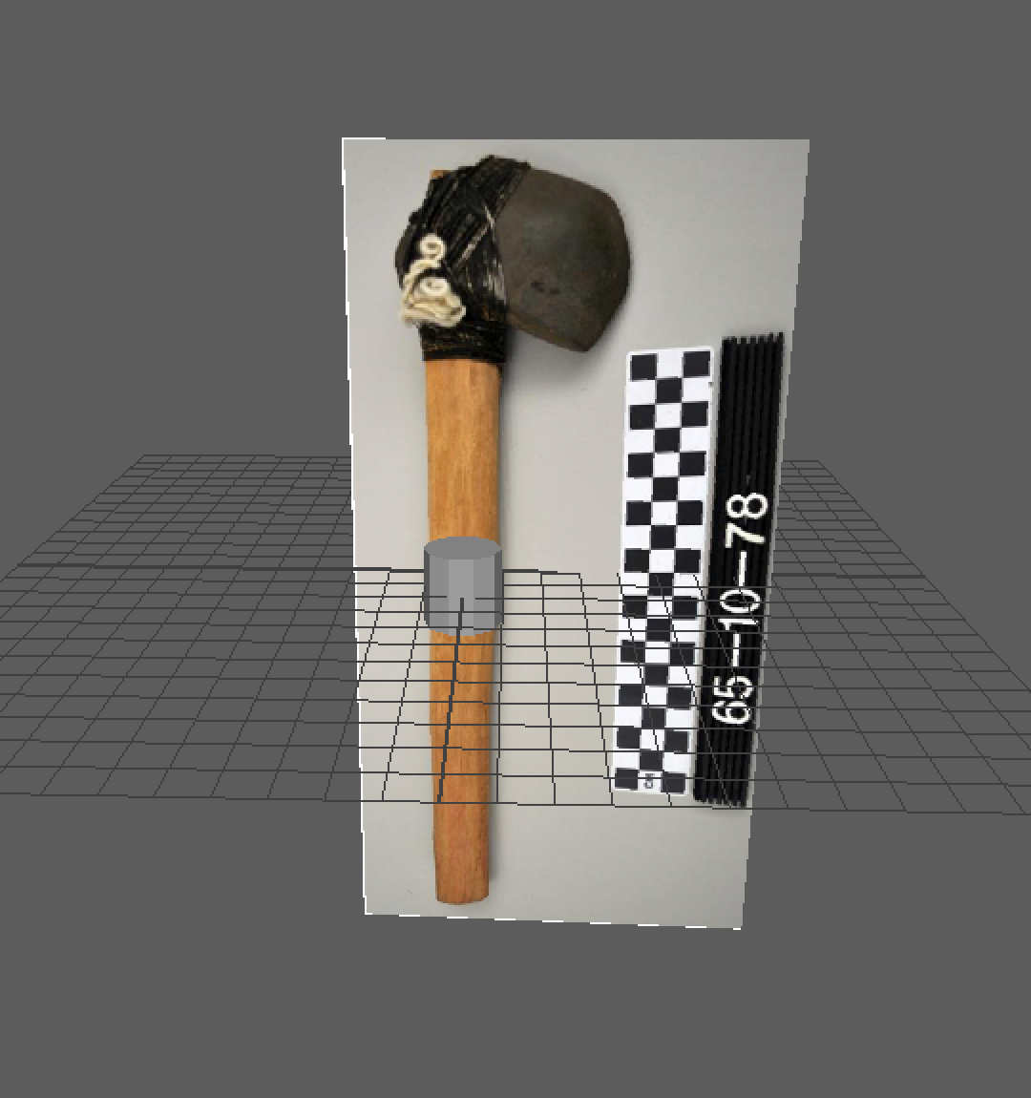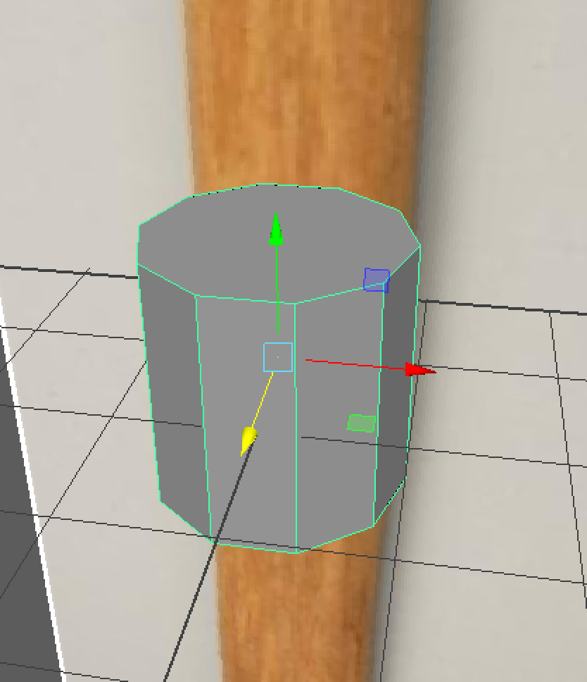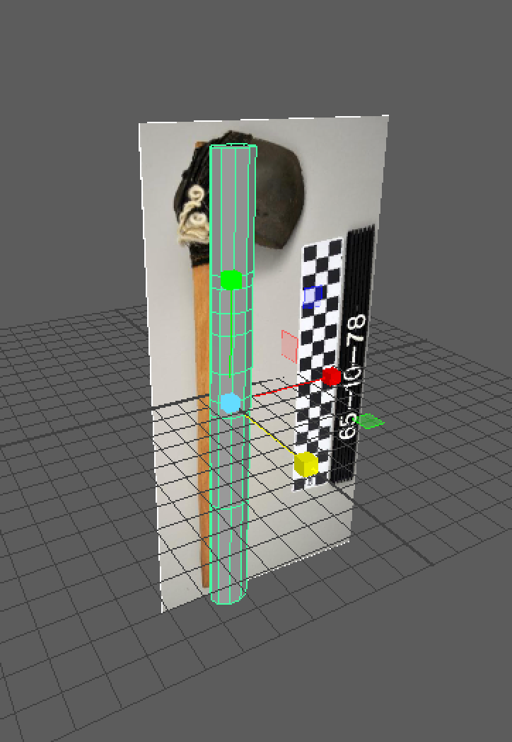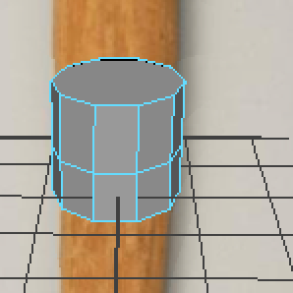

**Figure 5:** Blade of the stone axe set on Maya software plane.

**Figure 4:** Rotated and propped stone axe in Maya software.

**Figure 6:** Construction of polygon shape for the stone axe handle.

**Figure 7:** Polygon with 10 faces being used as a base for the handle.

**Figure 9:** The fully extruded handle created with vertices along the middle slightly to the right and to the left of the polygon.

**Figure 8:** Edge loops function used in Maya software and placed onto the polygon to prepare for extruding features to 30 centimeters in length.

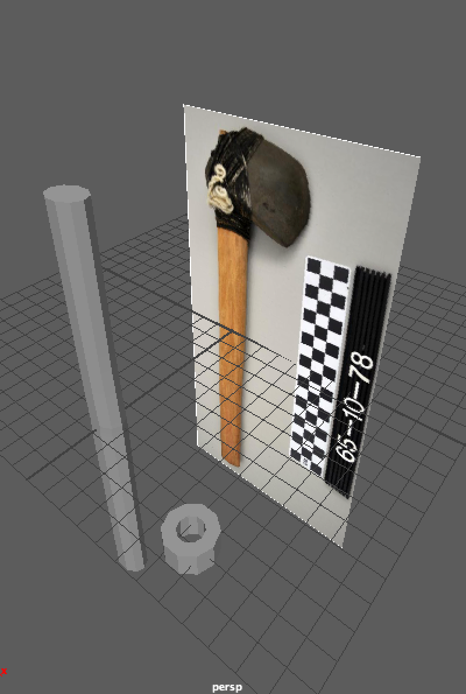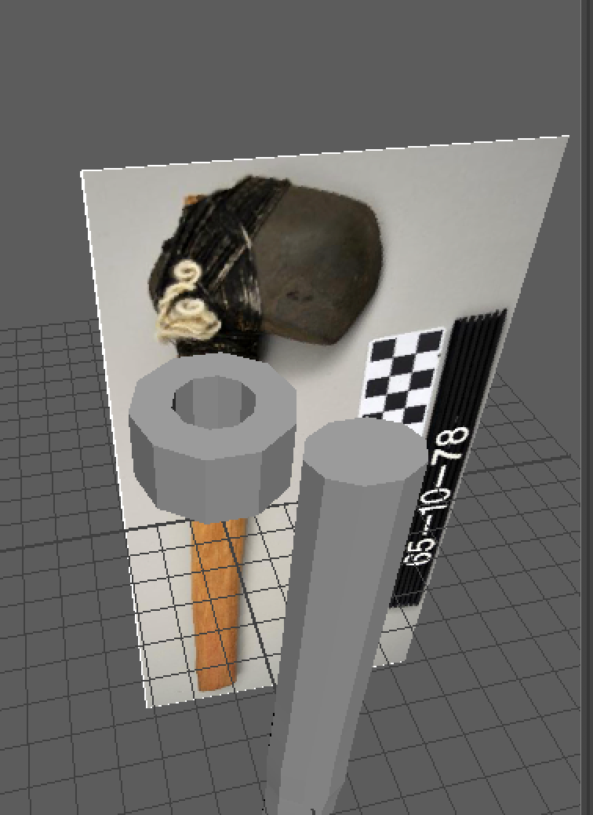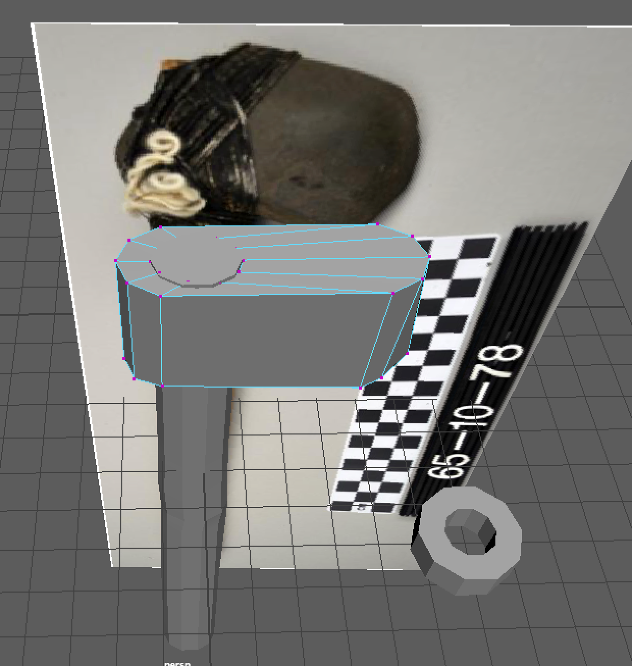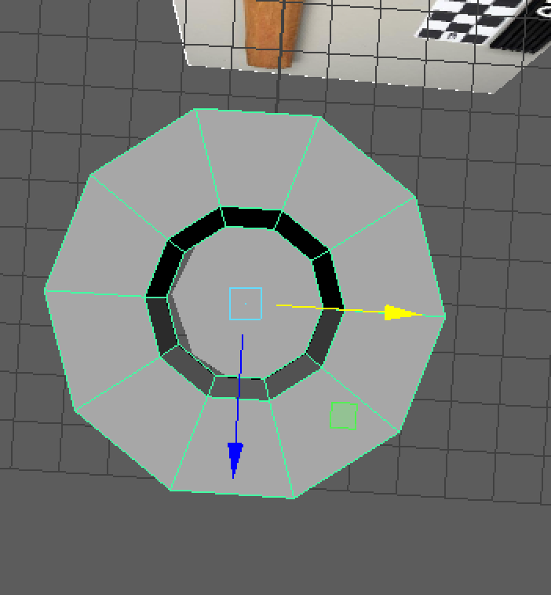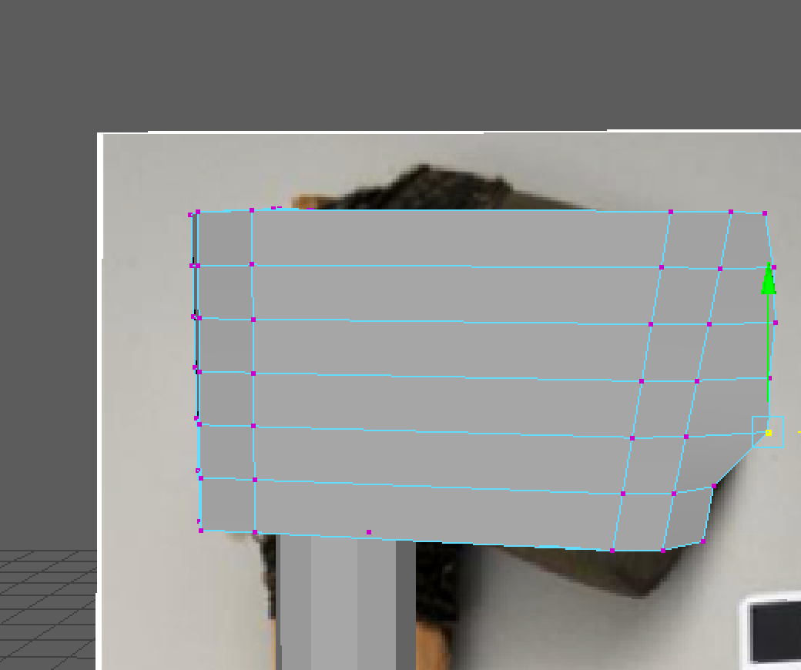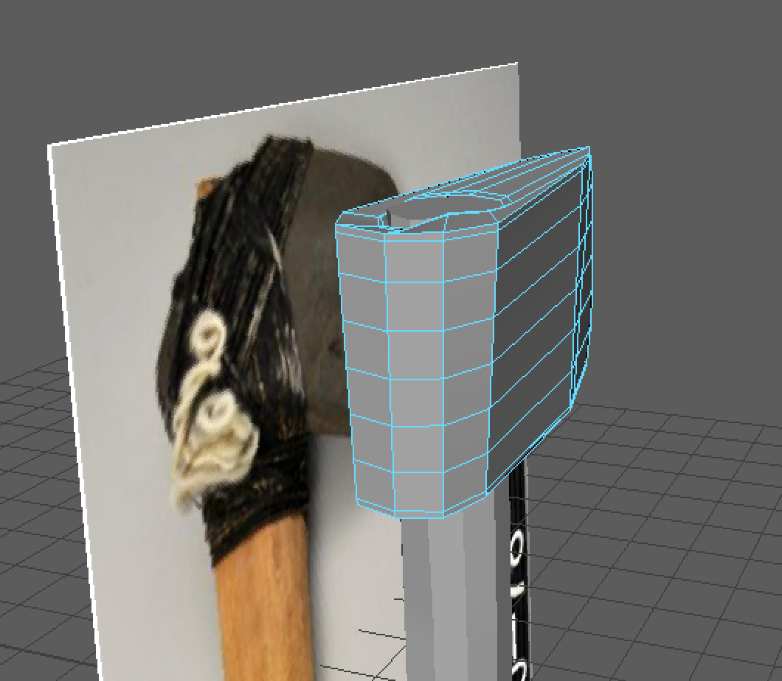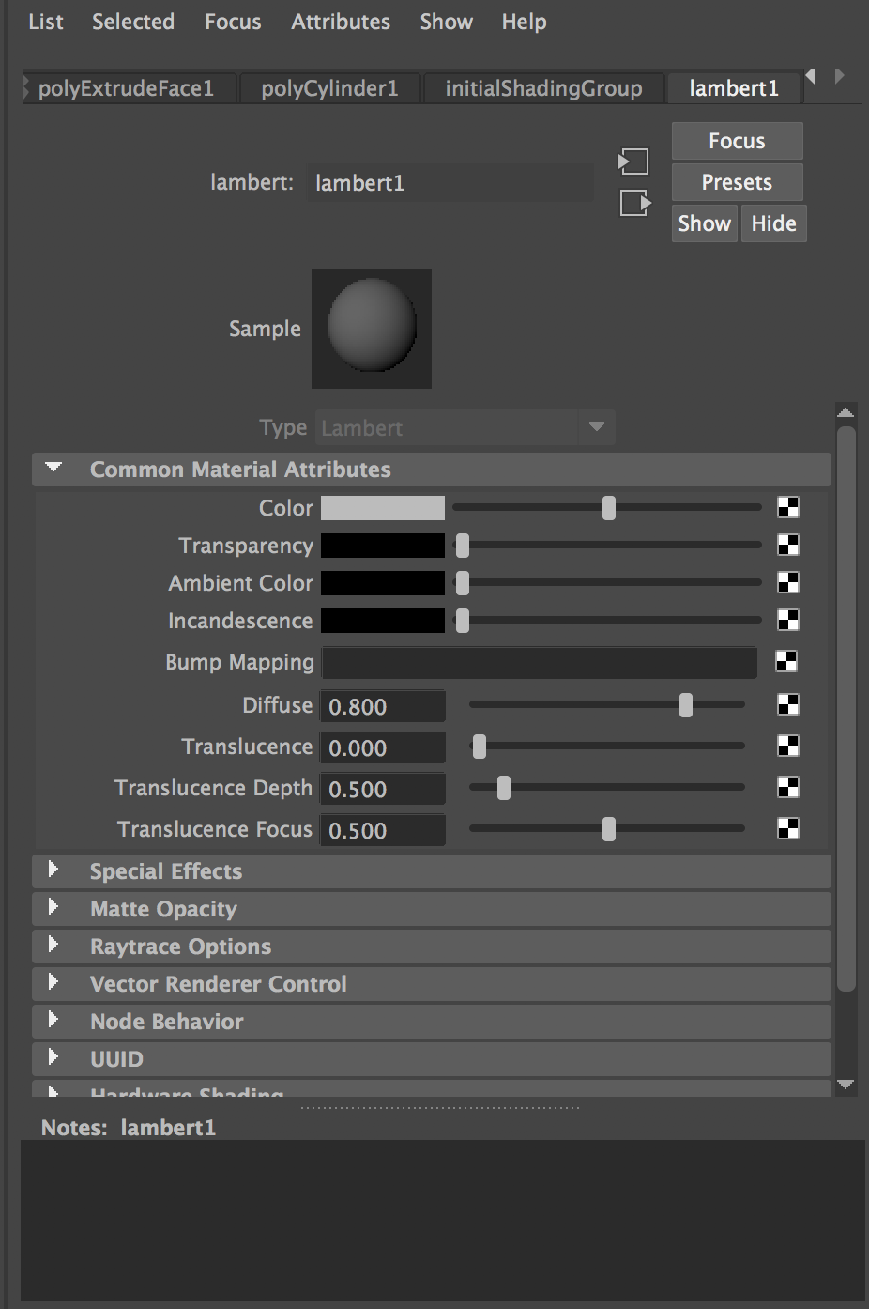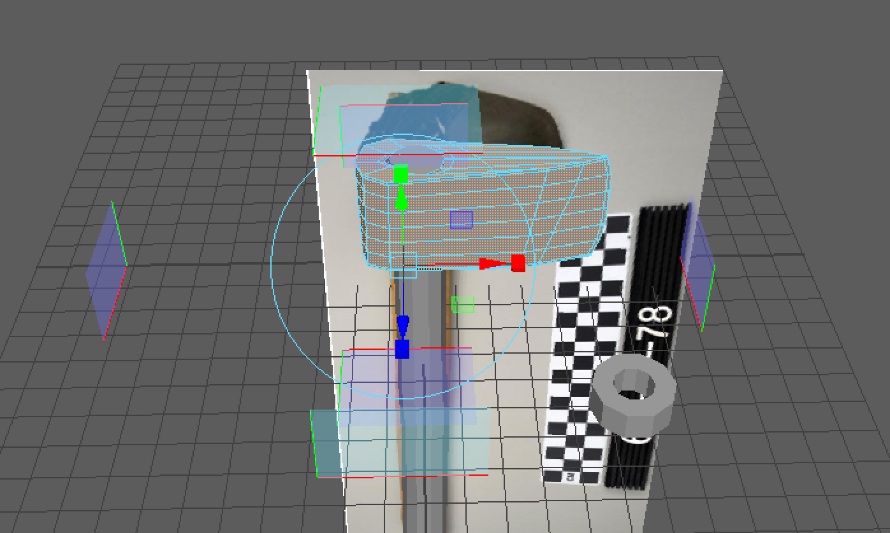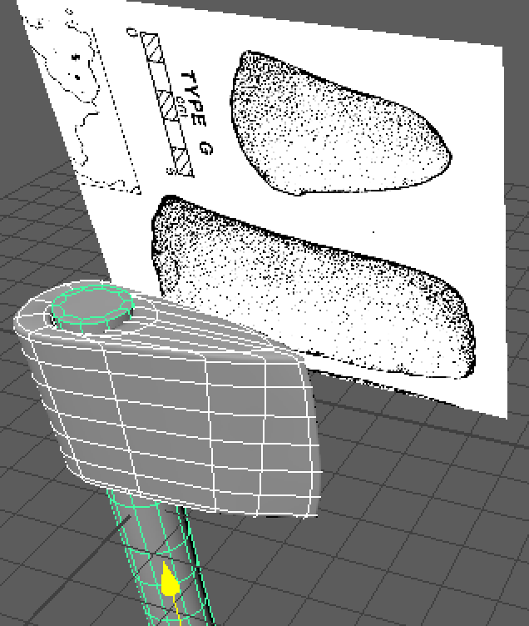/Users/ivanesmeral/Desktop/Screen Shot 2017-12-23 at 1.37.33 AM.png

**Figure 11:** Second Polygon shifted to appropriate position using Maya features.

**Figure 10:** Second polygon created specifically with an opening to easily mold onto the handle. Polygon serves as the binding and blade features, differentiated with texturing.

**Figure 13:** Second polygon extruded and edge loops added to mirror the reference image of the rectangular shaped blade. Left-most side completely dedicated to rope binding texture.

**Figure 12:** Second polygon of binding and blade placed over handle.

**Figure 15: More Edge loops made specifically for binding on rear of polygon.**

**Figure 14: Inserted edge loops and manipulated polygon to mirror rectangular base and rounded surface of stone.**

**Figure 17: Texturing polygon window in Maya. Binding and stone textures added to the second polygon and wood to the first.**

**Figure 16: Shape analyzed through the four Maya cameras and adjusted.**

**Figure 18: DeBoer image with a rectangular shape and rounded tip with model in front. Model thicker in the rear end due to rope binding to hold the blade and handle together.**

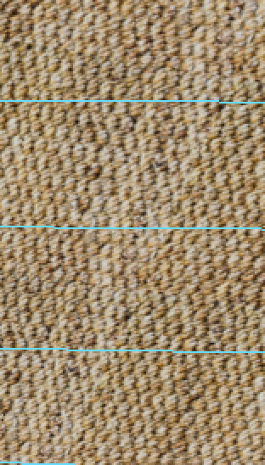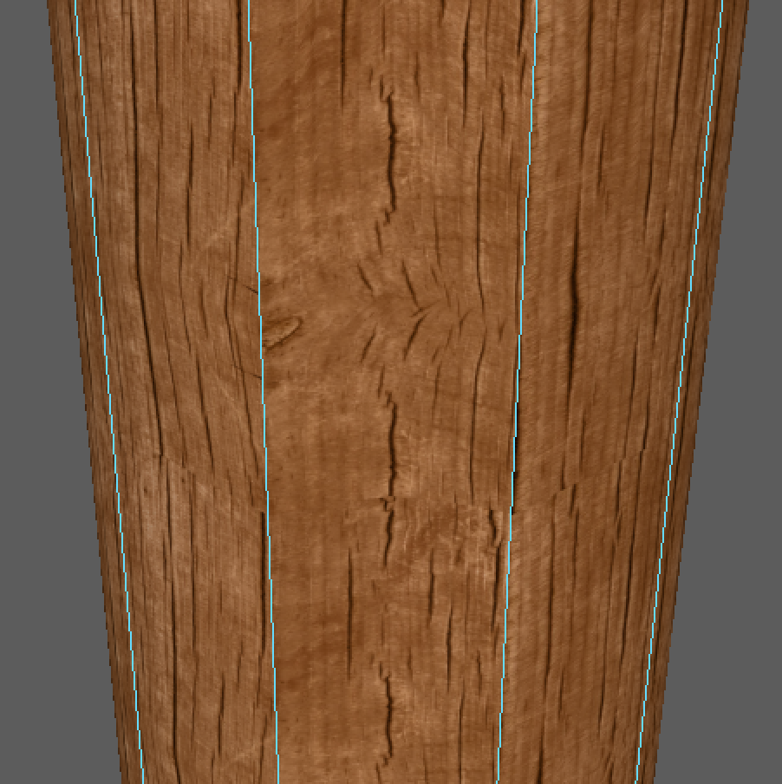

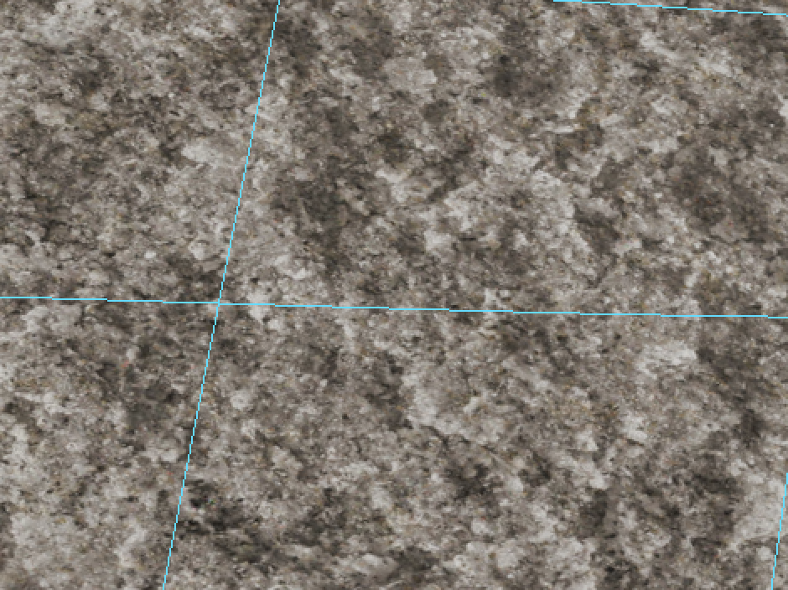

**Figure 19: Rope, wooden, and stone textures applied to the polygons- close-up on edge loops.**

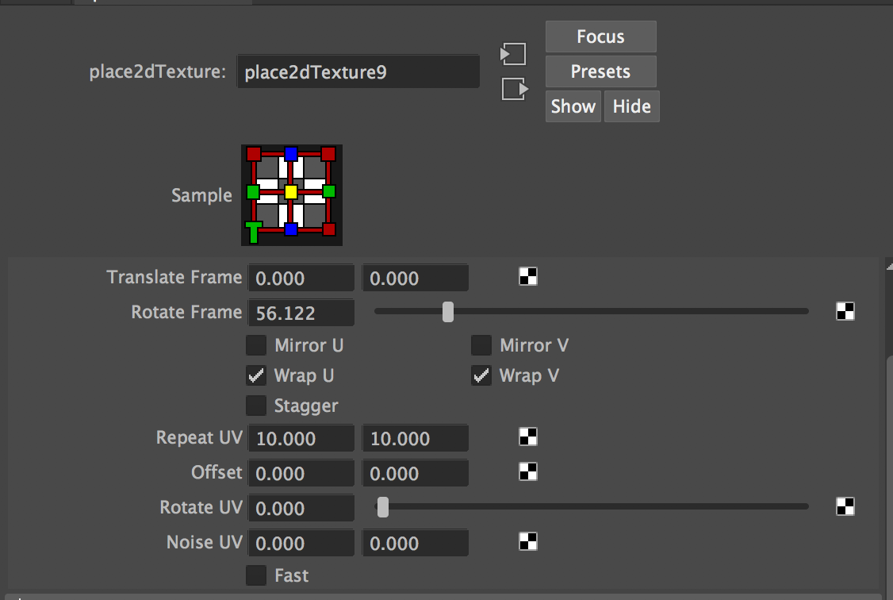

**Figure 20: Maya software scaling, rotation UV, and texture adjustment features.**

**Figure 21: Stone blade attached by rope binding onto a wooden handle.**

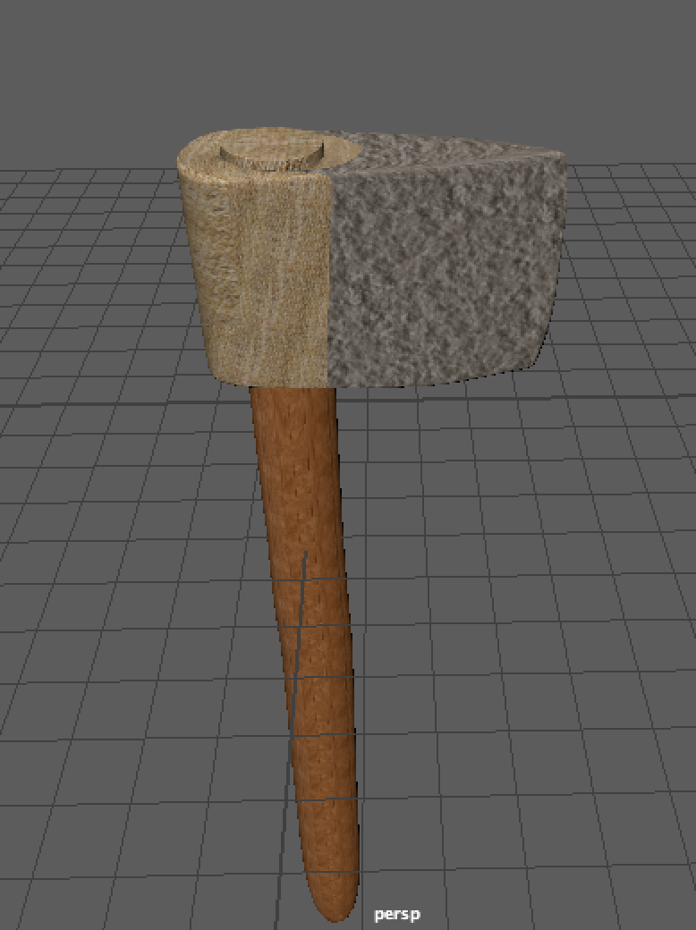

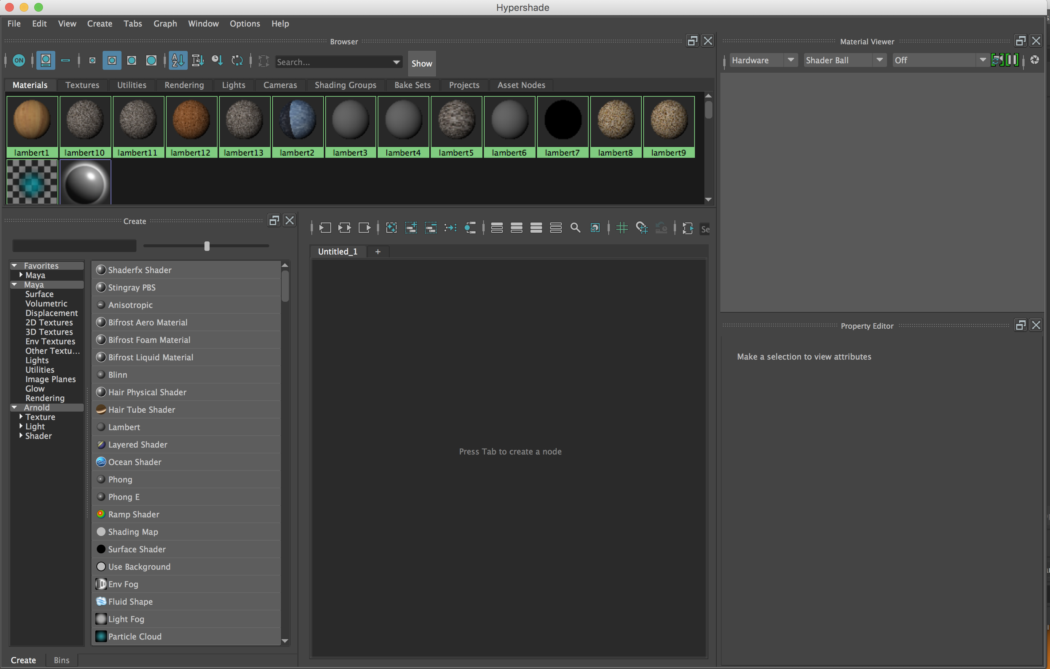

**Figure 22: Normal mapping application in Maya used to make the rope binding texture bumpier, standing out more clearly while draping over the stone and handle.**

**Figure 23:** Dan Brinkmeier’s image of scaffold and axe men.