Julia Bell and James Kelemen
ANTH258/CIS106
Visualizing the Past/Peopling the Present
Professors Badler and Erickson
Draft 2
December 16 2017

Final Project Figures

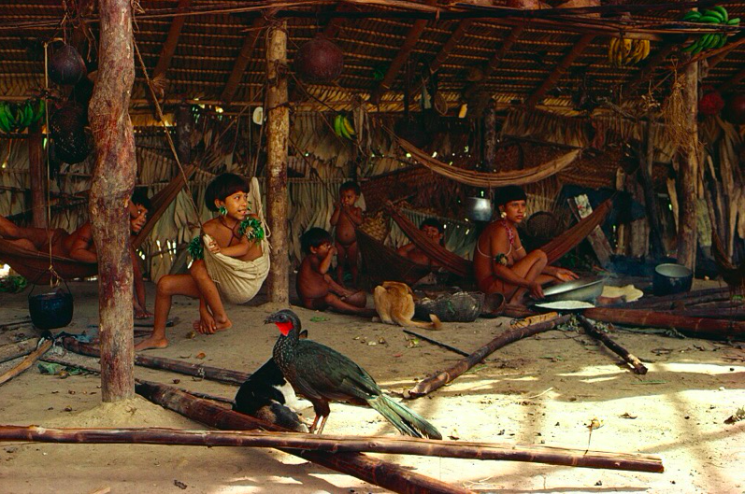
2.

3.

1.

Figure 1. Home depicting contemporary hammock usage in the Amazon, Yanonami peoples, Brazil (photograph by Robert Harding).

Labels
1. Support beams
2. Tying cords
3. Hammock body

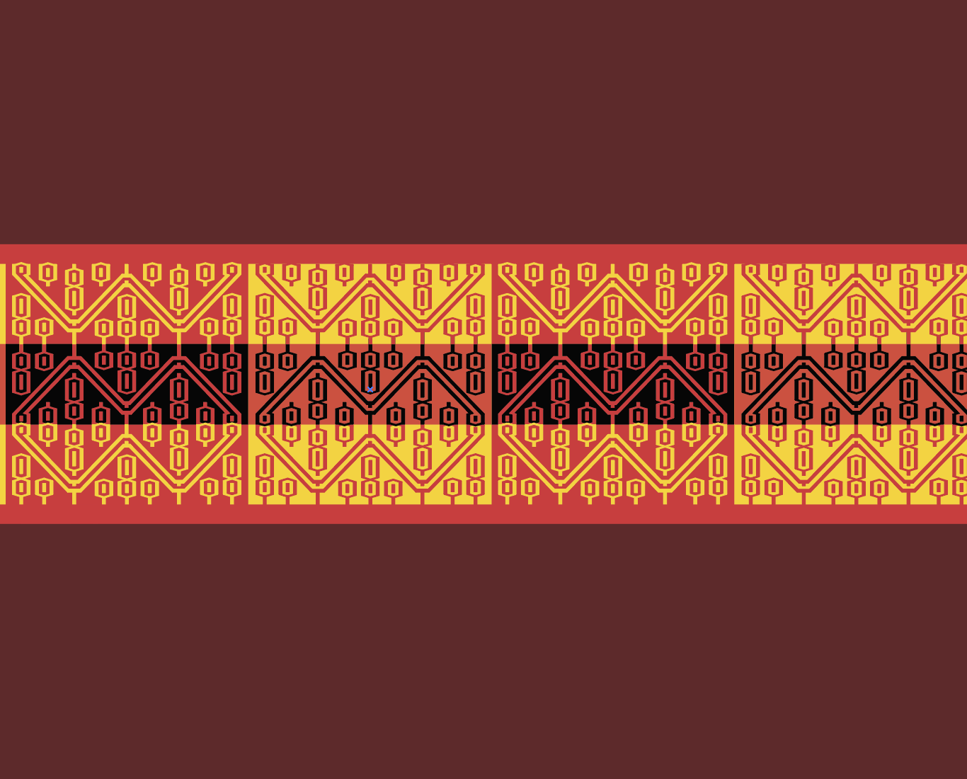
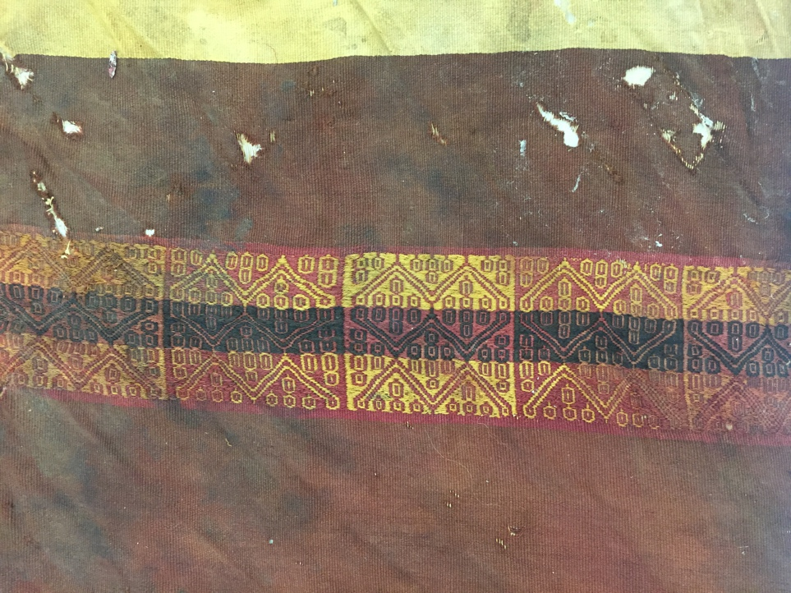
Figure 2. Pattern modeled in Adobe Illustrator (above) from tunic found in Penn Museum’s Amazon collection (below; culture unknown).

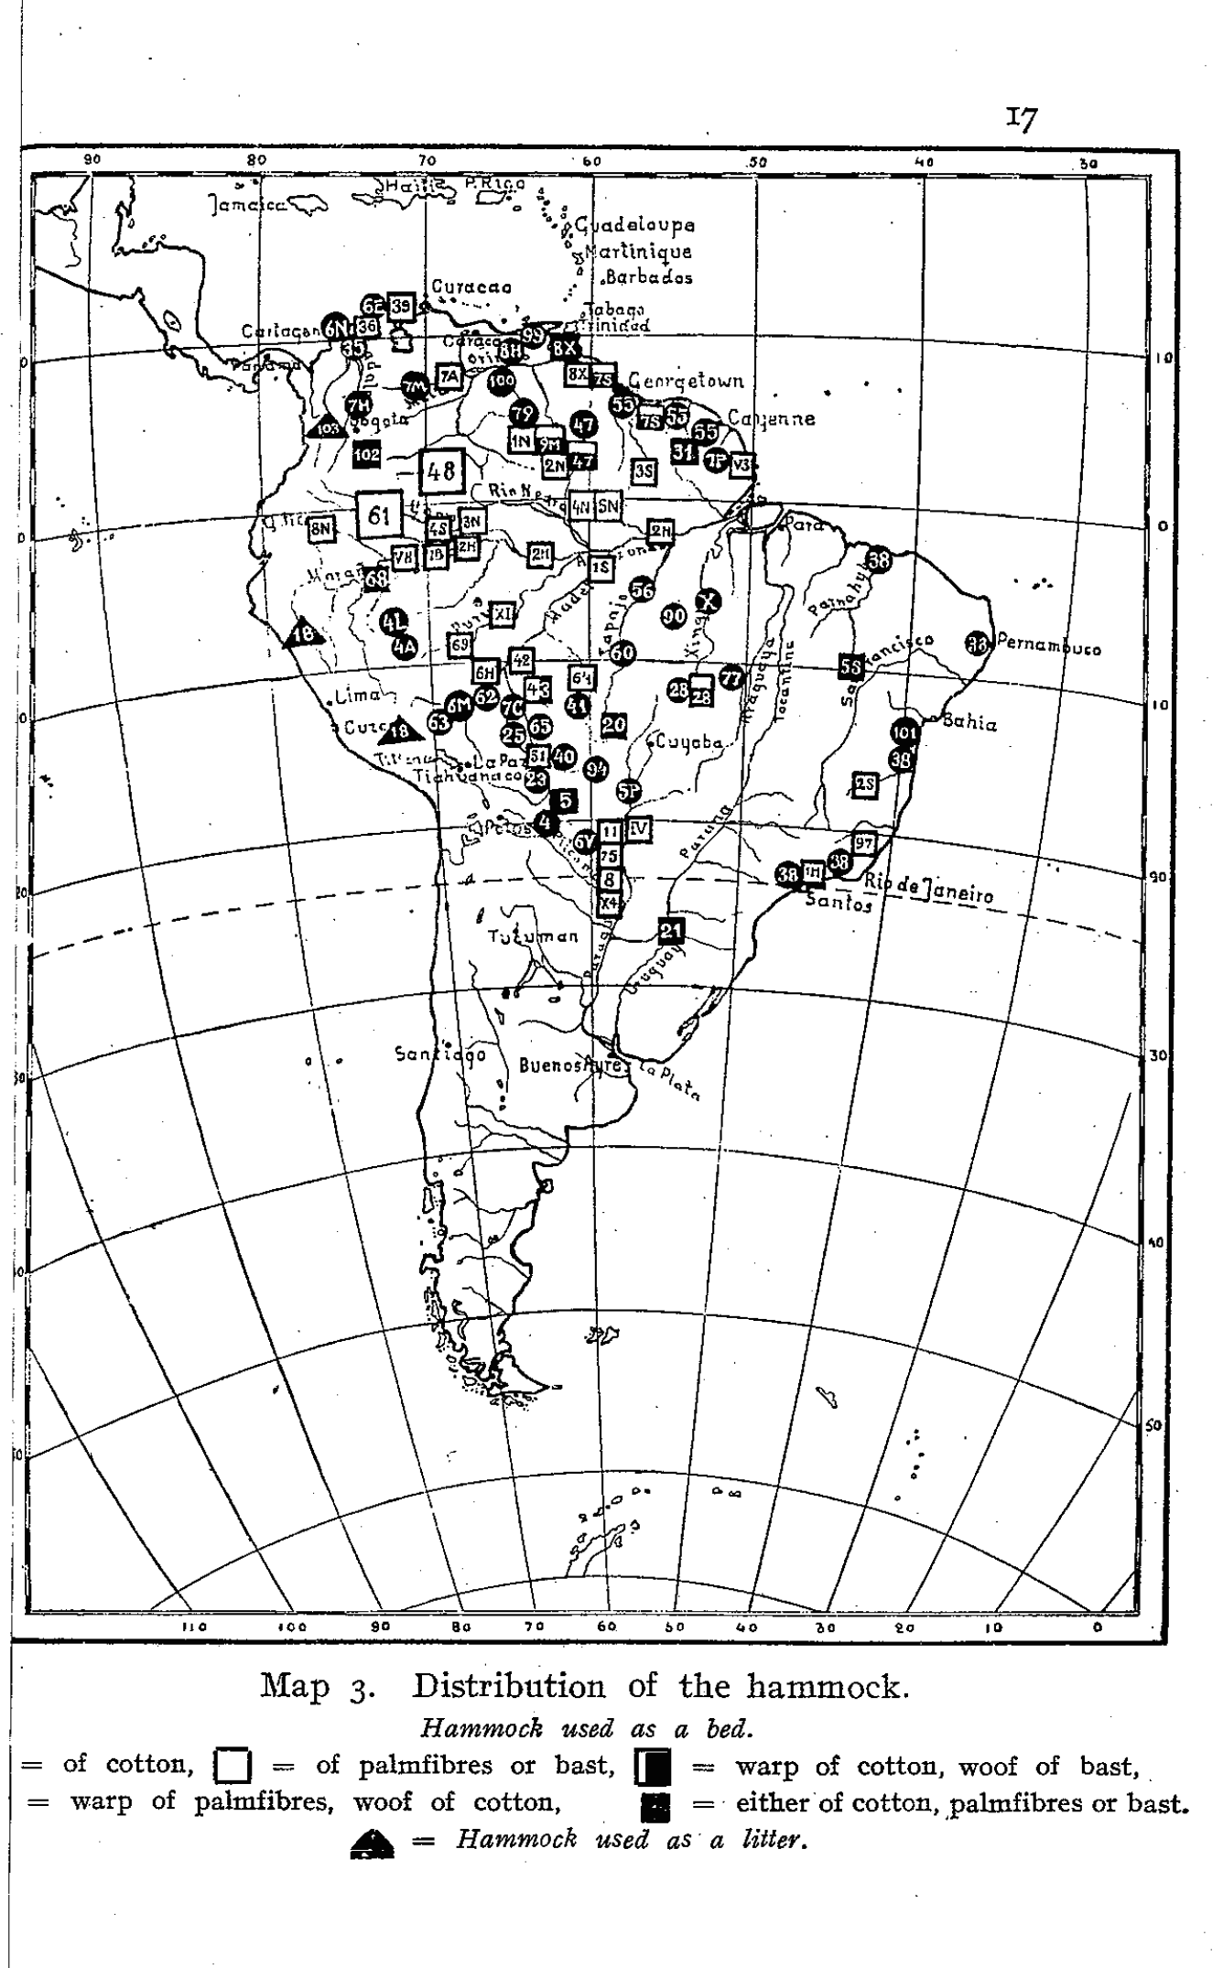

Figure 3. Distribution of the hammock used as a bed in South America (Nordenskiöld 1920:Figure 3).

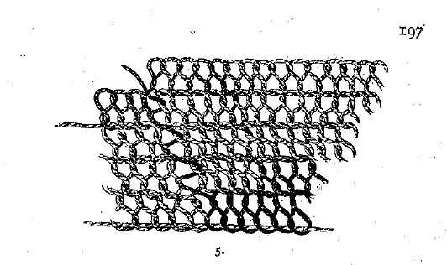

Figure 4. An example of a netted, “all-warp” hammock from the peoples of El Gran Chaco in Bolivia (Nordenskiöld 1919:Figure 60.5).

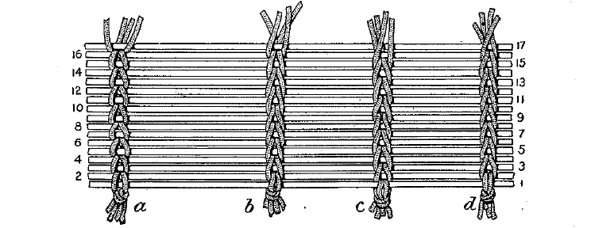

Figure 5. An example of a weft and warp hammock from the Carib and Makusi peoples of Central and South America (Roth 1916:Figure 198). The warps are the horizontal strings in this image, and the wefts are the interwoven, vertical bars.

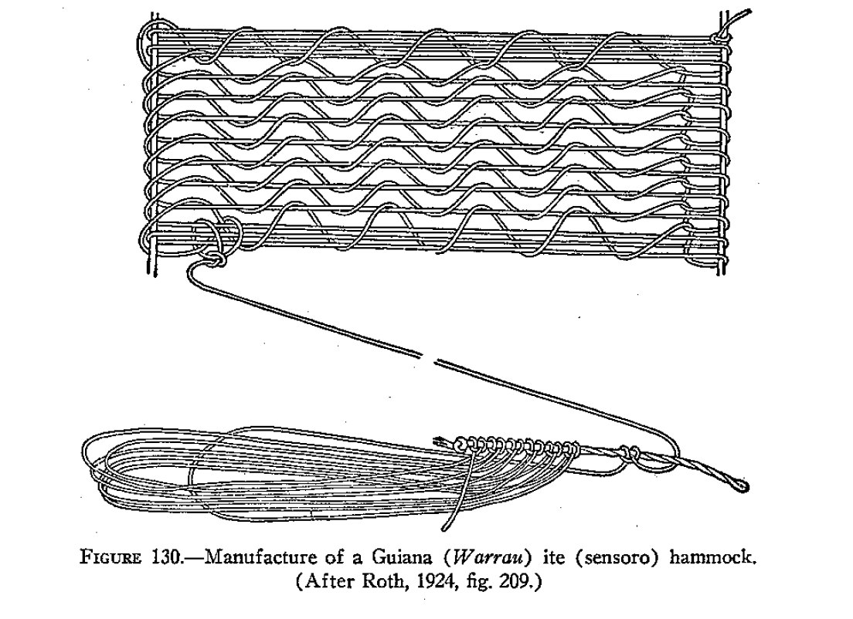

Figure 6. A netlike, warp hammock from the Warrau peoples of Guiana being made (Gullin 1948:Figure 130).

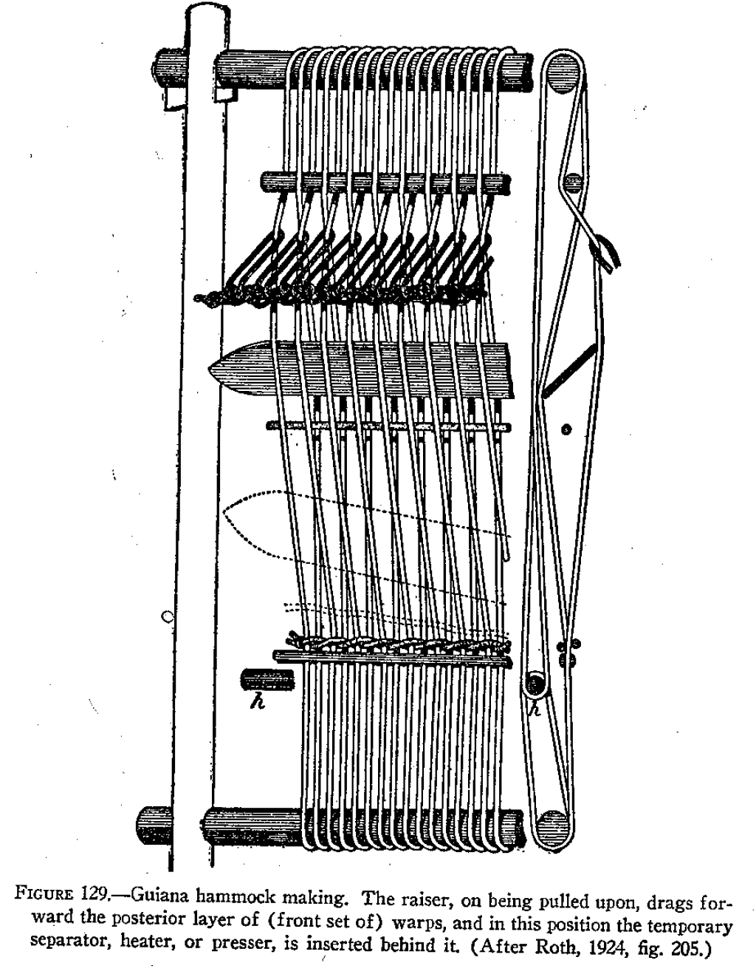
Figure 7. A weft and warp hammock from the Warrau peoples of Guiana being made with a loom (Gullin 1948:Figure 129).
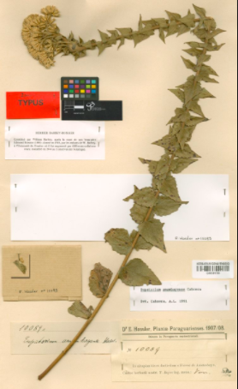

Figure 8. A pressed specimen of Euglypha rojasiana, used to make yellow dye (Lowie 1948; Public Plant Archive of Brazil).

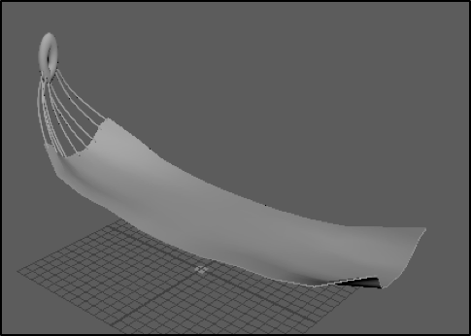

Figure 9. Early, flatter hammock shape, modeled using the soft-select tool and W-key. The widely space tying cords end in a thick loop.

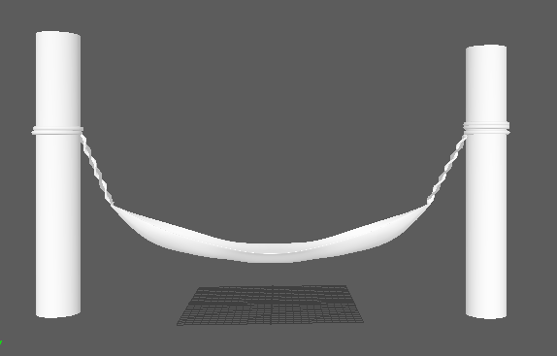

Figure 10. Final shape of the support beams, tying cords, and hammock without texture.



Figure 11. A sample of our results when searching for a rope texture map online. The dark black outline and perfectly rounded, smooth lines are inaccurate to the weaves we studied.

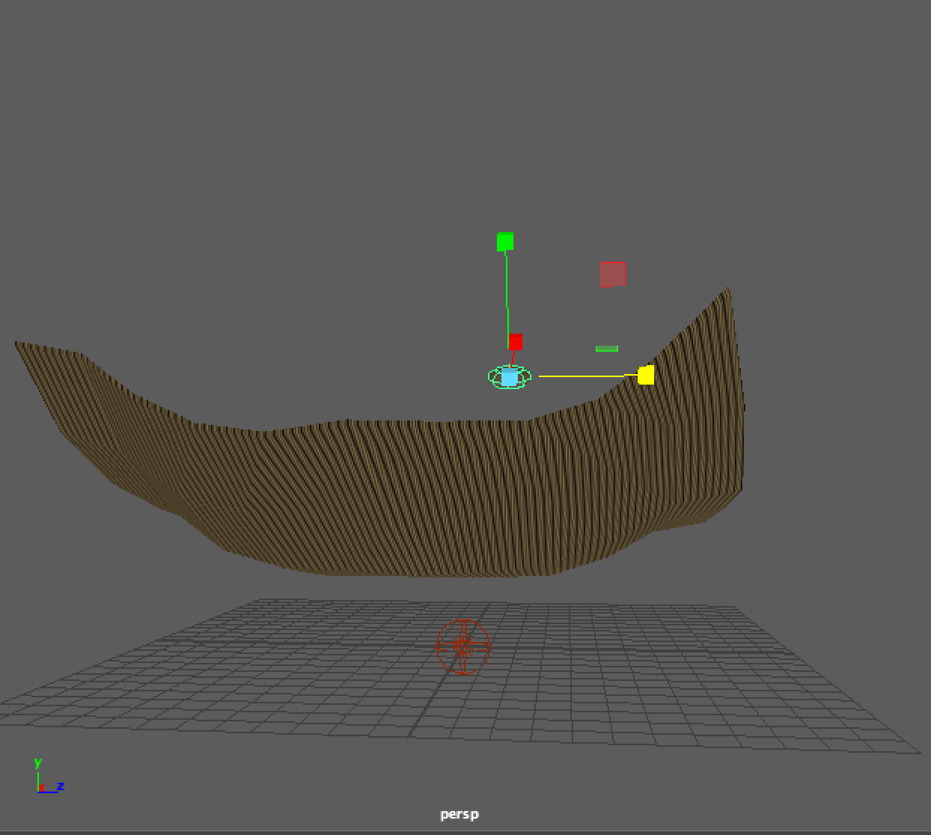

Figure 12. An early hammock shape with the rope texture from online applied.

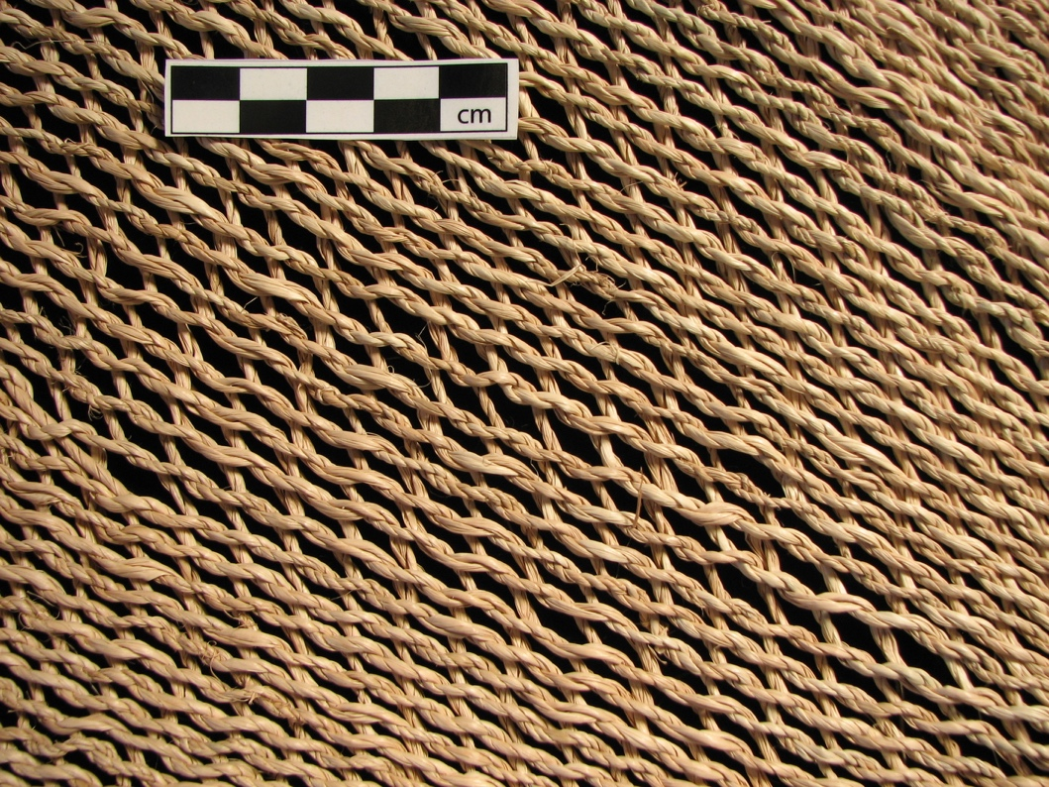

Figure 13. An all-warp, leaf fiber hammock from the Penn Museum’s Amazon collection, made by the Warao peoples of Venezuela.

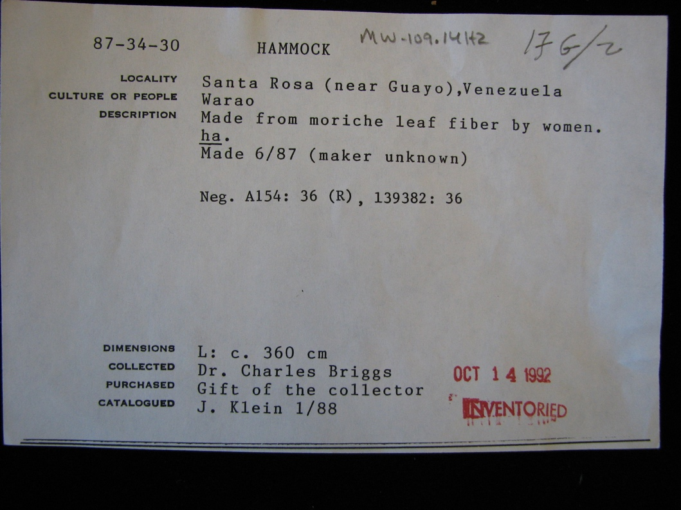

Figure 14. Registrar information corresponding to Figure 13.

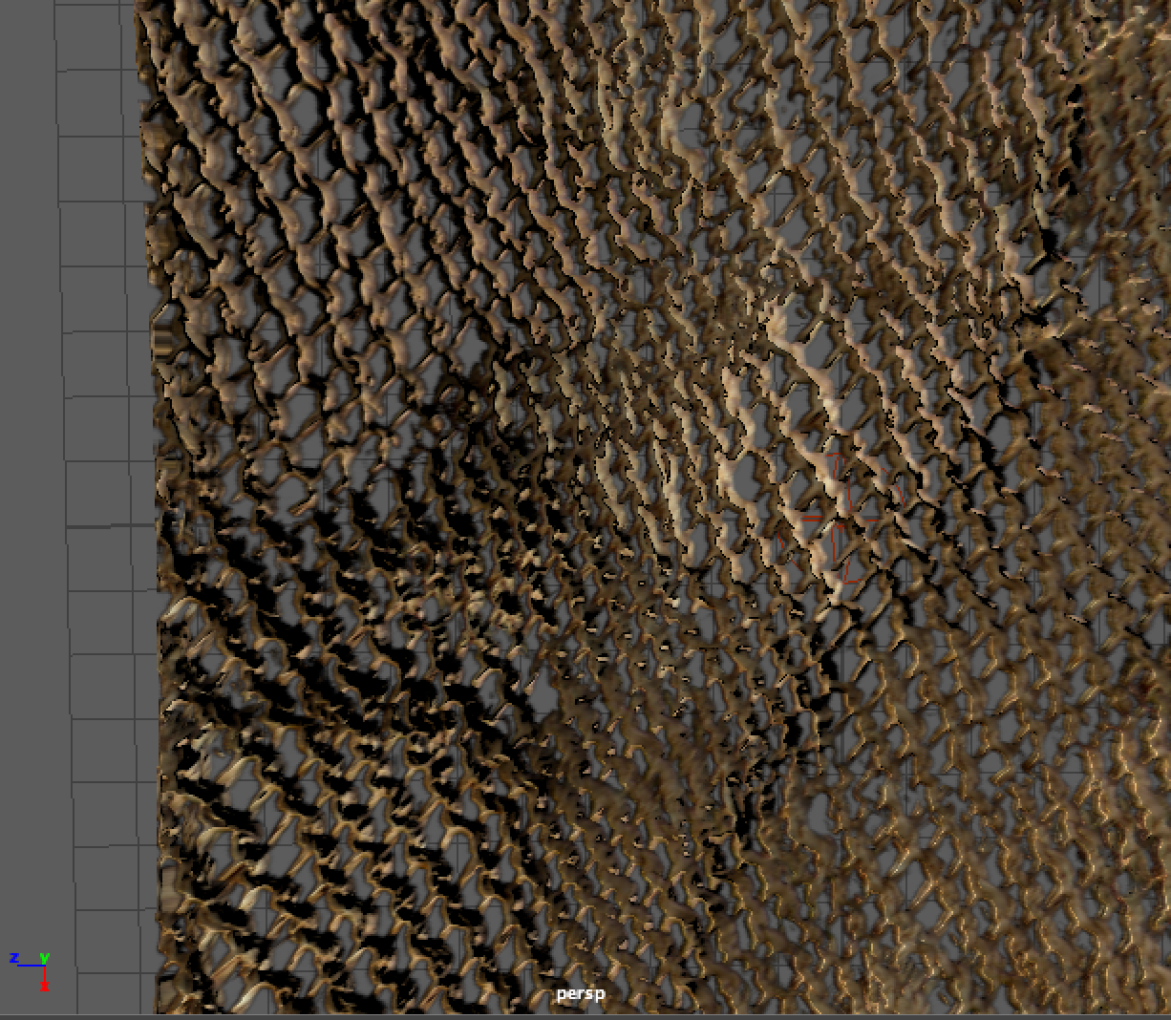

Figure 15. Hammock with texture, normal, and opacity maps applied responds to light.

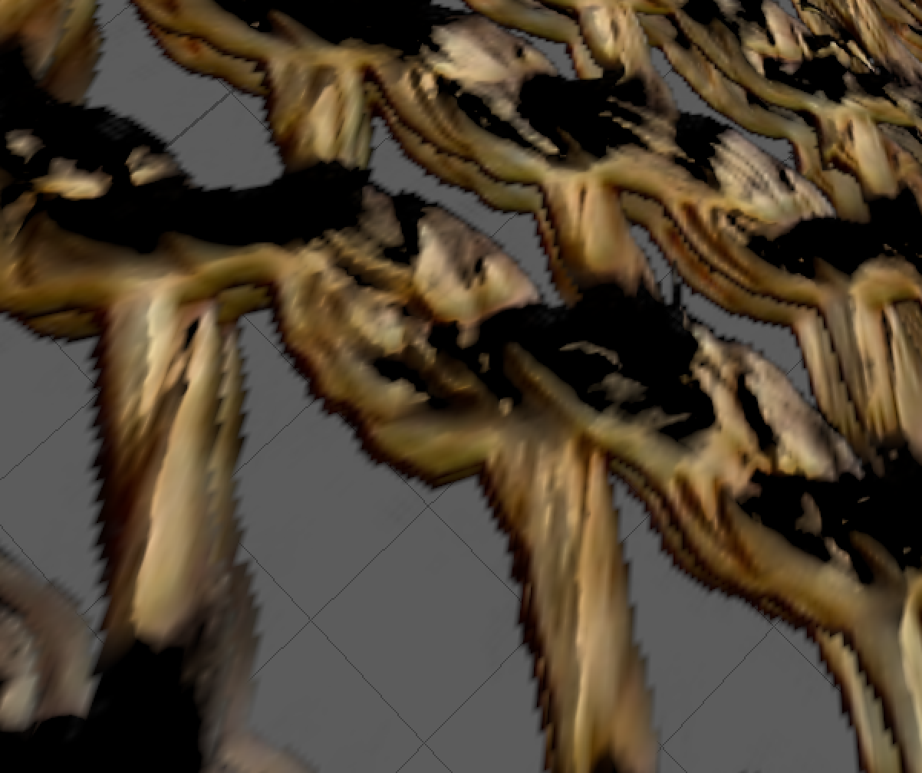

Figure 16. Two layers of mapping create thickness and result in more dynamic response to light.

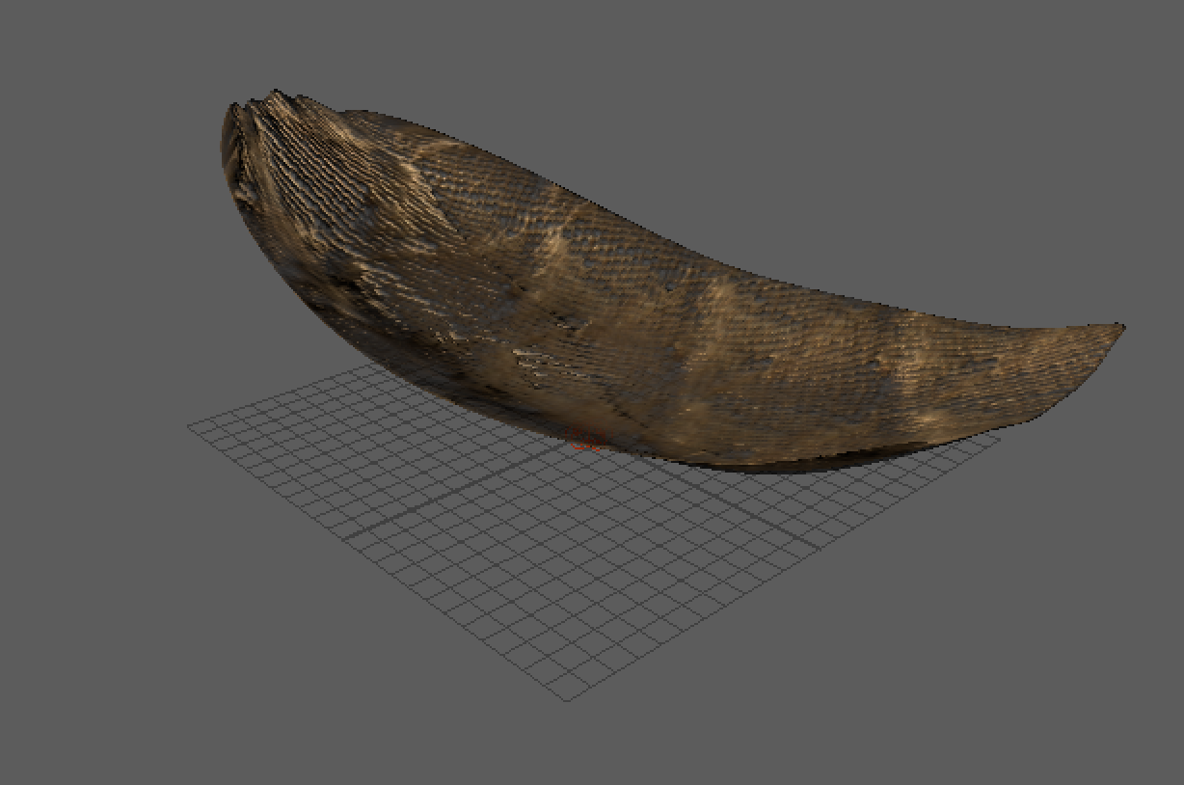

Figure 17. All-warp hammock body with maps applied.

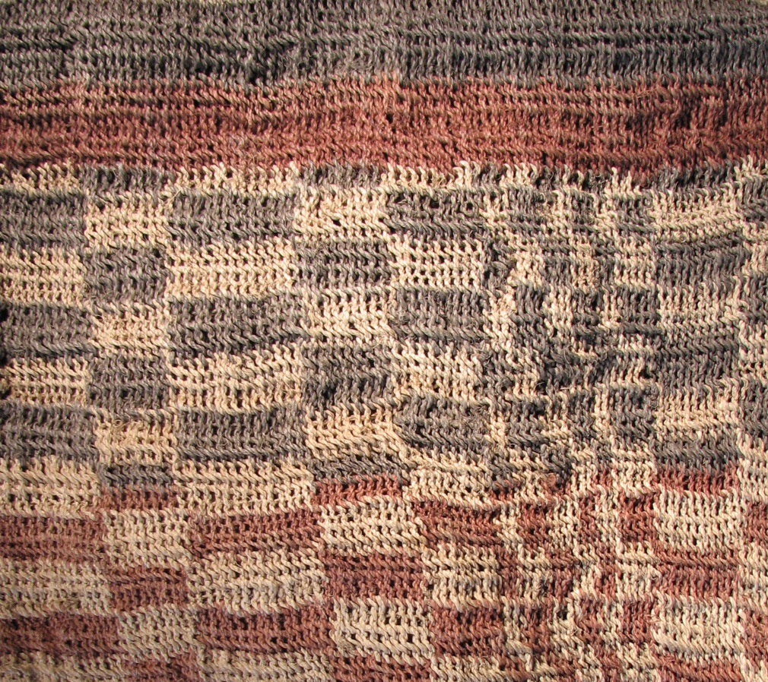

Figure 18. A weft and warp hammock made by the Angayti peoples of Paraguay from the Penn Museum’s Amazon collection (material unknown).

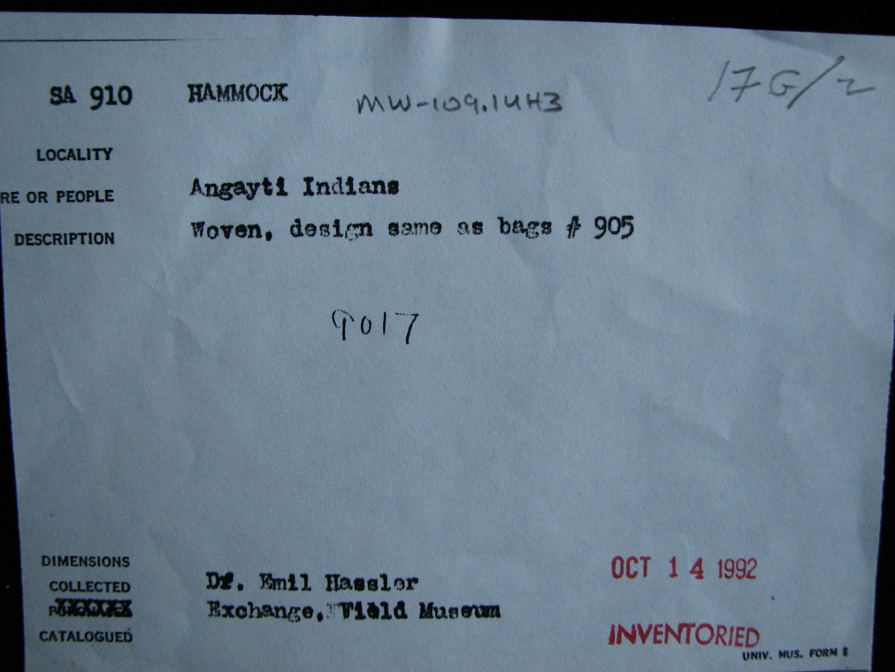

Figure 19. Registrar information corresponding to Figure 18.

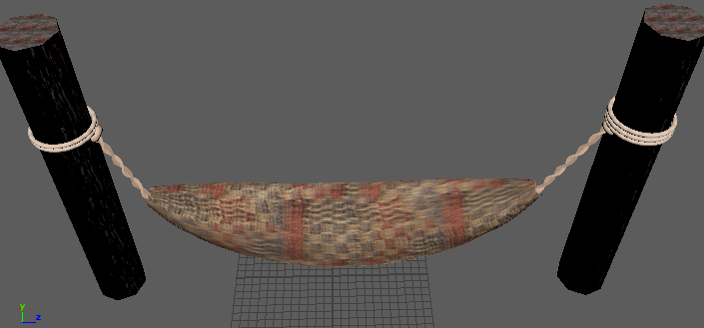

Figure 20. Final model of weft and warp hammock with texture applied.

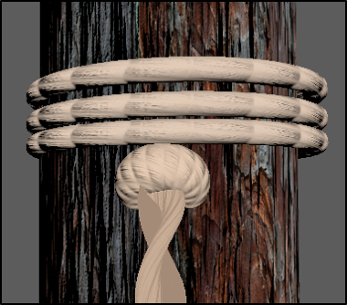

Figure 21. Support beam with tiled wood texture and cords which suspend the hammock.
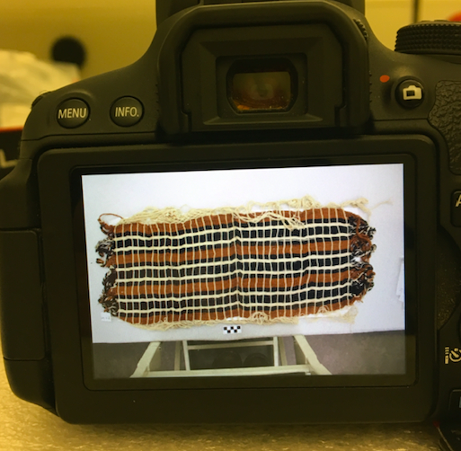

Figure 22. Weft and weave hammock made of cotton from the Guajira peoples of Columbia featuring an intricate fringe, a continuation of the wefts (photographed on December 7th museum visit with Clark Erickson).

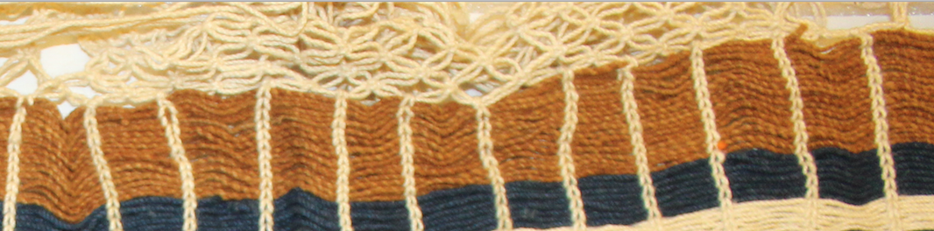

Figure 23. The intricate fringe from Figure 22.

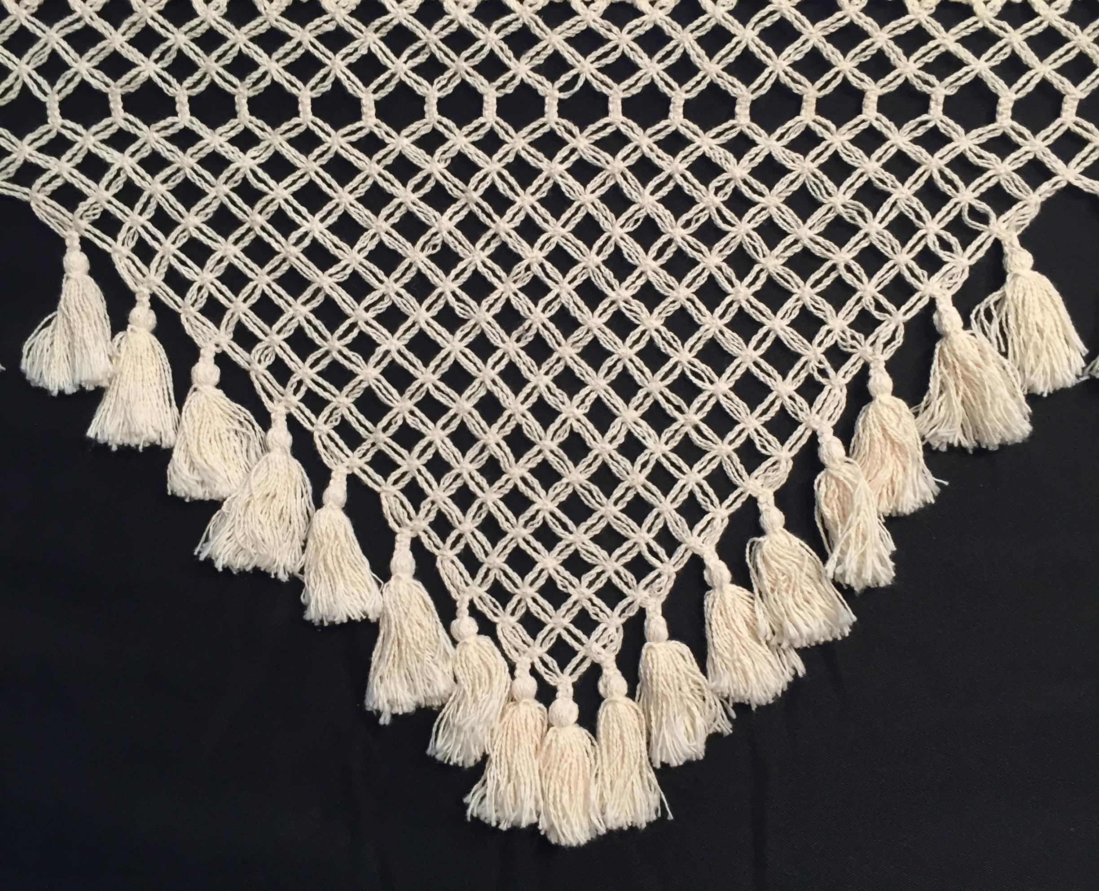

Figure 24. Photograph of intact fringe; used as texture map in Maya.

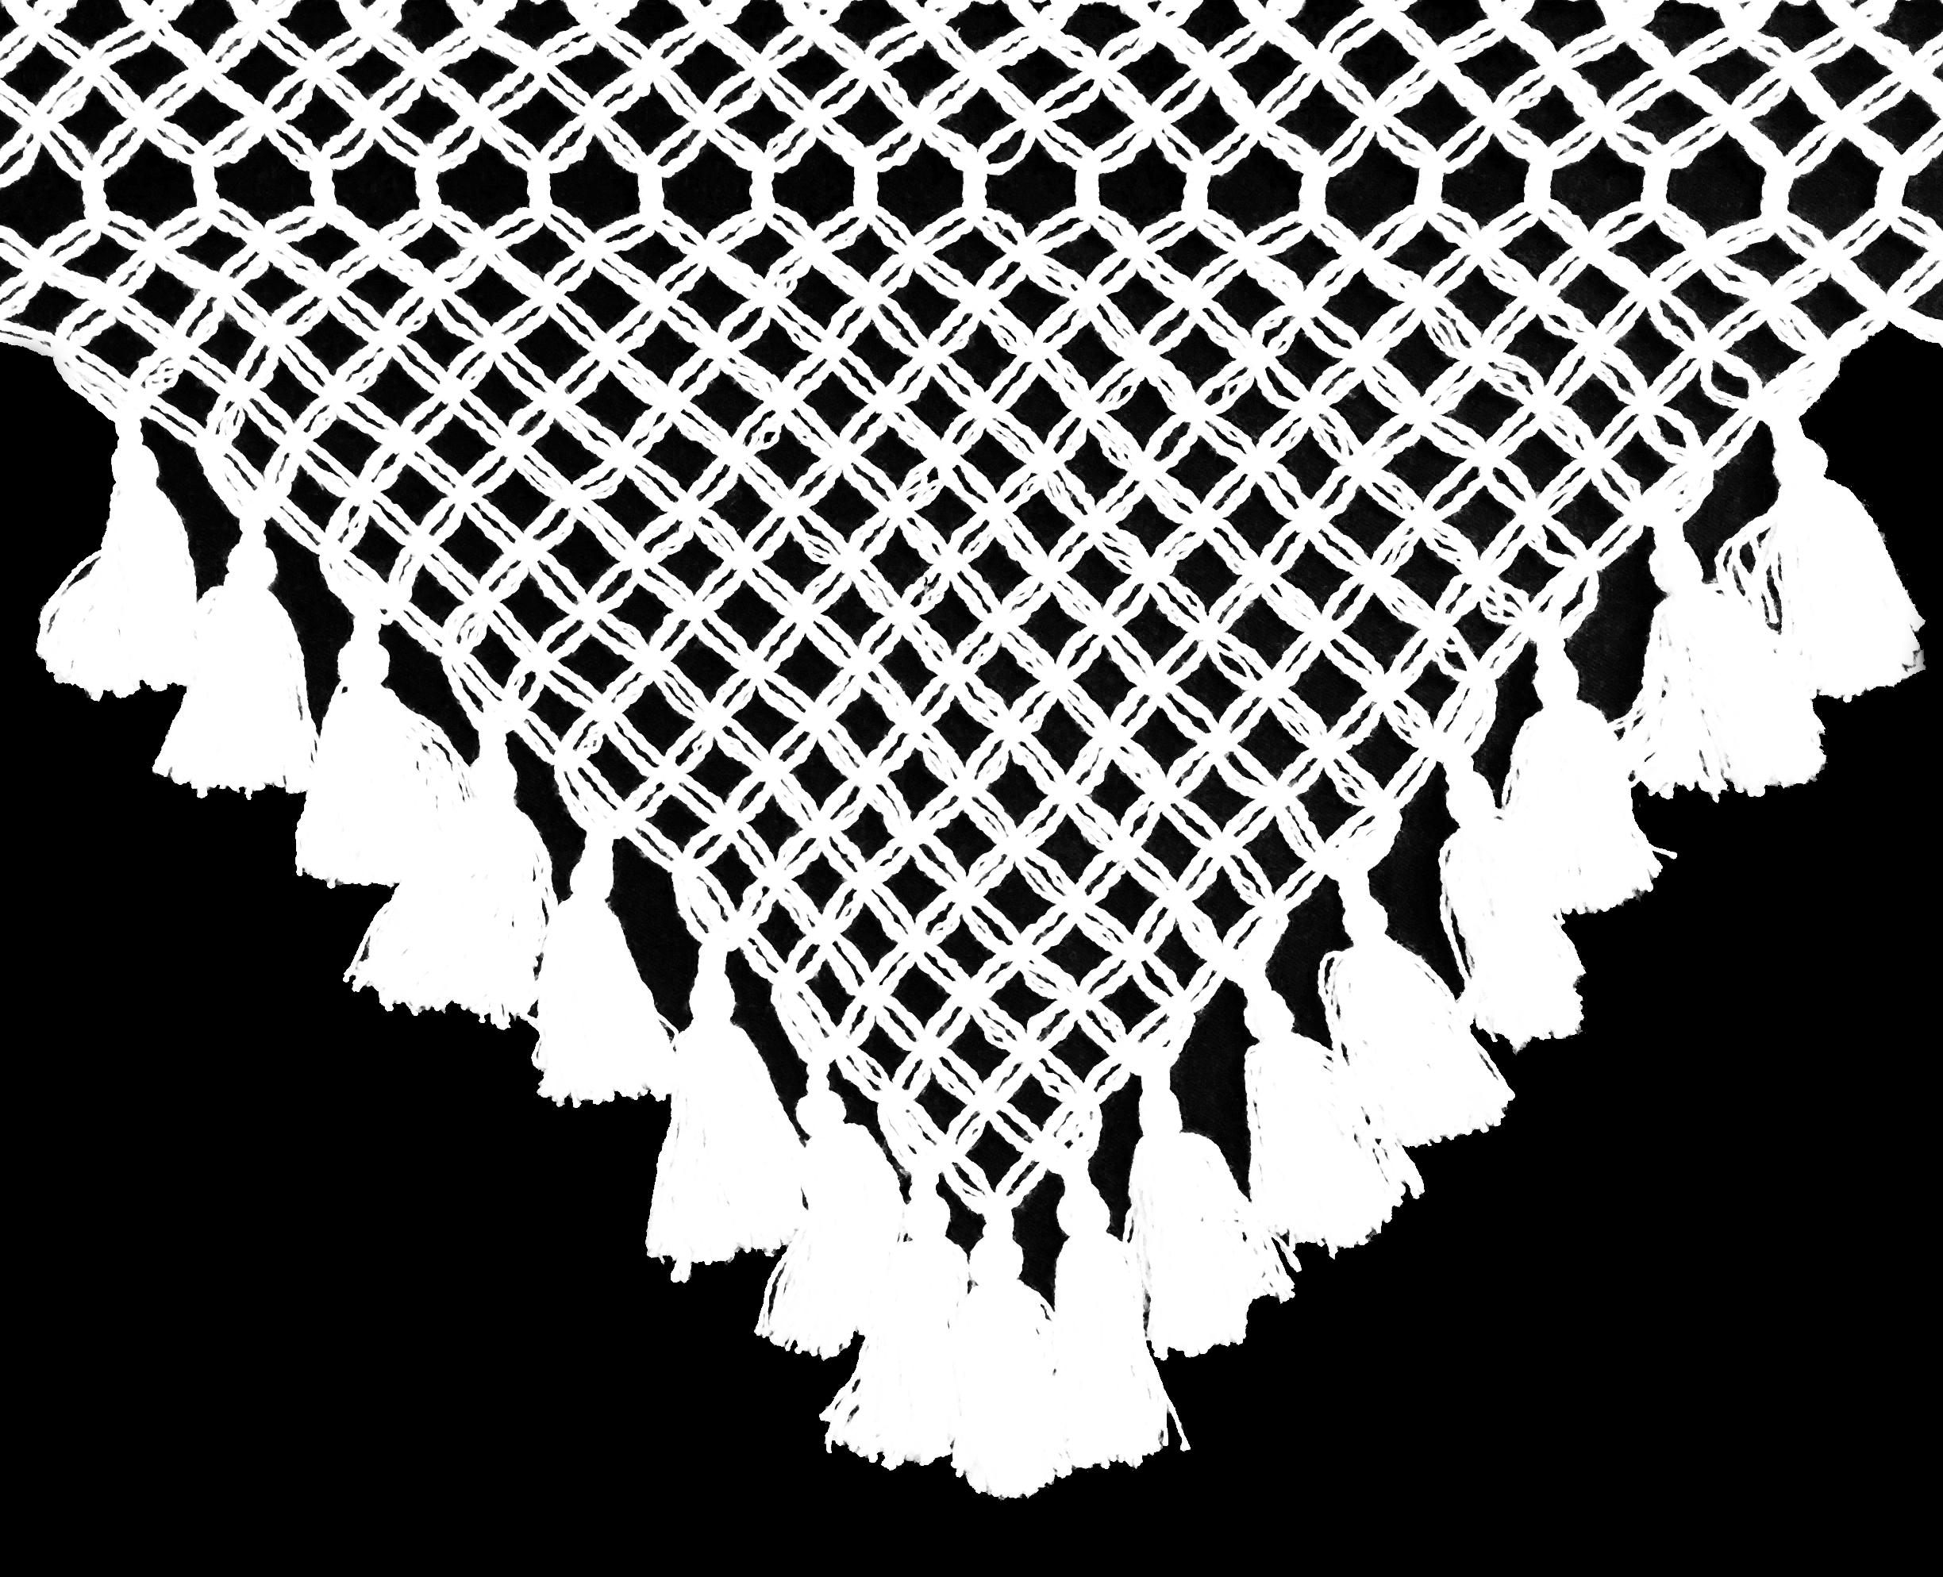

Figure 25. Opacity map of fringe created in Photoshop.

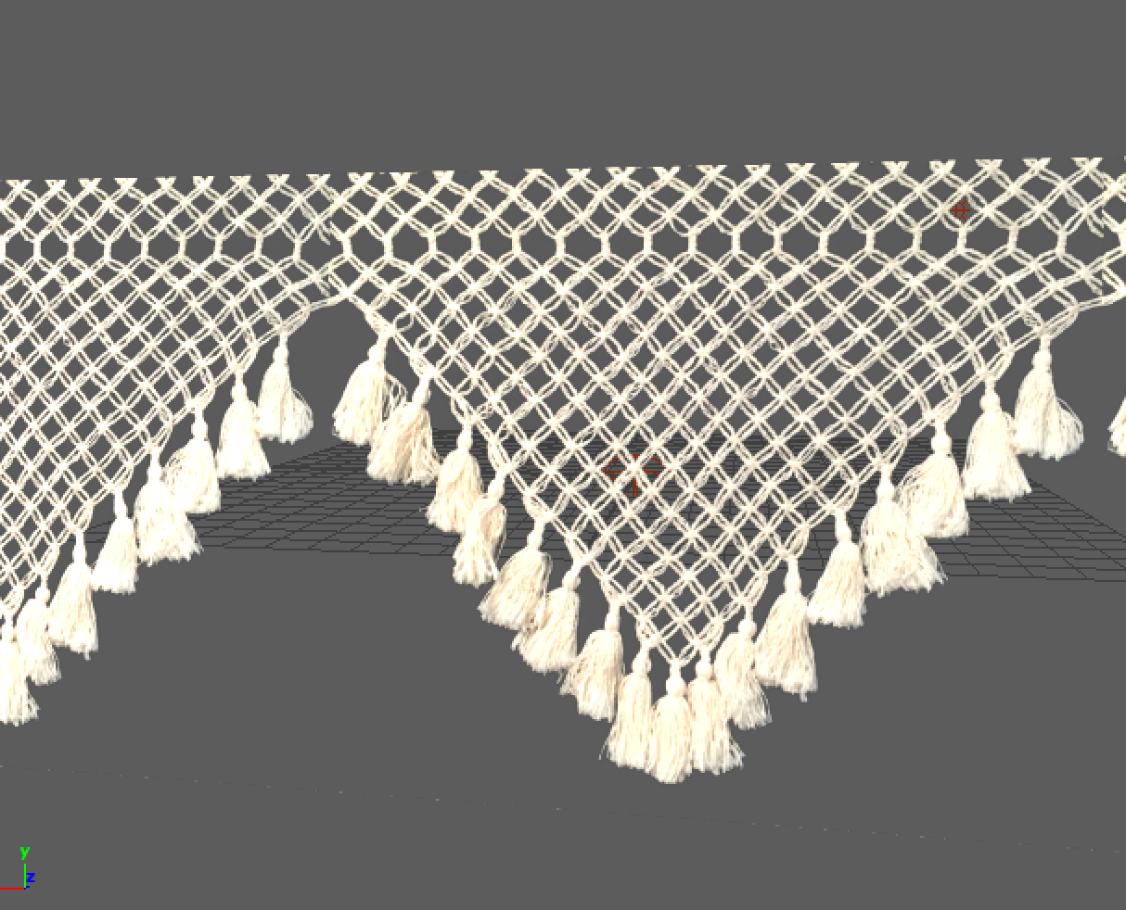

Figure 26. Fringe modeled in Maya.

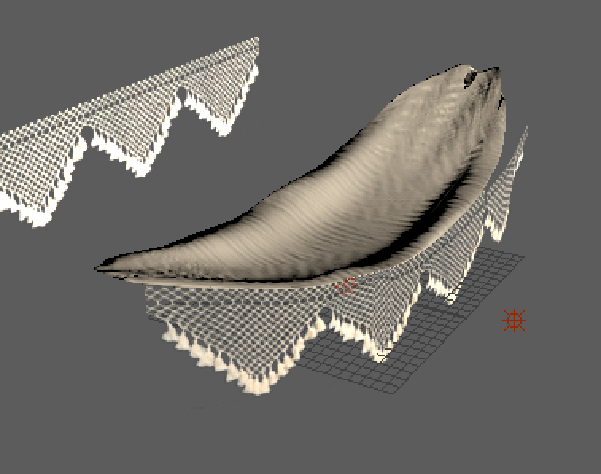

Figure 27. Final model of cotton, weft and warp hammock with fringe.

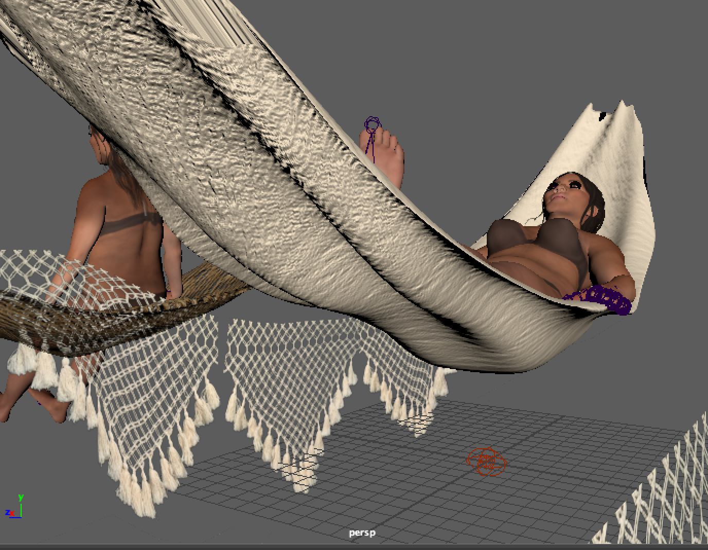

Figure 28. The hammock viewed from underneath forms to the woman’s legs and back.
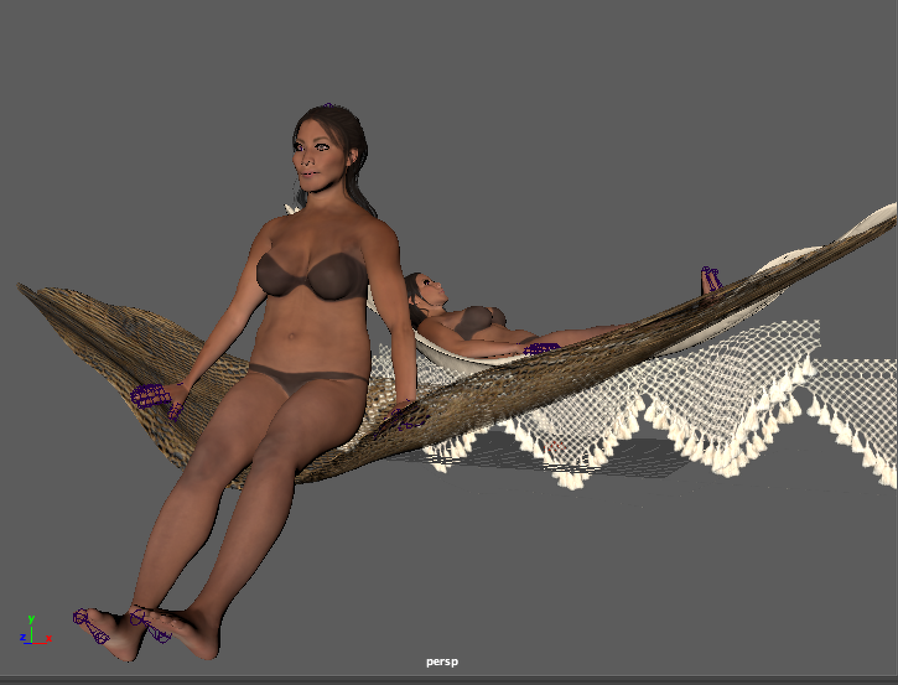

Figure 29. Final model of woman sitting in hammock.
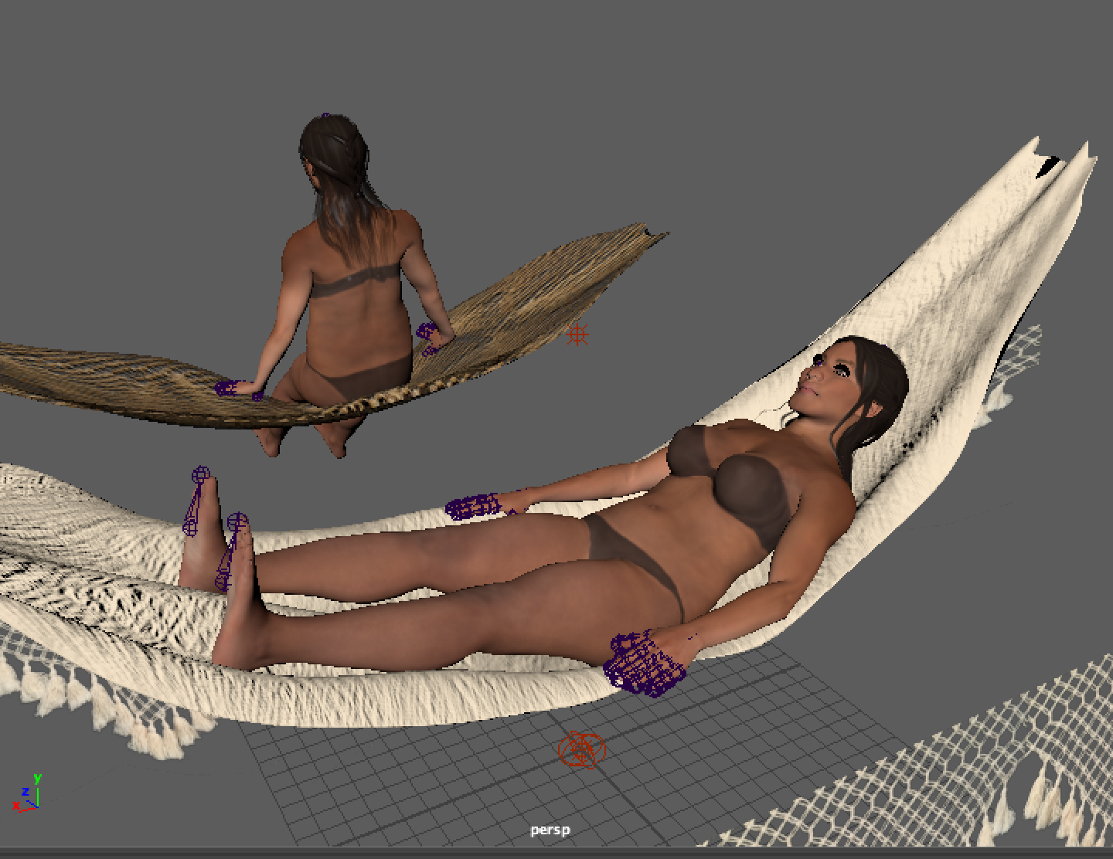

Figure 30. Final model of woman laying in hammock.
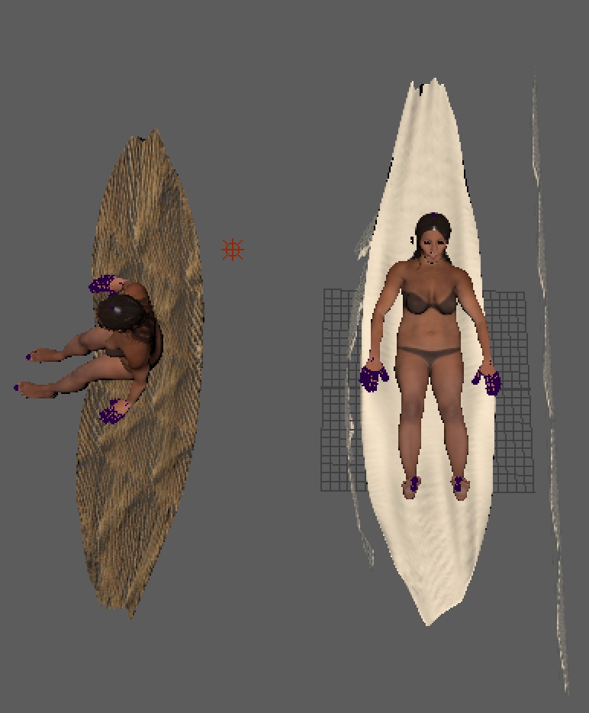

Figure 31. Final model from above.

