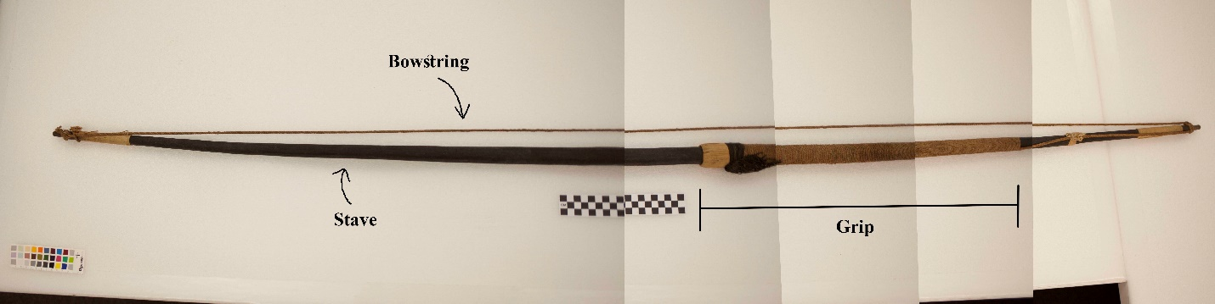
Figure 1: The bow from Penn Museum (SA693). It is from the Cayapo of Brazil.

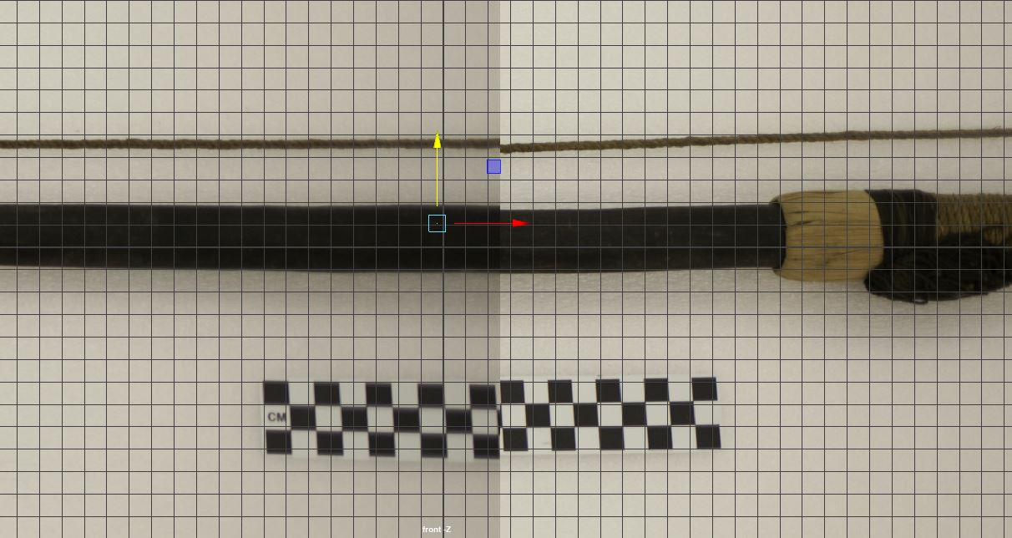
Figure 2: Scaling the reference image of the bow to the grid in Maya

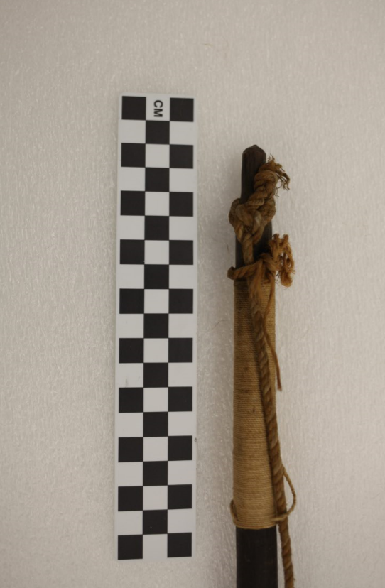
Figure 3: The bowstring seems to be tied on both ends with a double loop, where the string loops around the bow twice and the loose end is pulled through the two loops.

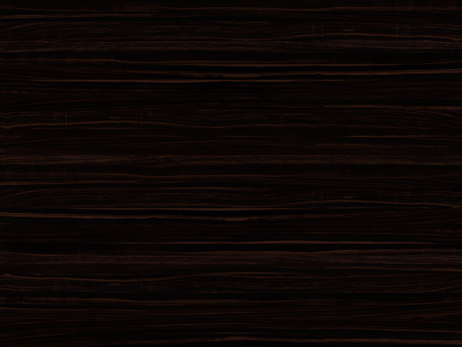
Figure 4: Ebony wood texture² for the bow stave.
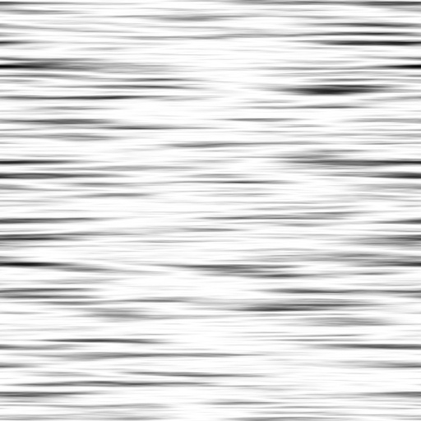
Figure 5: Smooth wood bump map³ for adding realism to the bow stave.

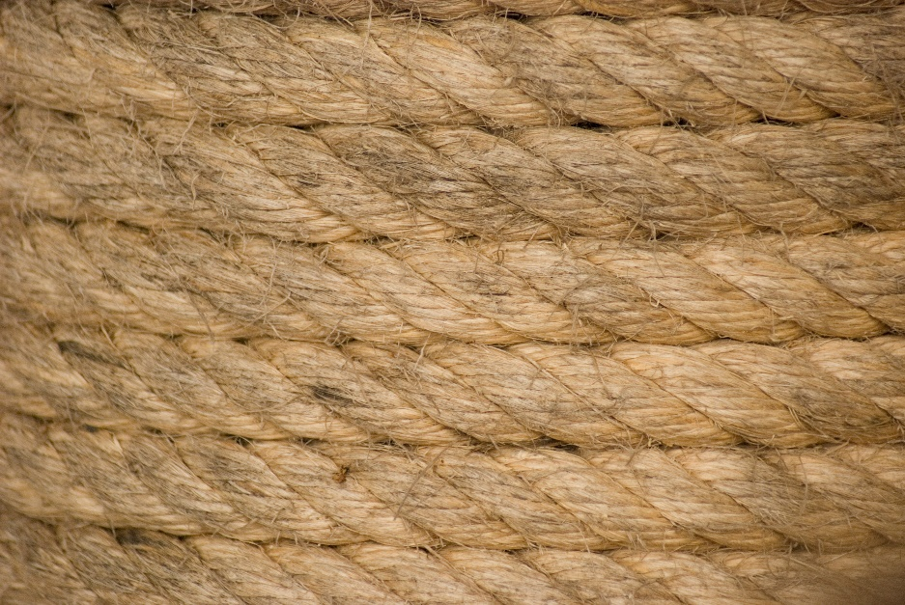
Figure 6: String texture¹ for the grip and bowstring.

Figure 7: Rope bump map⁴ for adding realism to the grip and bowstring.

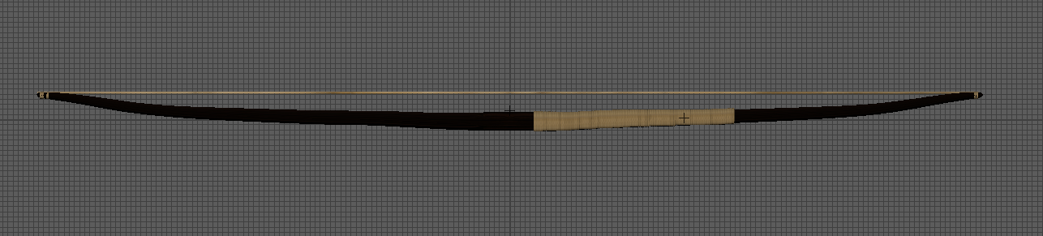
Figure 8: Bow, grip and bowstring with textures.
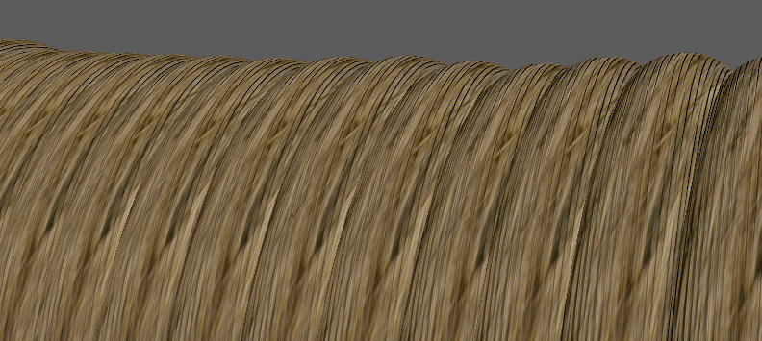
Figure 9: Detail of bow grip wrapping.

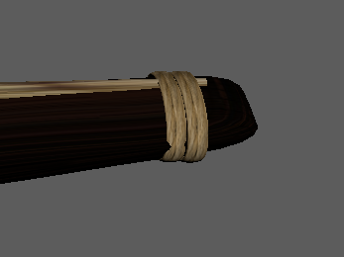
Figure 10: Detail of bowstring tied to bow end.

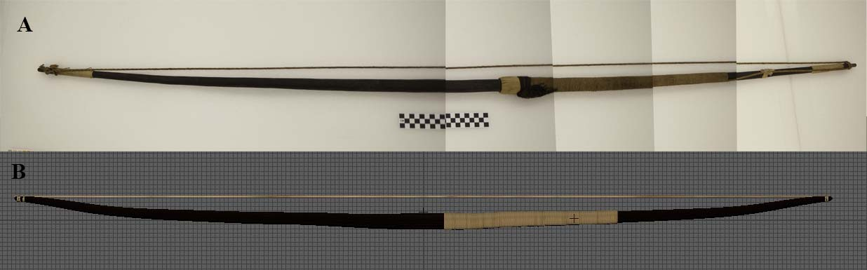
Figure 11: Reference bow from the Penn Museum (a) and final model of bow in Maya (b).

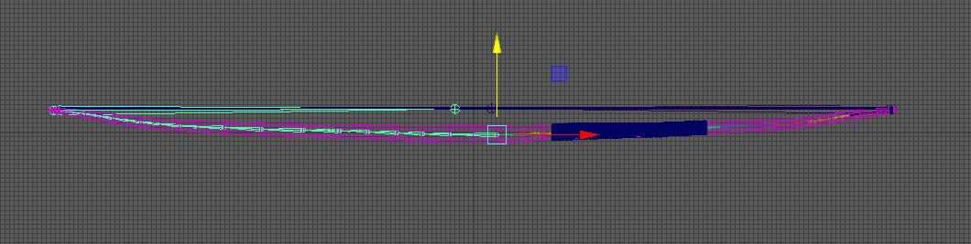
Figure 12: Bow with rigged skeleton.

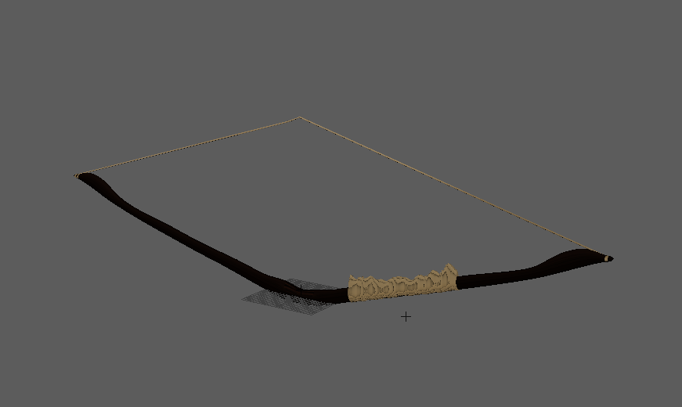
Figure 13: Bow deformed by the joints.

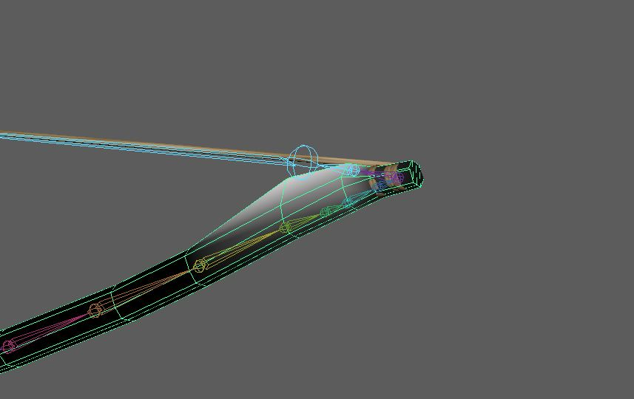
Figure 14: Painting the skin weights.

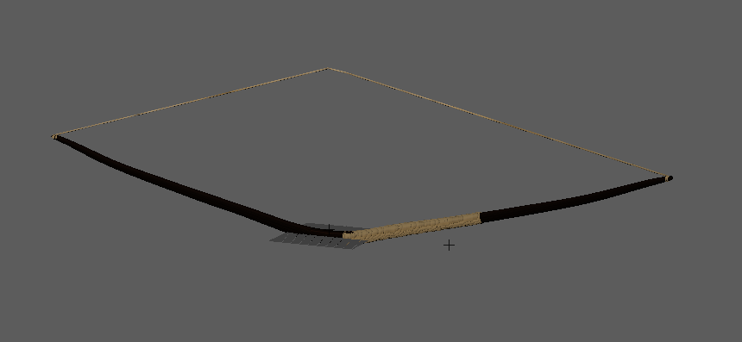
Figure 15: Bow bending smoothly after painting skin weights.

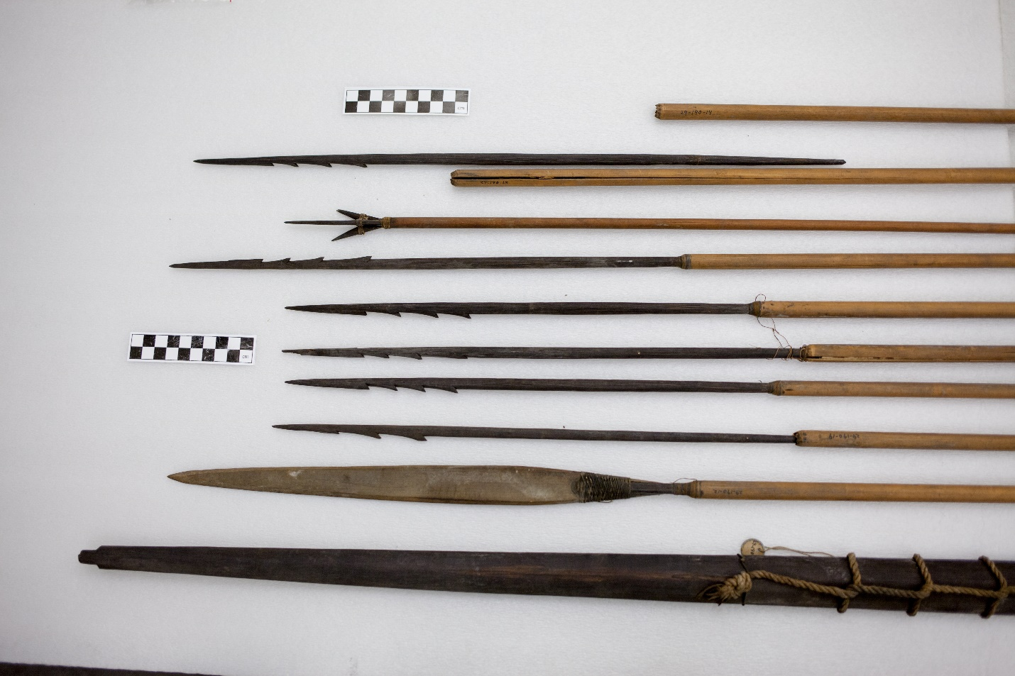
Figure 16: Arrows heads (29-190-12 to 19) and bow (29-190-11) from the Penn Museum. They are from the Andean culture group in the Peruvian Highlands.

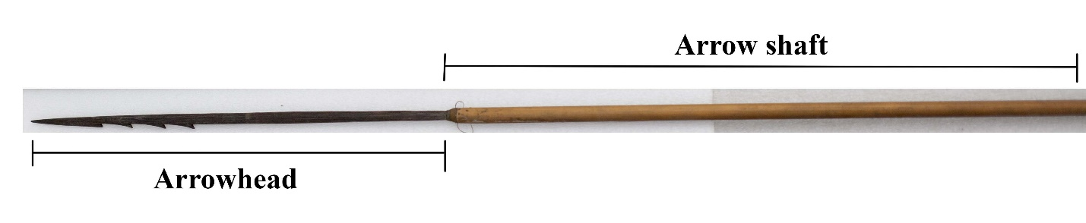
Figure 17: Labeled arrowhead and arrow shaft of an arrow with a serrated arrowhead.

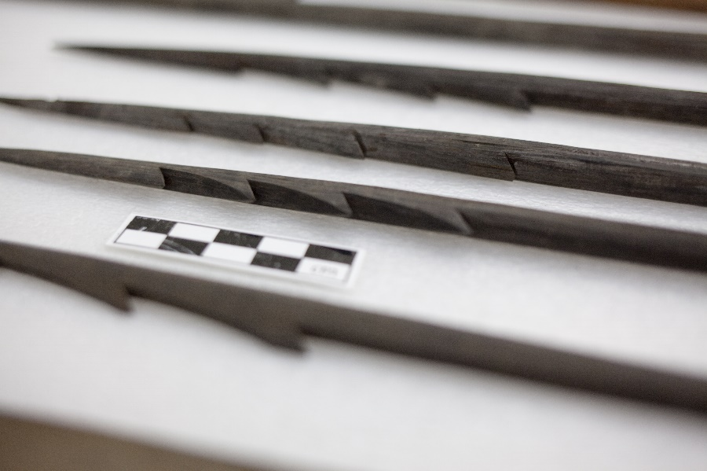
Figure 18: Detail of serrated rod arrowhead

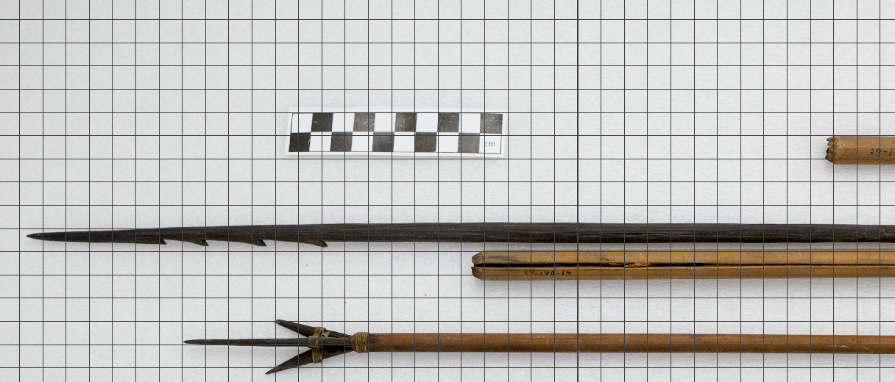
Figure 19: Scaling the reference image of the arrowhead to the grid in Maya

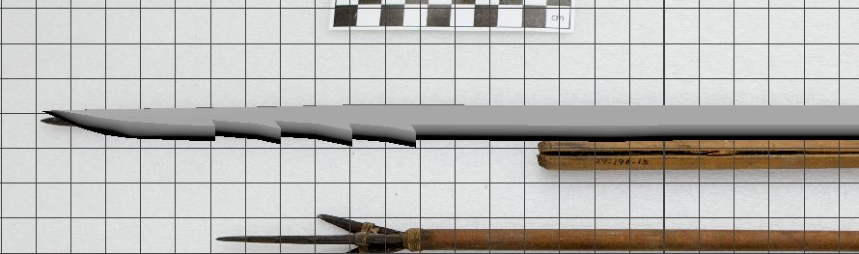
Figure 20: Finished model of serrated rod arrowhead with sharp edges.

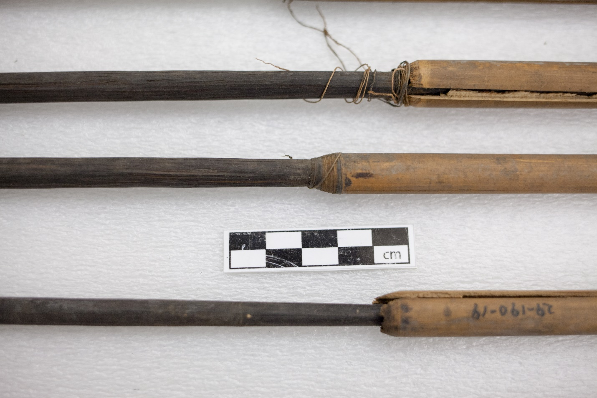
Figure 21: String was tied around the tip of the arrow shafts so the arrowheads will not fall out

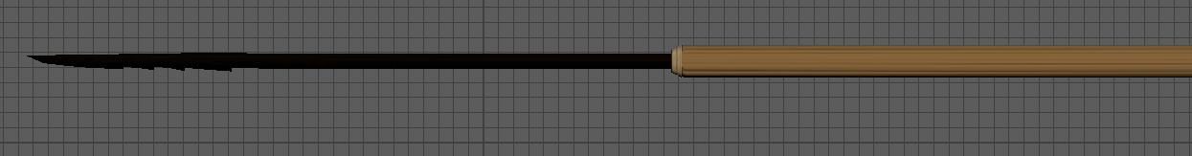
Figure 22: Finished arrowhead and shaft.
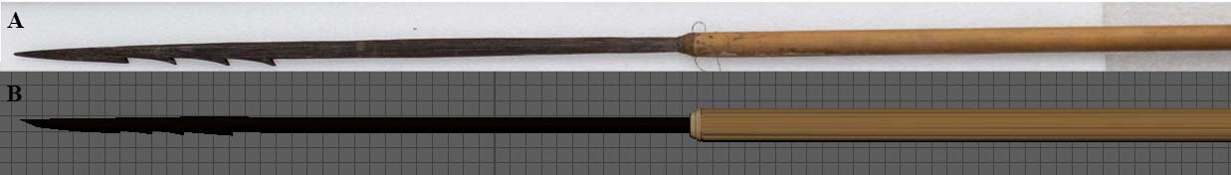
Figure 23: Reference arrow from the Penn Museum (a) and final model of the serrated arrowhead and arrow shaft in Maya (b).

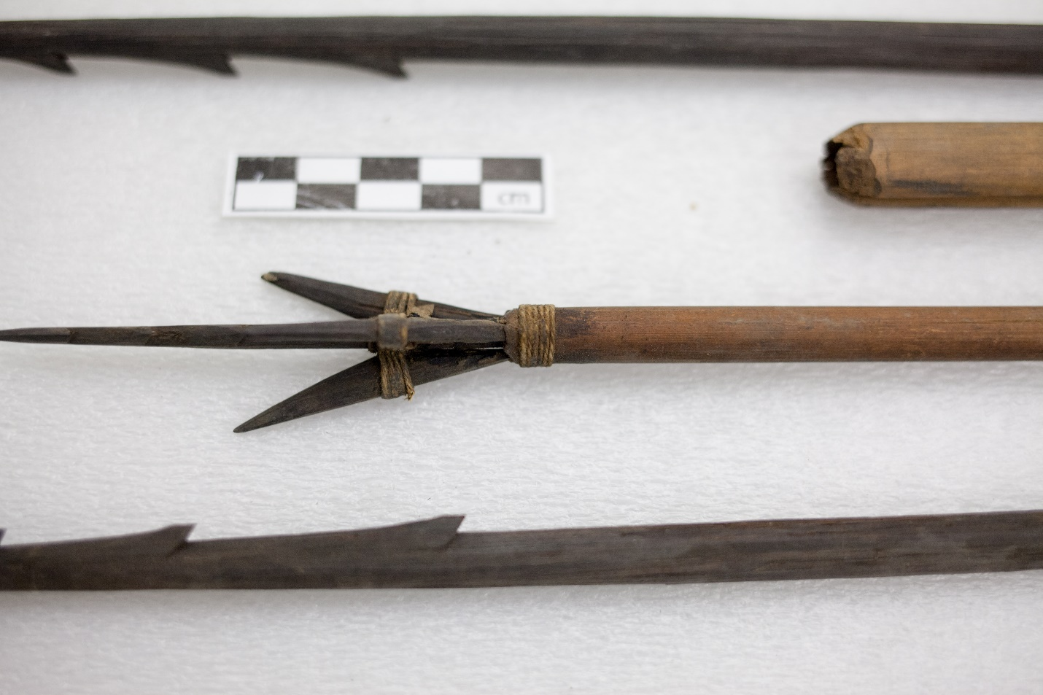
Figure 24: The 3 prong arrow from the Penn Museum (29-190-20) from the Andean culture group of the Peruvian Highlands.
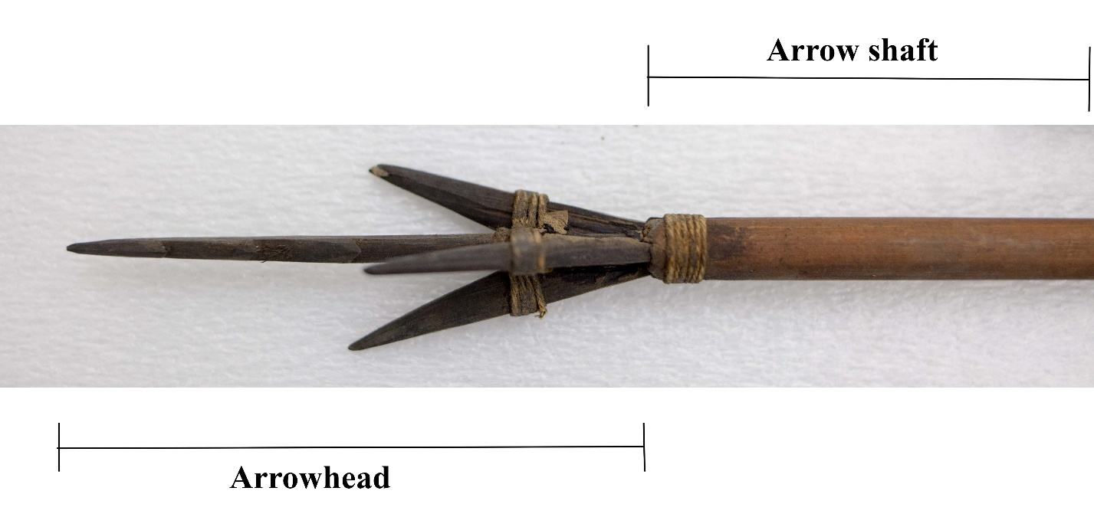
Figure 25: Labeled arrowhead and arrow shaft of an arrow with a 3-prong arrowhead.

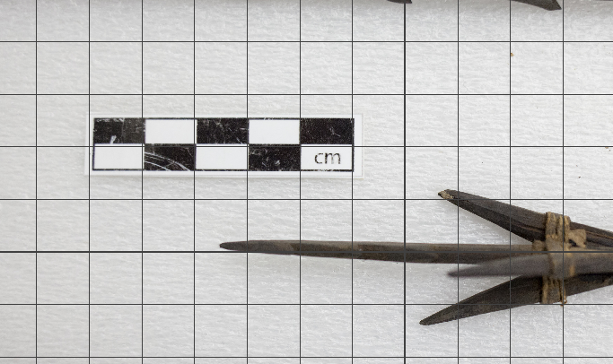
Figure 26: Scaling the reference image of the arrowhead to the grid in May8

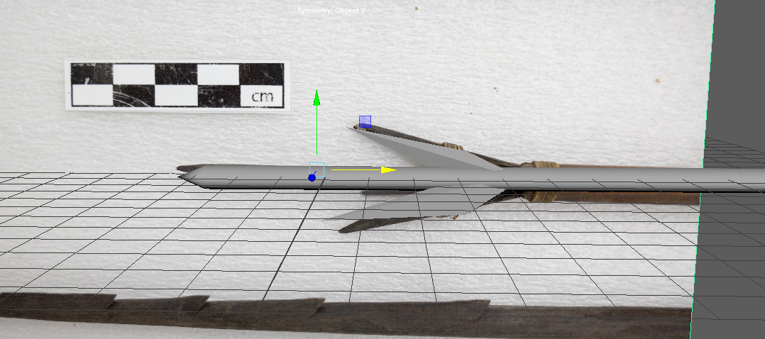
Figure 27: Attached prongs to central arrow foreshaft

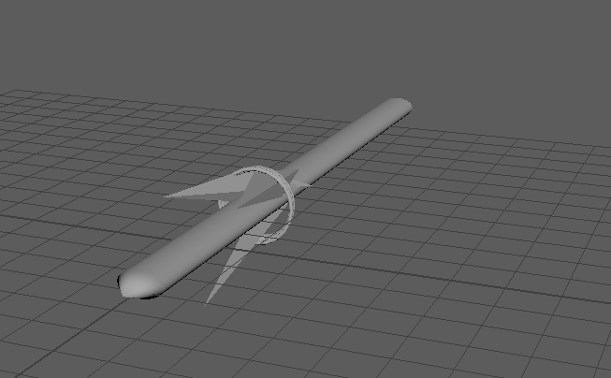
Figure 28: Added strings around the prongs to secure the arrowhead

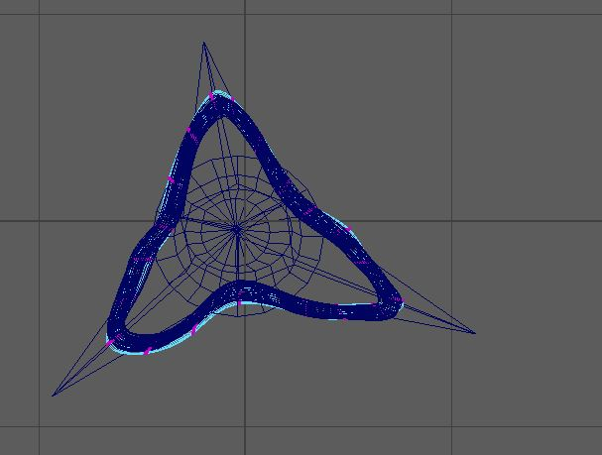
Figure 29: Side –x view of the arrowhead.

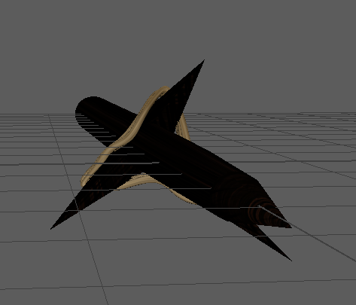
Figure 30: Wrapped string around 3 prong arrowhead.

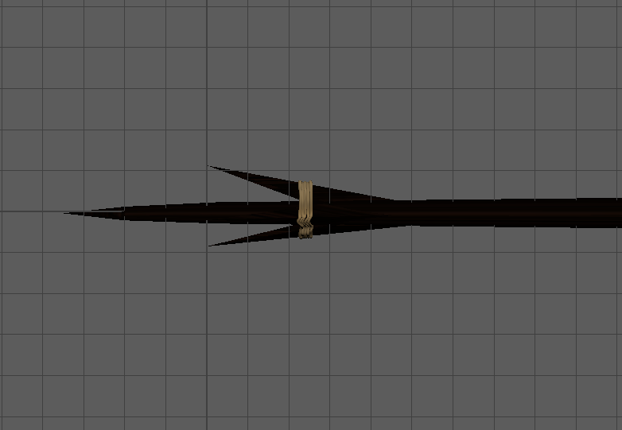
Figure 31: Finished model of 3 prong arrowhead.

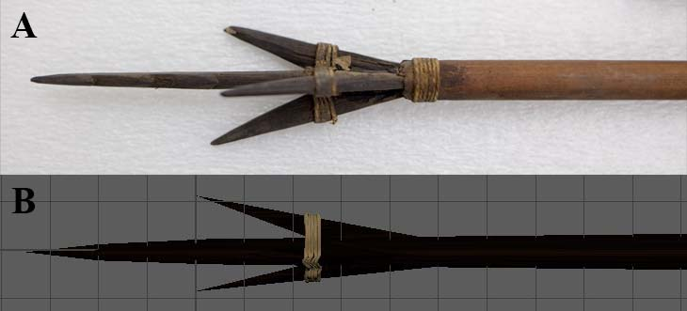
Figure 32: Reference arrow from the Penn Museum (a) and final model of the serrated arrowhead in Maya (b).

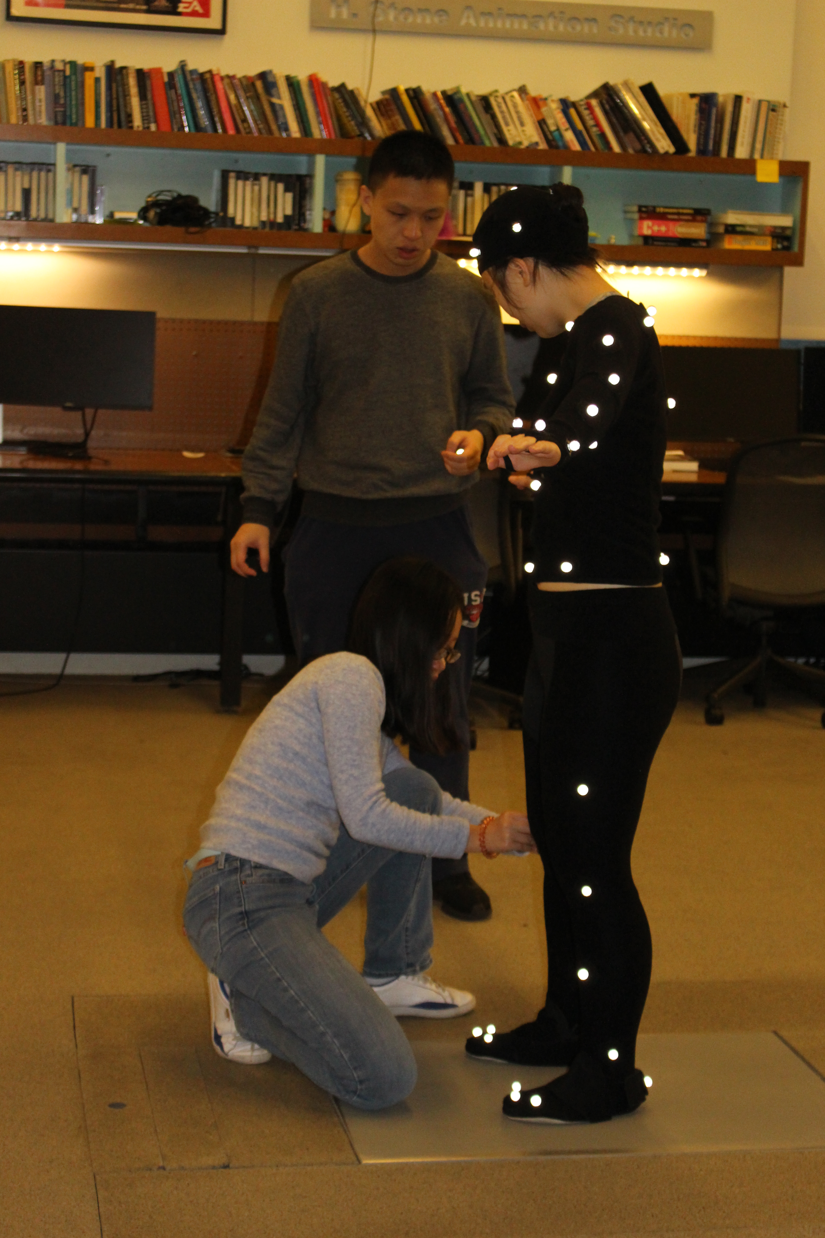
Figure 33: Wearing a motion capture suit with reflective markers (Photograph courtesy of Dr. Clark Erickson).
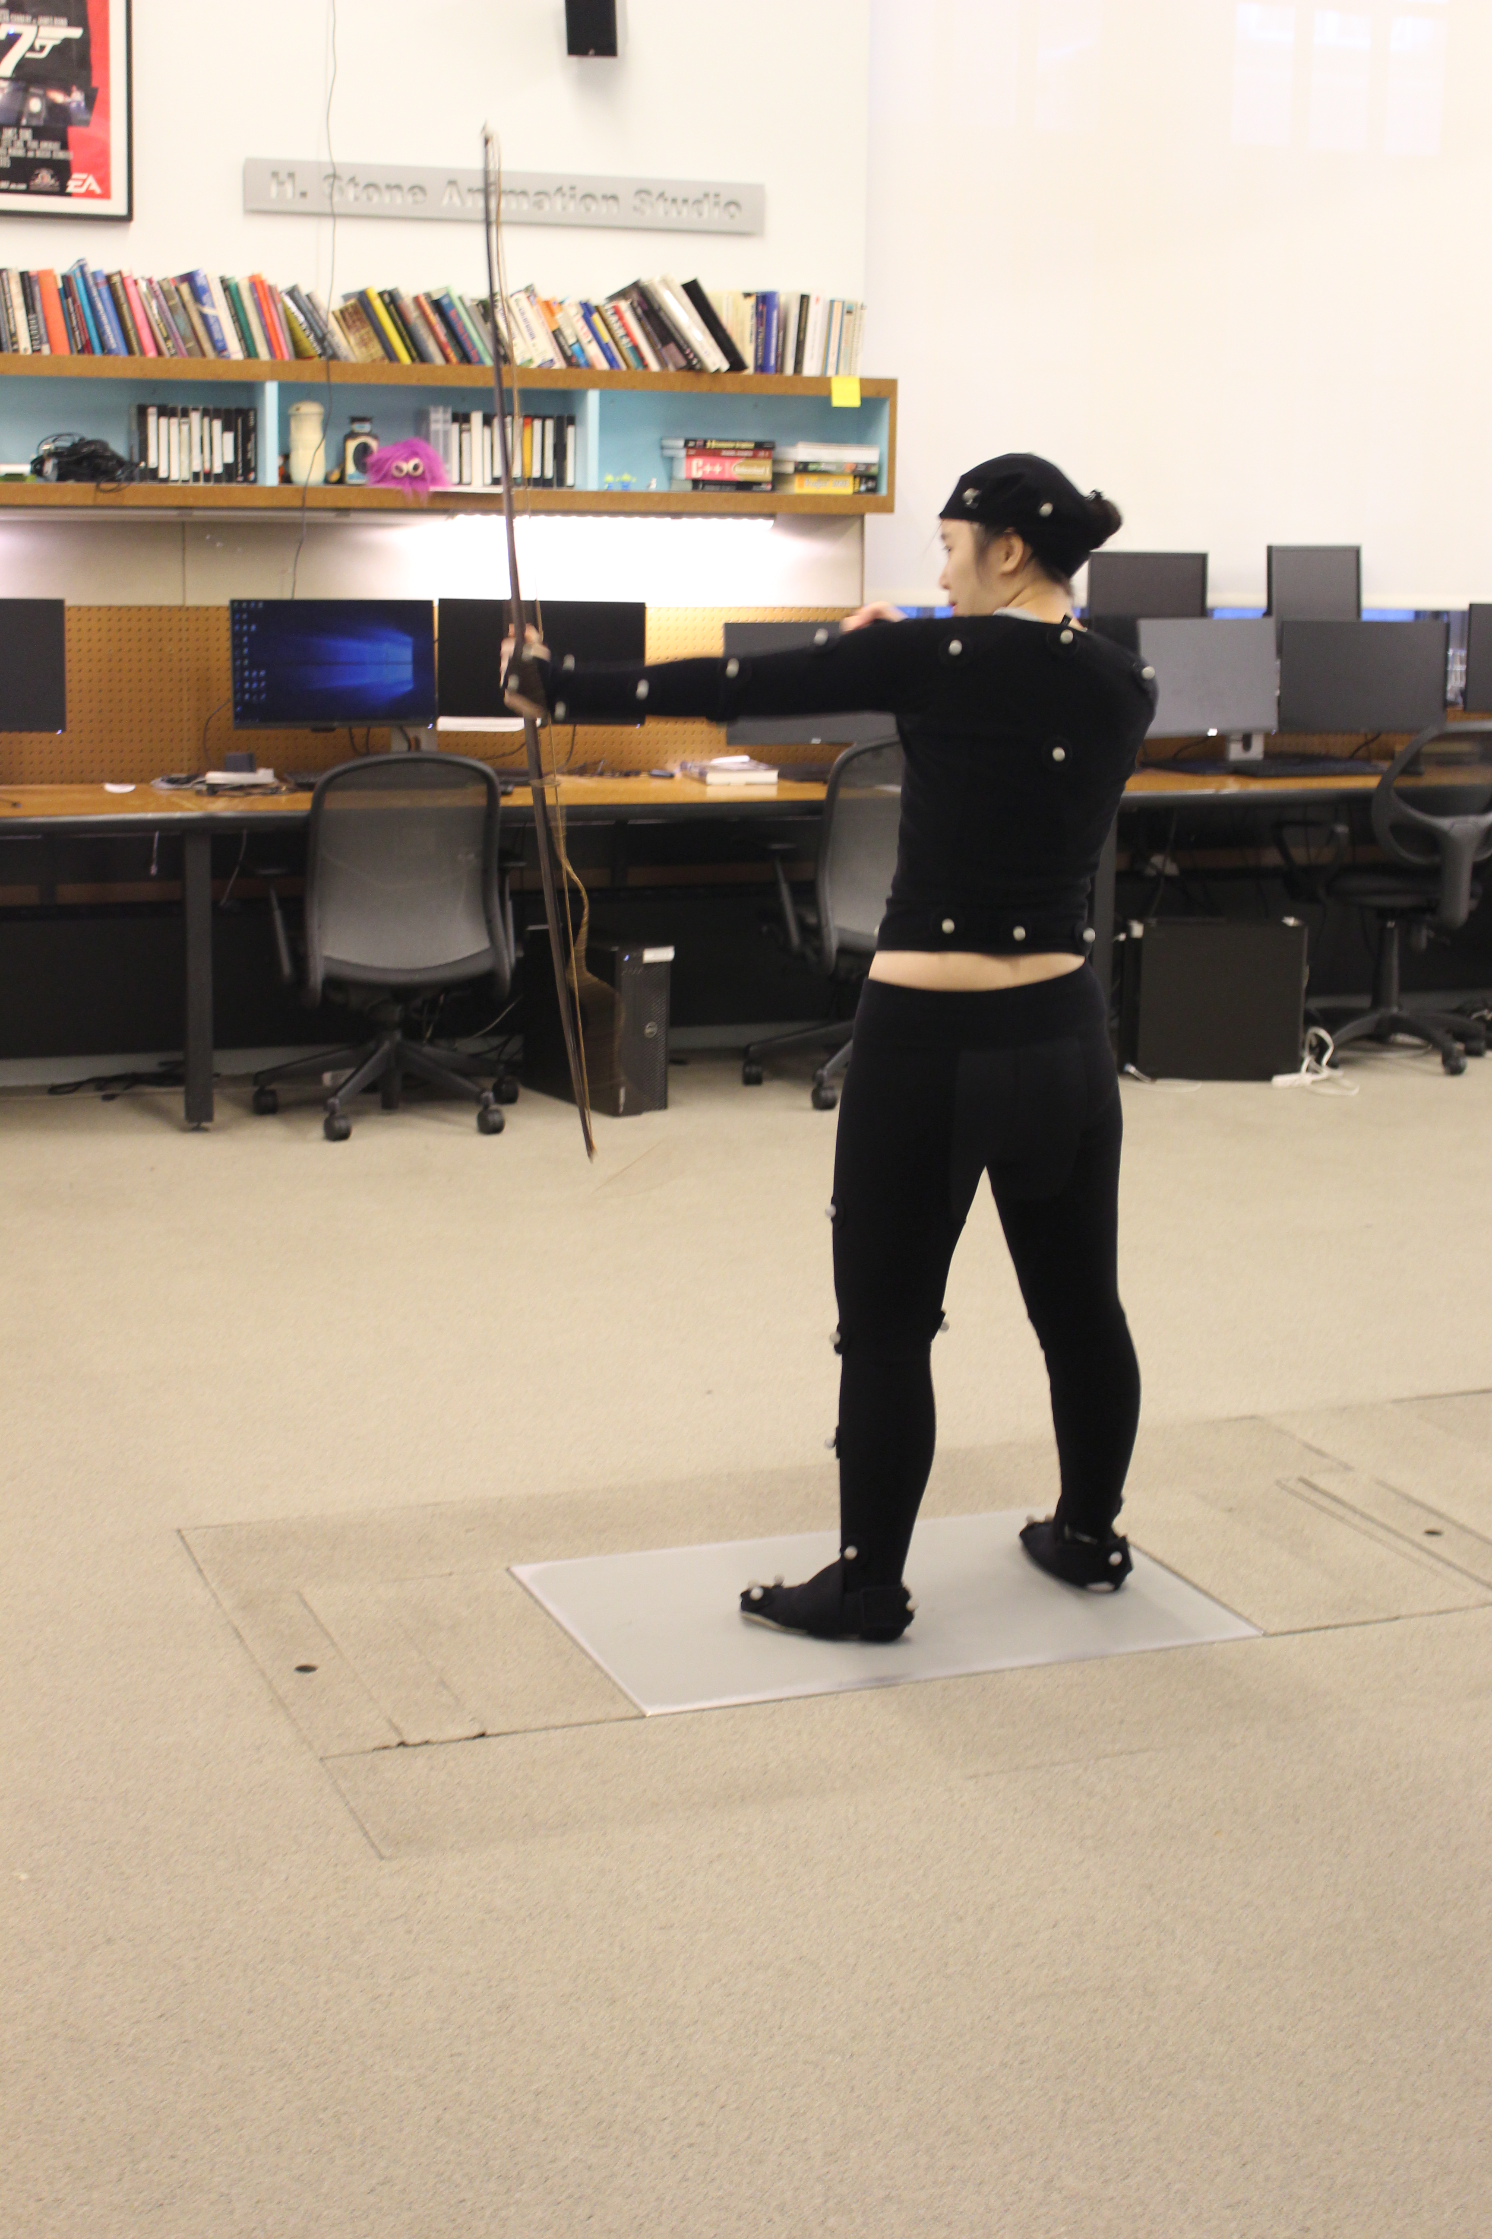
Figure 34: Creating motion of shooting an arrow horizontally (Photograph courtesy of Dr. Clark Erickson).

Endnotes
¹Bgfons.com
n.d. Rope texture. Electronic graphic, bfons.com, http://bgfons.com/download/2089, accessed December 7th, 2017

²CadNav
n.d. Macassar Ebony wood texture. Electronic graphic, CadNav, http://www.cadnav.com/textures/5482.html, accessed December 7th, 2017

³Filter Forge
n.d. Cottage Wood Bump Map. Electronic graphic, Filter Forge, https://www.filterforge.com/filters/5936-bump.html, accessed December 7th, 2017

⁴JDA
2002 Rope bump map. Electronic graphic, blenderartists.com, https://blenderartists.org/forum/showthread.php?222061-Texture-Problem-Normal-Map-not-work-for-me, accessed December 7th, 2017

