Figures

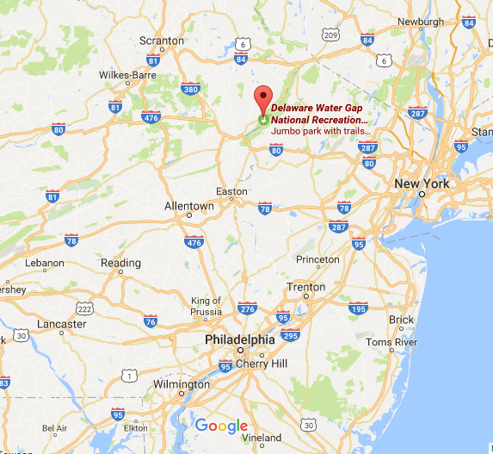
Figure 1. Upper Delaware Valley as archaeologically defined, Delaware Water Gap National Recreation Area.

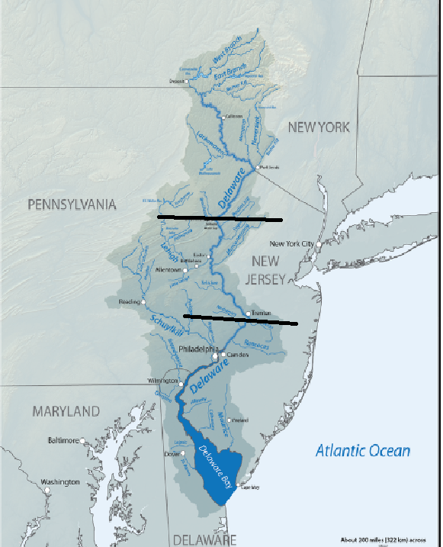
Upper Delaware Valley
Lower Delaware Valley
Middle Delaware
Valley
Figure 2- Geological Divisions of the Delaware River; Source: USGS
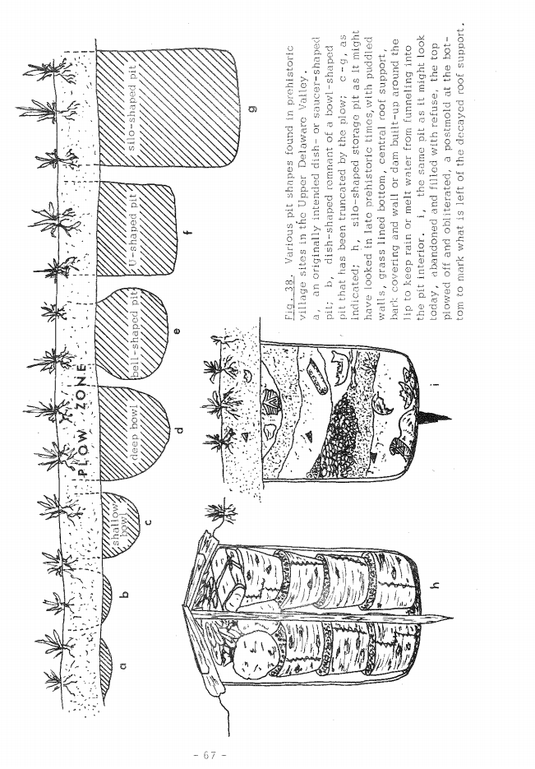
Figure 3- Pit types and fill in the Upper Delaware Valley, (Kraft 1975: 67)
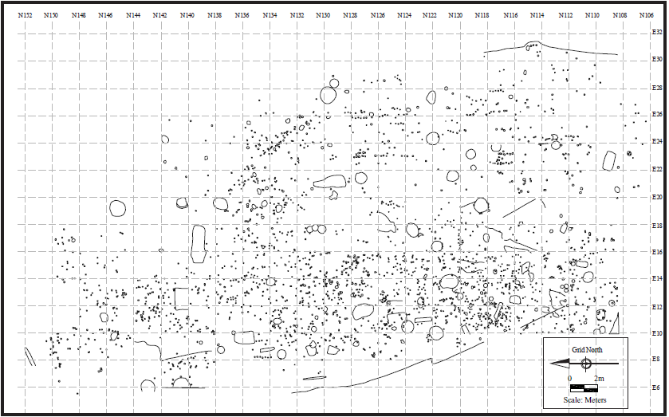
Figure 4- Complete Map
of Features at
Shoemakers Ferry;
(Barse 2006:4.11)

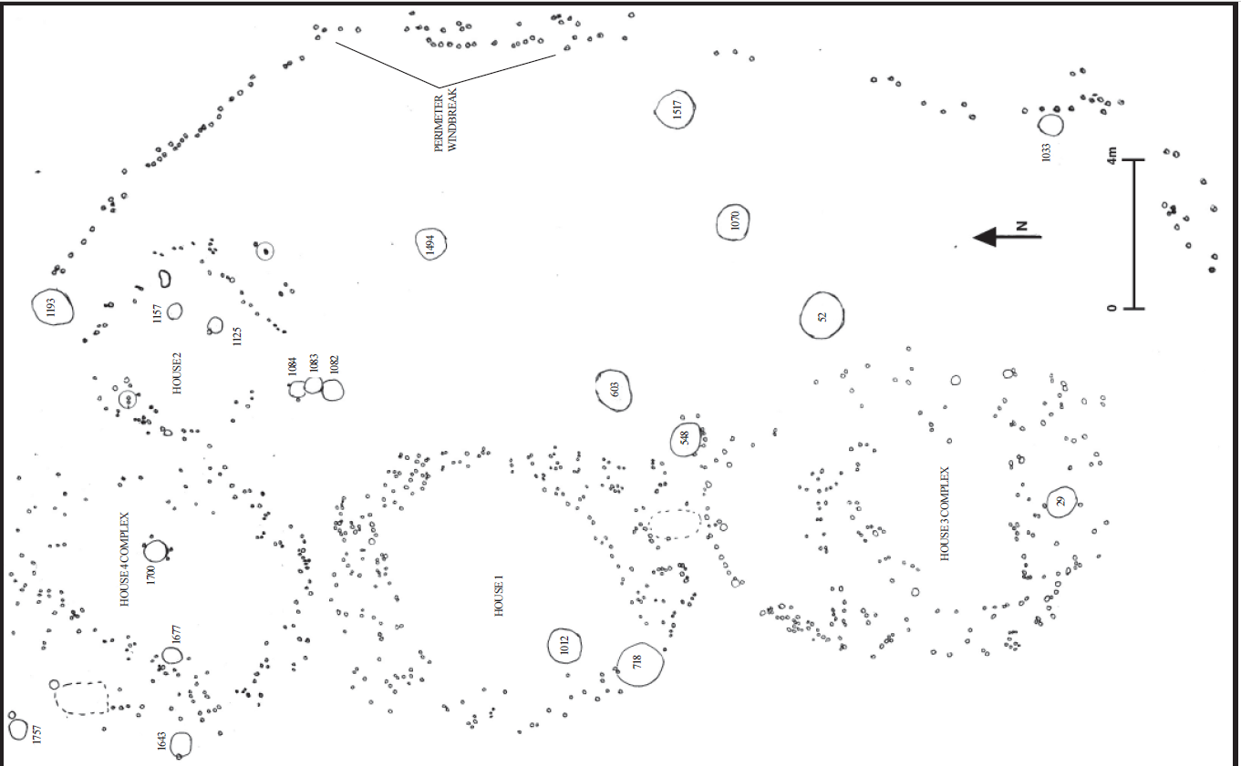

Figure 5- House Patterns and Features at Shoemakers Ferry; Source Barse 2006:4.76
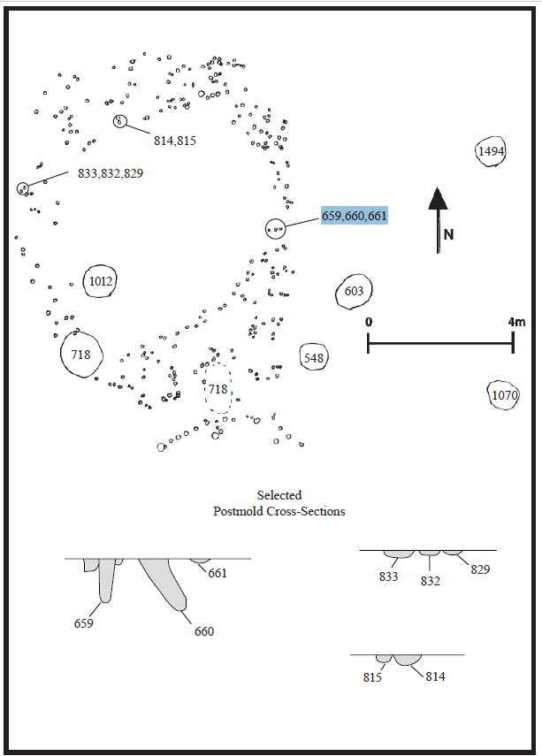Figure Figure 6- House Pattern 1 at Shoemakers Ferry; Source: Barse 2006:4.77
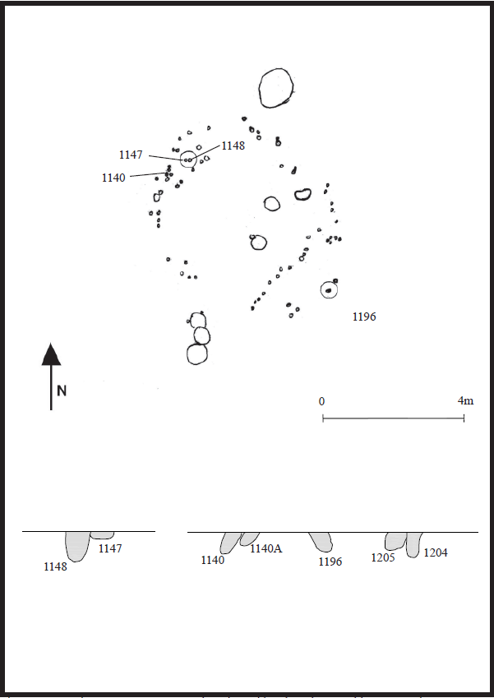
Figure 7- House Pattern 2 at Shoemakers Ferry; Source: Barse 2006: 4.80
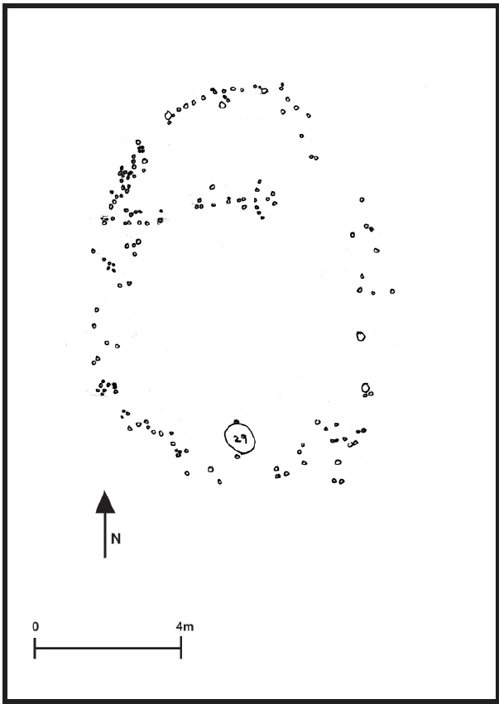
Figure 8- House Pattern 3a at Shoemakers Ferry; Source: Barse 2006:4.84
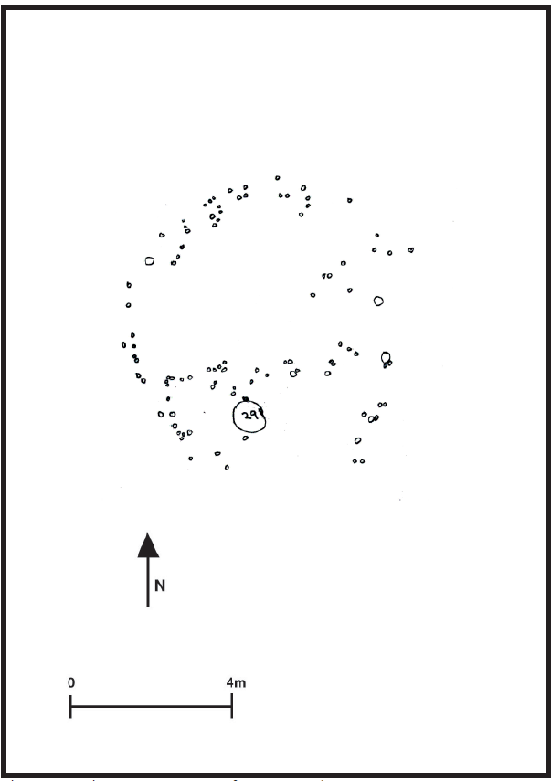
Figure 9- House Patter 3b at Shoemakers Ferry; Source Barse 2006: 4.83
Figure 10- House Pattern 4a Shoemakers Ferry; Source: Barse 2006: 4.86
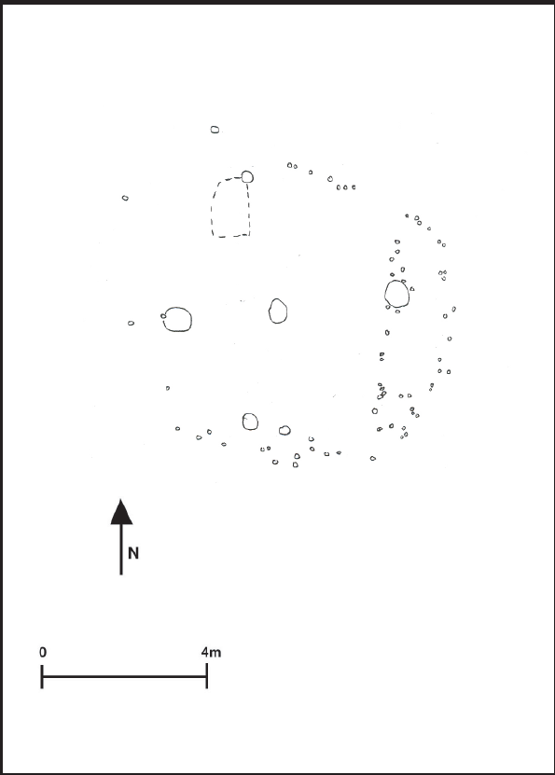
Figure 11- House Pattern 4b Shoemakers Ferry; Source: Barse 2006: 4.87
Figure 12- 1m DEM
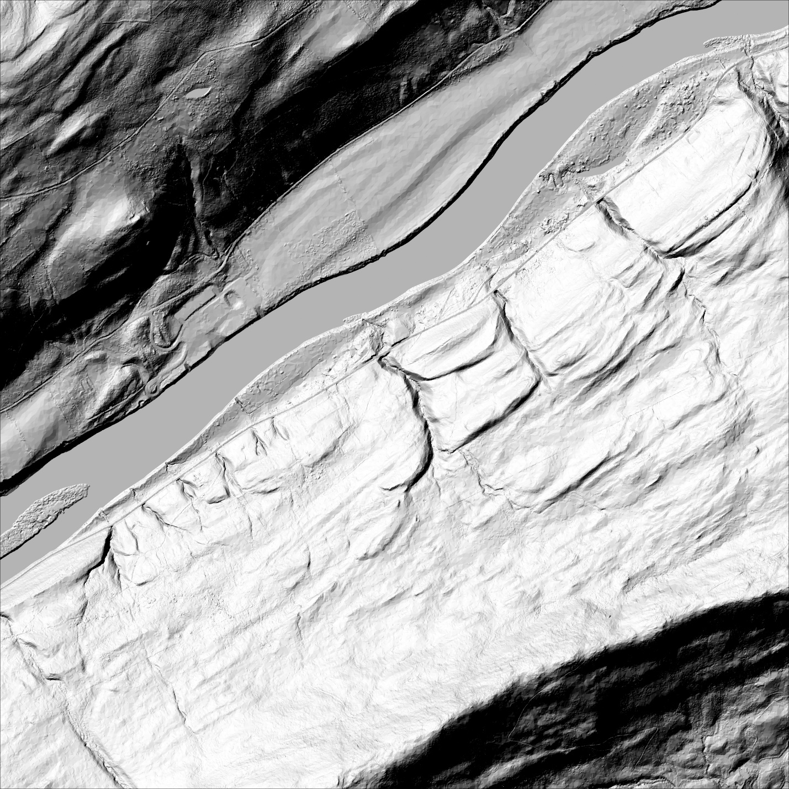Figure 13- 1m DEM as hillshade

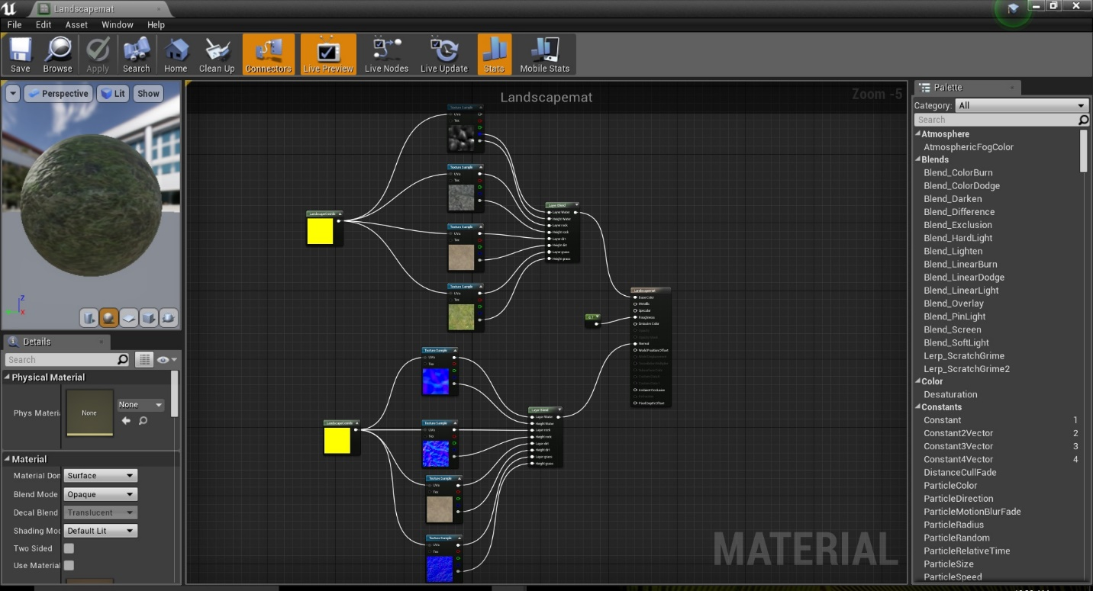Figure 14- Landscape Material Blueprint
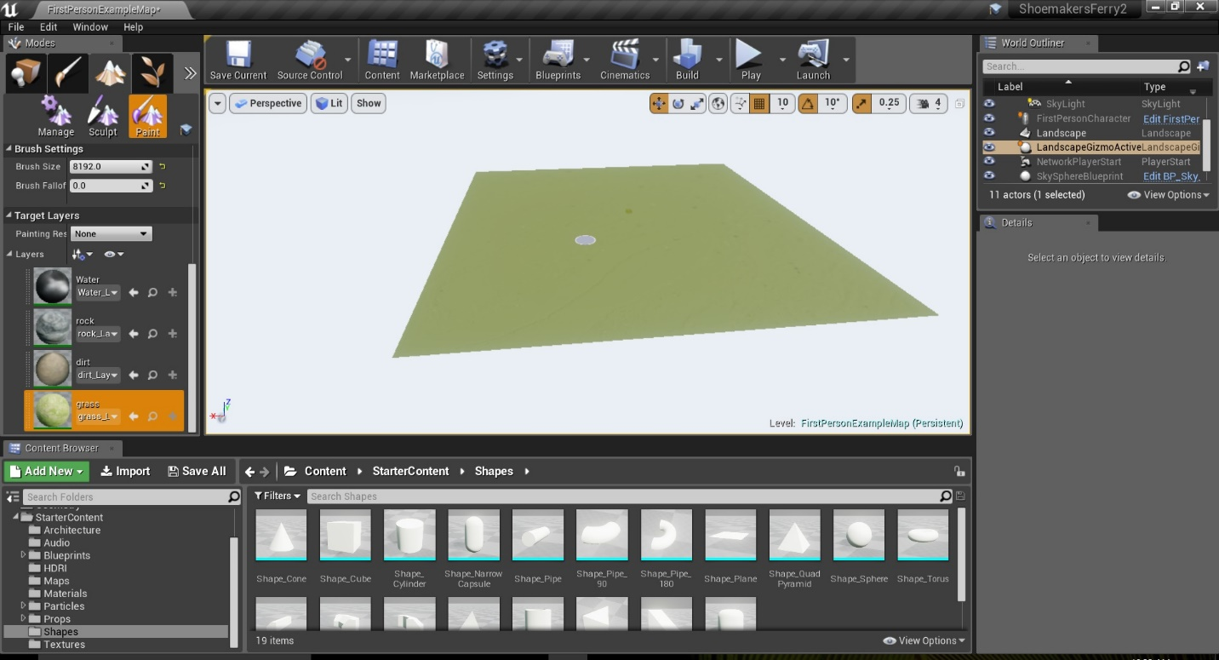Figure 15 Landscape Material applied to DEM in Unreal Game Engine

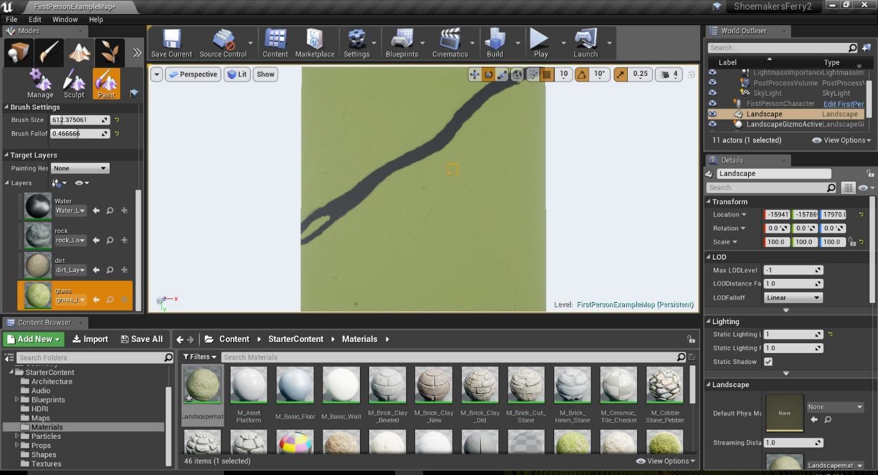Figure 16- Marking the Delaware River in Unreal

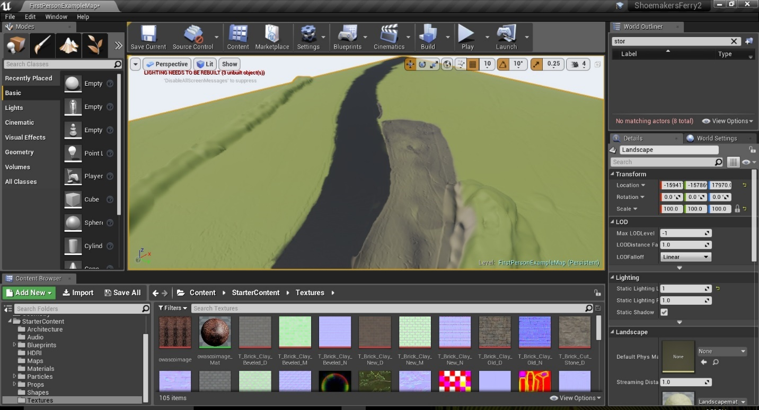Figure 17- Landscape After Sculpting Facing North

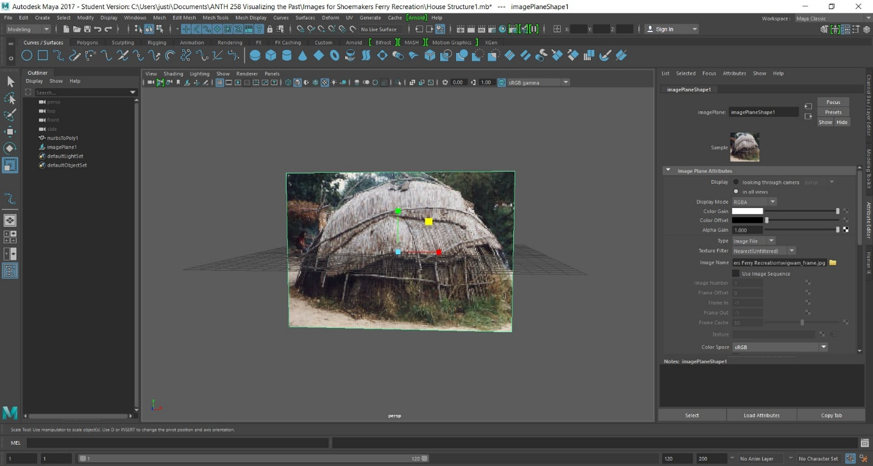Figure 18-Wigwam Free Image Plane
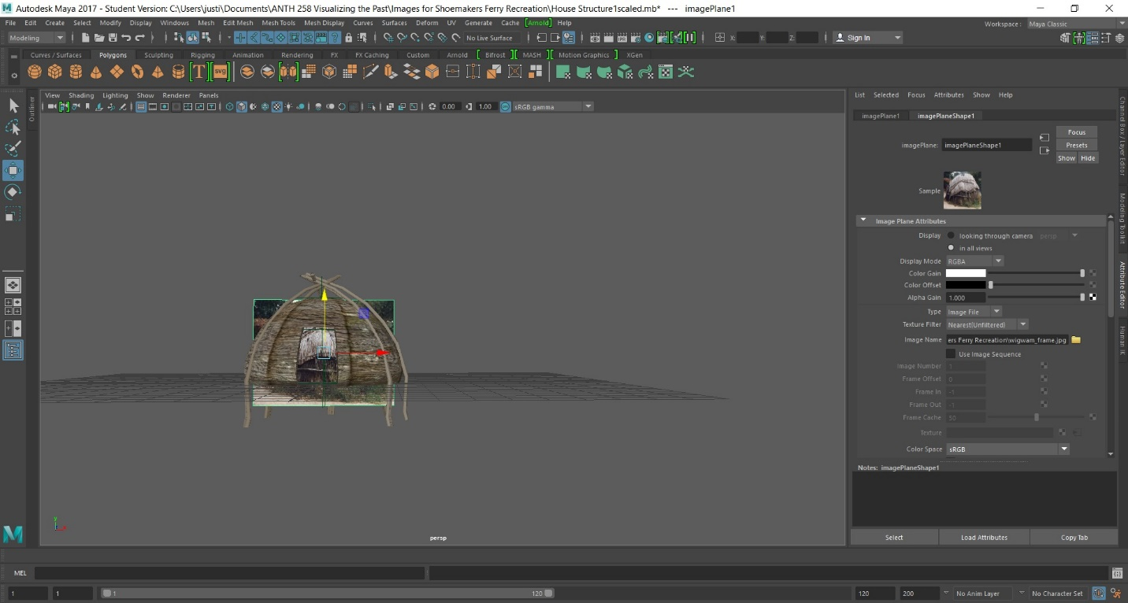
Figure 19- House Structure Scaled

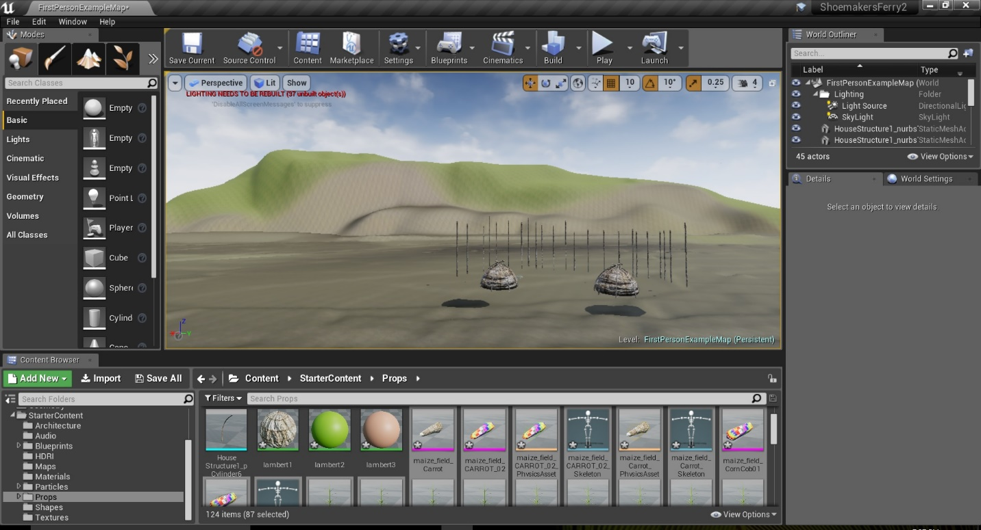
Figure 20- Houses and Windbreak Posts in Unreal Game Engine
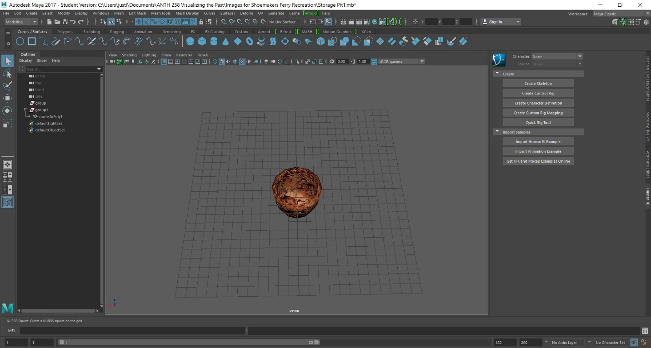Figure 21- Storage Pit with Lambert Applied

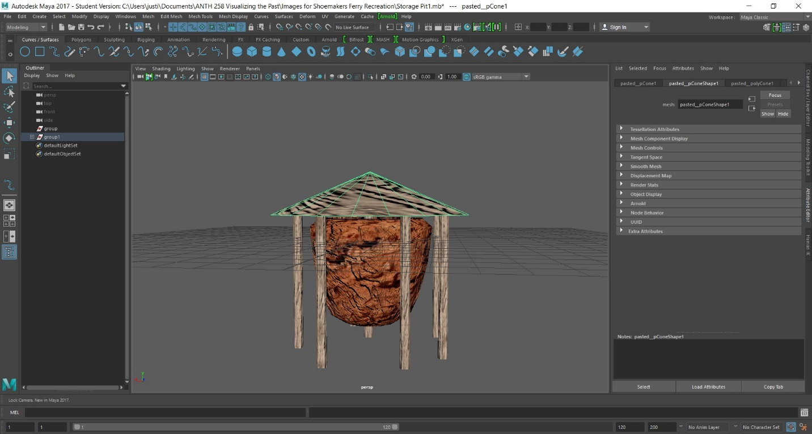Figure 22- Finished Storage Pit in MAYA
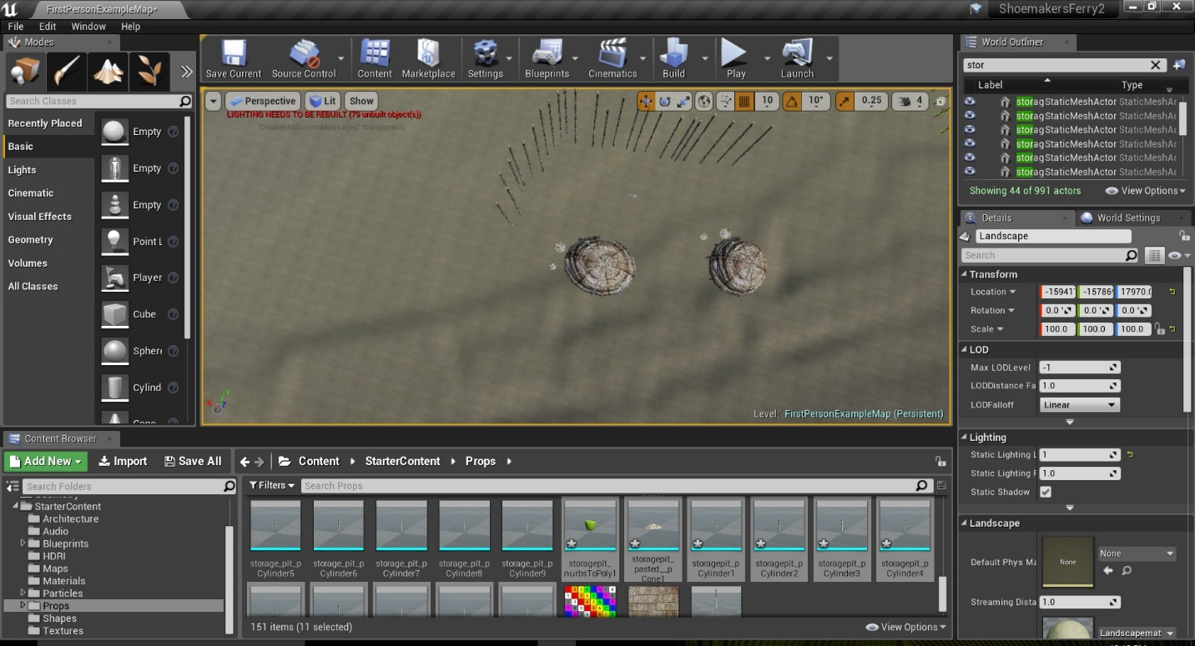Figure 23- Storage Pits imported into Unreal Game Engine and arranged

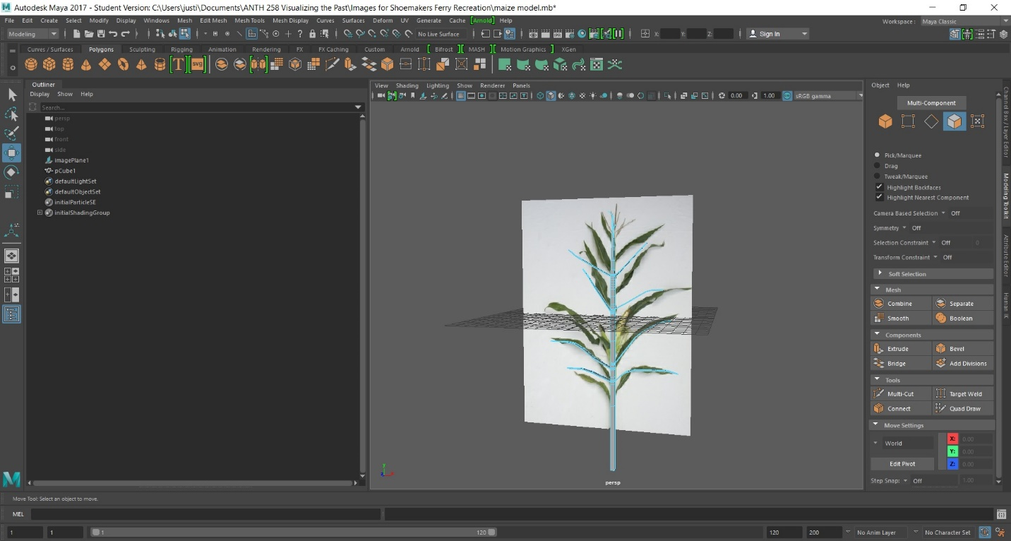Figure 24 Modelling the maize plant
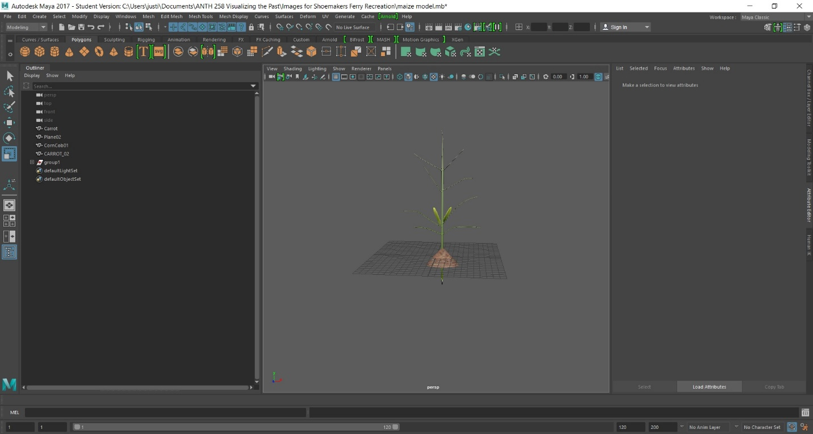
Figure 25- Completed single maize plant model

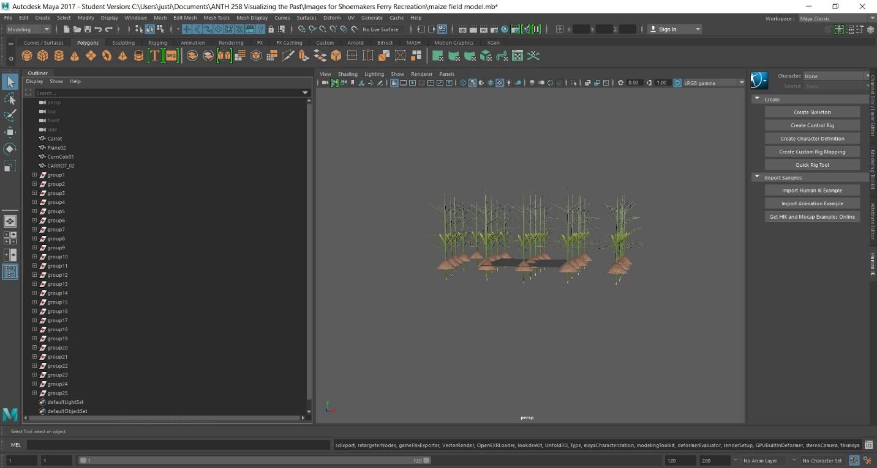Figure 26 Modelled Maize field
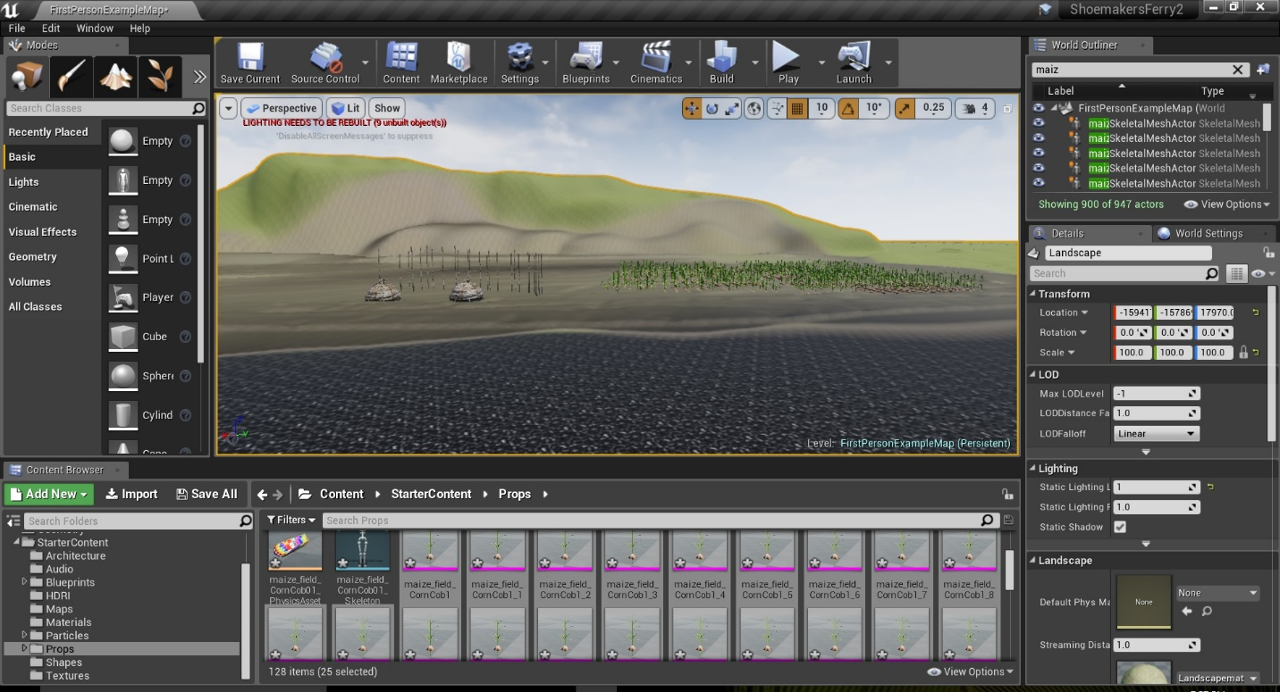Figure 27- Maize plants in Unreal Game engine
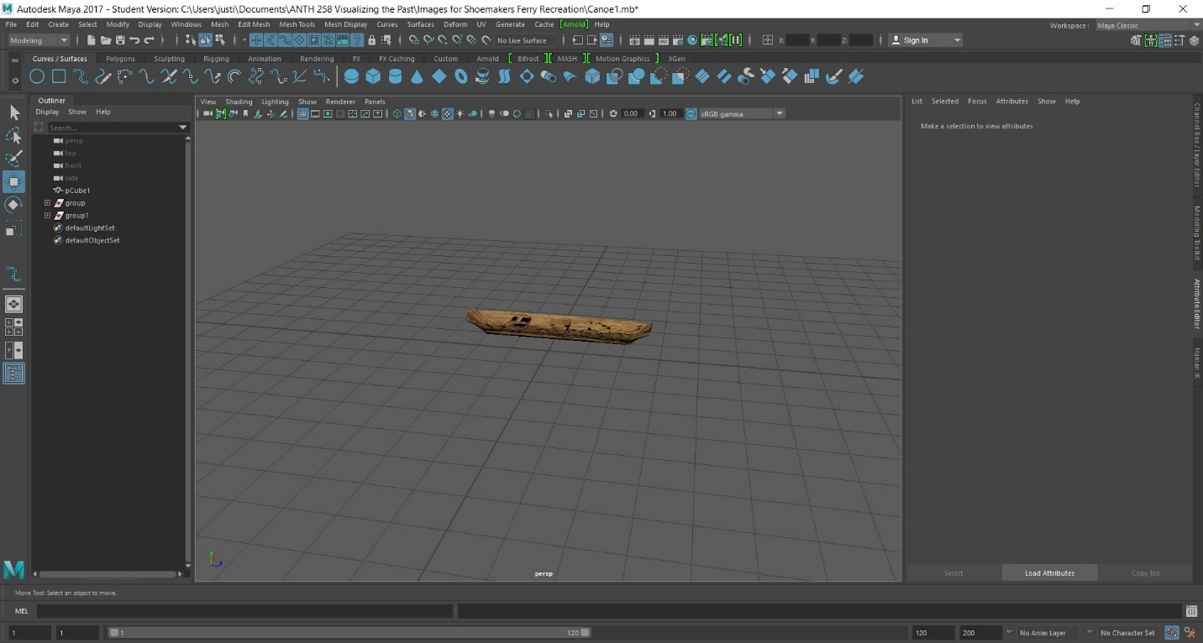Figure 28- canoe Model
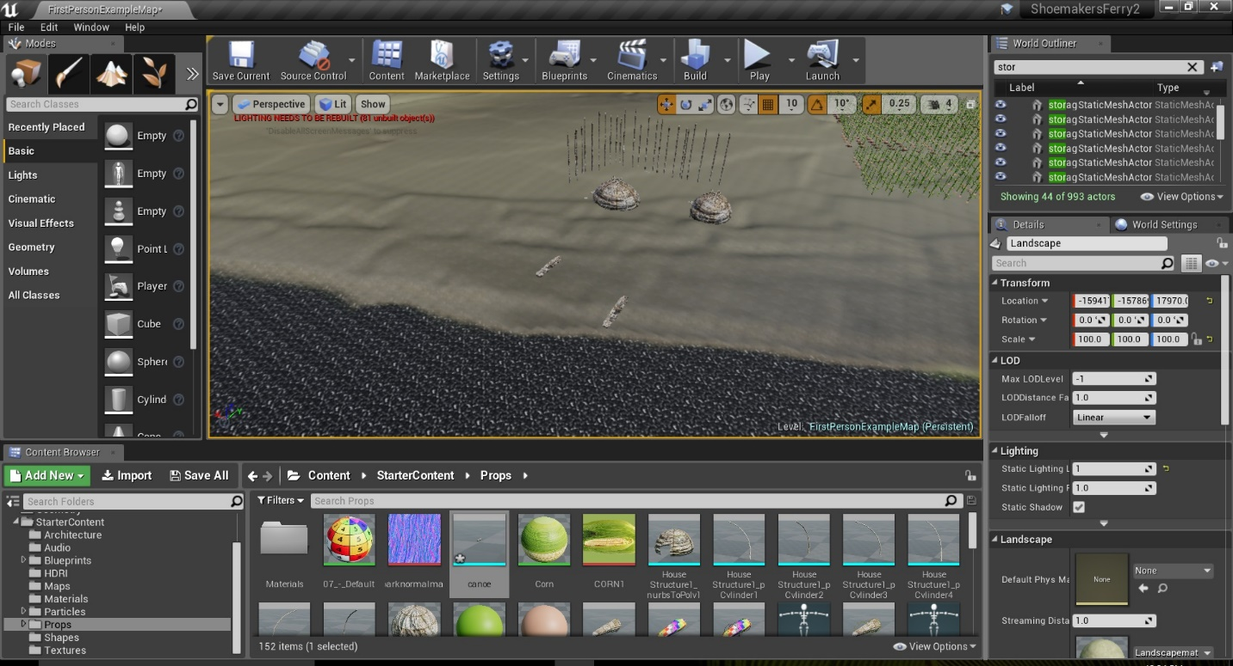Figure 29- Canoe Models imported into Unreal Game Engine

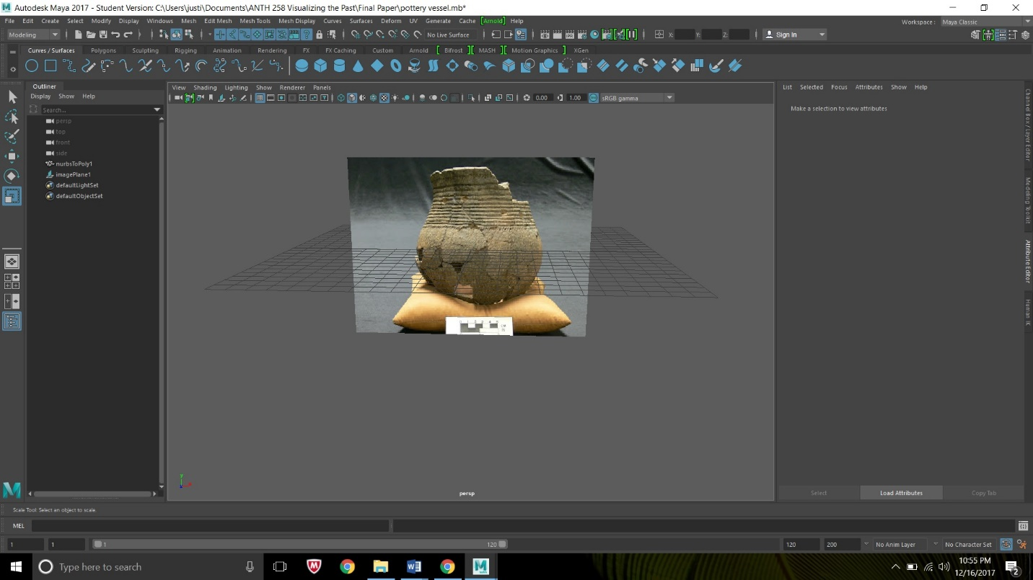Figure 30- Owasco Corded Vessel Image plane 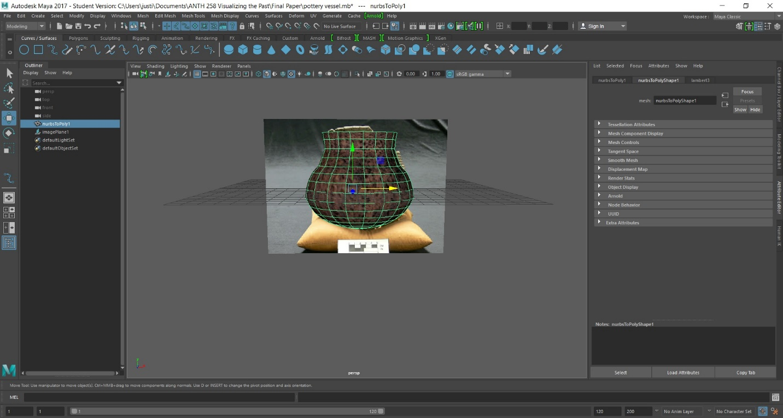Figure 31- Owasco Corded Vessel Model Complete

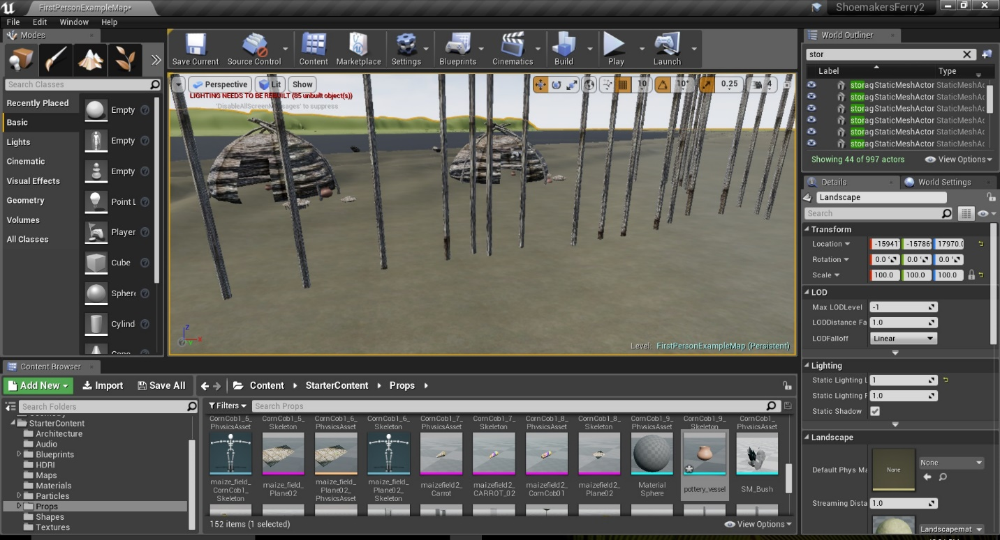Figure 32- Owasco Corded Vessel Model in Unreal Game Engine
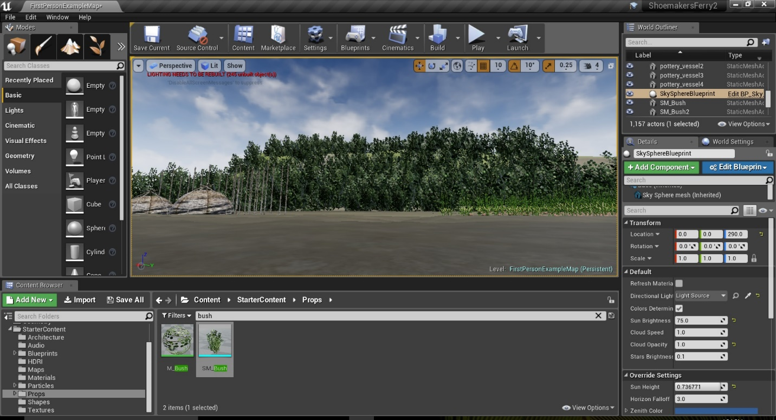
Figure 33- Foliage in Unreal Game Engine Level

TABLES
House Data
House | Dimensions (m) | Area (m²) | Occupation Phase | Estimated Occupation Span
House 1 | 8.5x6.8 | 57.8 | 1 | A.D. 1000-1020
House 2 | 6.0x4.25 | 25.5 | 1 | A.D. 1000-1020
House 3a | 7x5 | 35 | 2 | A.D. 1040-1060
House 3b | 10.5x8 | 84 | 2 | A.D. 1040-1060
House 4a | 8.5x7 | 59.5 | 3 | A.D. 1080-1100
House 4b | 8.5x7 | 59.5 | 3 | A.D. 1080-1100

Table 1- House Data From Shoemakers Ferry

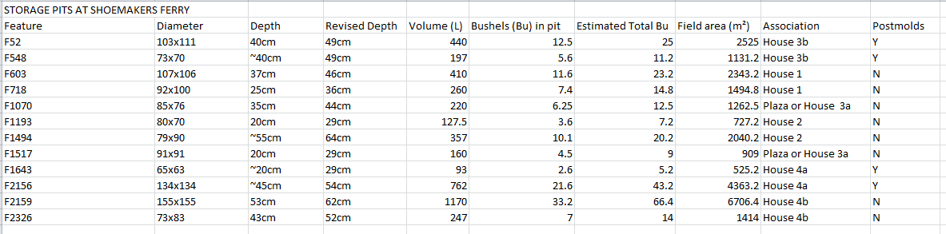
Table 2- Storage Pits at Shoemakers Ferry
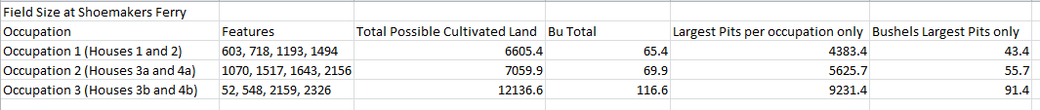
Table 3- Field Size from Pits at Shoemakers Ferry

