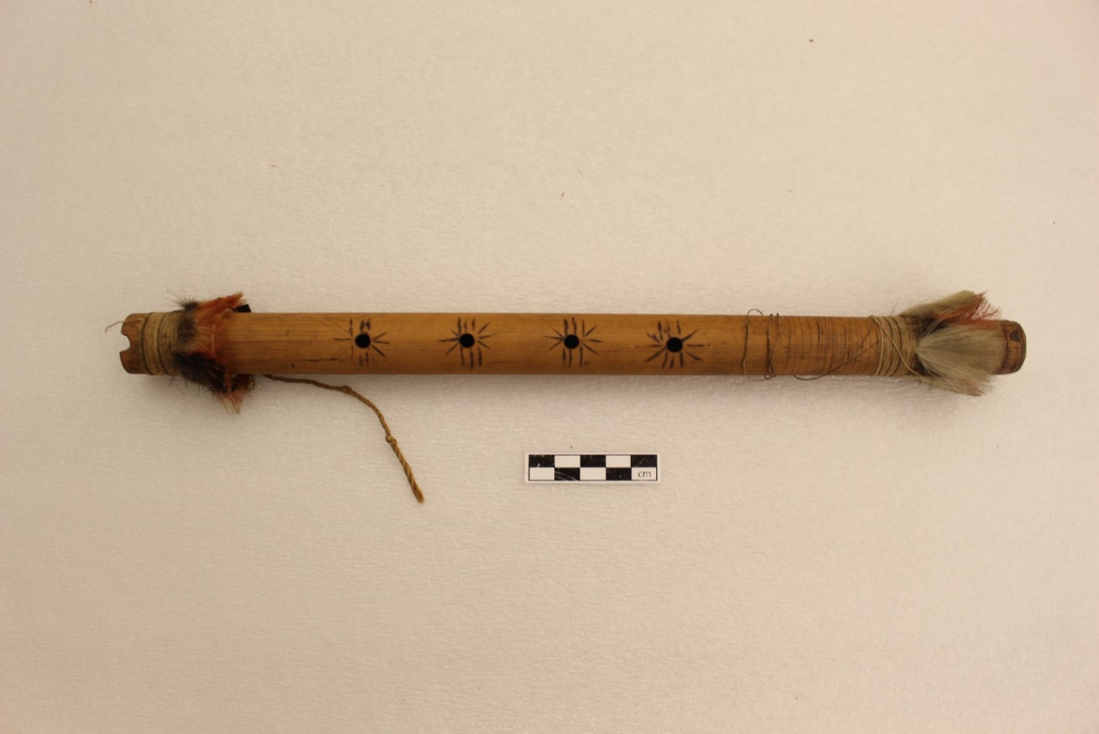

Figure 1a Reference image of a quena of the American Section of the Penn Museum for the 3D-modelled quena (Object SA66)

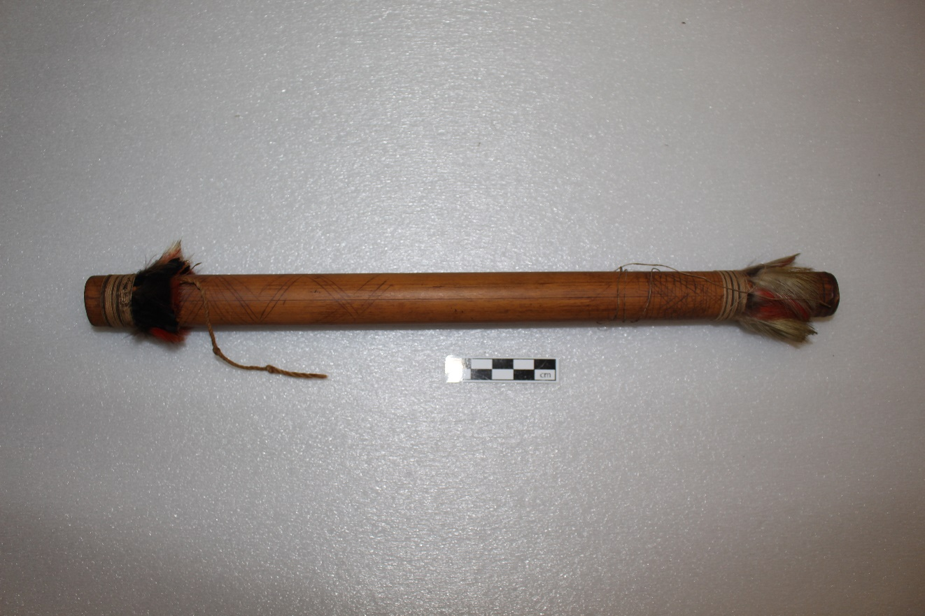

Figure 1b Reference image of the backside of Object SA66

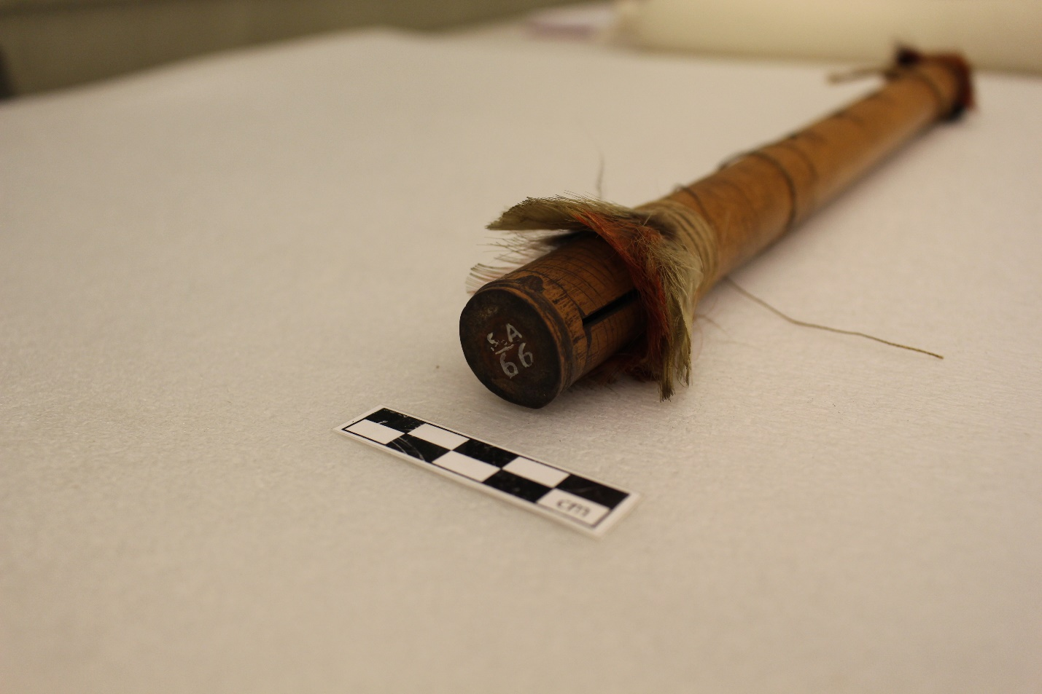

Figure 1c Reference image of distal end of Object SA66

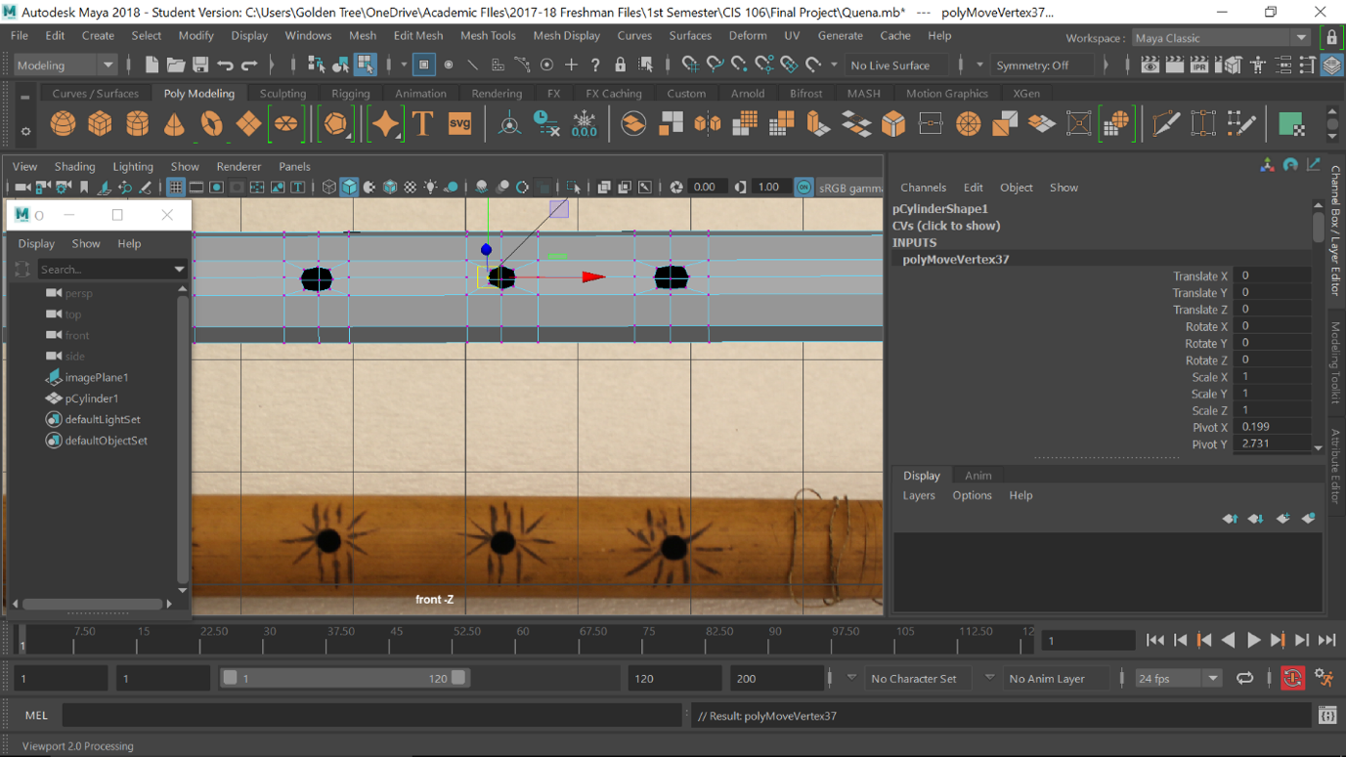

Figure 2 Using edge loops and the extrude base feature to create circular holes

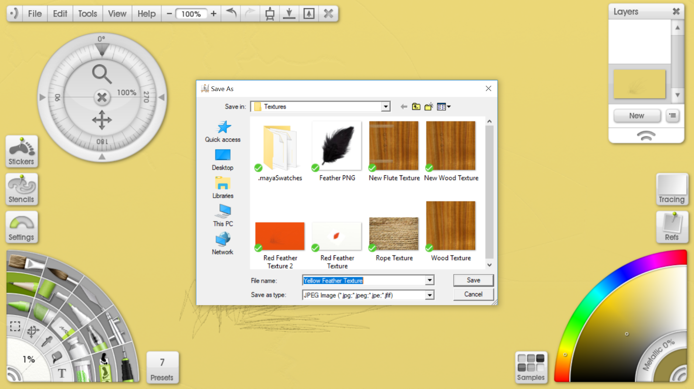

Figure 3 The interface for ArtRage

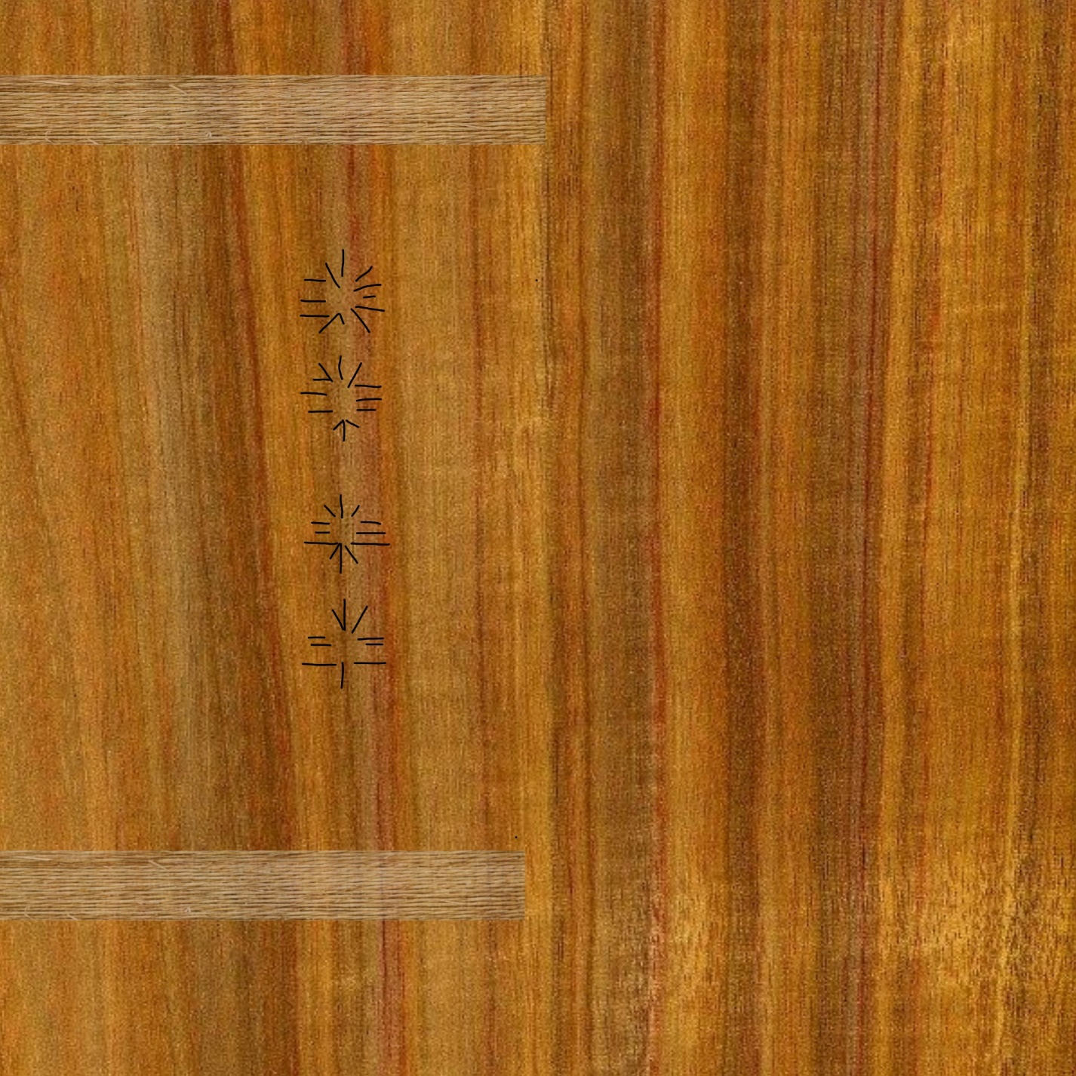

Figure 4 The texture that was edited in ArtRage and imported into the UV Editor

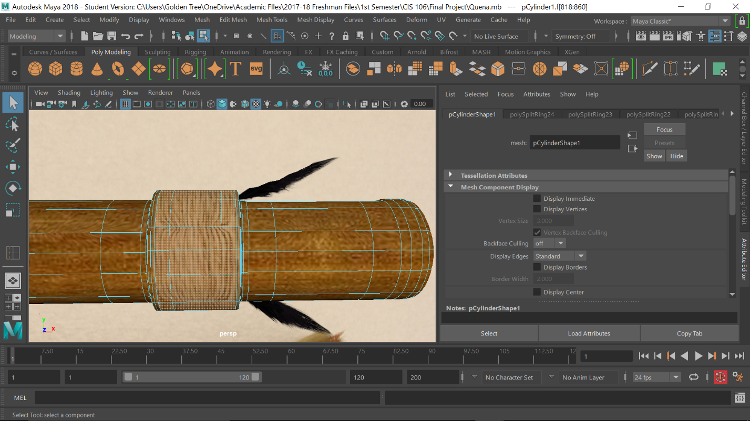

Figure 5 Adding thickness to the portion of the quena that is wrapped in rope

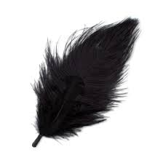

Figure 6 The feather transparency image imported into Maya

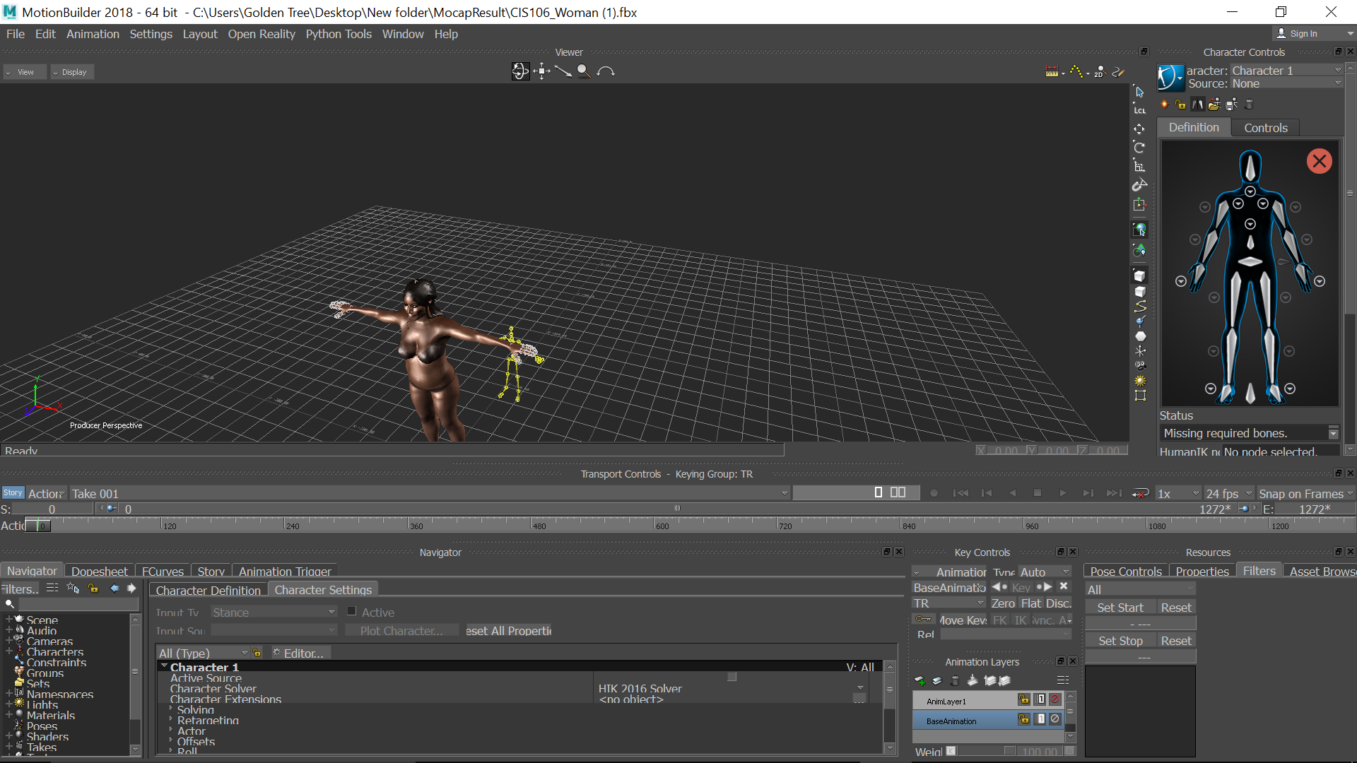

Figure 7 Using MotionBuilder to map the motion capture movements onto the human 3D model

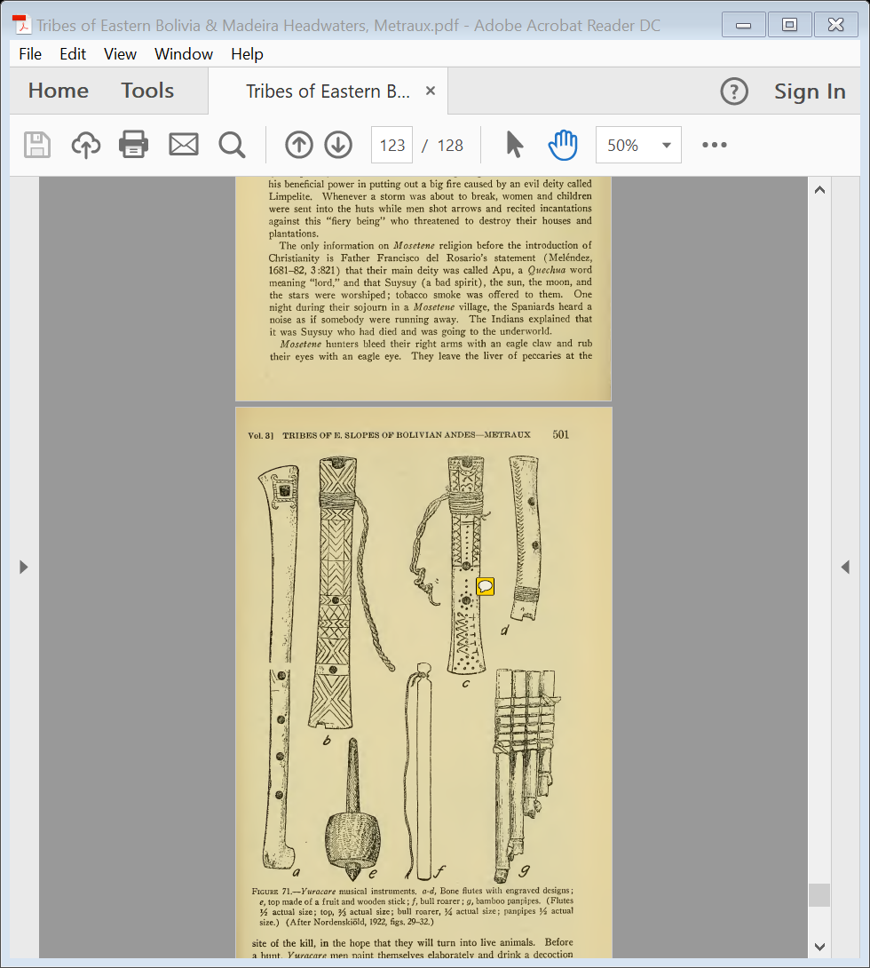

Figure 8 Image of different types of wind instruments found in eastern Bolivia

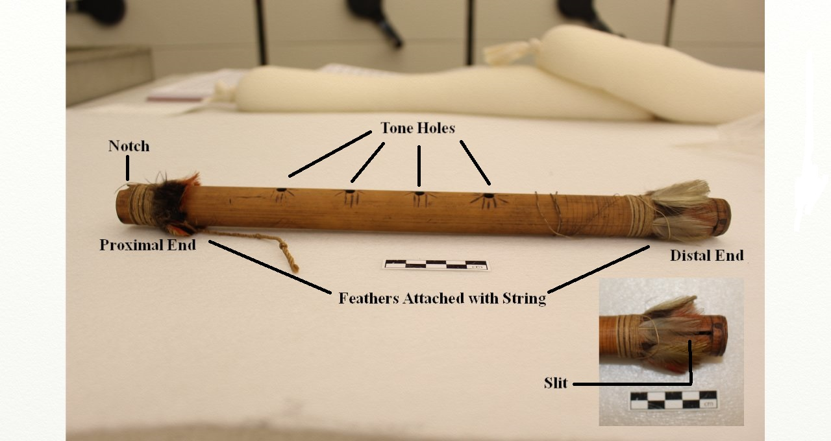

Figure 9 Technical names of all of the parts of the quena

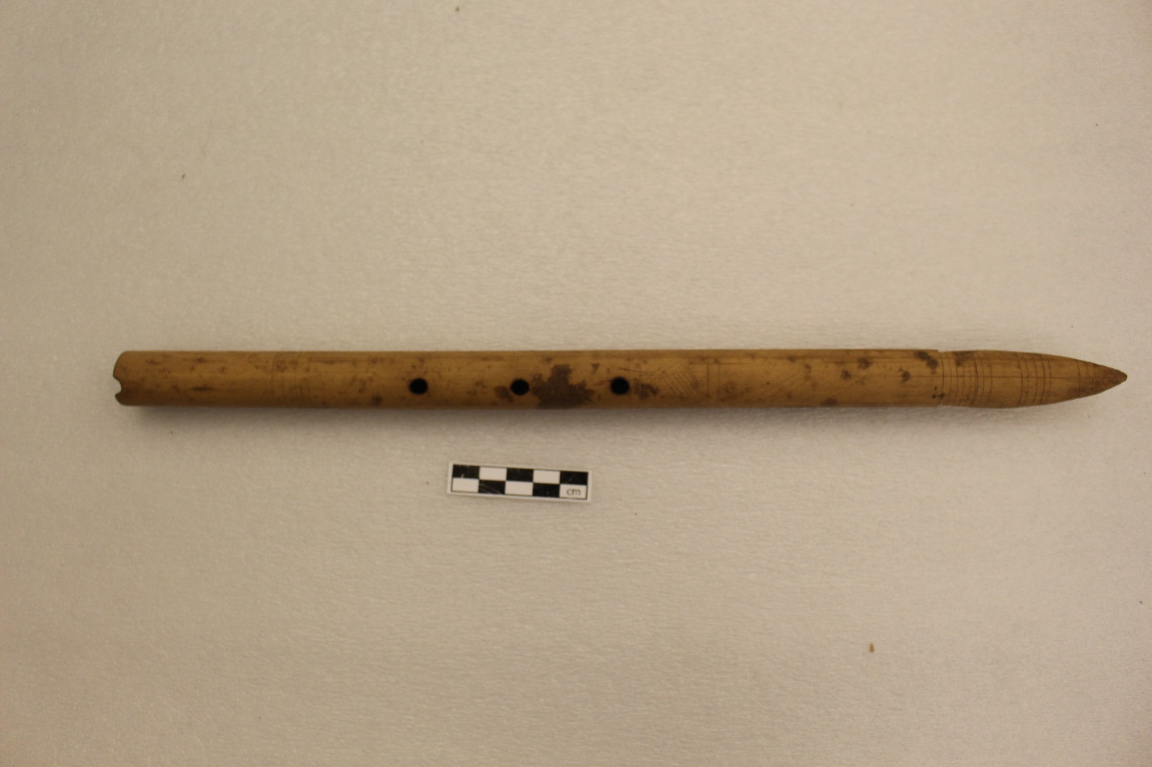

Figure 10 Another quena collected by Dr. Farabee in the Penn Museum (Object SA395)

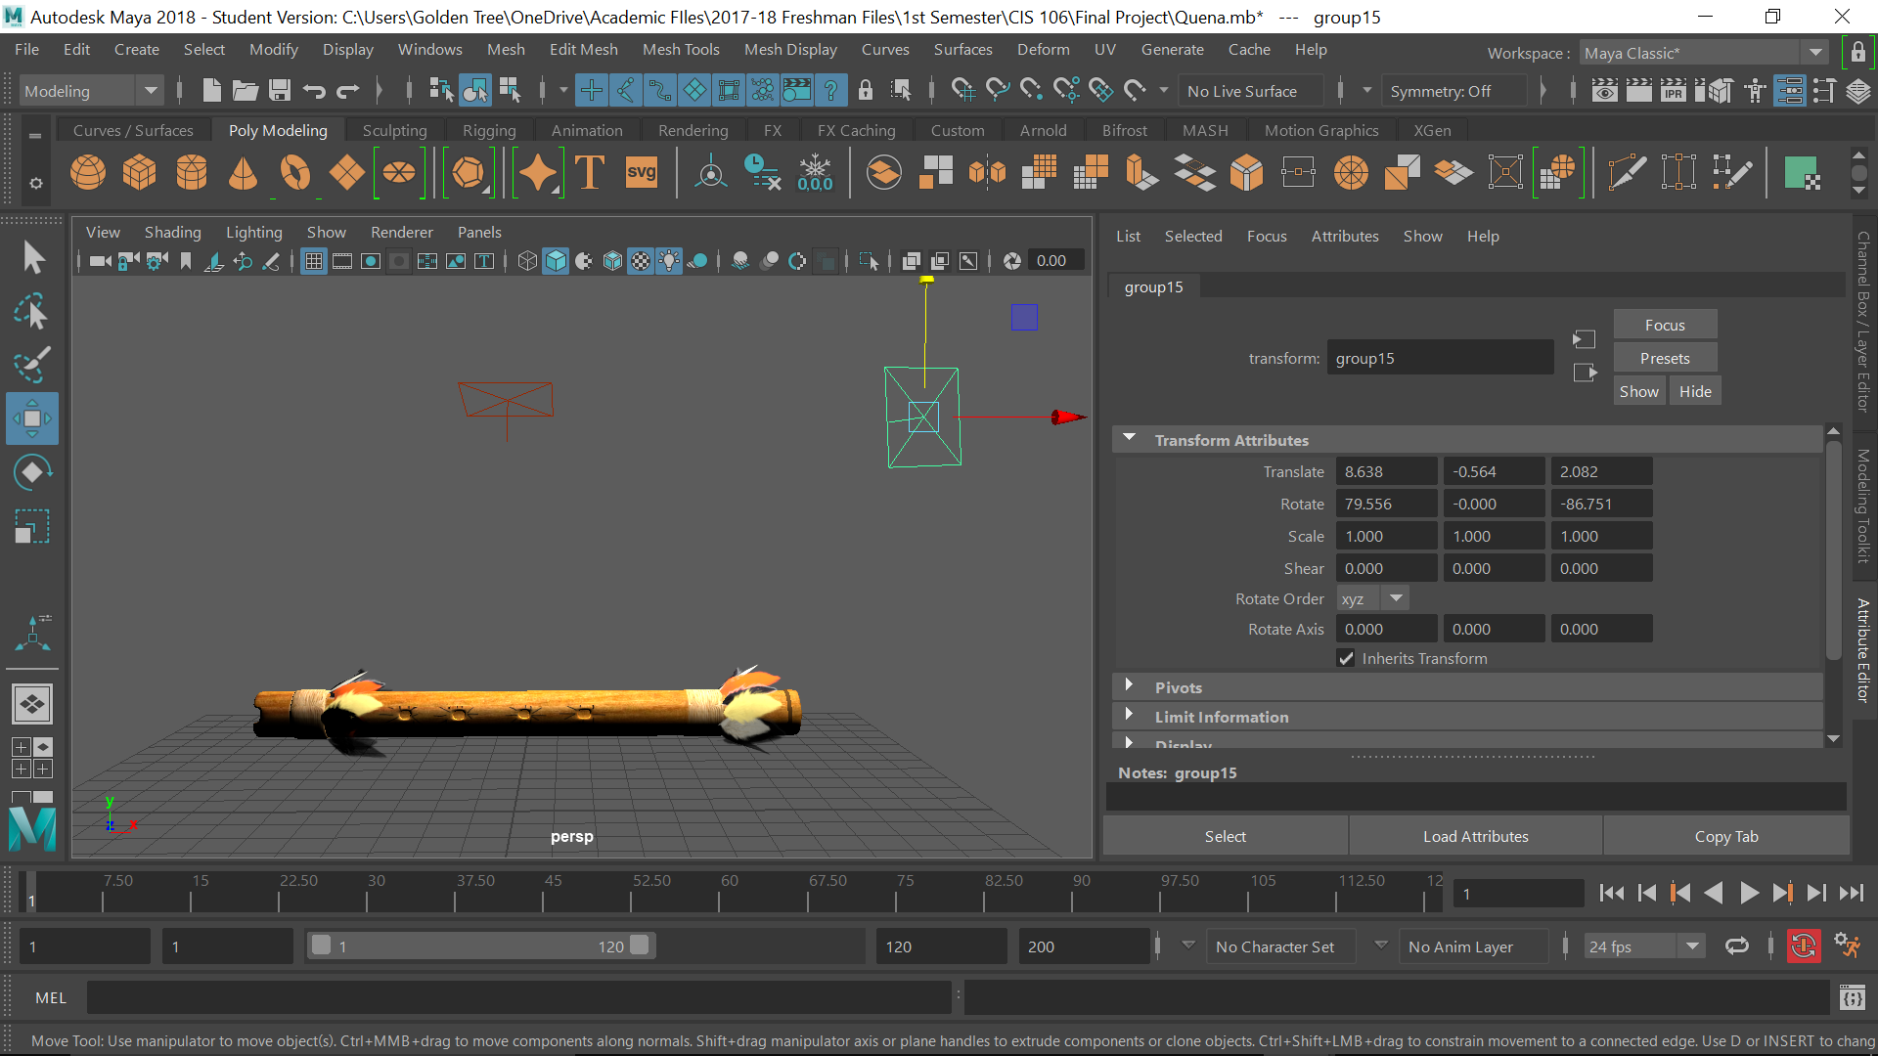

Figure 11 The completed virtual model of the quena

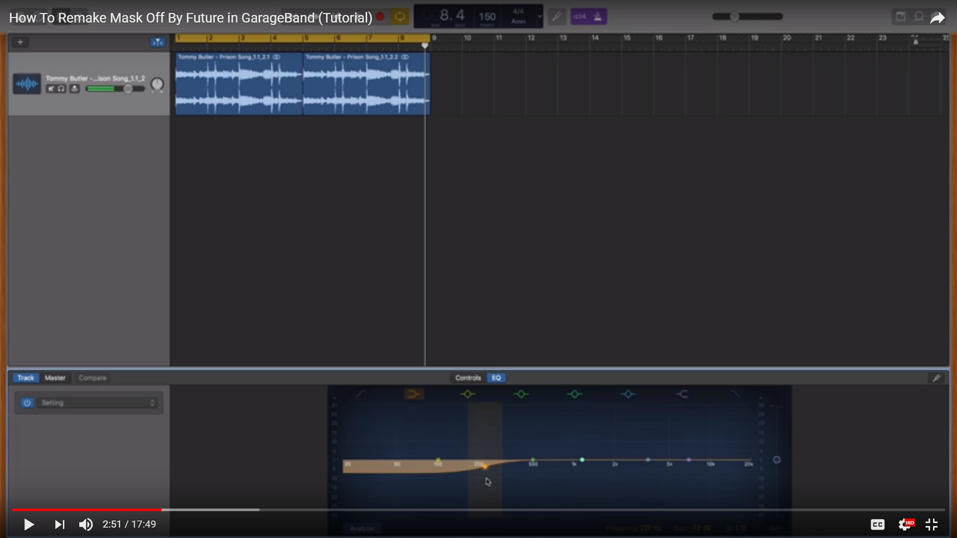

Figure 12 GarageBand user interface with EQ editor in the bottom window

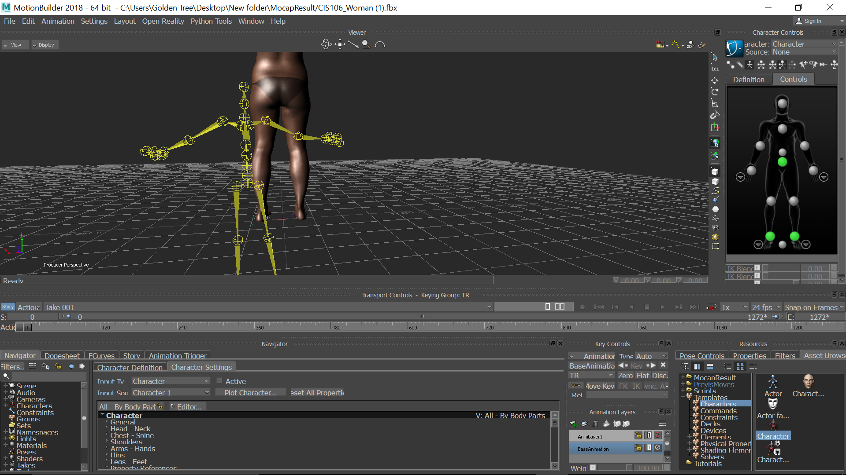

Figure 13 Close-up of yellow skeleton that has the motion capture movements stored. The characterize icon can be seen in the bottom left Asset Browser window.