Siyona Ravi
CIS 106/ANTH 256
Visualizing/Peopling the Past
Final Project Figures
December 21, 2016

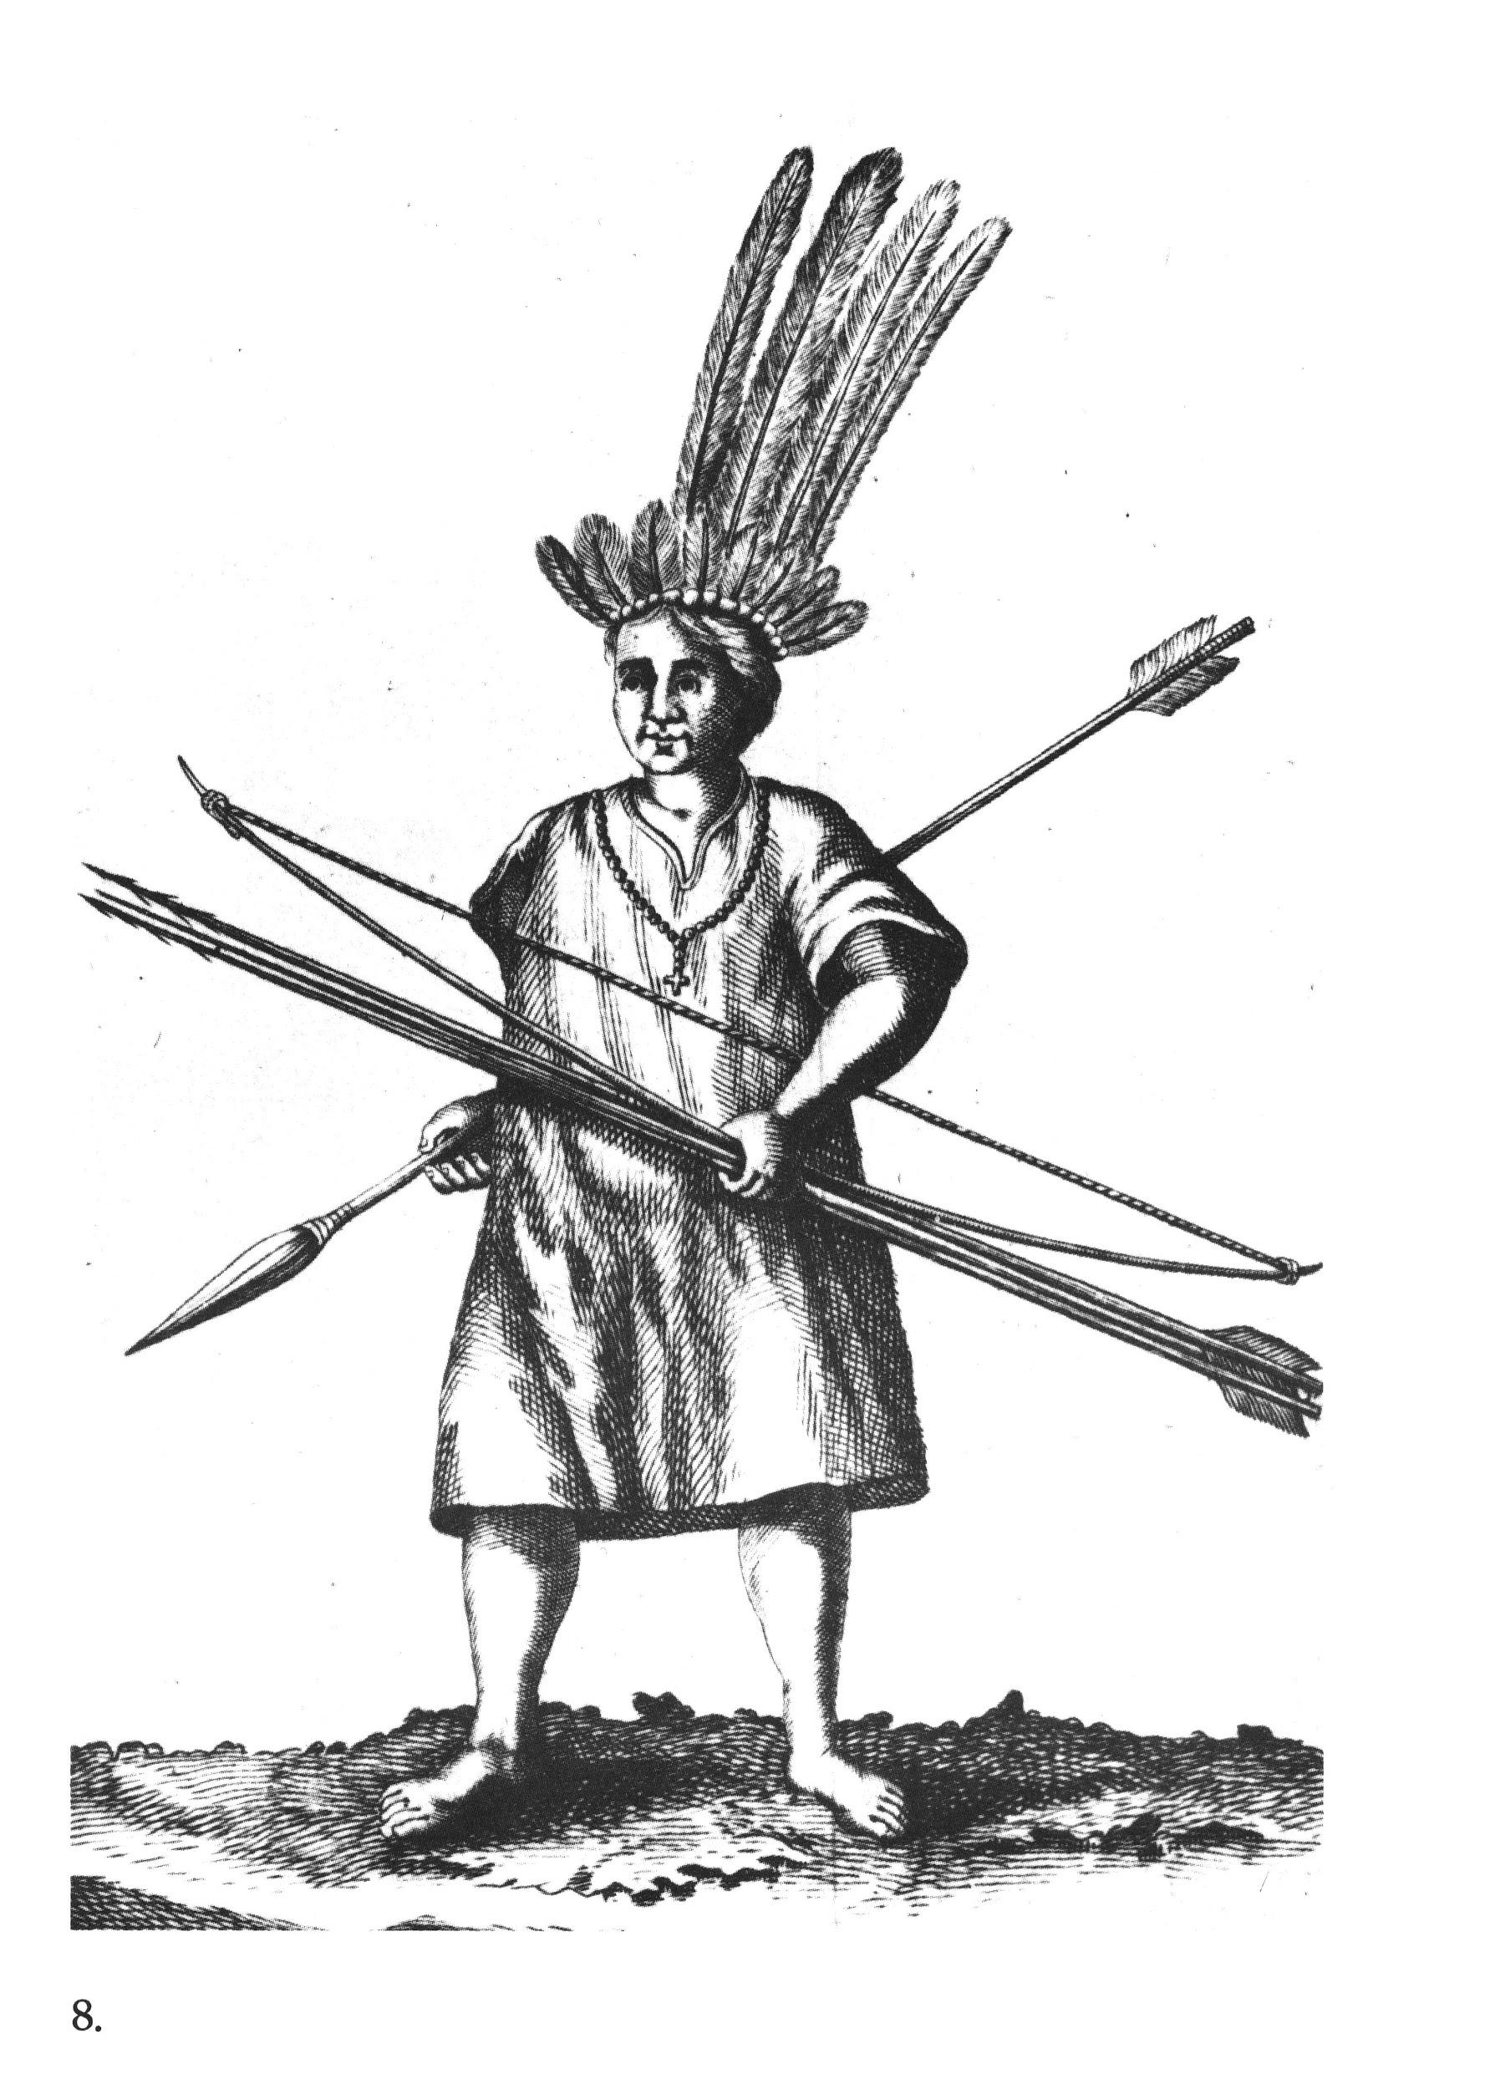
Figure 1. Men’s cushma (Eder 1791)

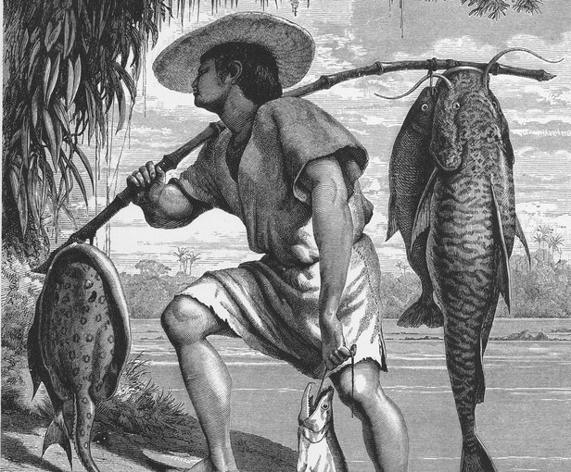
Figure 2. Man fishing in loose fitting garment (Keller 1875)
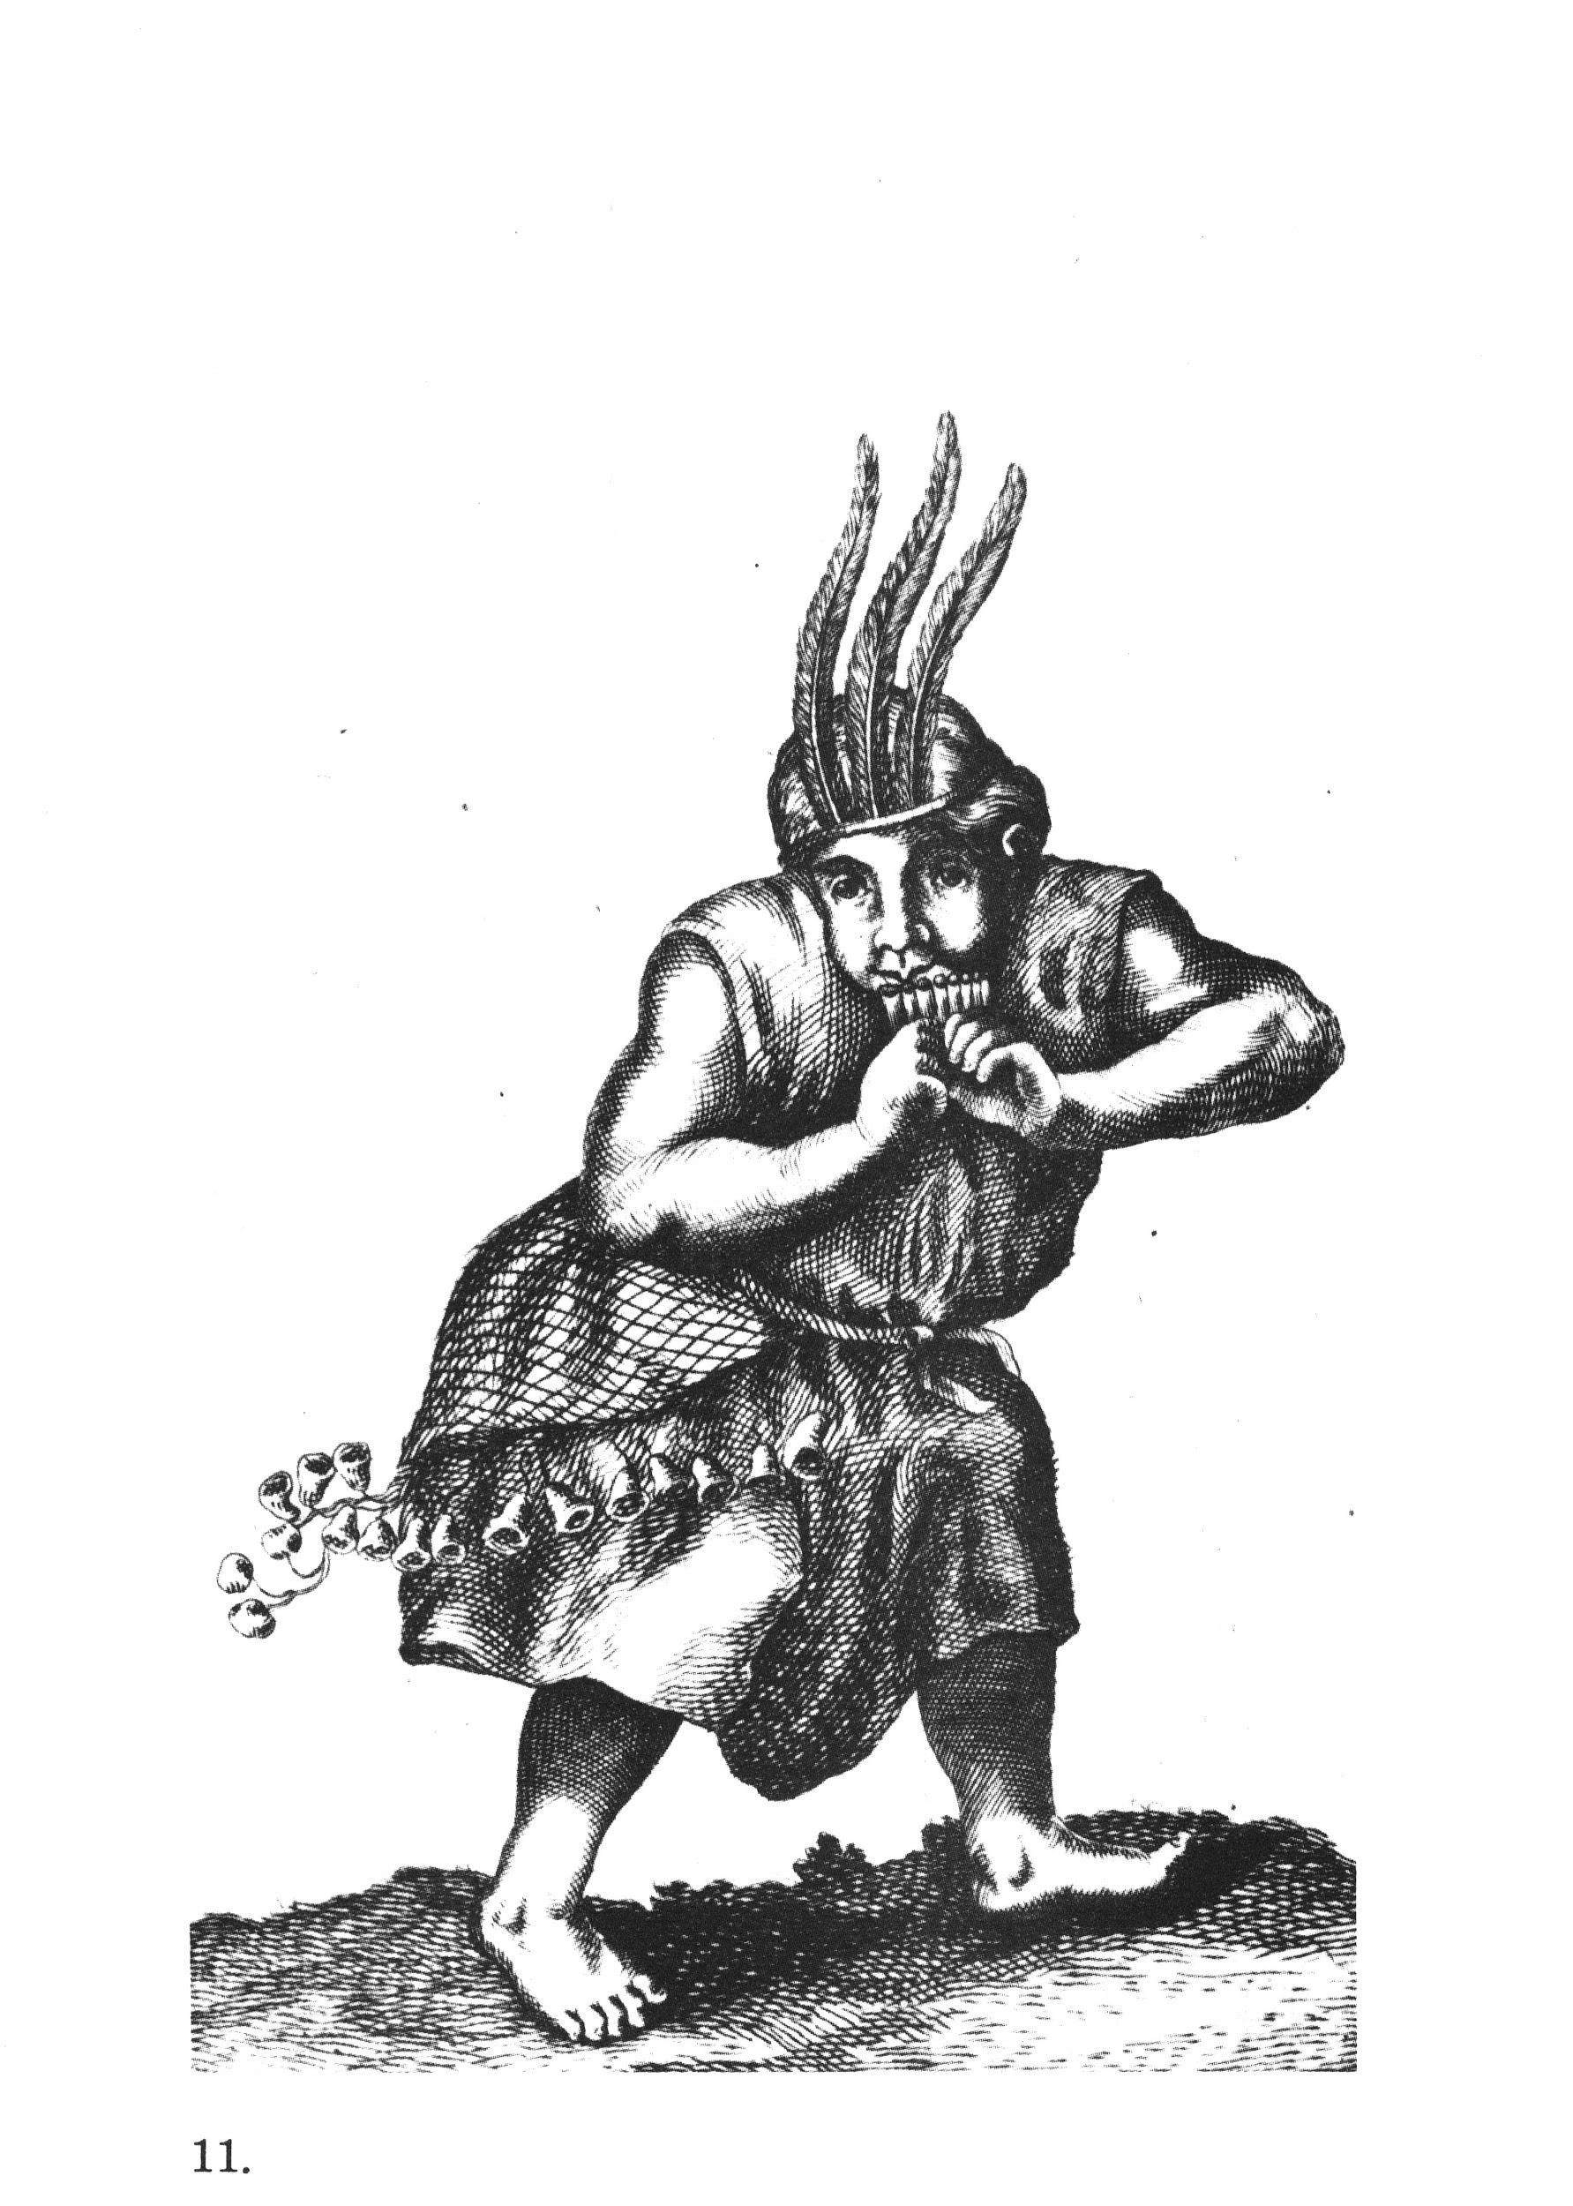
Figure 3. Man posed to fight (Eder 1791)

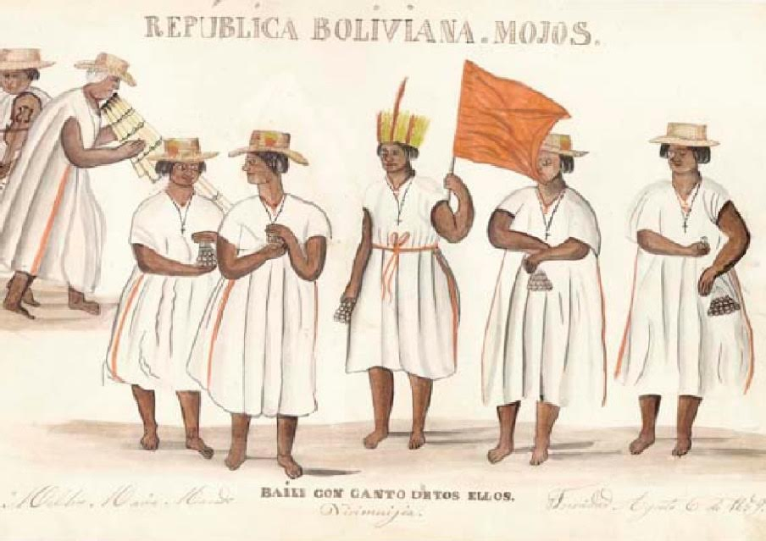
Figure 4. Mojos Indians wearing hats and belts (Melchor 1991)

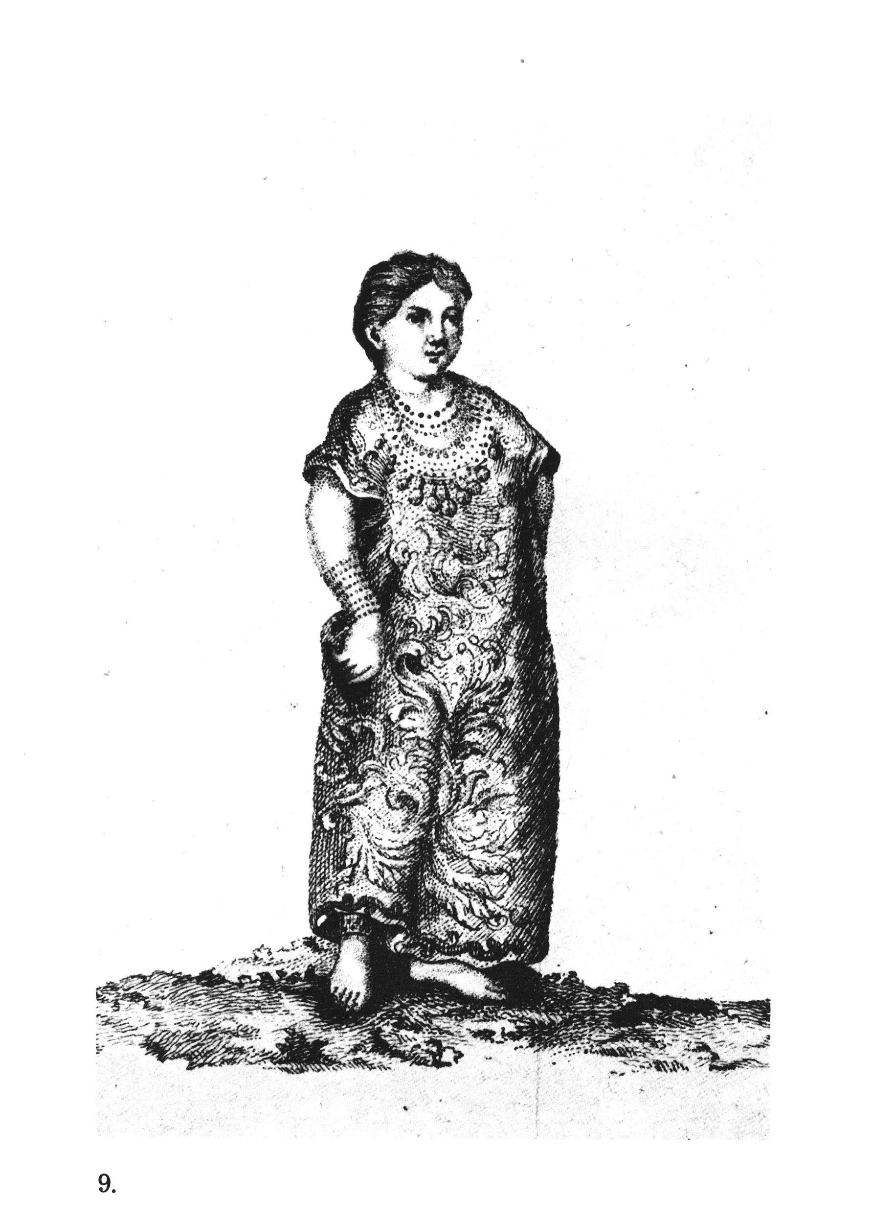
Figure 5. Woman wearing decorated garment (Eder 1791)

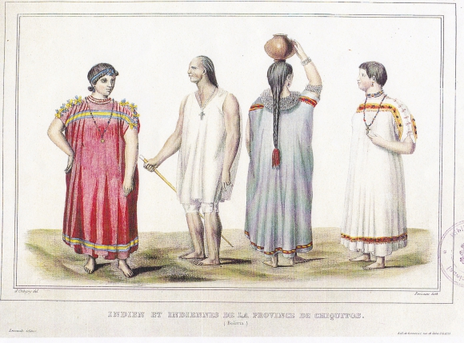
Figure 6. Men and women wearing different colors and styles, hair tied (D’Orbigny 1845)

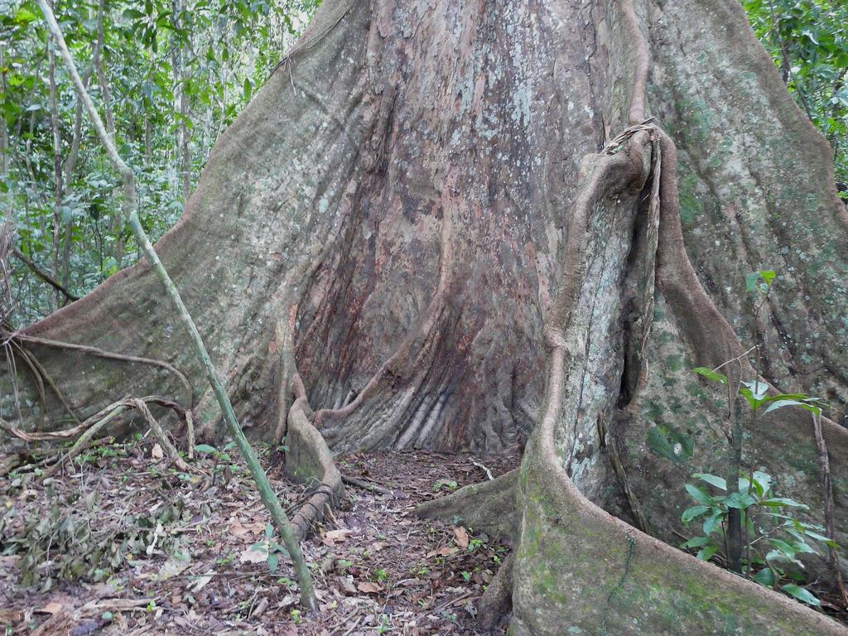
Figure 7. Bibosi tree (Bolivia Bella 2016)
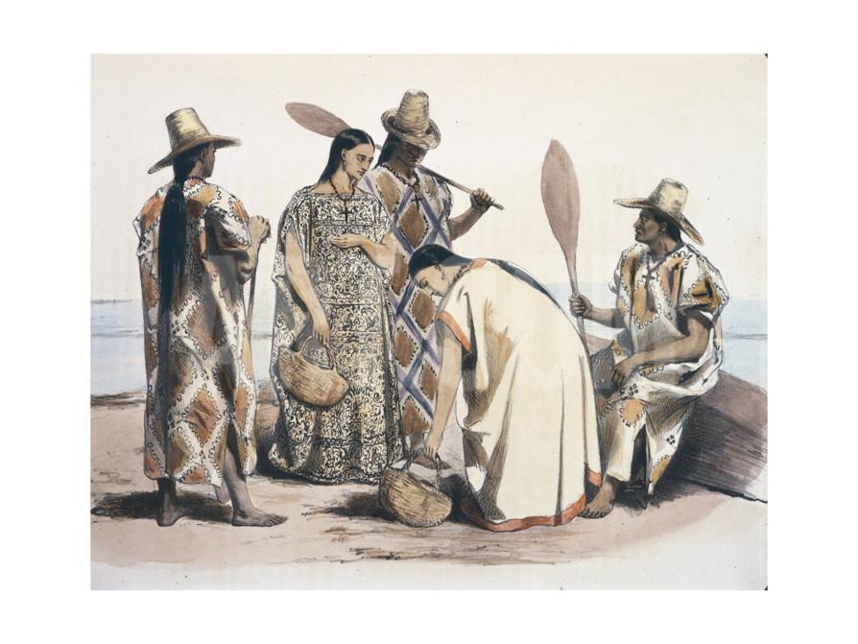
Figure 8 Men and women’s attire: slits for male garments, but hat shows Western influence (D’Orbigny 1845)
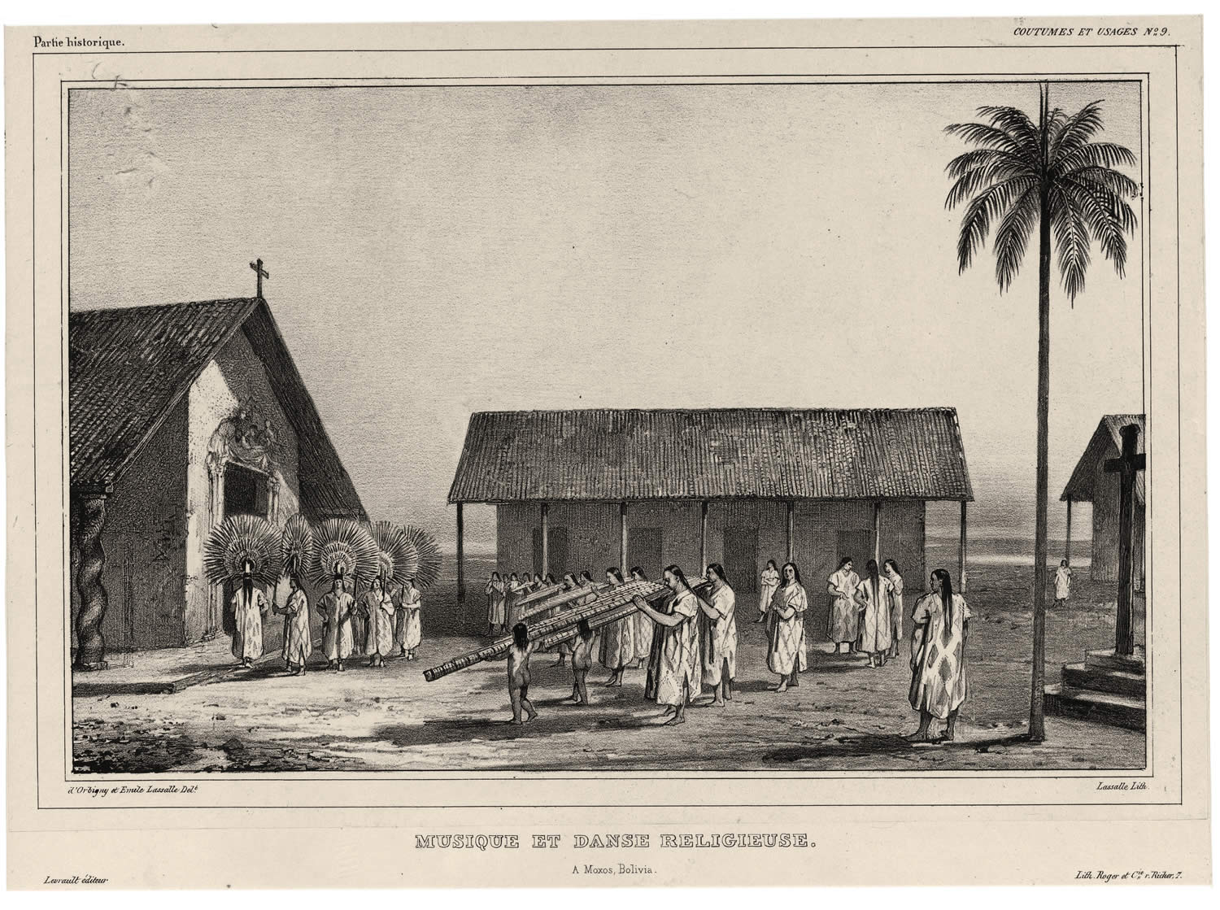
Figure 9. A scene from a religious ceremony (D’Orbigny 1845)

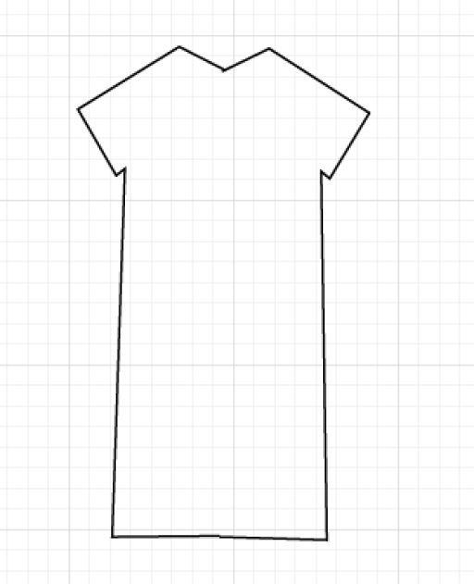
Figure 10. Basic pattern. This is first converted into a 2D panel, which in turn transforms into the 3D garment.

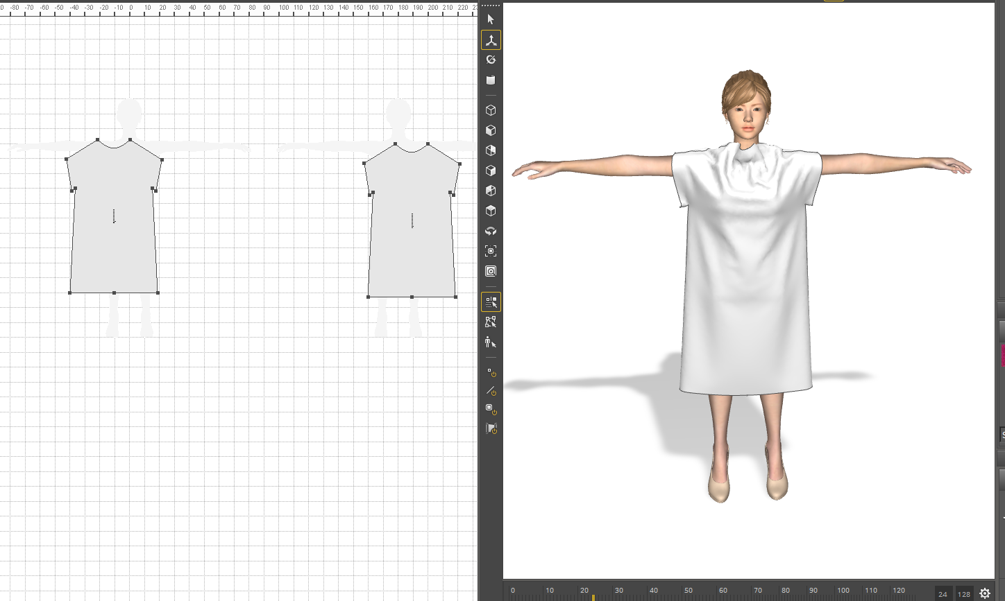
Figure 11. Women’s garment early trial

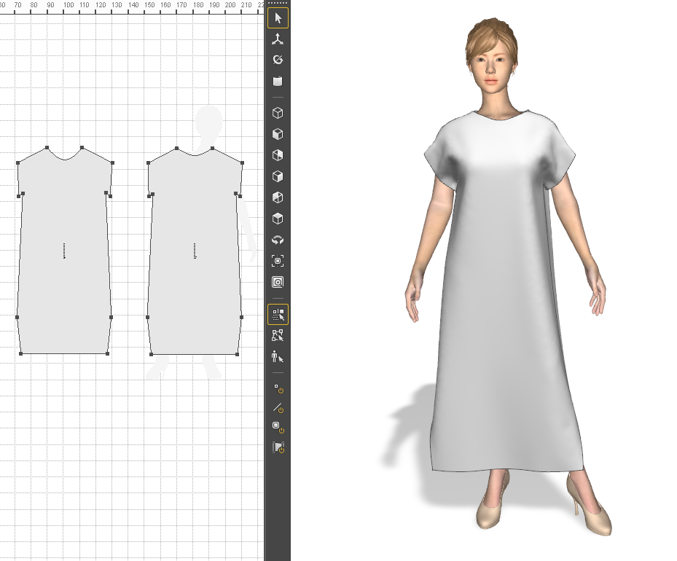

Figure 12. Women’s garment final pattern

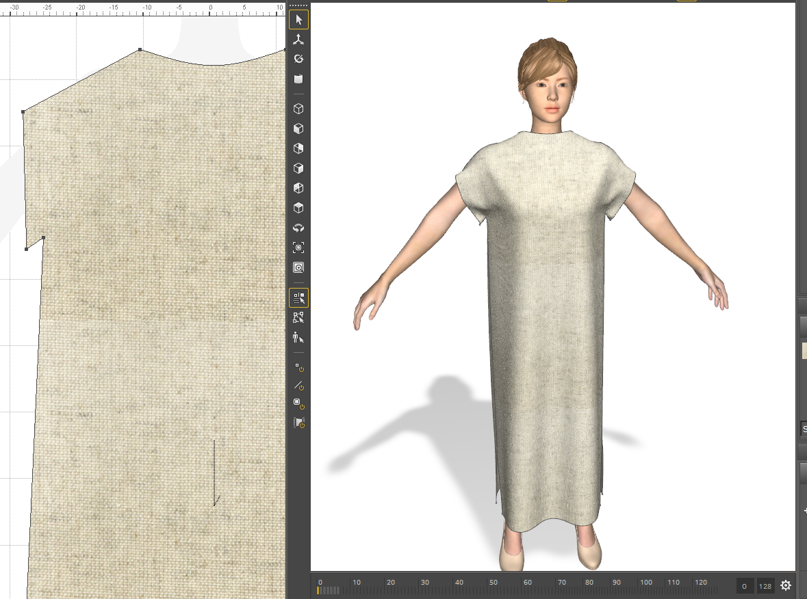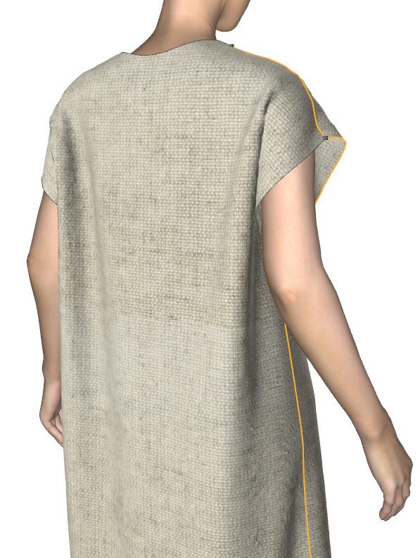
Figure 13. Textile and texture

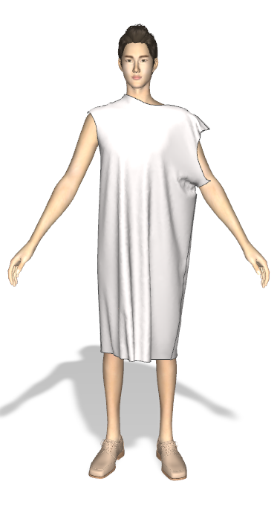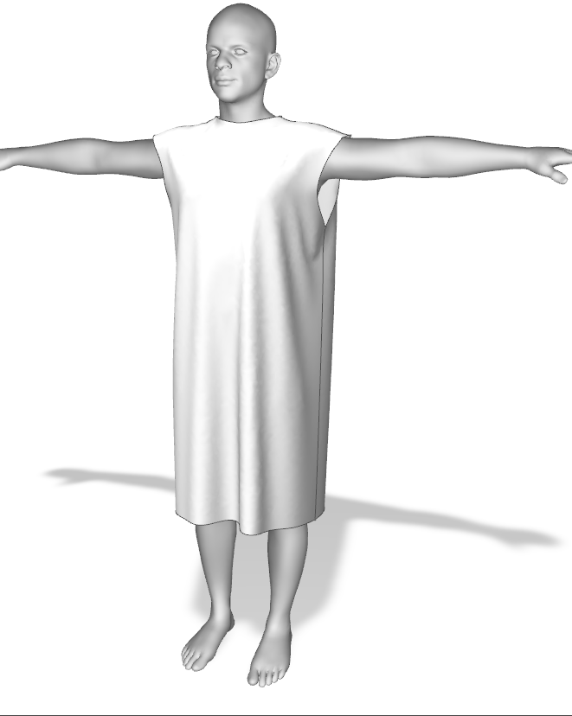
Figure 14. The same garment on two different models (program default on left, Bolivian model on right)

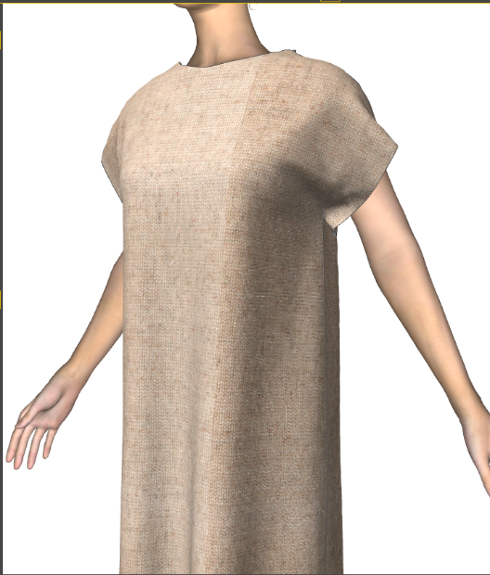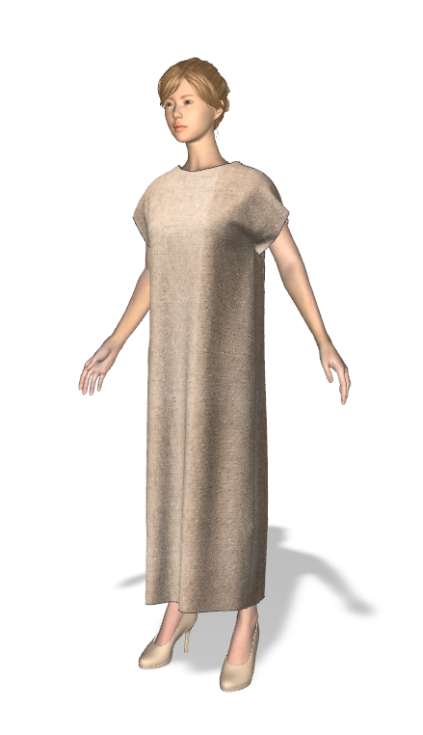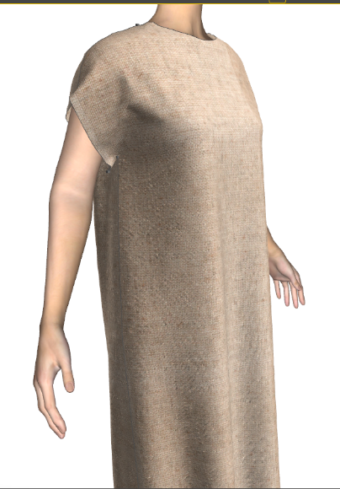
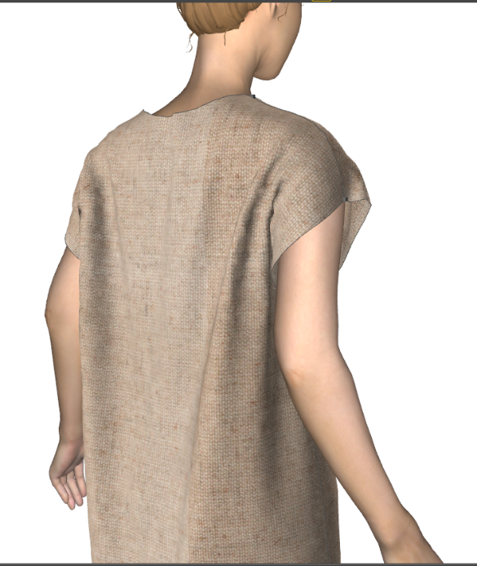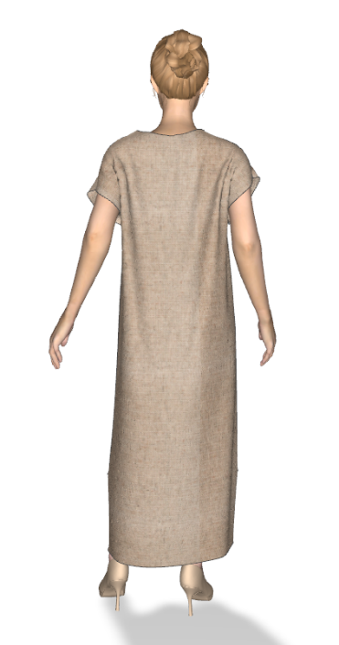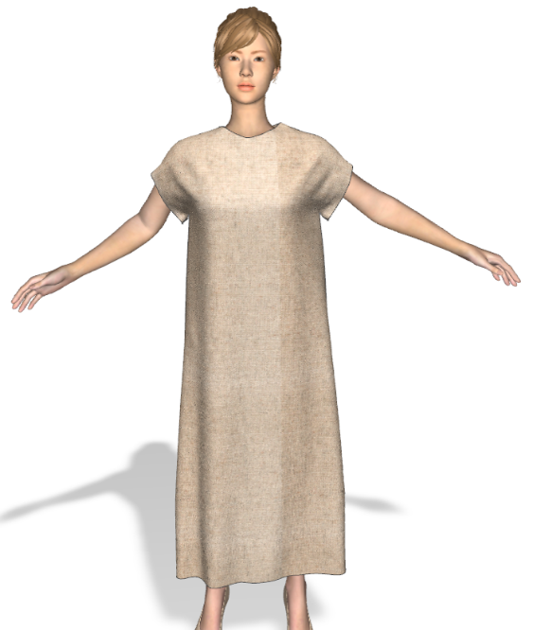

Figure 15. Final woman’s garment

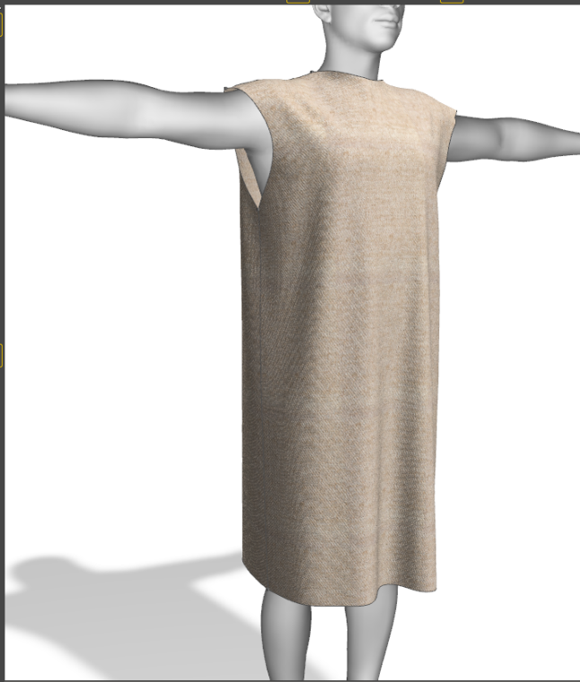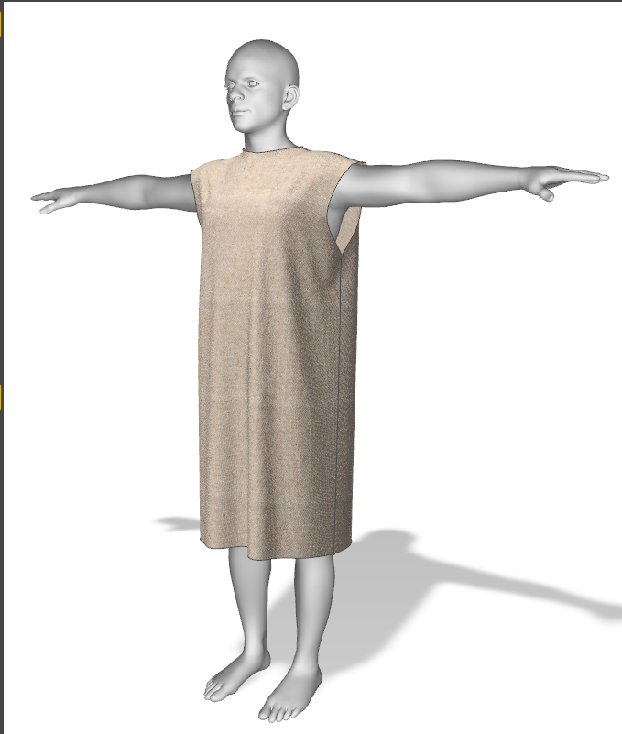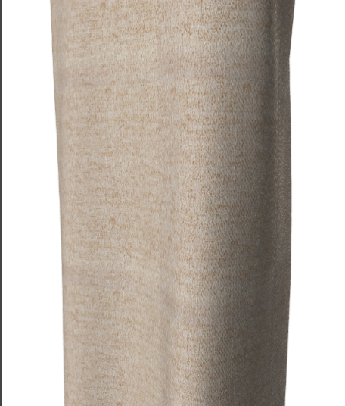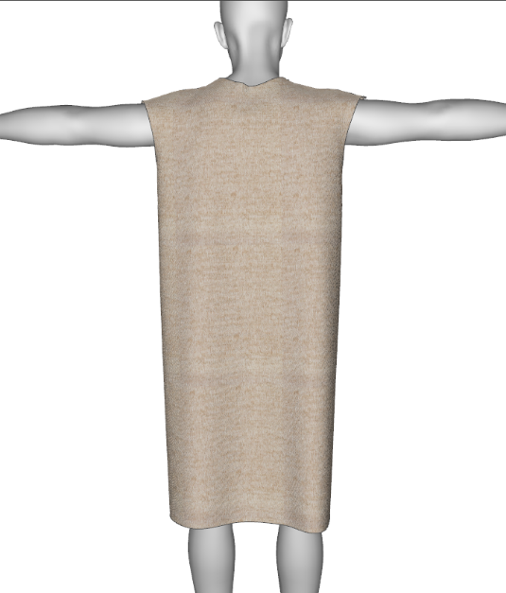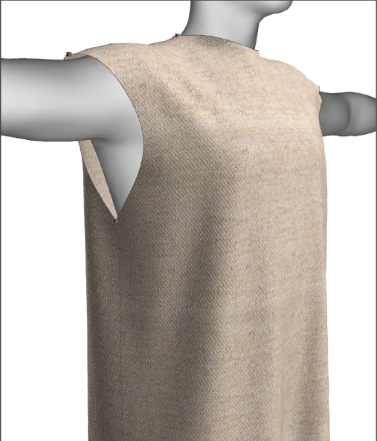

Figure 16. Final men’s garment

