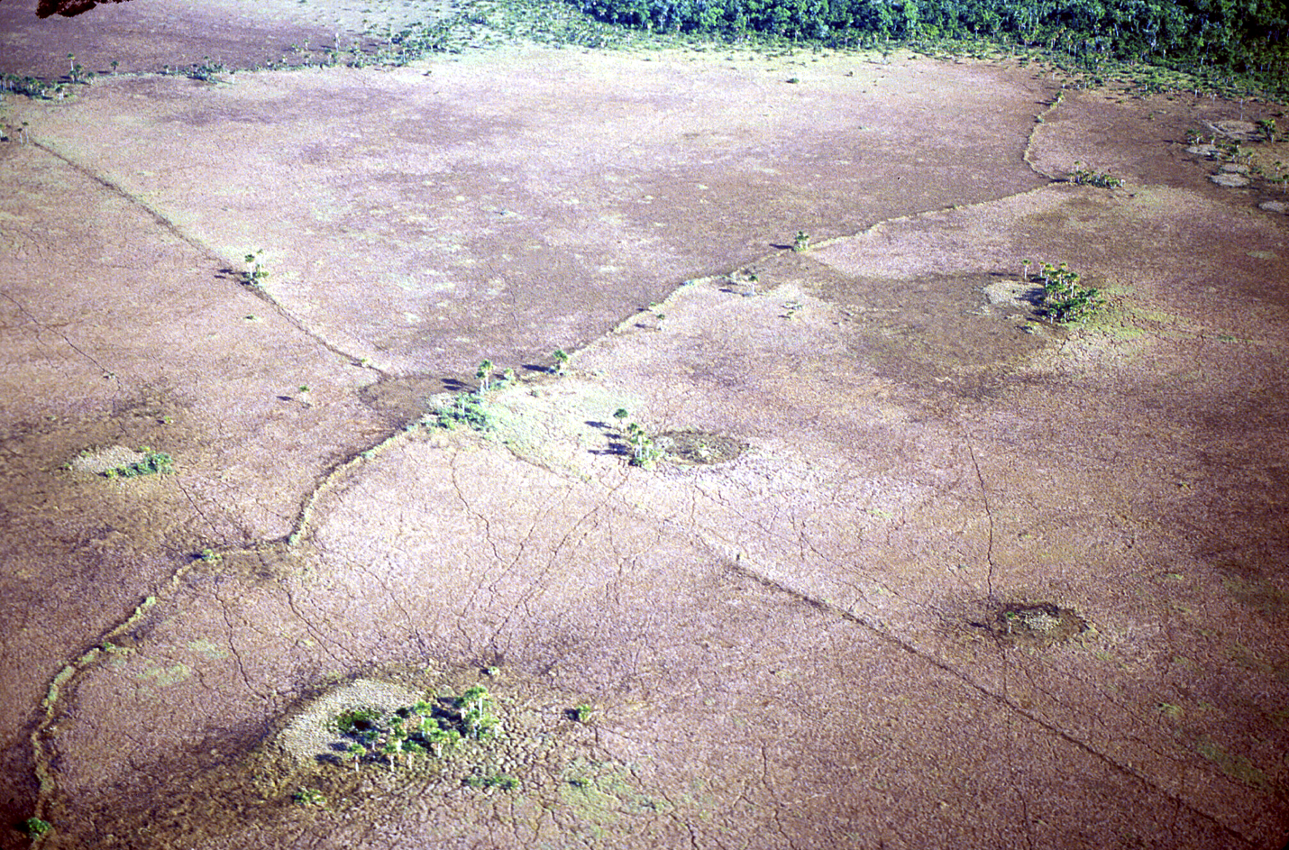
Figure 1. A bird’s eye view of the Bolivian landscape dotted with fish weirs and fish ponds
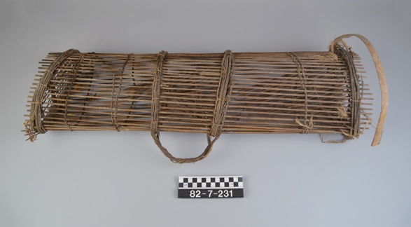
Figure 2. A fish weir trap from Thailand. Object 82-7-231 in the Penn Museum Object Database
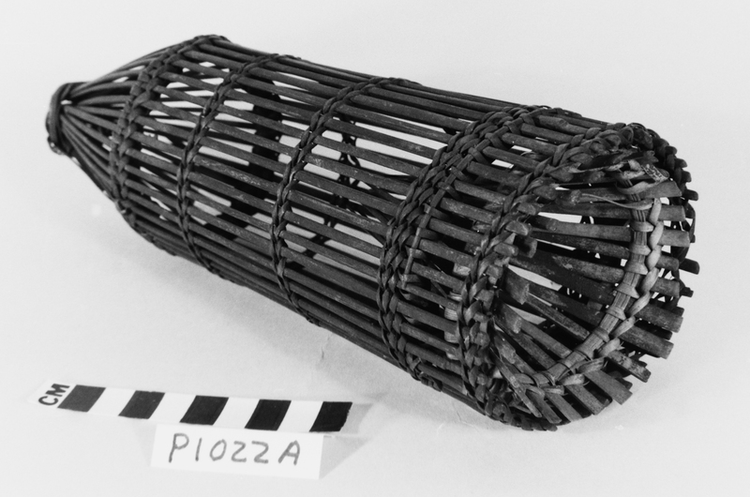
Figure 3. A fish weir trap from Borneo. Object P1022A in the Penn Museum Object Database
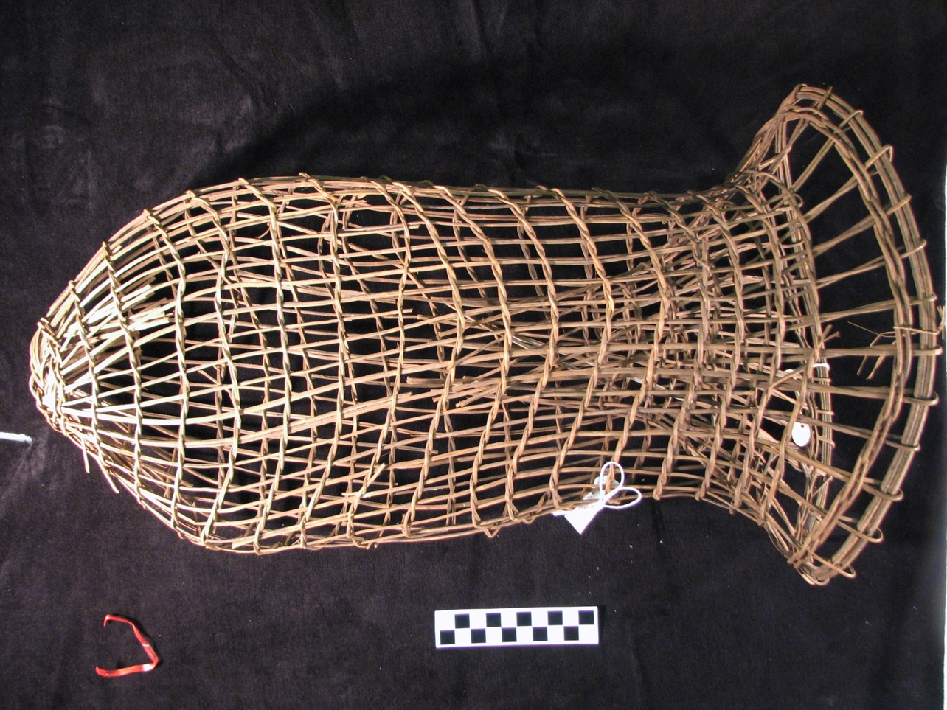
Figure 4. A fish weir trap from Brazil. Object 31-48-358 in the Penn Museum Object Database
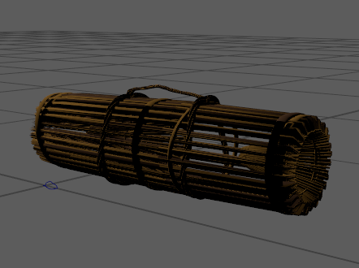
Figure 5. 3D-model of a fish weir trap from Thailand by James Prell
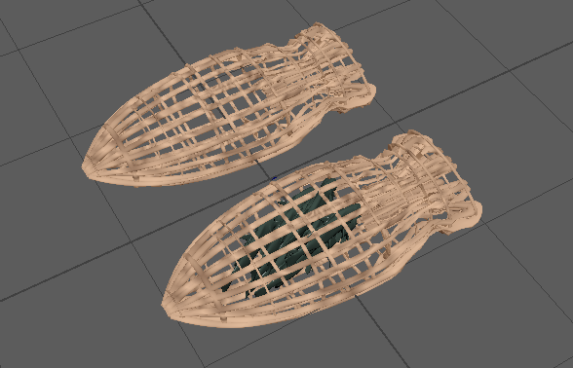
Figure 6. 3D-model of a fish weir trap from Brazil by James Prell
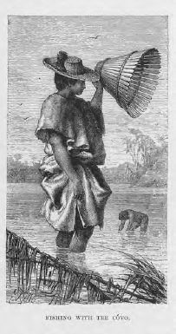
Figure 7. Artwork of a Native American using the cóvo to catch fish by Franz Keller
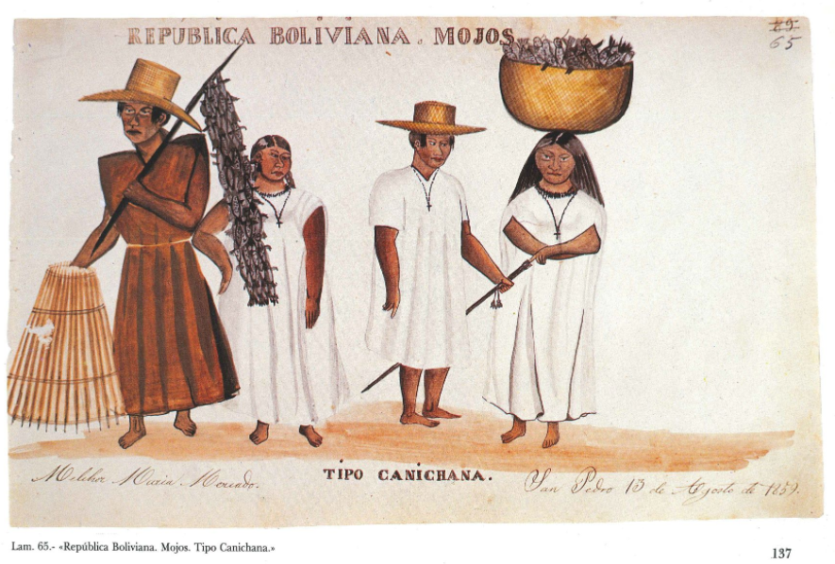
Figure 8. Artwork depicting fishing tools by Melchor Maria Mercado
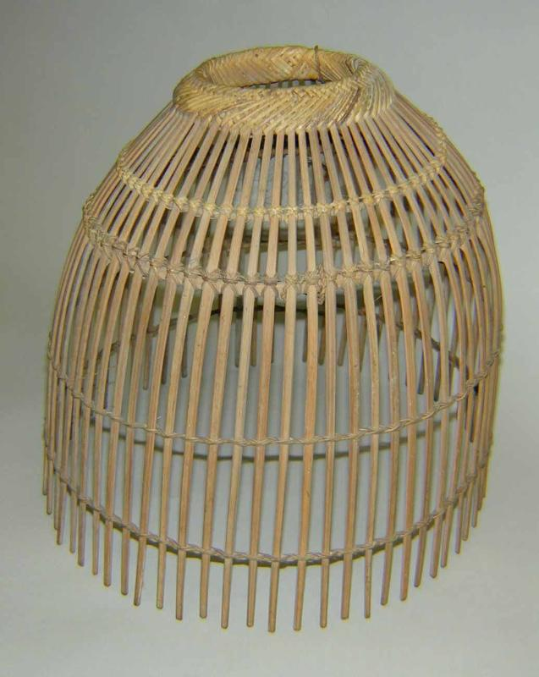
Figure 9. A hand trap from the Philippine Islands. Object Object CIVIC.1993.X.783 in the Penn Museum Object Database
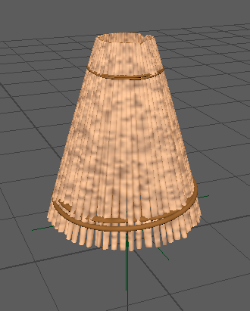
Figure 10. 3D-model of a Cóvo hand trap by James Prell

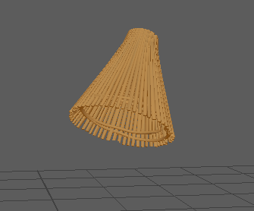
Figure 11. 3D-model of a small Cóvo hand trap by James Prell
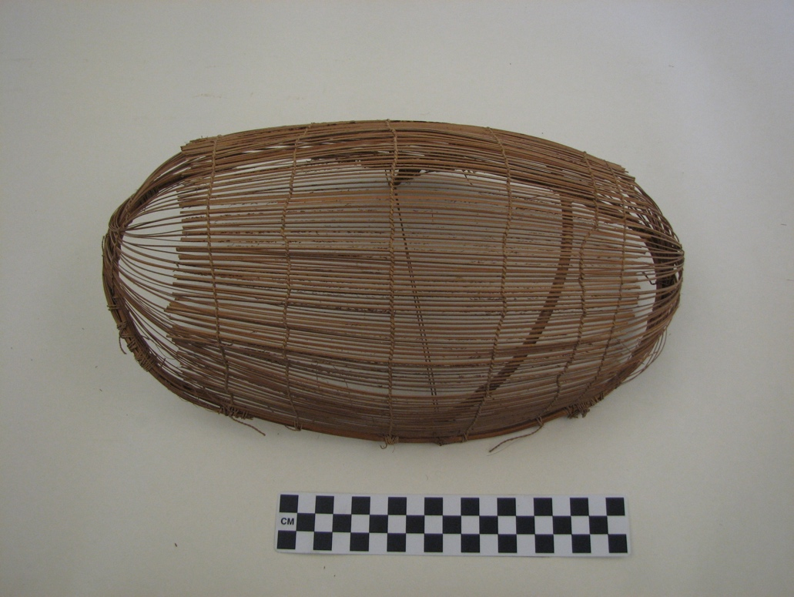
Figure 12. A fish basket located in the Penn Museum archives from Brazil

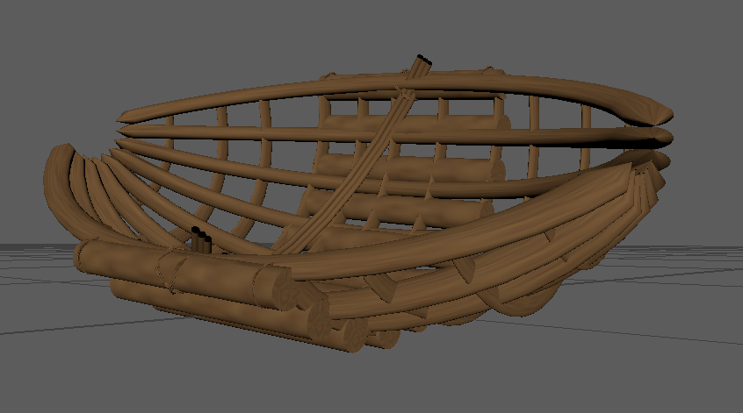
Figure 13. 3D-model of a fish basket from Brazil by James Prell
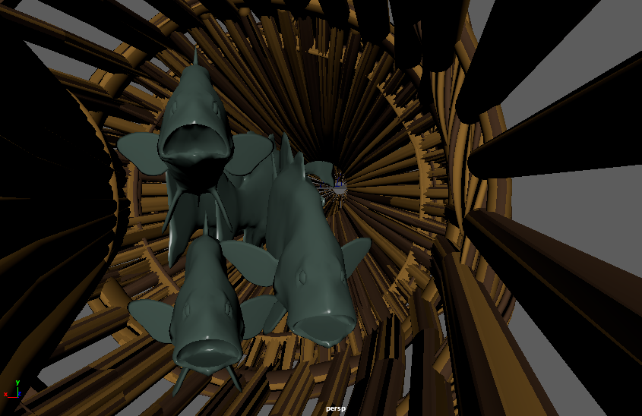
Figure 14. 3D-model of fish trapped in a weir trap by James Prell, model provided by umar6419
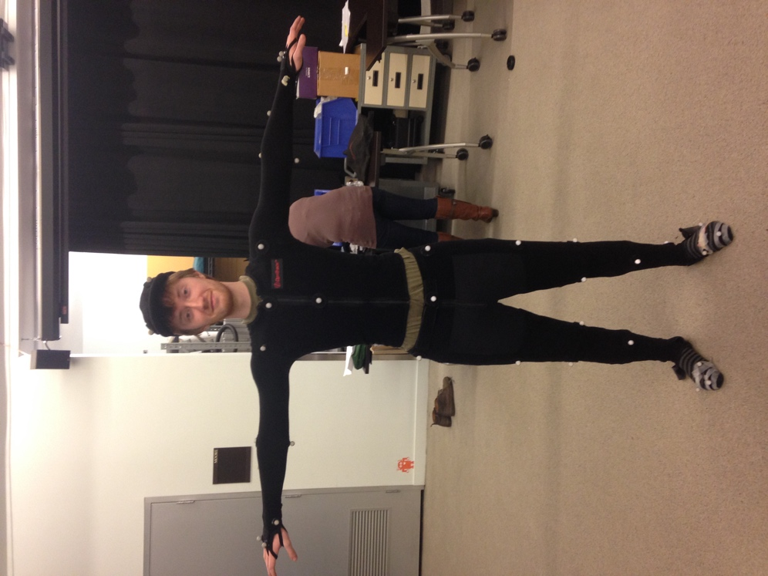
Figure 15. A picture of James Prell making the "T-pose" photographed by Greg Howard
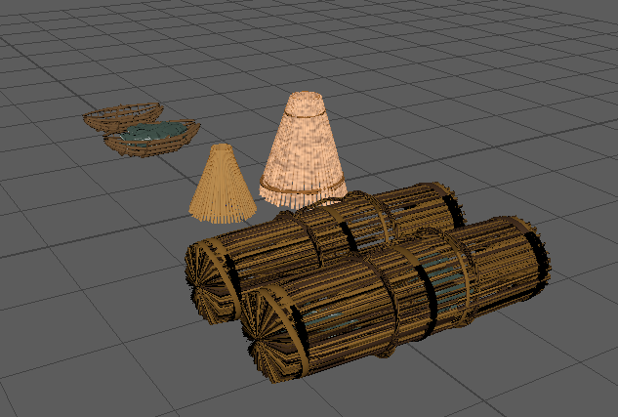
Figure 16. Most of the baskets and traps placed next to each other for size reference

