December 21, 2016, Clark’s comments

Malkia

Most of the content of the text is fine, but your writing is poor. I was surprised because your writing in the Assignment 1 paper was very good. Getting help from the Writing Center is an excellent idea. I’ve made many comments and suggestions to help you quickly revise for resubmission and a higher grade.

Try to avoid using “it is” “there is” “this is” and related vacuous expressions in your formal writing. Although grammatically correct, you overuse them. In all cases, the sentence can easily be rewritten to be clear, concise, and direct.

You did not follow the guidelines about the use of a style guide.

Your Figure Captions could be improved through rewriting and few more relevant details about what the image represents

If I assigned a grade to this version, you would receive a grade of “C”. I suggest that you revise and resubmit immediately. Add “b” to the end of the file name and add the date of submission to the first page of the text file to keep versions separated.

Malkia Okech

Prof. Clark Erickson & Prof. Norm Badler

CIS 106 / ANTH 258

Visualizing the Past/Peopling the Past

19 December 2016

Digital Exploration of Broken Pottery

When looking at any one thing in history, an image comes to our head. Whether or not our vision is informed, a mental picture comprised of everything we have learned about x,y, and z synchronizes into an image and thoughts. These images could be negatively or positively informed, but they exist. What we envision in our minds is all a compilation of sights and experiences. What about the past is so special in particular when thinking about this concept? Without living in these past times or places, a clear idea of the past is difficult to what?. Therefore, these images, especially if we have not studied it, come from loosely based ahistorical iconoclasms presented through media. Digital Technology presents a wonderful opportunity to correct these myths. This is possible by visualizing or peopling the past. Peopling the past is an idea in which we place a vision unto the past. This is a term often employed by historians and anthropologists, seeking to get a “snapshot” of the time before their own. By making and creating academic goals with this mindset, preconceived notions of life and times of the centuries before us can be attributed with fuller and more accessible resources. An audience must be engaged in order to hope that they leave with something they did not know or desire before. The above section is well written but a bit vacuous and vague in actual content. We had many readings relevant to most if not all of the ideas above that could be formally cited and expanded upon. You need some authority in your writing and show your research.

CIS 106 / ANTH 258 was a course that challenged the student to take these ideas to heart and create something out of it. Gathering computer science and social science students, each was given the challenge to create an engaging piece of content that would help us to people or visualize the past.

I was particularly interested in implications and actions involved with pottery. In general, I enjoy looking at material culture, how things are crafted, how they evolve through time, how they are acquired, and what we do with these finds. Pottery is a common good passed around throughout history, transcending geography. It is a staple of material culture, contributing to our anthropological knowledge of day-to-day activities, storage, exchange, and burial ritual. Archaeology helps one to differentiate, or attempt to differentiate, these functions. Understanding these functions helps us to understand the lives of those of the civilization being studied. Day-to-day items like pottery are important to contextualizing the past, therefore helping us to visualize and people it. Again, the above is decently written but vacuous. Why is pottery so important to the people of the past and to archeologists? What functions does pottery have in past societies? Can it “speak?” What does it tell us about people of the past? I suggest adding an entire section about the Importance of Pottery. You have some content in the section below. I suggest a section on pottery in general, then a section about how archaeologists study pottery and what sherds can tell, methods used to describe, analyze, and interpret pottery, with a focus on drawing pottery and doing reconstructions of vessel forms and why.

Approaching my project, I focus on the implications, difficulties, and trial and error involved with broken pottery or pot sherds. Pot sherds are one of the most common, and aggravating, finds on an archaeological excavation. Archaeologists have a love-hate relationship with pottery. broken pottery can be found all over a site, and depending on a number of factors can determine the functionality of it, from cooking to storage. Vague. Therefore, breakage is definitely an important aspect of studying pottery. Some information is definitely lost from this type of incident? which is sometimes inevitable through time, however this provides further tools for contextualization; type of pot, how it was made, and where it is found as well as breakage gives us a lot of cultural information.[1] Vague I believe it is important to share this with a public audience because it places a common narrative to the everyday person of ancient life. We often focus on the “treasures” and royalty of the past, but when we look at ourselves today we have to remember that our presence alone also leaves a legacy on the future, even our most common items. This is how archaeologists look at the past. How a broader audience peoples the past is influenced on what features of the past are emphasized. Therefore, I wanted to put together a project with sole focus on the beauty and hardships of pottery, aestheticizing it in such a way that one would not expect such a common object to be. The above text has little content. Please rethink this and rewrite. I suggest consulting a basic textbook on archaeological pottery such as Anna Shepard’s classic work or reread the more modern treatment by Orton and Hughes that you cite..

Goal: To “image the past” by examining a common artifact, pottery, and the archaeological methods attached to it, then try it make it fun and interesting for multiple audiences. I want to learn how to digitally replicate ancient pottery using three-dimensional software, paired with a realistic depiction of excavation conditions and the process of reconstruction. I will primarily utilize 3D scanning using a NextEngine laser scanner, and the 3D modelling program Maya. I will finally compare these processes to the traditional method of drawing pottery. Rewrite the above paragraph to be concise, clear, and direct.

Context

The pottery that I chose for my project is a vessel from the city or Ur, located in present-day Iraq. It was found during the joint excavation by the British Museum and University of Pennsylvania Museum of Anthropology and Archaeology (Penn Museum), directed by Sir Leonard Woolley from 1923 to 1924[2] (Figure: a map?). Its records show it was found in the Persian level of the excavation in a building called the *Giparu*[3]. This was a temple used by magical women referred to as *entu*-priestesses[4]. They were wife-figures and proponents of sacral marriage. this particular pot may have been used for ritual purposes. Its linguistic roots link it too many “its” to being a storehouse as well as sacred place[5]. Perhaps this vessel stored foodstuffs of some sort, or a kind of offering.

Physical attributes of this vessel include an ovoid or egg-like body, a flat base, and a wide short neck that flares out (Figure ?). It is buff colored, with markings around it. The darker spots could be wear, or burn marks. The original what kind of? number is written directly on the object, with a “U” or “Ur” number. This helped me trace the object in original publications. It also helped me when I initially played around with the sherds to see what fit where, since cracks are through the labels?.

Process

My process for this project can be broken down in the following segments: The traditional model and the digital model? 🡨Too vague. I think that you mean “method”. First I will examine the traditional, physical, method of recording sherds and pottery. Then, I will run through the more complex methods I used to create my digital project. The general processes of these two segments both contain their own benefits and setbacks?, which I will also consider. Rewrite the above paragraph.

1. Traditional model:

For the traditional model I used the traditional process for pottery profile drawing. This practice is common for recording pottery on archaeological digs. It uses simple measurements and geometry to draw a simplistic look? at the body of a pot. I had an advantage already, having sherds that I know go together and that are in large chunks?. Rewrite last two sentences.

The most essential element in this approach is the rim. Taking a sherd with a good amount of the rim on it, I measure it on a rim chart to measure the diameter of a pot. First, explain what a “rim chart” is; then how it chart is used and why. The correct measurement is whichever curve that the rim best aligns with. For this vessesl, the sherd fit perfectly at five centimeters in radius. This number multiplied by two is the diameter of the what of the vessel?, which comes to ten centimeters. Using a ruler I can begin drawing a T chart? explain, the diameter being the horizontal top of the T?. explain For the vertical portion of what?, I measure the length of the sherd that is the largest chunk? of the pot’s body. It is just about three inches. It is important to measure from zero for all of these calculations. Next I measure the base. This isn’t a typical practice but since it was available I wanted to get the most accurate measurements possible. The diameter of the base came to five centimeters, based on it being at the two point five mark on the rim chart. Now I have an approximated skeleton of my pot. The above text needs to be completely rewritten to be clear, concise, and direct. I suggest taking a look at how the process if described in archaeological field manuals or pottery textbooks.

Almost every sentence starts with “I” 🡪Next I can look at the curves of the body?. I only have to do this for one side?. Later on I can flip, or mirror image, the one-sided drawing? Which drawing?. I did not have all appropriate tools at my disposal, so this was the roughest part of my drawing. I measured the next flaring out, about one centimeter, then the first outward curve of the body, 3 centimeters, and the inward curve of the body going to the base, so about 5 centimeters. I had to approximate the angles since I did not have an appropriate tool to measure it. What is the appropriate tool? This is not standard practice and note taken for future reference. For the thickness of the body, I used the caliper and measured thickness at as many cross-sections of the pot sherd? that seemed necessary. The physical process of what? took me about thirty minutes. Most archaeologist would use an old fashioned carpenter’s scribe ($5) to get the physical vertical curvature of a rim sherd, then transfer the curve to the paper at 100% scale.

For the final illustration, I created a neater two-dimensional image?. I scanned my drawing and uploaded it to Adobe Illustrator as a layer. In a new layer I used the pen tool to trace my profile drawing as neatly as possible. I copied and pasted the posterior to the other side and [flipped it-you can find better words for this]. Then I reopened the file in Adobe Photoshop, selected the left side where thickness? =The sherd profile? is present, and filled it in. The final illustration looks neat and professional. It was a very simple but time consuming process. How long did the entire drawing process take with this method?

1. Digital Method:

The digital method for reconstructing vessels from pot sherds of my project was done over a series of days. It was much more involved and used more programs, all of which were foreign to me. The biggest obstacle to my project was the learning curve. However, once I thoroughly learned each process I did not understand or learn at the computer lab, it all made sense and I was able to proceed confidently. 🡨rewrite Because of the difference in process and function of programs at each step, I will divide this section into five parts: Scanning, cleaning, reconstruction, animation, and setting the scene.

1. Scanning

For the scanning of the sherds, I used a NextEngine laser scanner, courtesy of Dr. Peter Cobb of CAAM at the Penn Museum. from the beginning I built and configured everything by myself, with only minimal assistance. It was less complex of a process than I expected.

The NextEngine system comes in two main parts, the 3D? laser scanner and the platform. The Scanner is a box, with an area where the laser light beams [shoot out], and a large flash for capturing two-dimensional images of the pieces=potsherds?. The platform has a base that rotates during the scanning process, a rod, and the platform itself. The platform consists of [a top and bottom part?], which hold the object together?. This part? Which one, the top or bottom? is not more than foot and a half or so tall, limiting the types and size of objects to be scanned. You need to define what you mean by “pieces”.

In preparation for scanning, the object is placed on the platform and the top piece? =top part? holds the object in place. This must be done strategically so that all the important pieces are recognized? Top piece and what other pieces?, as the bits? that the platform is holding will lose data since the platform gets scanned too. You lost me.

After “scan” is first clicked on the NextEngine program, NextEngine ScanStudio, the flash releases taking an initial live image for a preview area. Here, I can adjust the scanners placement, and make sure the object is centered and in focus. It is important that the rod is at the left side of the screen, since the base rotates clockwise.

By clicking “scan” again, the actual scanning process begins taking about fifteen. minutes for the whole process. The base rotates and stops at five checkpoints, creating five different images and scans from different viewpoints that will be later combined?.

At the end of the process, one must click “trim” to edit crop? the platform pieces? using polygon and rectangle tools. The pieces that will be cut are highlighted red after selecting. Then one can delete the selected pieces. After this, clicking “fuse” merges the the scans and photographs to a single piece =3D image or 3D model?. I did an initial save as back-up, then exported the files as mokech scan#.obj to be consistent. .Obj files are uploadable to Maya and most other three-dimensional modelling platforms.

1. Cleaning

While searching for ways to clean up my scans, which were full of holes after the initial process, I found Autodesk Remake. 🡨rewrite. This program is specifically designed to work with three-dimensional scans and images with options to do photogrammetry, editing, and preparation for three-dimensional printing. I uploaded my .obj files, I decided to work with six sherds, and edited them individually.

to fill mesh holes, I clicked “edit” then the “fill hole” option. There are 2 options for patching up a hole: smooth or flat. I first tried smooth but it rounded and [puffed out] the area, which was the edge of a sherd so this was not accurate. I undid this and tried flat, which worked perfectly. I could not fill every single hole, and the program slowed down and crashed a couple of times. But it was a quick and easy process, yielding cleaner scans.

1. Reconstruction

This process took the longest amount of time. I know that tweaking must be done to my final product [, but I spent quite a number of hours even getting it to that point? Which point,the final product or tweaking the final product?. I took a series of photographs in which I paired a sherd with its most logical immediate relative. This was my bouncing off point. I uploaded an object at a time, in conjunction to immediate relative, and scaled each object at x = .099, y = .099, z = .099. It took me a little while to realize that having a stationary scale system incomplete sentence?. After I had good size and its pair, I [fondled with] rotation and translation for each sherd until I believe it fit.

Once I had an approximate location for each sherd, I did a profile spin to make a template to finalize sherd placement and prepare for the animation. I did this by going to “curves/surfaces”, and used the “curve” tool to mark along the profile, starting at 0,0,0 and ending slightly above the origin point making the thickness of the pot. I then hit “revolve” and the pot was made. I scaled it down a little so that the sherds settled comfortably on top of the template, as opposed to meshing them together, which looked sloppy. I finally made the spinned pot transparent and a bright color to make it stand out but still let there be focus on the sherds when they rested on it.

1. Animation

For animation I wanted the sherds [to pop out in an explosive fashion]. I wanted the pieces? Sherds? to be scattered, then come back together. 🡨rewrite. Specifically what kind of animation are you trying to produce and why? Explain first. Key frames are a relatively easy concept to understand. The program does most of the work, you just have to set the start and end points. To make things easier, I worked backwards, so I set the first key frame by hitting the “s” key for each sherd while they were attached to the template. Then, individually, I scattered the pieces, fitting “s” again for each. When I pressed “play”, the sherds gracefully scattered off =separated from? of the pot. By hitting the reverse “play” button, the pot put itself back together, which was one of my goals. after creating a plane and an archaeological dig-site scene, I decided to make this animation in two parts. Rather than go through the work of manually reversing the animation so I would not have to worry about reverse “play”, I would do the following: Copy the first key frame and past it to the very end at “200”, since the animation was just set from zero to “115” at this time. So what would happen, is that the pot would come apart, rest in the dirt for a few seconds, then pick itself back up and unto the template again. my justification is to show A pot starts together, then breaks over time (wear and tear, stratigraphically piled on, broken during the dig), then it is the archaeologist's job to piece the pot back together if they choose to, or as I am choosing to through animation.

1. Setting the Scene

Setting came in between animation, since I worked on that on and off, but I did not think to do this until the end of my process. I decided I wanted to place my pot where it came from, the Middle Eastern ancient sands, on an excavation site. While a minimalist free-floating view can emphasize certain futuristic look, context is important for the viewer to understand and helps them to “visualize the past.”

First I had to create a plane, so selecting this option from the “polygon” tab and stretching it appropriately, I was ready to work on it. To create a realistic texture for the plane, I made my plan with a DEM (Digital Elevation Model) stock photograph. I did this by using the “Sculpt Geometry Tool”, selecting the “pull” parameter, and then importing the DEM as the map. .png files work best for this method. I stretched it so I could make it seem like a bumpier close-up area. I thickened it using the “extrude” tool. Next I wanted it to be realistic, so I created texture by right clicking the plane, selecting “create new material", adding a new lambert, selecting the grid next to “color” for lambert”, and played around with different terrains. I settled with mountainous, but I added a stock image on top to make it more realistic.

To increase the realism, I replicated some of the sherds, resized them, and scattered them across the plane. This applies to the idea that sherds are complicated to pick out and piece together. 🡨rewrite. I wanted this to be as clear as possible in the simplest way

You can summarize the following “Data” in a regular sentence in the main text

Data

|  |  |  |  |
| --- | --- | --- | --- |
| Pot | Rim | Base | Height |
| 29-174-4 | 10cm | 5cm | 7.62 cm (3in) |

Figures belong with the figures file, not here.

Below are the axes of all of the sherds when put together.

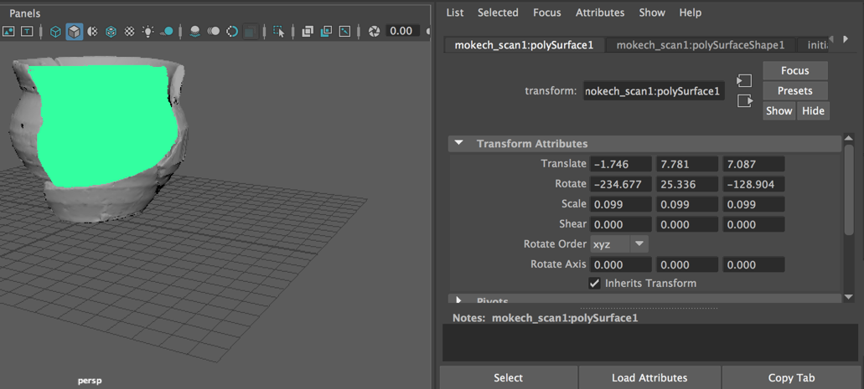

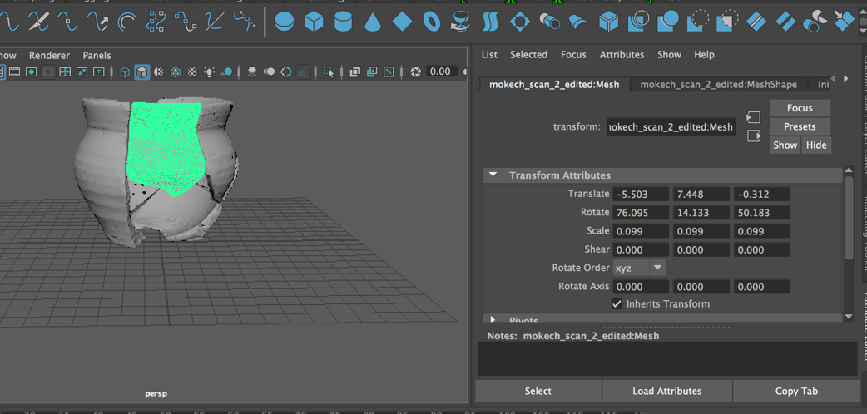

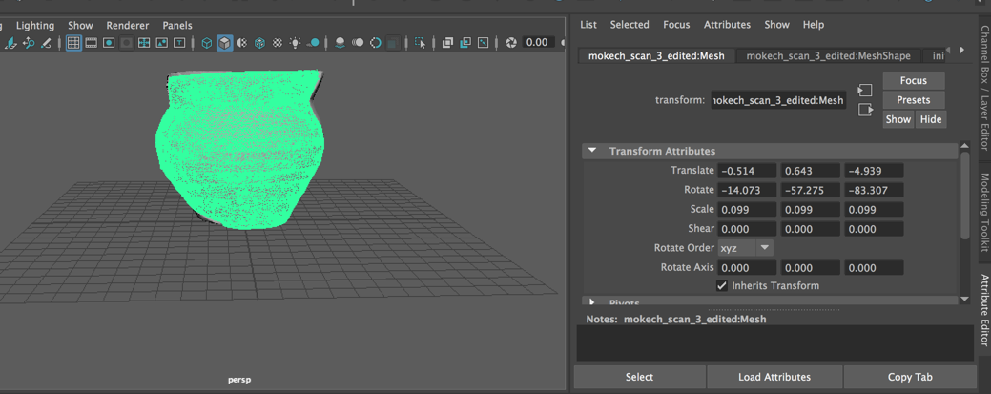

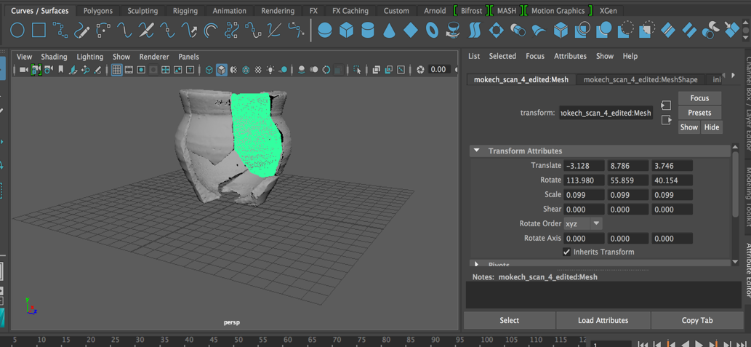

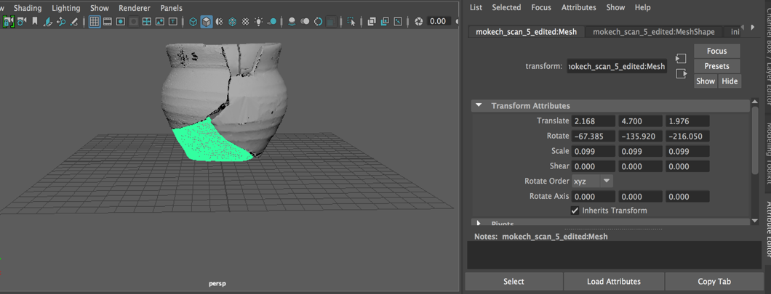

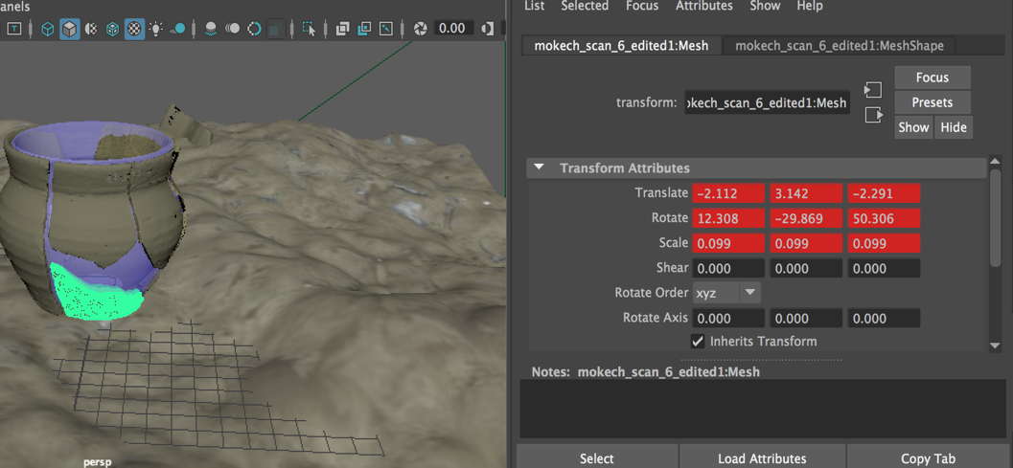

Move to figures file. All figures need Figures Numbers and Figure Captions (see formatting in Style Guide)

Conclusion

this project helped me acquire multiple ways of illustrating pottery. I drew, spun =rotated?, and scanned the same pot, recording the differences in each process. Again, what were the two processes? Drawing is faster and easier, but not as aesthetically pleasing as what? [and more for professional publication?]. Even if it is part of a [painted picture?] or more elaborate two-dimensional design?, there is no interactive quality to it? . 🡨rewrite to be clear Typically, archaeologists do not have the time to create complex [pictures? vessel reconstructions? Vessel profiles? vessel images?] out of these records anyway-which records?, for time and convenience sake. Therefore, the process (which one) is not useful helpful outside of an academic setting. I have seen pottery profiles in galleries at museums but I believe it still serves as [an academic map?] more than an engaging feature. I’m not sure of the relevance or point in the last sentence.  
 Creating a pot digitally by spinning its profile on Maya is a step above [drawing], as it is three-dimensional and is more engaging visually in a 360 degree perspective. This type of application is useful for inserting pottery vessels into games and scenes. Even though you can make the pot as close to any profile as you want, inserting designs can be a complicated process. 🡨rewrite. Overall, this application is a lot more flexible and entertaining to wider audiences.

Finally, scanning sherds was a fascinating, yet time-consuming, process. The three-dimensional scanner took 15 minutes a piece? Sherd?, 17 minutes for the largest one, sherd mokech_scan 3.obj, and it was a daunting process uploading , patching and cleaning sherd scans in addition to adding texture to the body and inserting them into the scene. However, this labor has yielded useful results and the time was well spent despite the steep learning curve.

Next to the processes themselves, it is important to consider real-world application. I believe my concept could be interpreted in a variety of enjoyable and entertaining ways. For example, someone is in a gallery or a VR environment could see the pottery vessel as an interactive game. I would design this section of the gallery show the real pottery vessel on display and the digital 3D object in an interactive station with an interactive projection, a hologram, or geo-mapped and accessible by smartphone. The plane setup is conducive to the archaeological feel??. It is not uncommon to find sandpit dig activities for kids at dinosaur museums, but I believe a digital interaction engages a greater age-range and more general academic level, when the subject matter is simplified and [aestheticized?]

My goal was to create a simple and education tool to show pottery reconstruction, using three-dimensional methods. I advocate for academic accessibility, and the idea that educational tools should be open-access and spread through as many contemporary mediums as possible, in the most ethical way possible. Pottery is the most well-known type of object, being present in almost every through time culture in its own unique way, both functionally and artistically. These pieces of craft represent thousands of years’ worth of human culture and societal development. I hope that with a 3D platform like I designed, it could be the start of a learning resource and anthropological engagement tool that is easily accessible.

References Cited

See the style Guide for American Antiquity for proper formatting of the References Cited.

All citation here have to be cited at least once in the main text.

Adkins, Lesley, and Roy Adkins. *Archaeological Illustration*, Cambridge: Cambridge UP, 1989.

Balme, Jane, and Alistair Paterson. *Archaeology in Practice: A Student Guide to Archaeological*

*Analyses*. Malden, MA: Blackwell Pub., 2006. Print.

Dillon, Brian D. *The Student's Guide to Archaeological Illustrating*. Los Angeles: Institute of

Archaeology, U of California, Los Angeles, 1985. Print.

Print.

Drawing Pretty Pictures of Broken Pots. Girl Archaeologist's Blog. 2012.

<https://girlarchaeologist.wordpress.com/2012/07/12/drawing-pretty-pictures-of-broken->

pots/.

Kampel, Martin and Hubert Mara. "Automated Extraction of Profiles from 3d-Models of

Archaeological Fragments." Proceedings of the CIPA 2003 XIXth International.

Leonard Woolley and M. E. L. Mallowan. Ur Excavations IX: The Neo-Babylonian and Persian

Periods&nbsp;. London: Pub. for the Trustees of the two museums by the Oxford

University Press, 1962.

Museum, Ur Digitization Project-Penn Museum & British. "UrOnline - the Digital Resource for the Excavation of Ur." . Accessed Dec 09, 2016. http://www.ur-online.org/.

Orton, Clive, and Mike Hughes. *Pottery in Archaeology*. Cambride: Cambrige UP, 2013. Print.

Penelope N. Weadock. "The Giparu at Ur." *Iraq* 37, no. 2 (1975): 101-28. doi:10.2307/4200011.

Steiner, MeÌlnie, and Lindsay Allason-Jones. *Approaches to Archaeological Illustration: A*

*Handbook*. York: Council for British Archaeology, 2005. Print.

1. Orton, Clive, and Mike Hughes. *Pottery in Archaeology*. Cambridge: Cambridge UP, 2013. Print. NO footnotes for citations. See the style guide for American Antiquity.
2. Museum, Ur Digitization Project-Penn Museum & British. "UrOnline - the Digital Resource for the Excavation of Ur." . Accessed Dec 09, 2016. http://www.ur-online.org/.
3. Leonard Woolley and M. E. L. Mallowan. Ur Excavations IX: The Neo-Babylonian and Persian Periods&nbsp;. London: Pub. for the Trustees of the two museums by the Oxford University Press, 1962.
4. Penelope N. Weadock. "The Giparu at Ur." *Iraq* 37, no. 2 (1975): 101.line - the Digital Resource for e start of a d a bright color to make it stand out but still let there be focus on the sherds wh
5. Ibid. 103.