Malkia Okech
Prof. Clark Erickson & Prof. Norm Badler
CIS 106 / ANTH 258
19 December 2016
Digital Exploration of Broken Pottery
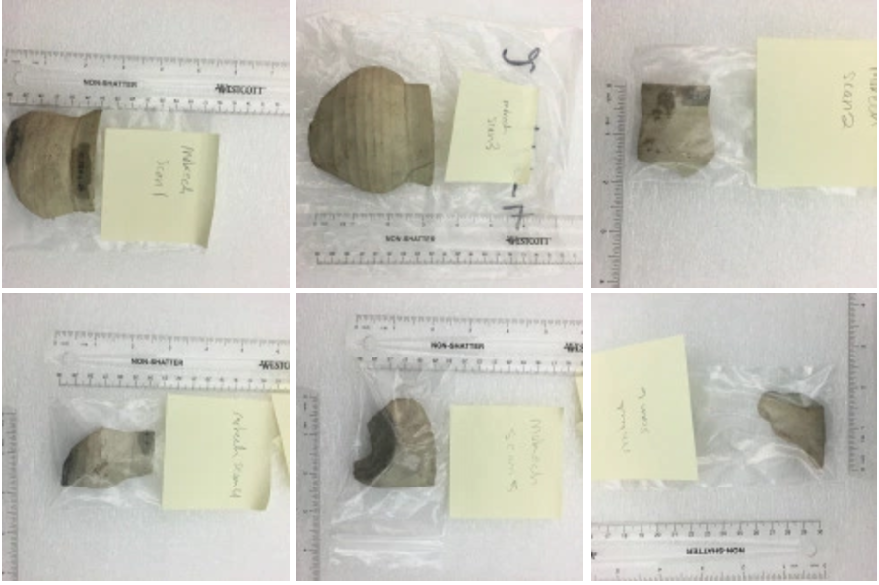
Figure 1 The Six Sherds I used for my project. I originally scanned 8 but decided to narrow it down to these.

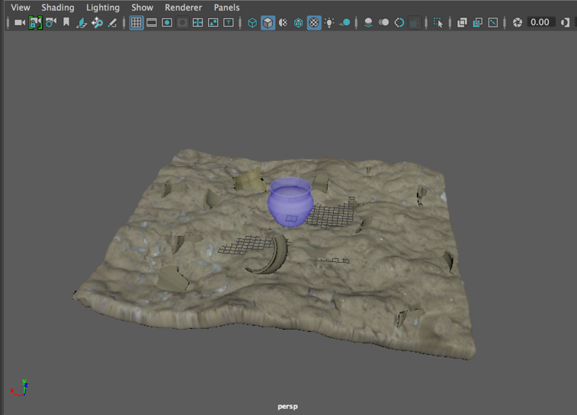
Figure 2 Final Product in Maya
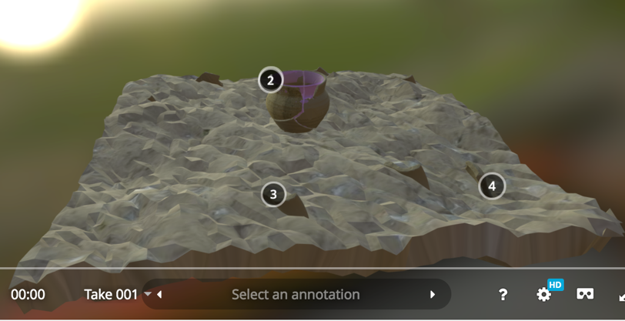
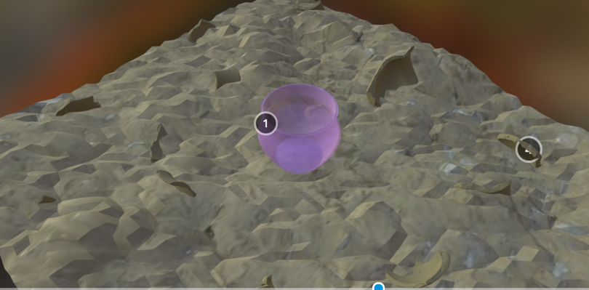
Figure 4 Final Product in Sketchfab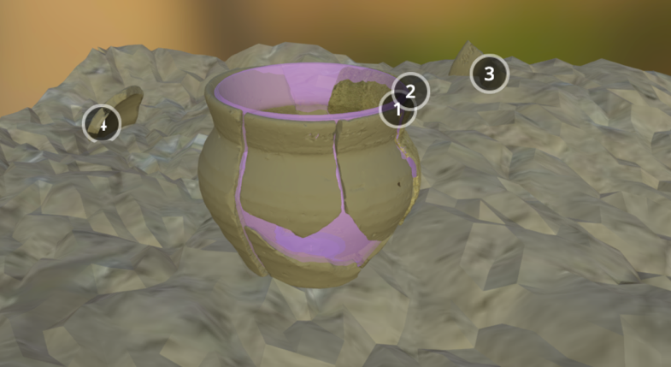
Figure 3 Final Product in Sketchfab (2)
Figure 5 Final product in sketchfab (3)
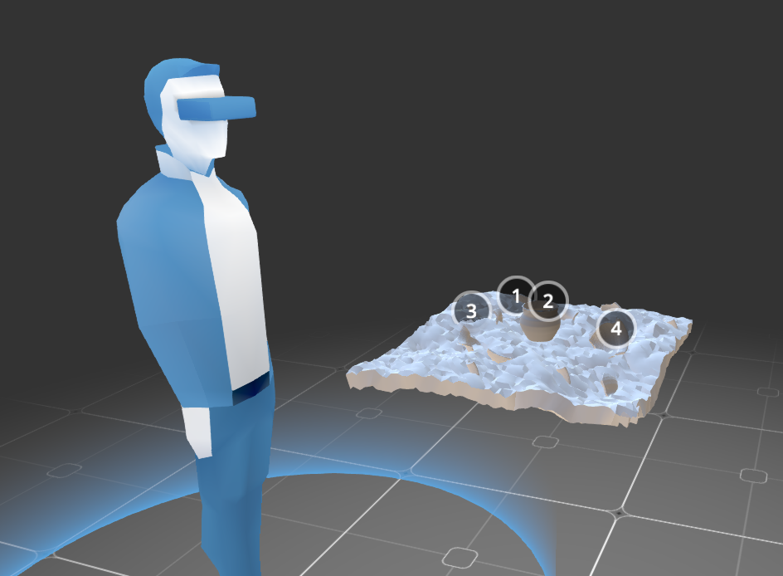
Figure 6 Real-World Application; tool in Sketchfab for modifying VR. Great view for brainstorming.
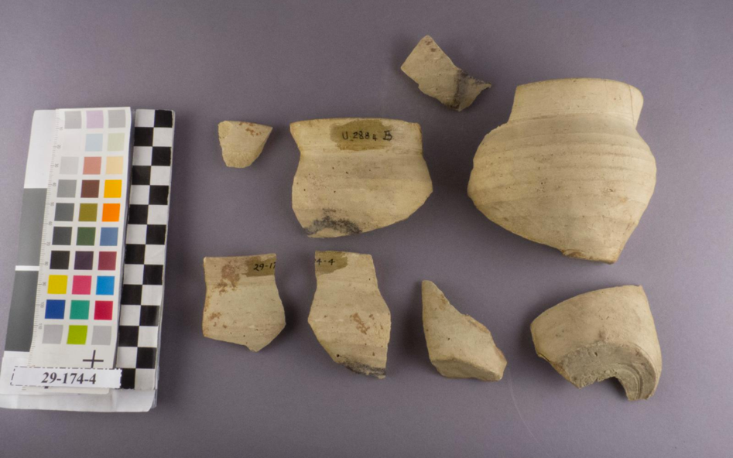
Figure 7 Photo of 29-174-4 (courtesy of Penn Museum)
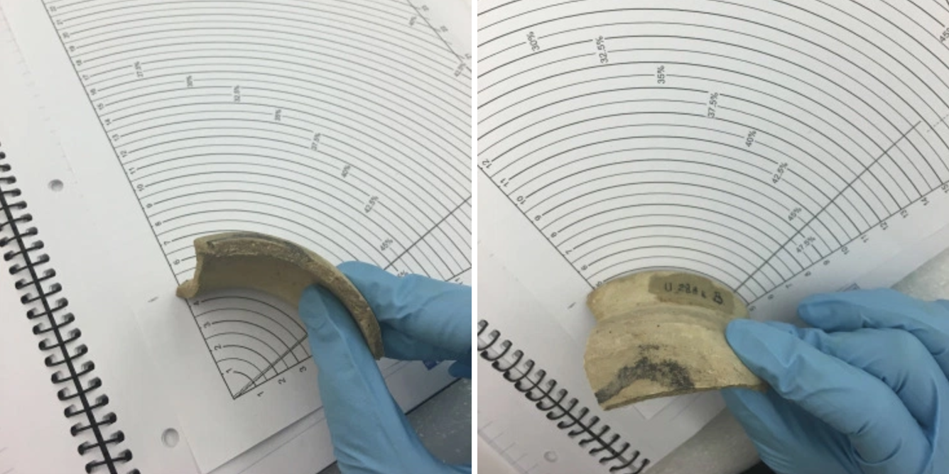
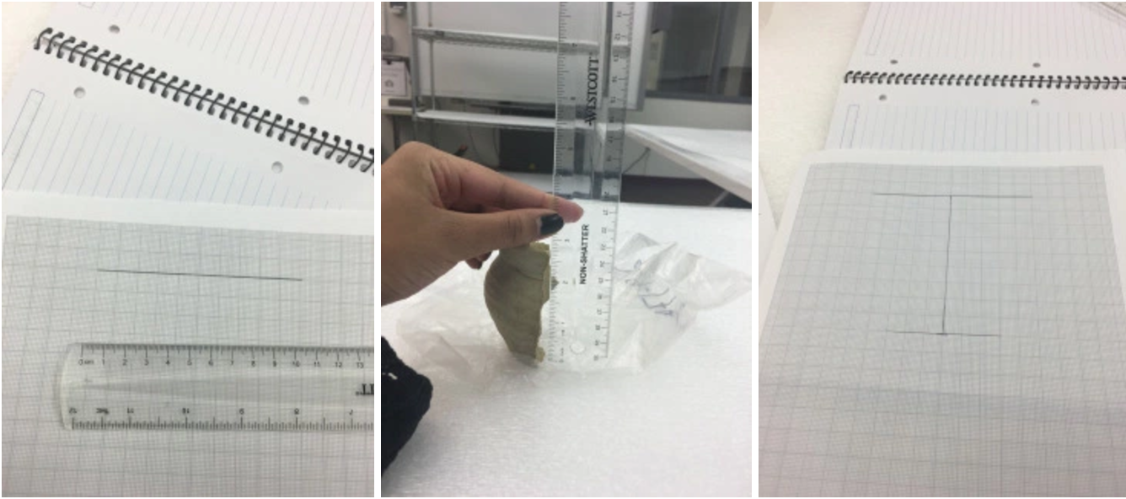

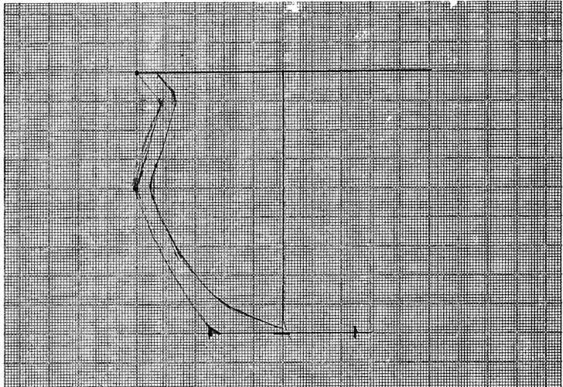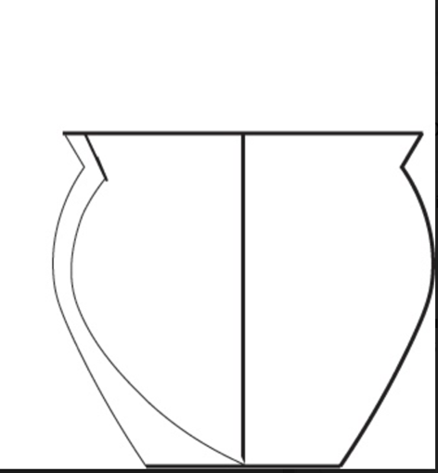
Figure 8 Drawing process, measurements, and part 1 (bottom left) + 2 (bottom right)

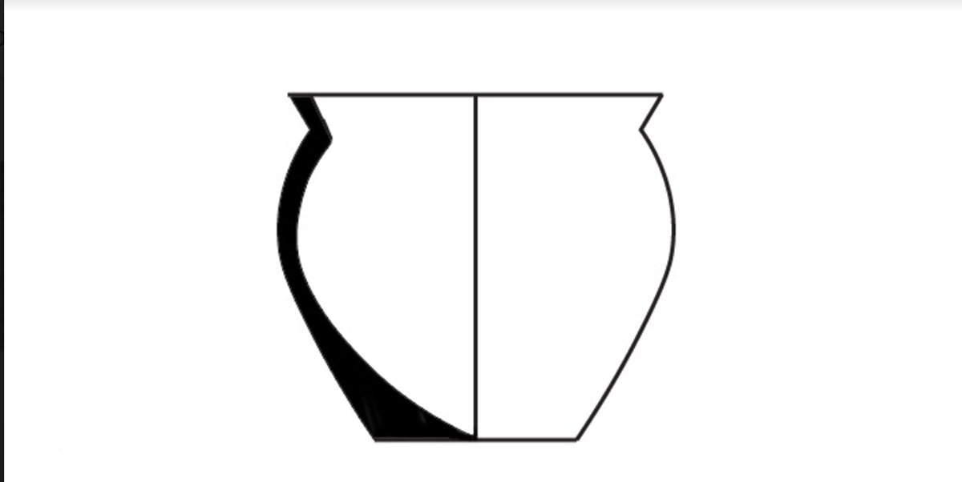
Figure 9 Drawing part 3
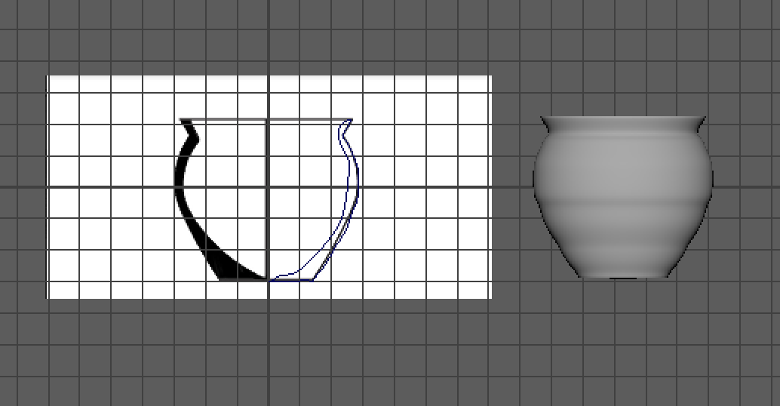
Figure 10 Spinning a pot from the drawing profile

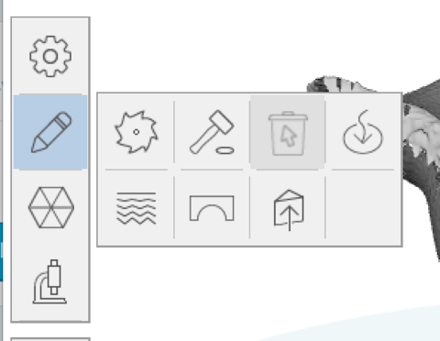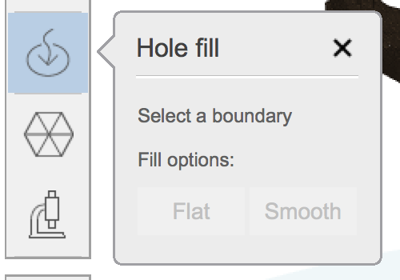
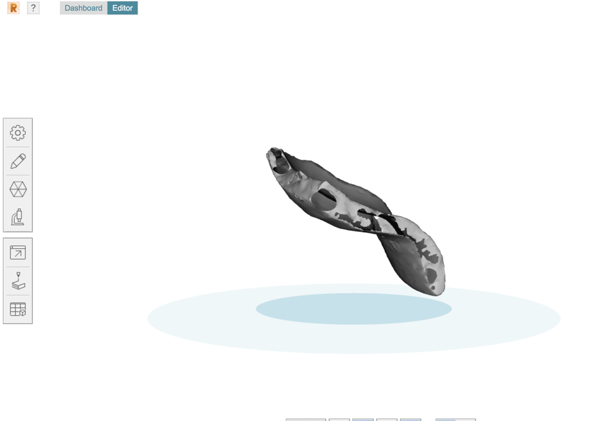
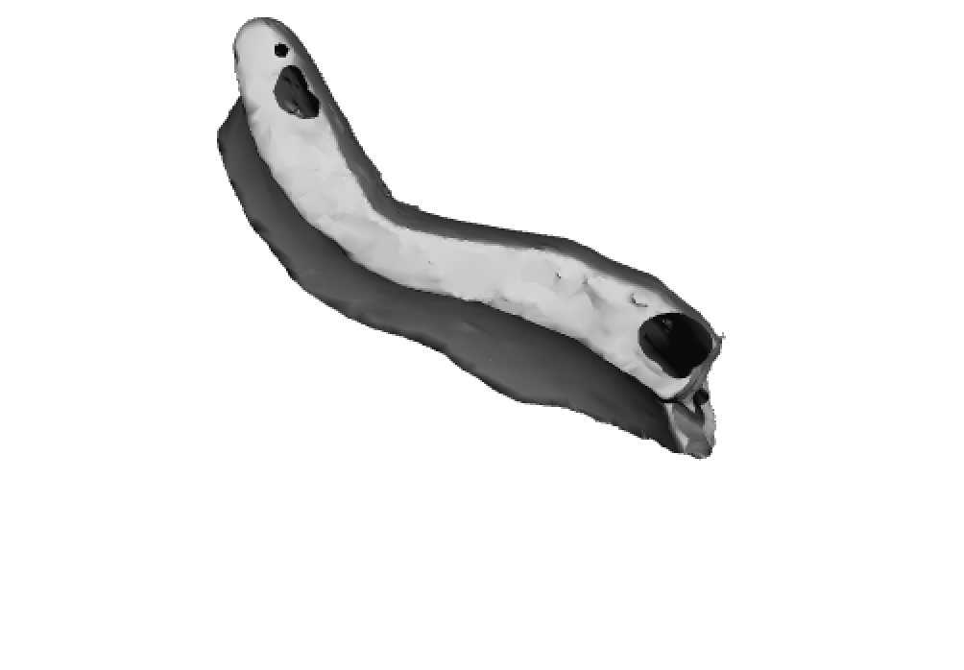
Figure 11 (top left and right) Steps to filling a hole. (Middle) Freshly scanned sherd with holes. (Bottom) Revised sherd with filled holes.

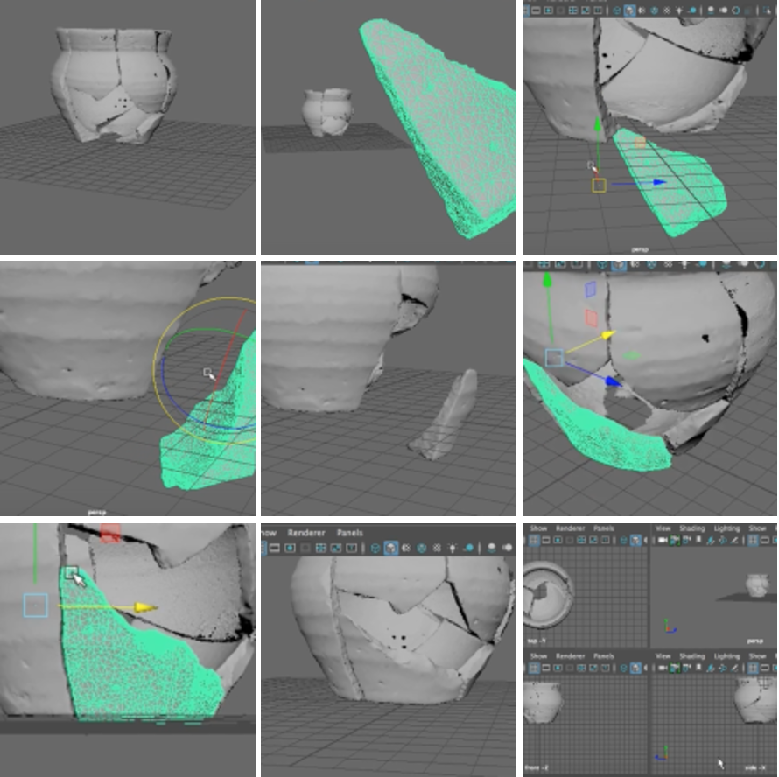
Figure 12 Pottery Reconstruction; process of placing a final piece on the sherd
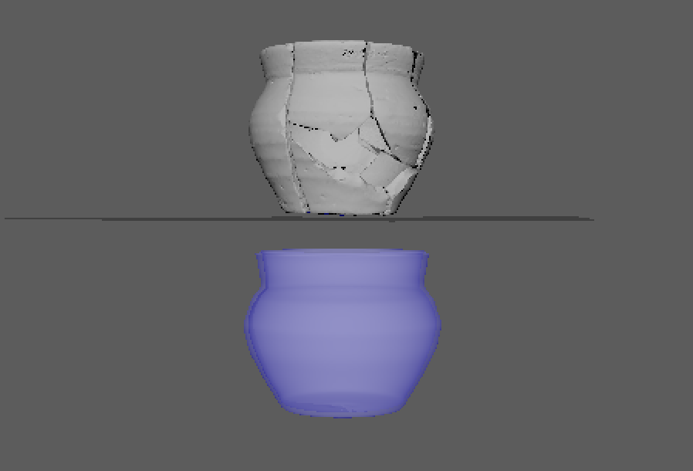
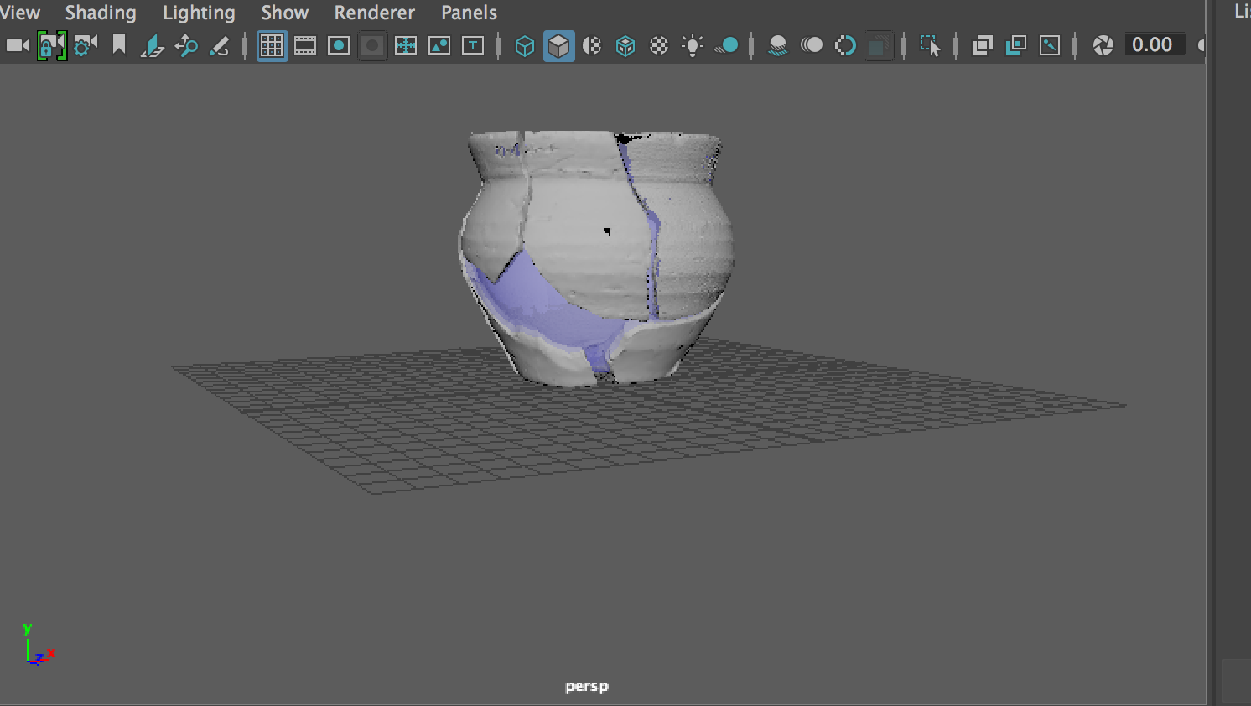
Figure 13 (Top) sherds reconstructed into a pot, and a spinned pot based on the reconstruction's profile. (Bottom) Spinned profile resized slightly to fit snuggly underneath the sherds.

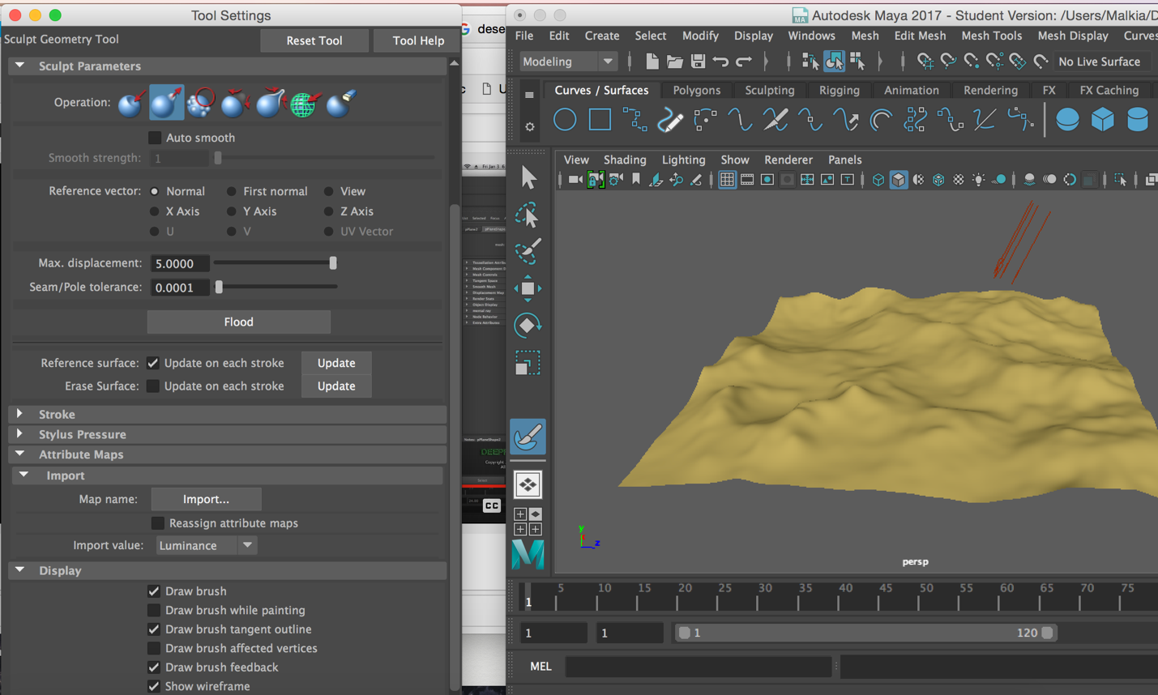
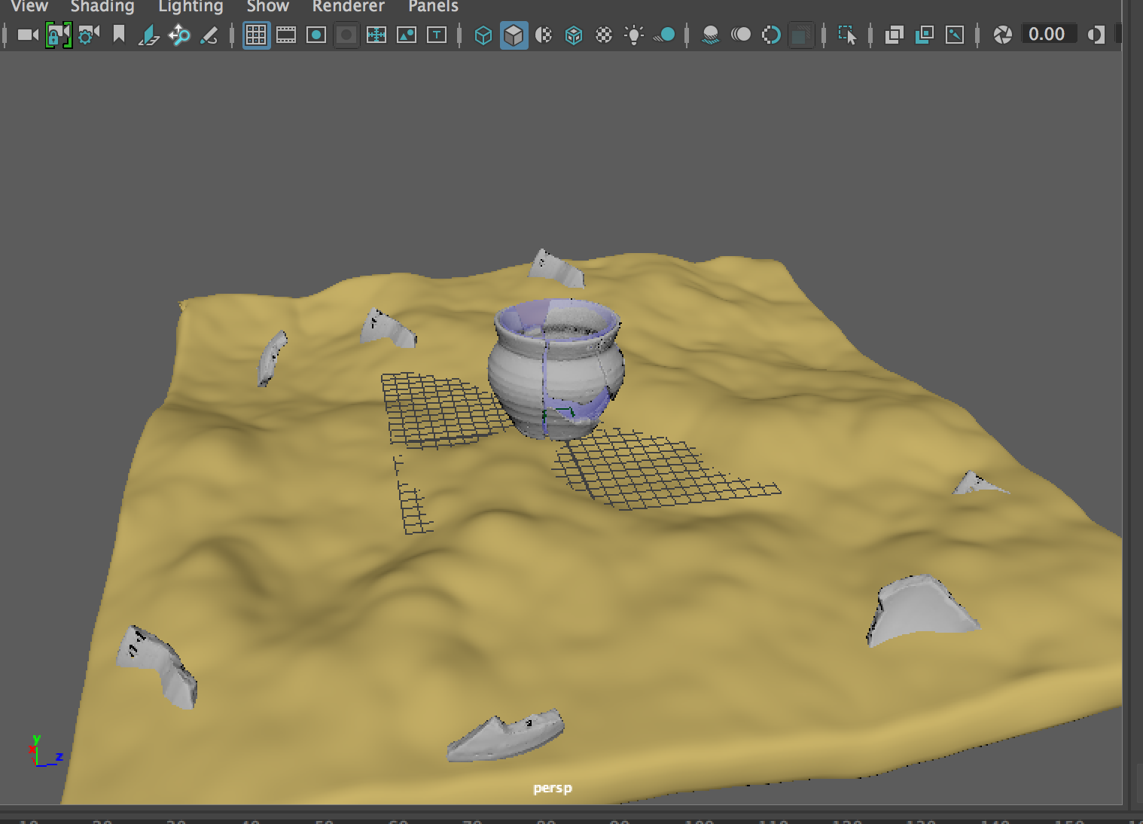
Figure 14(Top) Sculpt Geometry Tool - setup for plane modification. (Bottom) Plane thickened, inserted/scattered sherds, before texture applied. http://texturelib.com/license/
Youtube progress videos I made:
https://www.youtube.com/watch?v=HP-NM1AGM9c
https://www.youtube.com/watch?v=LMVRzE00_rk

