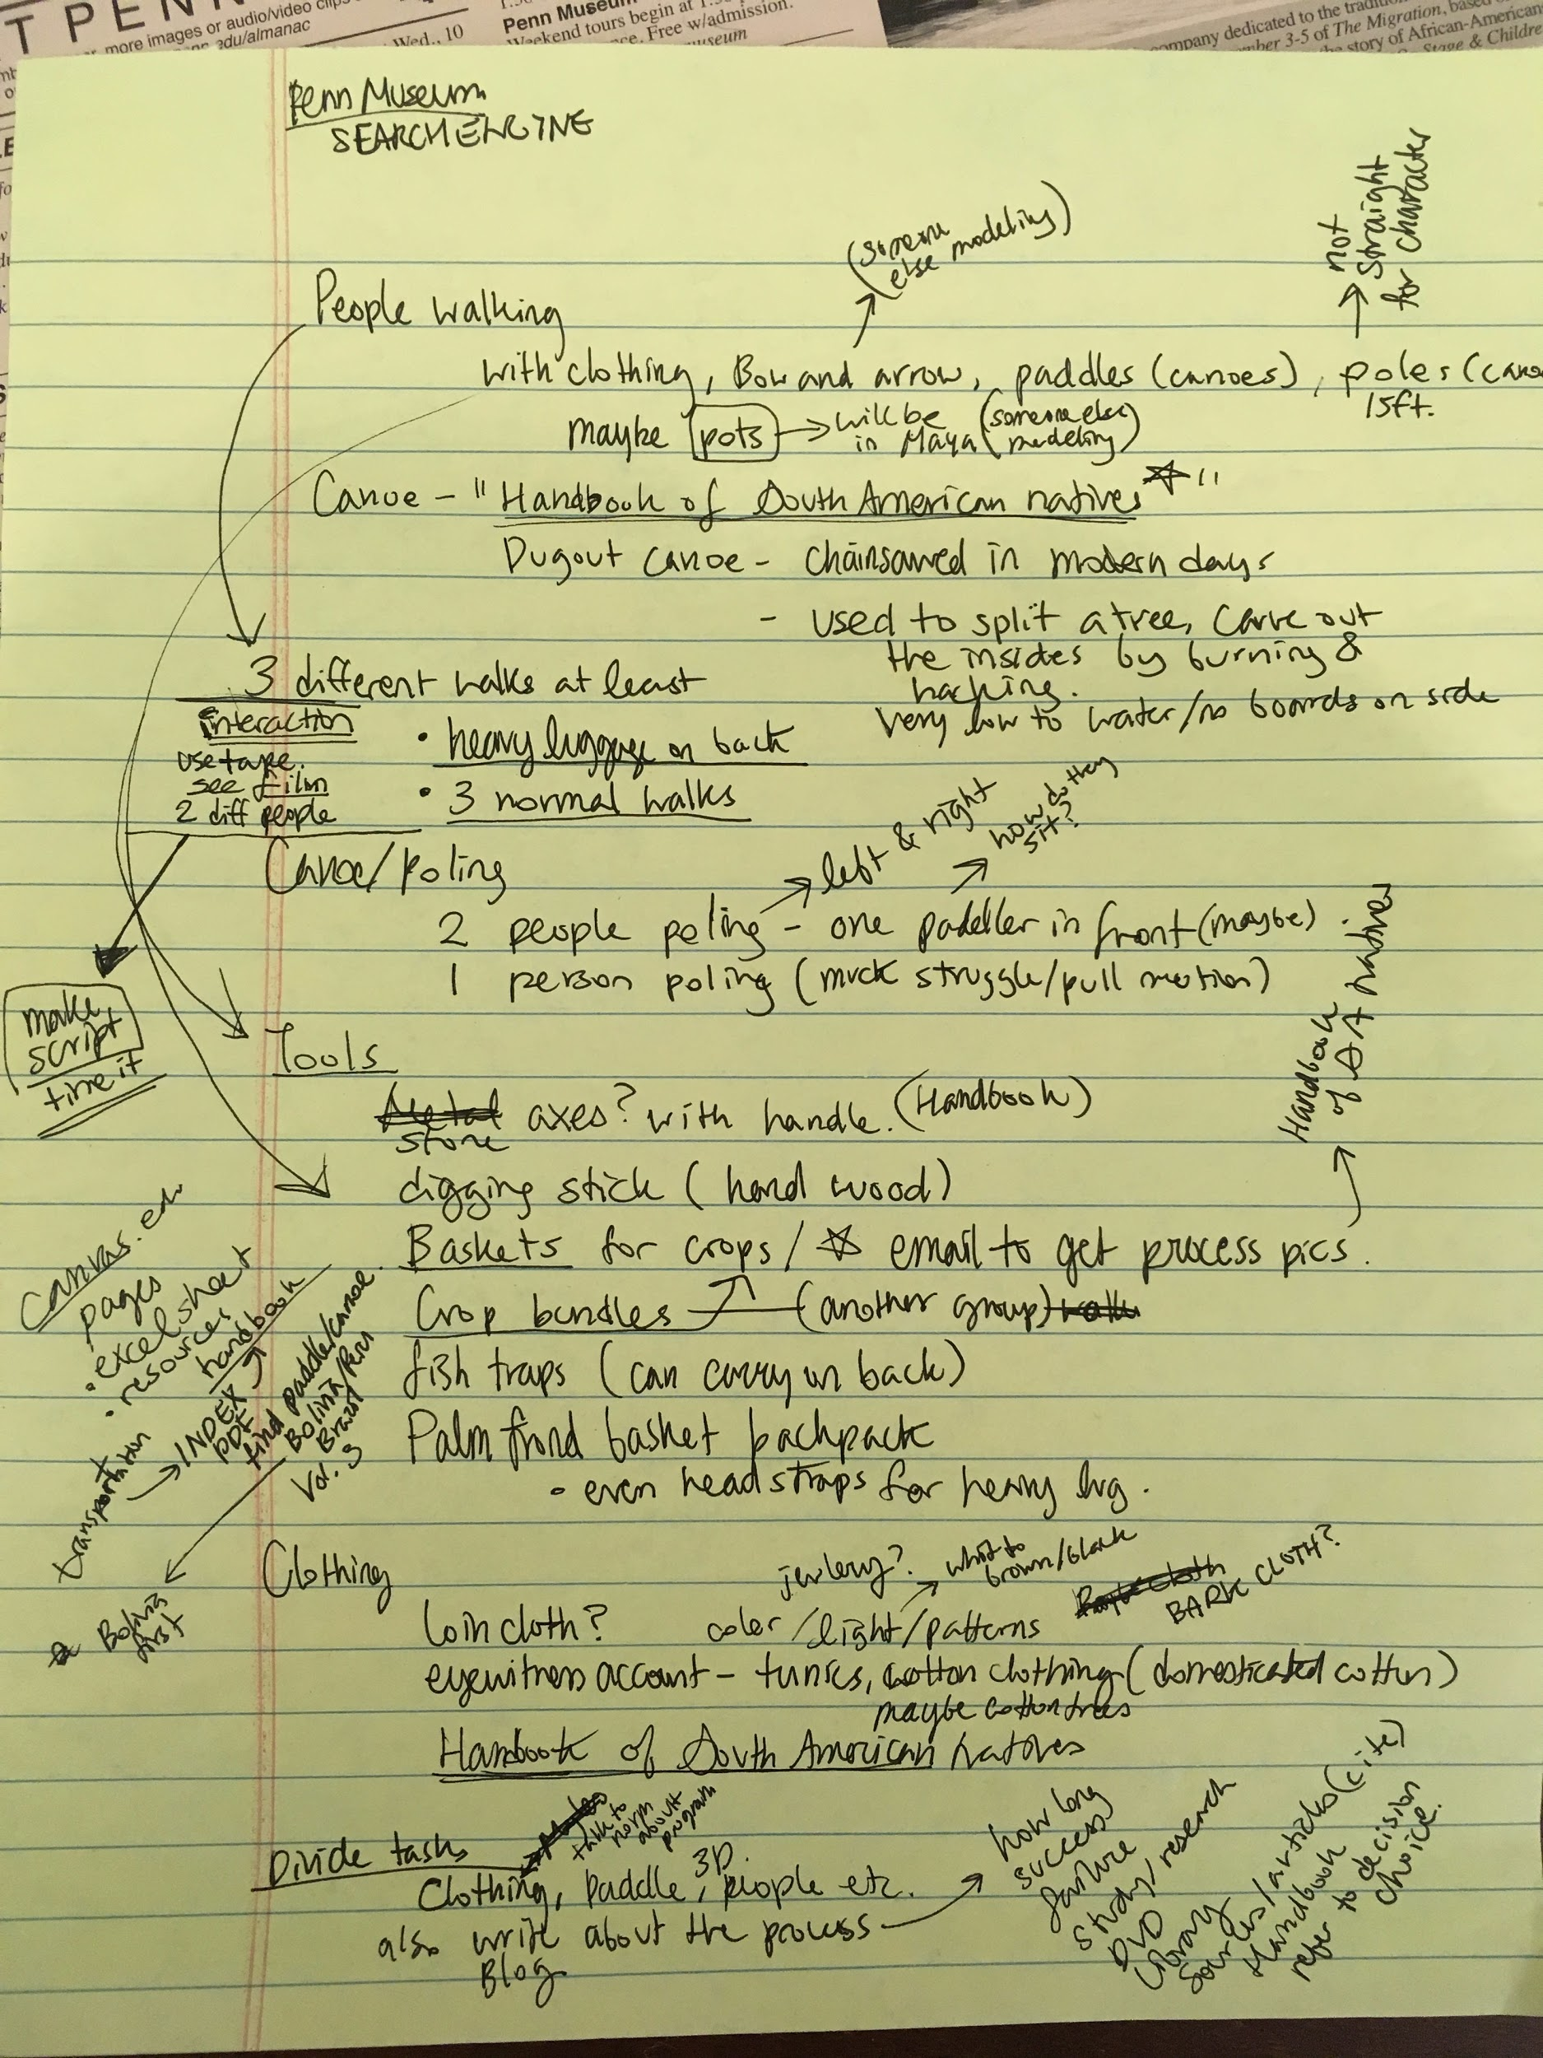
Figure 1. Notes by Sangeun Lee from meeting with Prof. Clark Erickson

Basketry, Backpacks and Visualization (Emiliya Al Yafei):
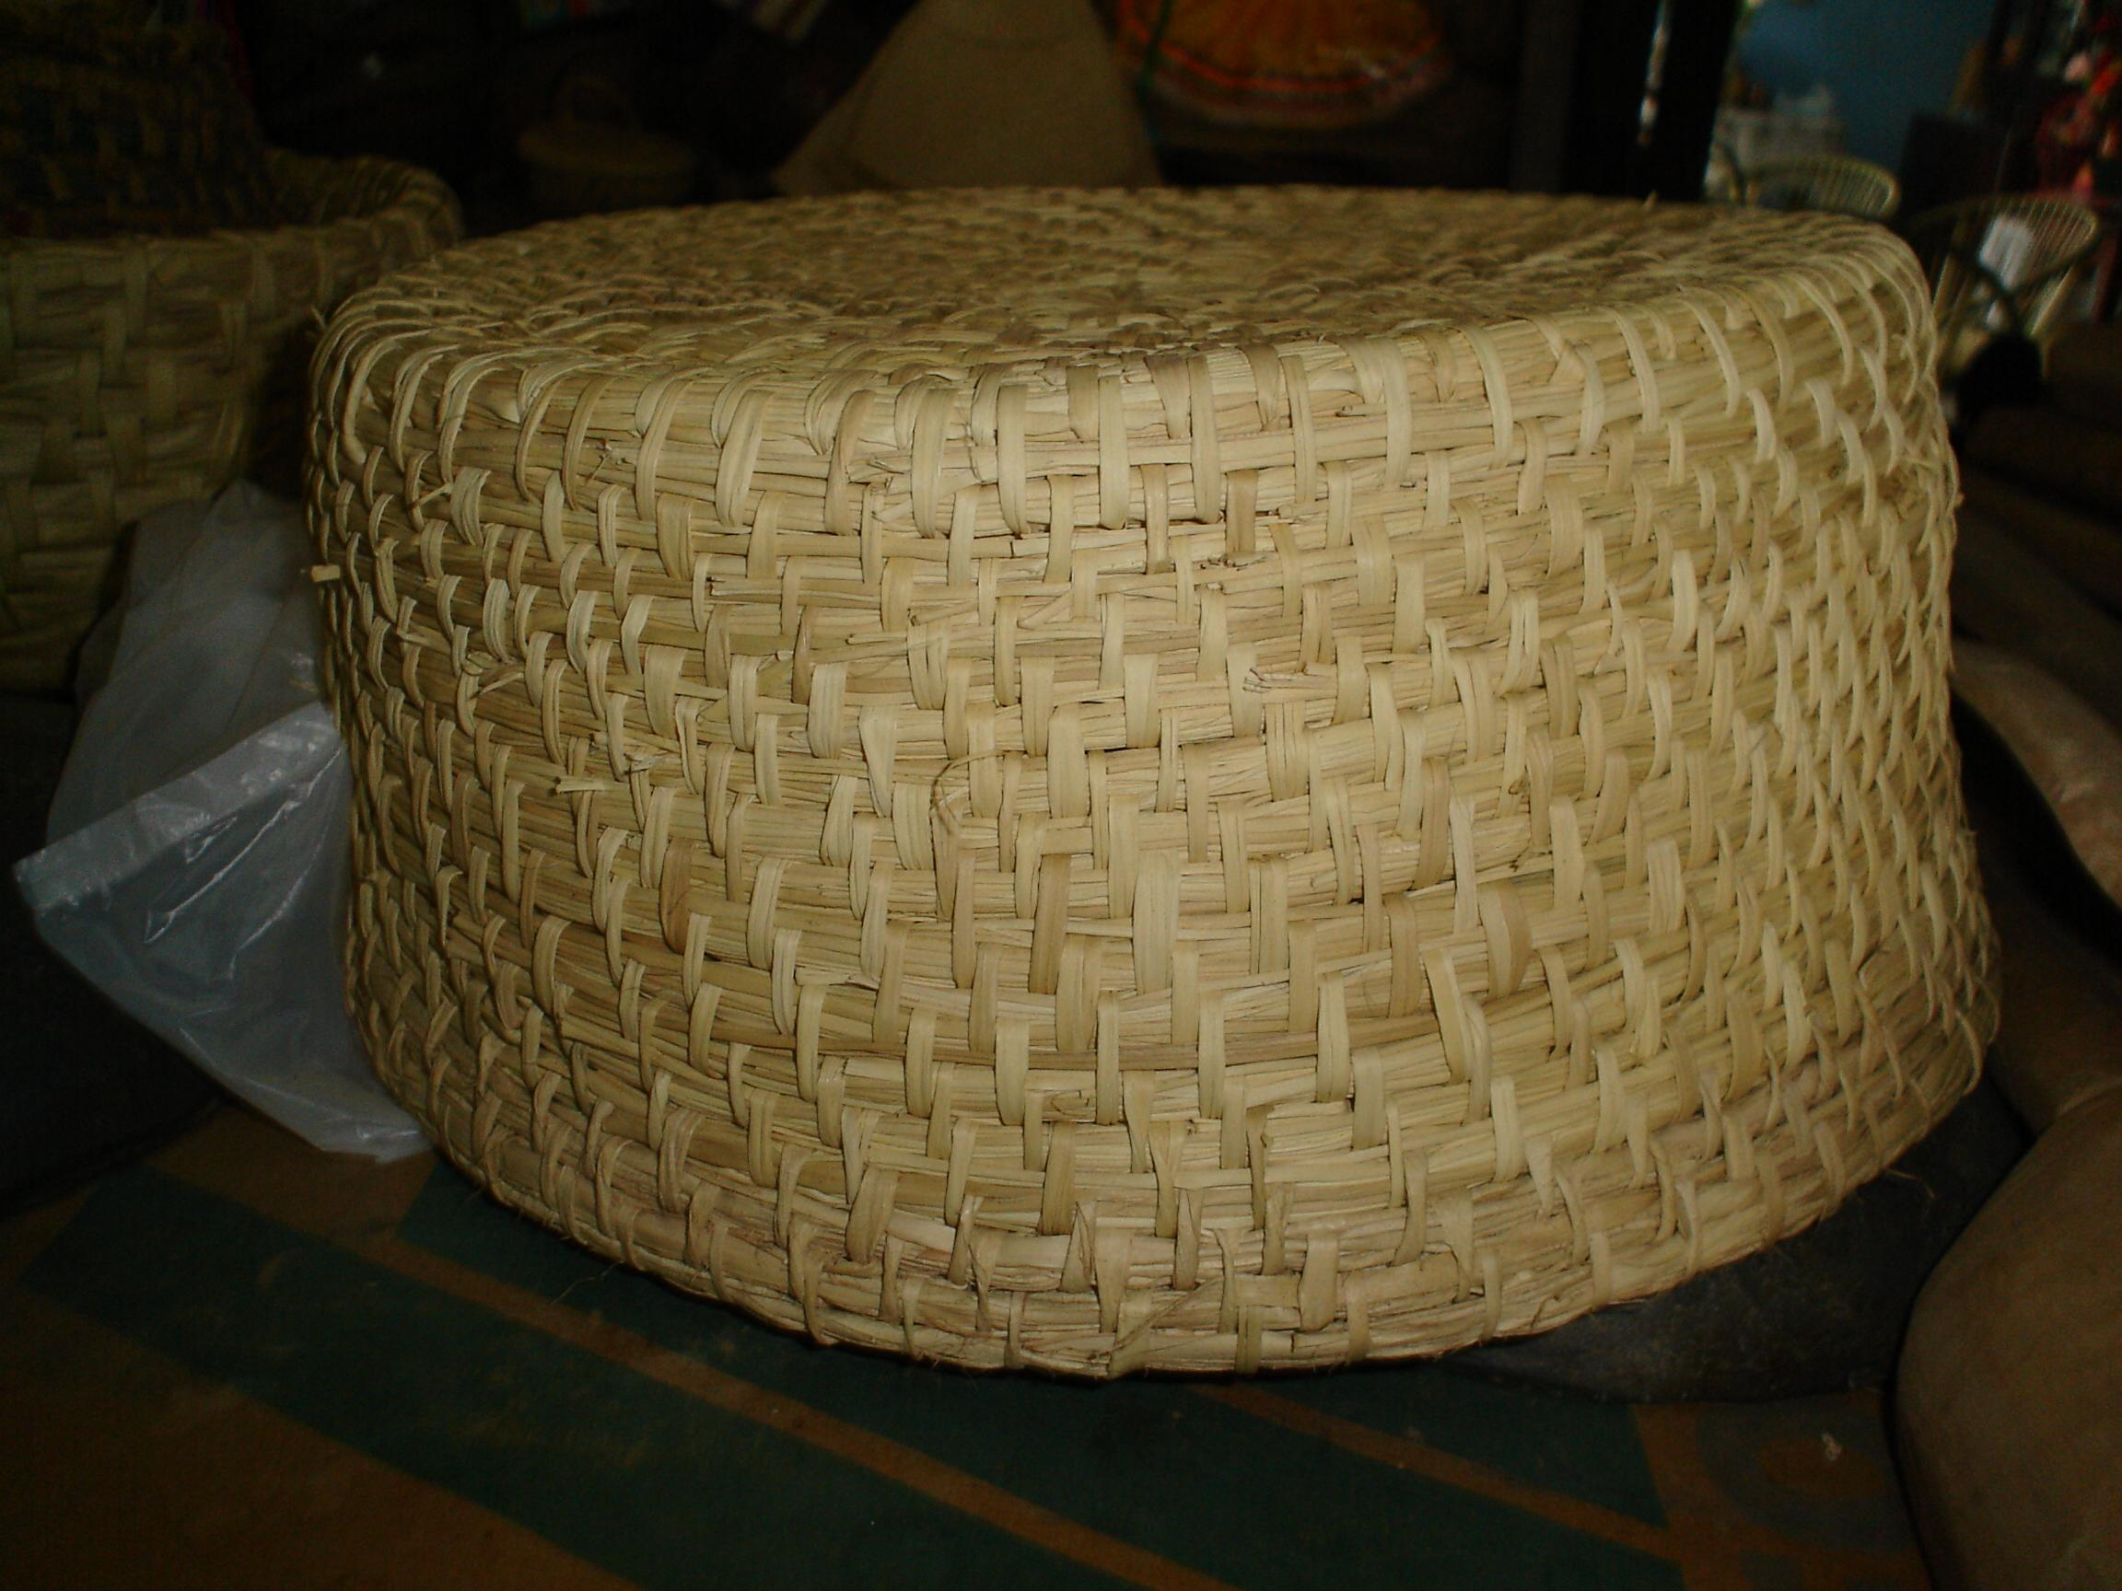 | 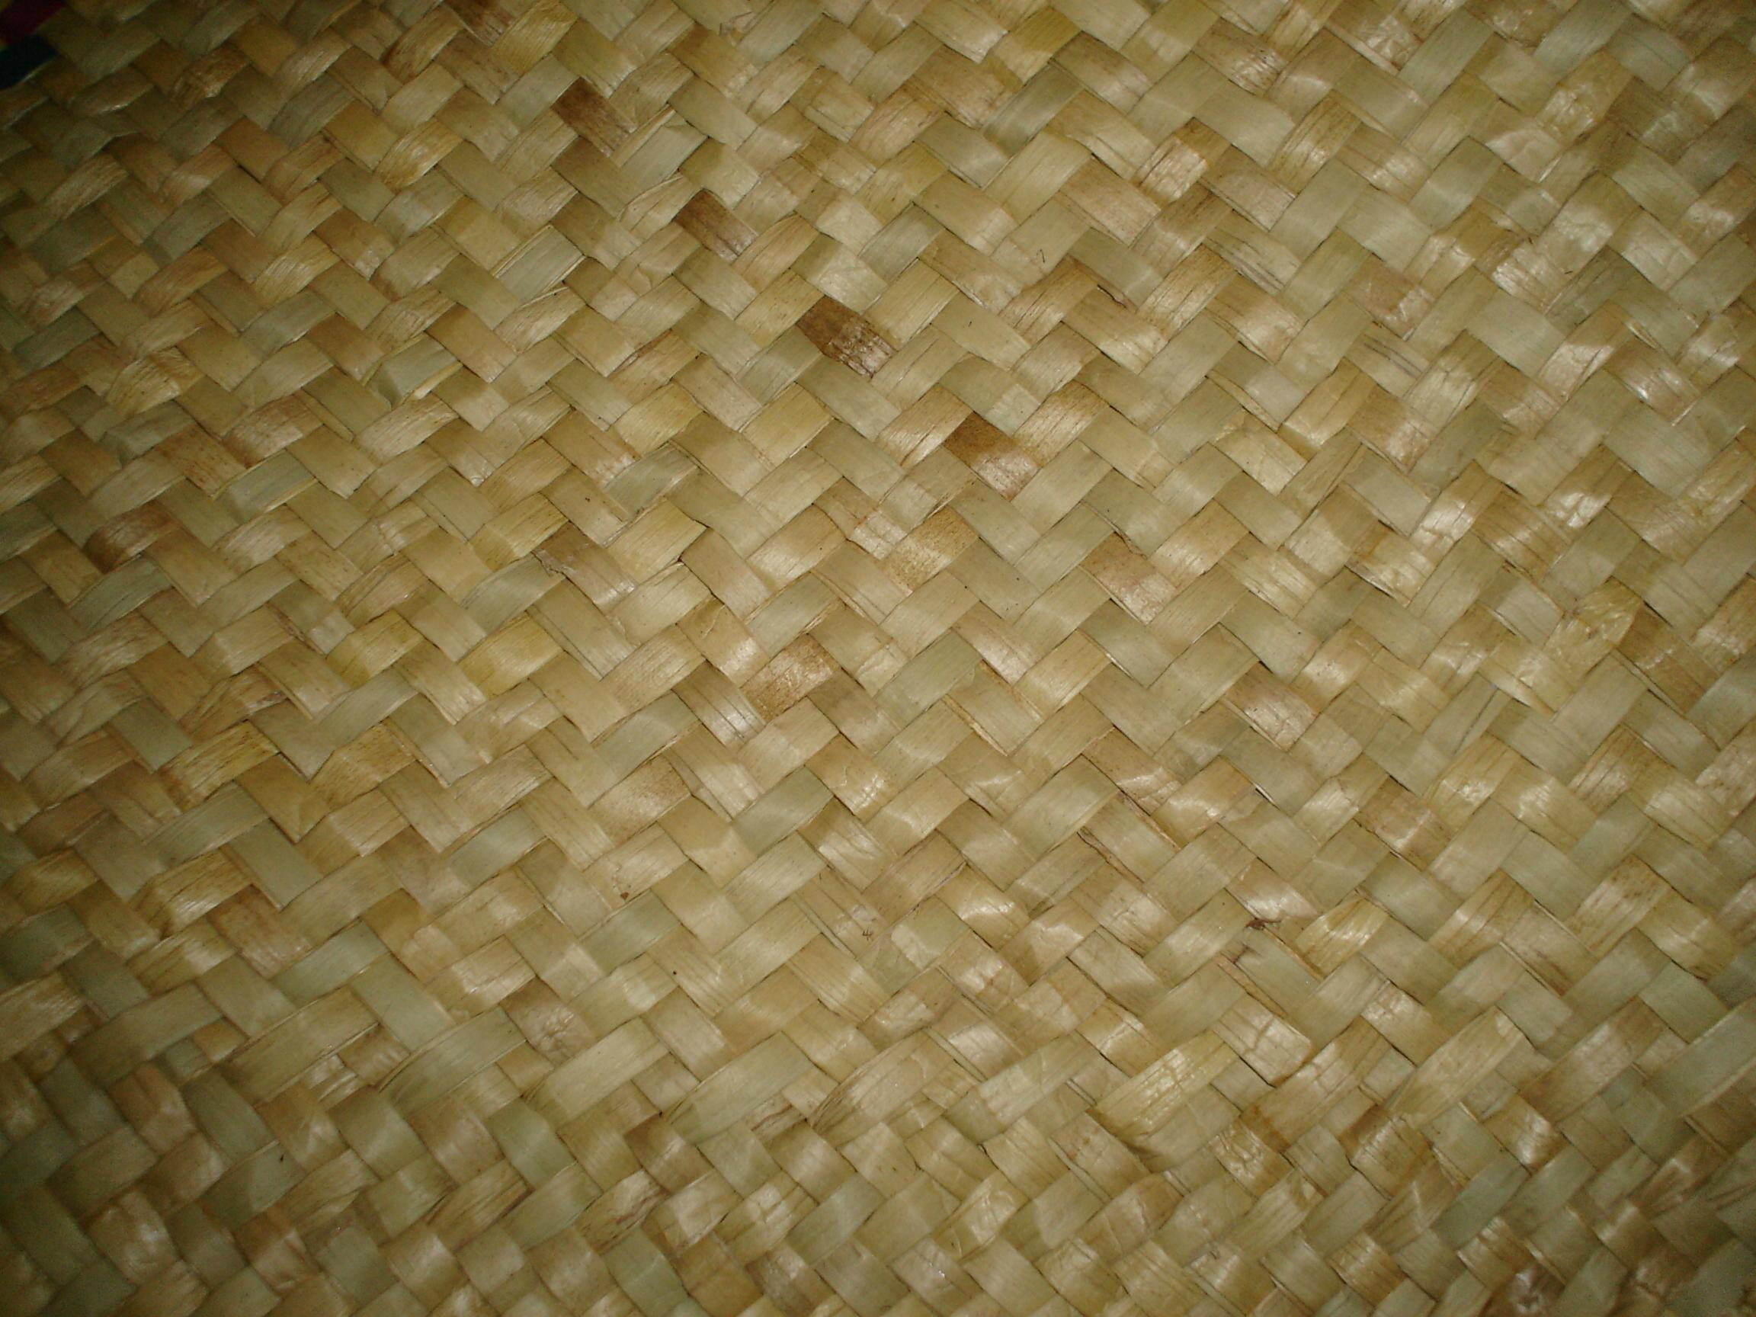
Figure 2. Basket of the Ultimas, shown in full size (left) and in detail (right). Texture taken from detail shot. (Courtesy Clark Erickson, photographer)
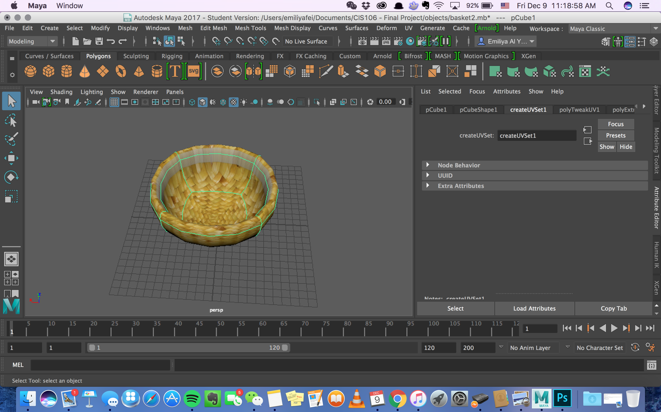 | 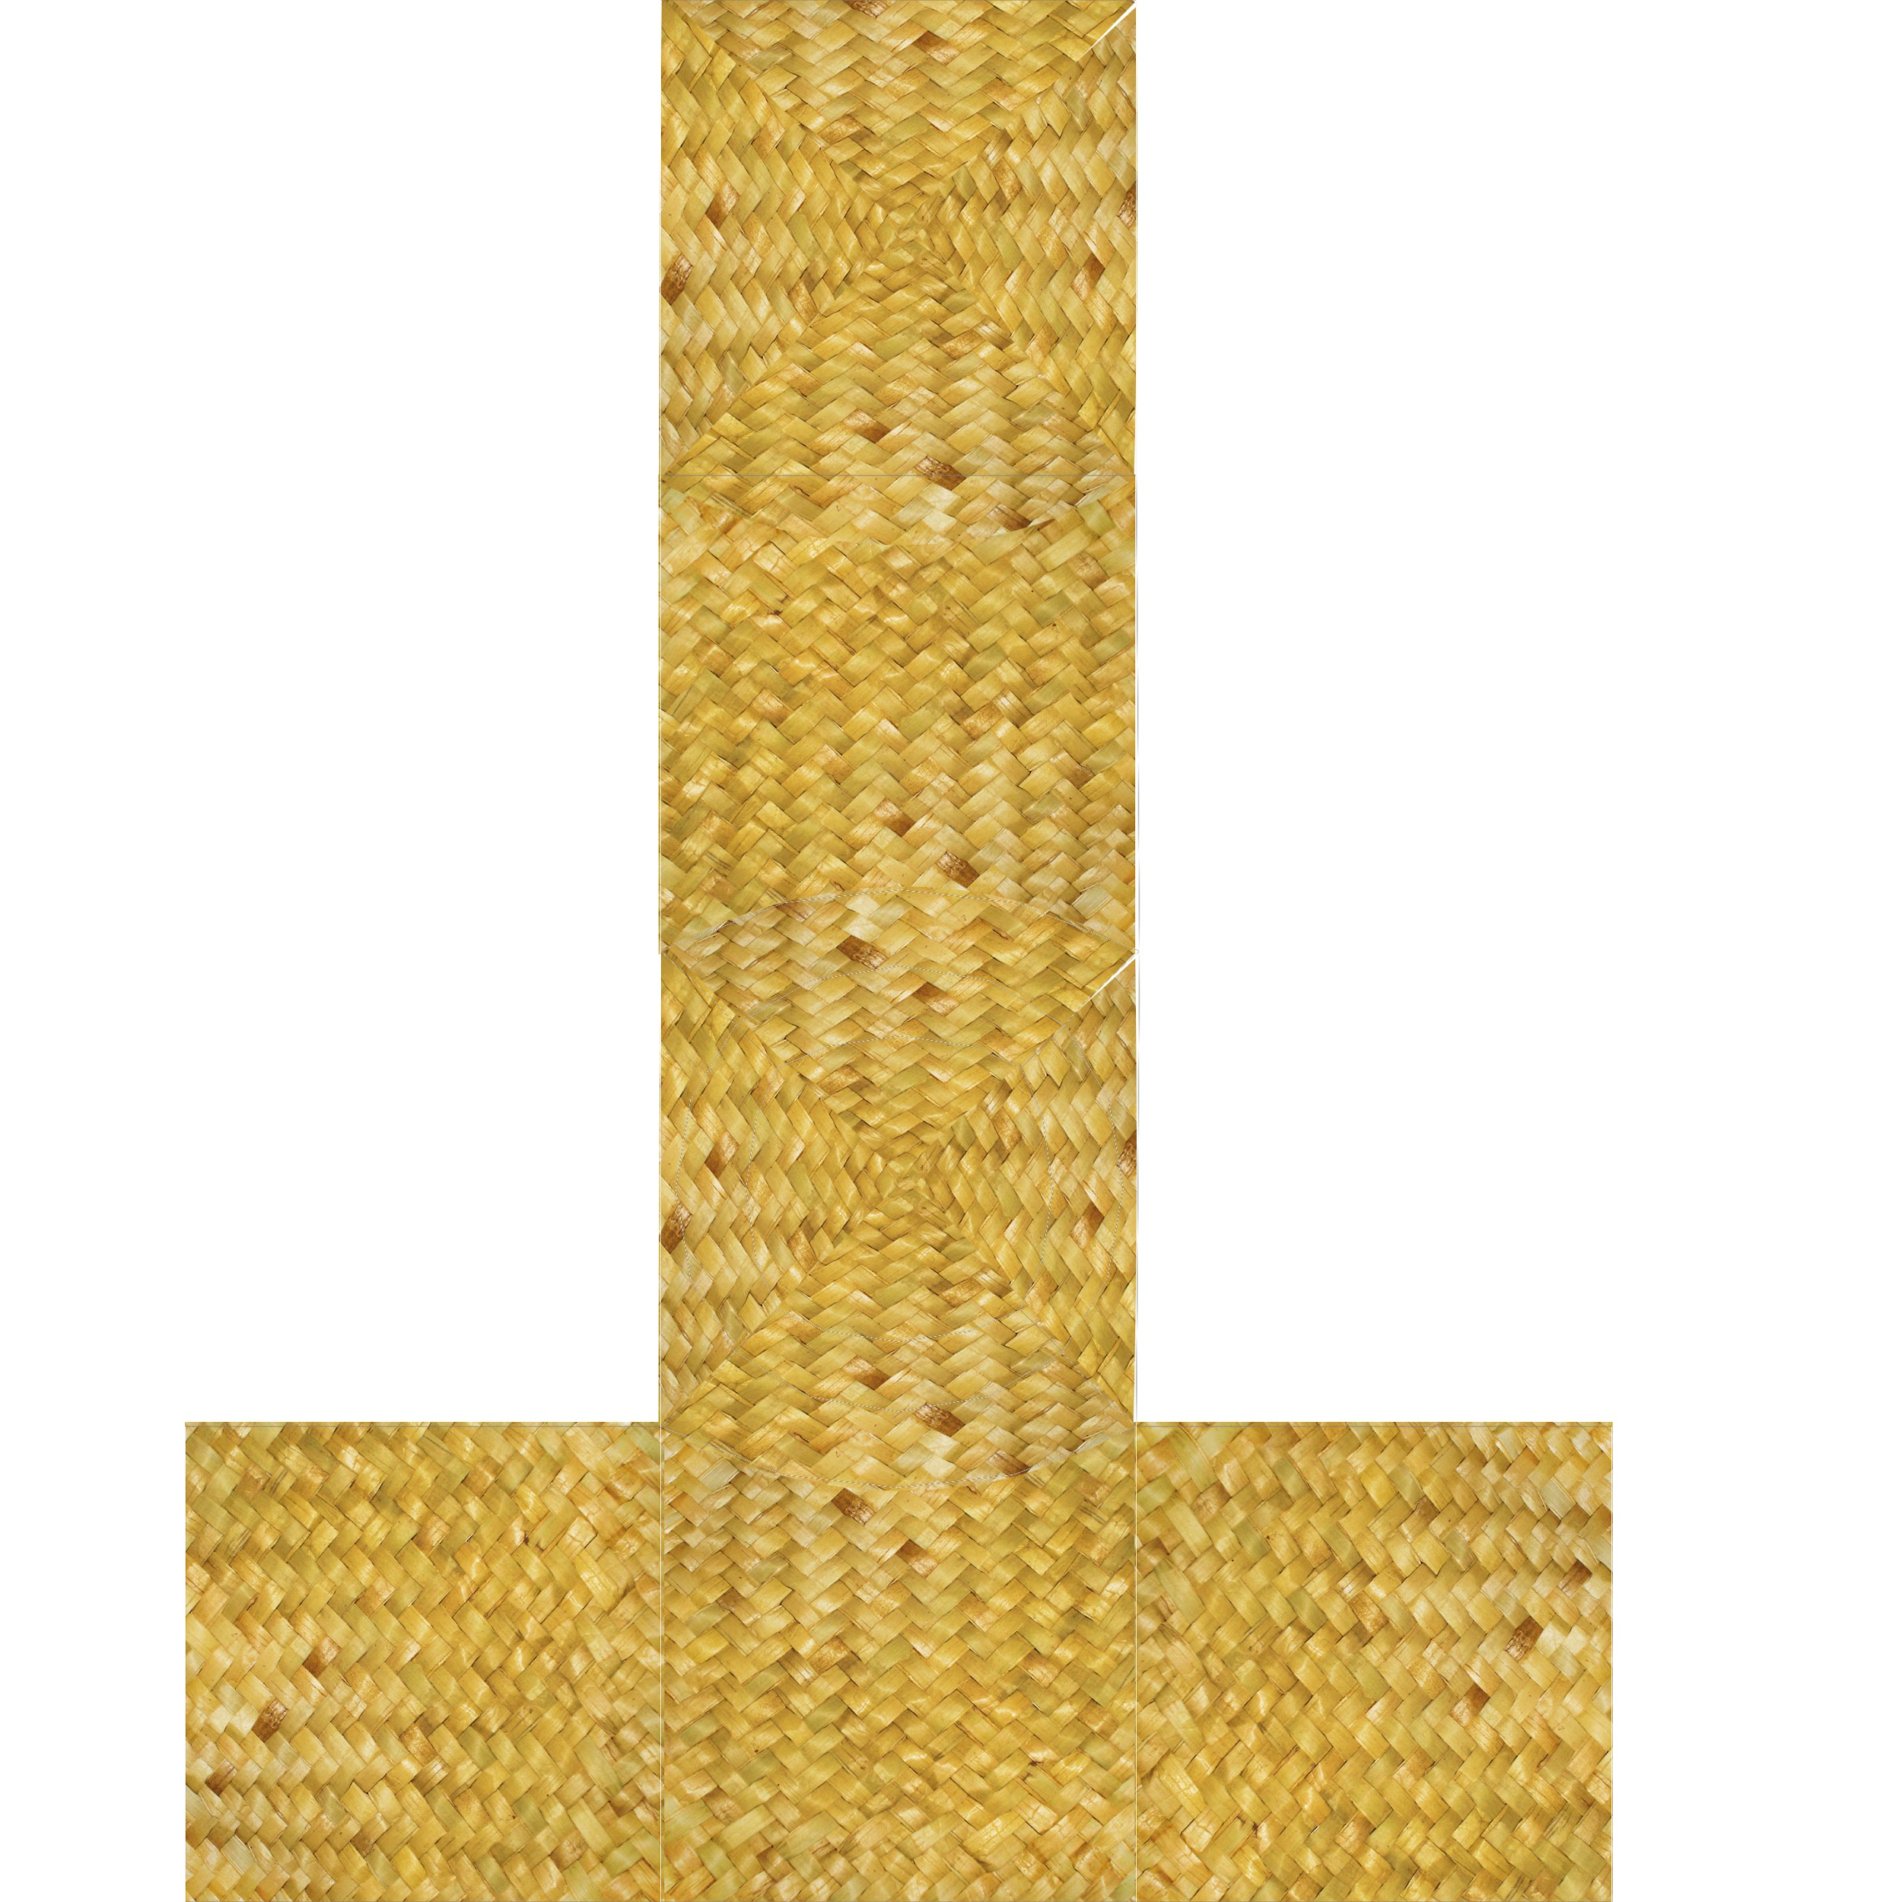
Figure 3. Model of Ultimas basket created by Emiliya Al Yafei, as seen from top view. | Figure 4. UV for Model of Ultimas Basket created by Emiliya Al Yafei, using edited reference photo.
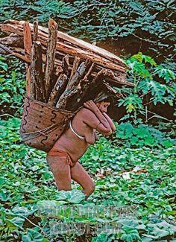 | 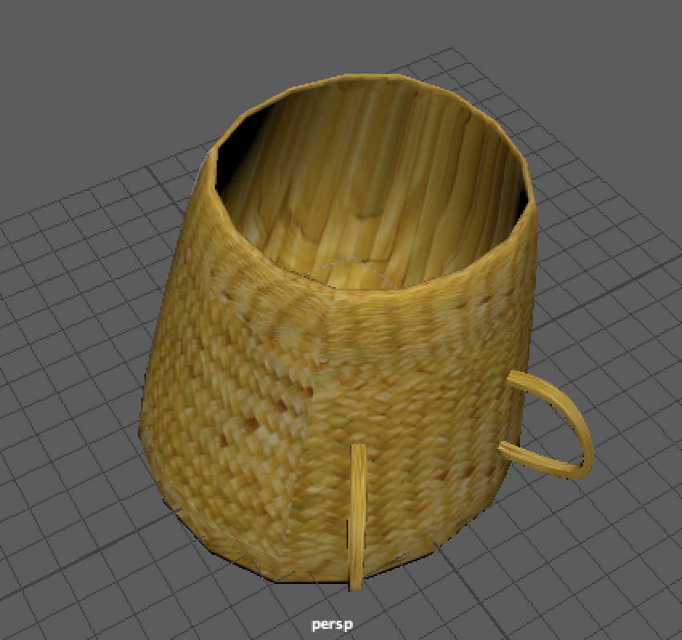
Figure 5.  Photograph of Yanomami woman carrying a basket on her back (photograph courtesy of Victor Englebert, photographer, 1982). | Figure 6. Model of Yanomami Basket, using same texture as that for the previous basket.
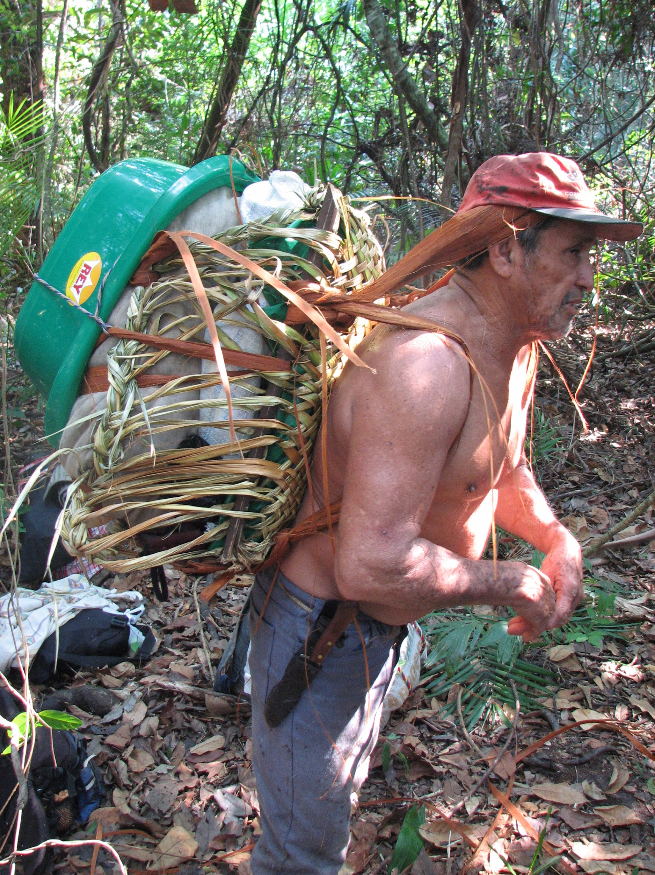 | 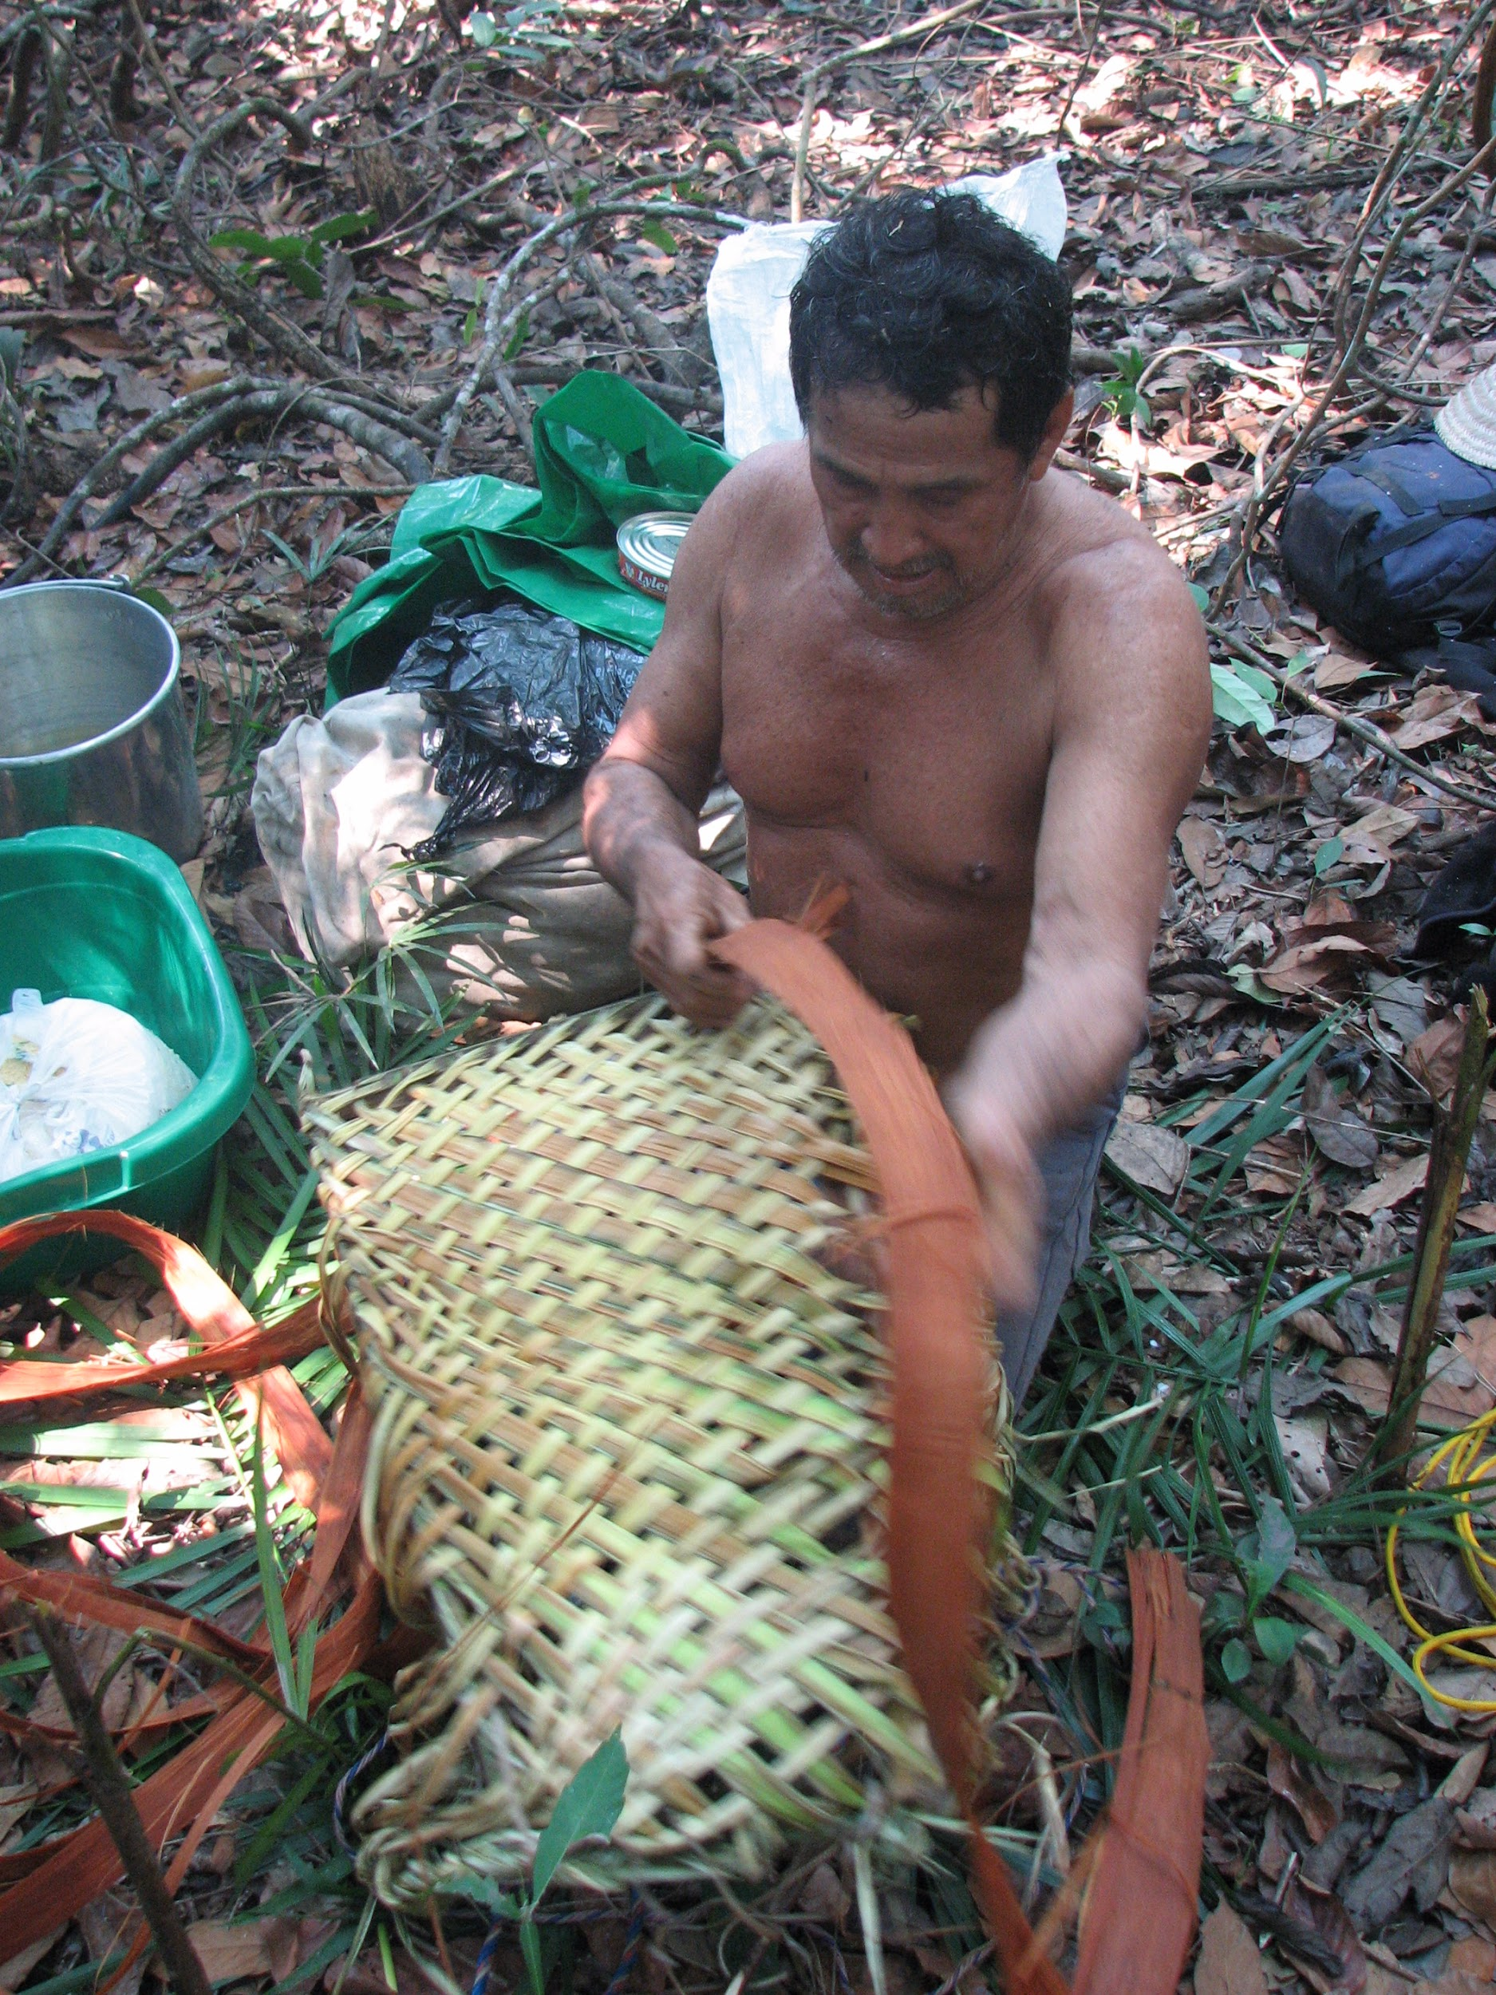
Figure 7. Images of Woven Baskets with handles from PennBox (Courtesy Clark Erickson, photographer) .
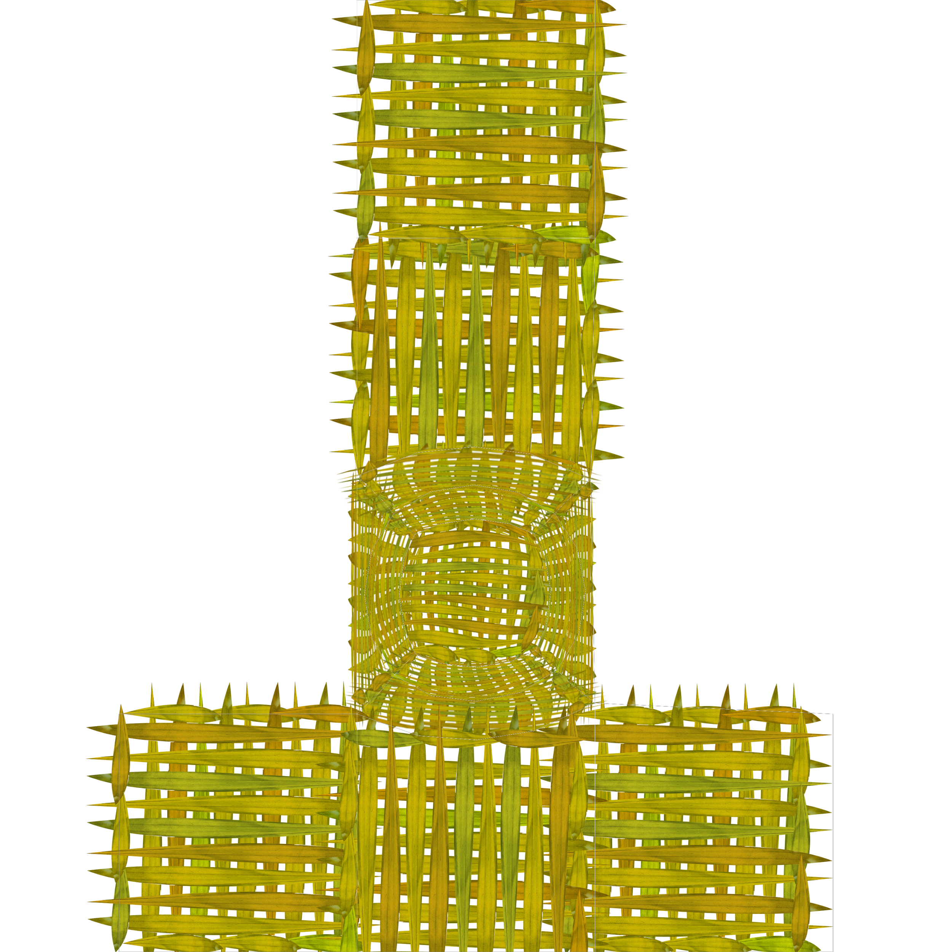 | 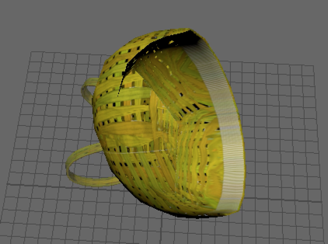
Figure 8. Transparent Basket UV created by Emiliya Al Yafei, made using edited reference photo | Figure 9. Basket transparency, as shown in Autodesk Maya.
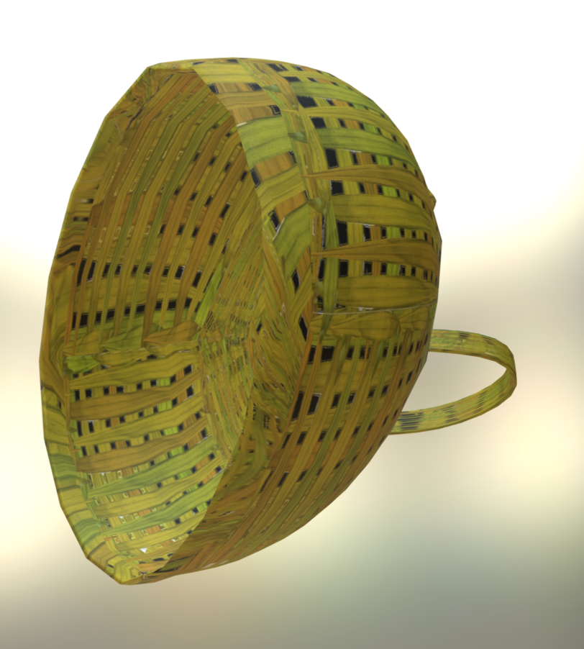 | 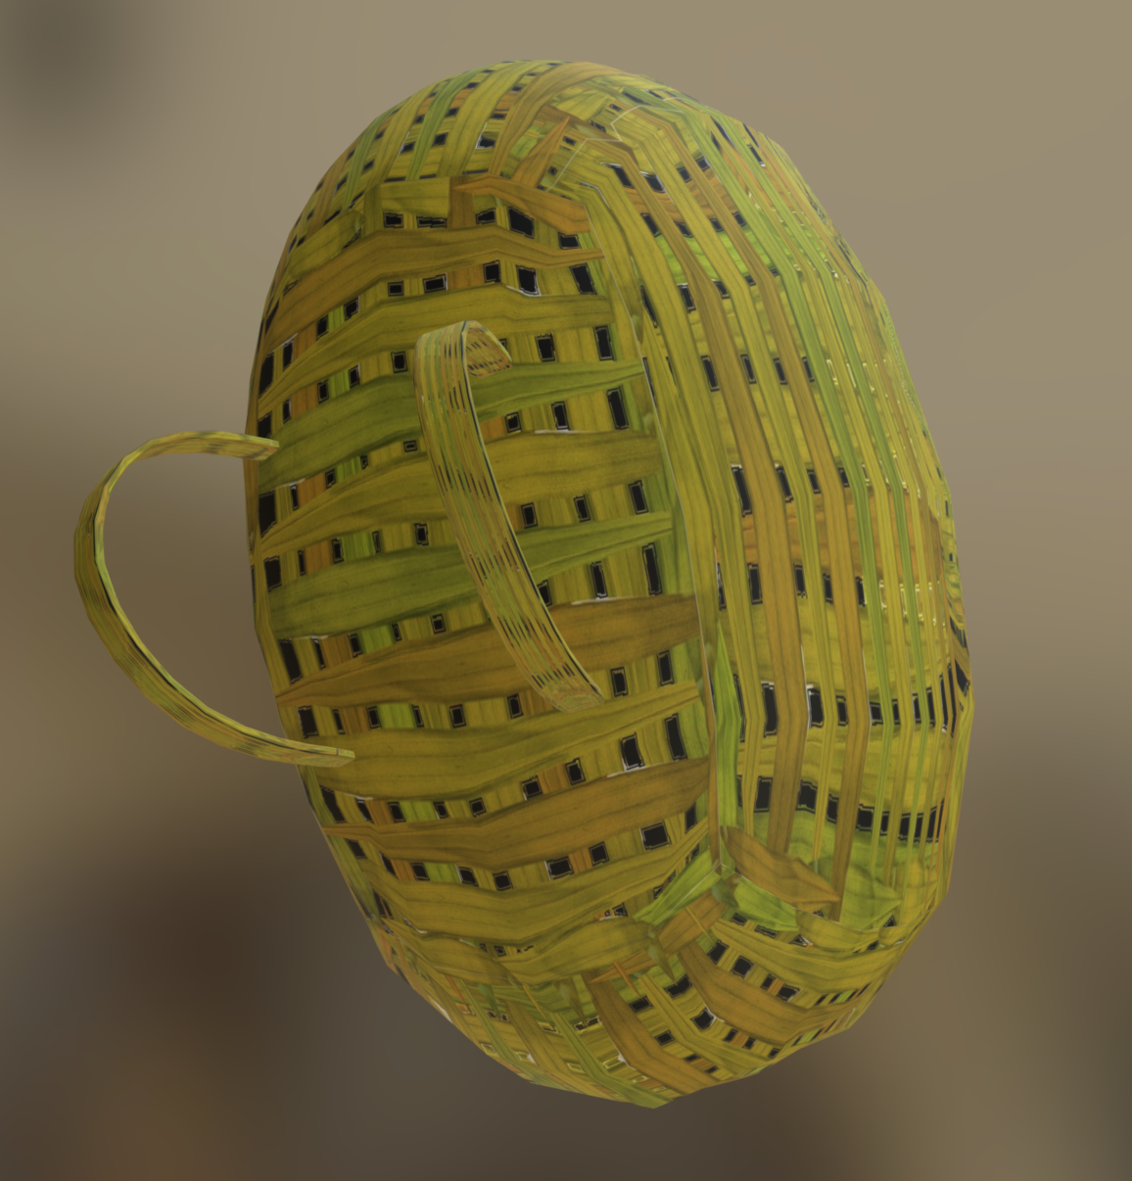
Figure 10. Rendered view of Baskets created by Emiliya Al Yafei

Canoe, Paddle, and Pole (Sangeun Lee)
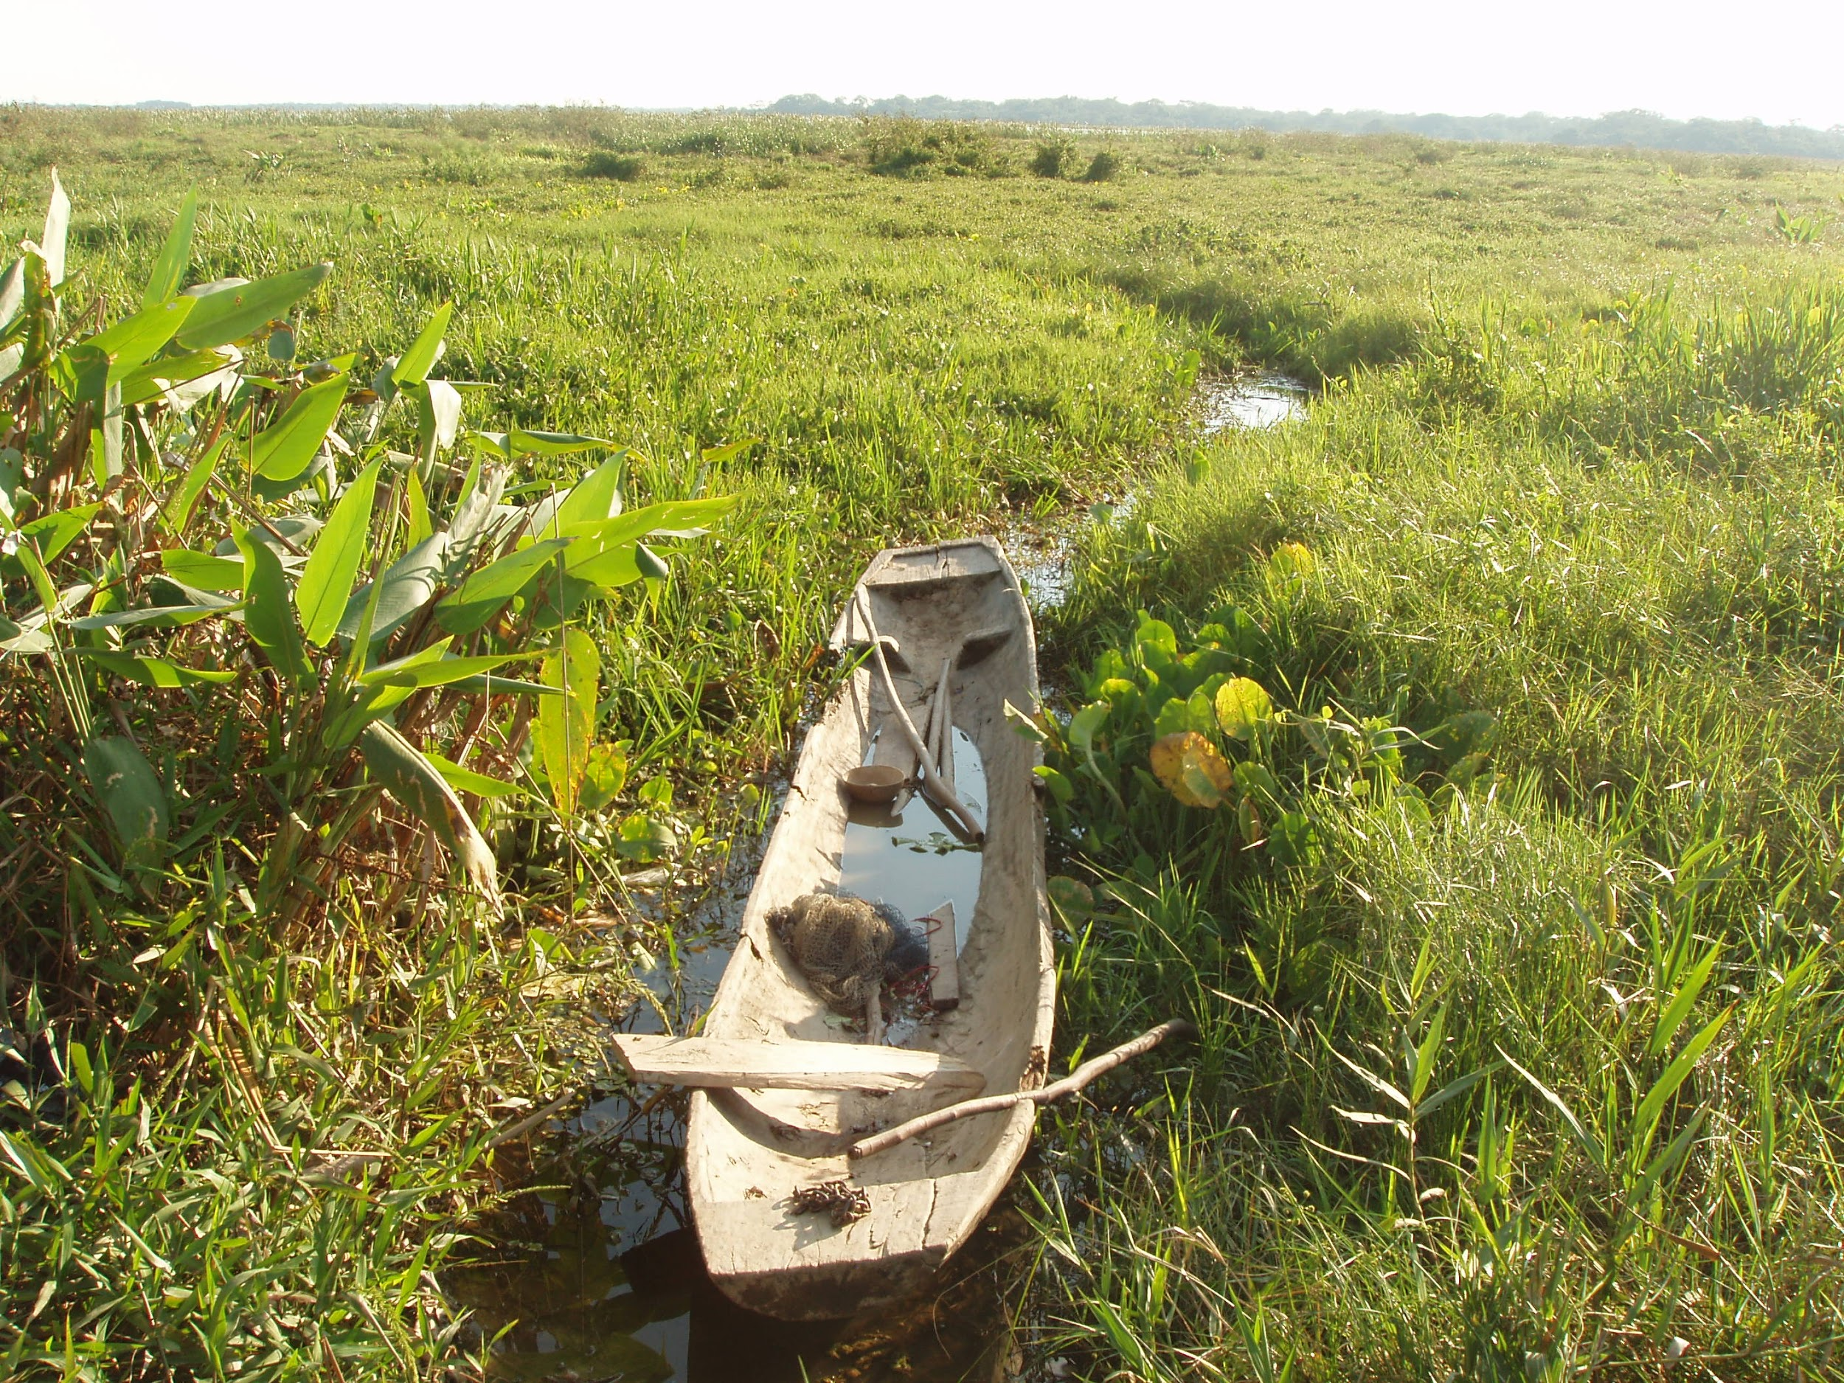
Figure 11. Chimane dugout canoe from PennBox. (Courtesy Clark Erickson, photographer)
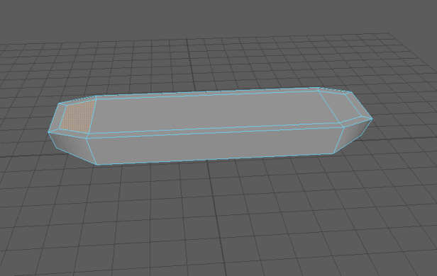
Figure 12. Third attempt by Sangeun Lee at creating a Chimane canoe
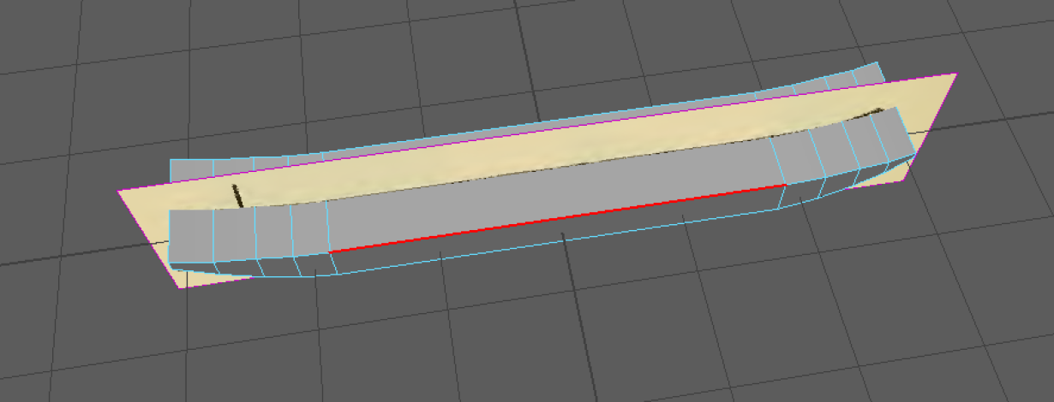
Figure 13. Fifth attempt by Sangeun Lee to model the Chimane dugout canoe
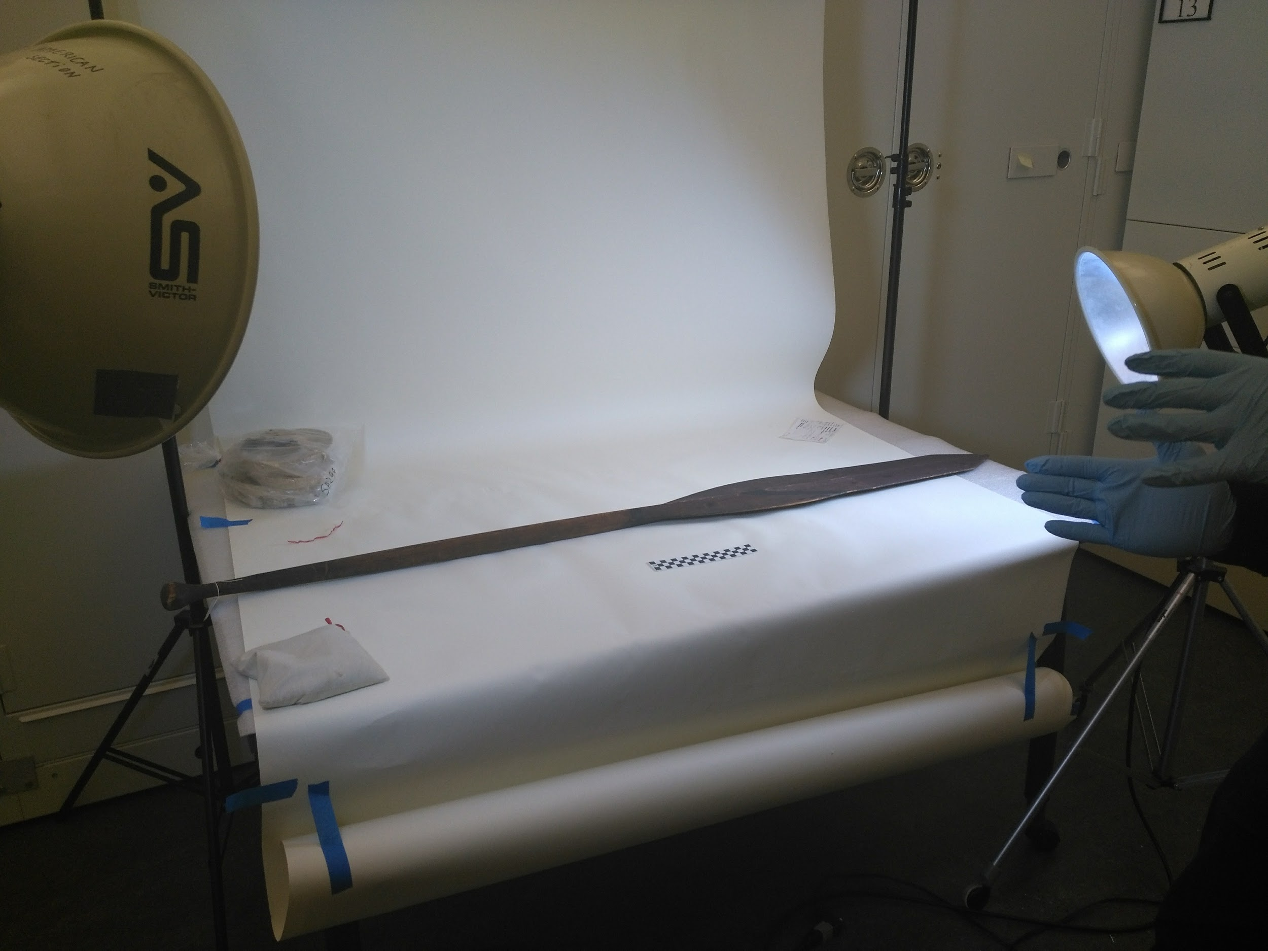
Figure 14. NA 8565 Alaskan Paddle (University of Pennsylvania. Courtesy of Tunika Onnekikami)

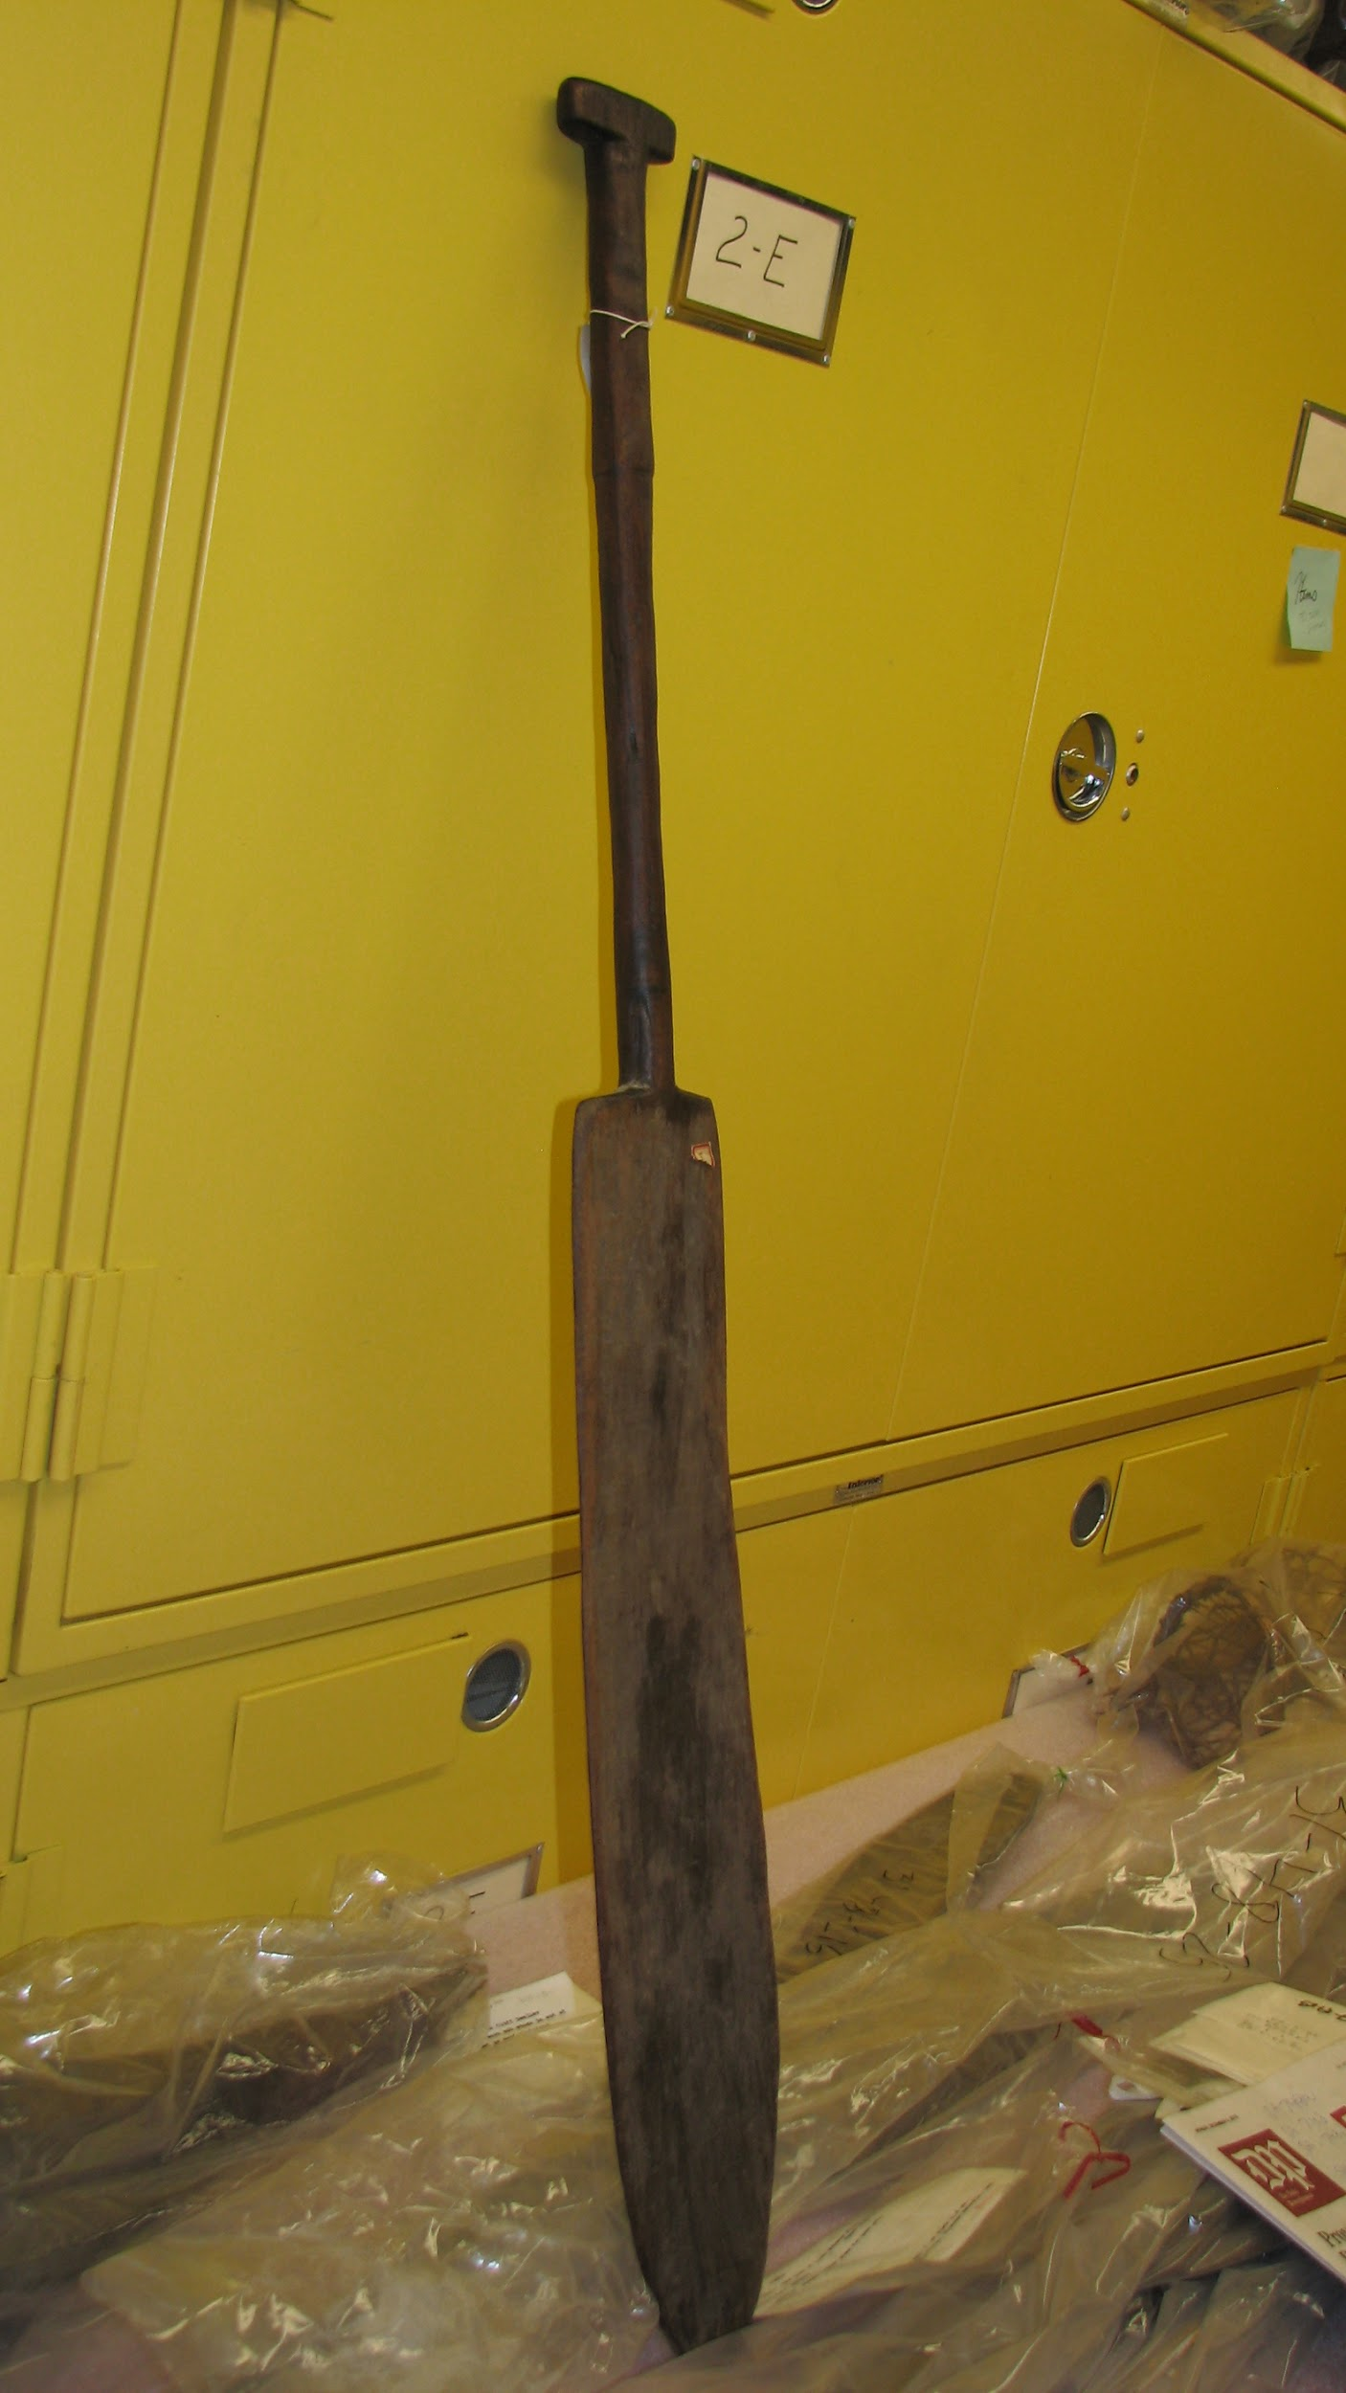

Figure 15. Kuikutl Paddle from the west bank of lower Kuluana River (University of Pennsylvania. Courtesy Clark Erickson)
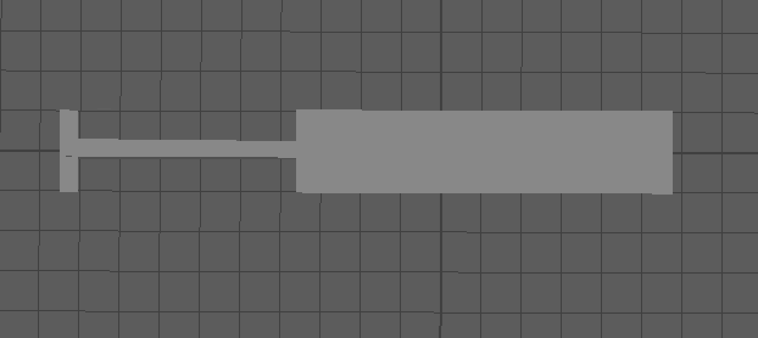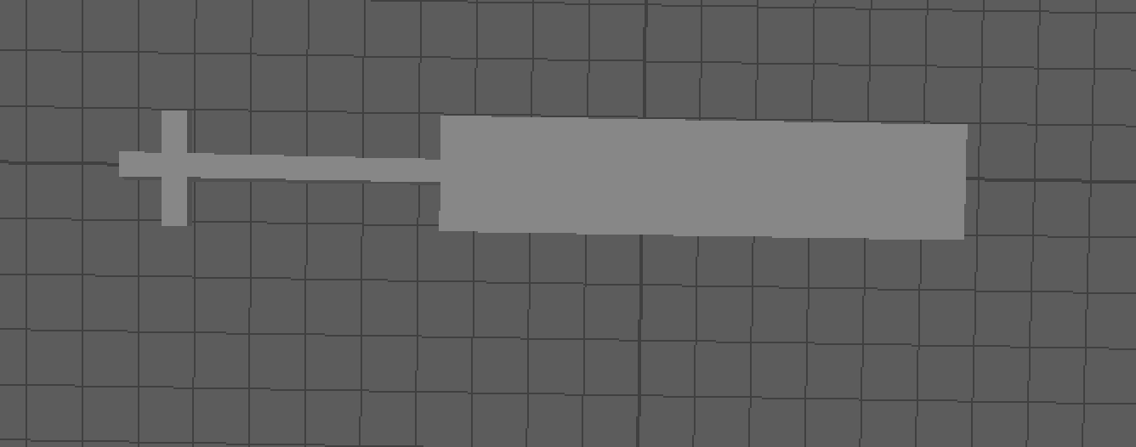
Figure 16. (a)Assemblage of separate objects to create a paddle (b)the grip of the handle moved inwards

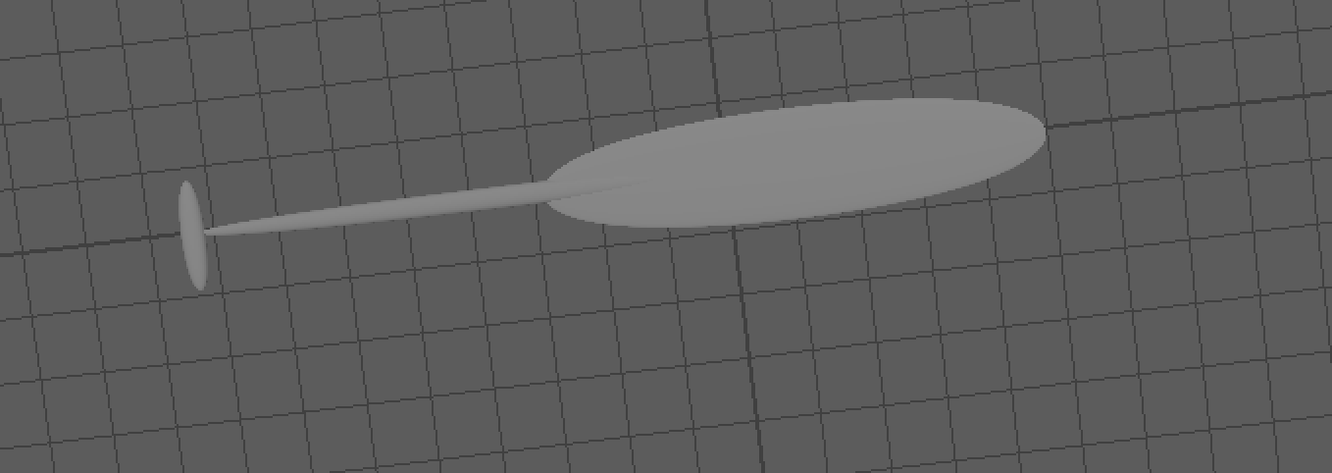
Figure 17. The paddle auto-smoothed
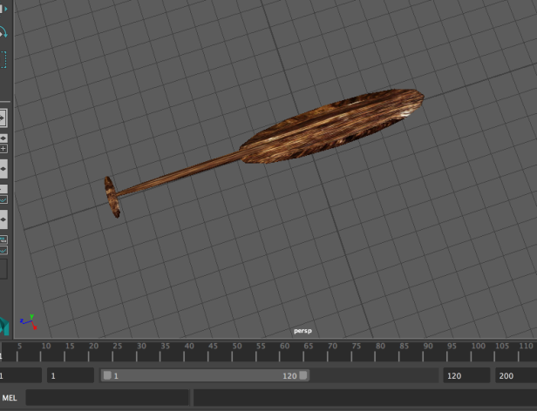
Figure 18. The paddle with texture applied created by Sangeun Lee
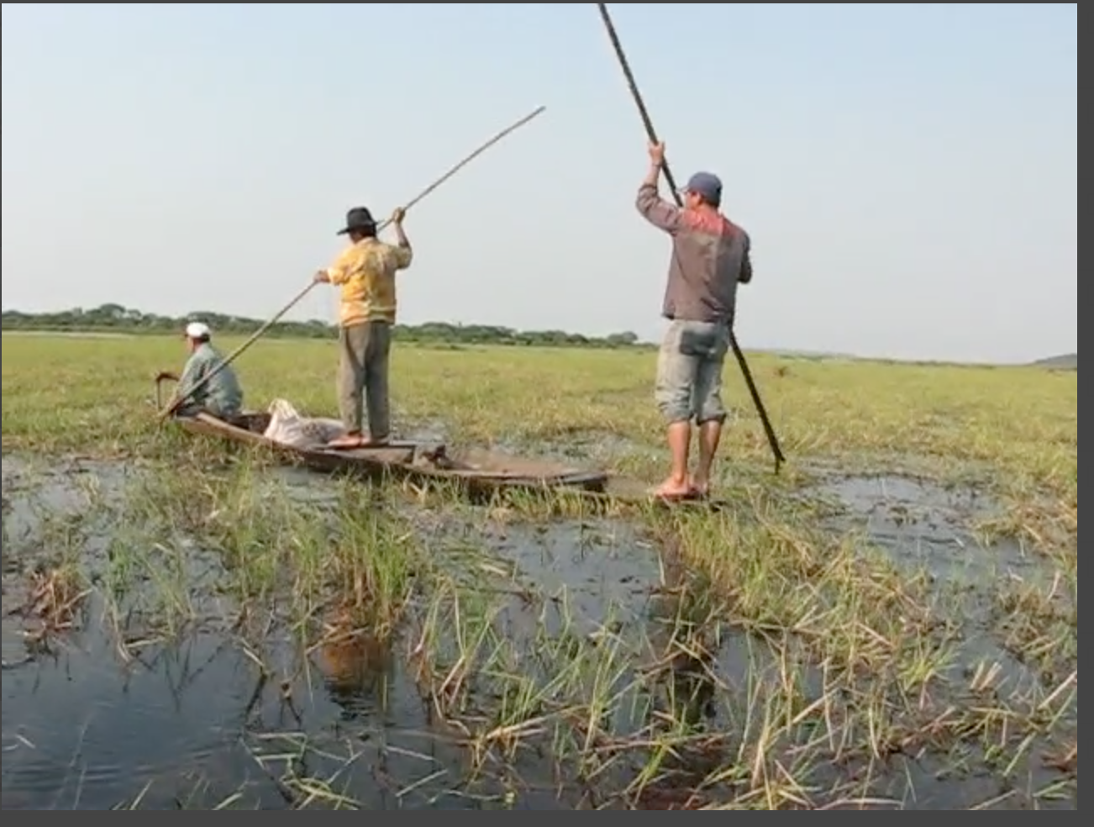
Figure 19. Bolivian locals poling (Courtesy Clark Erickson)

Motion Capture (Tunika Onnekikami)
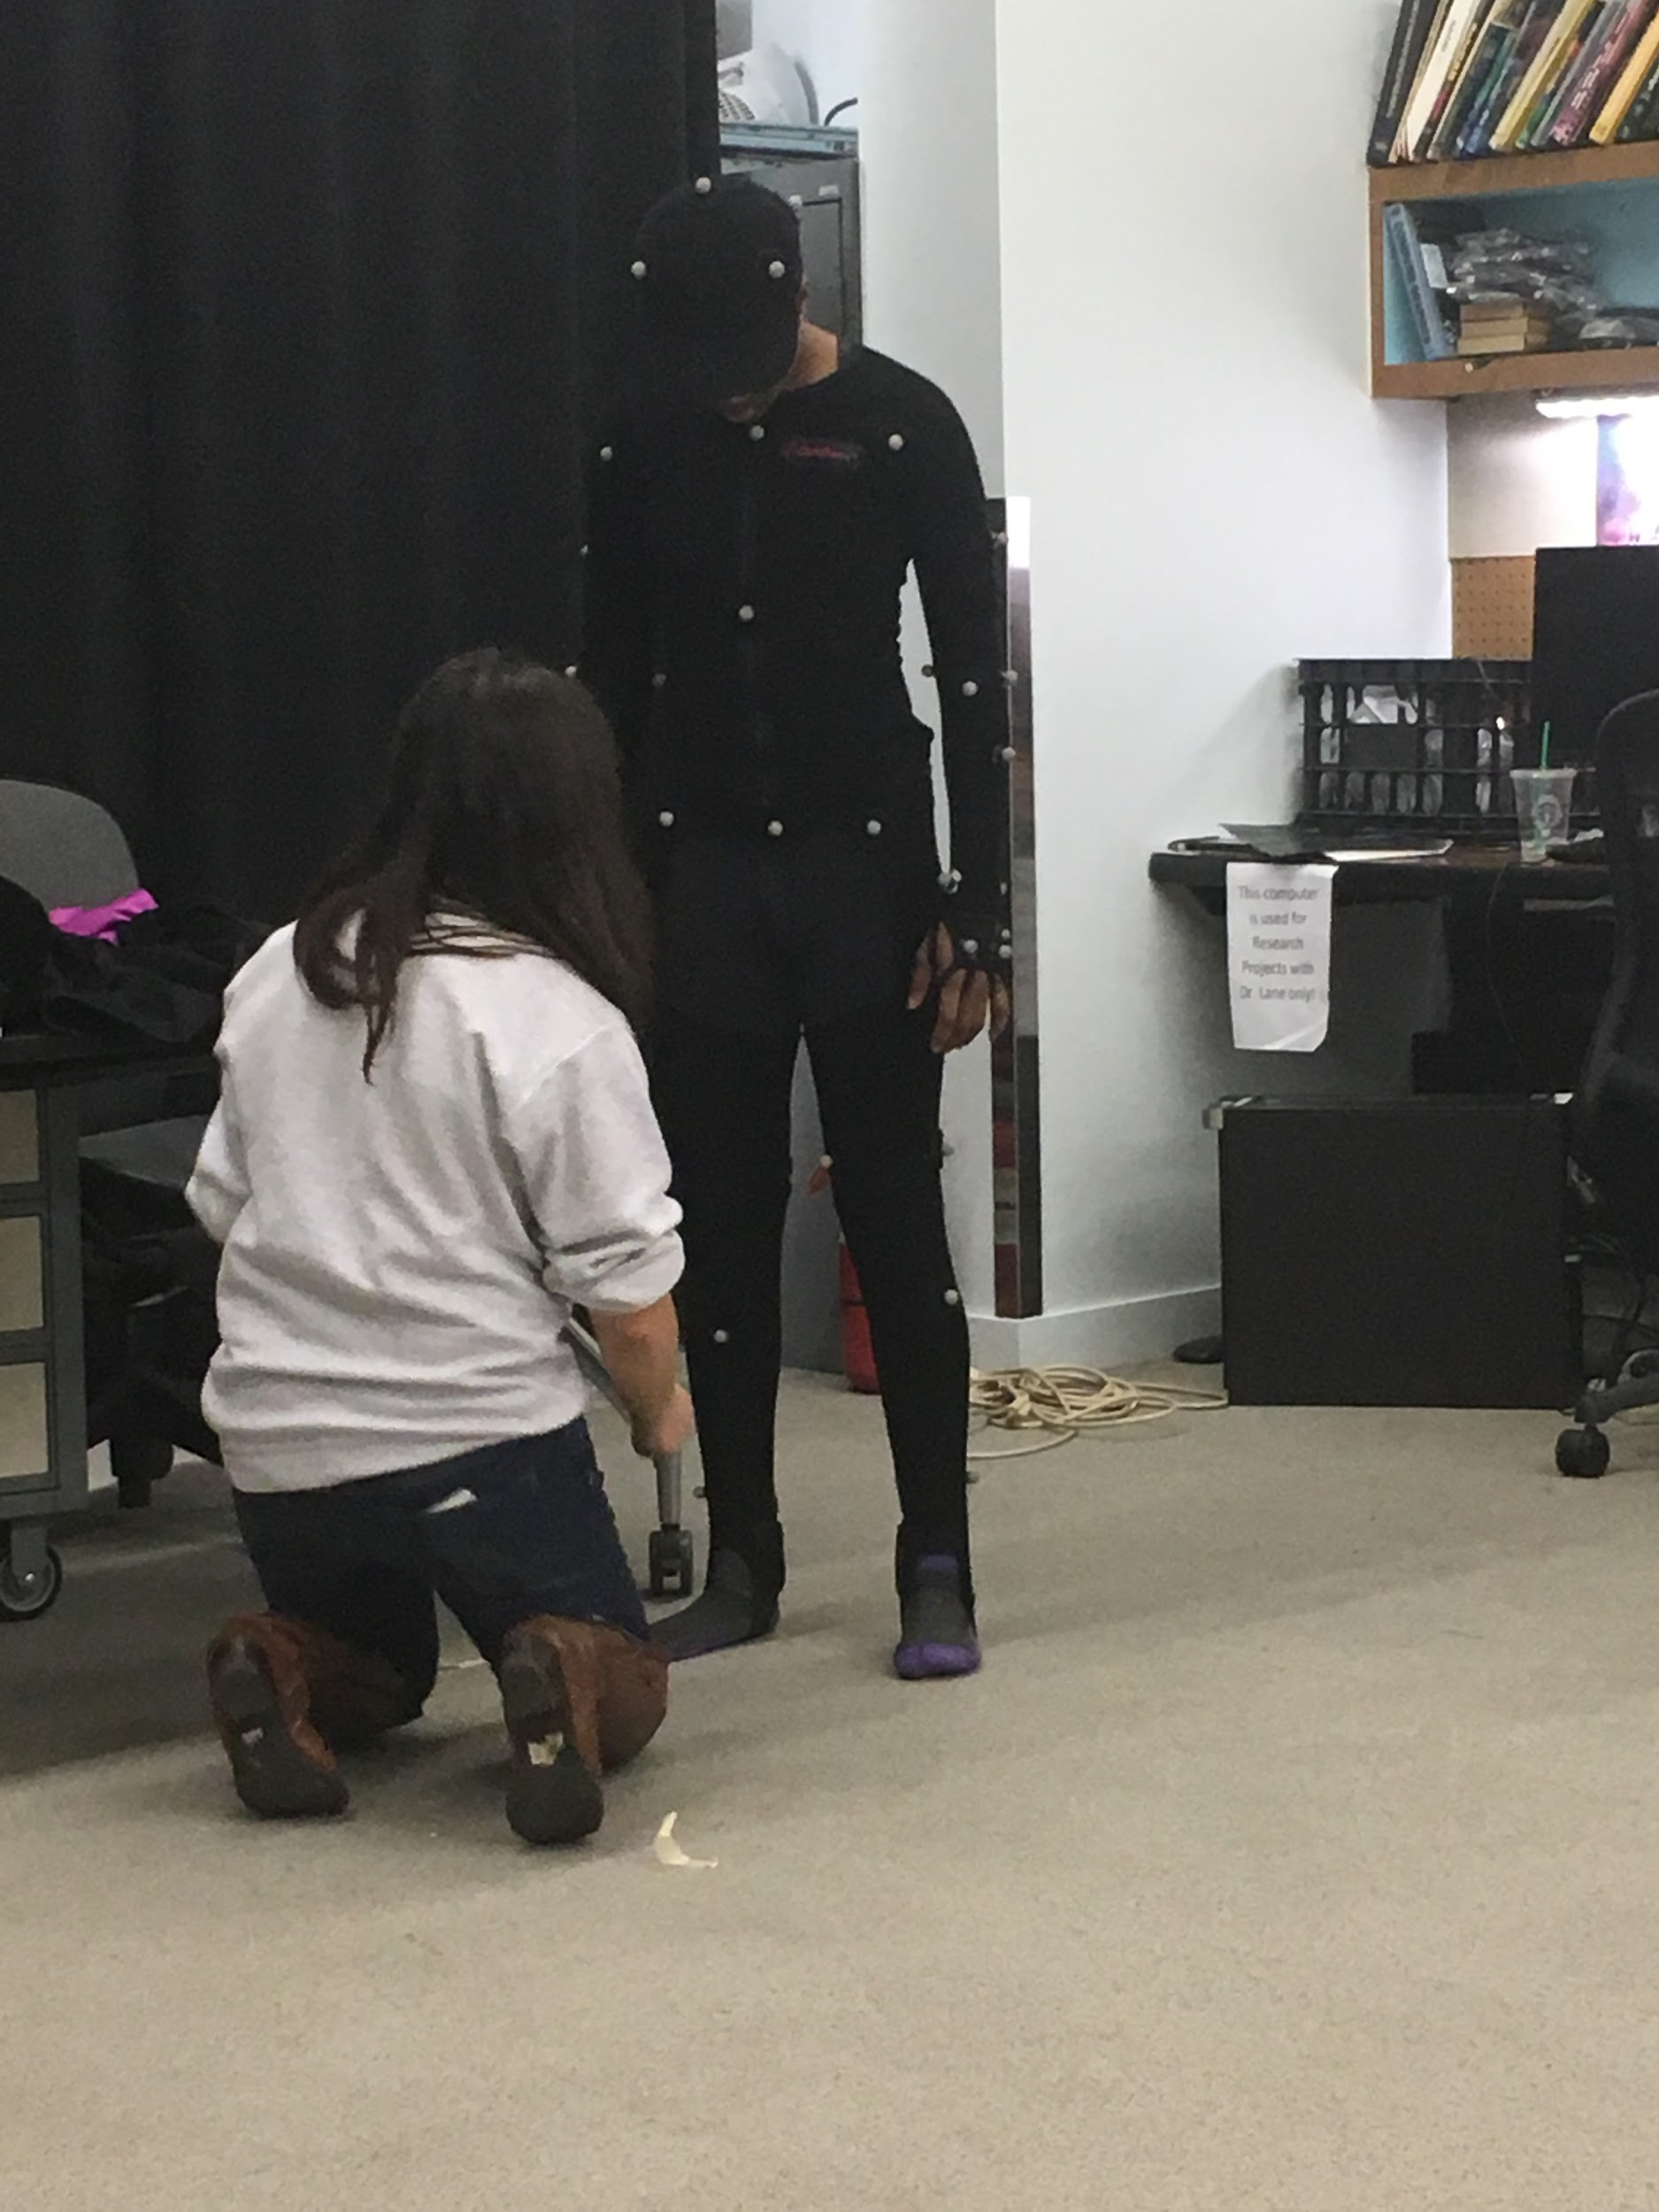 | 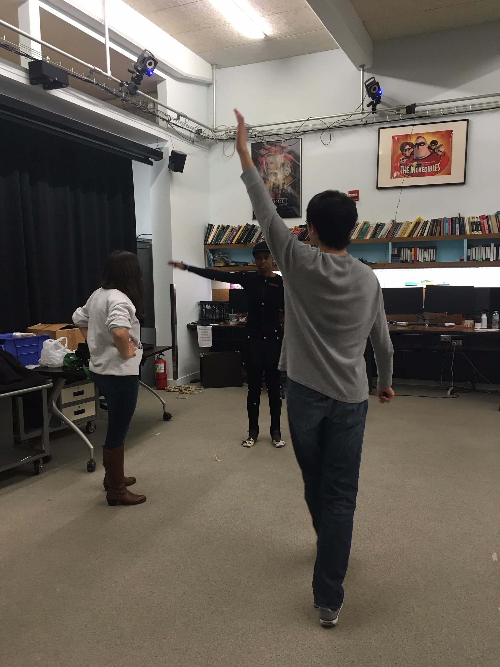
Figure 20. Tunika Onnekikami, Robert Zhou, and Chloe Snyder dress and test the motion capture suit (Courtesy of Emiliya Al Yafei)
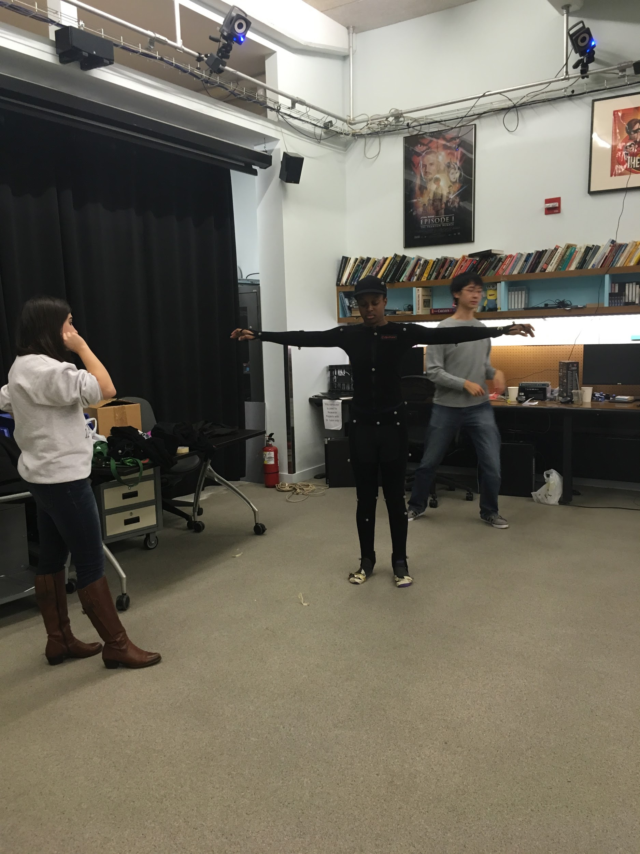 | 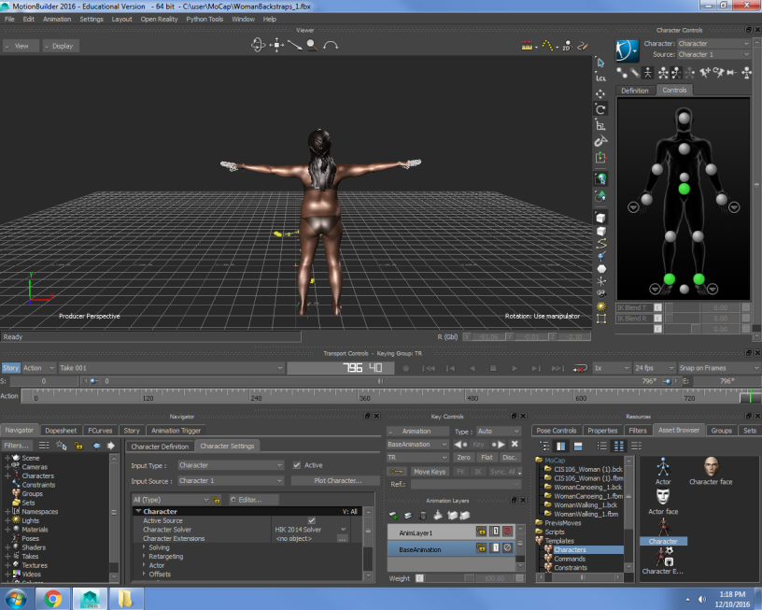
Figure 21. (a) The imperative ‘t-pose’ in real life. (b) the t-pose on the monitor
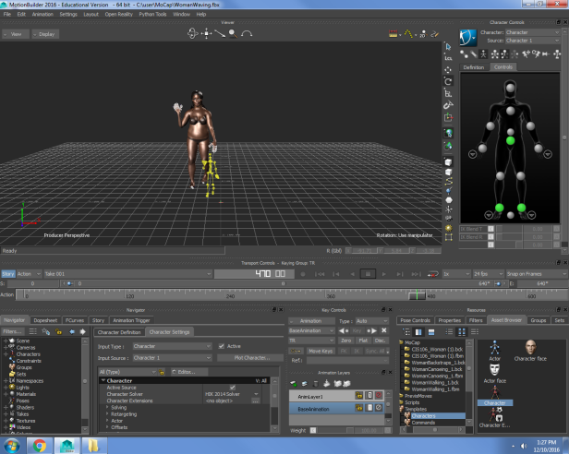
Figure 22. A screenshot of the ‘interaction’ motion, a simple wave.
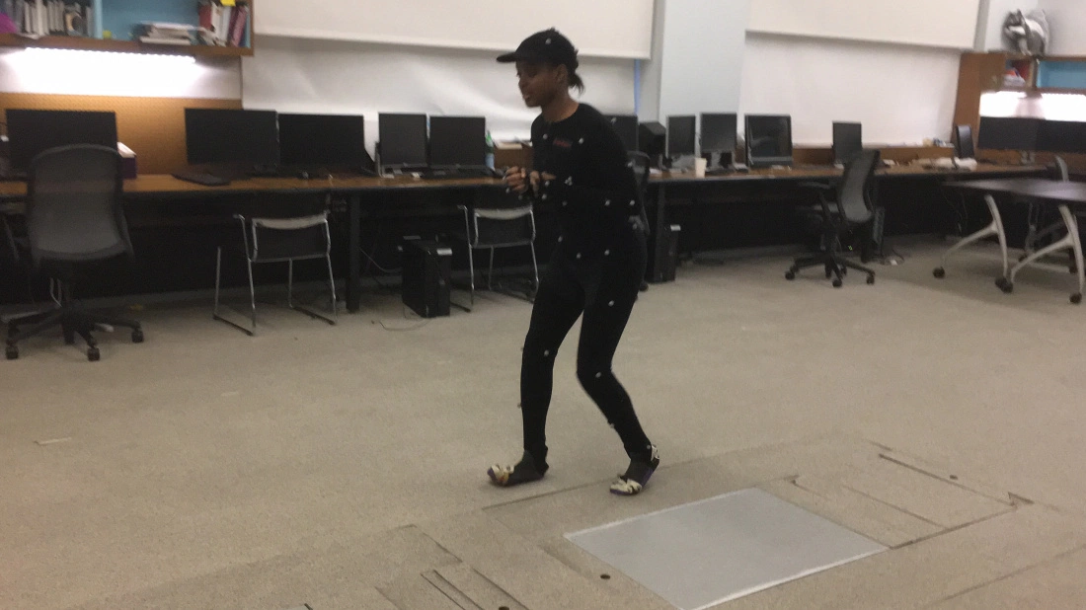
Figure 23. Tunika Onnekikami goes through the ‘backing’ motion (that is the movement where a bag is carried on one’s back).
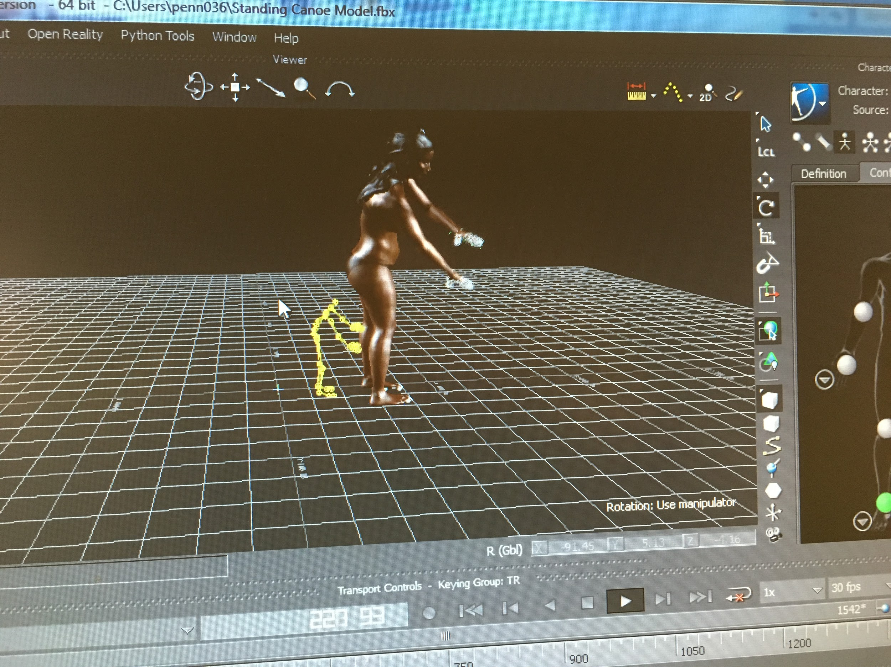 | 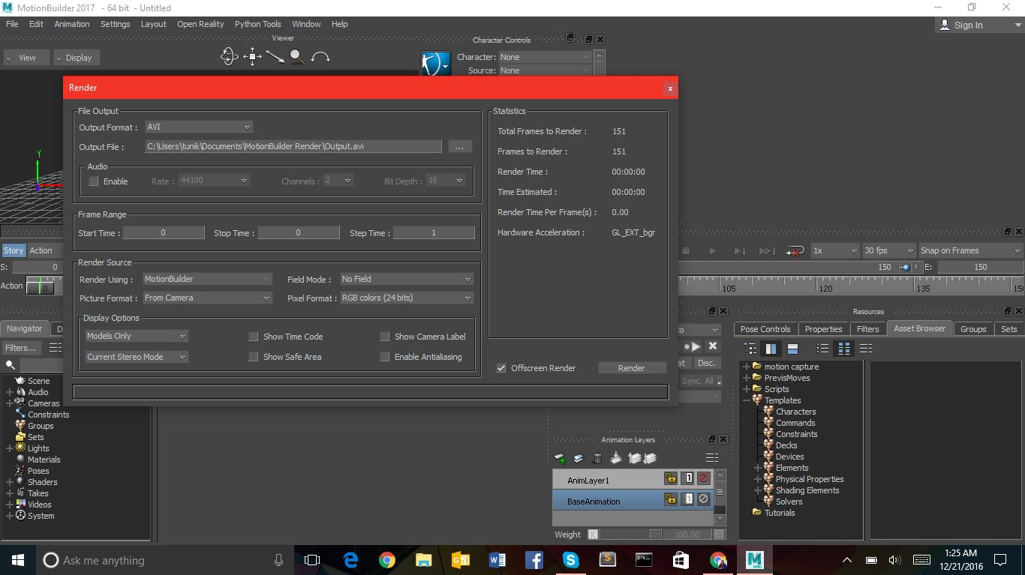
Figure 24. (a) One of the motions that was captured and ‘brought to life’ in MotionBuilder. (b)Screenshot of the first step of ‘rendering’ or recording the captions in MotionBuilder.

