Figure 1: Map of General Location of Zhujiajiao

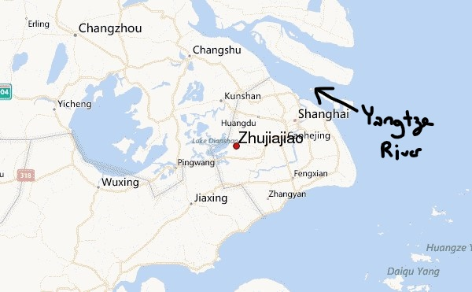

Source: Zhujiajiao Weather Forecast

Figure 2: Closer Look of Zhujiajiao on a Map with Nearby Tourist Locations/Airports

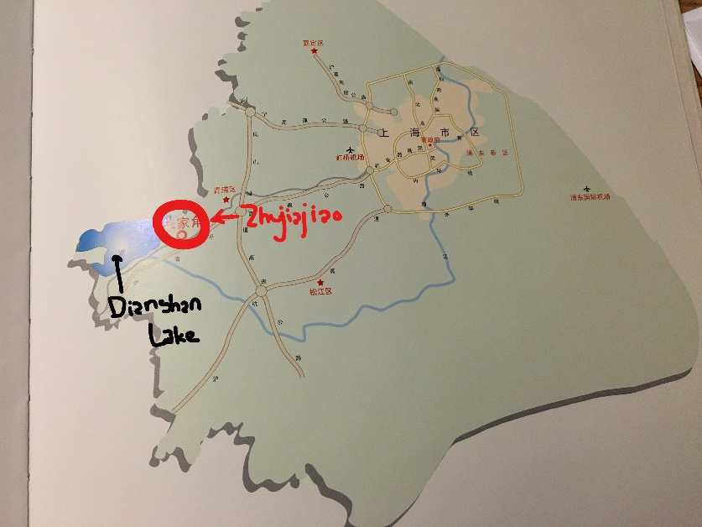

(Source: *Zhujiajiao Shanghai)*

Figure 3: Paddy Habitude Exhibition Hall: seasonal scenes of rice farmers’ life

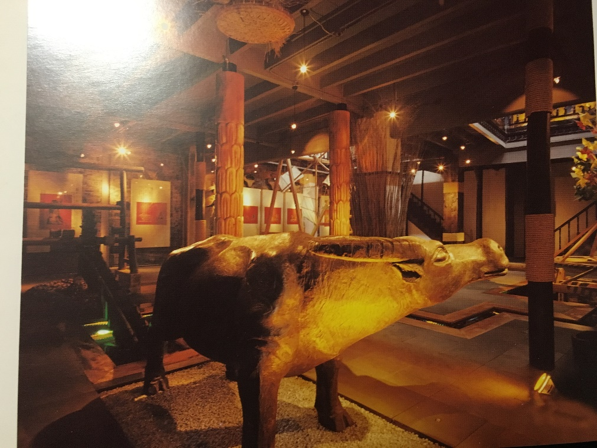

(Source: *Zhujiajiao Shanghai)*

Figure 4 & 5: Material of Rafts and Gossamer Fabric, Spears, and Baskets

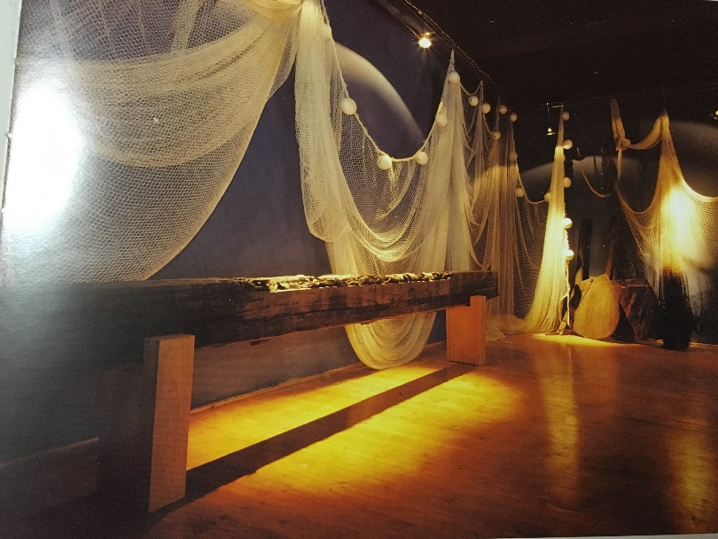

(Source: *Zhujiajiao Shanghai)*

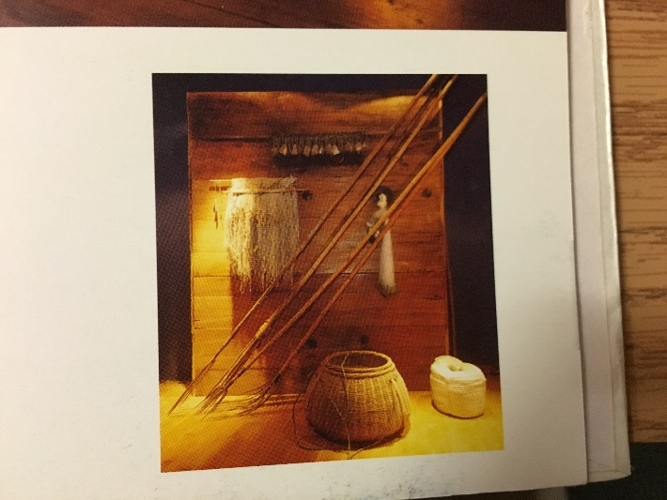

(Source: *Zhujiajiao Shanghai)*

Figure 6 and 7: Modelling of the Lang Bridge and surroundings by Kristin

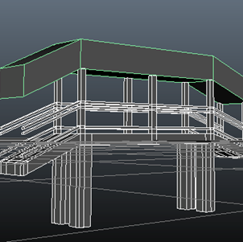

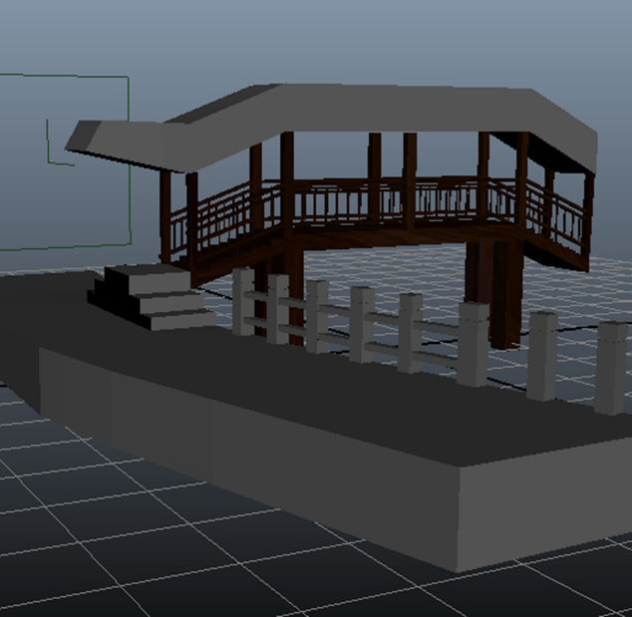

Figures 8-10: Modern Zhujiajiao Boats

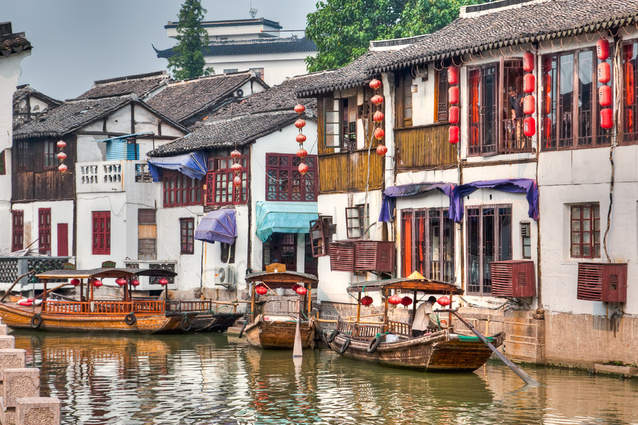

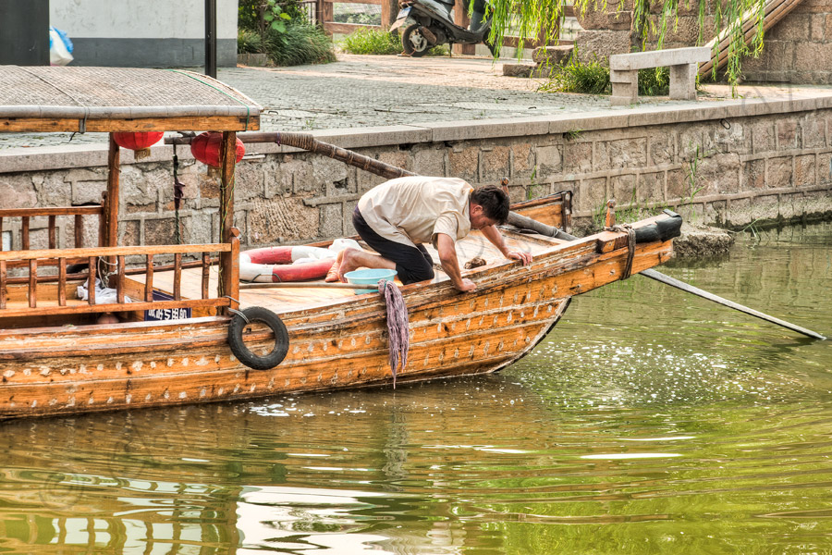

(Source: *Radley)*

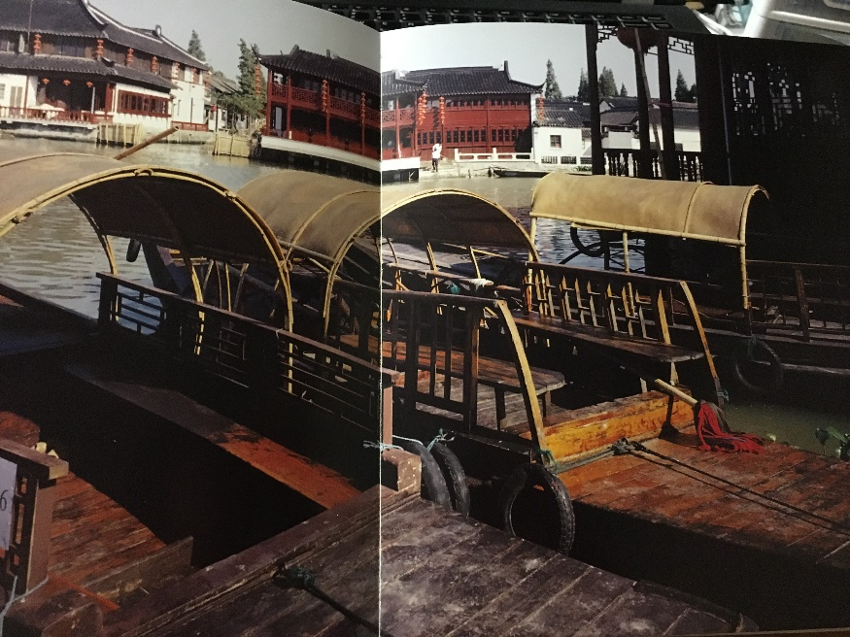

(Source: *Zhujiajiao Shanghai)*

Figures 11-13: Calligraphic Paintings of Boats from the Qing Dynasty

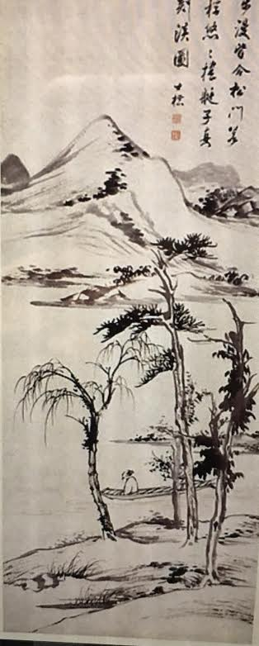

“Old Man Boating on a River”

By: Zha Shibiao

(Source: *Metropolitan Museum of Art online gallery)*

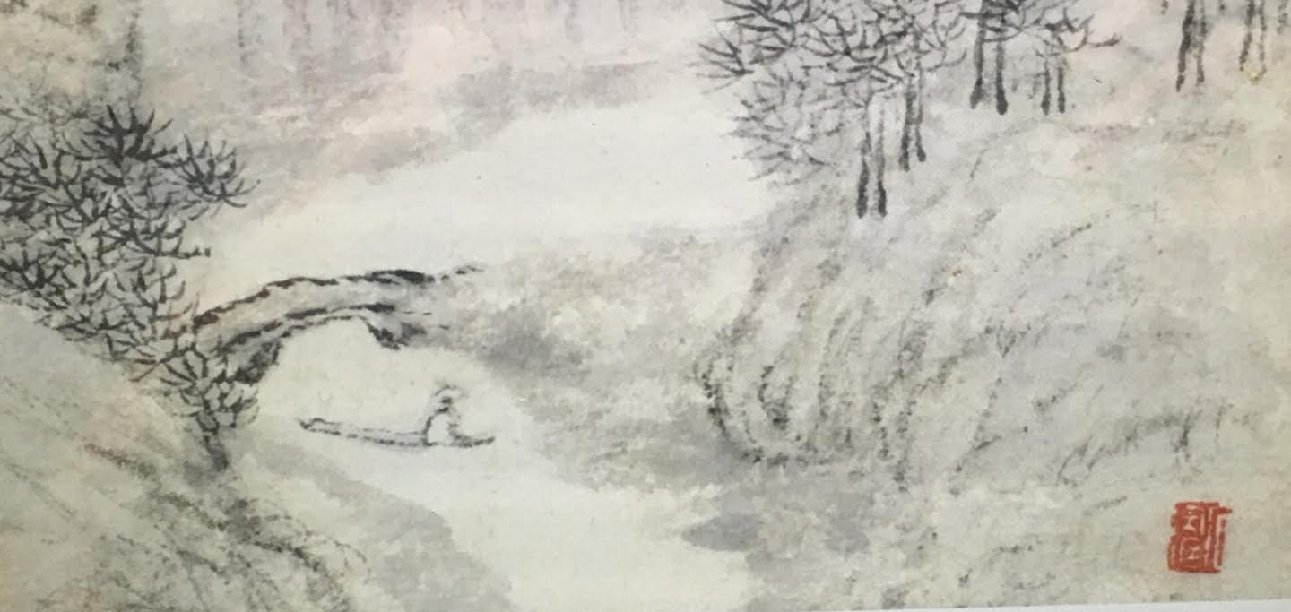

(No title)

(Source: *Metropolitan Museum of Art online gallery)*

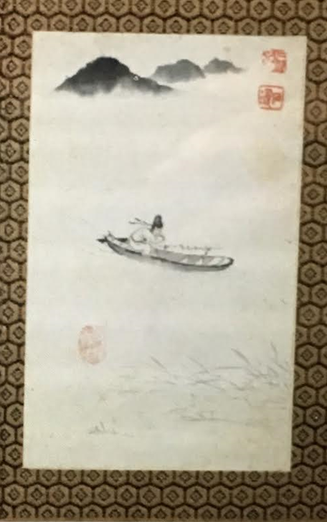

“Returning Home”

By: Shitao

(Source: *Metropolitan Museum of Art online gallery)*

Figure 14: sketchy drawing of a non-specified bridge recovered from the Qing Dynasty

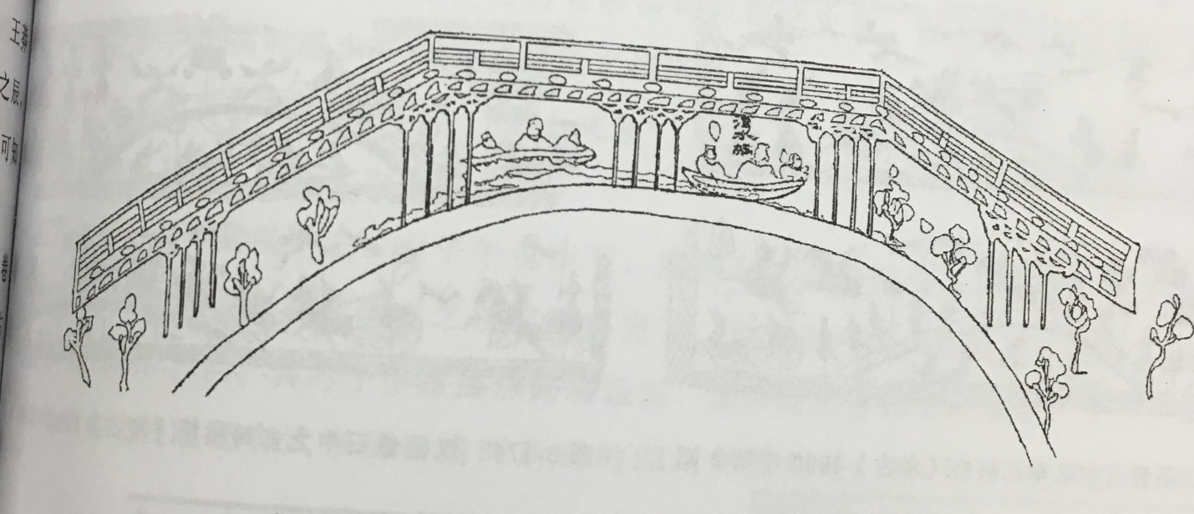

(Source: Sun)

Figure 15: A photograph taken in the 1900s of a river boat in Zhujiajiao

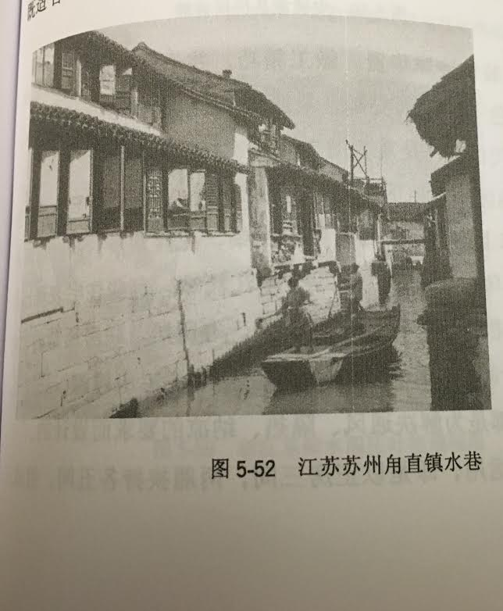

(Source: Sun)

Figure 16: An additional photo of a modern Zhujiajiao boat that is more close to the depictions of the Qing Dynasty

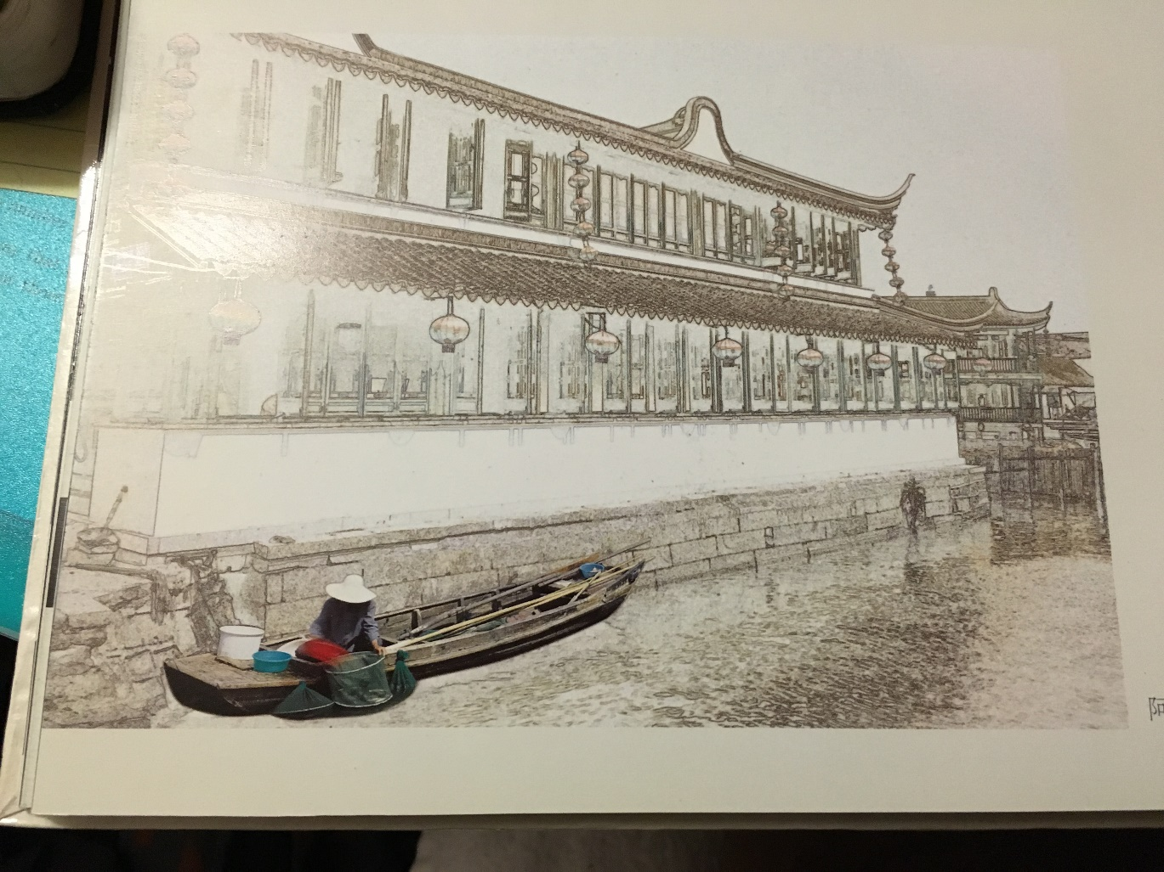

(Source: *Zhujiajiao Shanghai*)

Figure 17: Indents in Boat using Maya Autodesk

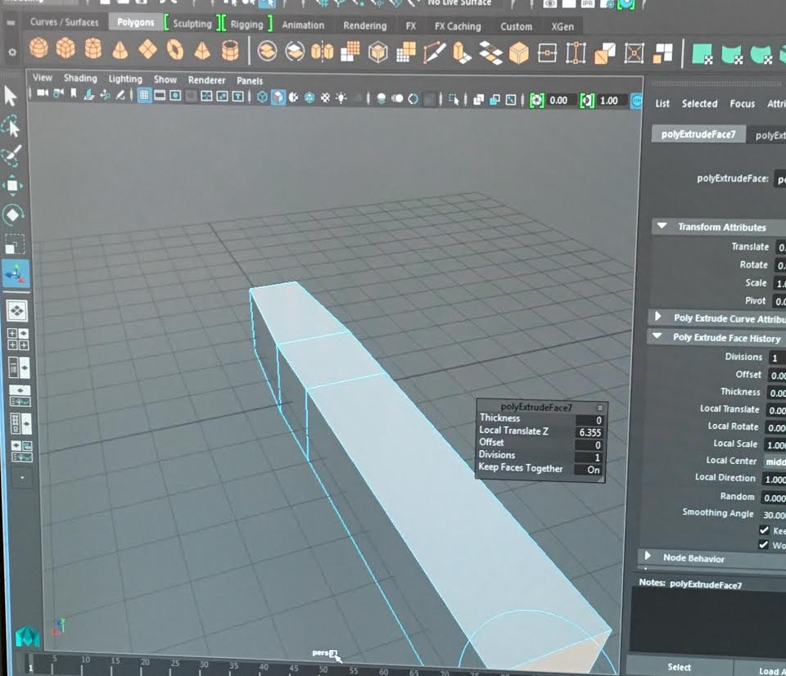

Figure 18: Boat with Curvature

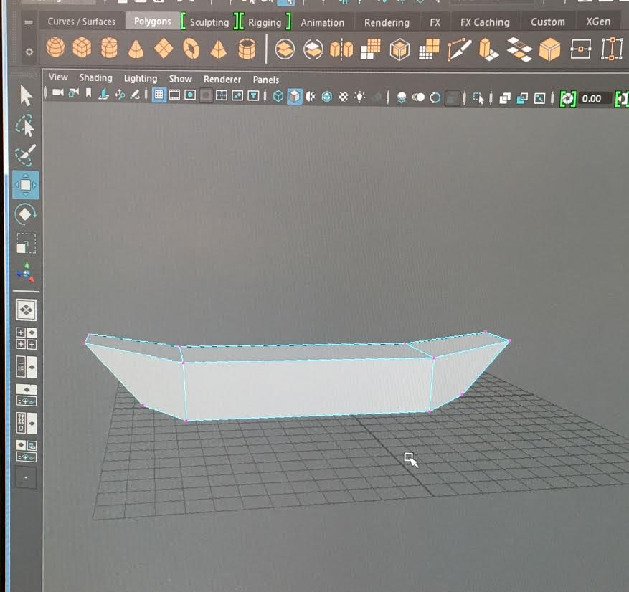

Figure 19: Boat with interior extrusions as well as protrusions

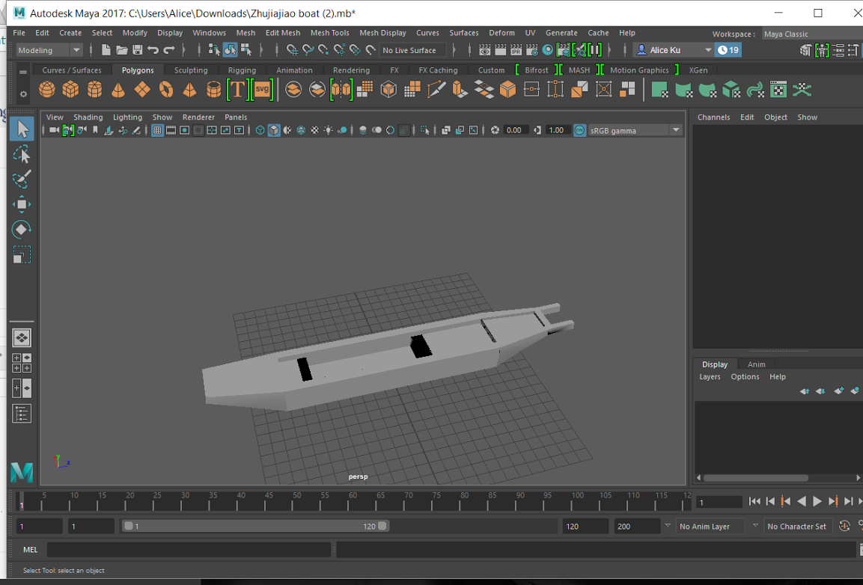

Figure 20: Protrusions from boat

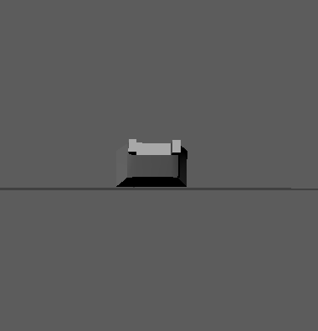

Figure 21: Paddle that was constructed for the purpose of eventual Motion Builder

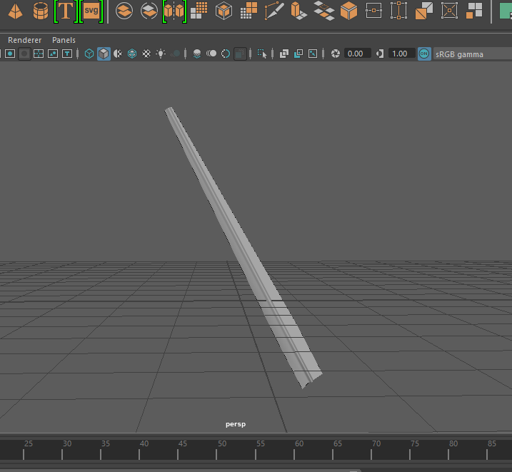

Figure 22: Motion Capture suit in the T-Position

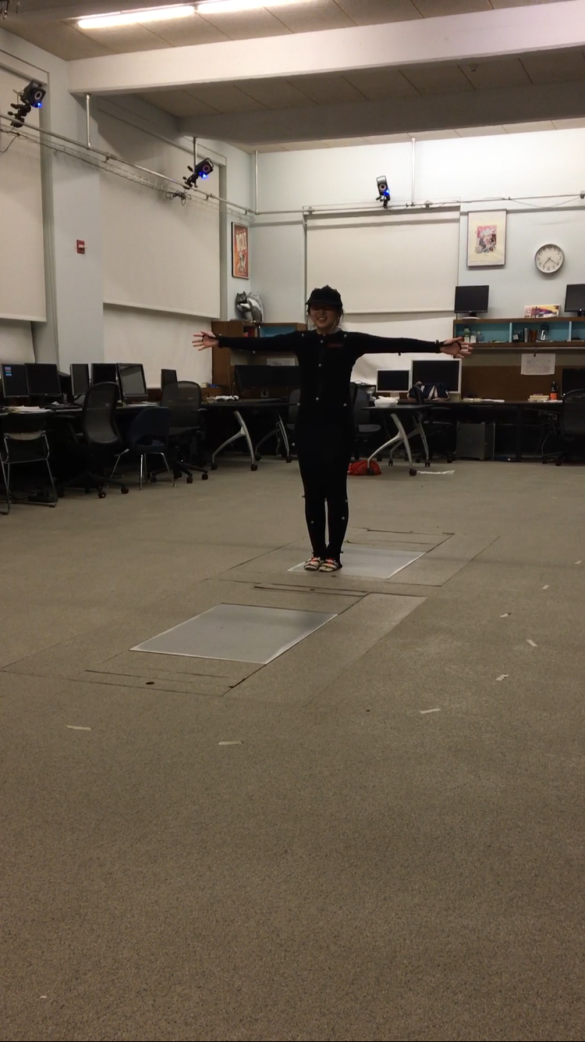

Link 1: PowerPoint of Motion Capture Data

<https://docs.google.com/presentation/d/1AK0u2K3cEKF3DTGVqCBWC-QkN-9kk1evgryzfaHQ3eo/edit#slide=id.p3>

Link 2: Modern-day boat rowing

<https://www.youtube.com/watch?v=UjyE7dyR2X4>