Gregory Howard
Visualizing the Past / Peopling the Past
ANTH 258 / CIS 106
Final Project Figures

Fish Weirs and Ponds in the Bolivian Amazon

Figure 1: “Oblique photograph of a fish weir and artificial ponds between forest islands in the savannahs of Baures. Fish weirs are the zigzag structures, lower left to upper right; artificial ponds are the circular features surrounded by palms (approximately 20 m in diameter). The diagonal feature (upper left to lower right) is a contemporary path” (Erickson 2000: 192).

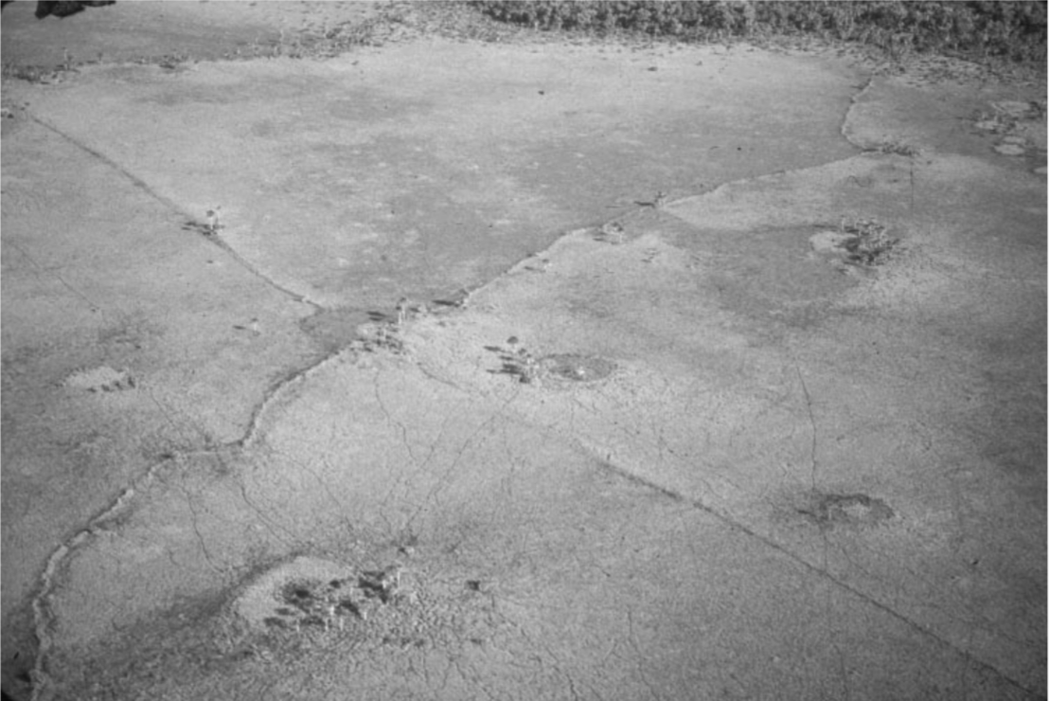

Figure 2: “Plans of fish weirs (zigzag structures). Small parallel openings in the weirs are present every 50-200 m” (Erickson 2000: 193).

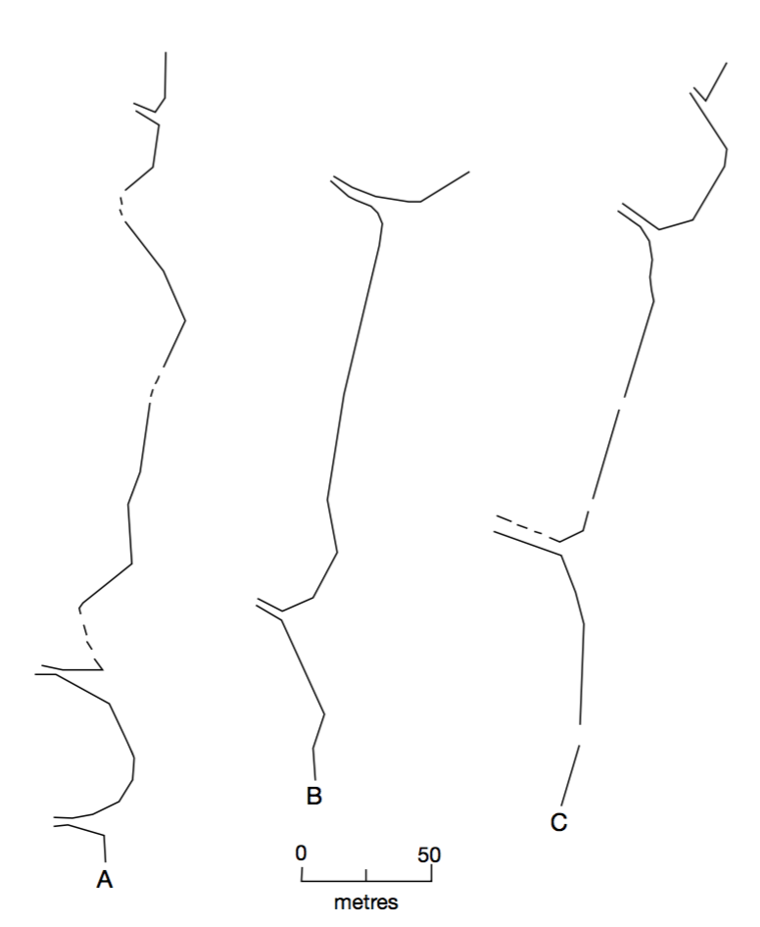

Figure 3: Photograph: Clark L. Erickson, from Net Fishing in the Bolivian Amazon presentation.

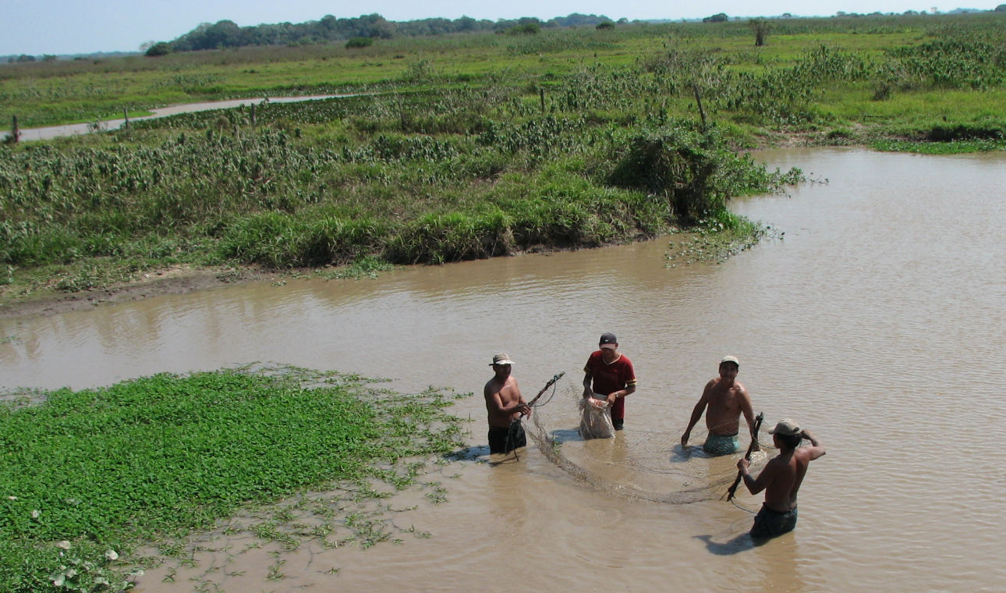

Figure 4: Photograph: Clark L. Erickson, from Net Fishing in the Bolivian Amazon presentation.

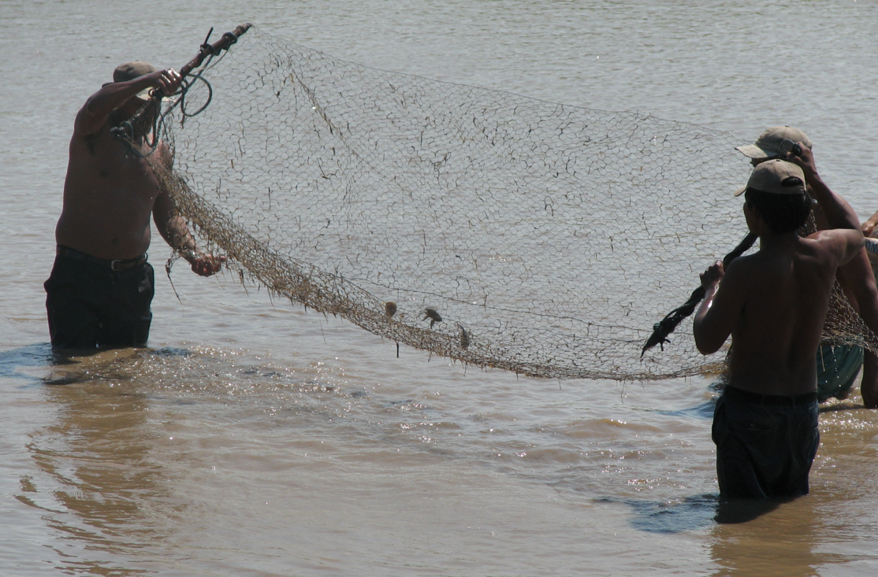

Figure 5: Photograph: Clark L. Erickson, from Net Fishing in the Bolivian Amazon presentation.

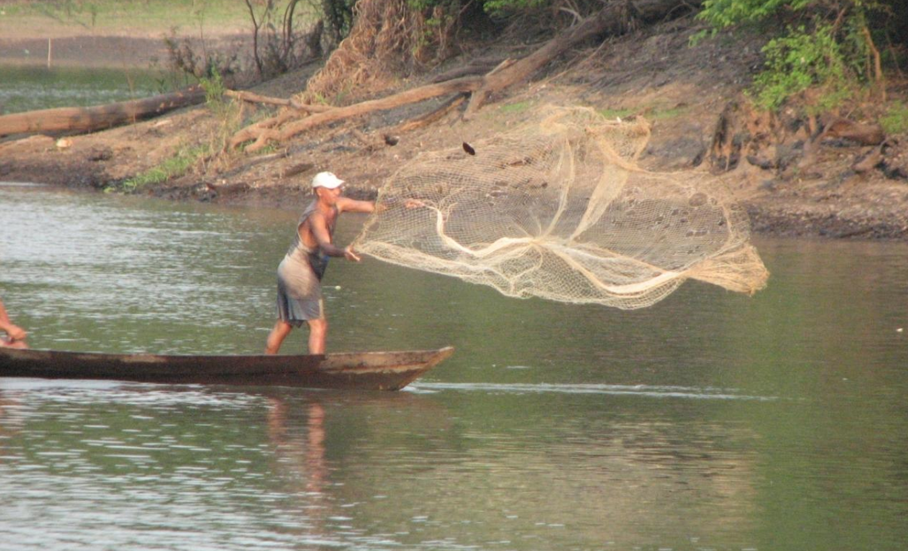

Figure 6: Photograph: fish weir, Clark L. Erickson, from Baures Landscapes for 3d Modeling in Unity presentation (2016).

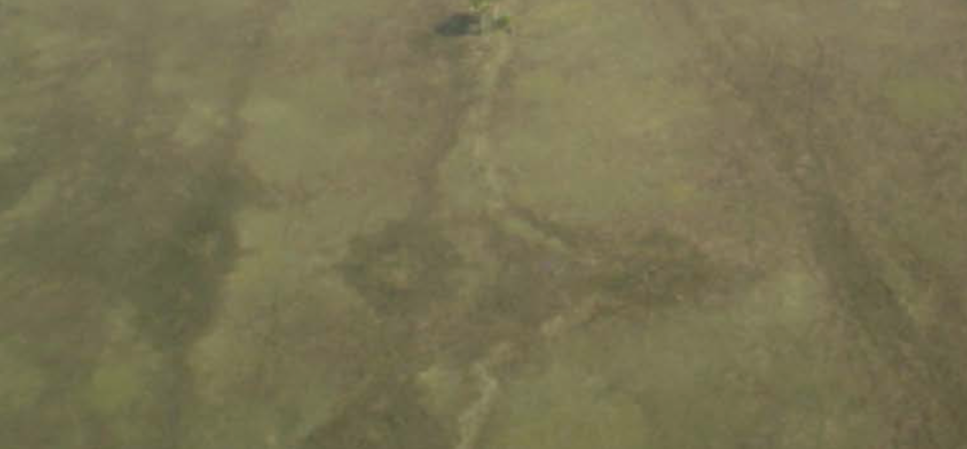

Figure 7: Photograph: weir opening from ground, Clark L. Erickson, shared on Penn Box.

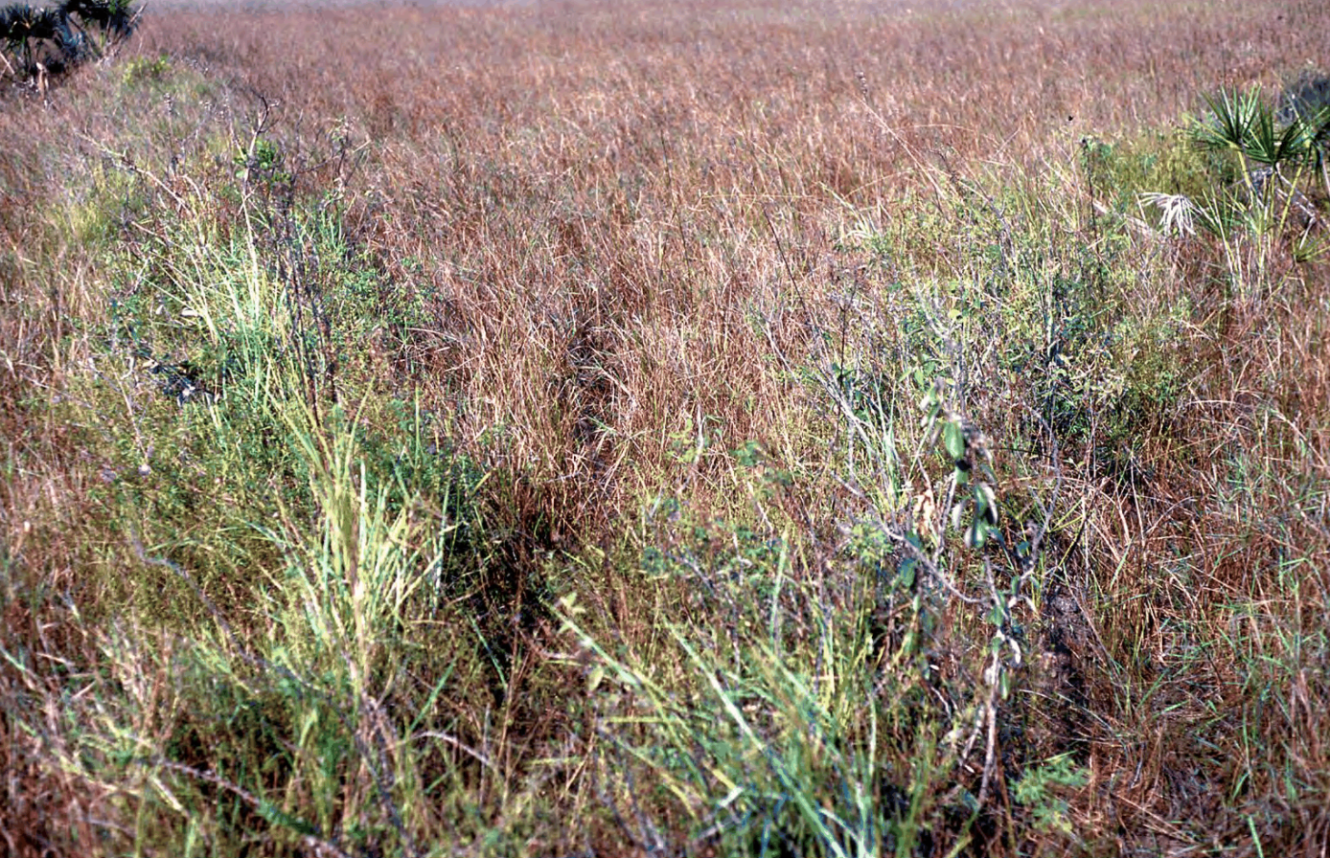

Figure 8: Photograph: fish weirs, Clark L. Erickson, shared on Penn Box.

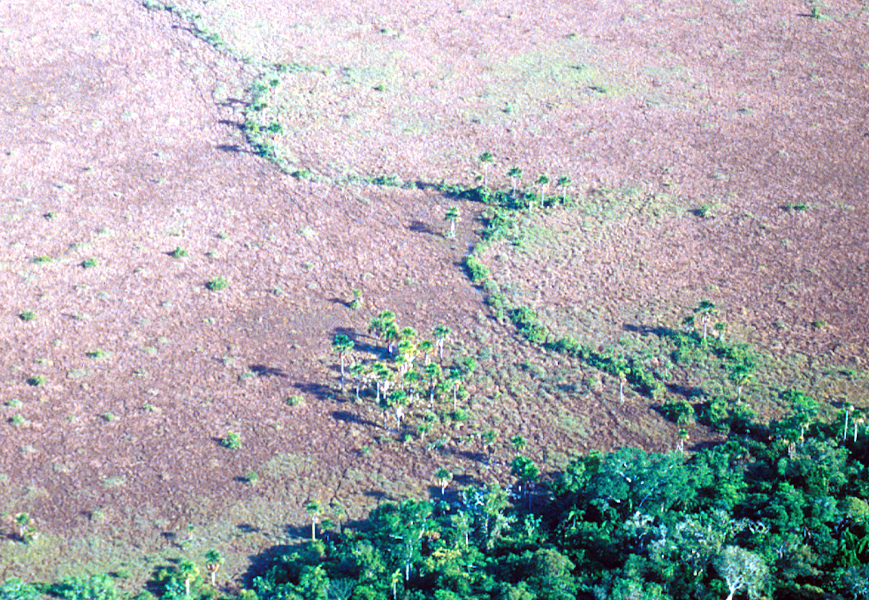
Figure 9: Screenshot of the original area I intended to model (Microsoft 2016). I failed to take scale into account.

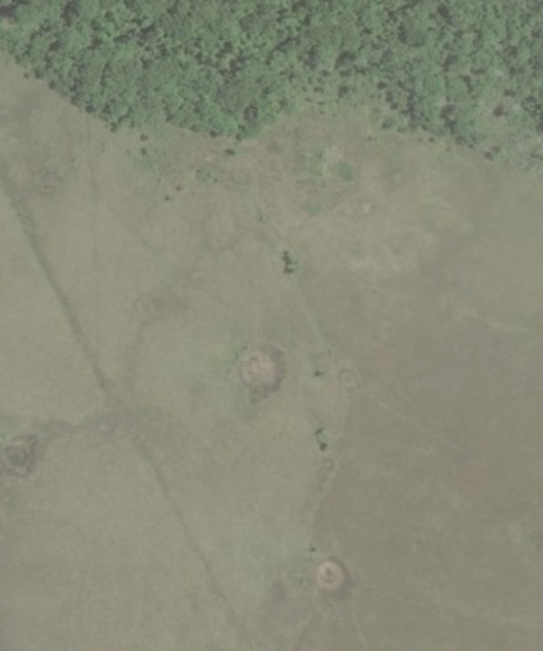

Figure 10: Screenshot of second area intended for modeling (Microsoft 2016).

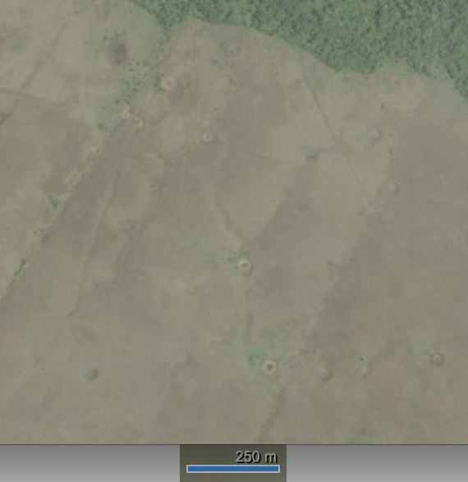
Figure 11: Attempt at capturing real-world height map, using terrain.party (OpenStreetMaps 2016). The blue, square grid has a side length of 8km.

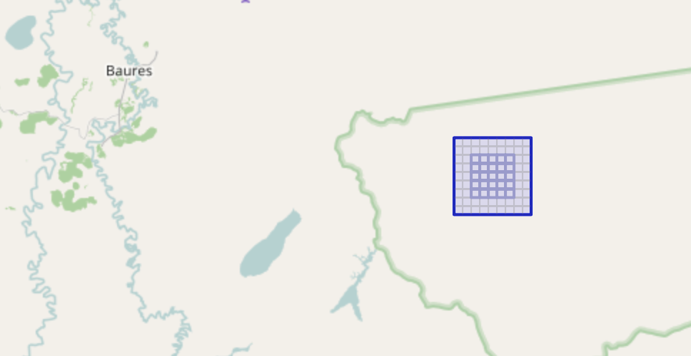

Figure 12: My first Maya fish pond model, which fails to take scale into account.

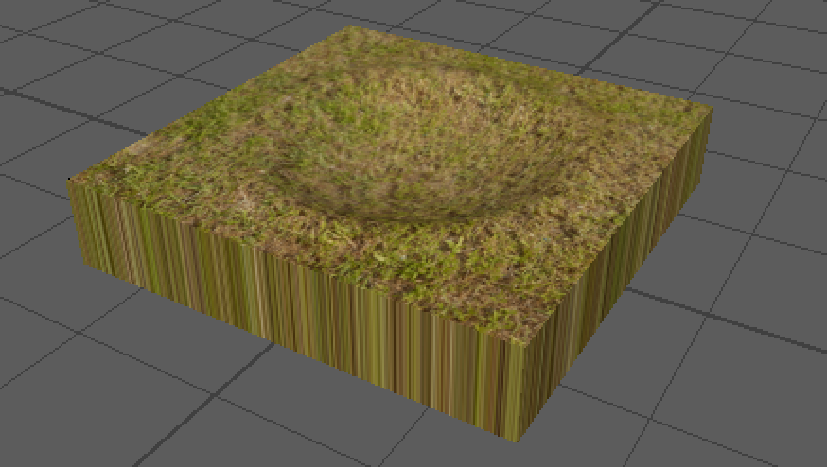

Figure 13: A few different angles and views of my first Maya fish weir, which fails to take scale into account.

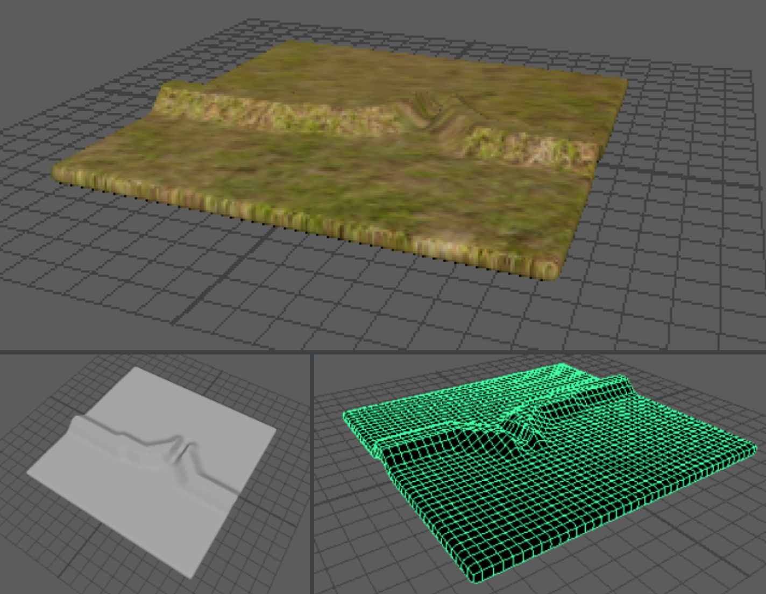

Figure 14: Accurately scaled fish weir. Each square in the gridded model (bottom left) has a side length of 1 m.

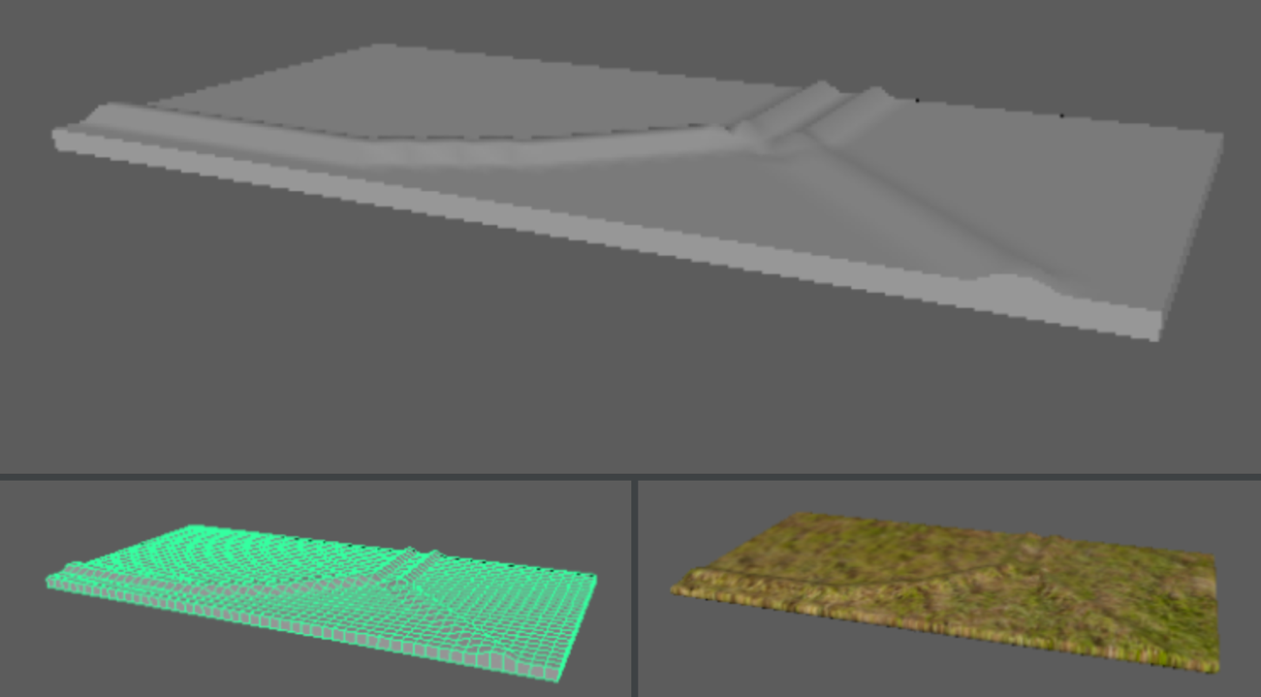

Figure 15: Accurately scaled fish pond. Each square in the gridded model (bottom) has a side length of 1 m.

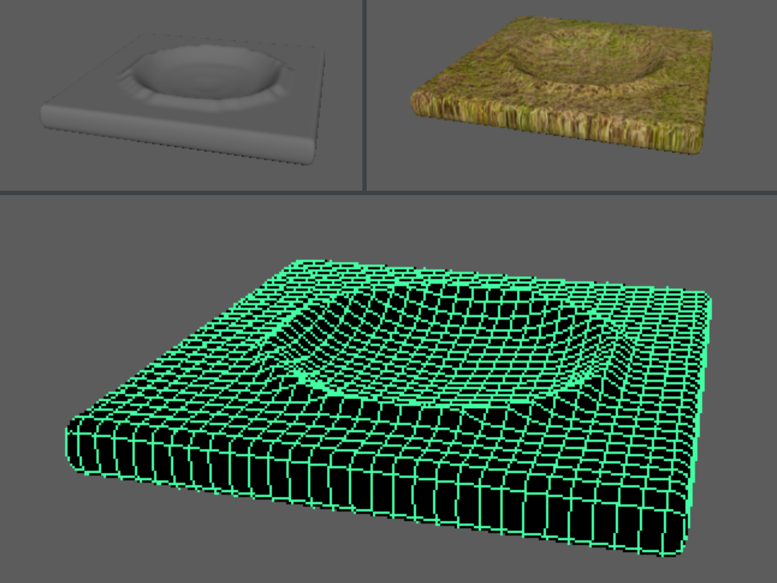

Figure 16: Unfinished assembled scene, next to screenshot of location on Bing Maps (Microsoft 2016).

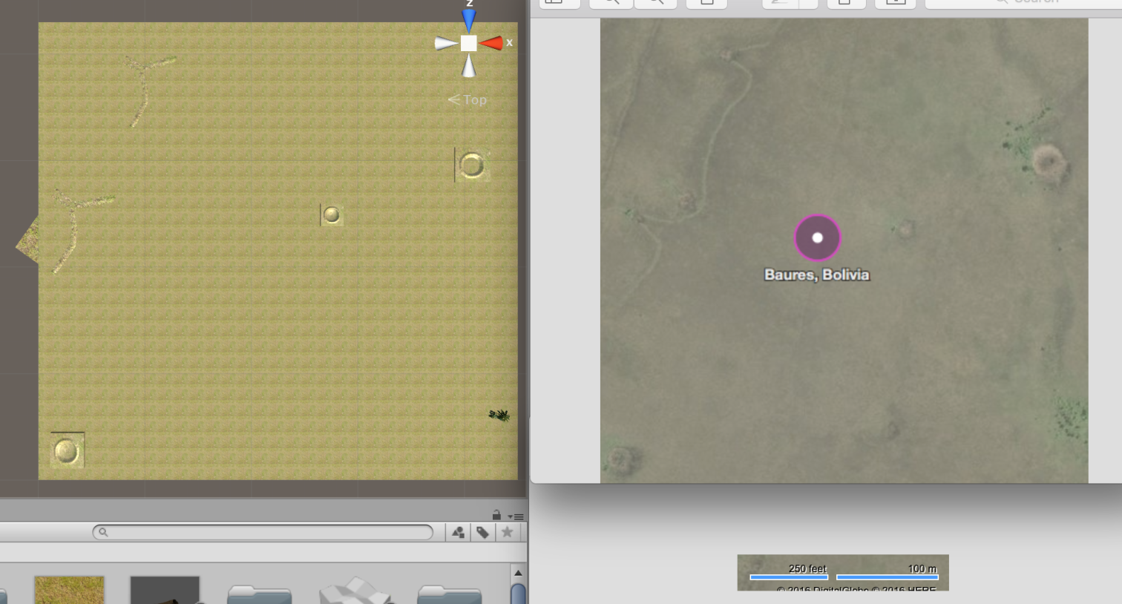

Figure 17: James Prell’s weir trap, imported, with texture importation failure notification.

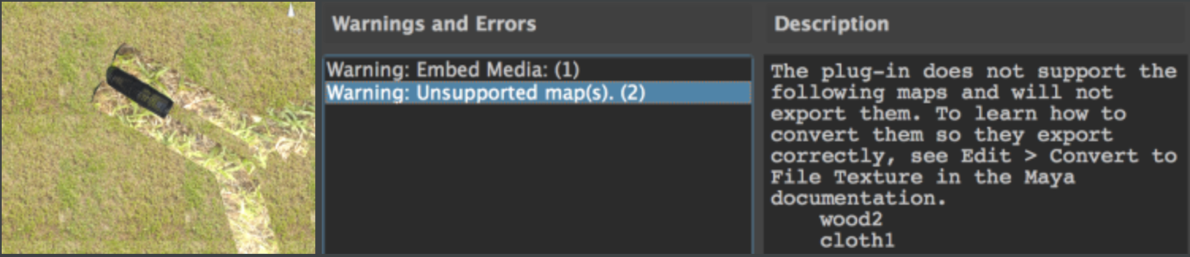

Figure 18: Pond model superimposed over terrain object, on which I could not lower the terrain to show the depth of the pond. Each square on the pond object grid has a side length of 1 m.

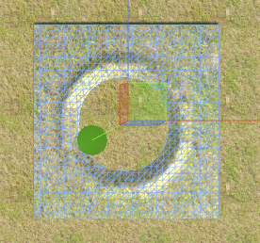

Figure 19: Fish pond with 20 m diameter in Unity scene.

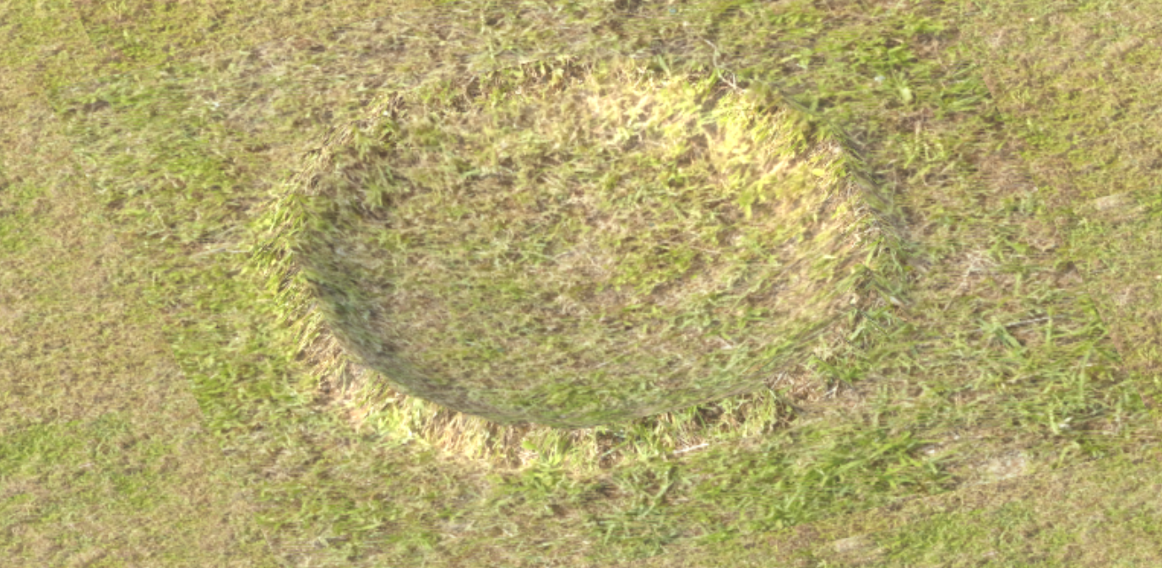

Figure 20: Fish pond with 20 m diameter, realistic berms, and un-textured water in Unity scene.

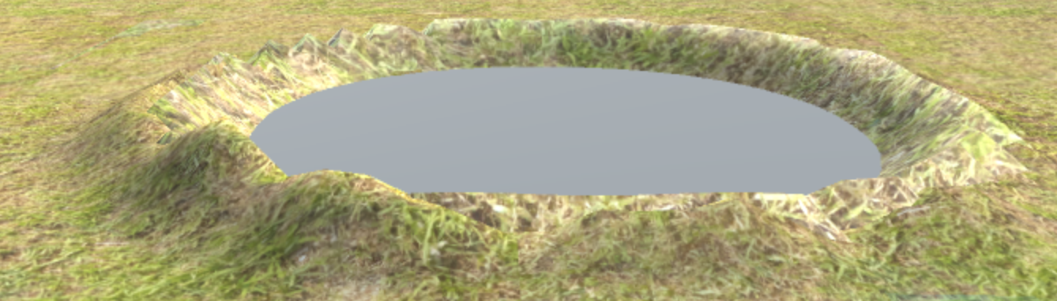

Figure 21: Unfinished 450 km² Unity scene from above with palms included.

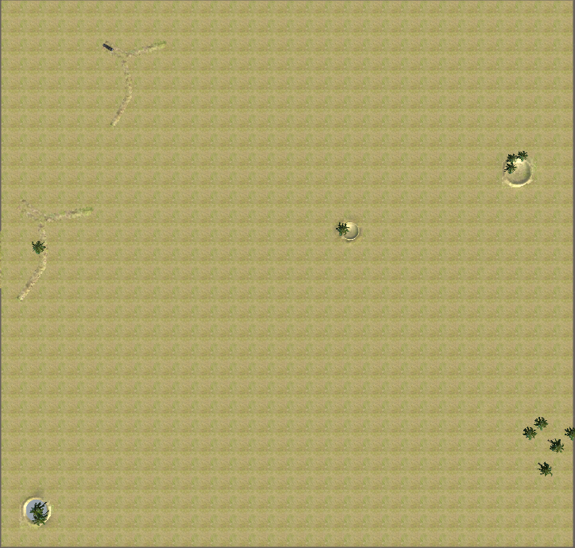

Figure 22: Vegetation in Unity scene.

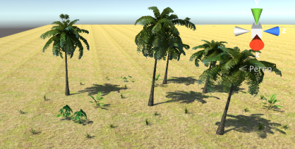

Figure 23: Vegetation in another part of the Unity scene.

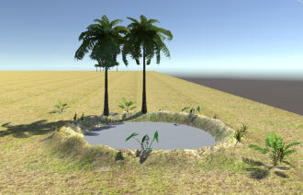
Figure 24: Two views of the weir connector model. 1 square has a side length of 1 m.

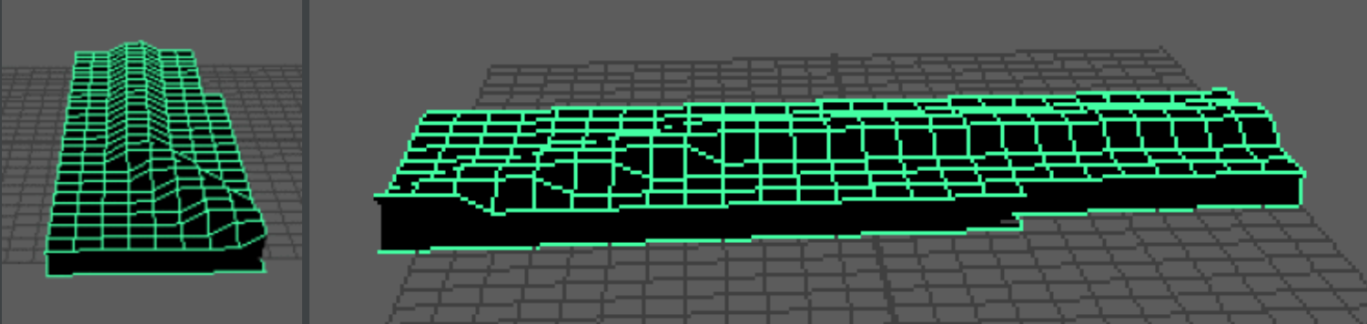

Figure 25: Complete 450 km² Unity scene during the dry season. The weir trap (black figure in the upper left) would not actually be left in this position during the dry season.

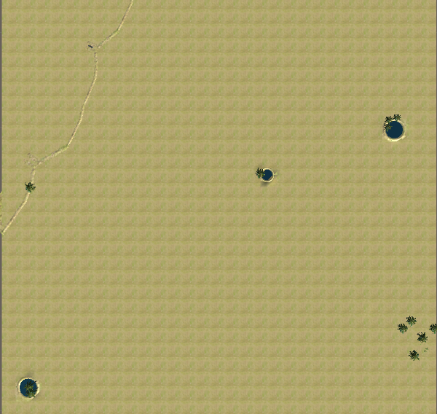
Figure 26: Complete 450 km² Unity scene, flooded. The misshapen ponds reflect a texture rendering error in the game engine.

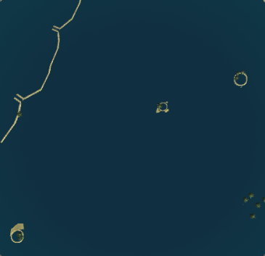

Figure 27: Close up screenshot of a flooded fish pond, highlighting the different texturing by the game engine. This is the pond from the lower left hand corner of Figure 26.

