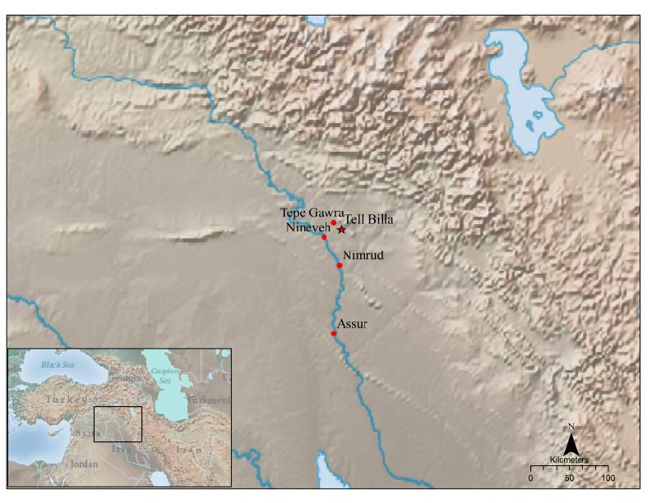

Figure 1: Regional Map with Tell Billa and Major Sites

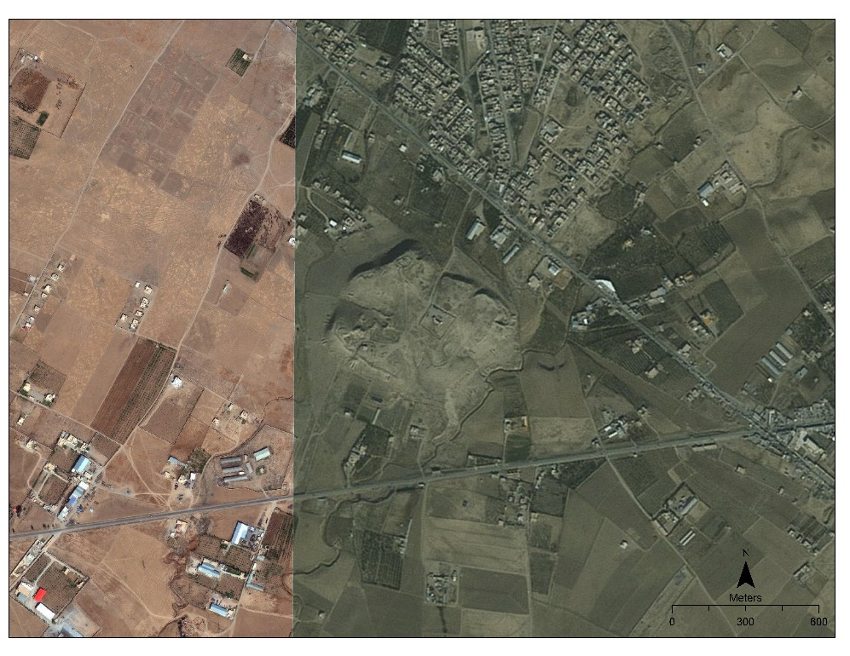

Figure 2: Modern Bing Image of Tell Billa with Visible Military Fortifications and Encroachment

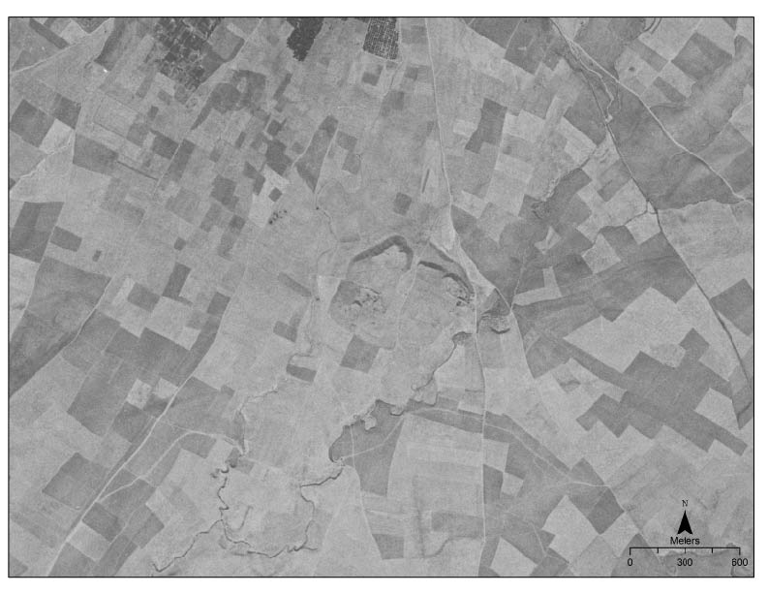

Figure 3: 1968 Corona Image of Tell Billa
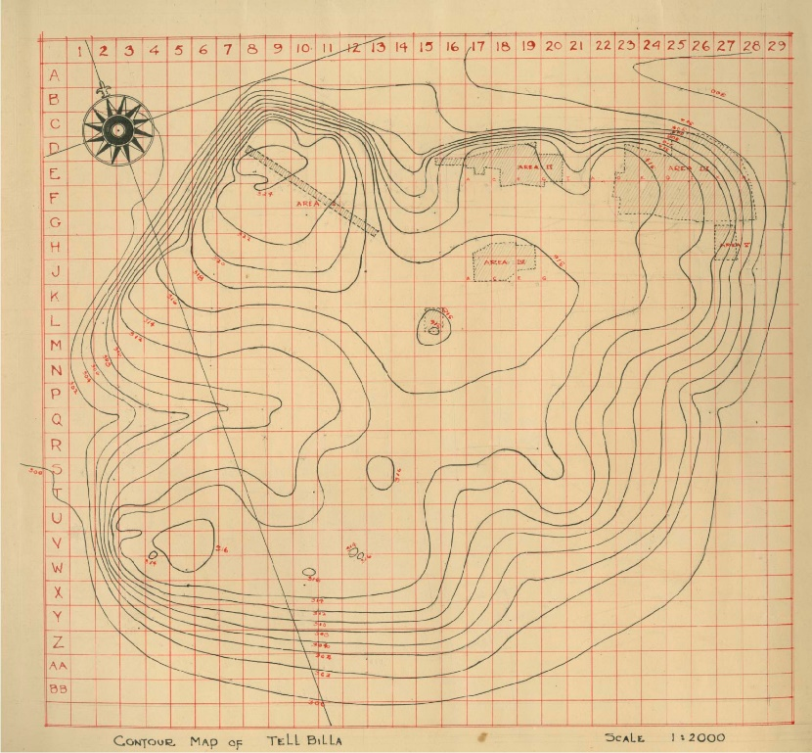
Figure 4: Topographic Map of Tell Billa with Excavation Squares

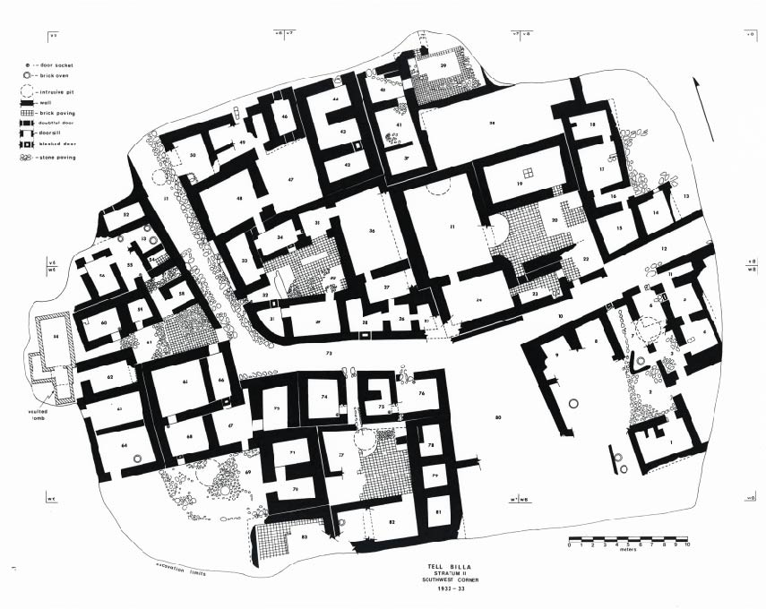
Figure 5: Level IA (Neo-Assyrian) Plan of Tell Billa’s Residential Quarter

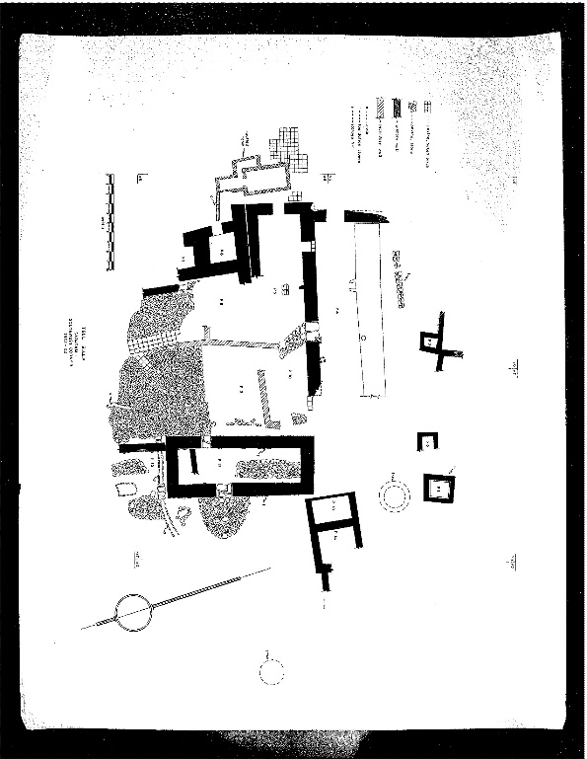
Figure 6: Level 1 (undated) Plan of Tell Billa’s Residential Quarter

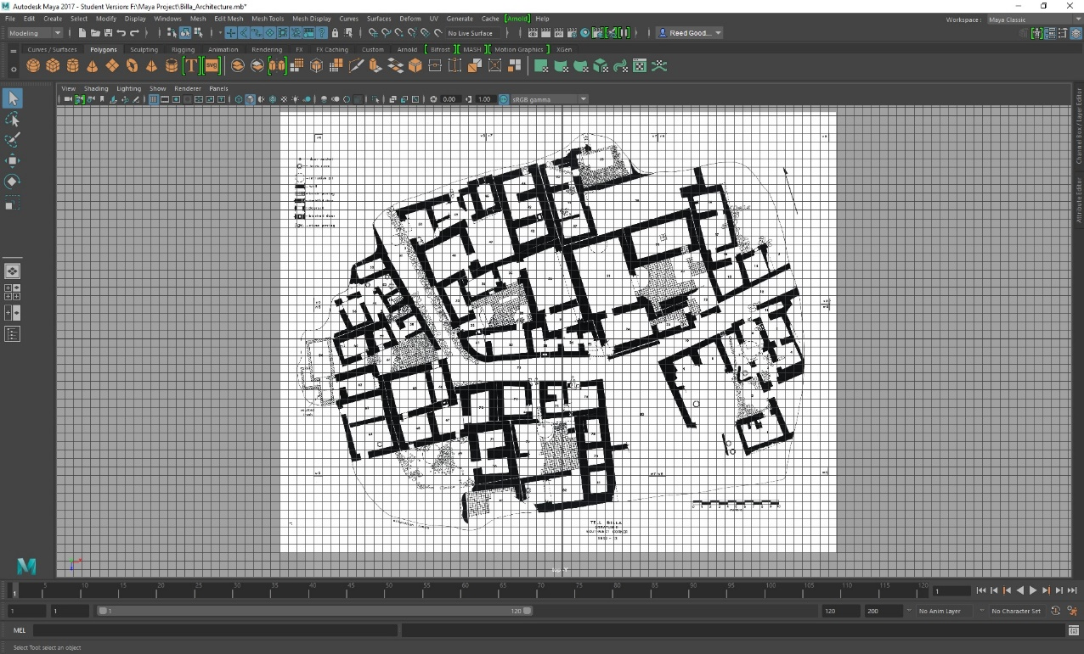
Figure 7: Metric-based Grid Creation

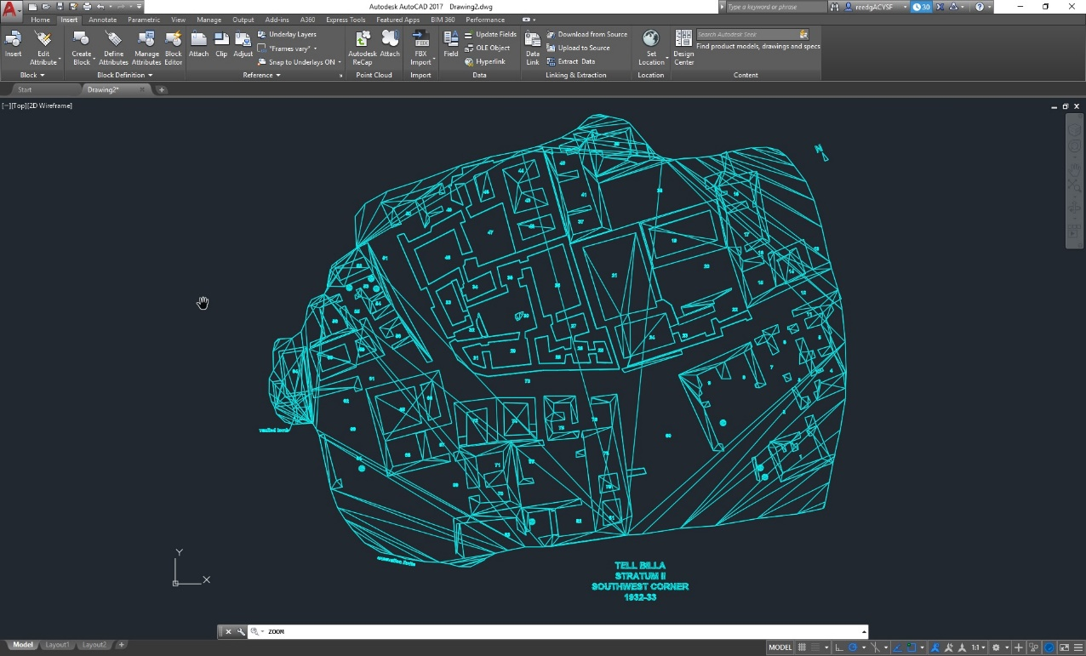
Figure 8: Level IA Trace in AutoCAD

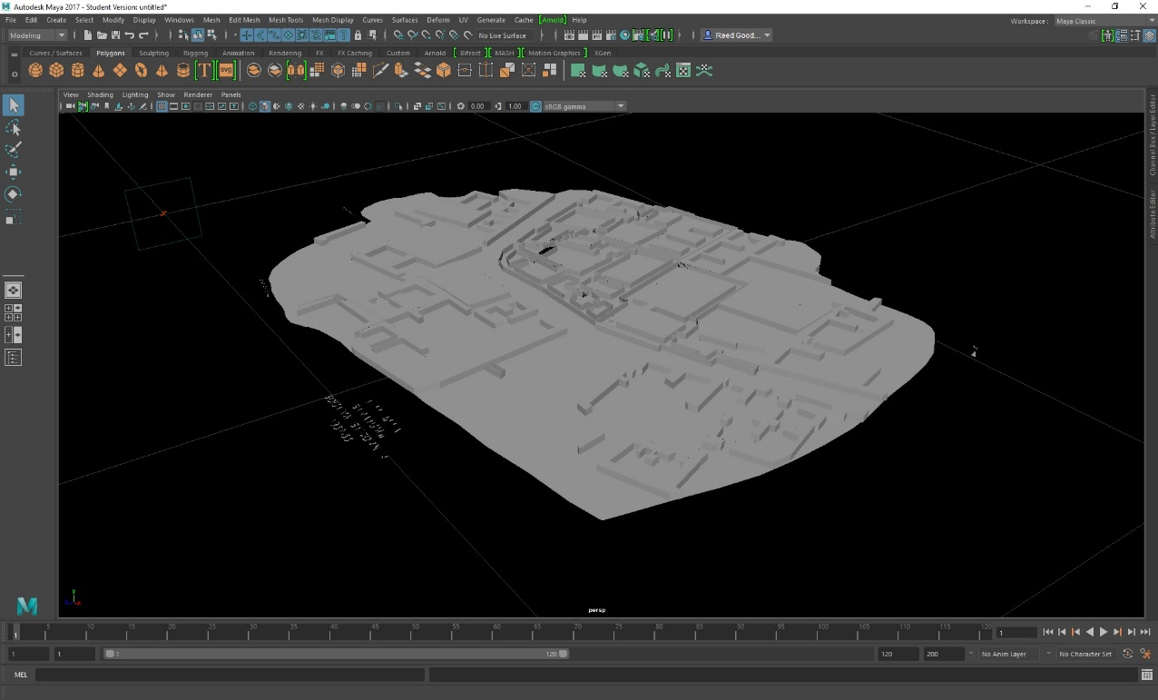
Figure 9: Over- and Under- Interpolated Surfaces after File Transfer from AutoCAD to Maya
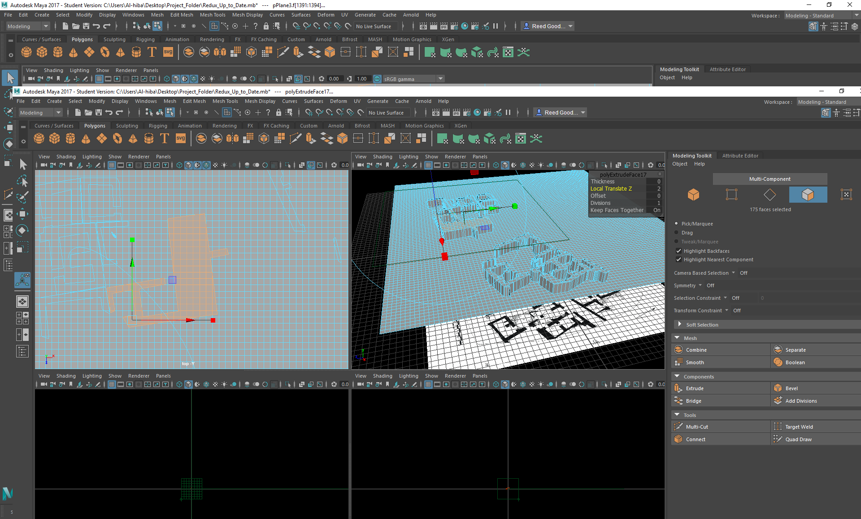
Figure 10: Single Polygonal Mesh with Early Divisions and Results

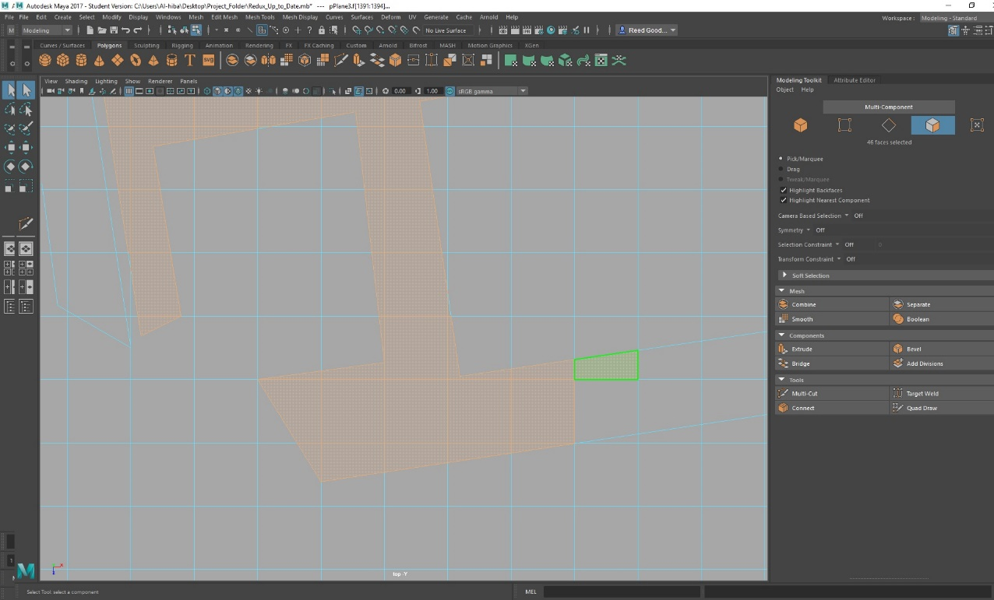
Figure 11: Multi-Cut Tool to Trace out and Cut Polygons
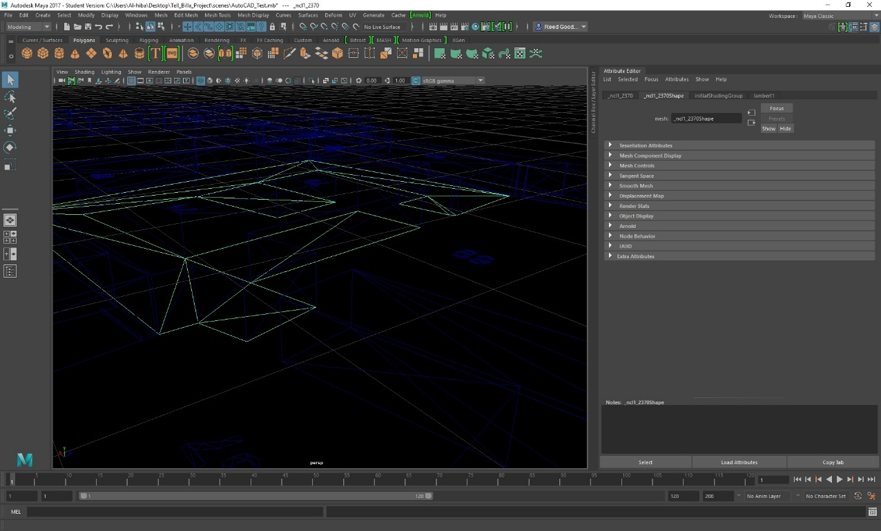
Figure 12: Wire-Frame Surface in Maya

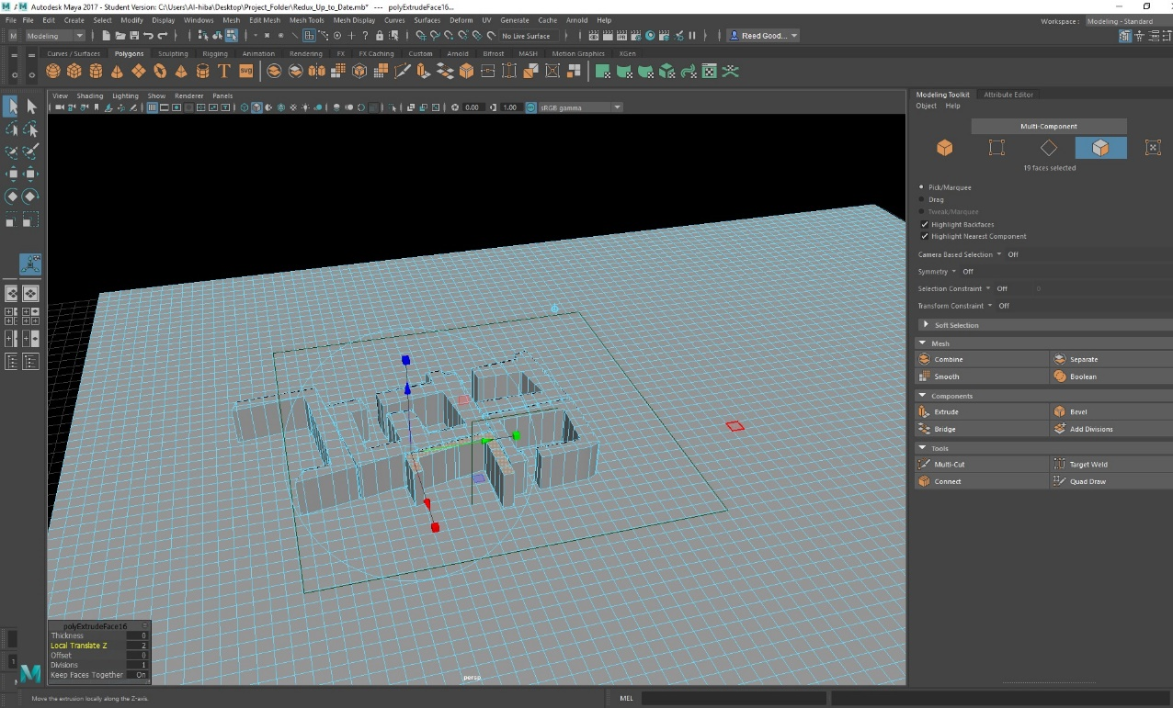
Figure 13: Modeling Toolkit Panel in Maya with Local Translation of Z Axis
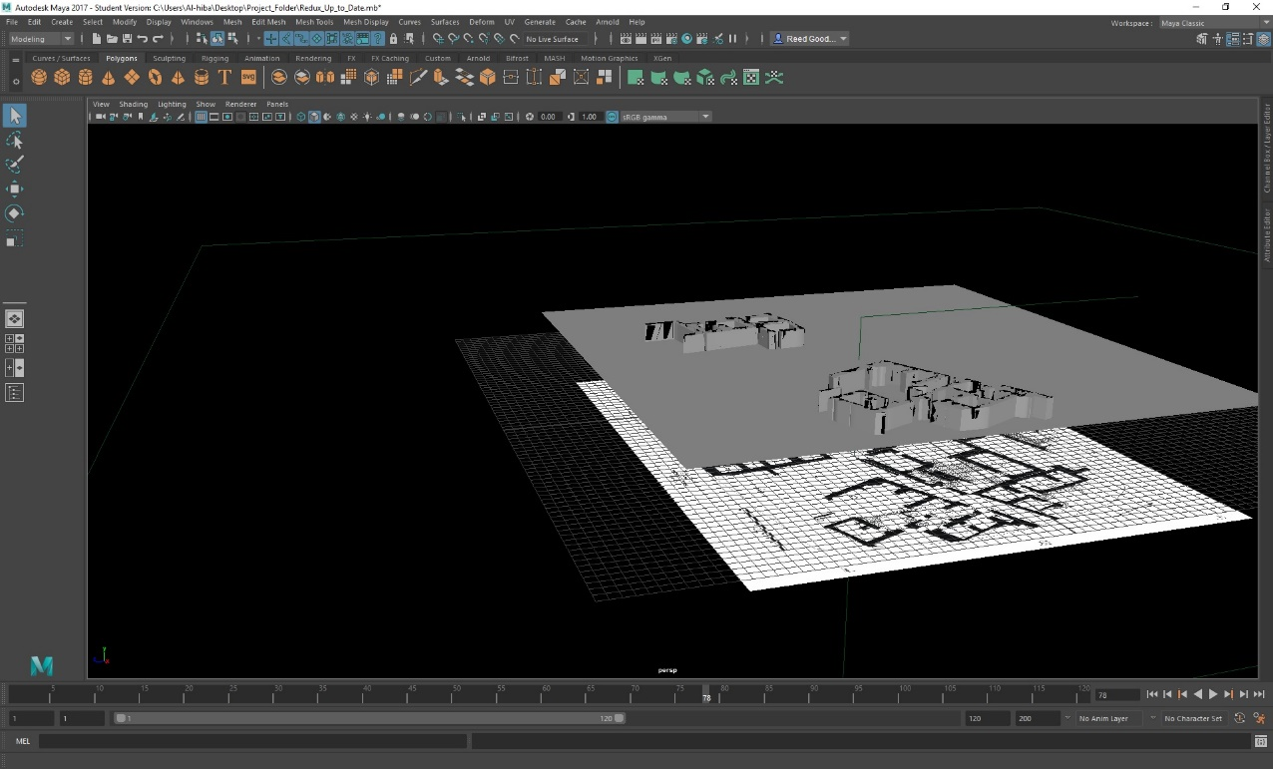
Figure 14: Early Wall Extrusion Results in Maya

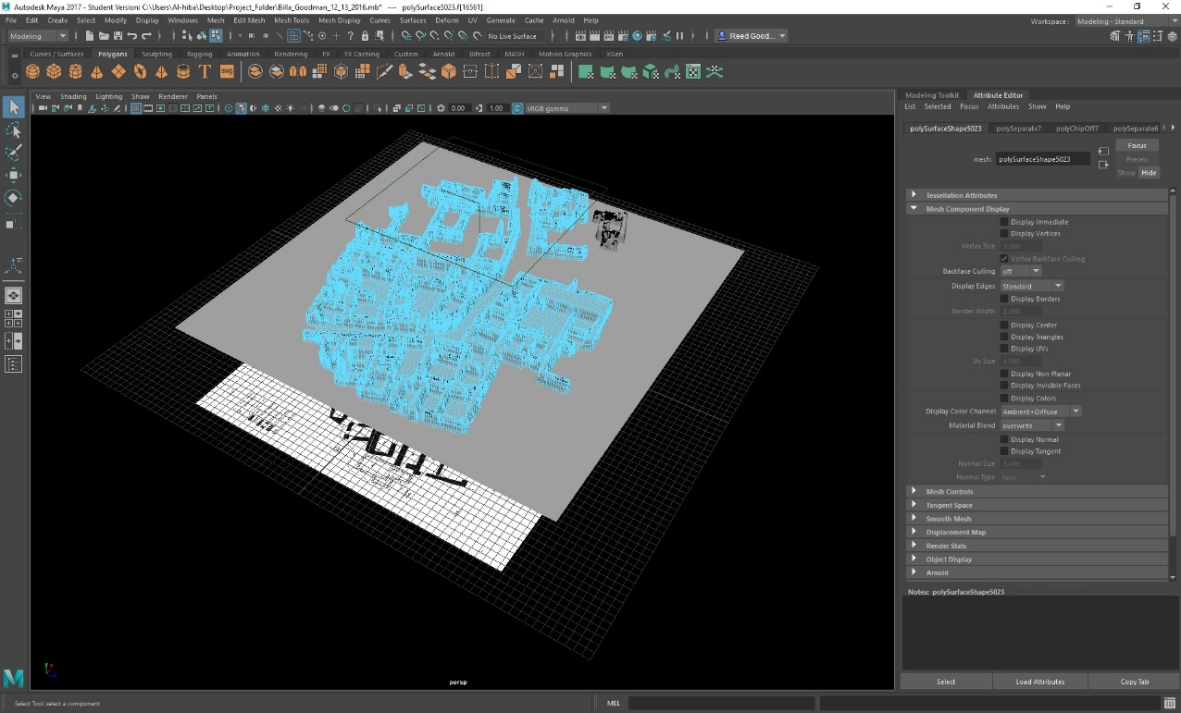
Figure 15: Completed Walls and Underlying Base Mesh
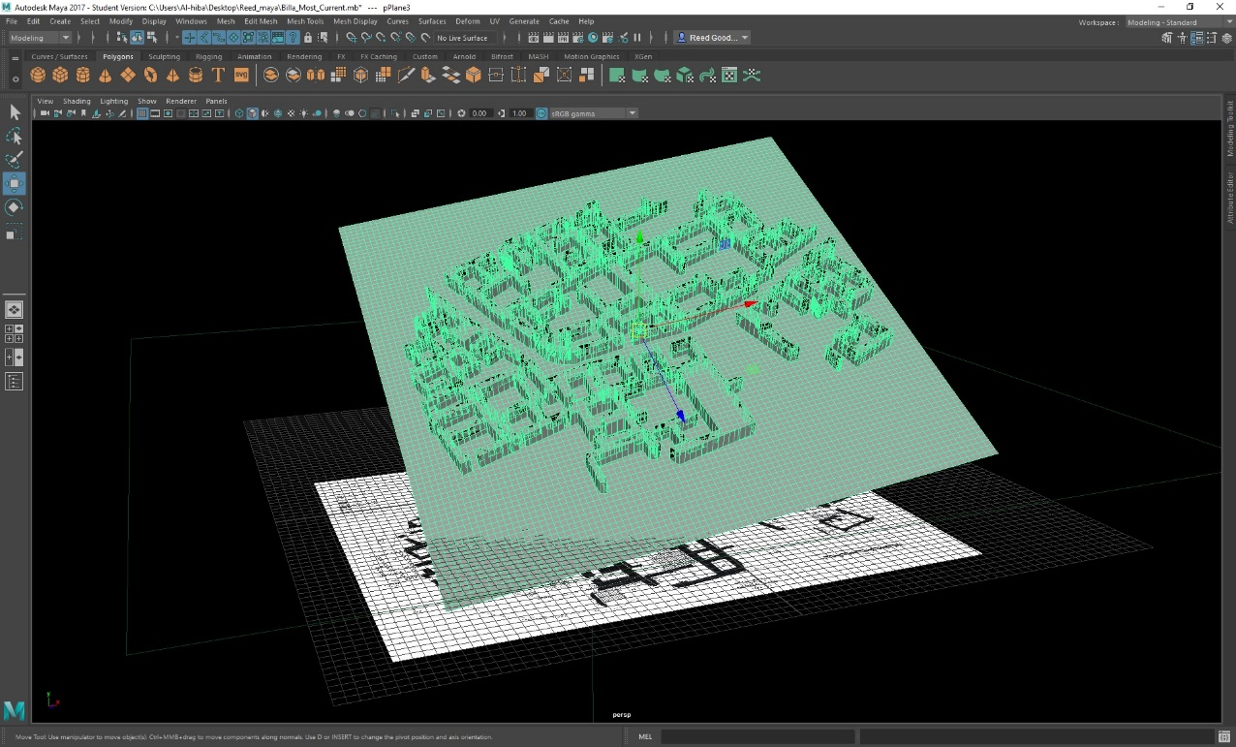
Figure 16: Entire Mesh Remains a Single Group of Polygonal Faces, Line Edges and Point Vertices

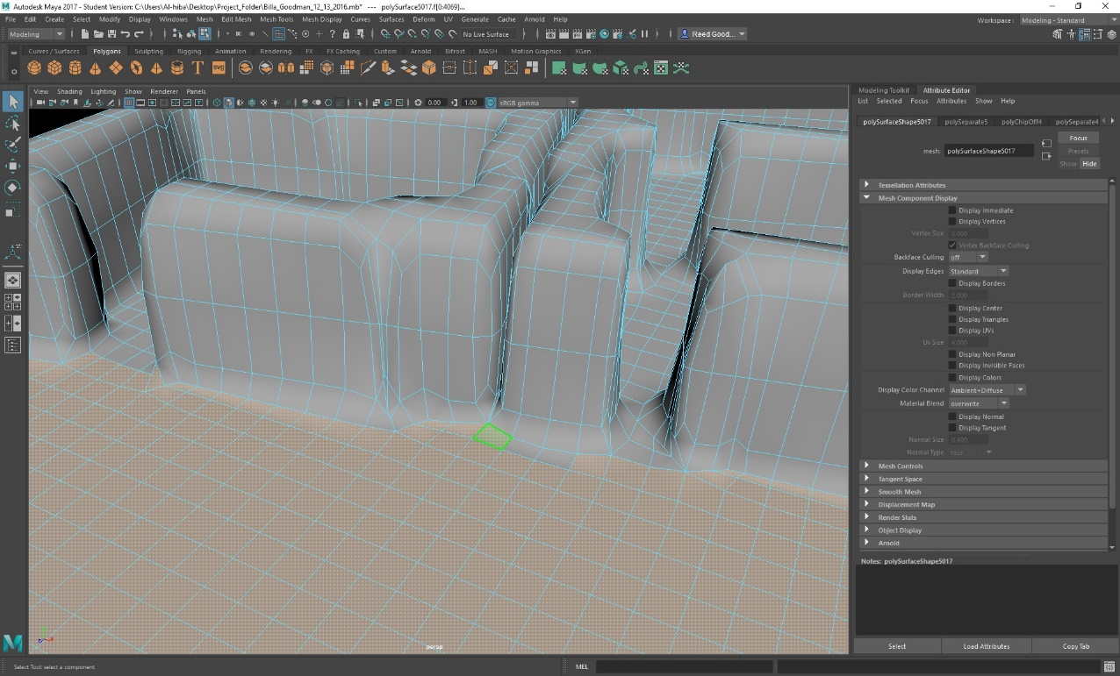
Figure 17: Separating Wall from Floor Mesh with Attribute Editor
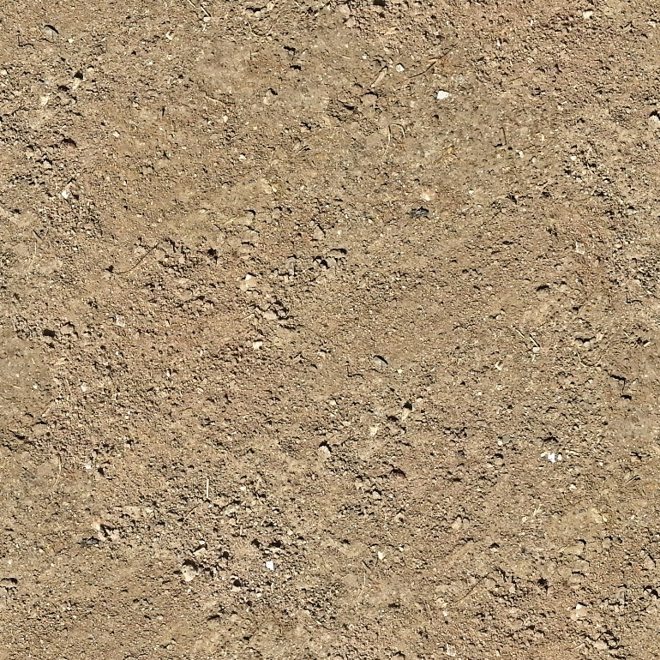
Figure 18: Google Image Uploaded to Maya for Ground Texture

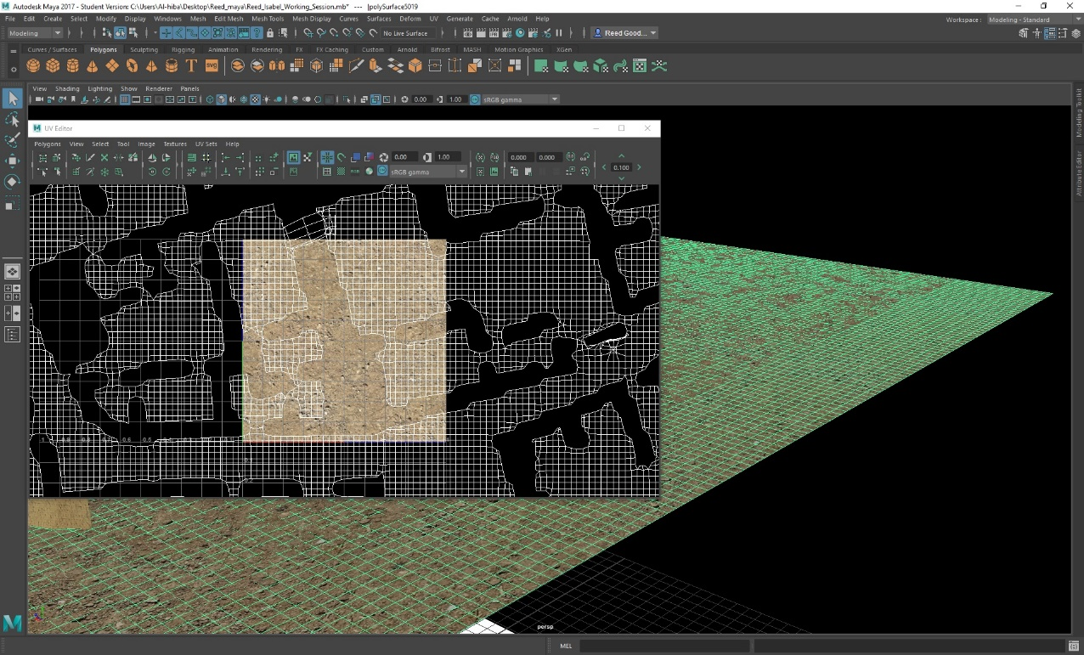
Figure 19: Selection of UV Shells for Rescaling in UV Editor
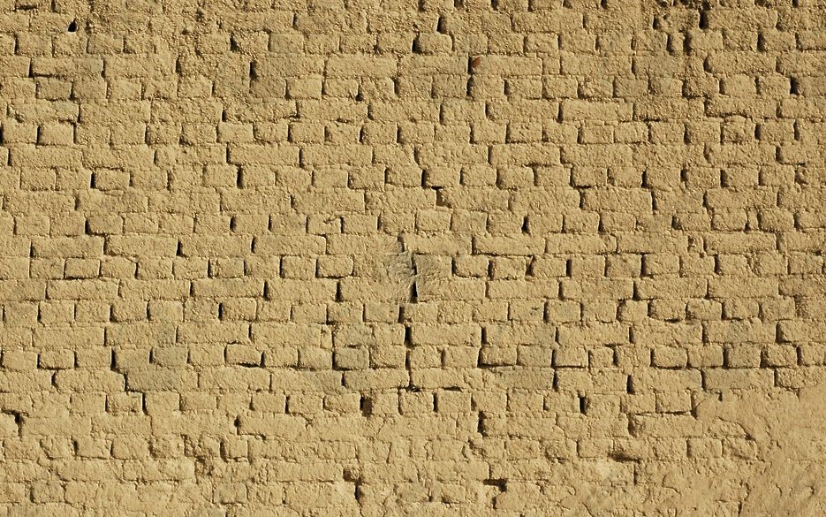
Figure 20: Google Image Uploaded to Maya for Wall Texture

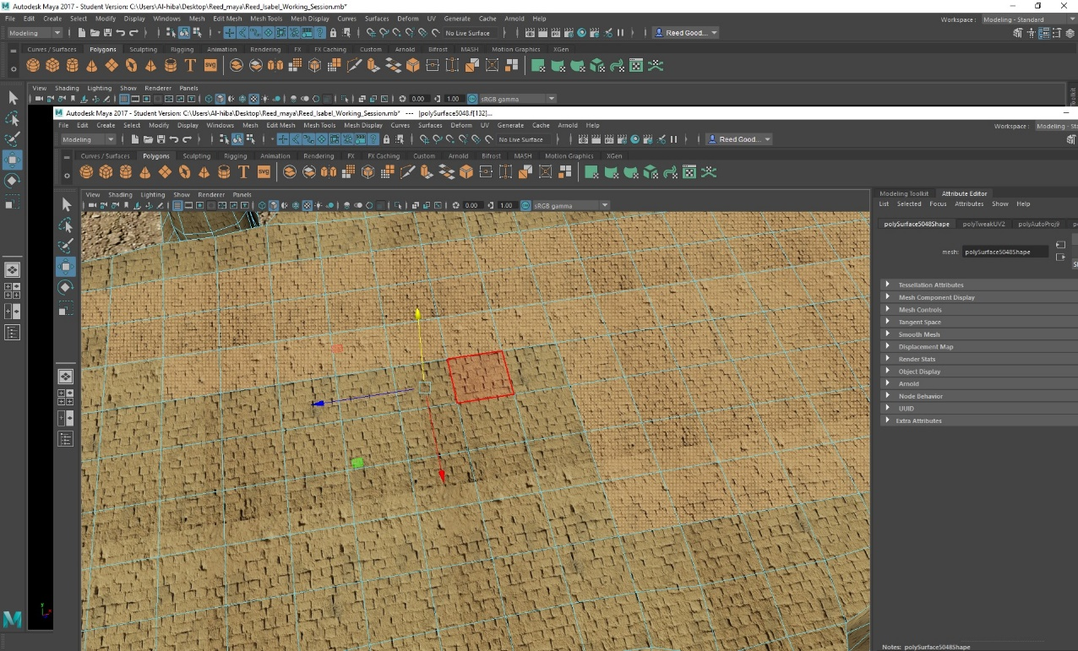
Figure 21: Face Selection for Conversion to Roof
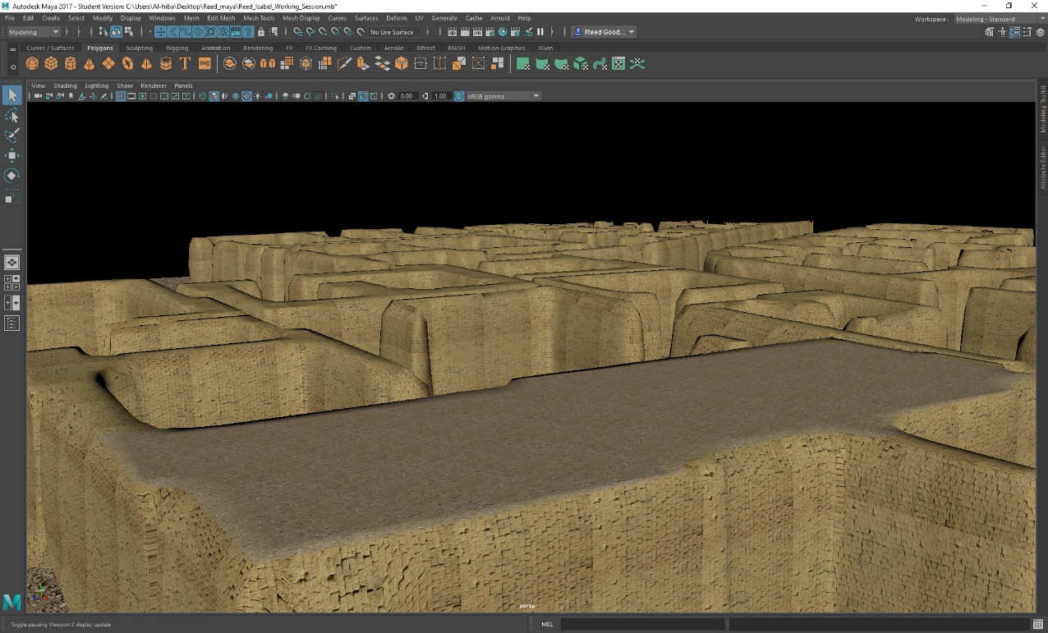
Figure 22: Textured Result of Tamped-Clay Roof

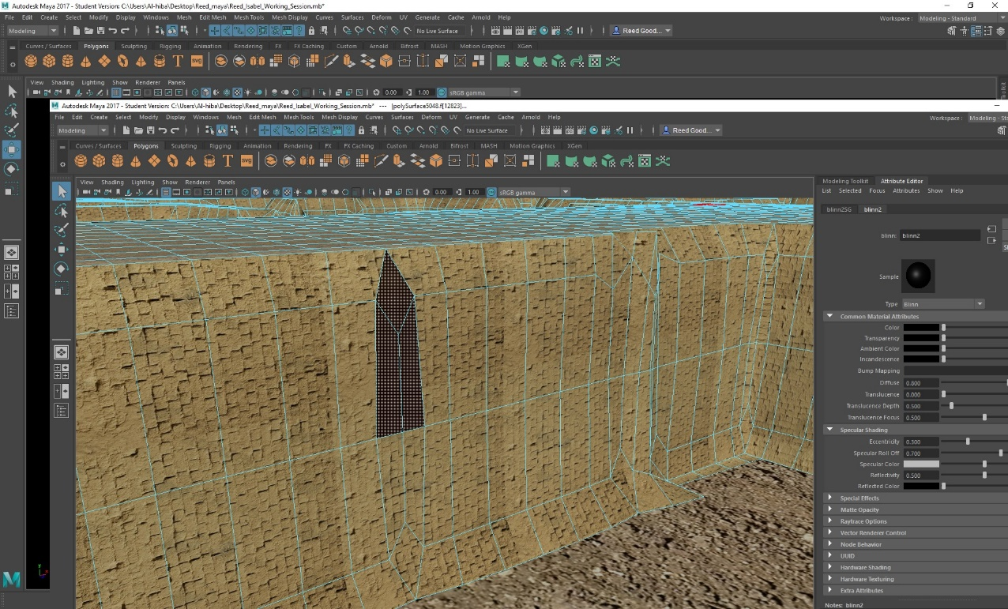
Figure 23: Window Creation through Face Selection, Extrusion and Texturing
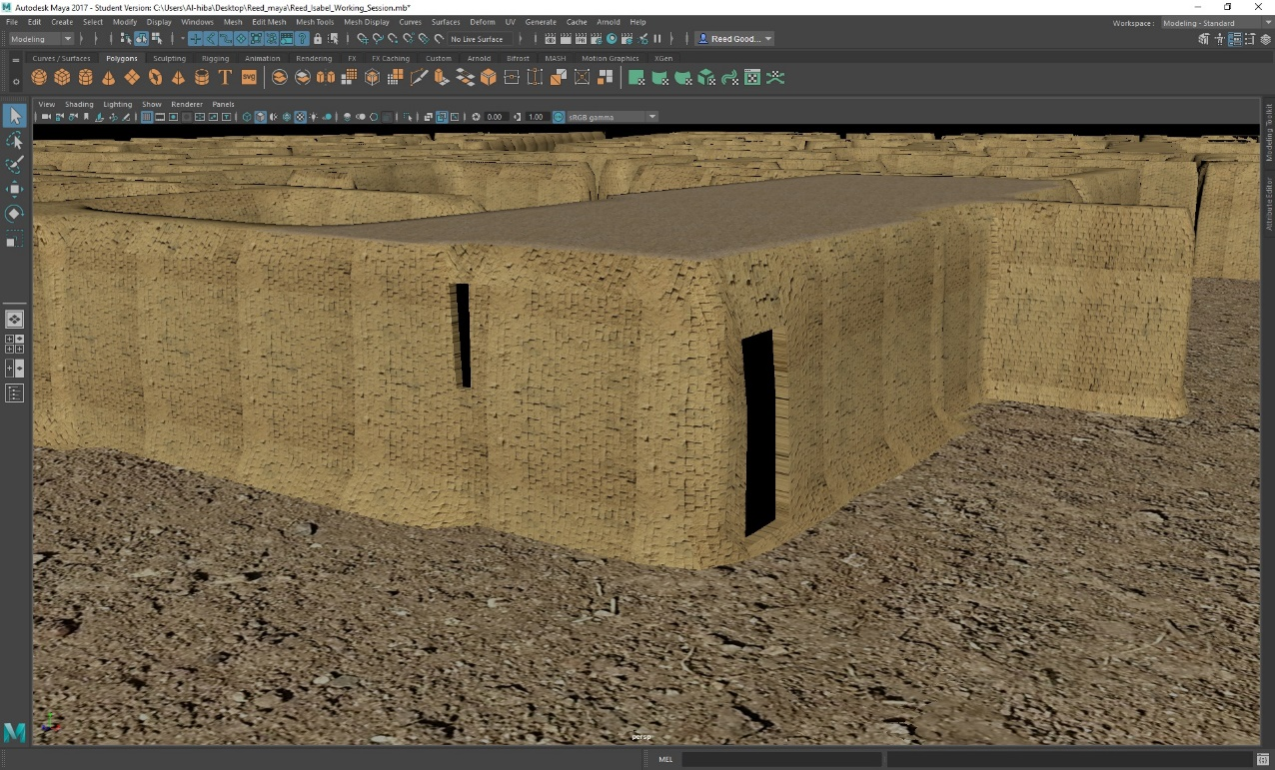
Figure 24: Door Creation through Face Selection, Extrusion and Texturing

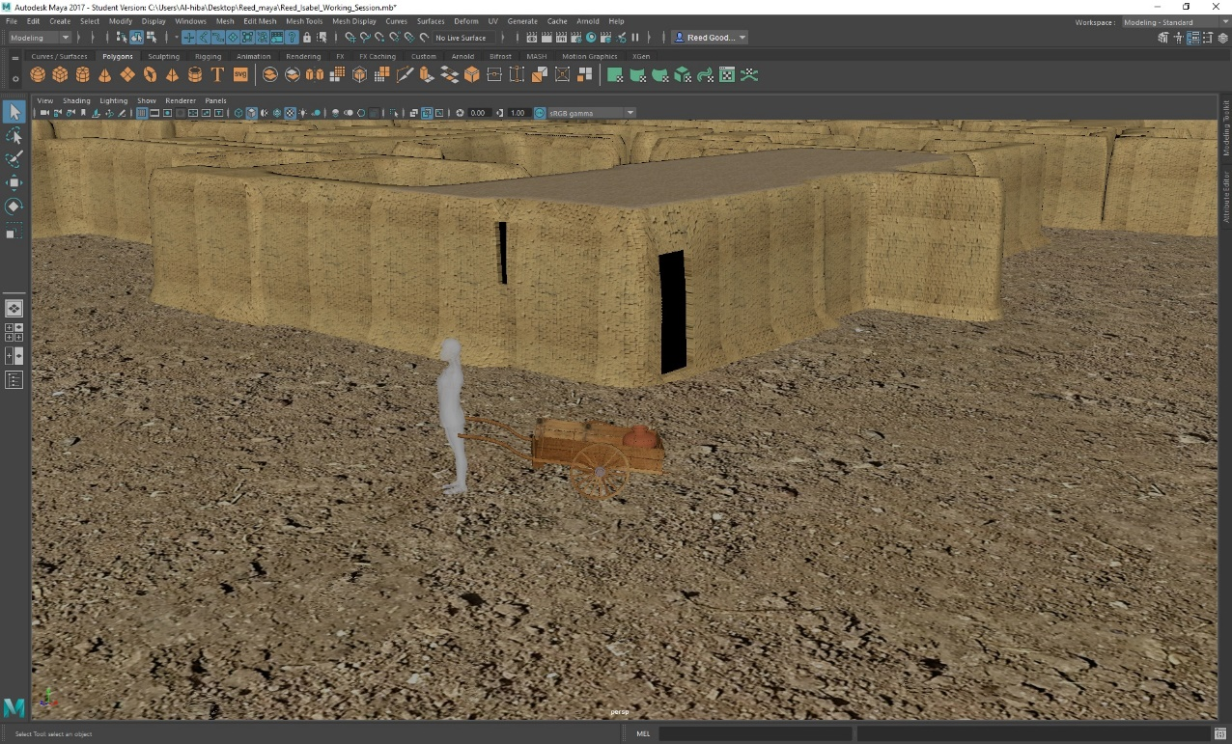
Figure 25: Female Individual with Wooden Cart and Ceramic Vessel
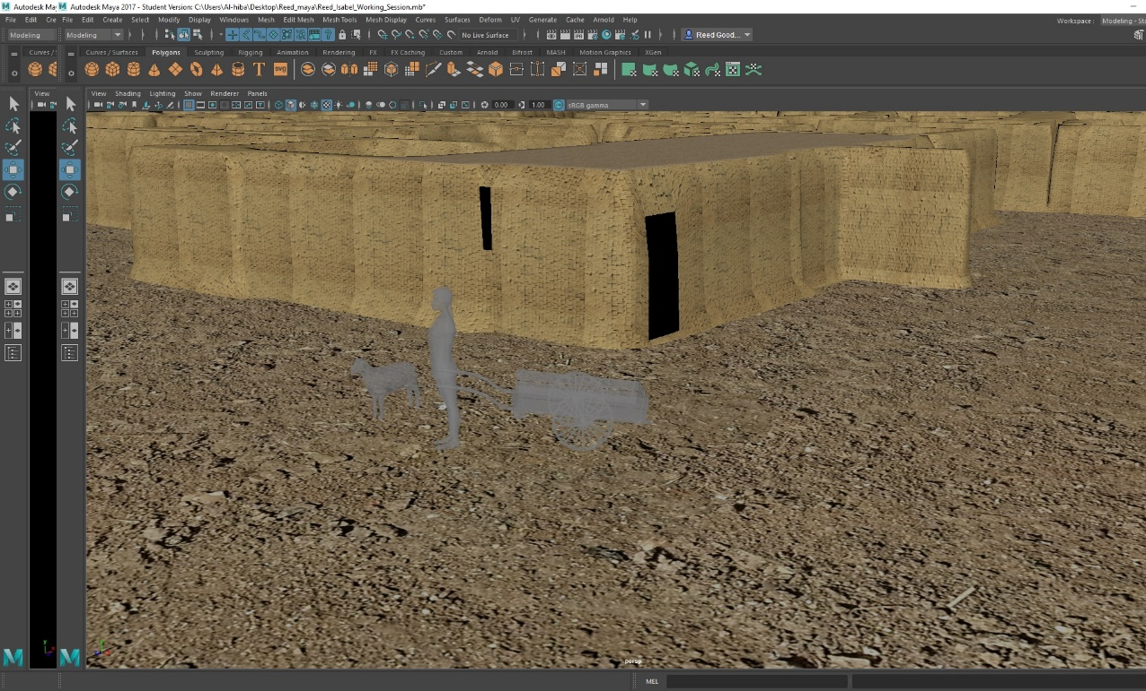
Figure 26: Sheep with Female Individual and Wheelbarrow

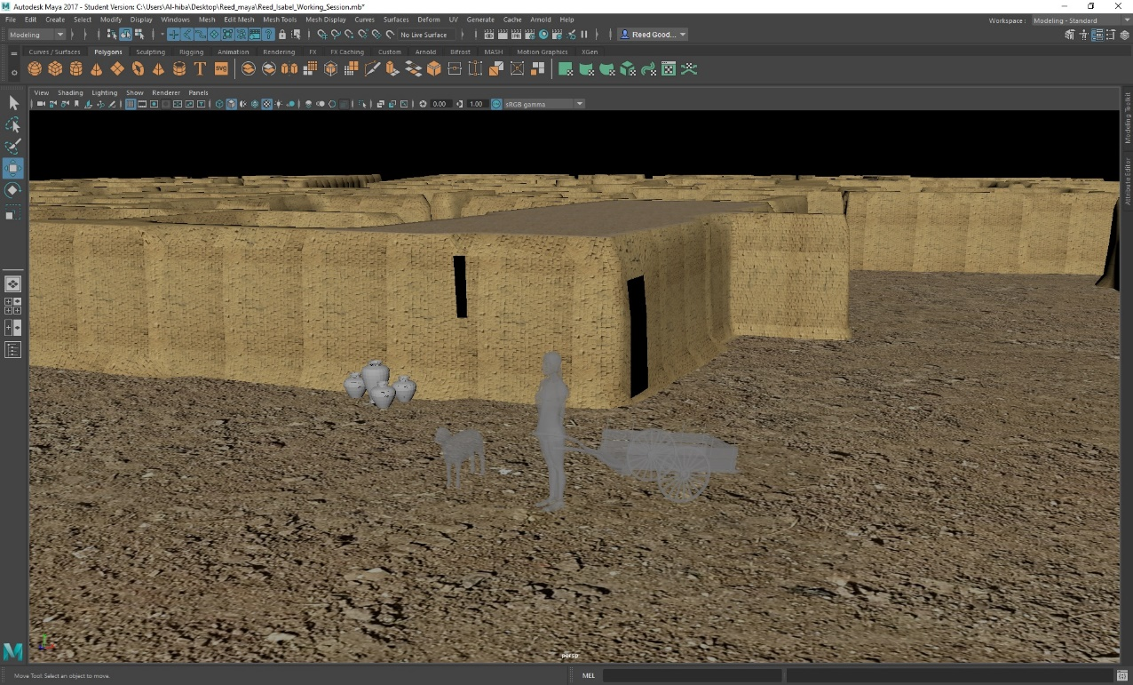
Figure 27: Additional Pottery Vessels with Sheep, Female Individual and Wheelbarrow
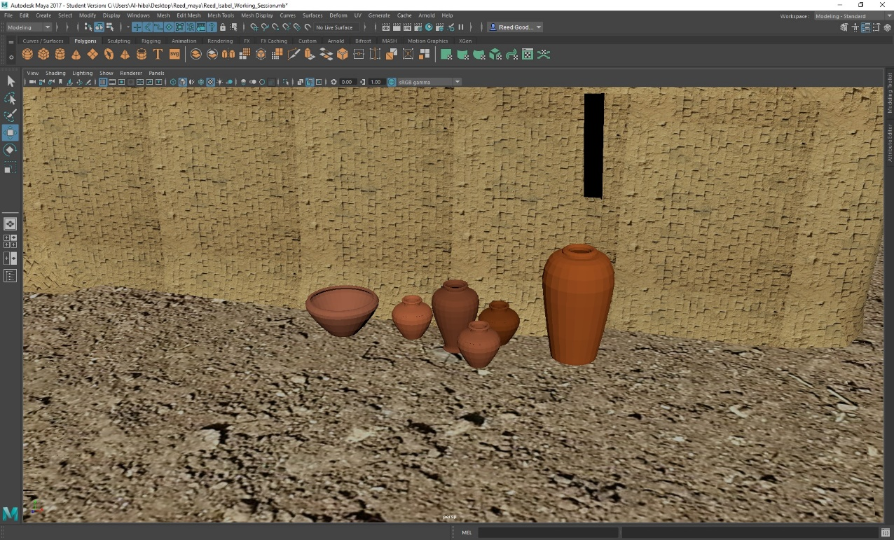
Figure 28: Textured Pottery Vessels with Realistic Paste Applied

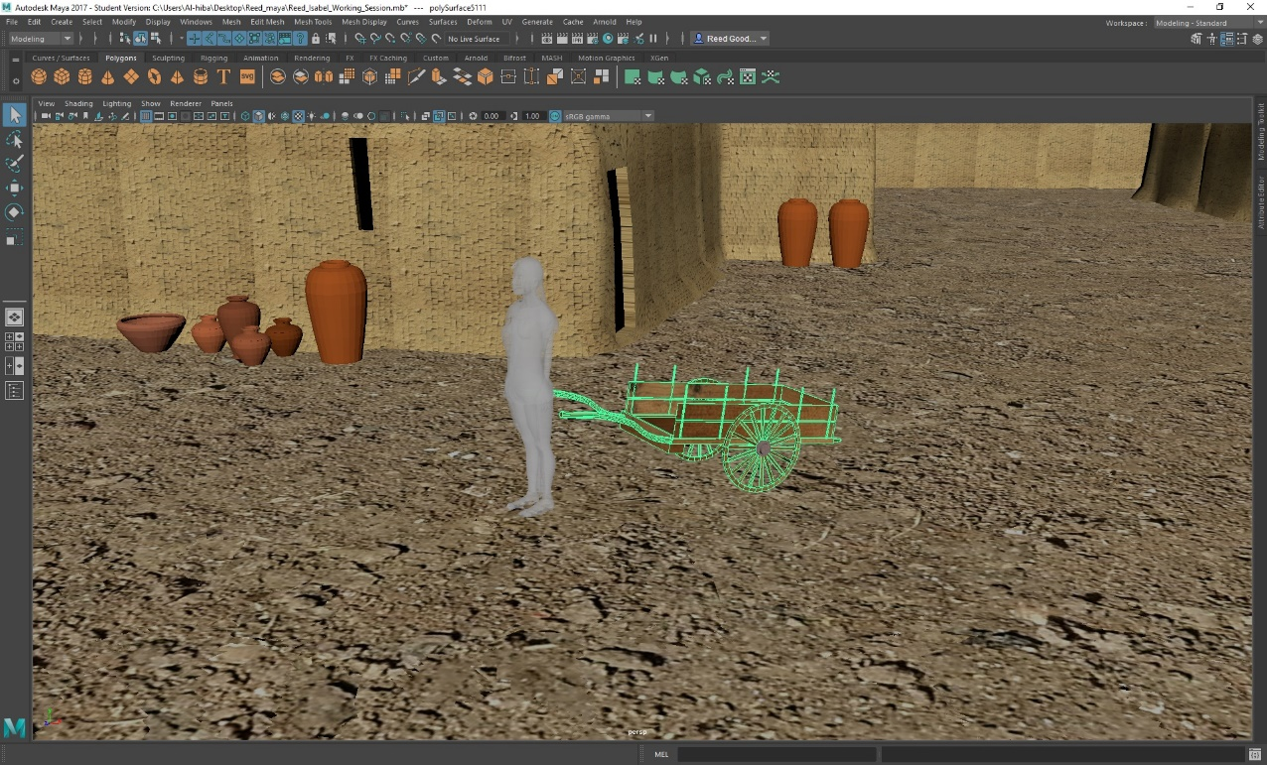
Figure 29: Modeled Wheelbarrow
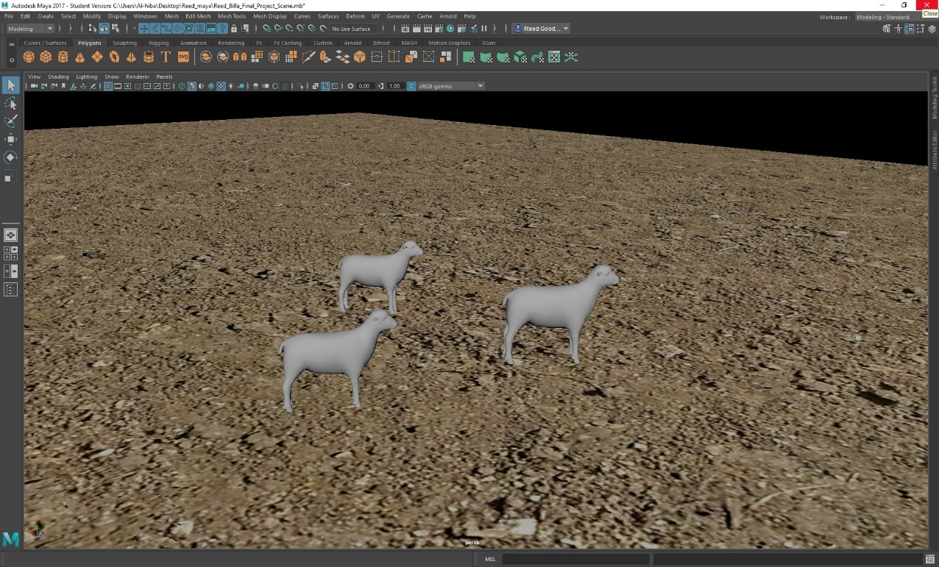
Figure 30: Reduplicated and Scaled Sheep

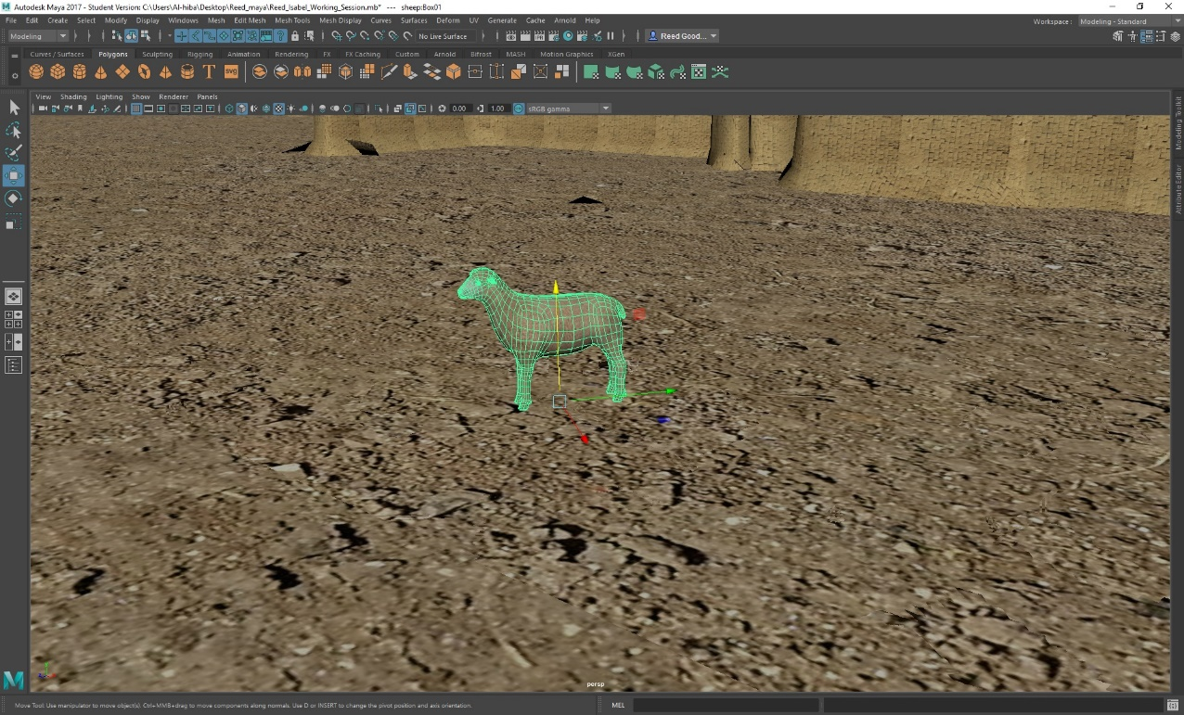
Figure 31: Textured Sheep
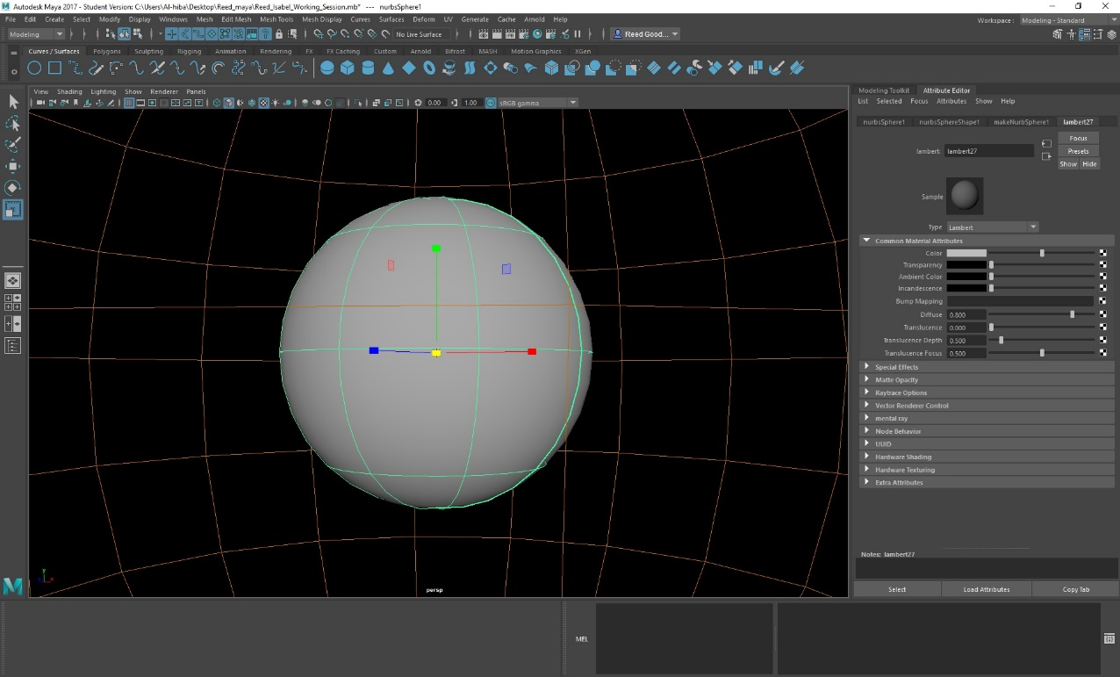
Figure 32: NURBS Sphere Encapsulating Entire Model (Inside Sky Colored Texture)

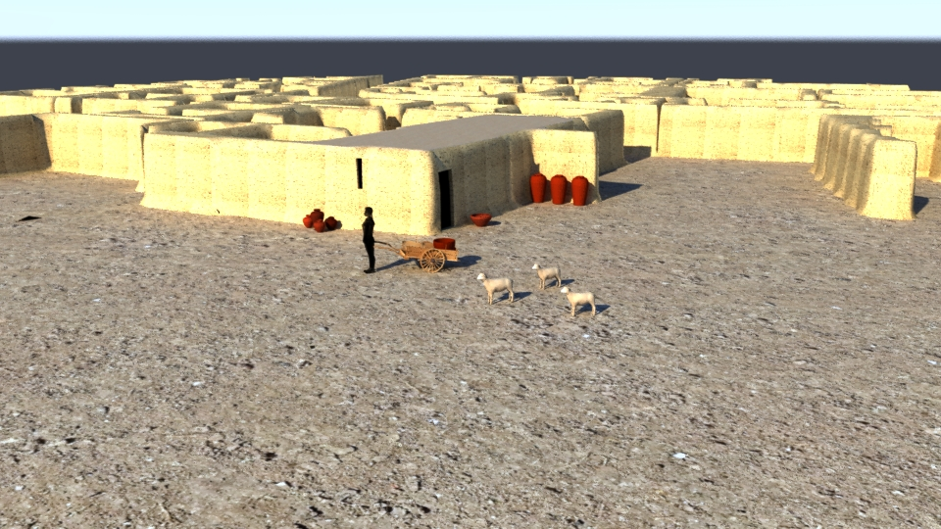
Figure 33: First Render with Mental Ray 3ds Max
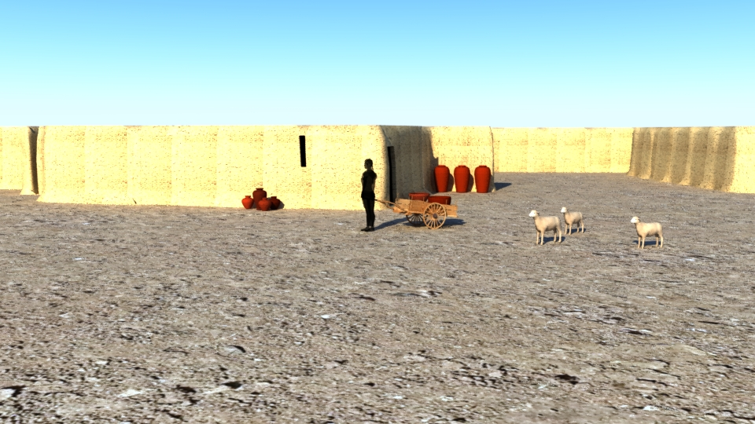
Figure 34: Second Render with Mental Ray 3ds Max

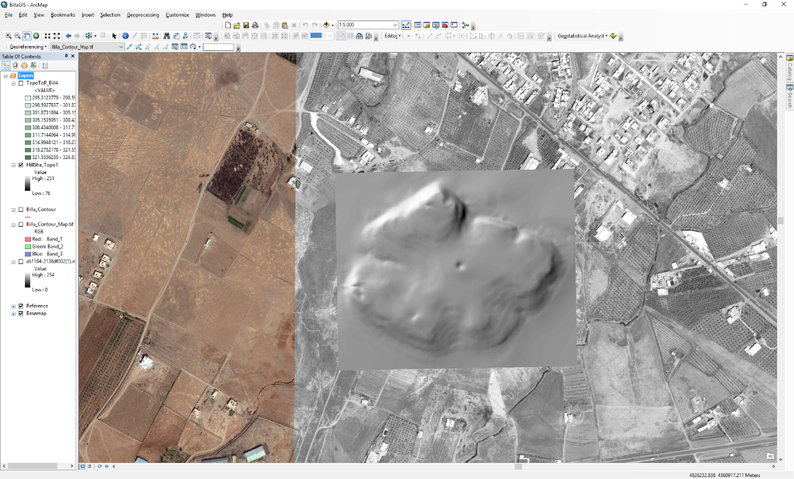
Figure 35: Digital Elevation Model of Tell Billa
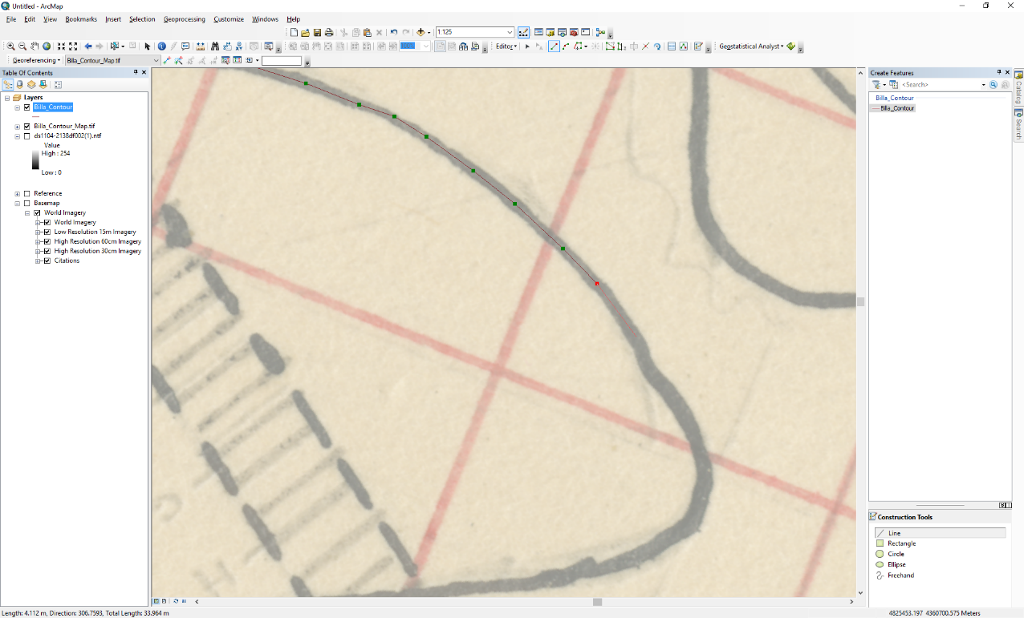
Figure 36: Contour Tracing in ArcGIS for Digital Elevation Model

