Estee Ellis
ANTH 258/CIS 106
Visualizing the Past/Peopling the Past
Final Project: Images
December 19, 2016

Roots of Knowledge:
Modeling Manioc in the Bolivian Amazon

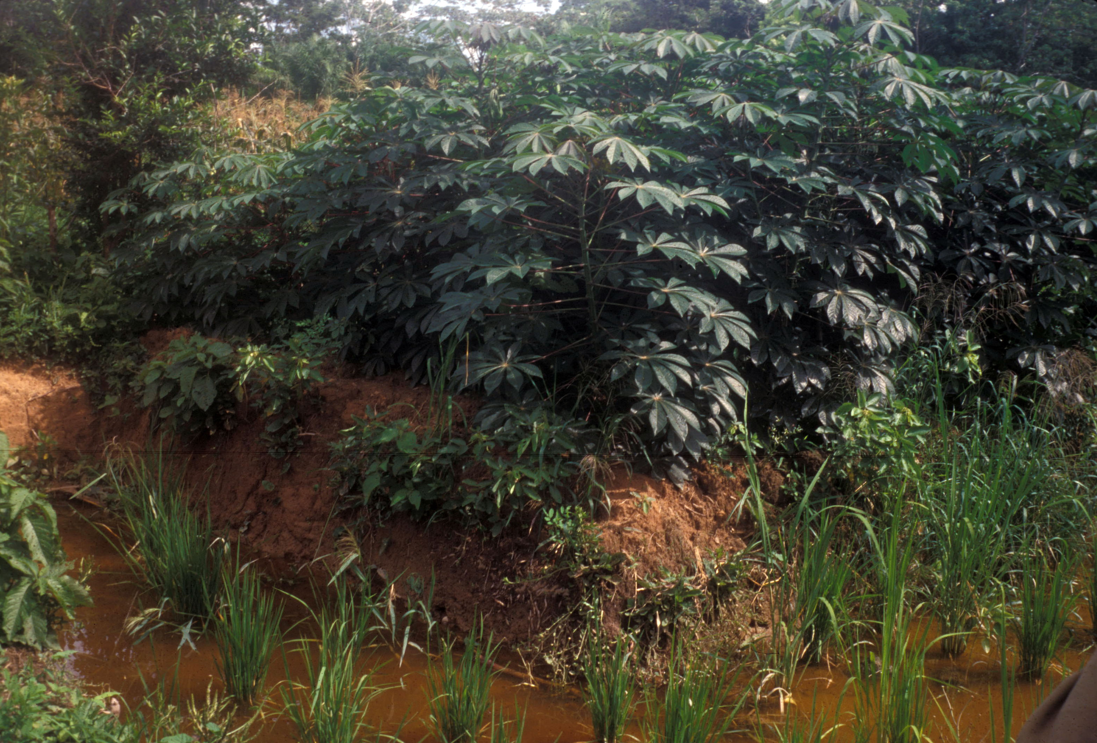Figure 1 Raised beds of soil allow farmers to continue producing crops during the flood seasons (Erickson).

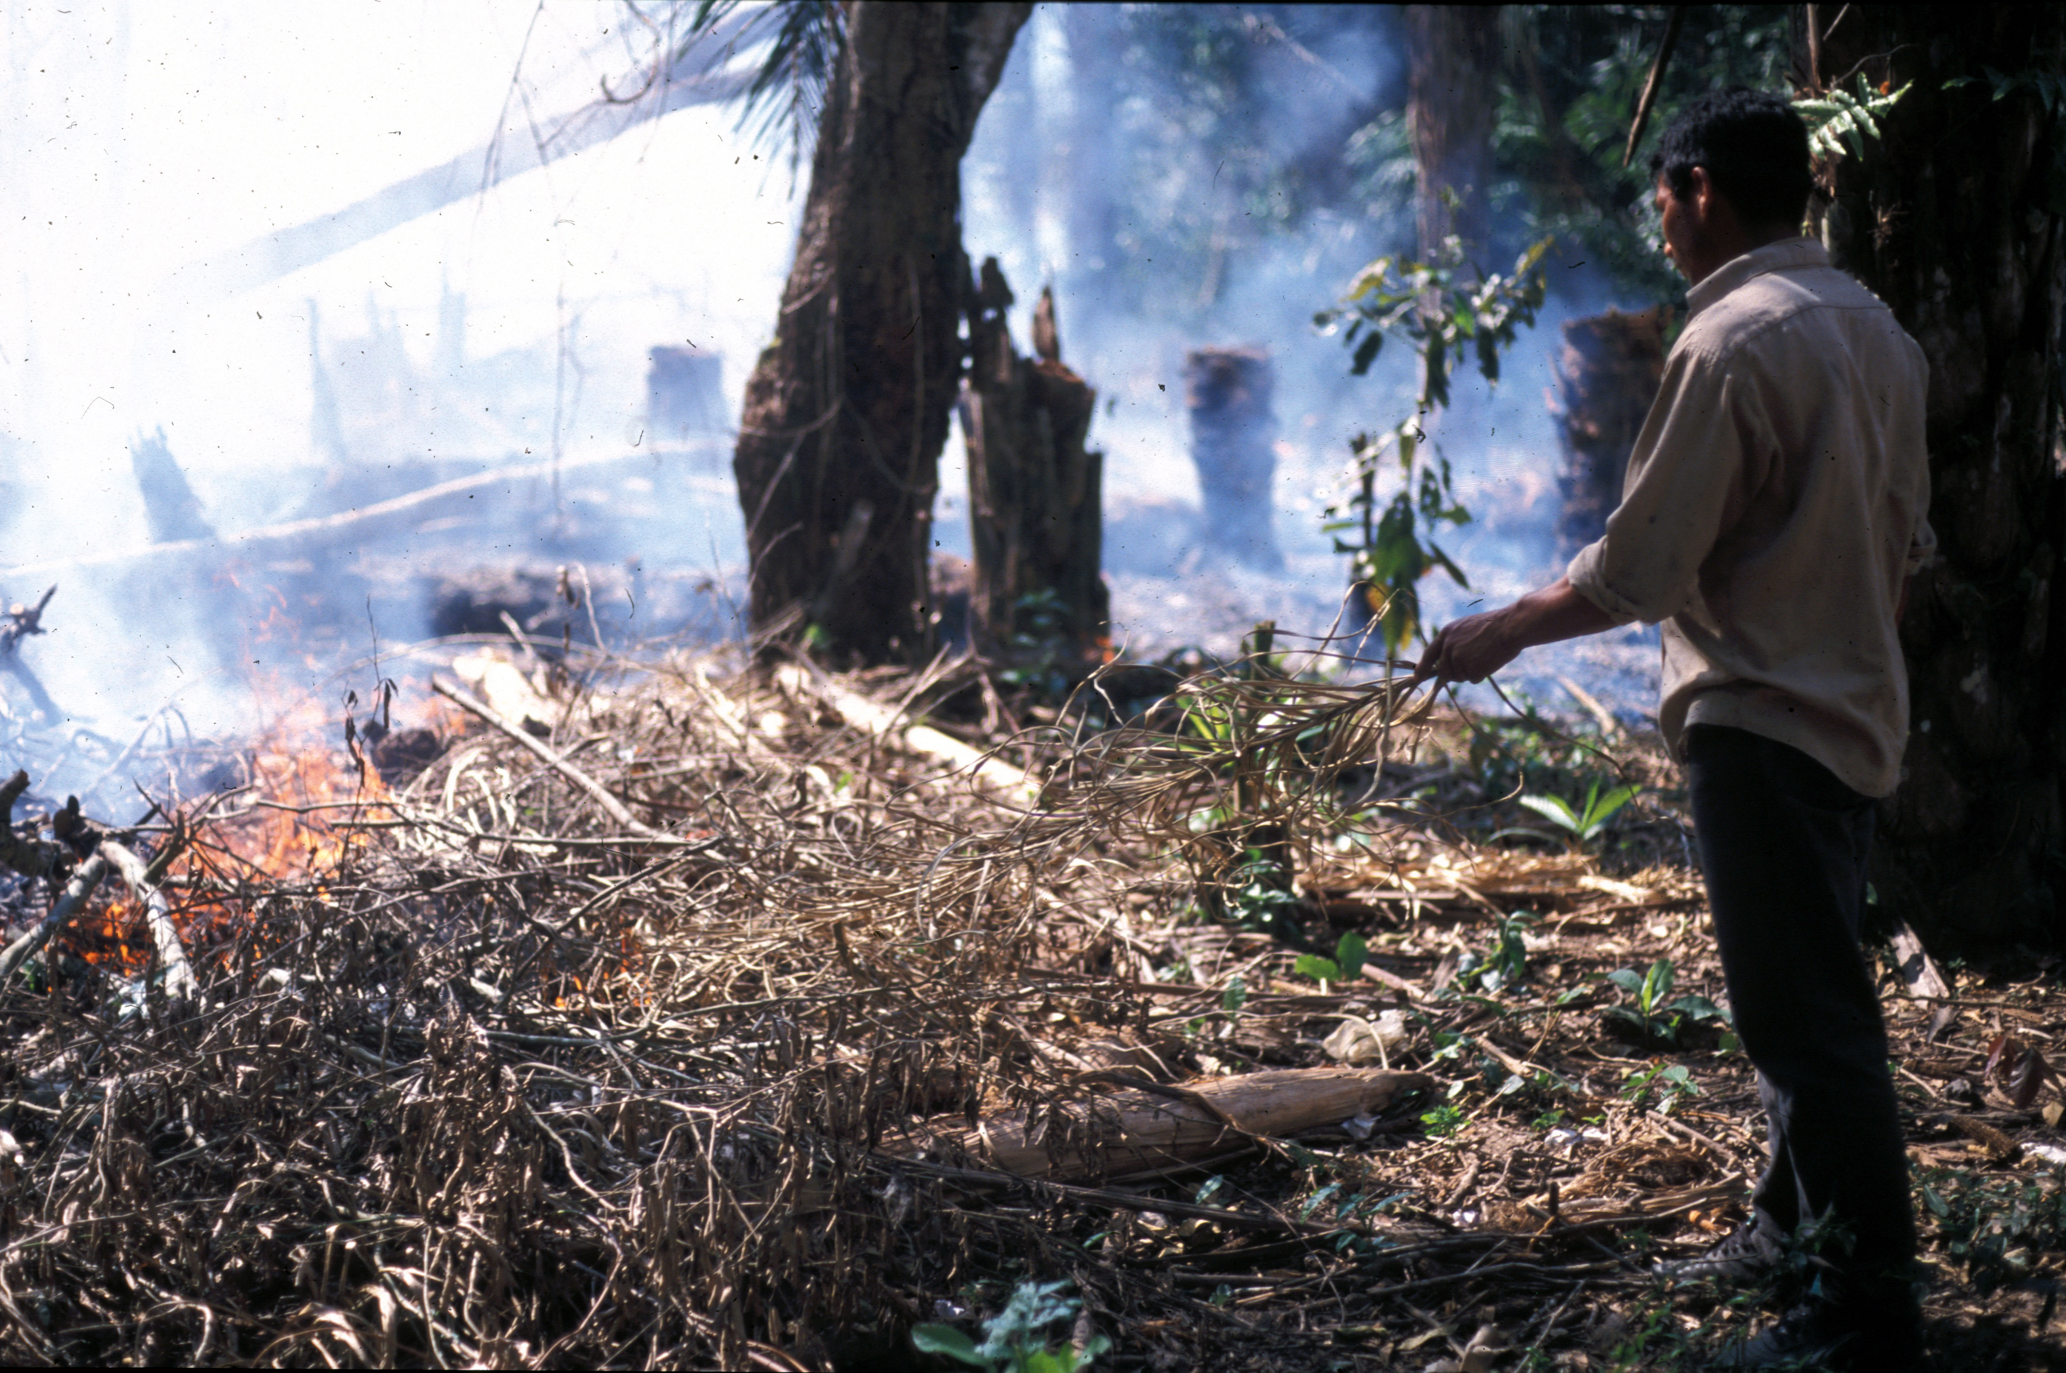Figure 2 A man stands while an areas of forest is burned for farming (Erickson).

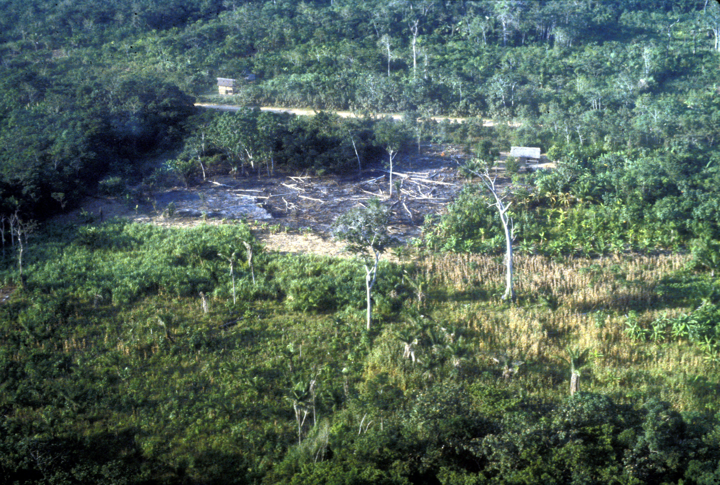Figure 3 Cleared areas of forest as part of slash and burn farming (Erickson).

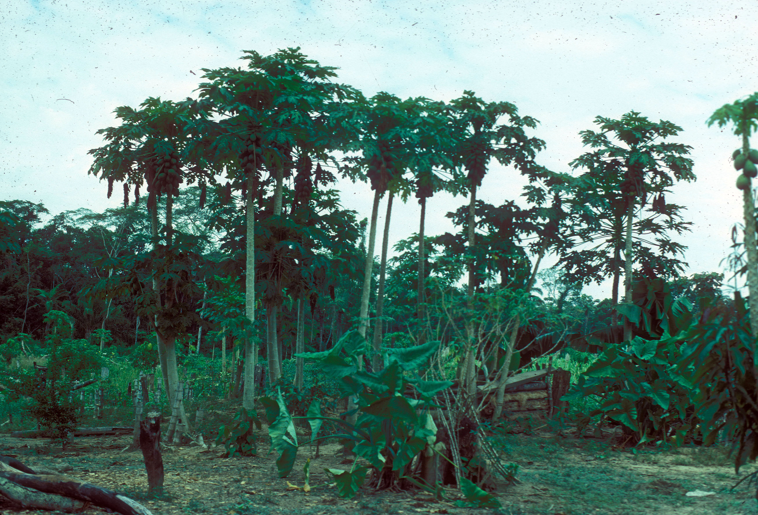Figure 4 Behind the structure of a house there is tangle from a house garden (Erickson).

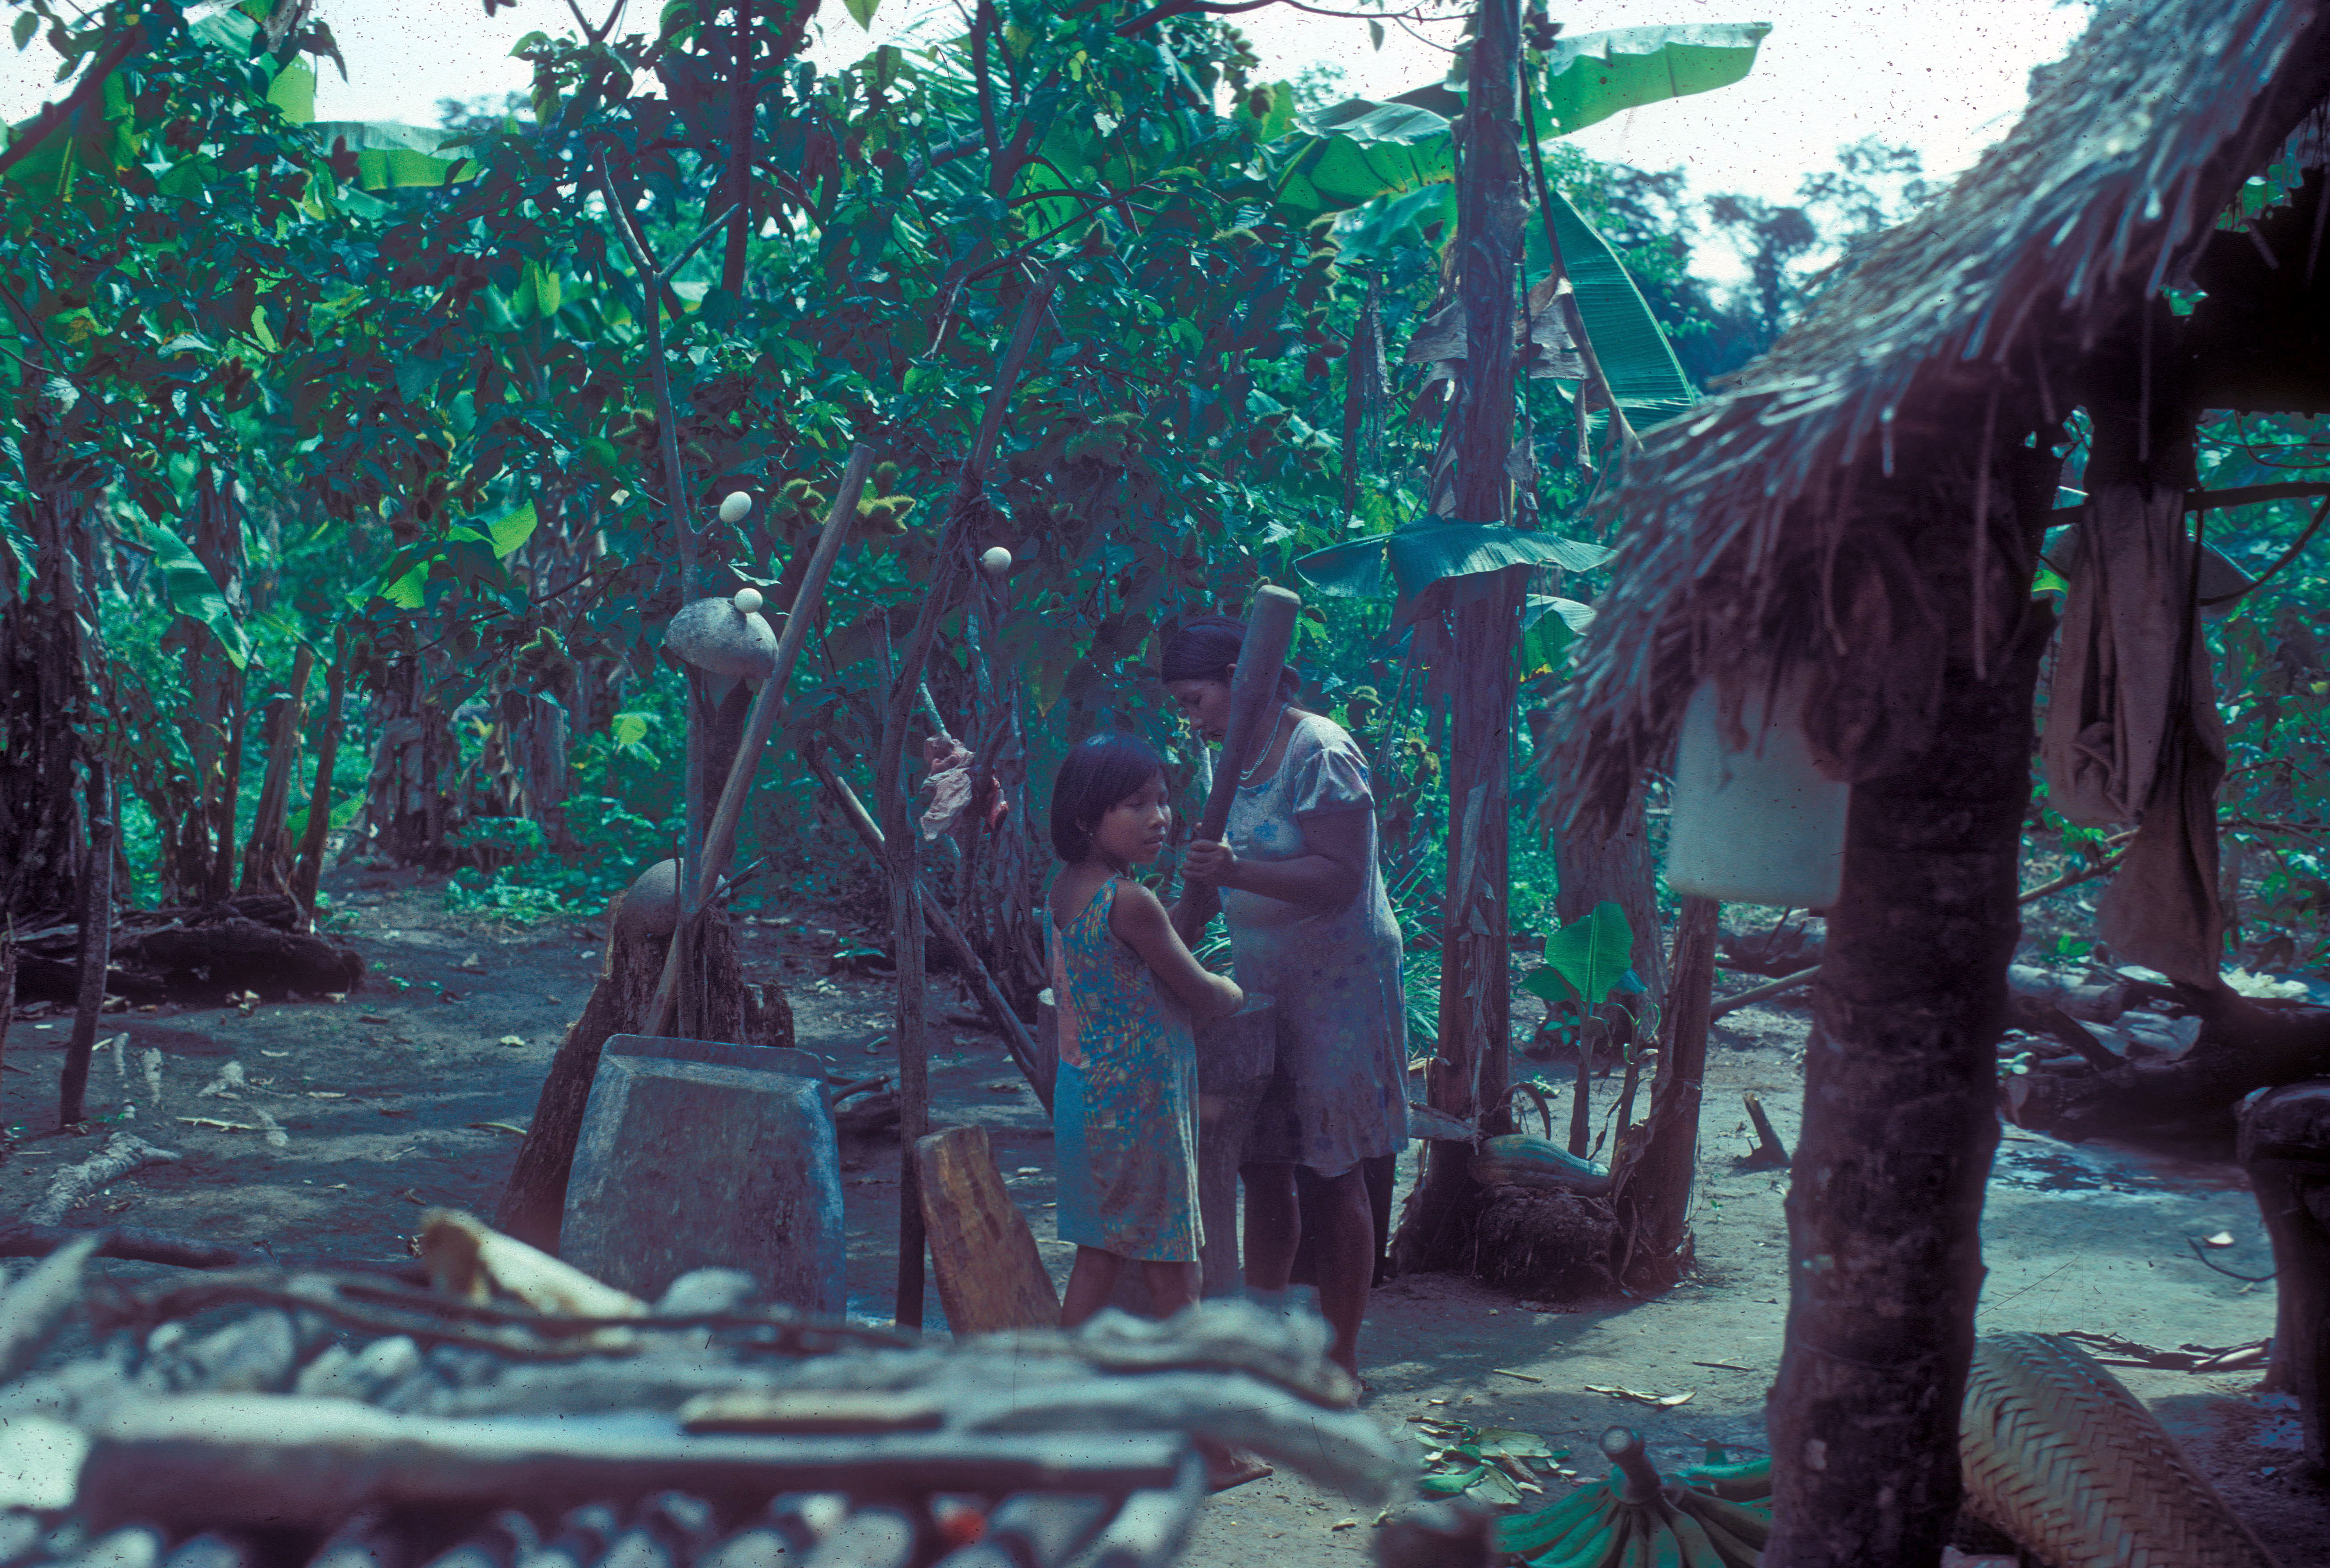Figure 5 House gardens allow residents easy access to their produce and growth (Erickson).

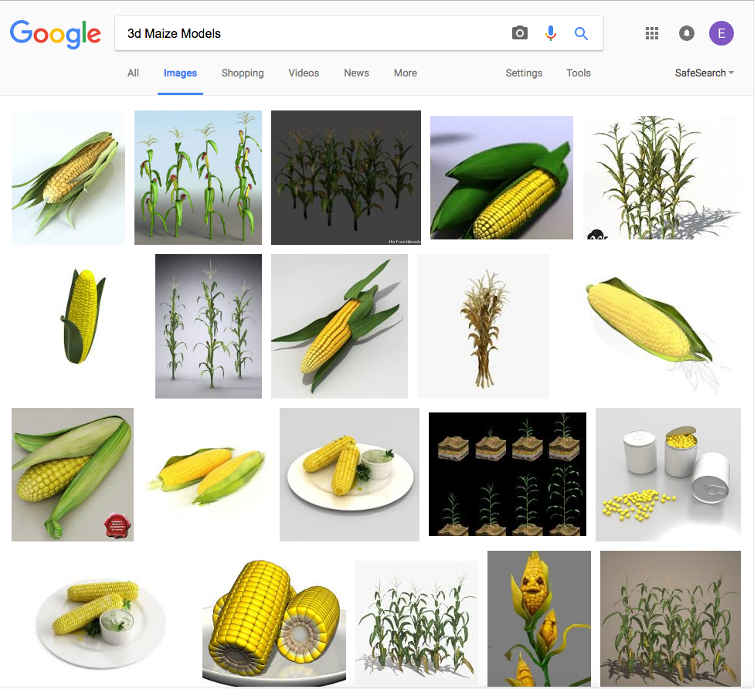Figure 6 Google image search results for “3d maize model” yields rich results (Ellis).

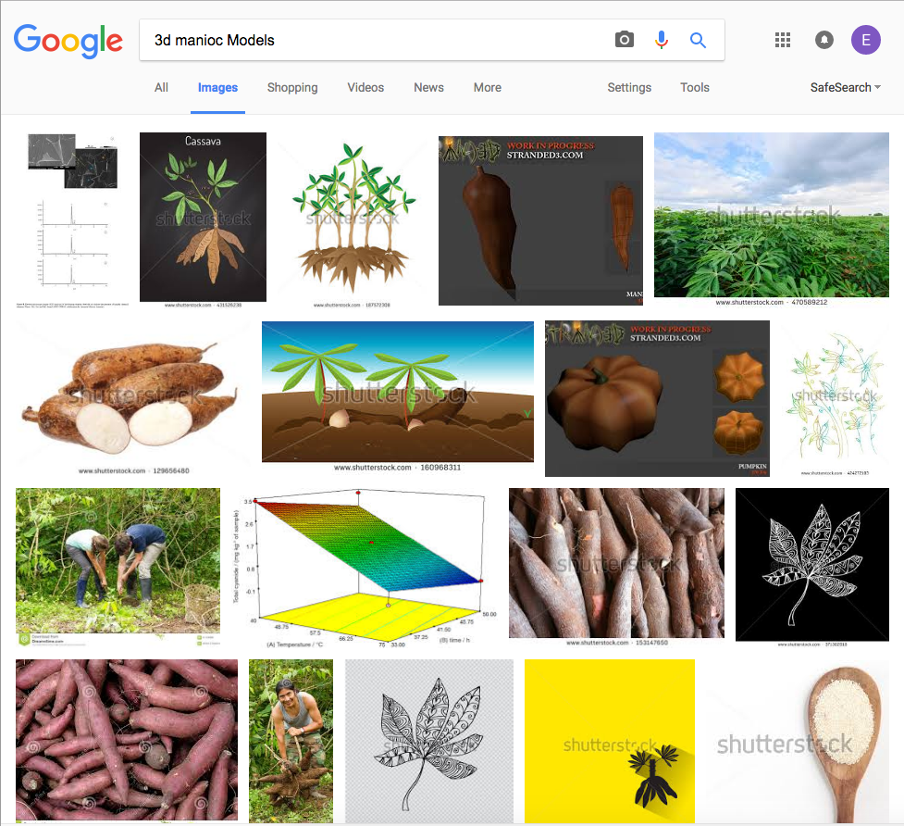Figure 7 Google image search for “3d manioc models” produces fewer results (Ellis).

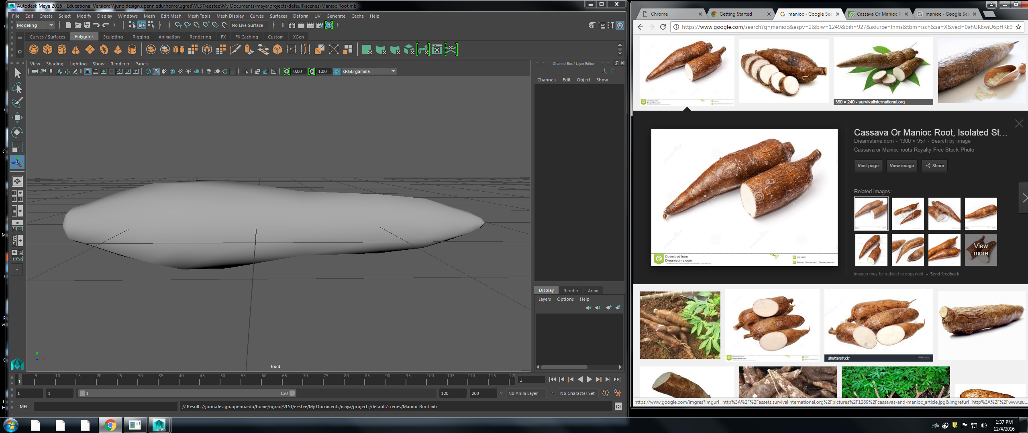Figure 8 Early stage of root modeling (Ellis).

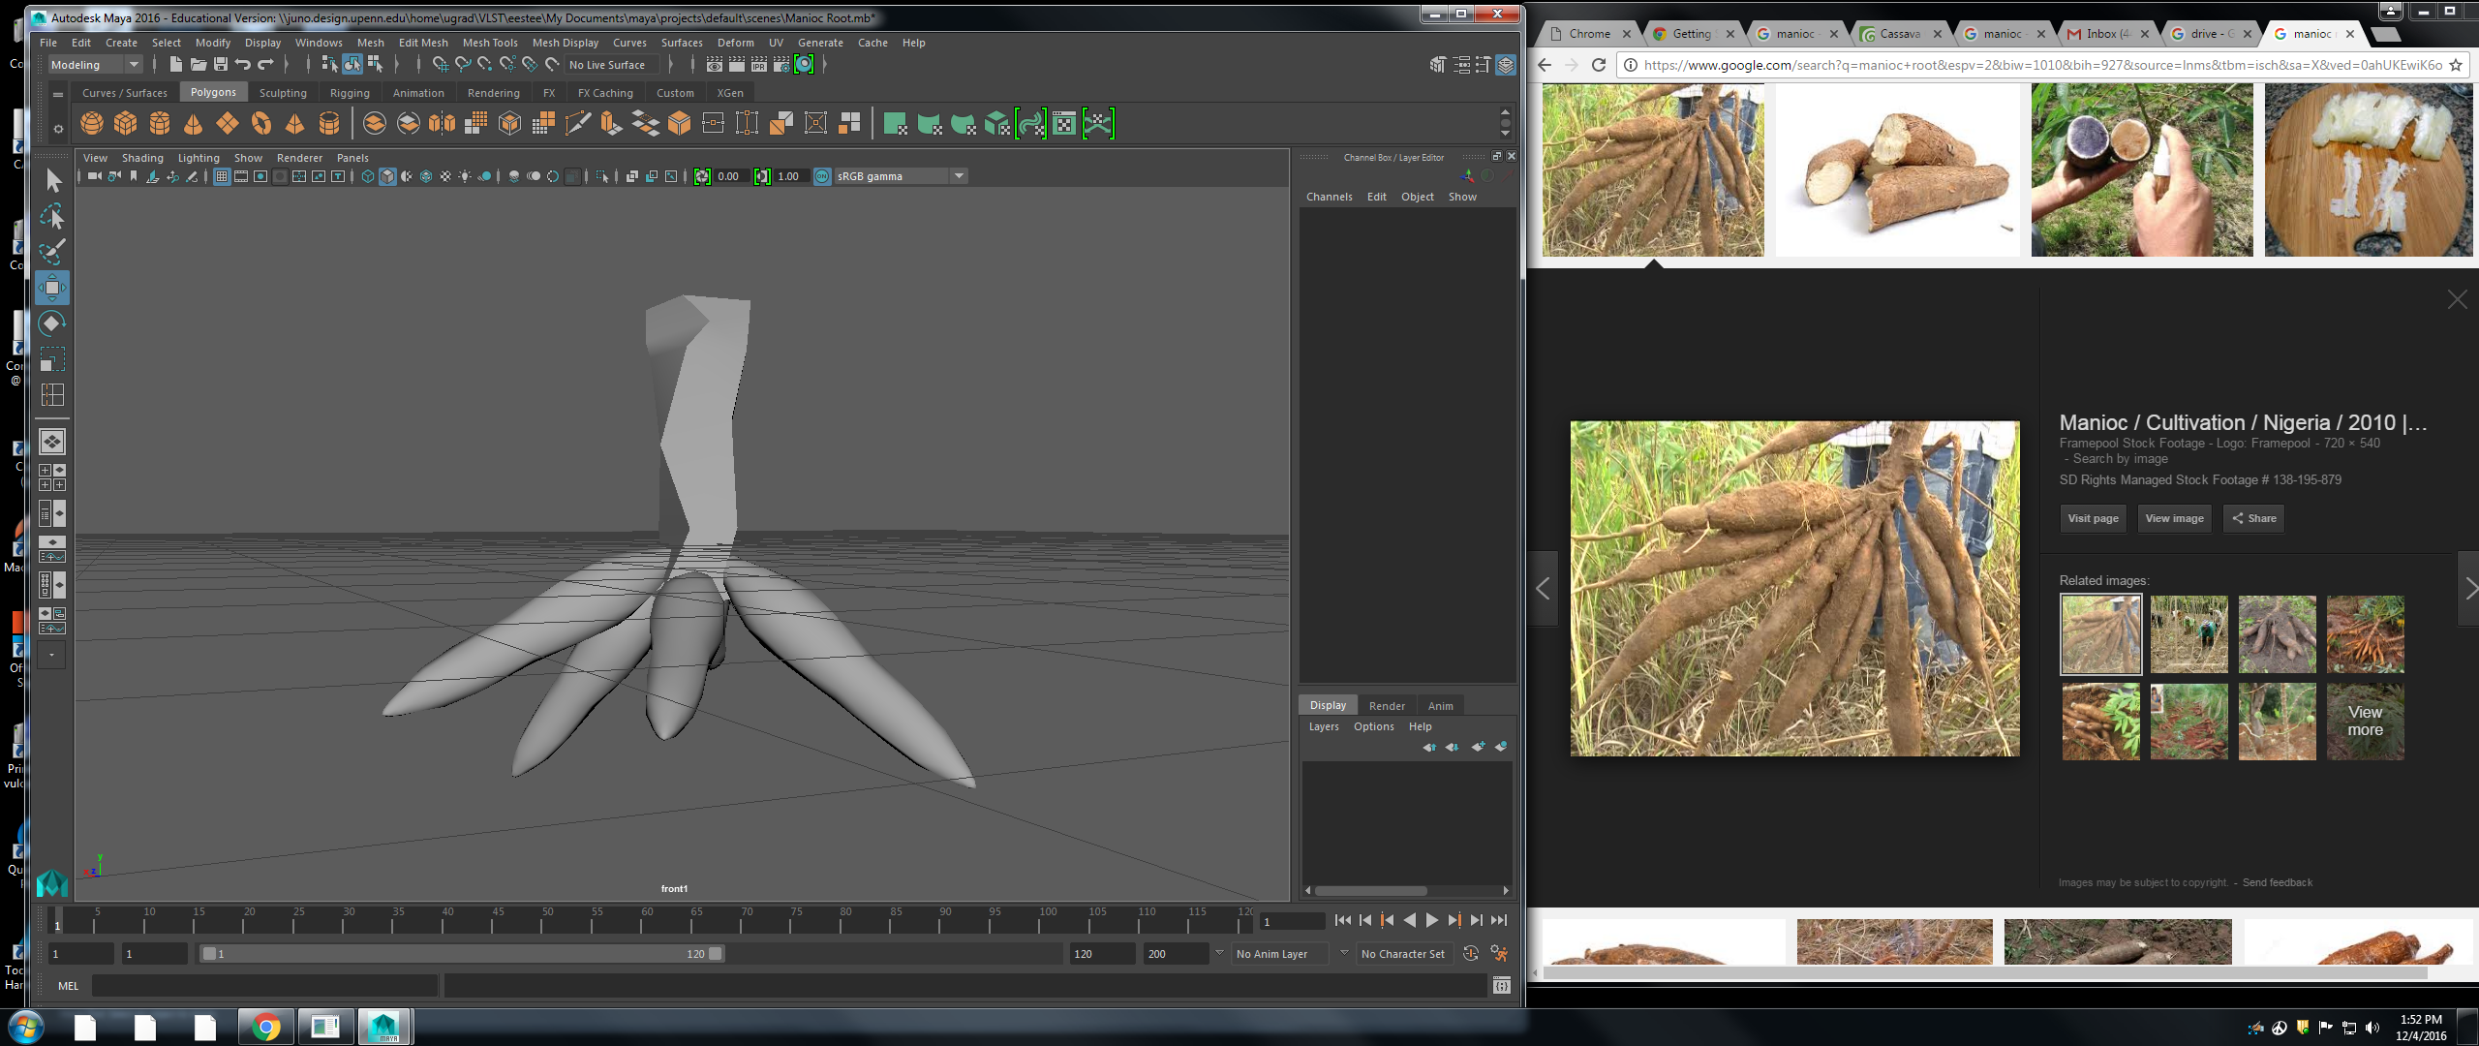Figure 9 Root and lower stalk modeling (Ellis).

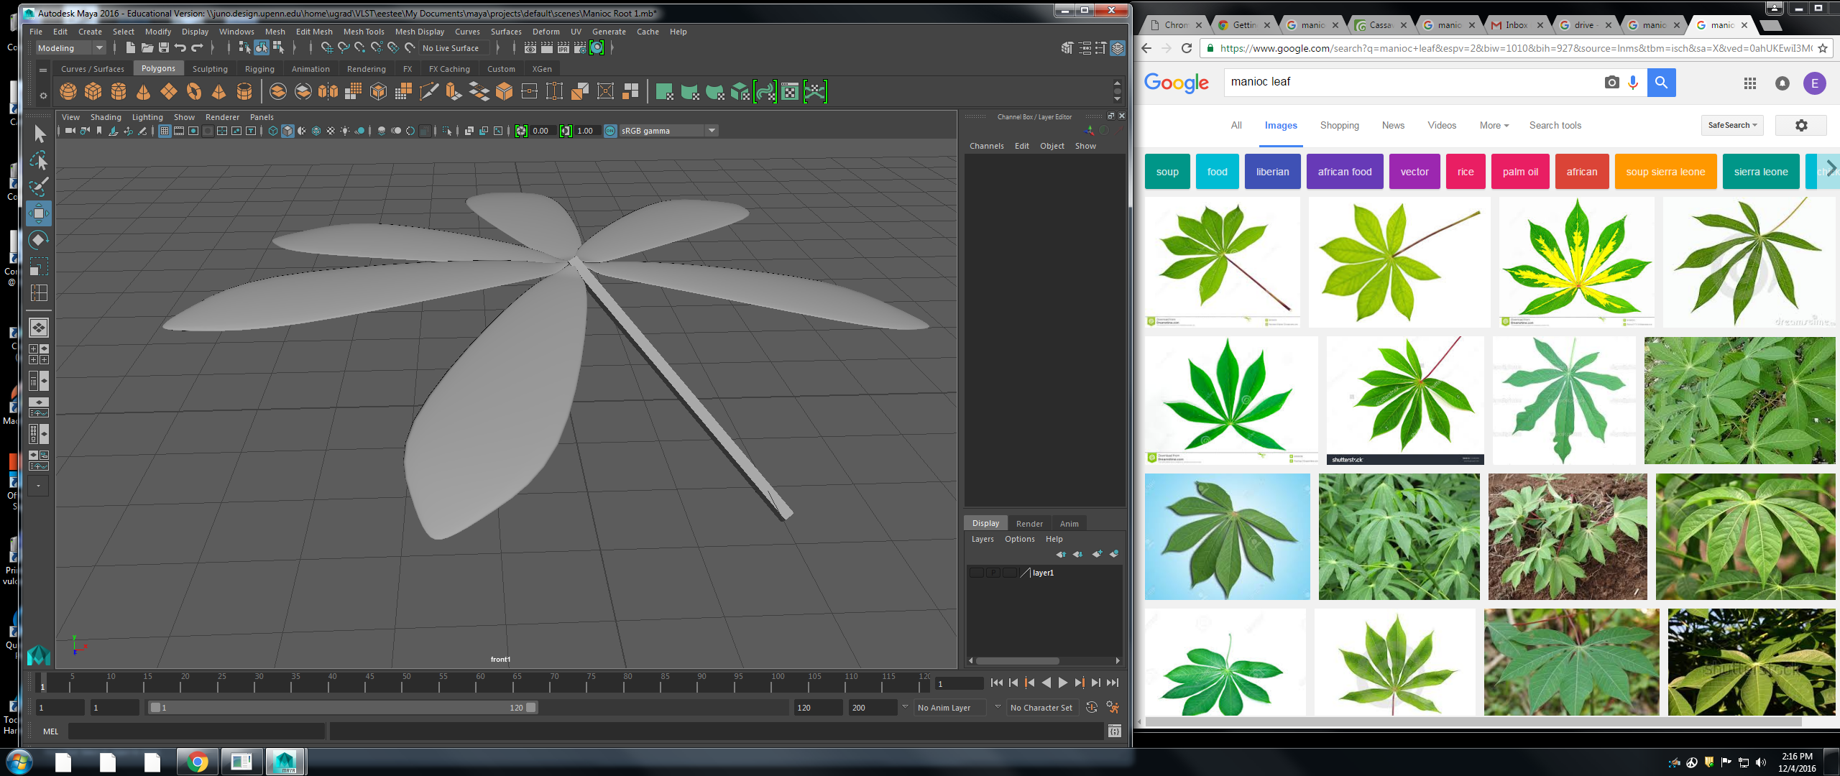Figure 10 Leaf modeling (Ellis).

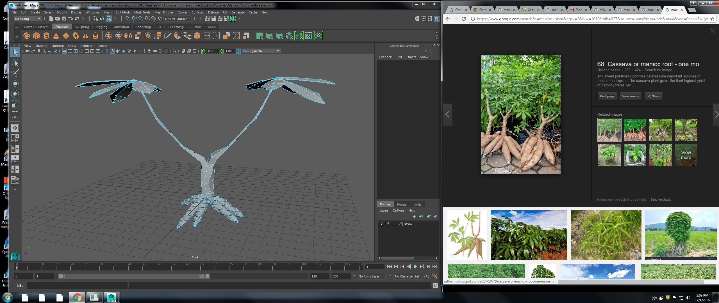Figure 11 Full manioc plant modeling (Ellis).

Figure 12 Gear for motion capture technology (Ellis).

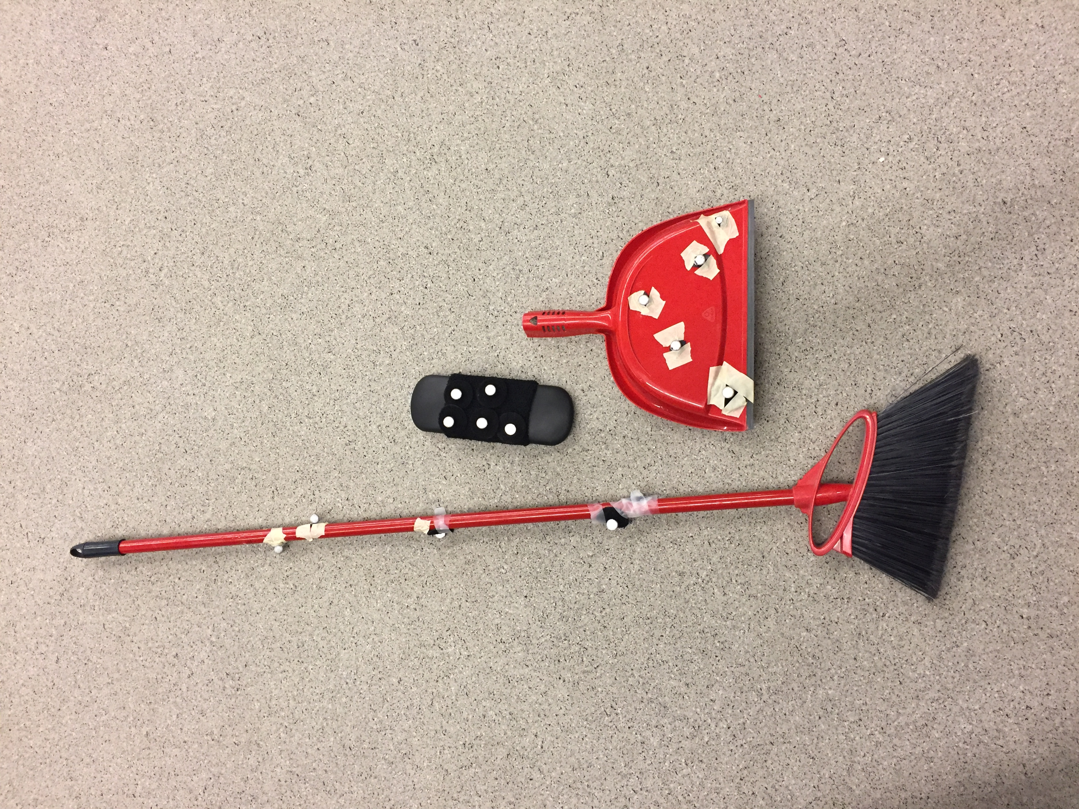Figure 13 Broom, dustbin, and chair piece with sensors for motion capture (Ellis).

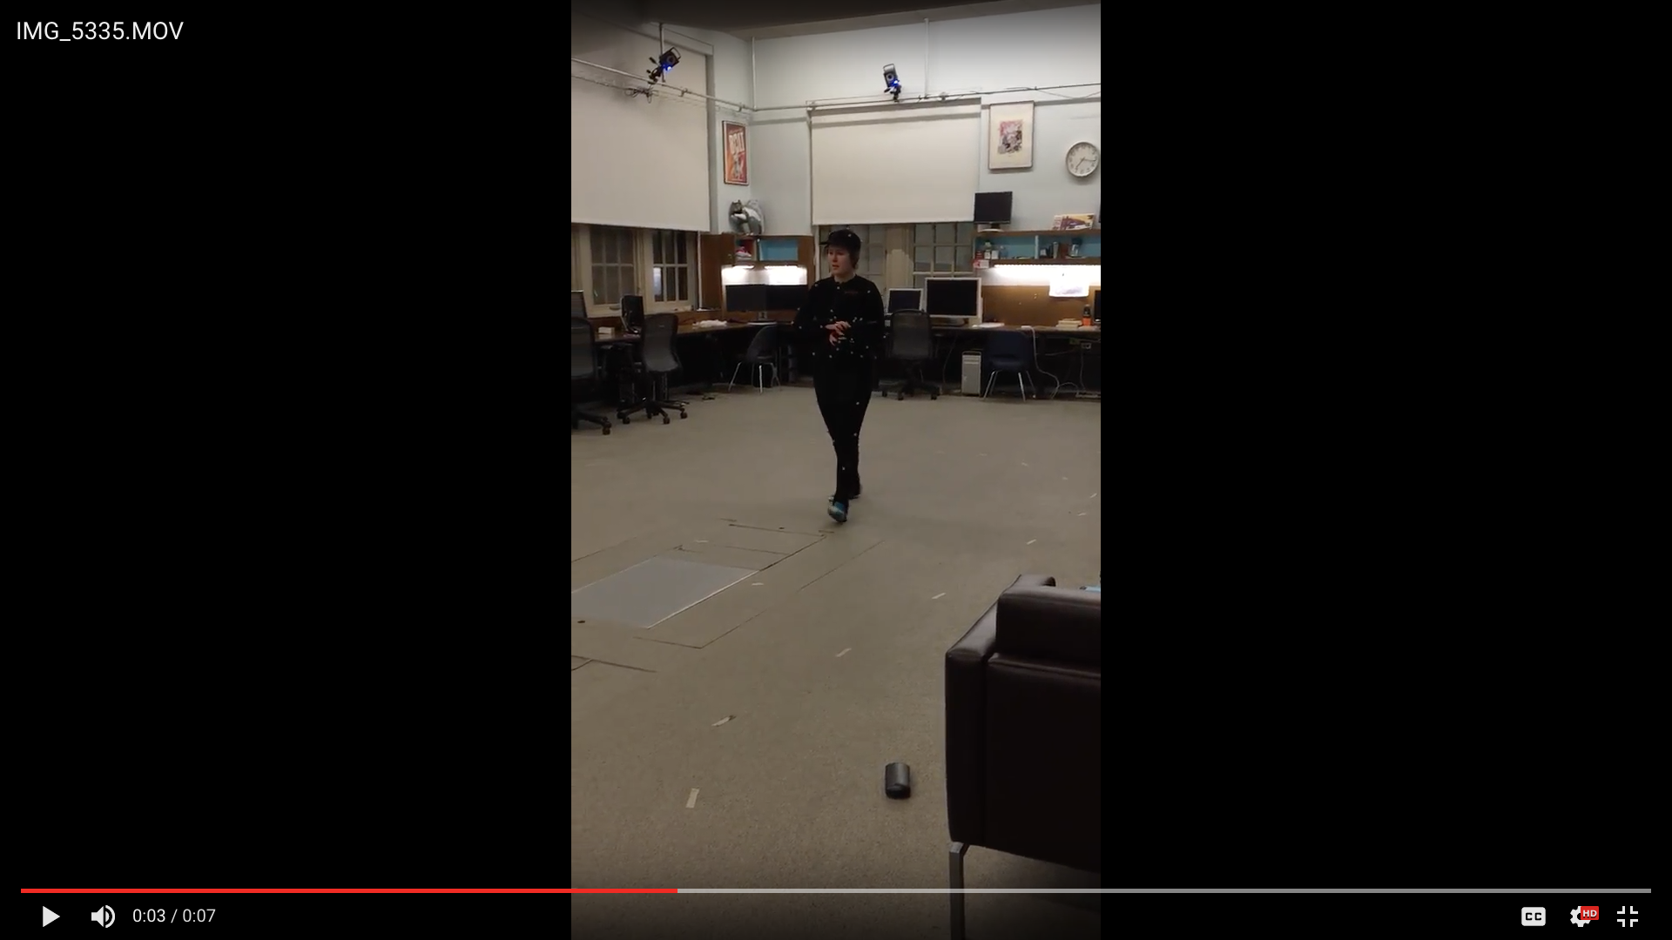Figure 14 Still from motion capture clip; dropping cutting to plant (Ellis).

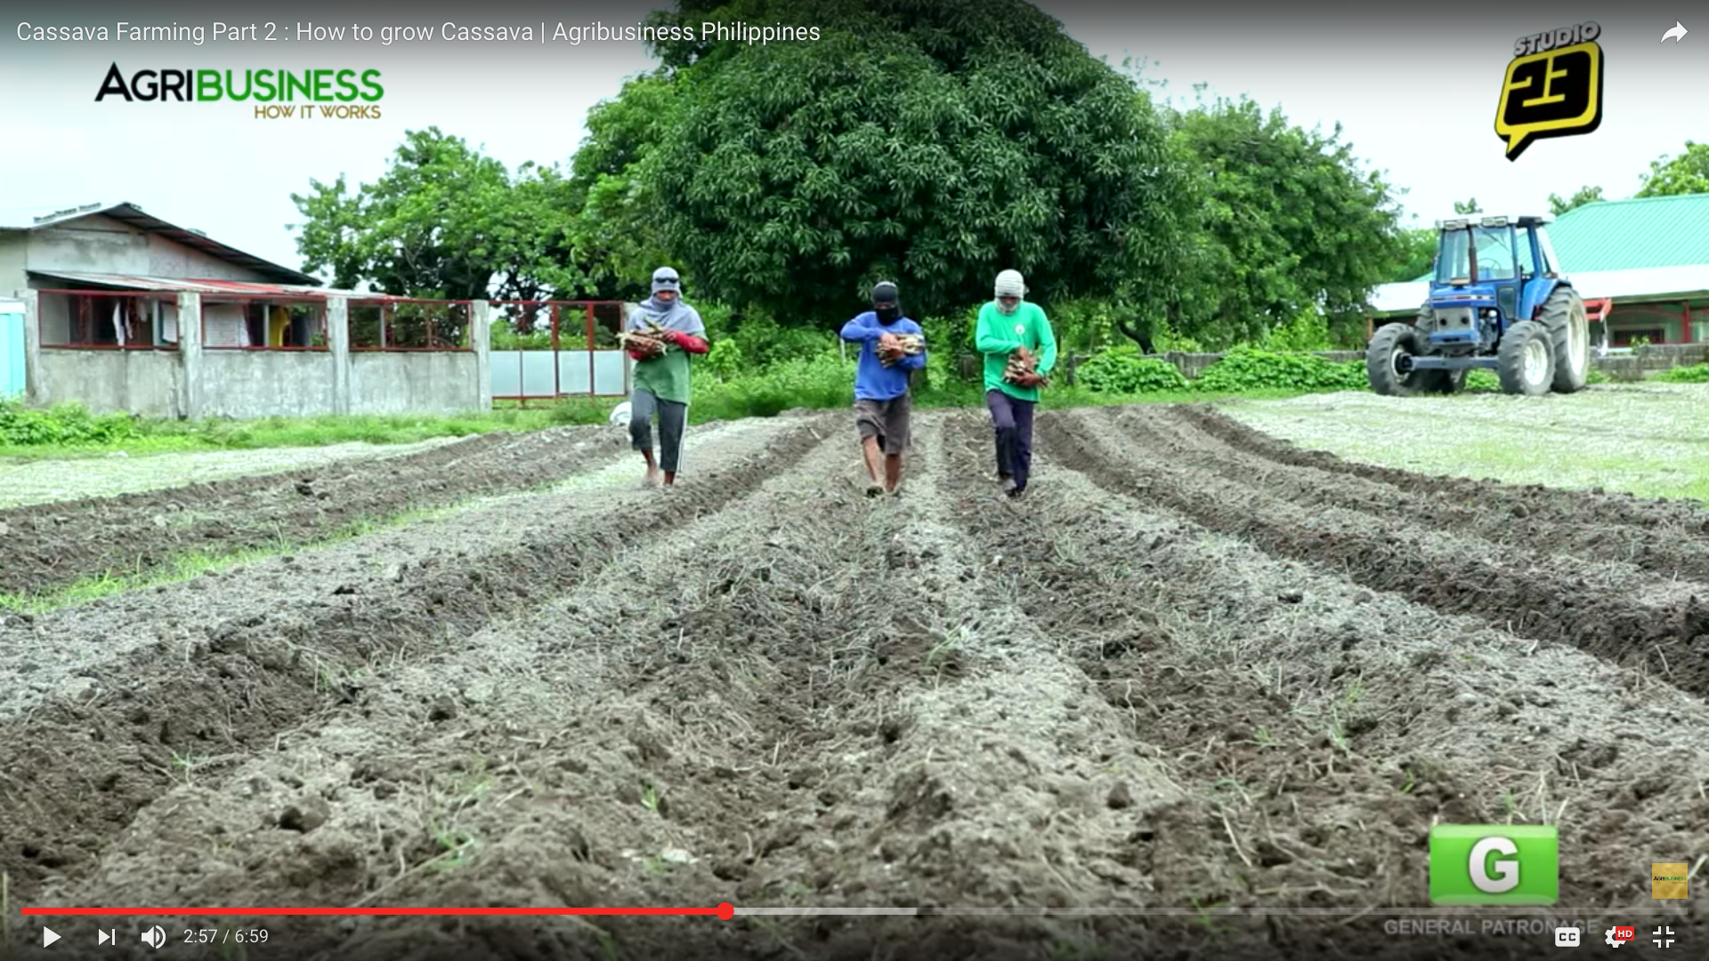Figure 15 Still from YouTube video; dropping cuttings to plant (Agribusiness How It Works).

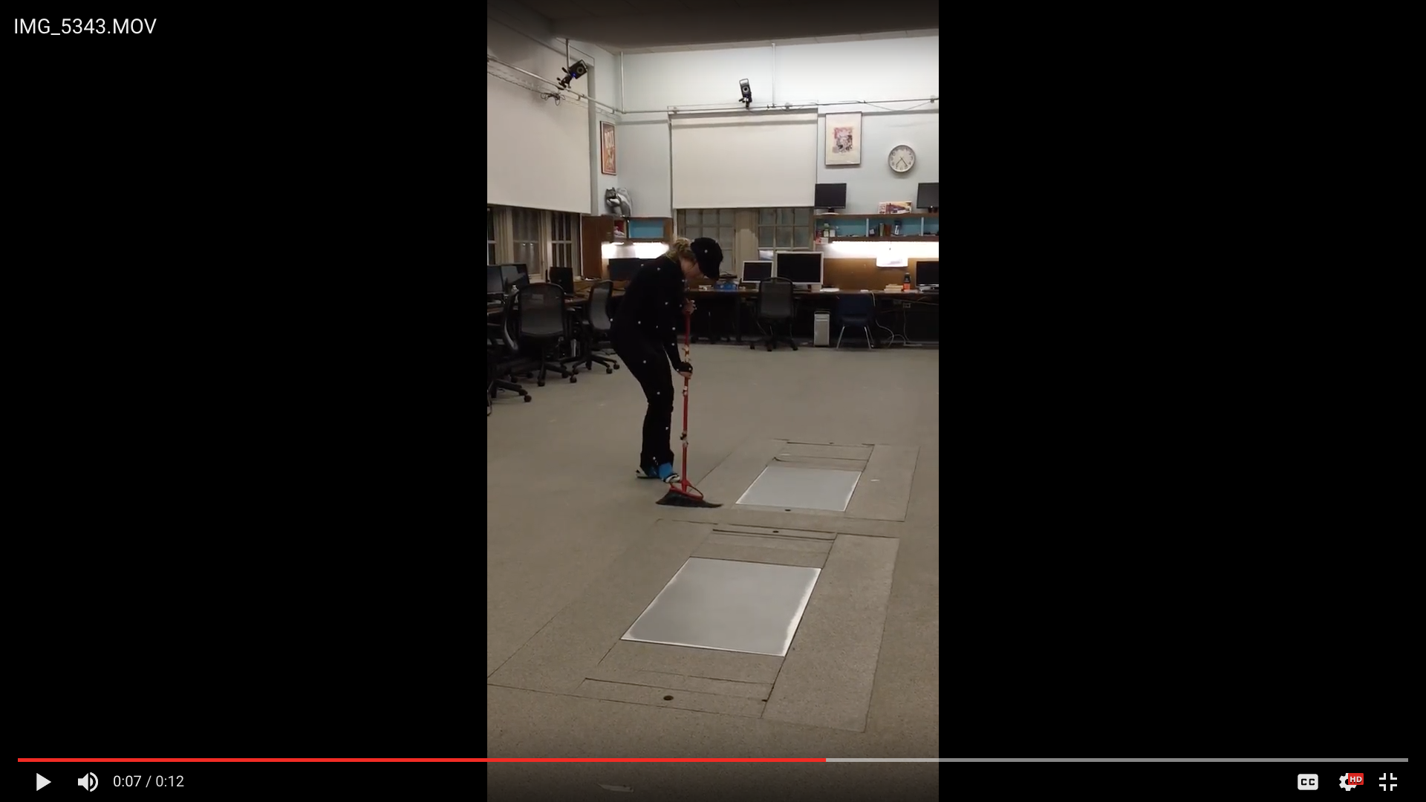Figure 16 Still from motion capture clip; unearthing root (Ellis).

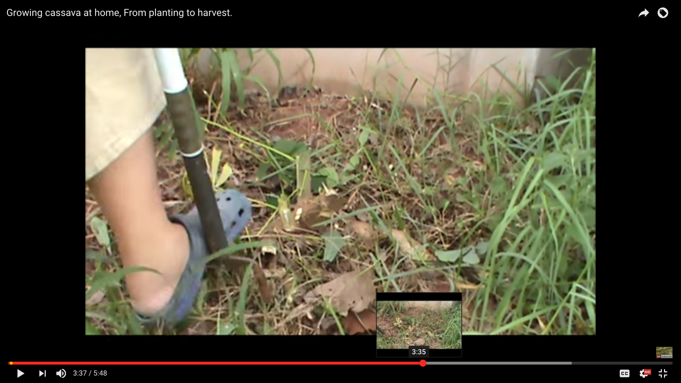Figure 17 Still from YouTube clip; unearthing root (Lifeinthailand).
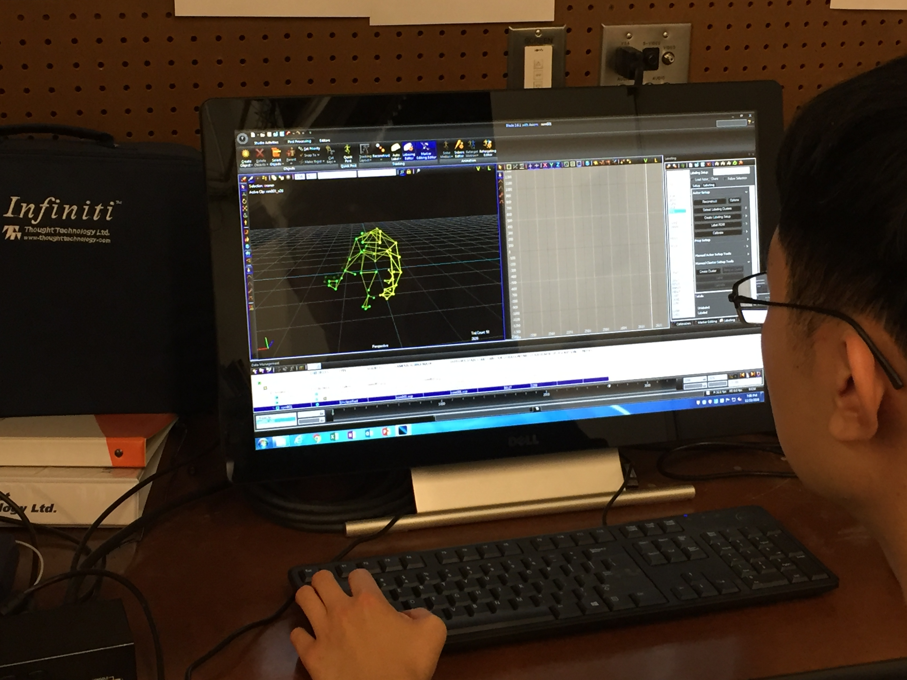Figure 18 Motion data on digital display; chopping roots on branch (Ellis).
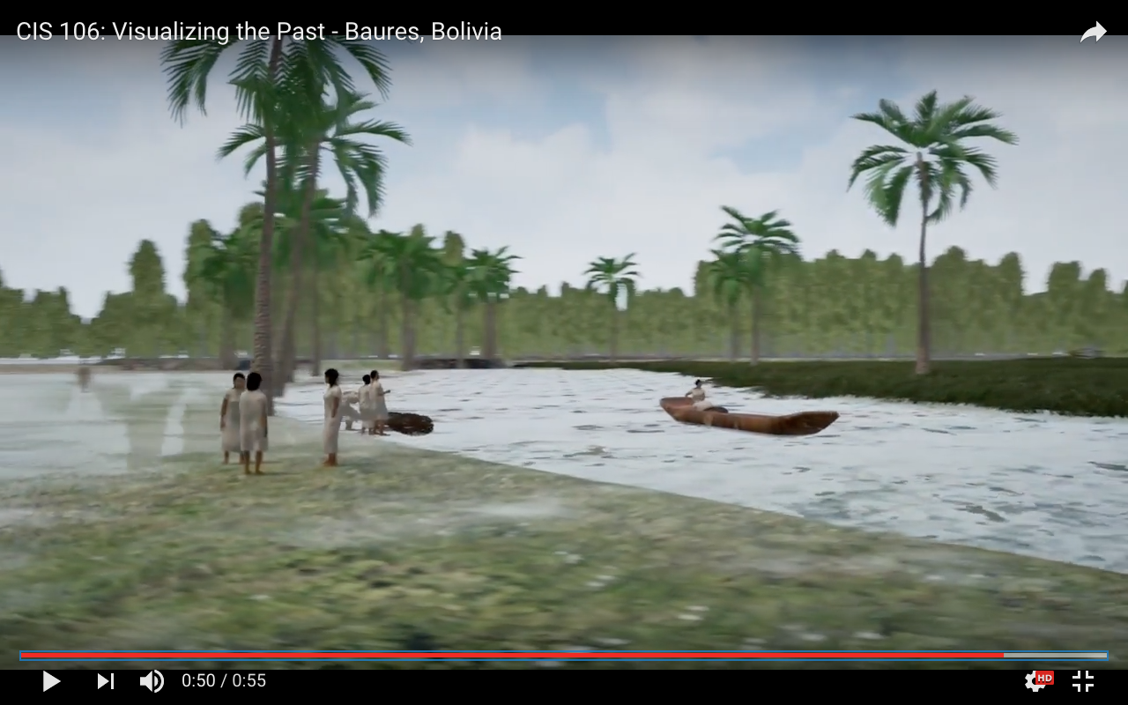Figure 19 Final ANTH 258/CIS 106 model with landscapes, objects, and people (Best and Students of ANTH 258/CIS 106).
References Cited
Agribusiness How It Works.
2013 “Cassava Farming Part 2: How to grow Cassava | Agribusiness Phillipines.” Youtube video published on 20 Oct. Accessed from: https://www.youtube.com/watch?v=rQZ53WWzKW0
Ellis, Estee.
2016. Photographs taken by Chloe Snyder. Visualizing the Past/Peopling the Past, pictures from The University of Pennsylvania. Philadelphia.
Erickson, Clark.
2016. Visualizing the Past/Peopling the Past, Lectures and personal communication at The University of Pennsylvania. Philadelphia.
Lifeinthailand.
2013 “Growing cassava at home, From growing to harvest.” Youtube video published on 4 Jun. Accessed from: https://www.youtube.com/watch?v=ZokEAu-VB7s
Tar160.
2009 “the magic plant.” Youtube video published on 24 Jan. Accessed from: https://www.youtube.com/watch?v=BQdDCs12Ons

