**Figure 1: A KFC boldly presents at the entrance of the town (Lawrence 2013)**

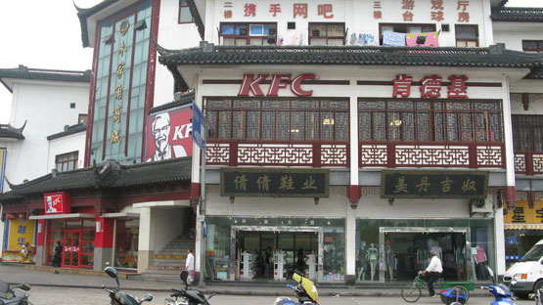

**Figure 2: A Starbucks along one of the main streets (Travels of Four 2014)**

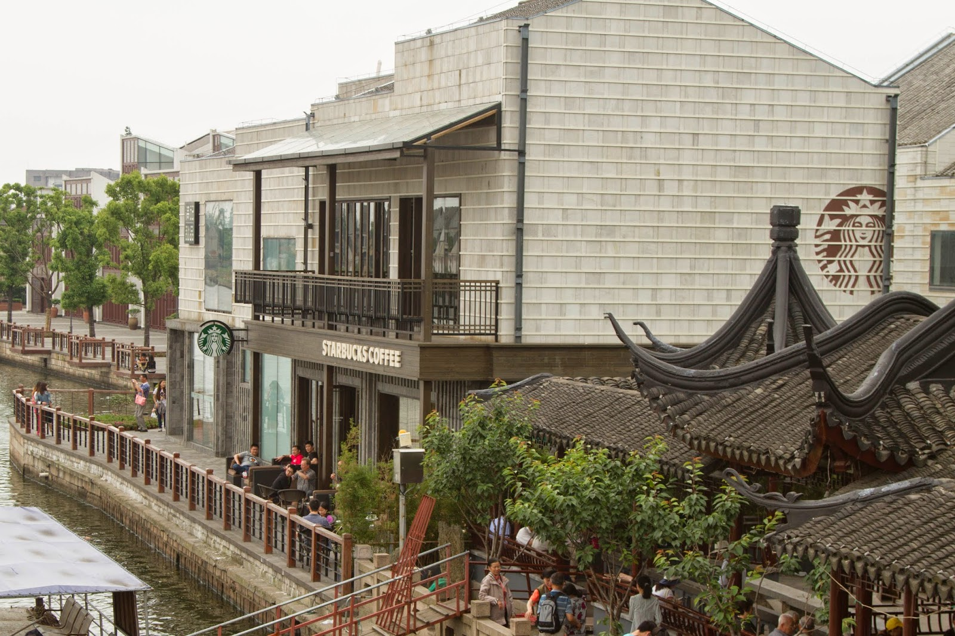

**Figure 3: Before remodeling the buildings around the Lang Bridge (Lawrence 2013)**

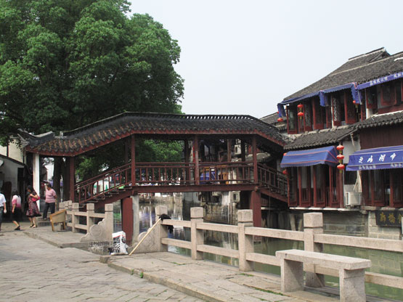

**Figure 4: After remodeling the buildings around the Lang Bridge (Lawrence 2013)**

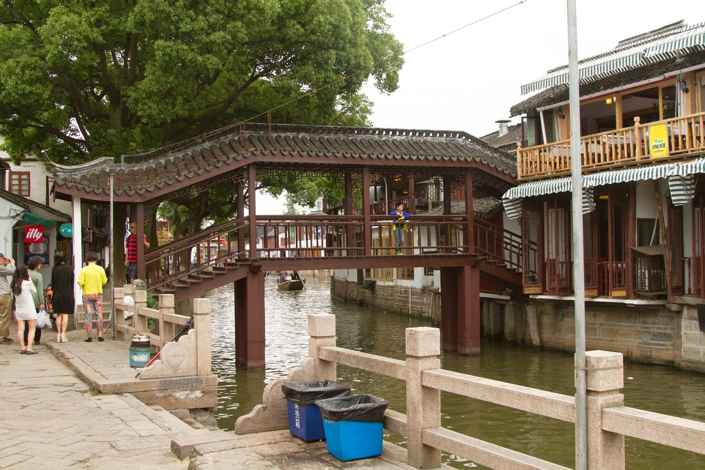

**Figure 5: Construction around the city (Lawrence 2013)**

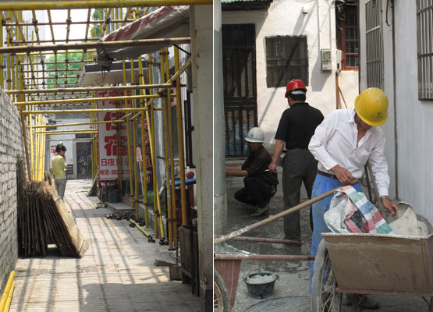

**Figure 6 and 7: Bridge Architecture from the Qing Dynasty (Paths)** 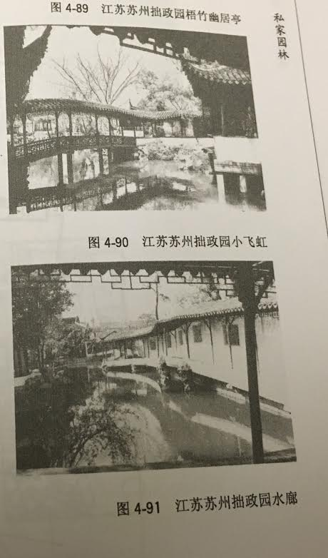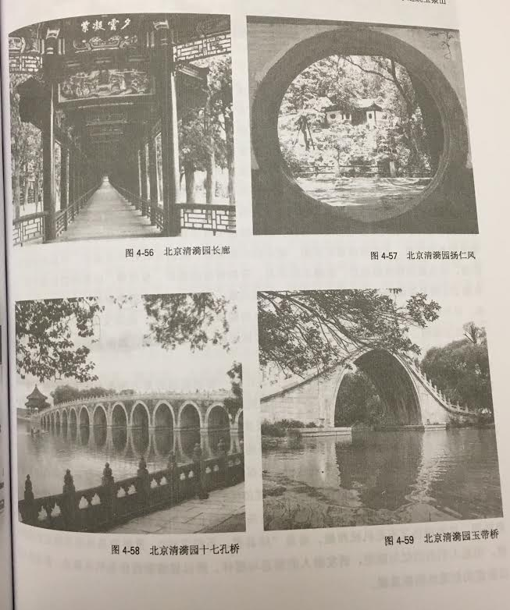

**Figure 8: Lang Bridge (Zhujiajiao Shanghai 2003)**

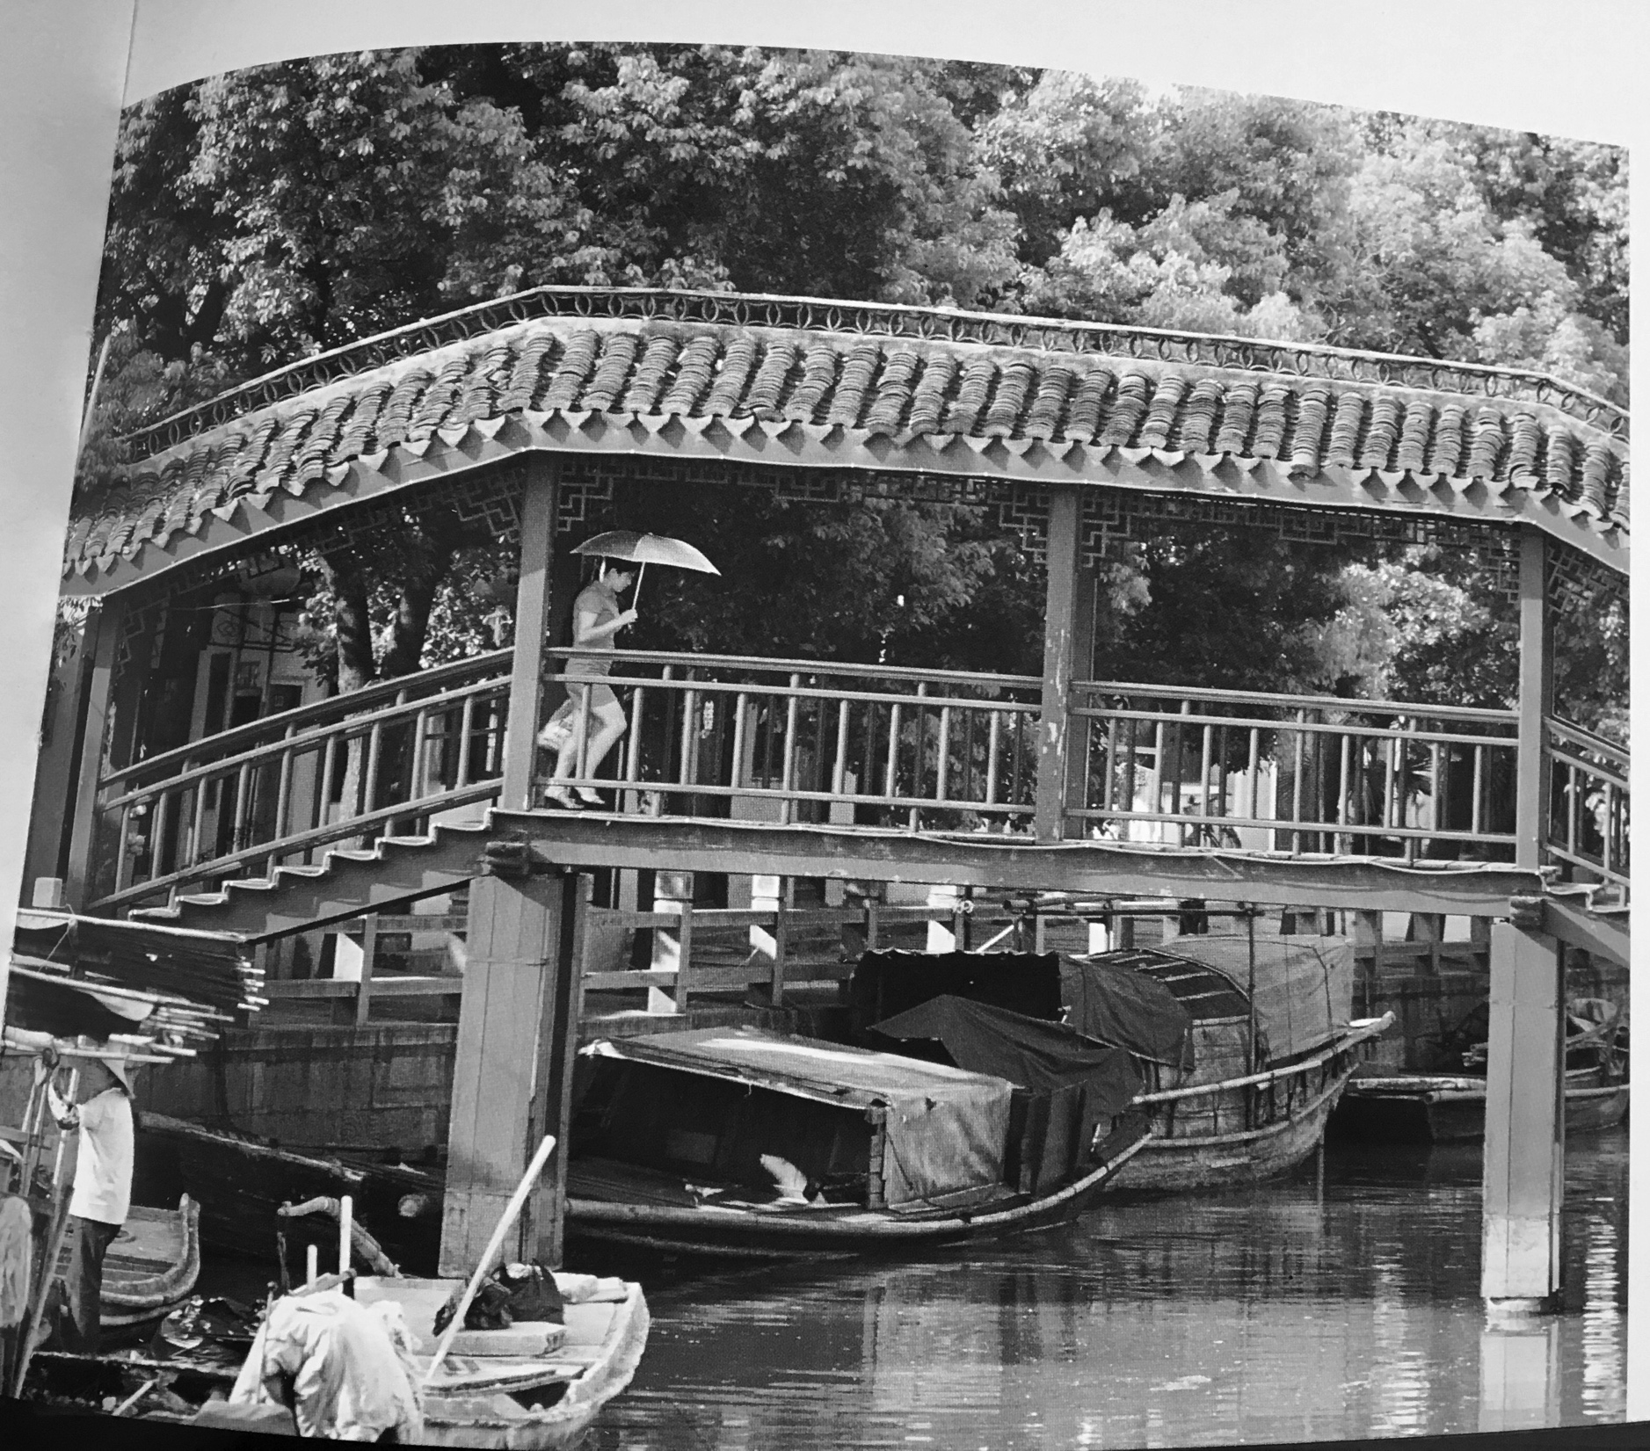

**Figure 9-14: Modeling process of the bridge**

