Andrés De los Ríos

ANTH258/ CIS106

Visualizing the Past/Peopling the Past

December 19, 2016

Voicing the Past – Learning Agents in a Virtual Landscape of Baures.

Figures:

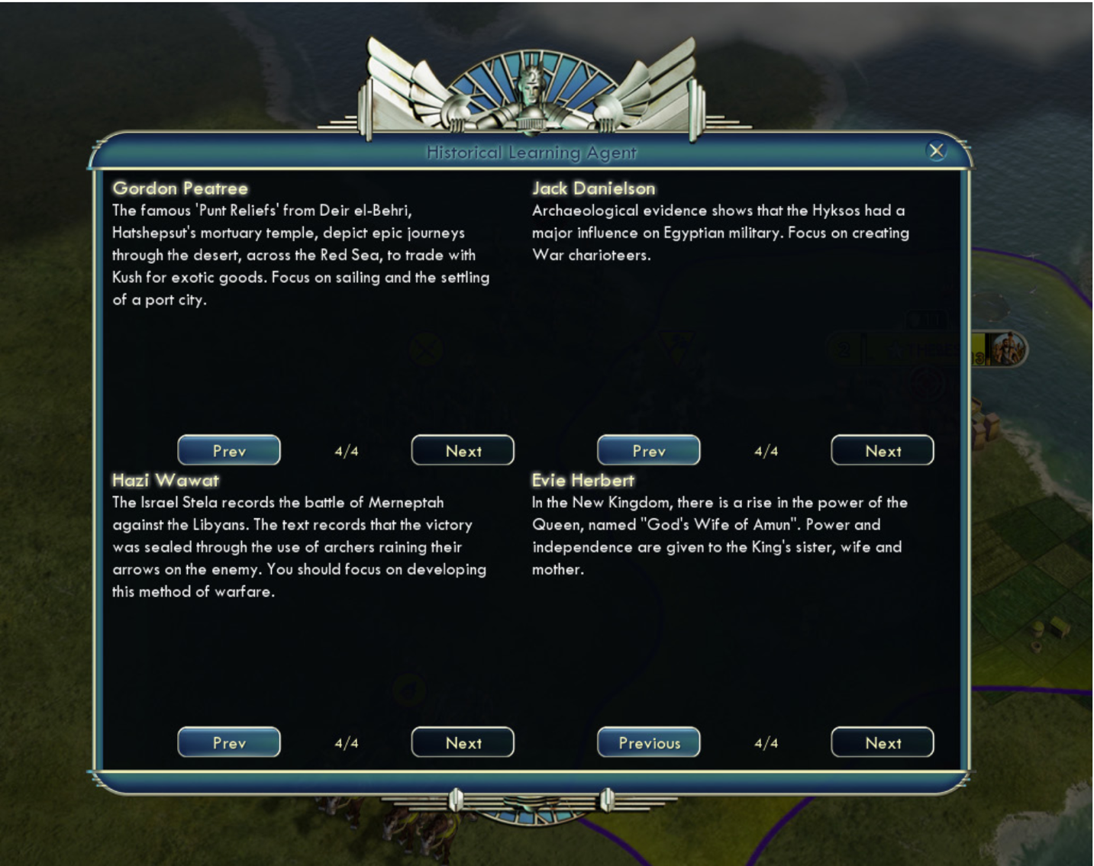

*Figure 1. Watrall’s Historical Learning Agents offering advice based on their academic concentrations and historiographical biases.*

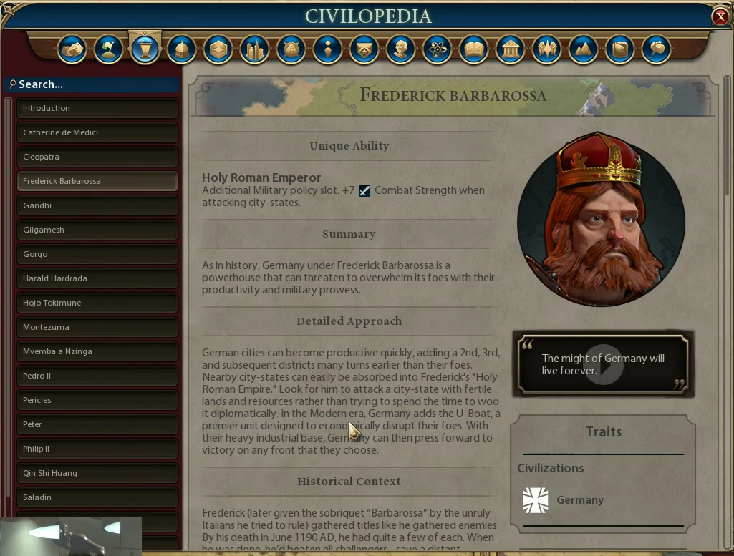

Figure 2. Civilopedia entry from the franchise's latest entry, Civilization VI (2016).

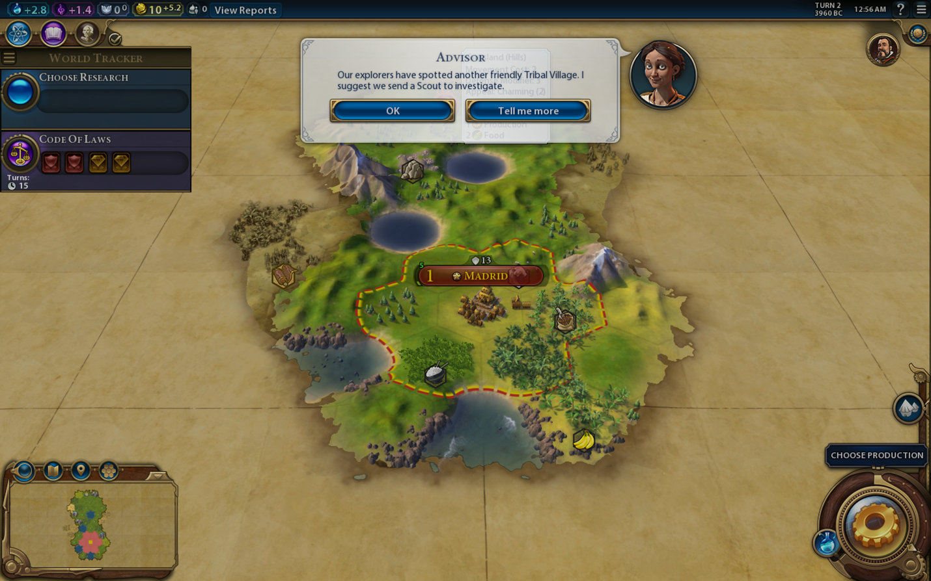

Figure . Civilization's subtle notification system presenting bite-sized pieces of information and offering the possibility to know more on certain situations, objects, or characters.

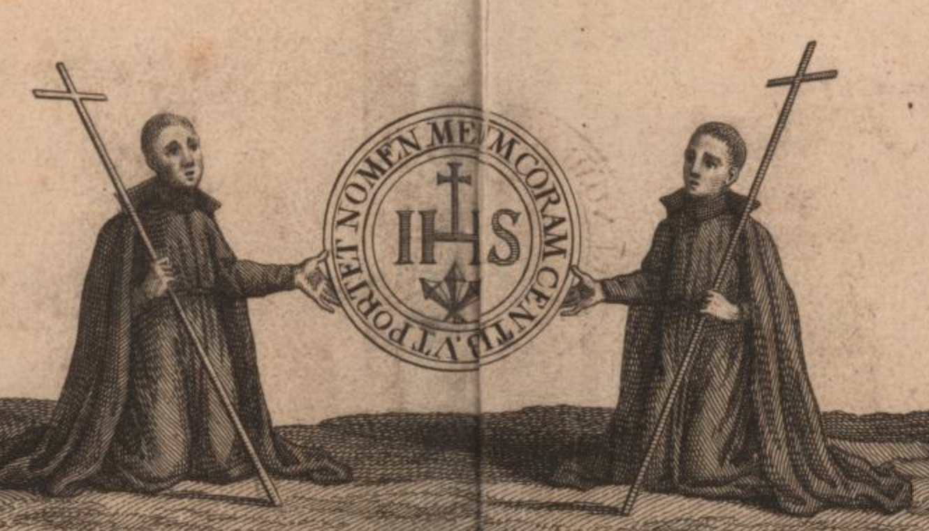

Figure . Example of two Jesuit priests from a 18th-century map of the Mojos region.

References Cited

Fireaxis Games

2016 *Civilization VI*. 2k Games. Electronic document, <https://civilization.com>, accessed November 15, 2016.

John Carter Brown Library.

c. 1713 “Mision de Mojos de la Compañia de HIS [Jesus] de el Peru*”*. Electronic document,<http://jcb.lunaimaging.com/luna/servlet/detail/JCBMAPS~1~1~1896~106010005:Mission-de-Mojos-de-la-Compañia-de->, accessed December 10, 2016.

Watrall, Ethan

2014 “Red Land/Black Land: Teaching Ancient Egyptian Archaeology through Digital Game-Based Learning”. In *Advances in Archaeological Practices* 2 (1): 38-49.